**MongoDB Task-1**

**Database Name: MyDatabase**

**Collection Name: Products**

1. **Find all the information about each products.**

**Query: db.Products.find();**

**Output:**

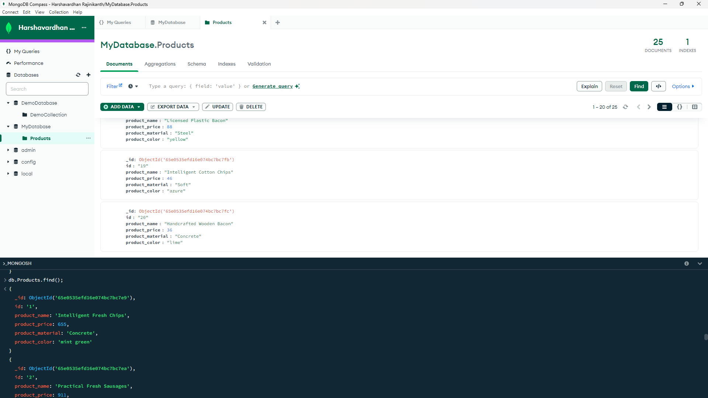









1. **Find the product price which are between 400 to 800**

**Query: db.Products.find({‘product_price’:{$gte:400,$lte:800}});**

**Output:**

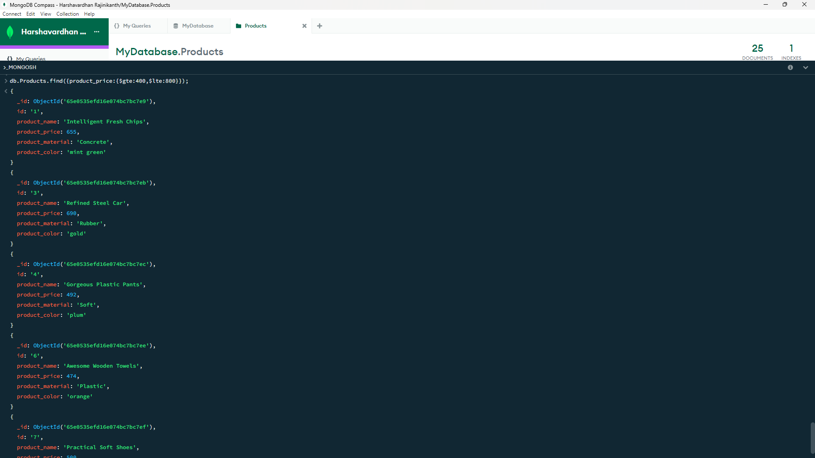

1. **Find the product price which are not between 400 to 600**

**Query:db.Products.find({‘product_price’:{$not**:**{$gte:400,$lte:600}}});**

**Output:**

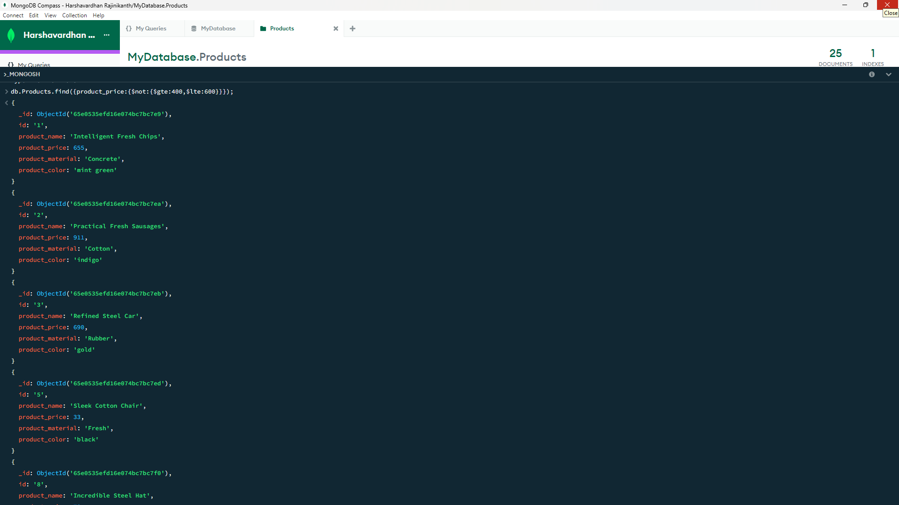

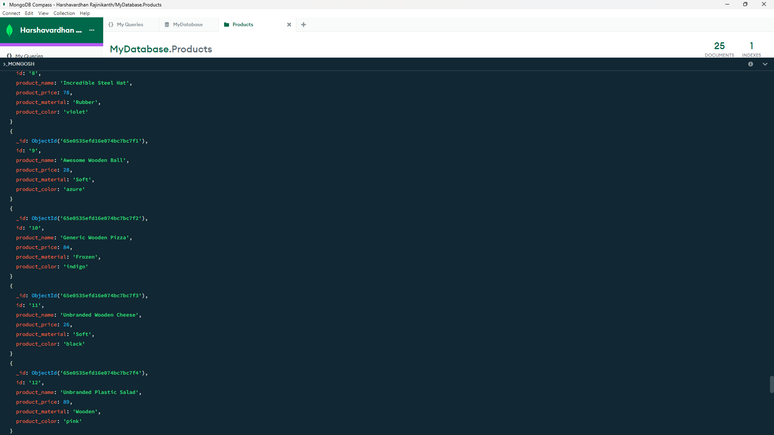

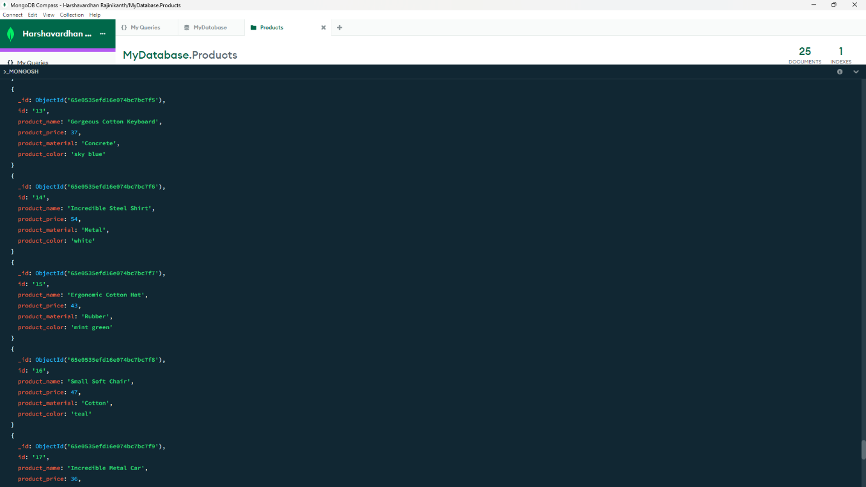

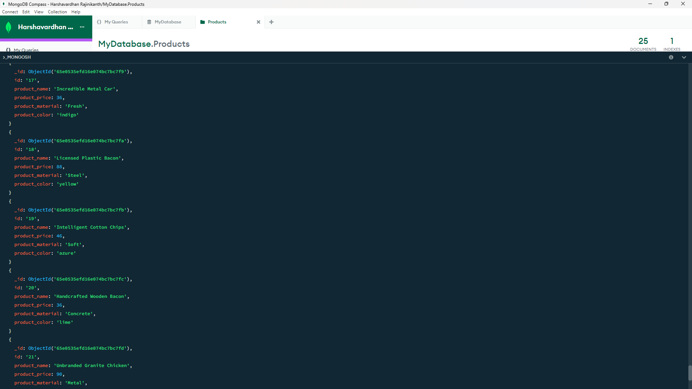

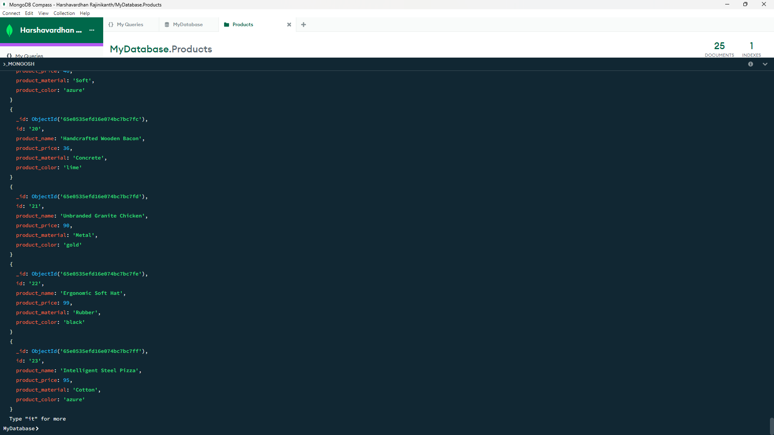

1. **List the four product which are greater than 500 in price**

**Query:** **db.Products.find({‘product_price’:{$gt:500}})** **.limit(4);**

**Output:**

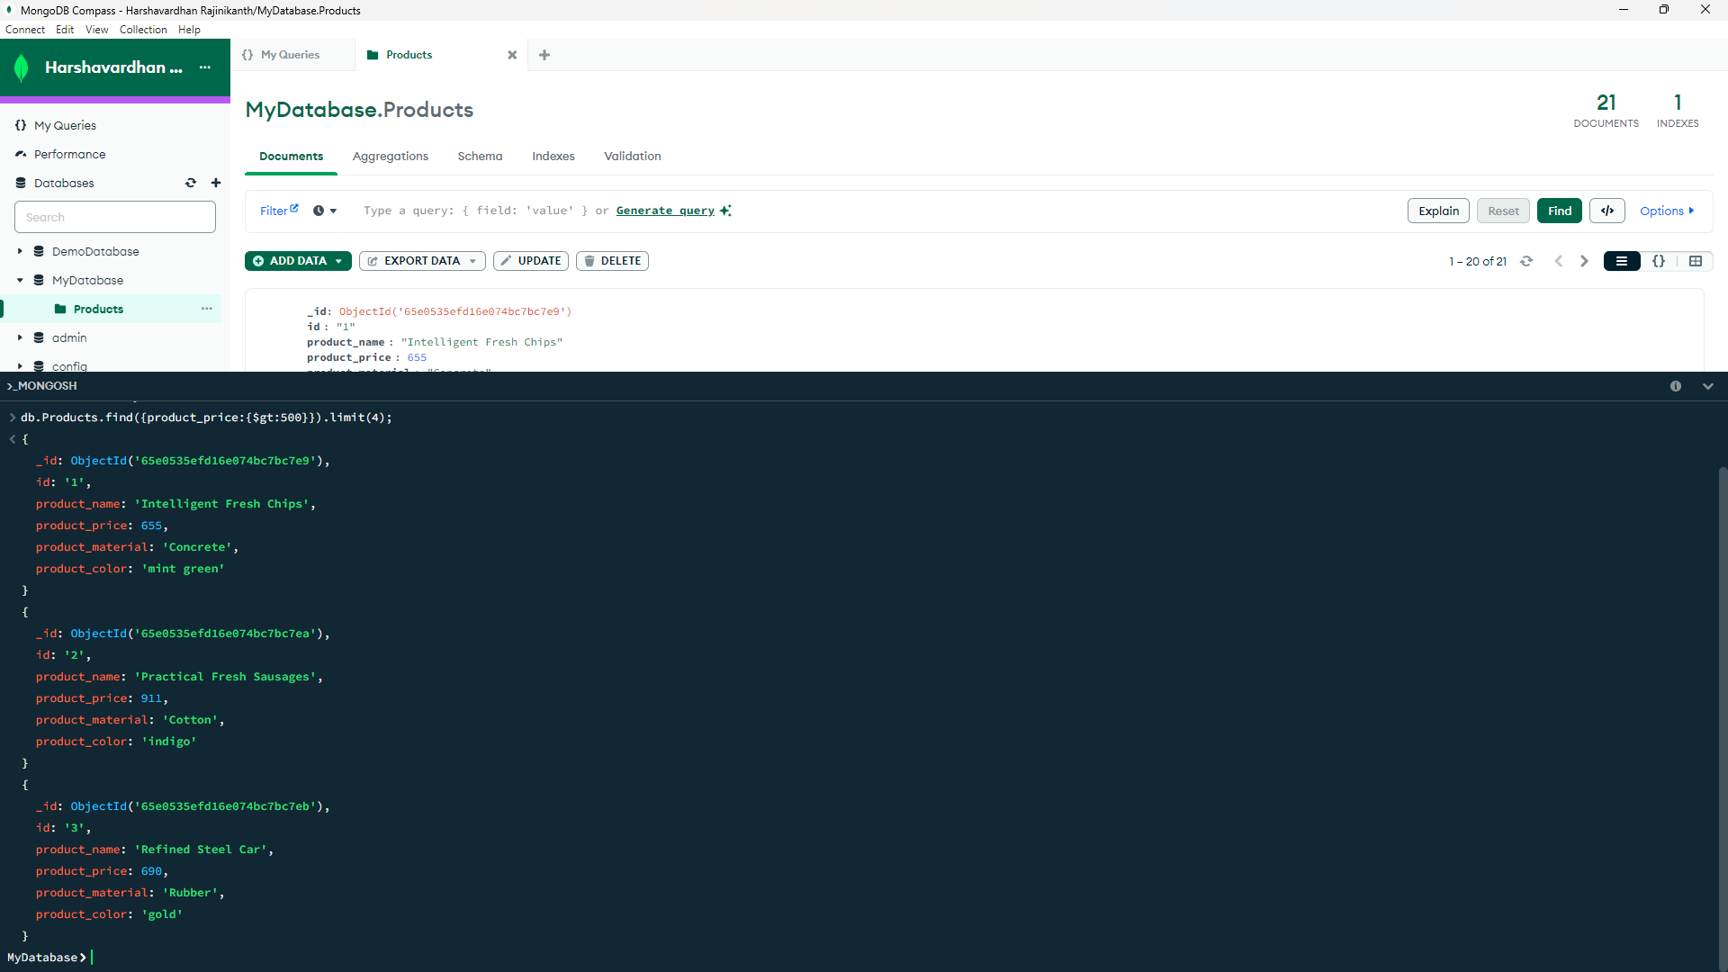

1. **Find the product name and product material of each products**

**Query:**

**db.Products.find({},{‘product_name’:1,’product_material’:1});**

**Output:**

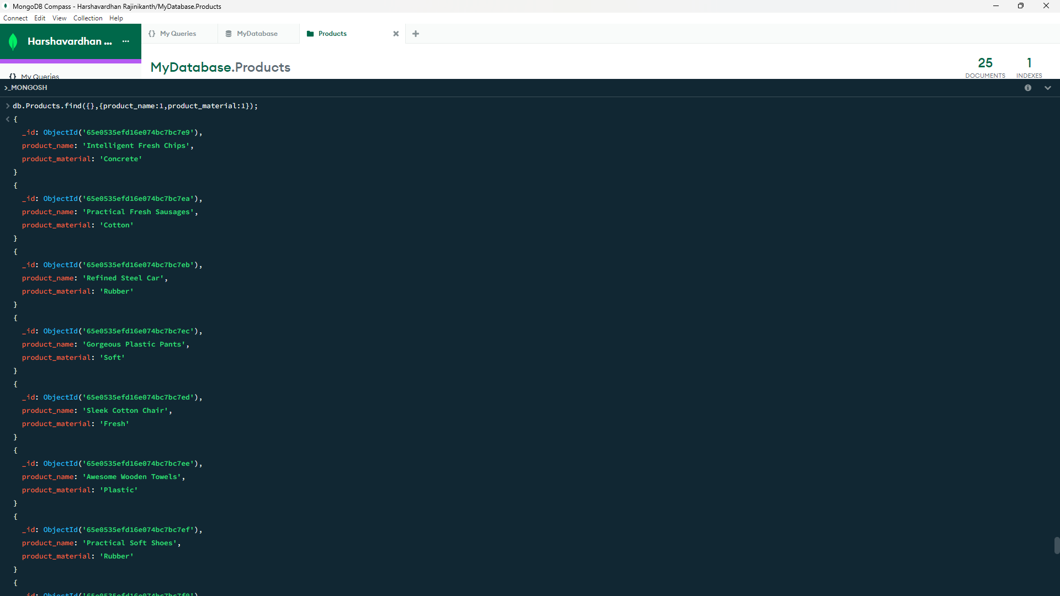

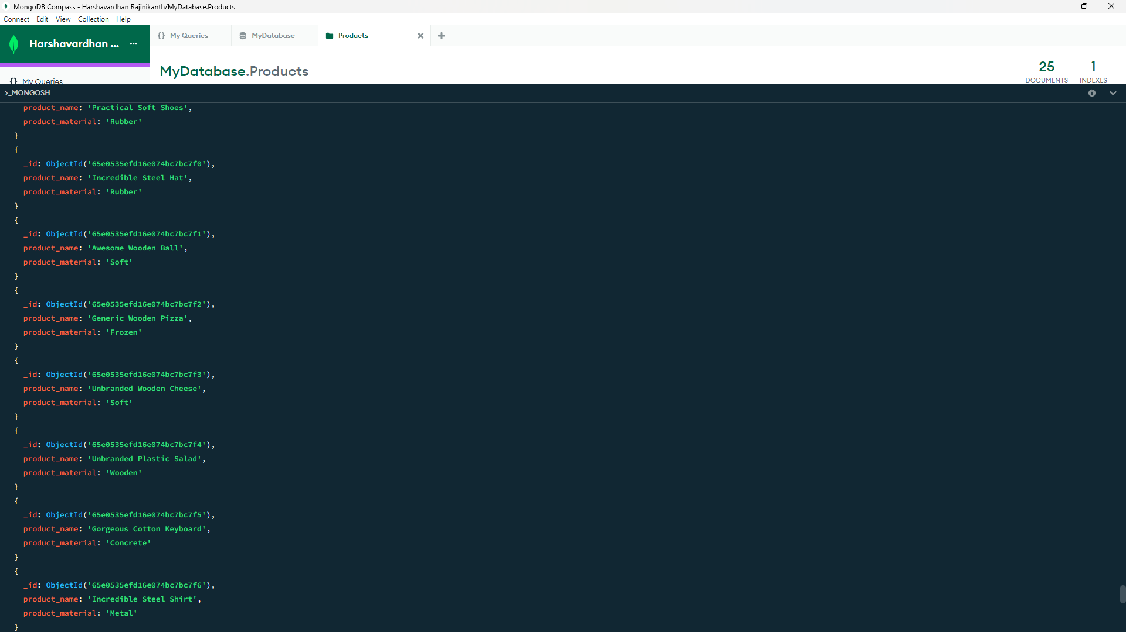

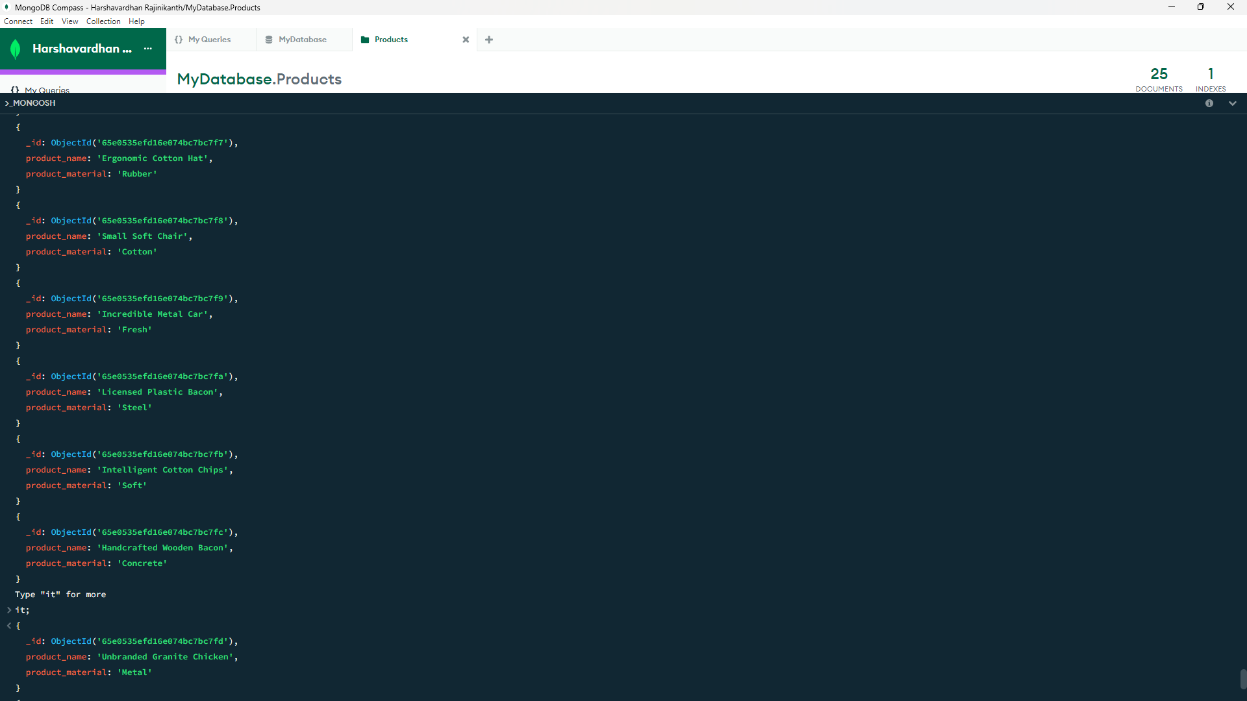

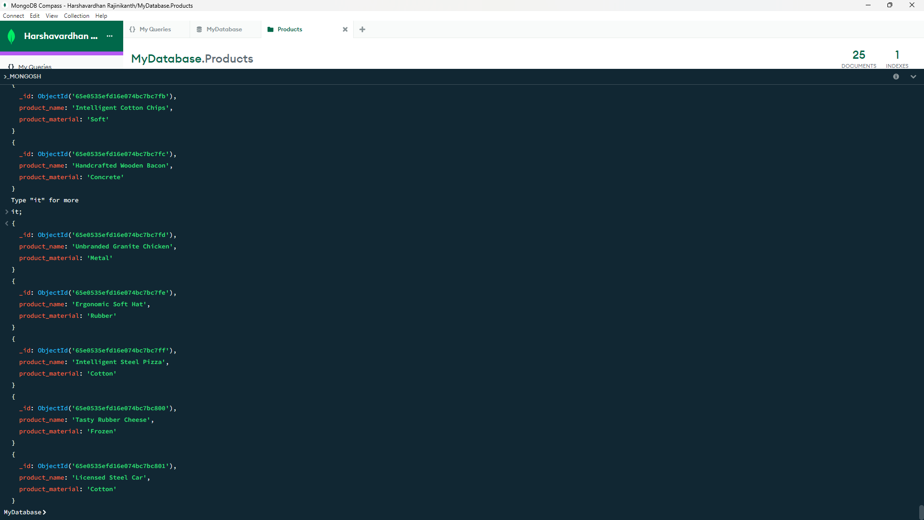

1. **Find the product with a row id of 10**

**Query:** **db.Products.find({'id':'10'});**

**Output:**

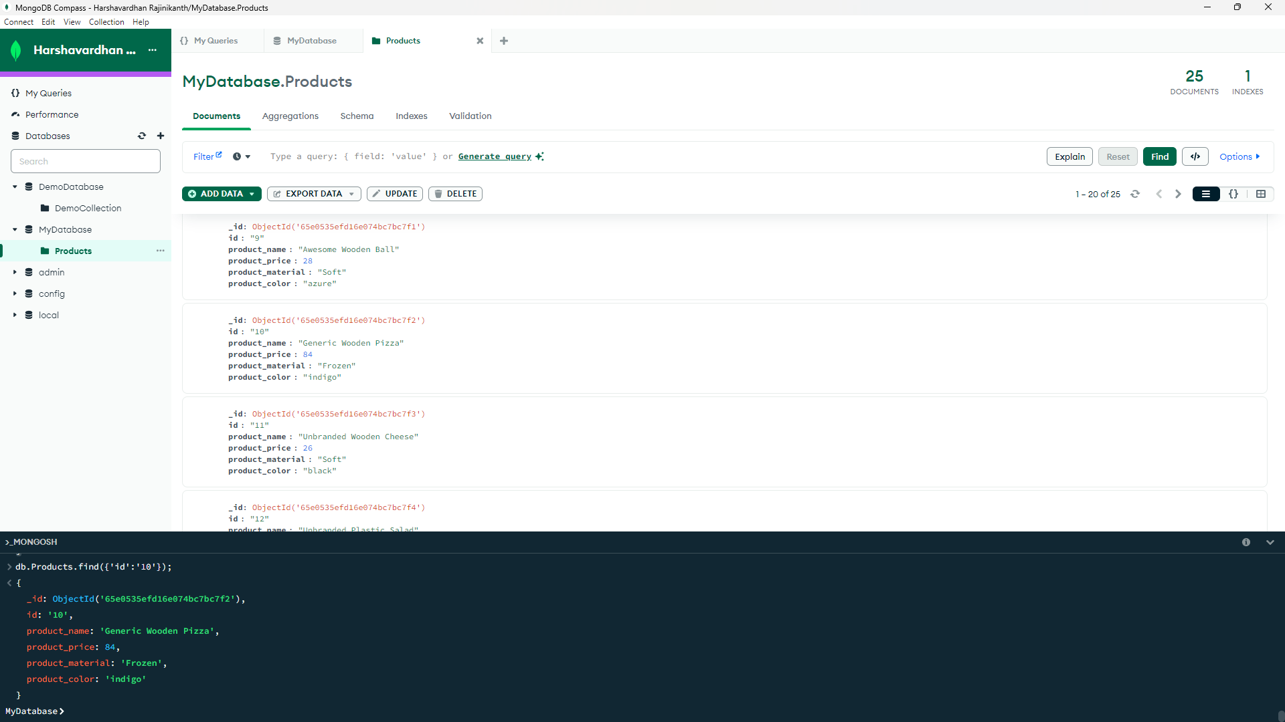

1. **Find only the product name and product material**

**Query:db.Products.find({},{'_id':0,'id':0,'product_price':0,'product_color':0});**

**Output:**

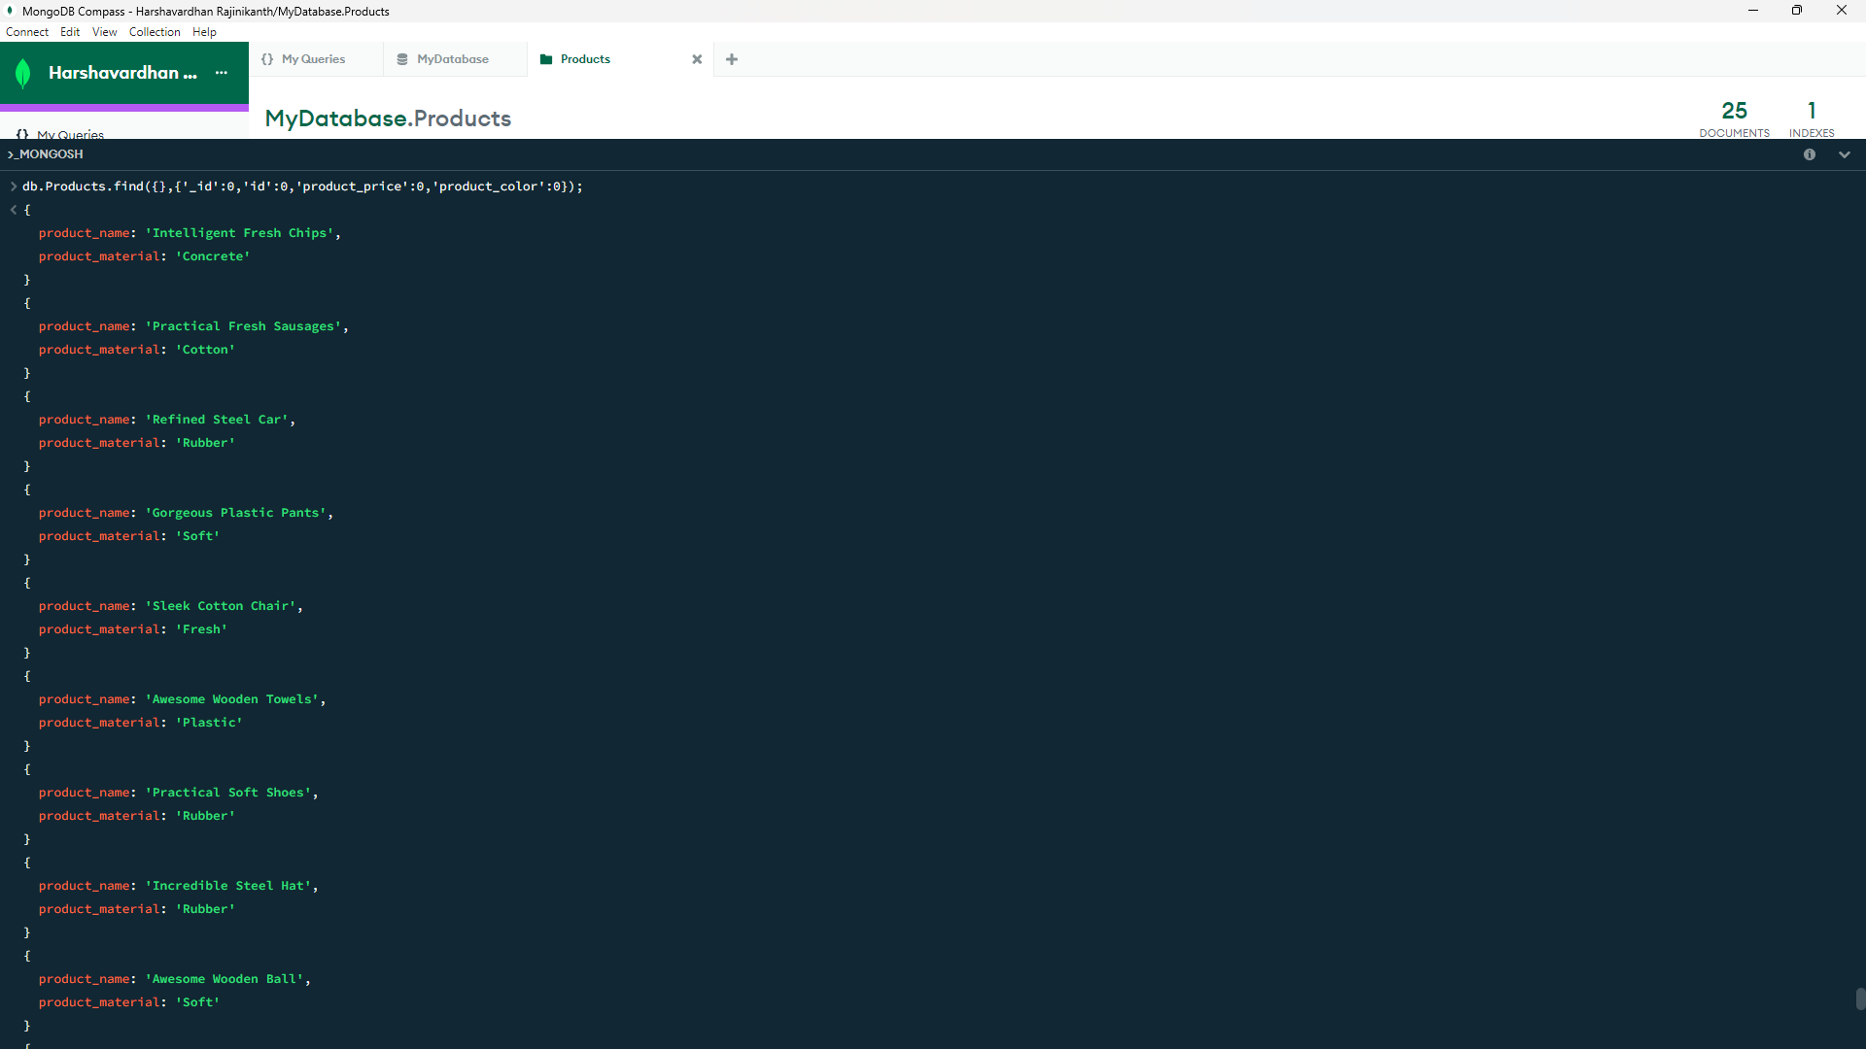

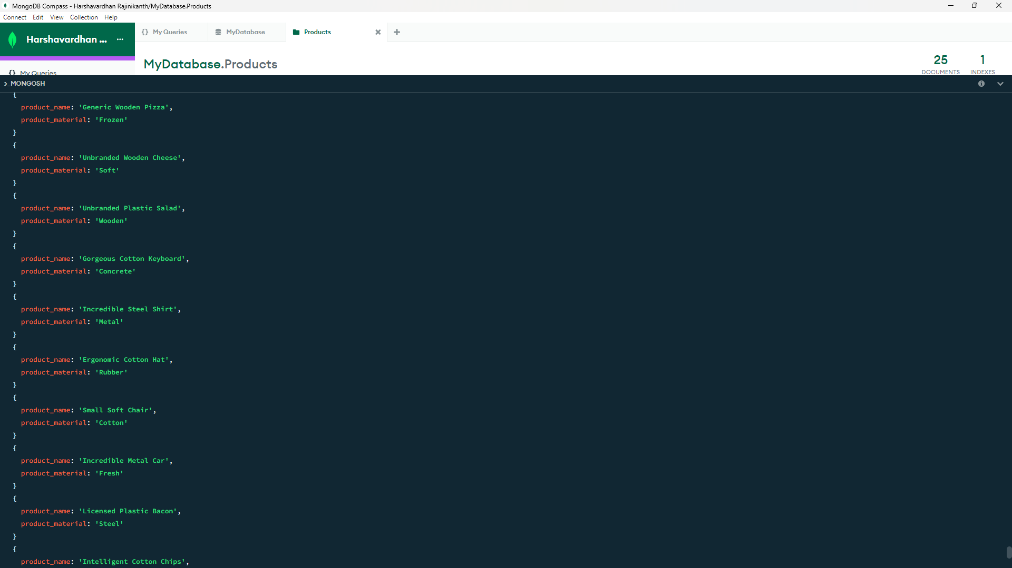

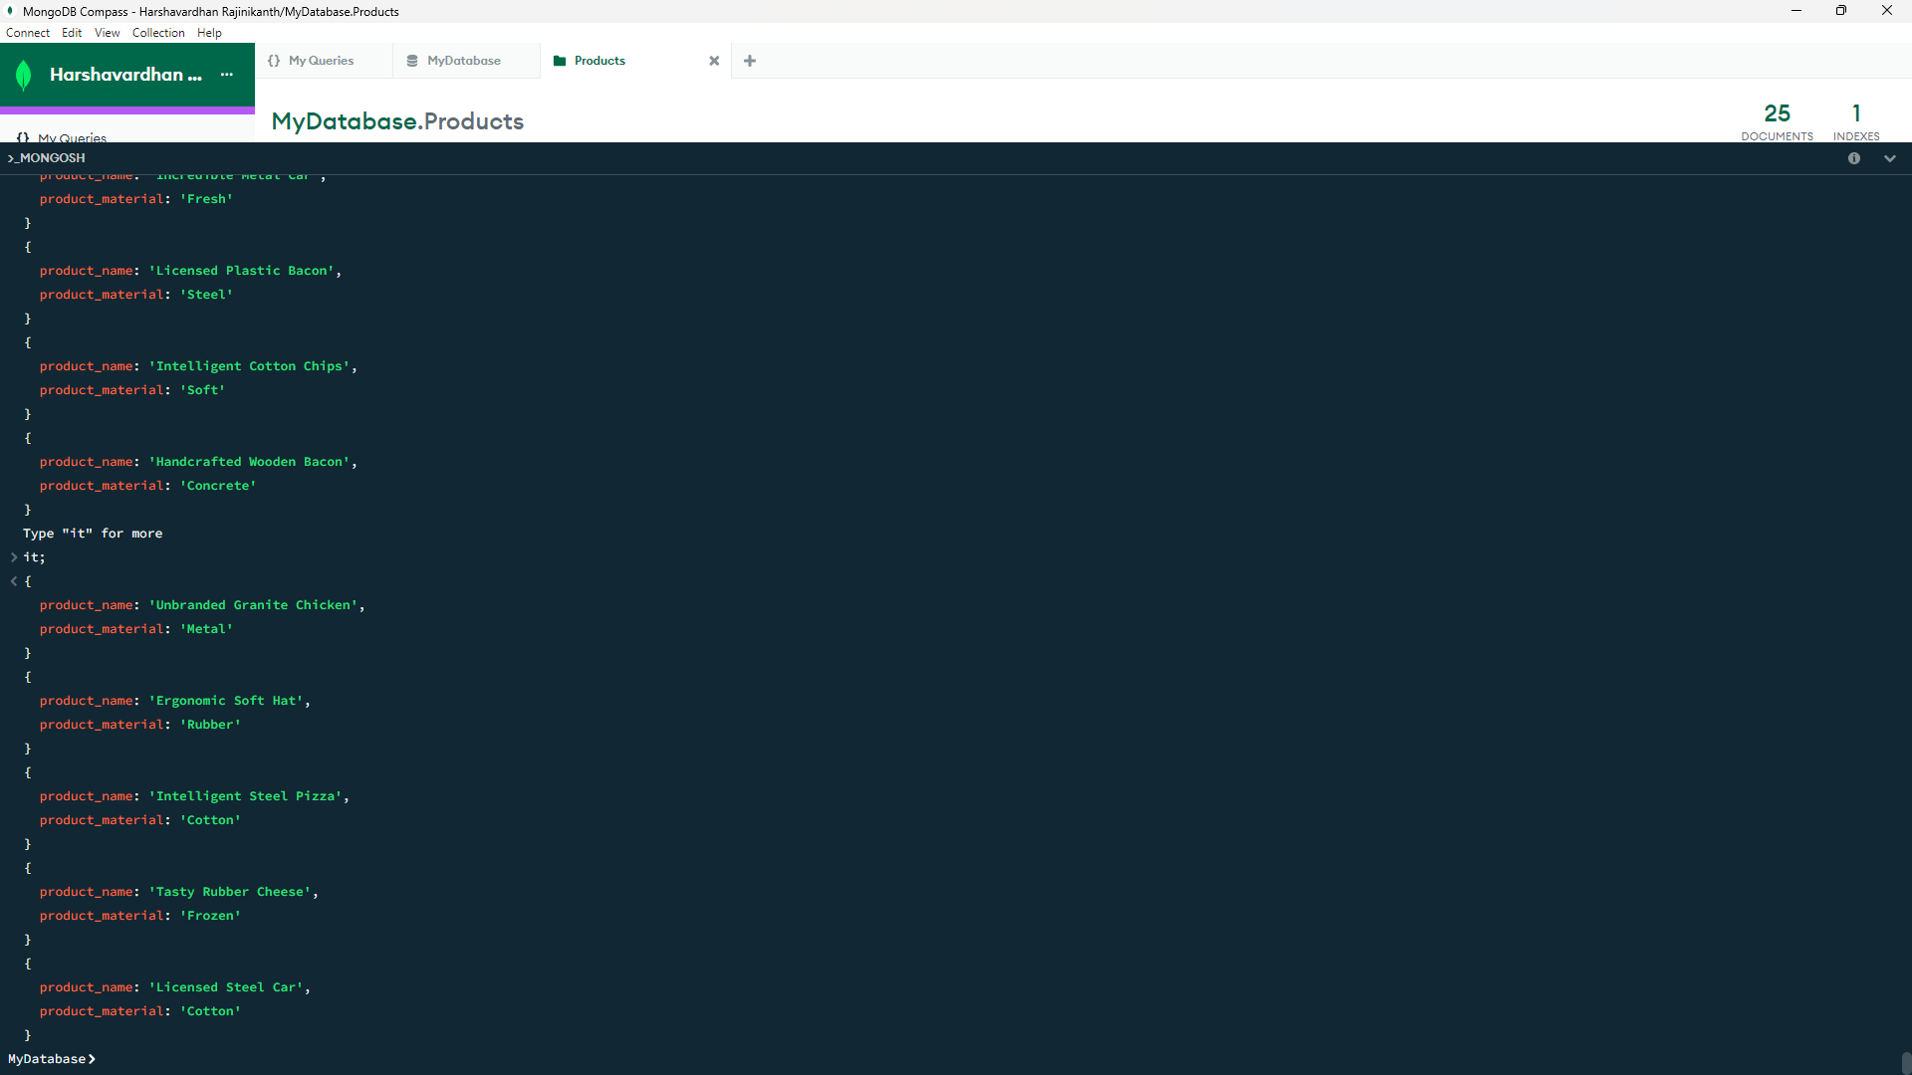

1. **Find all products which contain the value of soft in product material**

**Query:** **db.Products.find({'product_material':'Soft'});**

**Output:**

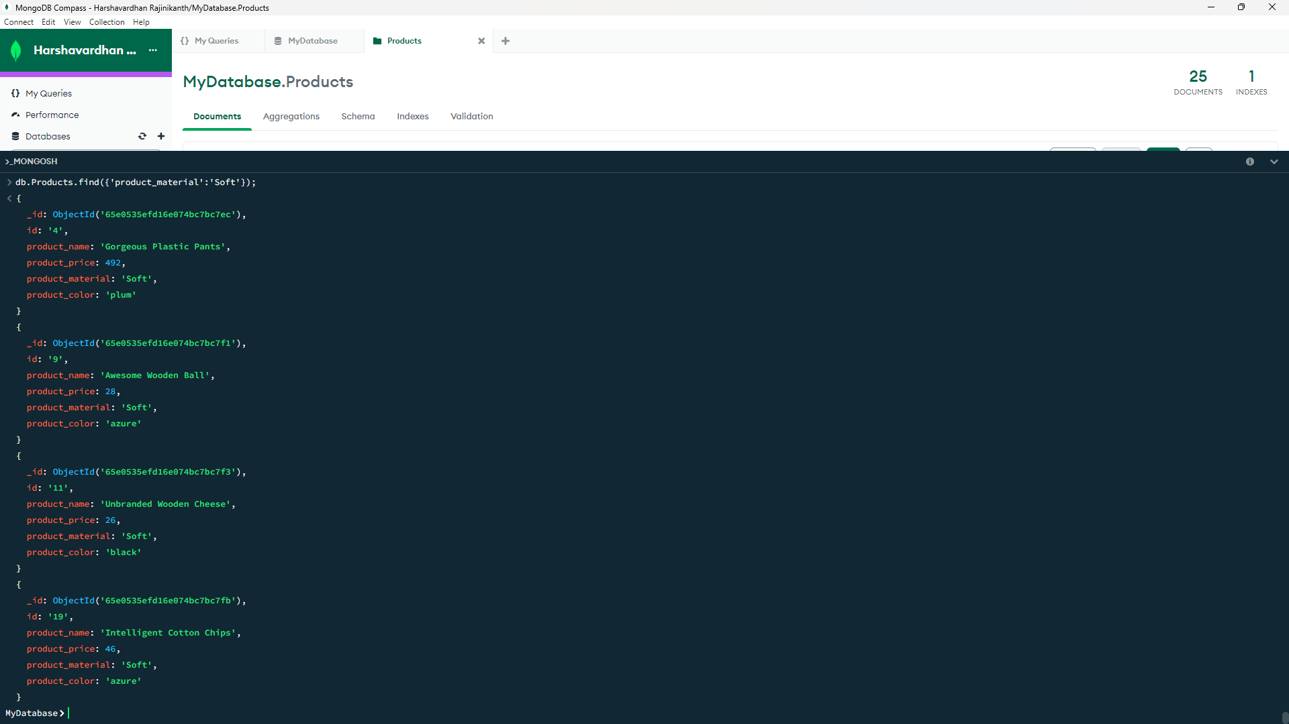

1. **Find products which contain product color indigo  and product price 492.00**

**Query:**

**db.Products.find({$and:[{'product_color':'indigo'},{'product_price':492}]});**

**Output: No products present according to the condition.**

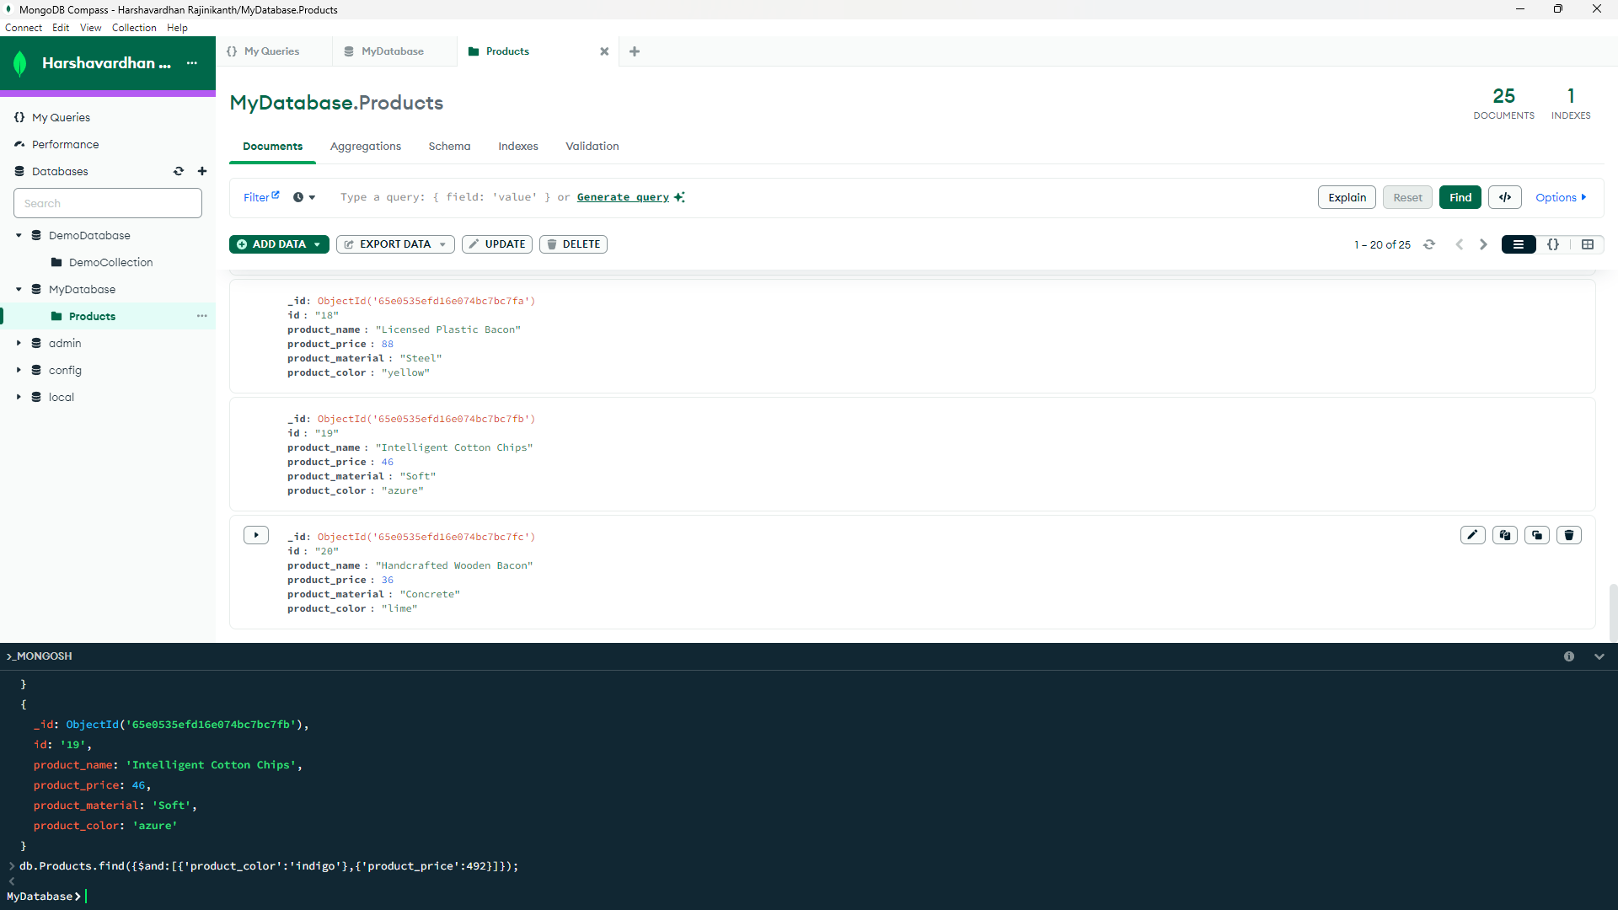

1. **Delete the products which product price value are same**

**Query:**

db.Products.aggregate([

{

$group: {

_id: '$product_price',

count: { $sum: 1 }

}

},

{

$match: {

count: { $gt: 1 }

}

}

]).forEach((e) => {

db.Products.deleteMany({ product_price: e._id });

});

**Output: Deleted Product with ‘id’ are 16,17,20,24**

