# Tideman voting

You already know about plurality elections, which follow a very simple algorithm for determining the winner of an election: every voter gets one vote, and the candidate with the most votes wins.

But the plurality vote does have some disadvantages. What happens, for instance, in an election with three candidates, and the ballots below are cast?

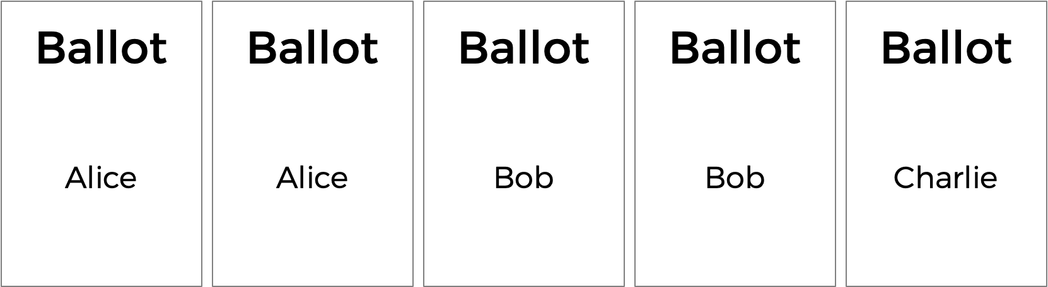

A plurality vote would here declare a tie between Alice and Bob, since each has two votes. But is that the right outcome?

There’s another kind of voting system known as a ranked-choice voting system. In a ranked-choice system, voters can vote for more than one candidate. Instead of just voting for their top choice, they can rank the candidates in order of preference. The resulting ballots might therefore look like the below.

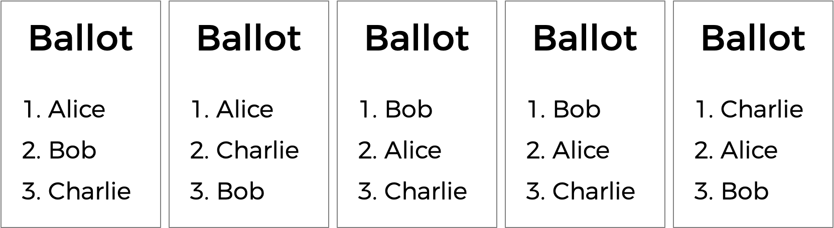

Here, each voter, in addition to specifying their first preference candidate, has also indicated their second and third choices. And now, what was previously a tied election could now have a winner. The race was originally tied between Alice and Bob. But the voter who chose Charlie preferred Alice over Bob, so Alice could here be declared the winner.

Ranked choice voting can also solve yet another potential drawback of plurality voting. Take a look at the following ballots.

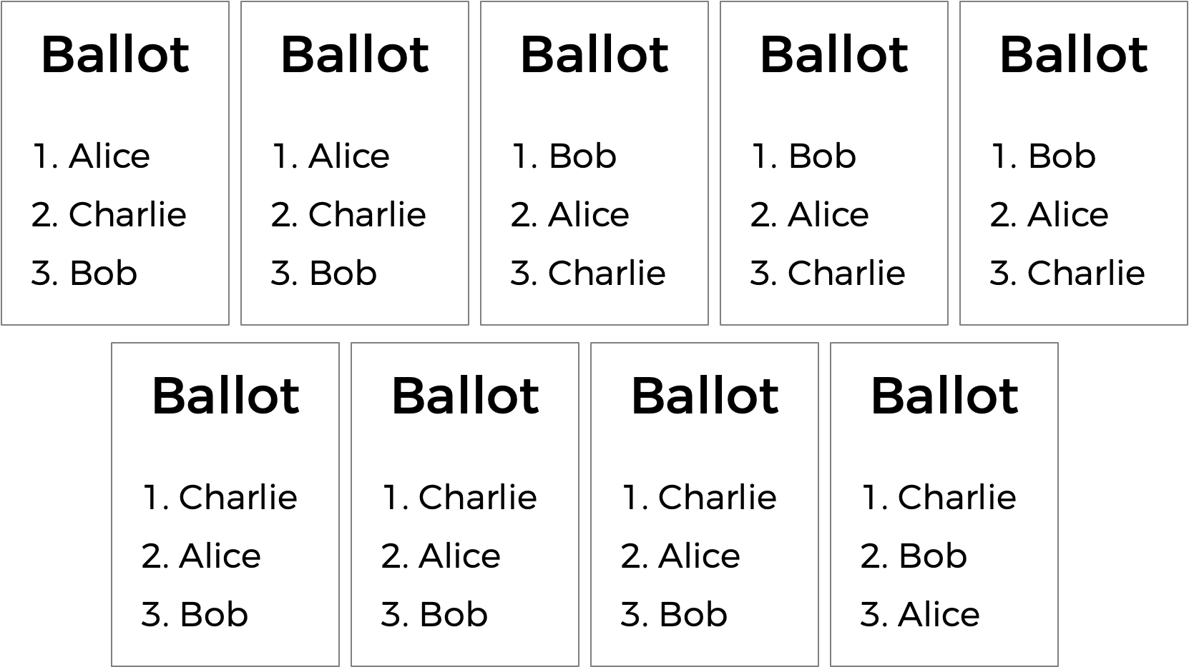

Who should win this election? In a plurality vote where each voter chooses their first preference only, Charlie wins this election with four votes compared to only three for Bob and two for Alice. (Note that, if you’re familiar with the instant runoff voting system, Charlie wins here under that system as well). Alice, however, might reasonably make the argument that she should be the winner of the election instead of Charlie: after all, of the nine voters, a majority (five of them) preferred Alice over Charlie, so most people would be happier with Alice as the winner instead of Charlie.

Alice is, in this election, the so-called **“Condorcet winner”** of the election: the person who would have won any head-to-head matchup against another candidate. If the election had been just Alice and Bob, or just Alice and Charlie, Alice would have won.

The Tideman voting method (also known as “ranked pairs”) is a ranked-choice voting method that’s guaranteed to produce the Condorcet winner of the election if one exists.

Generally speaking, the Tideman method works by constructing a “graph” of candidates, where an arrow (i.e. edge) from candidate A to candidate B indicates that candidate A wins against candidate B in a head-to-head matchup. The graph for the above election, then, would look like the below.

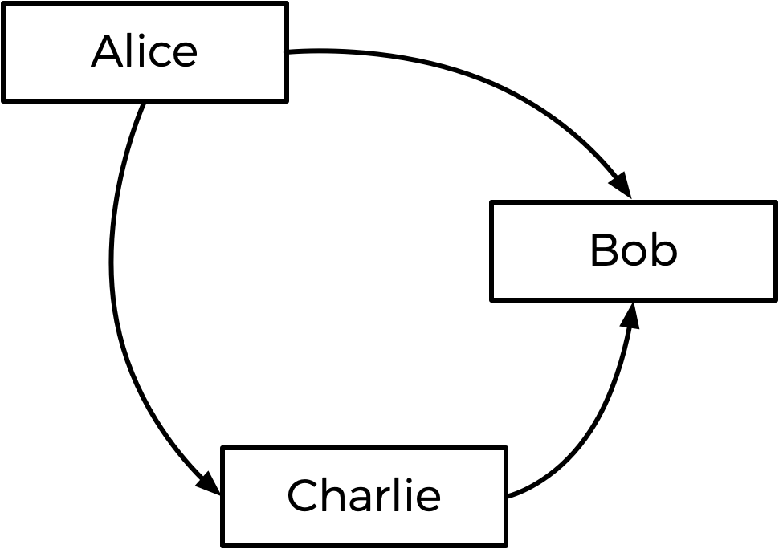

The arrow from Alice to Bob means that more voters prefer Alice to Bob (5 prefer Alice, 4 prefer Bob). Likewise, the other arrows mean that more voters prefer Alice to Charlie, and more voters prefer Charlie to Bob.

Looking at this graph, the Tideman method says the winner of the election should be the “source” of the graph (i.e. the candidate that has no arrow pointing at them). In this case, the source is Alice — Alice is the only one who has no arrow pointing at her, which means nobody is preferred head-to-head over Alice. Alice is thus declared the winner of the election.

It’s possible, however, that when the arrows are drawn, there is no Condorcet winner. Consider the below ballots.

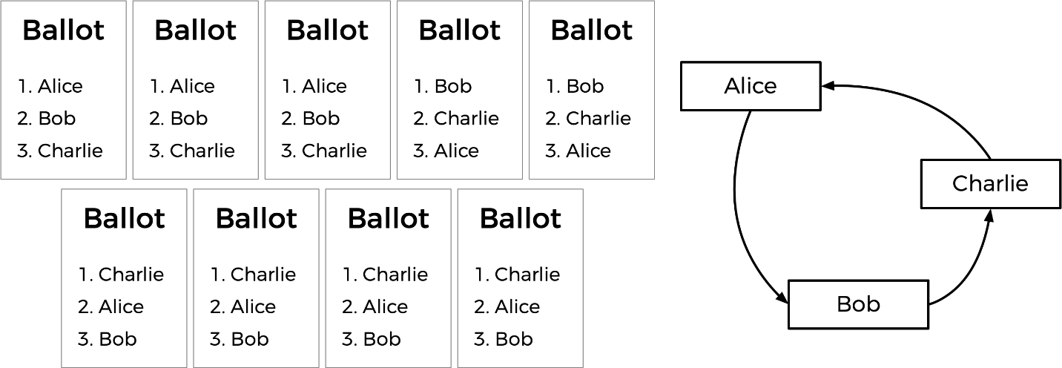

Between Alice and Bob, Alice is preferred over Bob by a 7-2 margin. Between Bob and Charlie, Bob is preferred over Charlie by a 5-4 margin. But between Charlie and Alice, Charlie is preferred over Alice by a 6-3 margin. If we draw out the graph, there is no source! We have a cycle of candidates, where Alice beats Bob who beats Charlie who beats Alice (much like a game of rock-paper-scissors). In this case, it looks like there’s no way to pick a winner.

To handle this, the Tideman algorithm must be careful to avoid creating cycles in the candidate graph. How does it do this? The algorithm **locks** in the strongest edges first, since those are arguably the most significant. In particular, the Tideman algorithm specifies that matchup edges should be “locked in” to the graph one at a time, based on the “strength” of the victory (the more people who prefer a candidate over their opponent, the stronger the victory). So long as the edge can be locked into the graph without creating a cycle, the edge is added; otherwise, the edge is ignored.

How would this work in the case of the votes above? Well, the biggest margin of victory for a pair is Alice beating Bob, since 7 voters prefer Alice over Bob (no other head-to-head matchup has a winner preferred by more than 7 voters). So the Alice-Bob arrow is locked into the graph first. The next biggest margin of victory is Charlie’s 6-3 victory over Alice, so that arrow is locked in next.

Next up is Bob’s 5-4 victory over Charlie. But notice: if we were to add an arrow from Bob to Charlie now, we would create a cycle! Since the graph can’t allow cycles, we should skip this edge, and not add it to the graph at all. If there were more arrows to consider, we would look to those next, but that was the last arrow, so the graph is complete. In other words, the weakest edge is dropped.

This step-by-step process is shown below, with the final graph at right.

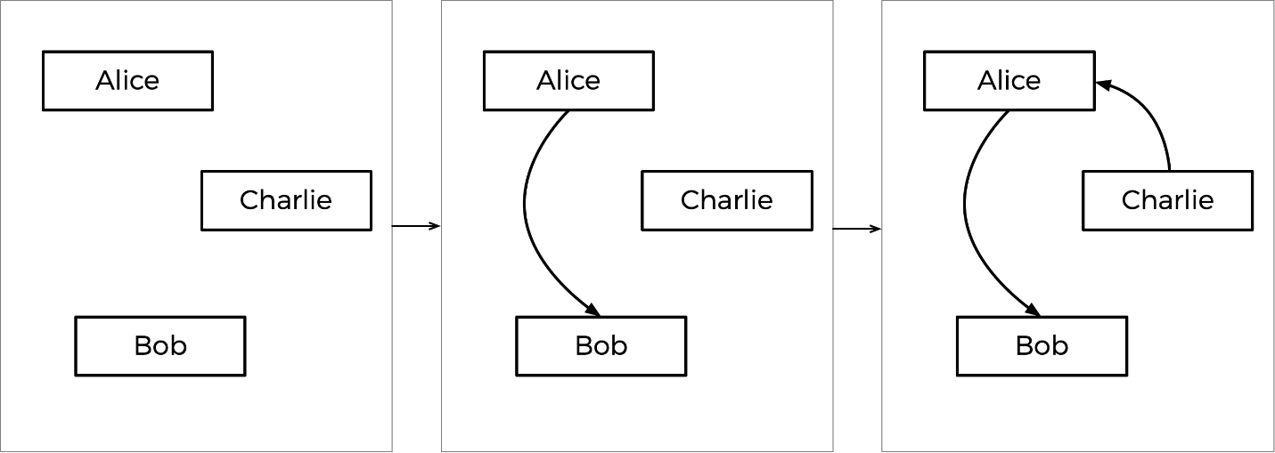

Based on the resulting graph, Charlie is the source (there’s no arrow pointing towards Charlie), so Charlie is declared the winner of this election.

Put more formally, the Tideman voting method consists of three parts:

* **Tally**: Once all of the voters have indicated all of their preferences, determine, for each pair of candidates, who the preferred candidate is and by what margin they are preferred.
* **Sort**: Sort the pairs of candidates in decreasing order of strength of victory, where strength of victory is defined to be the number of voters who prefer the preferred candidate.
* **Lock**: Starting with the strongest pair, go through the pairs of candidates in order and “lock in” each pair to the candidate graph, so long as locking in that pair does not create a cycle in the graph.

Once the graph is complete, the source of the graph (the one with no edges pointing towards it) is the winner!

# Understanding the code

First, notice the two-dimensional array preferences. The integer preferences[i][j] will represent the number of voters who prefer candidate i over candidate j.

The file also defines another two-dimensional array, called locked, which will represent the candidate graph. locked is a boolean array, so locked[i][j] being true represents the existence of an edge pointing from candidate i to candidate j; false means there is no edge. (If curious, this representation of a graph is known as an “adjacency matrix”).

|  |  |  |  |  |  |  |  |  |  |
| --- | --- | --- | --- | --- | --- | --- | --- | --- | --- |
|  | I | | | | | | | | |
| J | Candidate no. | 0 | 1 | 2 | 3 | 4 | 5 | 6 | 7 |
| 0 |  |  |  |  |  |  |  |  |
| 1 |  |  |  |  |  |  |  |  |
| 2 |  |  |  |  |  |  |  |  |
| 3 |  |  |  |  |  |  |  |  |
| 4 |  |  |  |  |  |  |  |  |
| 5 |  |  |  |  |  |  |  |  |
| 6 |  |  |  |  |  |  |  |  |
| 7 |  |  |  |  |  |  |  |  |

Thus preference[i][j] would indicate how many votes candidate I got over j, and so forth.

Next up is a struct called pair, used to represent a pair of candidates: each pair includes the winner’s candidate index and the loser’s candidate index.

The candidates themselves are stored in the array candidates, which is an array of strings representing the names of each of the candidates. There’s also an array of pairs, which will represent all of the pairs of candidates (for which one is preferred over the other) in the election.

The program also has two global variables: pair_count and candidate_count, representing the number of pairs and number of candidates in the arrays pairs and candidates, respectively.

Now onto main. Notice that after determining the number of candidates, the program loops through the locked graph and initially sets all of the values to false, which means our initial graph will have no edges in it.

Next, the program loops over all of the voters and collects their preferences in an array called ranks (via a call to vote), where ranks[i] is the index of the candidate who is the ith preference for the voter. These ranks are passed into the record_preference function, whose job it is to take those ranks and update the global preferences variable.

Once all of the votes are in, the pairs of candidates are added to the pairs array via a called to add_pairs, sorted via a call to sort_pairs, and locked into the graph via a call to lock_pairs. Finally, print_winner is called to print out the name of the election’s winner!

Further down in the file, you’ll see that the functions vote, record_preference, add_pairs,sort_pairs, lock_pairs, and print_winner are left blank. That’s up to you!