TABLE DES MATIères / TABLE OF CONTENTS

Front-end description 3
I Payload architecture 3
I.1 Specifications 3
I.2 Down Converter Architecture 3
I.3 Table – Evolution of electrical performances (Gain, NF, IP3, C/I3) 4
I.4 Conformity table 4
II FILTER SPECIFICATIONS 4
II.1 Mixing Spurious Power 4
II.2 Attenuation Specifications – Filter type 4
System Harmonic Balance simulations 5
III Down Converter Simulation results 5
III.1 Down-Converter simulation : Single tone 5
III.2 Down-Converter simulation : multitone 5

Front-end description

Payload architecture

Specifications

Parameters |  | Specifications (25°C)
Input Frequency |  | [28.5 – 30] GHz
Output Frequency |  | [18.3 – 19.8] GHz
LO Frequency |  | 10.2 GHz
Input Power Level |  | -28 dBm
Noise Figure |  | ≤ 11.5 dB
Gain |  | 26 dB
Linearity C/I |  | ≥ 50 dB
Mixing Spurious | In-band | ≤ -65 dBc
Mixing Spurious | Out-of-Band | ≤ -35 dBc
Mixing Spurious | LO harmonics | ≤ -50 dBc

Down Converter Architecture

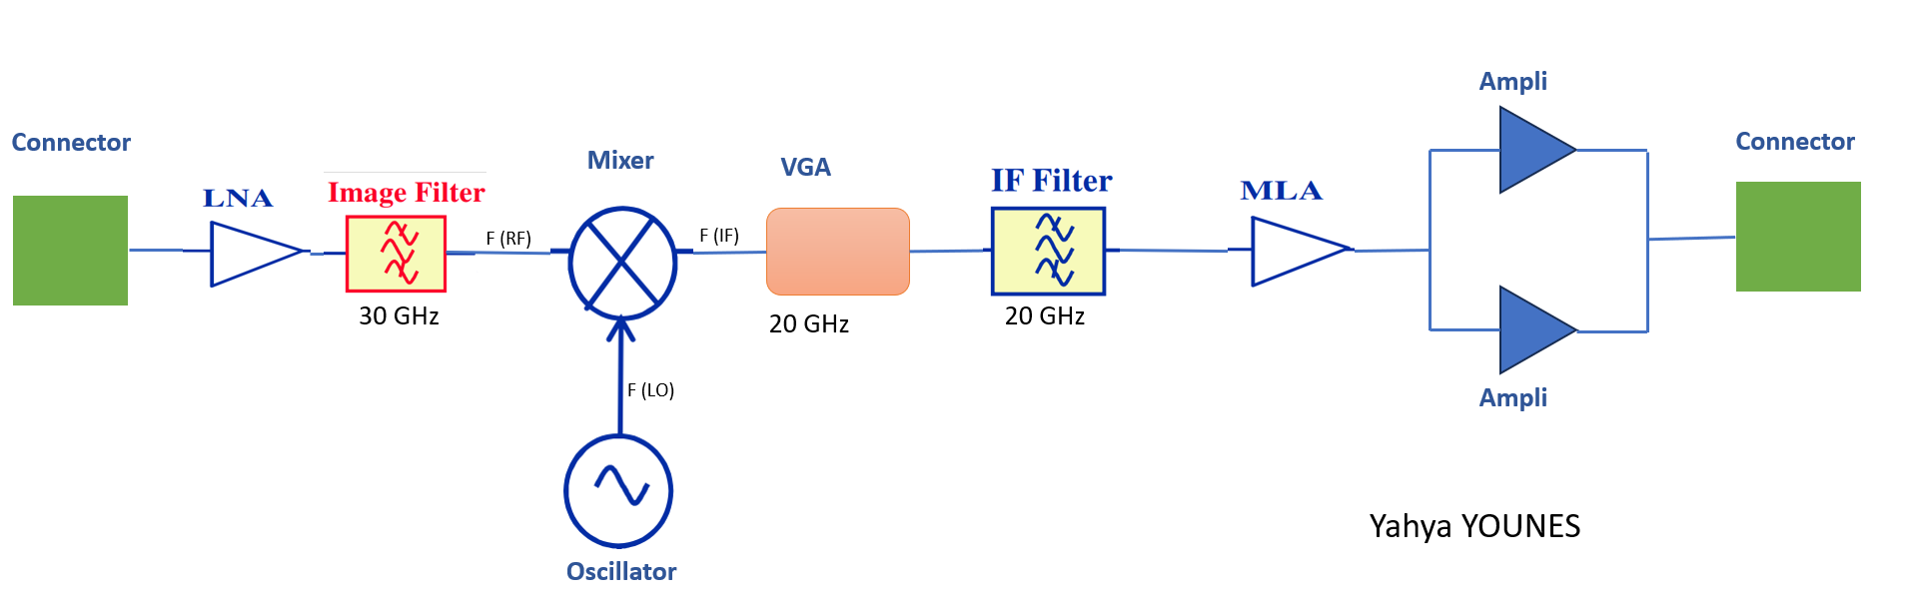

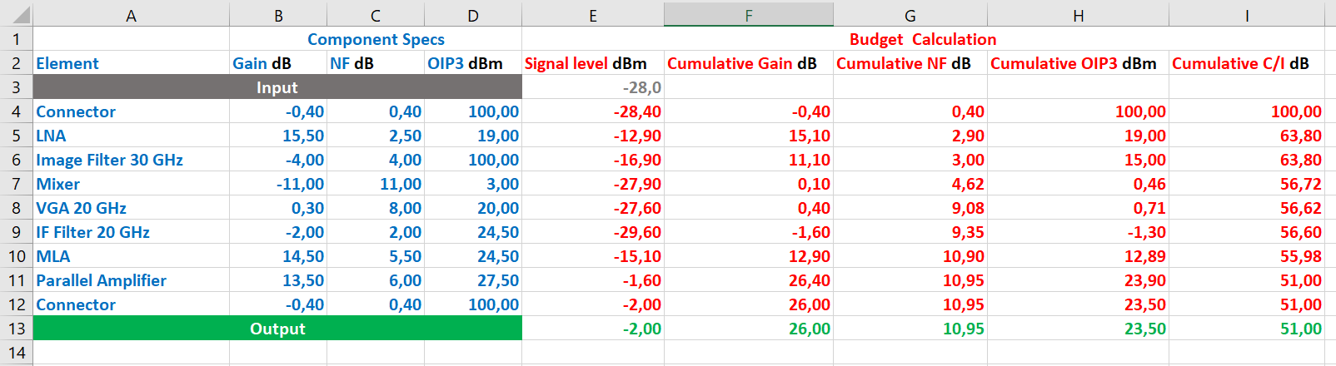
Table – Evolution of electrical performances (Gain, NF, IP3, C/I3)

Conformity table
Parameters | Specifications (25°C) | Value
Input Frequency | [28.5 – 30] GHz
Output Frequency | [18.3 – 19.8] GHz
LO Frequency | 10.2 GHz
Input Power Level | -28 dBm
Noise Figure | ≤ 11.5 dB | = 10.95 dB
Gain | 26 dB | = 26 dB
Linearity C/I | ≥ 50 dB | = 51 dB

We verify that our payload architecture verifies all the requirements.

FILTER SPECIFICATIONS

Mixing Spurious Power
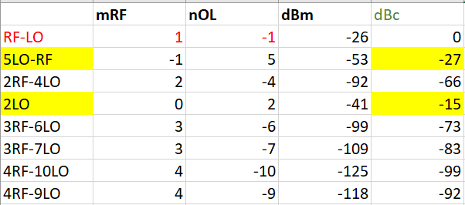
We notice that only the 5LO-RF and 2LO that a have dBc values greater than -35dBc so our filter will be designed to attenuate those two values to at least -35 dBc.

Attenuation Specifications – Filter type

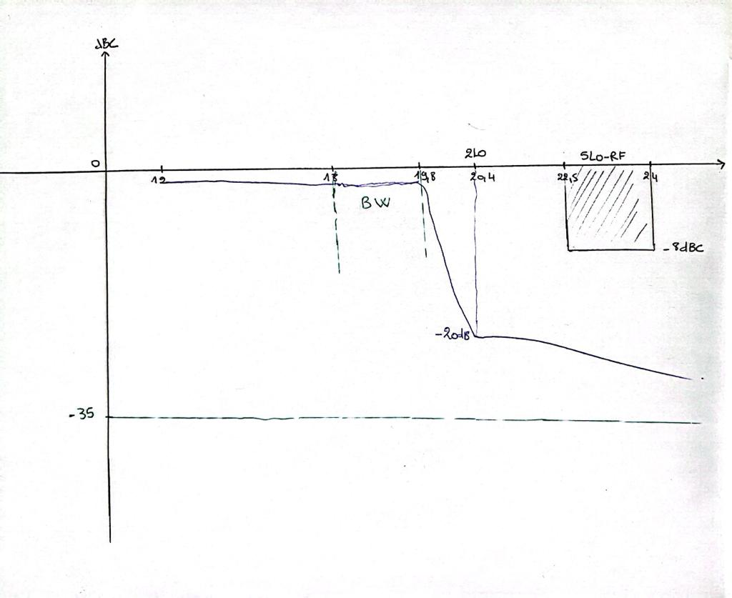
GHz

System Harmonic Balance simulations

Down Converter Simulation results

Down-Converter simulation: Single tone

- IF Filter frequency response:

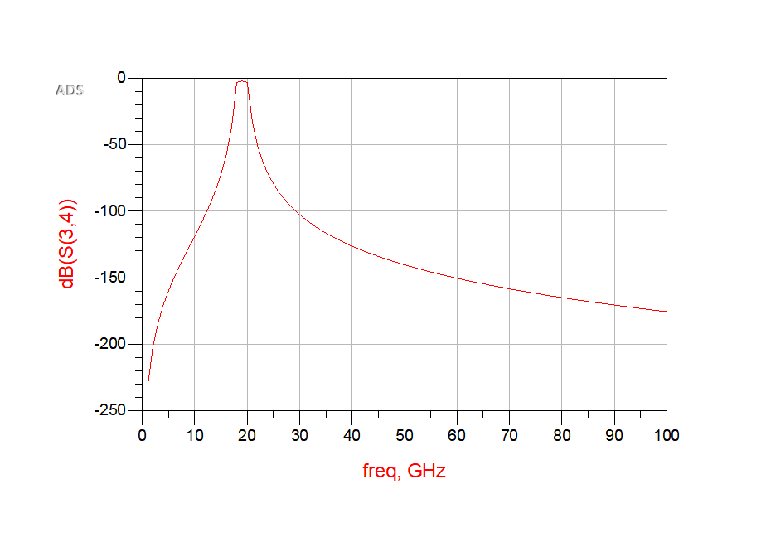

- Output RF spectrum:
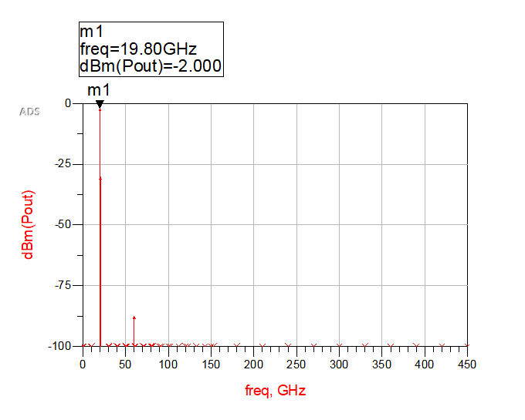

- Output Time Domain response:

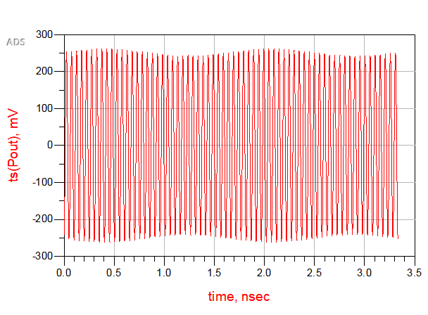

Comments:
The output signal displays a power level of -2 dBm, meanwhile the input signal strength registers at -28 dBm this makes a gain (G) of 26 dB. In the Excel representation of the downconverter design, a Variable Gain Amplifier (VGA) gain of 0.3 dB proved satisfactory for meeting the specifications. Nonetheless, during simulations, it became imperative to fine-tune the VGA gain to 0.579 dB.

After conducting the simulations, we deduce that the envisioned downconverter architecture successfully fulfills the specified requirements.

Down-Converter simulation: multitone

- Output RF spectrum (considering f_{RFmin} and f_{RFmax}) :

Parameters | Specifications (25°C) | Value
Input Frequency | [28.5 – 30] GHz
Output Frequency | [18.3 – 19.8] GHz
LO Frequency | 10.2 GHz
Input Power Level | -28 dBm
Gain | 26 dB | 26 dB
Linearity C/I | ≥ 50 dB | 51 dB

- Final filter specifications :

 | Filter  @ 30 GHz | Filter  @20 GHz
Filter type (bandpass, lowpass) | bandpass | bandpass
order | 5 | 7
Center Frequency | 30.50 GHz | 19 GHz
Inband Ripple | 0.01 dB | 0.01 dB
Insertion Loss | 4 dB | 2 dB
Relative Bandwidth | 1.6 GHz | 2 GHz

-END OF DOCUMENT-

