**Yahya Alhinia**

**Oct 22, 2019**

**CSCI4511W**

**Problem 1:**

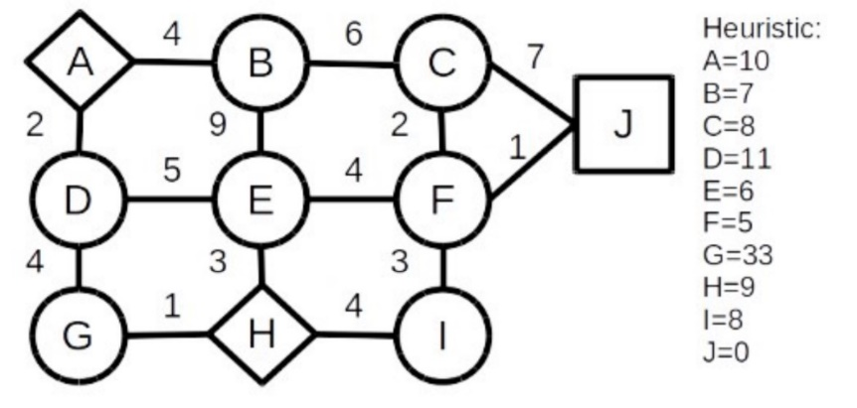

1. **A:** (D 2+11= 13) (B 4+7=11)

**H:** (G 1+33=34) (E 3+6=9) (H 4+8=12)

1. **A:** (B 4+7=11)

**H:** (G 1+33=34) (H 4+8=12)

**D:** (E 7+6=13) (G 6+33=39)

**E:** (B 12+7= 19) (F 7+5=12)

1. **A:**

**H:** (G 1+33=34) (H 4+8=12)

**D:** (E 7+6=13) (G 6+33=39)

**E:** (B 12+7= 19)

**B:** (C 10+8=18)

**F: (J 8+0=0)**

J is the goal

**The result of local beam search:**

H 🡪 E 🡪 F 🡪 J

**Problem 2:**



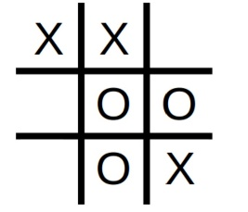

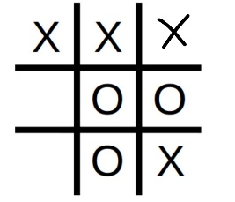 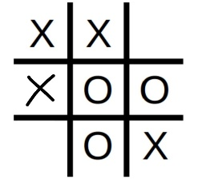 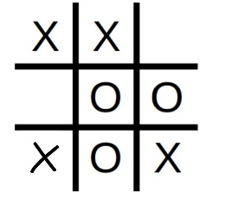

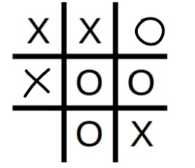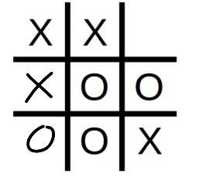 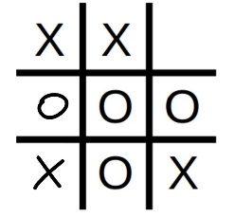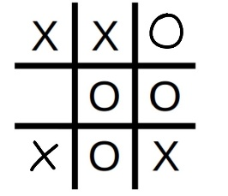

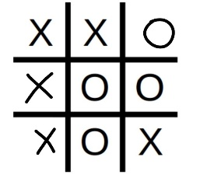 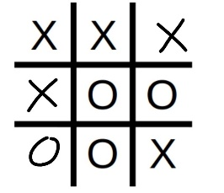 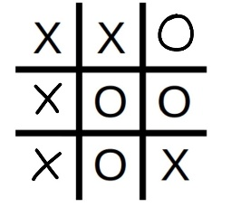

1

-1

1

-1

0

1

0

1

1

0

1

**Problem 5:**



**Situation 1:**

* **Relax problem**: The best way to relax this problem is to be able to move the knights freely to any position on the chess board.
* **Solve relax problem:** Moving either the white knights or the black knights to a position on the chess board so that each white knight can do one normal movement (L shape movement) to be on top of a black knight.
* **Find the heuristic:** The heuristic can be counted as the least amount of movements each knight can do to have all white knights be on top of black knights.

**Situation 2:**

* **Relax problem**: One way to relax this problem is to be able to move all people at a same time though the bridge. In this case, moving 5 people at a time thought the bridge.
* **Solve relax problem:** since we are moving all people at the same time though the bridge, there is going to be only one step forward because there is no need for anyone to return back to the other side of the bridge.
* **Find the heuristic:** One possible heuristic for this problem is to count the steps it takes to move all people to the other side of the bridge which can be represented by:

$$h1=2*\left\lceil \frac{number of people left}{2} \right\rceil -1$$

**Situation 3:**

* **Relax problem**: The three trucks can teleport to any place they have already been.
* **Solve relax problem:** Because we can teleport to any place we have been to; the trucks would not have to return back. By only going forward, trucks would build up a minimum spanning tree which covers all the houses using the least fuel possible.
* **Find the heuristic:** The heuristic is to count by the fuel costs each truck as to make to complete delivering letters.

$$h1=minimal distance of houes truck 1 is delevering letters to+ \\ minimal distance of houes truck 2 is delevering letters to+ \\ minimal distance of houes truck 3 is delevering letters to$$

**Problem 6:**

* **Is the genetic algorithm good in general to solve n-queens?** **Why or why not?**

No. Genetic algorithm is not systematic in finding the answer of n-queens problem. This algorithm keeps changing slightly hoping to reach a good solution. Thus; it keeps changing randomly towards a better solution the longer the algorithm runs.

* **What is the purpose of f_ thresh and how did you handle/use it in your testing?**

The purpose of this variable is to indicate the maximum bar of how every induvial needs to be in which to stop the algorithm once the fitness level is appropriate.

* **What is one positive thing about the genetic algorithm in general?**

It won’t be stuck at minimum/maximum locales and it changing continually towards a better solution the longer the algorithm runs.

* **One negative aspect?**

It takes so much time to reach a good enough solution. Also, it might never reach an optimal solution due to the fact it constantly varying.