**Yahya Alhinia**

**November 5th, 2019**

**CSCI4511W**

**Problem 1:**

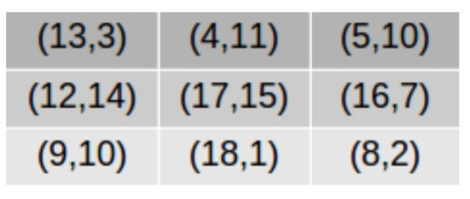

**for row:**

$$3A+10B=11A+B \\ A+B=1$$

Solving these equations, we get

$$A=\frac{9}{17},B=\frac{8}{17}$$

Row = 6.29411765

**for columns:**

$$13A+4B=9A+18B \\ A+B=1$$

Solving these equations, we get

$$A=\frac{2}{9},B=\frac{7}{9}$$

Row = 11

**Mixed strategies Nash equilibrium:**

[6.294, 11]

**Pareto optimal:**

* (13,3) is dominated by (17,15)
* (4,11) is dominated by (17,15)
* (5,11) is dominated by (17,15)
* (12,14) is dominated by (17,15)
* (17,15) is not dominated
* (16,7) is dominated by (17,15)
* (9,10) is dominated by (17,15)
* (18,1) is not dominated
* (8,2) is dominated by (17,15)

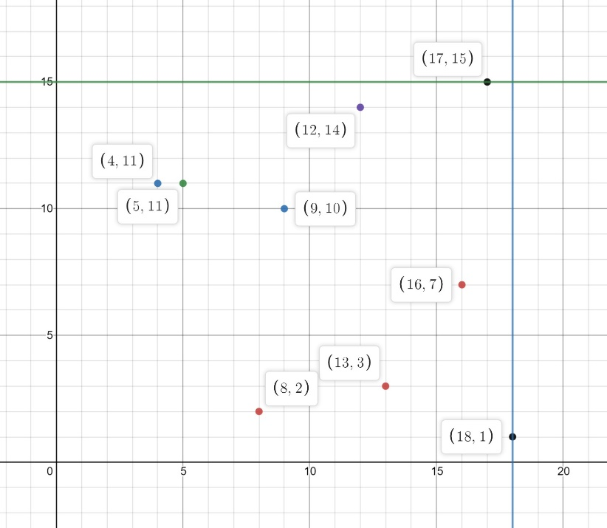

*Pareto optimal: (17, 15), (18, 1)*

**Problem 2:**

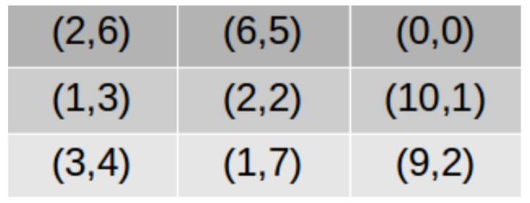

**2.1:**

**Cooperative:**

* If the other side is cooperative, then I should pick the row that maximizing the overall gain for both sides which in this case is the Pareto optimal

**Take advantage:**

* If the other side is trying to take advantage of me which means they are only maximizing their side without accounting for my gain, then I should choose the row that has the maximum amount of gain for me in whatever column they are choosing.

**2.2:**

**Cooperative:**

* (6,5), (6,5), (6,5), (6,5), (6,5)
* maximum reward you can accumulate = 30

**Take advantage:**

* (9, 2) or (6, 5), (9, 2) or (6, 5), (9, 2) or (6, 5), (9, 2) or (6, 5), (9, 2) or (6, 5)
* maximum possible reward you can accumulate = 45

**Problem 3:**

**1:**

**Maximum score possible:**

* **copycat:** 11 (cooperate – cooperate – cooperate – cooperate - cheat)
* **All cheat:** 0 (cheat – cheat - cheat – cheat - cheat)
* **All cooperate:** 12 (cheat – cheat - cheat – cheat - cheat)
* **Grudger:** 11 (cooperate – cooperate – cooperate – cooperate - cheat)
* **Detective**: 15 (cheat – cheat – cheat – cooperate – cooperate - cooperate - cheat)

**Total score: 49**

**2:**

**What are the largest effects of increasing/decreasing the mistake chance?**

* Changing the percentage of mistake chance has a major effect on the type of personal that going to dominate. Until it reaches 50% then the dominates personal is going to be random

**Are there any “special” values or ranges?**

The percentage value of mistake chance:

* **0% :** Copycat dominates
* **5% - 15%:** Copykitten dominates
* **20%:** Grudger dominates
* **25% - 40%:** Cheater dominates
* **45%:** Grudger dominates
* **50%:** Changes every time

**Problem 4:**

**What are your variables (and domains) for the problem?**

* **Variables:** { 2-cells wide, 4-cells wide }
* **Domains:** { Ooze, Oops, Eh, ER, EZ, He, HR, Sh, RP }

**Write out all the constraints involving these variables?**

1. The width of the cells has to match the sized of the word
2. The overlap cell has to match the letter for all the words involved.
3. Each word can only be used once.

**Problem 5:**

1

0

2

3

4

0

1

2

3

4



[row, column]

[starting index] – [last index] = {possible option}

**1-CONSISTENCY:**

* [0,0] – [3,0] = {Ooze, Oops}
* [1,0] – [1,3] = {Ooze, Oops}
* [3,0] – [3,1] = {Eh, ER, EZ, He, HR, Sh, RP}
* [3,1] – [4,1] = {Eh, ER, EZ, He, HR, Sh, RP}
* [4,1] – [4,2] = {Eh, ER, EZ, He, HR, Sh, RP}
* [3,1] – [4,1] = {Eh, ER, EZ, He, HR, Sh, RP}
* [0,2] – [1,2] = {Eh, ER, EZ, He, HR, Sh, RP}
* [1,3] – [2,3] = {Eh, ER, EZ, He, HR, Sh, RP}
* [2,3] – [2,4] = {Eh, ER, EZ, He, HR, Sh, RP}
* [2,4] – [3,4] = {Eh, ER, EZ, He, HR, Sh, RP}

**2-CONSISTENCY:**

**[0,0] – [3,0]**

* [0,0] – [3,0] = { Ooze } **with** [1,0] – [1,3] = { Oops }
* [0,0] – [3,0] = { Ooze } **with** [3,0] – [3,1] = { Eh, ER, EZ }
* [0,0] – [3,0] = { Oops } **with** [1,0] – [1,3] = { Ooze }
* [0,0] – [3,0] = { Oops } **with** [3,0] – [3,1] = { Sh }

**[1,0] – [1,3]**

* [1,0] – [1,3] = { Ooze } **with** [0,0] – [3,0] = { Oops }
* [1,0] – [1,3] = { Ooze } **with** [0,2] – [1,2] = { EZ }
* [1,0] – [1,3] = { Ooze } **with** [1,3] – [2,3] = { Eh, ER, EZ }
* [1,0] – [1,3] = { Oops } **with** [0,0] – [3,0] = { Ooze }
* [1,0] – [1,3] = { Oops } **with** [3,0] – [3,1] = { RP }
* [1,0] – [1,3] = { Oops } **with** [1,3] – [2,3] = { Sh }

**[3,0] – [3,1]**

* [3,0] – [3,1] = { Eh } **with** [3,1] – [4,1] = { HR }
* [3,0] – [3,1] = { ER, HR } **with** [3,1] – [4,1] = { RP }
* [3,0] – [3,1] = { He } **with** [3,1] – [4,1] = { Eh, ER, EZ }
* [3,0] – [3,1] = { Sh } **with** [3,1] – [4,1] = { He, HR }

**[3,1] – [4,1]**

* [3,1] – [4,1] = { Eh } **with** [4,1] – [4,2] = { HR }
* [3,1] – [4,1] = { ER, HR } **with** [4,1] – [4,2] = { RP }
* [3,1] – [4,1] = { He } **with** [4,1] – [4,2] = { Eh, ER, EZ }
* [3,1] – [4,1] = { Sh } **with** [4,1] – [4,2] = { He, HR }

**[1,3] – [2,3]**

* [1,3] – [2,3] = { Eh } **with** [2,3] – [2,4] = { HR }
* [1,3] – [2,3] = { ER, HR } **with** [2,3] – [2,4] = { RP }
* [1,3] – [2,3] = { He } **with** [2,3] – [2,4] = { Eh, ER, EZ }
* [1,3] – [2,3] = { Sh } **with** [2,3] – [2,4] = { He, HR }

**[2,3] – [2,4]**

* [2,3] – [2,4] = { Eh } **with** [2,4] – [3,4] = { HR }
* [2,3] – [2,4] = { ER, HR } **with** [2,4] – [3,4] = { RP }
* [2,3] – [2,4] = { He } **with** [2,4] – [3,4] = { Eh, ER, EZ }
* [2,3] – [2,4] = { Sh } **with** [2,4] – [3,4] = { He, HR }

**3-CONSISTENCY:**

**[0,0] – [3,0]**

* [0,0] – [3,0] = { Ooze } **with:**
  + [1,0] – [1,3] = { Oops }
  + [3,0] – [3,1] = { Eh, ER, EZ }
* [0,0] – [3,0] = { Oops } **with:**
  + [1,0] – [1,3] = { Ooze }
  + [3,0] – [3,1] = { Sh }

**[1,0] – [1,3]**

* [1,0] – [1,3] = { Ooze } **with:**
  + [0,2] – [1,2] = { EZ }
  + [1,3] – [2,3] = { Eh, ER, EZ }
* [1,0] – [1,3] = { Oops } **with:**
  + [3,0] – [3,1] = { RP }
  + [1,3] – [2,3] = { Sh }

**[2,3] – [2,4]**

* [2,3] – [2,4] = { Eh } **with:**
  + [1,3] – [2,3] = { He }
  + [2,4] – [3,4] = { HR }
* [2,3] – [2,4] = { ER } **with:**
  + [1,3] – [2,3] = { He }
  + [2,4] – [3,4] = { RP }
* [2,3] – [2,4] = { He } **with:**
  + [1,3] – [2,3] = { Eh }
  + [2,4] – [3,4] = { Eh, ER, EZ }
* [2,3] – [2,4] = { HR } **with:**
  + [1,3] – [2,3] = { Eh }
  + [2,4] – [3,4] = { RP }

**[3,1] – [4,1]**

* [3,1] – [4,1] = { Eh } **with:**
  + [3,0] – [3,1] = { He }
  + [4,1] – [4,2] = { HR }
* [3,1] – [4,1] = { ER } **with:**
  + [3,0] – [3,1] = { He }
  + [4,1] – [4,2] = { RP }
* [3,1] – [4,1] = { He } **with:**
  + [3,0] – [3,1] = { Eh }
  + [4,1] – [4,2] = { Eh, ER, EZ }
* [3,1] – [4,1] = { HR } **with:**
  + [3,0] – [3,1] = { Eh }
  + [4,1] – [4,2] = { RP }

**Problem 7:**

**Part 1:**

* The Japanese in house 5 owns the Zebra
* The Norwegian in house 1 drinks water

**Part 2:**

* The person with blond hair is in house 2
* The person with hair is in house 1