**Yahya Alhinia**

**November 26th, 2019**

**CSCI4511W**

**Problem 1:**

**1.**

|  |  |  |  |
| --- | --- | --- | --- |
| **🚩** |  | **1** | **0** |
| **3** | **🚩** | **2** | **1** |
| **🚩** |  | **🚩** |  |
| **🚩** | **3** | **2** | **🚩** |

|  |  |  |  |
| --- | --- | --- | --- |
| **🚩** | **🚩** | **1** | **0** |
| **3** |  | **2** | **1** |
| **🚩** |  | **🚩** |  |
| **🚩** | **3** | **2** | **🚩** |

**2.**

|  |  |  |  |
| --- | --- | --- | --- |
| **🚩** |  | **1** | **0** |
| **3** |  | **2** | **1** |
| **🚩** |  | **🚩** |  |
| **🚩** | **3** | **2** | **🚩** |

**3.**

|  |  |  |  |
| --- | --- | --- | --- |
| **🚩** |  | **1** | **0** |
| **3** |  | **2** | **1** |
| **🚩** | **SAFE** | **🚩** | **SAFE** |
| **🚩** | **3** | **2** | **🚩** |

**Problem 3:**

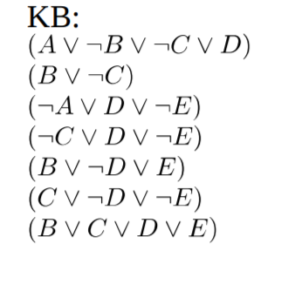

1. Merge KB1 and KB2: **(A ∨ ¬C ∨ D)**

2. Merge 1 and KB3: **(¬C ∨ D ∨ ¬E)**

3. Merge 2 and KB4 are the same: **(¬C ∨ D ∨ ¬E)**

4. Merge 3 and KB5: **(¬C ∨ B)**

5. Merge 4 and KB6: **(B ∨ ¬D ∨ ¬E)**

6. Merge 5 and KB7: **(B ∨ C)**

**1. KB ⊨ B:**

Merge step 4 and 6 to get: **B**

**B** and **¬B = contradiction**

*KB* Entails **B**

**2. KB ⊨ E:**

Merge Step 6 and KB1 to get: **(A v D)**

Merge Step 4 and step 6 to get:  **B**

Merge Step 4 and KB4 to get: **(B ∨ D ∨ ¬E)**

Merge Step 7 and KB3 to get: **(D ∨ ¬E)**

Merge Step 5 and step10 to get: **(B ∨ ¬E)**

Merge KB3 and KB5 to get: **(¬A v B)**

Merge Step 12 and KB1 to get: **(¬C ∨ D)**

**All possible options were investigated**

**KB** Does not entail **E**

**3. KB ⊨ (B ∨ E):**

¬(B ∨ E) == ¬B ∧ ¬E

Merge step 4 and 6 to get **B**

**B** anded **¬B ∧ ¬E** == **contradiction**

**KB** Entails **(B ∨ E)**

**Problem 4:**

**Relations:** Dad(2), EatApple(1), Mom(2), Person(1), Unicorn(1), WhiteHorn(1)

**1.** **Paragraph 1:**

$$∃_{x, y} \left(unicorn\left(x\right)∧WhiteHorn\left(x\right)⇒EatApple\left(x\right)\right)∨\left(unicorn\left(y\right)∧¬WhiteHorn\left(y\right)⇒¬EatApple\left(y\right)\right)$$

$$∧∃_{p} person\left(p\right)⇒EatApple\left(p\right)$$

**2. Paragraph 2:**

$$∀_{x, y,z}\left(unicorn\left(x\right)∧unicorn\left(y\right)∧unicorn\left(z\right)∧Dad\left(x,z\right)∧Mom\left(y,z\right)∧ \left(\left(WhiteHorn\left(x\right) ∧ WhiteHorn\left(y\right)\right)∨\left(¬WhiteHorn\left(x\right) ∧¬WhiteHorn\left(y\right)\right)\right)⇒ WhiteHorn\left(z\right)\right)$$

$$∧\left(unicorn\left(x\right)∧unicorn\left(y\right)∧unicorn\left(z\right)∧Dad\left(x,z\right)∧Mom\left(y,z\right)∧ \left(\left(WhiteHorn\left(x\right) ∧¬WhiteHorn\left(y\right)\right)∨\left(¬WhiteHorn\left(x\right) ∧WhiteHorn\left(y\right)\right)\right)⇒ ¬WhiteHorn\left(z\right)\right)$$

**Problem 5:**

$$1. Planet\left(Earth\right)⇒∃_{x} Star\left(x)∧Orbit(Earth, x\right)$$

$$2. Planet\left(Earth\right)⇔¬ Star\left(Earth\right)$$

$$3. Star\left(Sun\right) ⇔¬ Planet\left(Sun\right)$$

$$4. Satellite\left(S1\right)⇒∃_{y} Planet\left(y)∧Orbit(S1, y\right)$$

5. $Star\left(Sun\right)⇔Fussion\left(Sun\right)$

$$6. Fussion\left(Sun\right)⇒Large\left(Sun\right)∧Hot(Sun)$$

7. $∀_{x} Star\left(x\right)⇒Large(x) ^ Hot(x)$

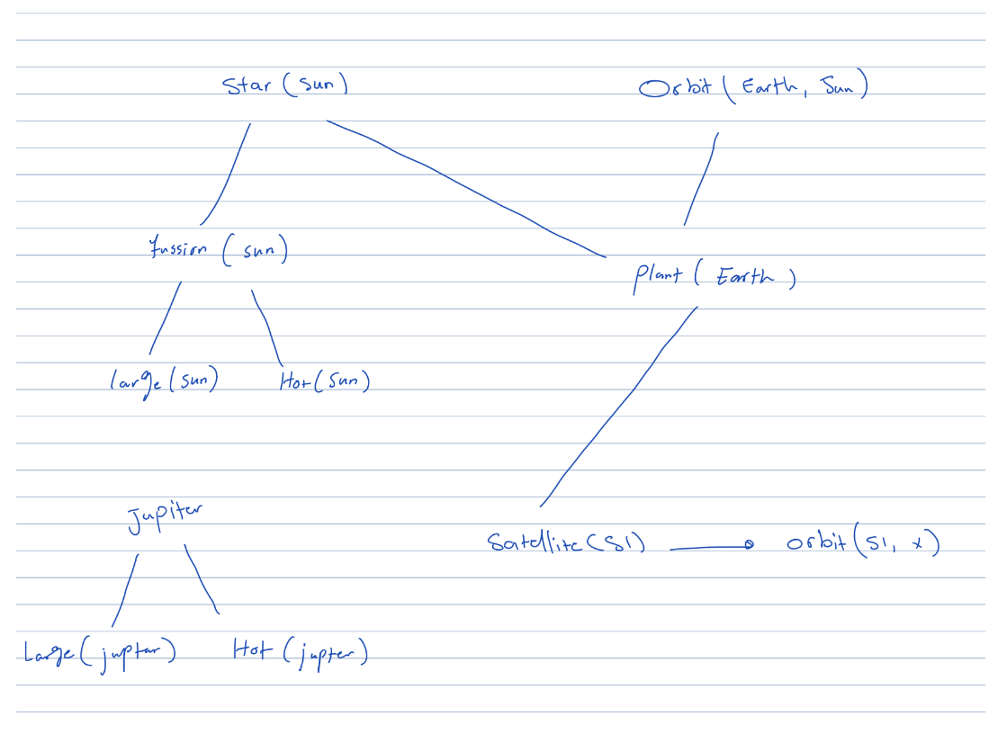

**Problem 7:**

1. **True**
2. **False**