Yahya Alhinai

EE5371

October 7th, 2019

**Problem 1:**

**A.**

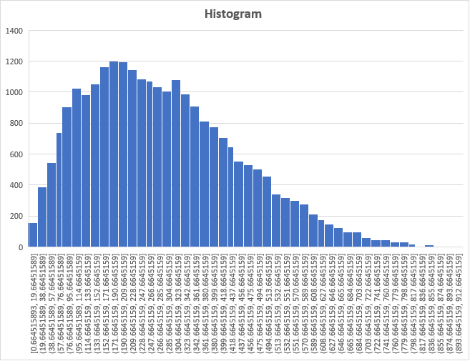

**B. CONFIDENCE INTERVALS FOR THE ARITHMETIC MEAN**

* 90% CONFIDENCE:

$$C_{2,1}=x_{arithmetic mean}± t_{0.95 }* \frac{s}{\sqrt{n}}$$

$C_{1}=284.16- 1.645 * \frac{159.71}{\sqrt{25000}}$ = 282.50

$C_{2}=284.16+ 1.654 * \frac{159.71}{\sqrt{25000}}$ = 285.82

**[282.50, 285.82]**

* 95% CONFIDENCE:

$$C_{2,1}=x_{arithmetic mean}± t_{0.975 }* \frac{s}{\sqrt{n}}$$

$C_{1}=284.16- 1.96 * \frac{159.71}{\sqrt{25000}}$ = 282.18

$C_{2}=284.16+ 1.96 * \frac{159.71}{\sqrt{25000}}$ = 286.14

**[282.18, 286.14]**

* 99% CONFIDENCE:

$$C_{2,1}=x_{arithmetic mean}± t_{0.995 }* \frac{s}{\sqrt{n}}$$

$C_{1}=284.16- 2.576 * \frac{159.71}{\sqrt{25000}}$ = 281.56

$C_{2}=284.16+ 2.576 * \frac{159.71}{\sqrt{25000}}$ = 286.76

**[281.56, 286.76]**

**C. CONFIDENCE INTERVALS FOR THE ARITHMETIC MEAN**

* 90% CONFIDENCE:

$$C_{2,1}=x_{harmonic mean}± t_{0.95 }* \frac{s}{\sqrt{n}}$$

$C_{1}=162.52- 1.645 * \frac{159.71}{\sqrt{25000}}$ = 160.86

$C_{2}=162.52+ 1.645 * \frac{159.71}{\sqrt{25000}}$ = 164.18

**[160.86, 164.18]**

* 95% CONFIDENCE:

$$C_{2,1}=x_{arithmetic mean}± t_{0.975 }* \frac{s}{\sqrt{n}}$$

$C_{1}=162.52- 1.96 * \frac{159.71}{\sqrt{25000}}$ = 160.54

$C_{2}=162.52+ 1.96 * \frac{159.71}{\sqrt{25000}}$ = 164.50

**[160.54, 164.50]**

* 99% CONFIDENCE:

$$C_{2,1}=x_{arithmetic mean}± t_{0.995 }* \frac{s}{\sqrt{n}}$$

$C_{1}=162.52- 2.576 * \frac{159.71}{\sqrt{25000}}$ = 159.92

$C_{2}=162.52+ 2.576 * \frac{159.71}{\sqrt{25000}}$ = 165.12

**[159.92, 165.12]**

**E. JACKKNIFE METHOD**

$$S_{H}=385.88$$

* 90% CONFIDENCE:

$$C_{2,1}=x_{harmonic mean}± z_{0.95 }* \frac{S_{H}}{\sqrt{n}}$$

$C_{1}=162.52- 1.645 * \frac{385.88}{\sqrt{25000}}$ = 158.48

$C_{2}=162.52+ 1.645 * \frac{385.88}{\sqrt{25000}}$ = 166.56

**[158.48, 166.56]**

* 95% CONFIDENCE:

$$C_{2,1}=x_{arithmetic mean}± {z_{0.975}}_{ }* \frac{S_{H}}{\sqrt{n}}$$

$C_{1}=162.52- 1.96 * \frac{385.88}{\sqrt{25000}}$ = 157.73

$C_{2}=162.52+ 1.96 * \frac{385.88}{\sqrt{25000}}$ = 167.30

**[157.73, 167.30]**

* 99% CONFIDENCE:

$$C_{2,1}=x_{arithmetic mean}± Z_{0.995 }* \frac{S_{H}}{\sqrt{n}}$$

$C_{1}=162.52- 2.576 * \frac{385.88}{\sqrt{25000}}$ = 156.23

$C_{2}=162.52+ 2.576 * \frac{385.88}{\sqrt{25000}}$ = 168.81

**[156.23, 168.81]**

**E. BOOTSTRAP METHOD**

* **K = 100:** 
  + 90% **[157.582, 166.601]**
  + 95% **[156.912, 167.112]**
  + 99% **[156.799, 167.579]**
* **K = 500:**
  + 90% [**158.18, 166.388]**
  + 95% **[157.531, 167.292]**
  + 99% **[156.051, 168.109]**
* **K = 5000:** 
  + 90% **[158.392, 166.416]**
  + 95% **[157.431, 167.163]**
  + 99% **[156.413, 167.846]**

**F. Compare and explain your results**

The major difference in the obtained confidence interval between the arithmetic and harmonic was a real surprised on my end. Although the interval’s period remained the same, the arithmetic mean was shifted almost twice as much as the harmonic mean since the distribution of data points is not symmetrical. Rather, data points have higher tendency to be at the upper half of the histogram.

If I had to choose between arithmetic and harmonic to describe this set of data points, I would certainly go for the latter. Unlike arithmetic mean, the harmonic mean minimized the effect of outliers. That’s why harmonic mean is closer to the area were a great deal of points are clustered the most.

The harmonic mean is used in part c, d, and e. The width of the intervals is the only difference between the three parts. Since part d is twice as mush as part c, the width of part d’s interval, as a result, is twice as much that is of part c. The results of part d and e are very close which was not expected to be the case in comparison to the difference presented in the paper [4]. The best way to describe this set of data points is though jackknife method because it gave the same value as bootstrap method when k was set to give 5000 steps resolution.

**Problem 2:**

**What is the tentative title of your project?**

* The efficiency task partitioning for multi-core network processors.

**Who will be doing the project?**

* I’ll be conducting several tests comparing the efficiency of partitioning a task for a multi-core processing vs a single-core processing

**What will be measured?**

* The throughputs result and the time it takes. As well as, the partitioning process and its efficiency. Also, the number of core vs performance and the memory factor in effectively divining up tasks.

**Why is this an interesting problem?**

* Most computers, nowadays, have multi-core processor and the number of cores seems to increase as time goes by. Generally, cranking up the speed of a core by a factor of 2, for instance, does not equal the performance of having 2 cores as a processor.

**How will you validate the measurements? For example, do you expect to develop an analytical model or a simulation model?**

* This issue required a great deal of simulation measurements. To validate the measurements obtained, a comparison between single-core processor and multi-core processor through simulation is required.

**What resources are needed for this project?**

* There has been a great deal of research papers published regarding this subject matter.
* I might use an open-source program.

**How will you get access to these resources?**

* Yes.