Yahya Alhinai

March 12, 2020

CSCI5521

Problem 1:

A **Model 2:**

$$P(x|)=\frac{1}{2π^{\frac{d}{2}}* |{\left(∑\right)}_{i}{\left.​\right|}^{\frac{1}{2}}} exp⁡(\frac{-1}{2} {\left(x- µ_{i}\right)}^{T} {\left(∑\right)}_{i}^{-1} (x - µ_{i}))$$

$$L({\left(∑\right)}_{i}| x)=\frac{-Nd}{2}log (2π)-\frac{N}{2}log |{\left(∑\right)}_{i}|- \frac{1}{2}\sum_{t=1}^{N}{{\left(x^{t}- µ_{i}\right)}^{T} {\left(∑\right)}_{i}^{-1} (x^{t} - µ_{i})}$$

$$\frac{d}{d{\left(∑\right)}_{i}} L({\left(∑\right)}_{i}| x)=-\frac{N}{2{\left(∑\right)}_{i}}-\frac{1}{2}\sum_{t=1}^{N}{{\left(∑\right)}_{i}^{-T}\left(x^{t}- µ_{i}\right) {\left(x^{t} - µ_{i}\right)}^{T}{\left(∑\right)}_{i}^{-T}} = 0$$

$${\left(∑\right)}_{i}=\frac{\sum_{t=1}^{N}{\left(x^{t}- µ_{i}\right) {\left(x^{t} - µ_{i}\right)}^{T}}}{N} \\ S_{i}=\frac{\sum_{t=1}^{N}{\left(x^{t}- µ_{i}\right) {\left(x^{t} - µ_{i}\right)}^{T}}}{N}$$

$$S_{1}=S_{2}$$

$$S_{1}+S_{2}=2S=\frac{\sum_{t=1}^{N_{1}}{\left(x^{t}- µ_{1}\right) {\left(x^{t} - µ_{1}\right)}^{T}}}{N_{1}}+\frac{\sum_{t=1}^{N_{2}}{\left(x^{t}- µ_{2}\right) {\left(x^{t} - µ_{2}\right)}^{T}}}{N_{2}}$$

$$S=\frac{1}{2}(S_{1}+S_{2})$$

**Model 3:**

$$S_{i}= α_{i}*I$$

$$L(α_{i}| x)=\frac{-Nd}{2}log (2π)-\frac{N}{2}log |α_{i}^{d}|- \frac{1}{2}\sum_{t=1}^{N}{{\left(x^{t}- µ_{i}\right)}^{T} α_{i}^{-1}I (x^{t} - µ_{i})}$$

$$\frac{d}{dα_{i}} L(α_{i}| x)=-\frac{Nd}{2α_{i}}-\frac{1}{2α_{i}^{2}}\sum_{t=1}^{N}{ {\left(x^{t} - µ_{i}\right)}^{T}\left(x^{t}- µ_{i}\right)}=0$$

$$α_{i}=\frac{\sum_{t=1}^{N}{{\left(x^{t} - µ_{i}\right)}^{T}\left(x^{t}- µ_{i}\right) }}{Nd}$$

B

1. ------------------------------------------------------------
2. ------------------------------------------------------------
3. Data Set 1
4. ------------------------------------------------------------
5. P(C1) = 0.2
6. P(C2) = 0.8
7. M1 = 0.6216, 0.5206, -0.5254, -0.1011, -0.0146, 1.0318, 0.2876, -0.0447
8. M2 = 1.0488  0.2043  0.8059  0.0749  0.5372  0.6031  0.6966  1.0544
9. -------------------------
10. Data Set 1 - Model 1
11. -------------------------
12. Error Rate = 0.2900
13. S1 =
14. 8.3481  -4.6489  -4.3645  -3.8639  3.3711  -4.6298  0.1901  5.3910
15. -4.6489  9.1407  -2.5567  4.2312  -0.7324  4.0982  3.3851  -4.5457
16. -4.3645  -2.5567  12.8978  3.0713  -2.3547  -1.9411  -5.8484  0.4108
17. -3.8639  4.2312  3.0713  7.4962  -1.4129  2.8157  -0.0400  -2.8332
18. 3.3711  -0.7324  -2.3547  -1.4129  5.6325  -4.5224  -1.4585  2.3261
19. -4.6298  4.0982  -1.9411  2.8157  -4.5224  8.5332  4.0668  -6.2549
20. 0.1901  3.3851  -5.8484  -0.0400  -1.4585  4.0668  6.0568  -1.9673
21. 5.3910  -4.5457  0.4108  -2.8332  2.3261  -6.2549  -1.9673  7.0420

24. S2 =
25. 6.9806  -2.2971  -2.9607  -1.7056  4.5878  -2.2326  -0.3004  2.2206
26. -2.2971  7.5959  -3.0854  1.0028  1.3683  0.7426  2.4512  -1.8130
27. -2.9607  -3.0854  9.3598  1.8725  -3.4296  -1.0595  -3.1999  2.5604
28. -1.7056  1.0028  1.8725  5.2913  0.5197  0.3795  0.0033  -0.0122
29. 4.5878  1.3683  -3.4296  0.5197  7.8898  -2.5563  0.2174  0.9157
30. -2.2326  0.7426  -1.0595  0.3795  -2.5563  4.2109  1.3974  -2.4591
31. -0.3004  2.4512  -3.1999  0.0033  0.2174  1.3974  3.5292  -1.7868
32. 2.2206  -1.8130  2.5604  -0.0122  0.9157  -2.4591  -1.7868  4.5089
33. -------------------------
34. Data Set 1 - Model 2
35. -------------------------
36. Error Rate = 0.2550
37. S1 =
38. 7.6644  -3.4730  -3.6626  -2.7848  3.9794  -3.4312  -0.0551  3.8058
39. -3.4730  8.3683  -2.8210  2.6170  0.3179  2.4204  2.9181  -3.1794
40. -3.6626  -2.8210  11.1288  2.4719  -2.8921  -1.5003  -4.5241  1.4856
41. -2.7848  2.6170  2.4719  6.3938  -0.4466  1.5976  -0.0183  -1.4227
42. 3.9794  0.3179  -2.8921  -0.4466  6.7611  -3.5393  -0.6206  1.6209
43. -3.4312  2.4204  -1.5003  1.5976  -3.5393  6.3721  2.7321  -4.3570
44. -0.0551  2.9181  -4.5241  -0.0183  -0.6206  2.7321  4.7930  -1.8771
45. 3.8058  -3.1794  1.4856  -1.4227  1.6209  -4.3570  -1.8771  5.7755

48. S2 =
49. 7.6644  -3.4730  -3.6626  -2.7848  3.9794  -3.4312  -0.0551  3.8058
50. -3.4730  8.3683  -2.8210  2.6170  0.3179  2.4204  2.9181  -3.1794
51. -3.6626  -2.8210  11.1288  2.4719  -2.8921  -1.5003  -4.5241  1.4856
52. -2.7848  2.6170  2.4719  6.3938  -0.4466  1.5976  -0.0183  -1.4227
53. 3.9794  0.3179  -2.8921  -0.4466  6.7611  -3.5393  -0.6206  1.6209
54. -3.4312  2.4204  -1.5003  1.5976  -3.5393  6.3721  2.7321  -4.3570
55. -0.0551  2.9181  -4.5241  -0.0183  -0.6206  2.7321  4.7930  -1.8771
56. 3.8058  -3.1794  1.4856  -1.4227  1.6209  -4.3570  -1.8771  5.7755
57. -------------------------
58. Data Set 1 - Model 3
59. -------------------------
60. Error Rate = 0.6500
61. σ1 = 7.73624137515677
62. σ2 = 6.093681509670718

65. ------------------------------------------------------------
66. ------------------------------------------------------------
67. Data Set 2
68. ------------------------------------------------------------
69. P(C1) = 0.2
70. P(C2) = 0.8
71. M1 = 1.2644, 0.2951, 0.0220, -0.4687, 0.1766, -0.0995, 1.2252, 1.0318
72. M2 = 1.1875  1.0339  1.2395  0.2855  0.6929  0.0440  0.9373  0.7190
73. -------------------------
74. Data Set 2 - Model 1
75. -------------------------
76. Error Rate = 0.0450
77. S1 =
78. 6.6564  0.6897  -4.8294  0.9371  -1.7943  3.1290  2.0019  -4.9913
79. 0.6897  1.7798  1.2671  -0.6797  0.9042  0.6182  -0.2131  -0.9381
80. -4.8294  1.2671  11.3396  -0.7255  3.9294  2.9642  -1.3406  1.9522
81. 0.9371  -0.6797  -0.7255  6.9097  -2.5162  1.8468  0.7678  -2.0457
82. -1.7943  0.9042  3.9294  -2.5162  3.2056  -0.1442  -0.2202  2.3499
83. 3.1290  0.6182  2.9642  1.8468  -0.1442  9.0158  1.6407  -6.0387
84. 2.0019  -0.2131  -1.3406  0.7678  -0.2202  1.6407  2.5507  -1.1931
85. -4.9913  -0.9381  1.9522  -2.0457  2.3499  -6.0387  -1.1931  7.8486

88. S2 =
89. 8.5976  2.6625  2.2209  -4.0600  -3.6996  -3.6332  -1.9657  -0.9823
90. 2.6625  4.7255  1.2548  -0.2870  -0.0853  -1.5999  0.4875  -1.5974
91. 2.2209  1.2548  3.2014  -1.7007  -0.6558  -0.9575  -0.8843  -0.6915
92. -4.0600  -0.2870  -1.7007  7.8644  3.9884  1.4676  1.6794  0.6439
93. -3.6996  -0.0853  -0.6558  3.9884  6.1081  0.8235  2.6251  -0.0603
94. -3.6332  -1.5999  -0.9575  1.4676  0.8235  4.3934  1.1359  0.7222
95. -1.9657  0.4875  -0.8843  1.6794  2.6251  1.1359  3.6609  0.4272
96. -0.9823  -1.5974  -0.6915  0.6439  -0.0603  0.7222  0.4272  2.5246
97. -------------------------
98. Data Set 2 - Model 2
99. -------------------------
100. Error Rate = 0.2100
101. S1 =
102. 7.6270  1.6761  -1.3042  -1.5614  -2.7469  -0.2521  0.0181  -2.9868
103. 1.6761  3.2527  1.2609  -0.4833  0.4095  -0.4909  0.1372  -1.2677
104. -1.3042  1.2609  7.2705  -1.2131  1.6368  1.0034  -1.1124  0.6304
105. -1.5614  -0.4833  -1.2131  7.3871  0.7361  1.6572  1.2236  -0.7009
106. -2.7469  0.4095  1.6368  0.7361  4.6568  0.3397  1.2025  1.1448
107. -0.2521  -0.4909  1.0034  1.6572  0.3397  6.7046  1.3883  -2.6583
108. 0.0181  0.1372  -1.1124  1.2236  1.2025  1.3883  3.1058  -0.3829
109. -2.9868  -1.2677  0.6304  -0.7009  1.1448  -2.6583  -0.3829  5.1866

112. S2 =
113. 7.6270  1.6761  -1.3042  -1.5614  -2.7469  -0.2521  0.0181  -2.9868
114. 1.6761  3.2527  1.2609  -0.4833  0.4095  -0.4909  0.1372  -1.2677
115. -1.3042  1.2609  7.2705  -1.2131  1.6368  1.0034  -1.1124  0.6304
116. -1.5614  -0.4833  -1.2131  7.3871  0.7361  1.6572  1.2236  -0.7009
117. -2.7469  0.4095  1.6368  0.7361  4.6568  0.3397  1.2025  1.1448
118. -0.2521  -0.4909  1.0034  1.6572  0.3397  6.7046  1.3883  -2.6583
119. 0.0181  0.1372  -1.1124  1.2236  1.2025  1.3883  3.1058  -0.3829
120. -2.9868  -1.2677  0.6304  -0.7009  1.1448  -2.6583  -0.3829  5.1866
121. -------------------------
122. Data Set 2 - Model 3
123. -------------------------
124. Error Rate = 0.6750
125. σ1 = 5.855114052034532
126. σ2 = 5.070305133828278

129. ------------------------------------------------------------
130. ------------------------------------------------------------
131. Data Set 3
132. ------------------------------------------------------------
133. P(C1) = 0.2
134. P(C2) = 0.8
135. M1 = 0.2362, 1.3669, 0.3367, 0.5549, -0.0063, 0.9241, 0.3775, 0.4070
136. M2 = 1.0253  0.4181  0.4563  0.3941  0.4005  0.6166  0.3171  0.9354
137. -------------------------
138. Data Set 3 - Model 1
139. -------------------------
140. Error Rate = 0.2400
141. S1 =
142. 2.0559  -0.3032  -0.5313  -0.4405  1.3070  0.4624  -0.1037  -0.1044
143. -0.3032  2.3104  -0.5280  -0.5306  -0.5244  -0.5516  -0.2588  0.2258
144. -0.5313  -0.5280  3.1636  0.4187  -0.0829  -0.4318  -0.2902  0.2899
145. -0.4405  -0.5306  0.4187  1.9929  -0.7272  -0.4296  0.8309  0.6381
146. 1.3070  -0.5244  -0.0829  -0.7272  2.6578  1.1431  -0.1203  -0.1389
147. 0.4624  -0.5516  -0.4318  -0.4296  1.1431  1.8975  -0.2714  -0.0160
148. -0.1037  -0.2588  -0.2902  0.8309  -0.1203  -0.2714  1.2821  0.2571
149. -0.1044  0.2258  0.2899  0.6381  -0.1389  -0.0160  0.2571  2.8011

152. S2 =
153. 3.6564  0.1506  -0.0568  0.3361  -0.5260  0.5598  -0.1873  -0.2860
154. 0.1506  3.4698  -0.7366  0.0109  -0.0128  0.2459  -0.1359  -0.2992
155. -0.0568  -0.7366  3.5129  -0.5629  -0.3901  0.2578  0.2308  0.5263
156. 0.3361  0.0109  -0.5629  3.9538  0.1582  0.2597  -1.4462  -0.2600
157. -0.5260  -0.0128  -0.3901  0.1582  3.7715  -0.2777  -0.5899  -0.1331
158. 0.5598  0.2459  0.2578  0.2597  -0.2777  2.9816  0.0559  -0.6324
159. -0.1873  -0.1359  0.2308  -1.4462  -0.5899  0.0559  5.3251  0.0595
160. -0.2860  -0.2992  0.5263  -0.2600  -0.1331  -0.6324  0.0595  3.9993
161. -------------------------
162. Data Set 3 - Model 2
163. -------------------------
164. Error Rate = 0.2650
165. S1 =
166. 2.8562  -0.0763  -0.2941  -0.0522  0.3905  0.5111  -0.1455  -0.1952
167. -0.0763  2.8901  -0.6323  -0.2599  -0.2686  -0.1528  -0.1974  -0.0367
168. -0.2941  -0.6323  3.3383  -0.0721  -0.2365  -0.0870  -0.0297  0.4081
169. -0.0522  -0.2599  -0.0721  2.9733  -0.2845  -0.0849  -0.3077  0.1891
170. 0.3905  -0.2686  -0.2365  -0.2845  3.2146  0.4327  -0.3551  -0.1360
171. 0.5111  -0.1528  -0.0870  -0.0849  0.4327  2.4396  -0.1077  -0.3242
172. -0.1455  -0.1974  -0.0297  -0.3077  -0.3551  -0.1077  3.3036  0.1583
173. -0.1952  -0.0367  0.4081  0.1891  -0.1360  -0.3242  0.1583  3.4002

176. S2 =
177. 2.8562  -0.0763  -0.2941  -0.0522  0.3905  0.5111  -0.1455  -0.1952
178. -0.0763  2.8901  -0.6323  -0.2599  -0.2686  -0.1528  -0.1974  -0.0367
179. -0.2941  -0.6323  3.3383  -0.0721  -0.2365  -0.0870  -0.0297  0.4081
180. -0.0522  -0.2599  -0.0721  2.9733  -0.2845  -0.0849  -0.3077  0.1891
181. 0.3905  -0.2686  -0.2365  -0.2845  3.2146  0.4327  -0.3551  -0.1360
182. 0.5111  -0.1528  -0.0870  -0.0849  0.4327  2.4396  -0.1077  -0.3242
183. -0.1455  -0.1974  -0.0297  -0.3077  -0.3551  -0.1077  3.3036  0.1583
184. -0.1952  -0.0367  0.4081  0.1891  -0.1360  -0.3242  0.1583  3.4002
185. -------------------------
186. Data Set 3 - Model 3
187. -------------------------
188. Error Rate = 0.2150
189. σ1 = 2.1566489029880214
190. σ2 = 3.785871862079163

**C**

|  |  |  |  |
| --- | --- | --- | --- |
| ERROR | Data Set 1 | Data Set 2 | Data Set 3 |
| Method 1 | 0.290 | 0.045 | 0.240 |
| Method 2 | 0.255 | 0.210 | 0.265 |
| Method 3 | 0.650 | 0.675 | 0.215 |

This table shows that each set of data has a certain model that can be best repents the data. Meaning that there is no one method that can perfectly model any data set.

This distinction is very obvious in the table above. Where Data set 1 is best modeled by Method 2 and Data set 2 is best modeled by Method 1. Finally, Data set 1 is best modeled by Method 3. These are the reason for the difference in error rate in each data set:

* Model 2 implies that the covariance for class 1 and class 2 are close from each other.
* Model 1 implies that the covariance for class 1 and class 2 are not related to each other. That’s leads to fewer assumption as it treats the data as dependent from each other with their unique covariance for each data.
* Model 3 implies that the data set is completely independent from each other as well as it treat is as it has the same variance for all dimensions.

**Problem 2:**

**A**

|  |
| --- |
| k = 1 - Error Rate: 0.05387205387205387 |
| k = 3 - Error Rate: 0.04713804713804714 |
| k = 5 - Error Rate: 0.05387205387205387 |
| k = 7 - Error Rate: 0.06060606060606061 |

**B**

Minimum number of eigenvectors that explain at least 90% of the variance = 21

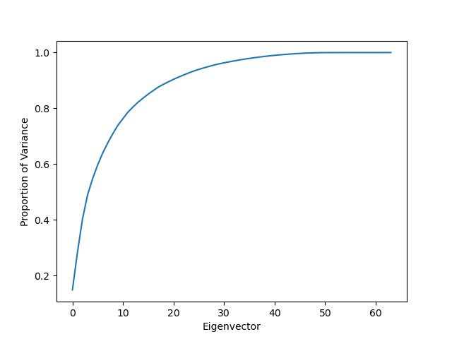

|  |
| --- |
| k = 1 - Error Rate: 0.04377104377104377 |
| k = 3 - Error Rate: 0.037037037037037035 |
| k = 5 - Error Rate: 0.04713804713804714 |
| k = 7 - Error Rate: 0.05387205387205387 |

**C**

**Training Set:**

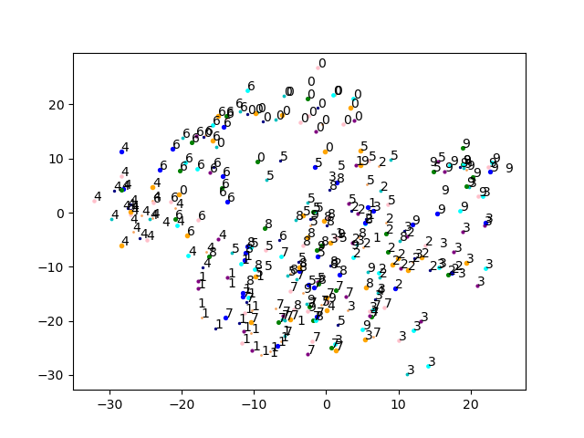

**Test Set:**

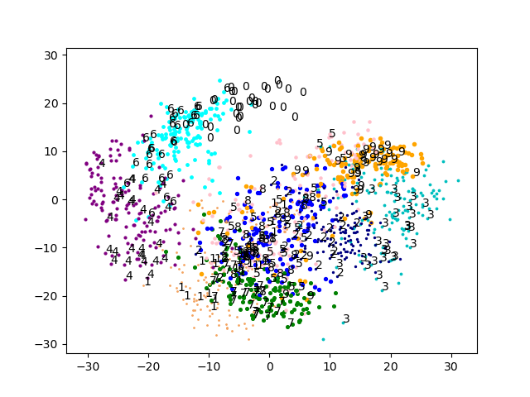

**D**

|  |
| --- |
| [L = 2 - k = 1] = Error Rate: 0.46464646464646464 |
| [L = 2 - k = 3] = Error Rate: 0.4208754208754209 |
| [L = 2 - k = 5] = Error Rate: 0.39057239057239057 |
| [L = 4 - k = 1] = Error Rate: 0.1919191919191919 |
| [L = 4 - k = 3] = Error Rate: 0.18518518518518517 |
| [L = 4 - k = 5] = Error Rate: 0.1750841750841751 |
| [L = 9 - k = 1] = Error Rate: 0.09764309764309764 |
| [L = 9 - k = 3] = Error Rate: 0.09427609427609428 |
| [L = 9 - k = 5] = Error Rate: 0.09764309764309764 |

**E**

**Training Set:**

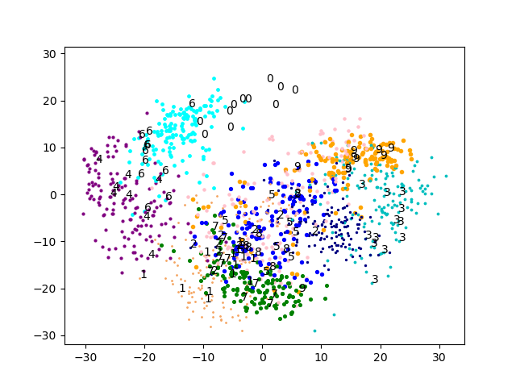

**Test Set:**

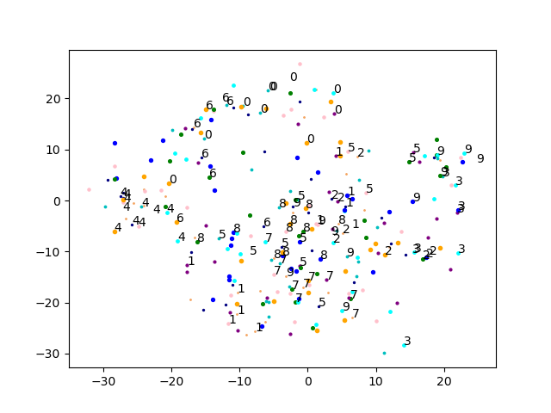

**Problem 3:**

**A**

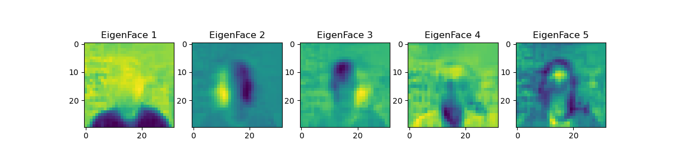

**B**

Minimum number of eigenvectors that explain at least 90% of the variance = **41**

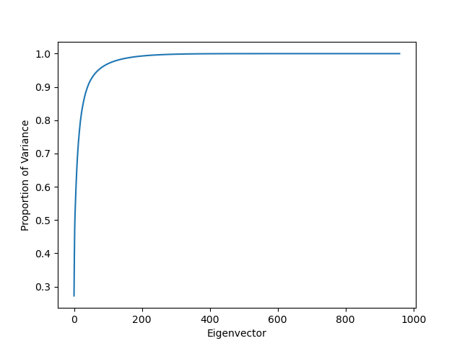

|  |
| --- |
| k = 1 - Error Rate: 0.10483870967741936 |
| k = 3 - Error Rate: 0.20161290322580644 |
| k = 5 - Error Rate: 0.3225806451612903 |
| k = 7 - Error Rate: 0.24193548387096775 |

**C**

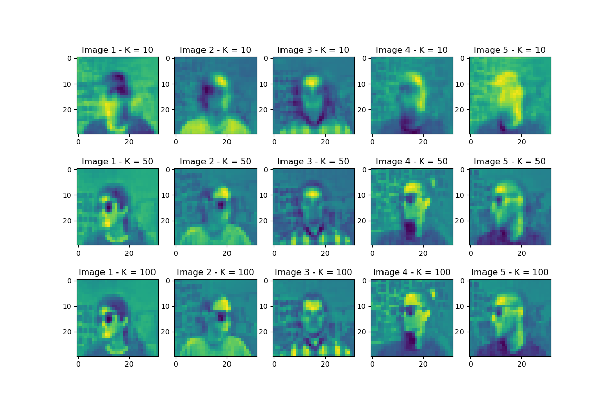

We can see from the picture above that the larger k gets, the more details included in the picture. This is due to the increase in the information content as more principal components added.

This is being said, increasing principal components has a log increase in the information content. In this picture, 41 principal components will give a 90% or more details of original picture. It is seen in K=50 and k=100, there is little details, almost unnoticeable, added even though we doubled the principal component.