**Yahya Alhinai**

**April 12, 2020**

**EE 5340**

* We know that θ is between 0 and $π/2$. Therefore, we can use the following to find the angle:
$$\sin\left(θ\right)=\frac{2 \sqrt{1\left(16-1\right)}}{16}$$

$$θ=\arcsin\left(\frac{2 \sqrt{1\left(16-1\right)}}{16}\right)=\arcsin\left(\frac{2 \sqrt{15}}{16}\right)=0.5053 rad$$

* The required Grover iteration required to reach a good solution us expressed as following:
$$R=\frac{\arccos{\sqrt{\frac{M}{N}}}}{θ}= \frac{\arccos{\sqrt{\frac{1}{16}}}}{0.5053}= 2.986$$

$$R ≈ 3$$

* Meaning that the ideal number of Grover iteration is 3.

**CODE:**

* Starting by preparing the oracle function of Grover’s algorithm

1. f <- function( x ){
2. **if**(x == 2) 1
3. **else** 0
4. }
6. g <- Uf(fun=f,n=4,m=1)

* Preparing the initial states of qubits to be in superposition before entering the Grover’s algorithm

1. # n=4 || m=1
2. qu <-tensor(ket(1,1), ket(1,1), ket(1,1), ket(1,1), ket(1,-1))

* Apply 6 iterations of the oracle and diffusion operator into the qubits:

1. # First iteration
2. qu <- g %*% qu
3. qu <- tensor(GroverDiffusion(4), I())%*% qu
5. # Second iteration
6. qu <- g %*% qu
7. qu <- tensor(GroverDiffusion(4), I())%*% qu
9. # Third iteration
10. qu <- g %*% qu
11. qu <- tensor(GroverDiffusion(4), I())%*% qu
13. # Fourth iteration
14. qu <- g %*% qu
15. qu <- tensor(GroverDiffusion(4), I())%*% qu
17. # Fifth iteration
18. qu <- g %*% qu
19. qu <- tensor(GroverDiffusion(4), I())%*% qu
21. # Sixth iteration
22. qu <- g %*% qu
23. qu <- tensor(GroverDiffusion(4), I())%*% qu
25. qu <- tensor(I(), I(), I(), I(), H()) %*% qu

The results of each iteration are noted below:

**THE 1st ITERATOIN:**

* The first iteration yells the following probabilities of all of N:

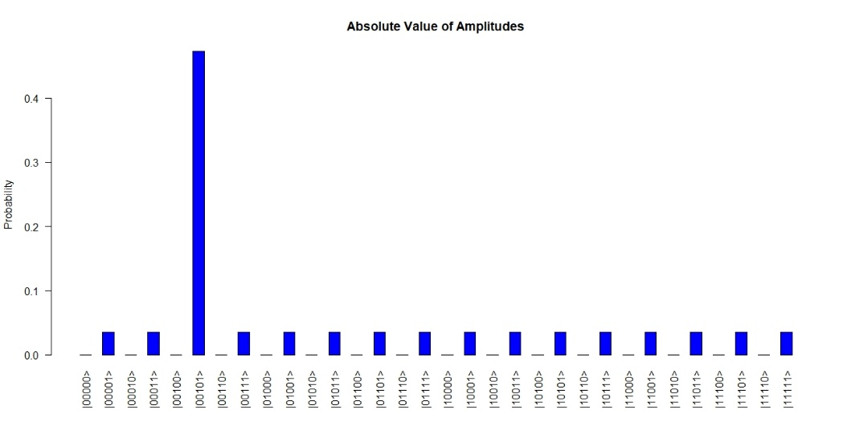

The probability of finding the solution index has increased drastically:

$$|sol>= |0010>\left[\frac{|0>-|1>}{\sqrt{2}}\right] has an amplitude 47.2\%$$

All other non-solitons indexes have an amplitude of 3.51% each. Meaning, 52.65% probability of settling on non-solution.

**THE 2ed ITERATOIN:**

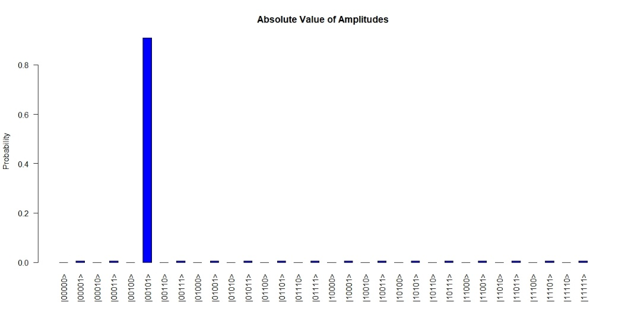

The probability of the solution index increased from 47.2% to 90.8% for the second iteration:

$$|sol>= |0010>\left[\frac{|0>-|1>}{\sqrt{2}}\right] has an amplitude 90.8\%$$

Non-solution indexes amplitude has decreased to 0.61% each. 9.15% probability of settling on non-solution.

**THE 3rd ITERATOIN:**

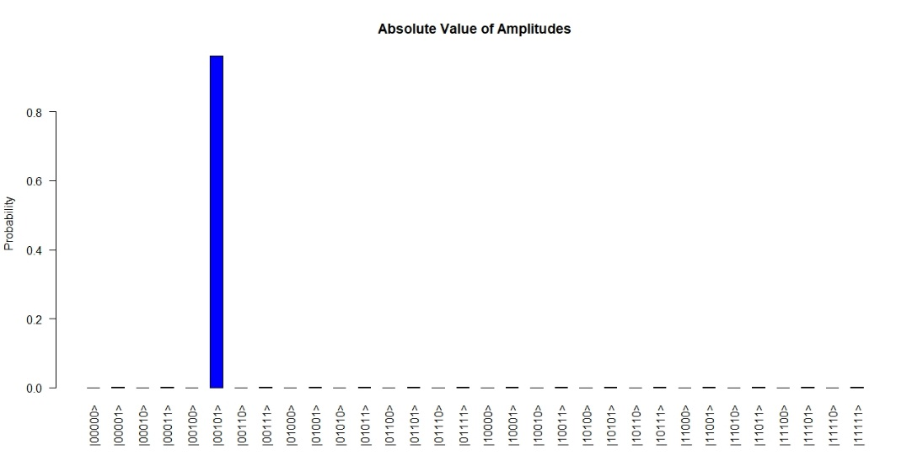

The probability of the solution index increased from 90.8% to 96.1% for the third iteration. Three interaction is the highest we can achieve based on the calculation we have done previously.

$$|sol>= |0010>\left[\frac{|0>-|1>}{\sqrt{2}}\right] has an amplitude 96.1\%$$

Non-solution indexes amplitude has decreased to 0.25% each. 3.75% probability of settling on non-solution.

**THE 4th ITERATOIN:**

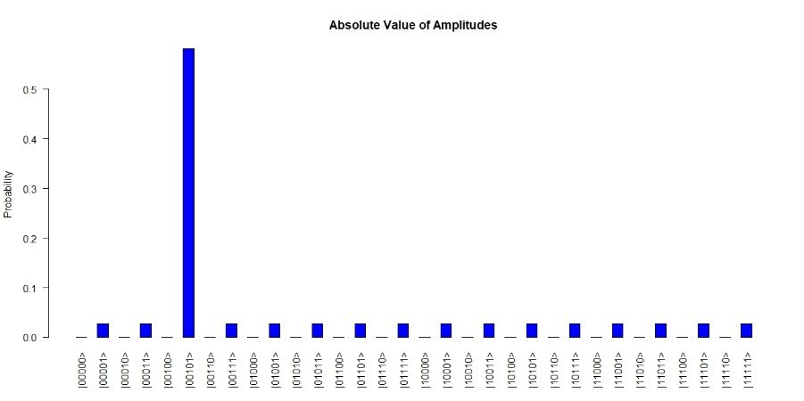

The probability of the solution index has majorly decreased from 96.1% to 58.1%. This is because we passed the range of angle from 0 to $\frac{π}{4}$ that are supposed to be bounded with.

$$|sol>= |0010>\left[\frac{|0>-|1>}{\sqrt{2}}\right] has an amplitude 58.1\%$$

Each non-solution indexes have an amplitude probability of 4.23% each. 63.45% probability of settling on non-solution.

**THE 5th ITERATOIN:**

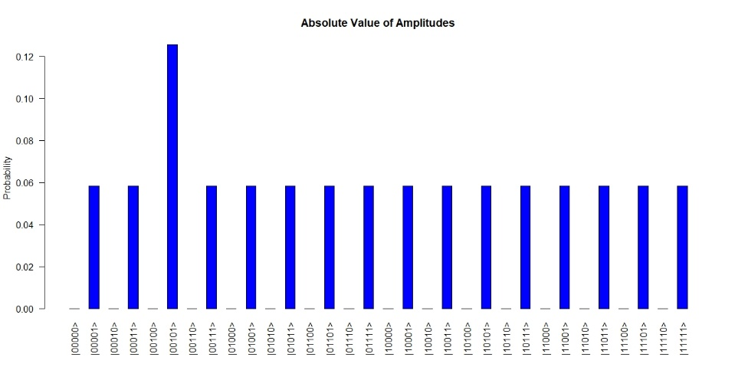

The probability of the solution index has decreased yet again from the last iteration to 12.5%. This is because we are getting further away from |β > axis with additional iterations. Though, solution index has higher amplitude probability than non-solution still. | > represents non-solution axis and |β > represents solution axis. The goal is to be as close to |β > axis as possible.

$$|sol>= |0010>\left[\frac{|0>-|1>}{\sqrt{2}}\right] has an amplitude 12.5\%$$

non-solution indexes have an amplitude probability of 5.83% each. 87.45% probability of settling on non-solution.

**THE 6th ITERATOIN:**

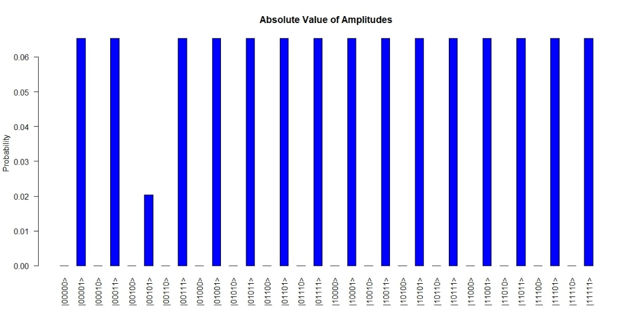

The probability of the solution index still in declined definition from 12.5% of the last nitration to 2.03%. his time amplitude probability of the solution is less than other non-solutions which say that it’s 97.9% not finding the solution. This is because it has reached close to | > axis on the other side where it started. Additionally, it’s even closer to | > axis now that before starting because the probability now is a lot less than starting what we started.

$$|sol>= |0010>\left[\frac{|0>-|1>}{\sqrt{2}}\right] has an amplitude 2.03\%$$

non-solution indexes have an amplitude probability of 6.53%.