**Yahya Alhinai**

**May 4, 2020**

**EE 5340**

**Bit Flip Code:**

1. Preparation of the first qubit to be in superposition and apply CNOT-gate transformation to the second and their qubit controlled by the first qubit. The last 2 qubits are prepared in the |00> state:
2. qu <- intket(x=c(0,16), n=5, amplitudes=c(1,1))
3. qu <- controlled(gate=X(), n=5, cQubits=0, tQubit=1) %*% qu
4. qu <- controlled(gate=X(), n=5, cQubits=0, tQubit=2) %*% qu

The resulted quantum state:

$$\frac{1}{\sqrt{2}}|00000>+\frac{1}{\sqrt{2}}|11100>$$

1. Creating bit-flip (X gate) error applied to one qubit at a time:
2. # bit-flip applied to the **first** qubit
3. qu <- tensor(X(), I(), I(), I(), I()) %*% qu
5. # bit-flip applied to the **second** qubit
6. qu <- tensor(I(), X(), I(), I(), I()) %*% qu
8. # bit-flip applied to the **third** qubit
9. qu <- tensor(I(), I(), X(), I(), I()) %*% qu
10. detecting the bit-flip error by measure the last 2 qubits which project error index:
11. qu <- controlled(gate=X(), n=5, cQubits=0, tQubit=3) %*% qu
12. qu <- controlled(gate=X(), n=5, cQubits=1, tQubit=3) %*% qu
14. qu <- controlled(gate=X(), n=5, cQubits=0, tQubit=4) %*% qu
15. qu <- controlled(gate=X(), n=5, cQubits=2, tQubit=4) %*% qu
16. qu <- measure(qu, 3, 4, l2r=TRUE)[[1]]

the resulted state for each of the bit-flip:

* 1. fix the detected error by applying CNOT-gate when necessary to the first 3 qubits:

1. qu <- controlled(gate=X(), n=5, cQubits=3, tQubit=1) %*% qu
2. qu <- controlled(gate=X(), n=5, cQubits=4, tQubit=2) %*% qu

If there is **no error** occurred, then qubits will preserve their original state:

$$\frac{1}{\sqrt{2}}\left|00000>+\frac{1}{\sqrt{2}}\right|11100> → \frac{1}{\sqrt{2}}\left|00000>+\frac{1}{\sqrt{2}}\right|11100>$$

Fix the bit flip error occurred on the **first** qubit:

$$\frac{1}{\sqrt{2}}\left|01111>+\frac{1}{\sqrt{2}}\right|10011> → \frac{1}{\sqrt{2}}\left|00011>+\frac{1}{\sqrt{2}}\right|11111>$$

Fix the bit flip error occurred on the **second** qubit:

$$\frac{1}{\sqrt{2}}\left|01010>+\frac{1}{\sqrt{2}}\right|10110> → \frac{1}{\sqrt{2}}\left|00010>+\frac{1}{\sqrt{2}}\right|11110>$$

Fix the bit flip error occurred on the **Third** qubit:

$$\frac{1}{\sqrt{2}}\left|00101>+\frac{1}{\sqrt{2}}\right|11001> → \frac{1}{\sqrt{2}}\left|00001>+\frac{1}{\sqrt{2}}\right|11101>$$

**Density Matrices and Pauli Noise:**

The following code produces the plot below:

1. fidelity <- function(V,W){
2. sum(diag( V %*% W ))
3. }
5. V <- convert_ket2DM(ket(1,0))
7. x_axis <- seq(0,1,length.out=101)
9. **for** (i in 1:length(x_axis)){
10. W <- PauliNoise(p=V,e=x_axis[i])
11. l[i] <- fidelity(V,W)
12. }

The produced plot:

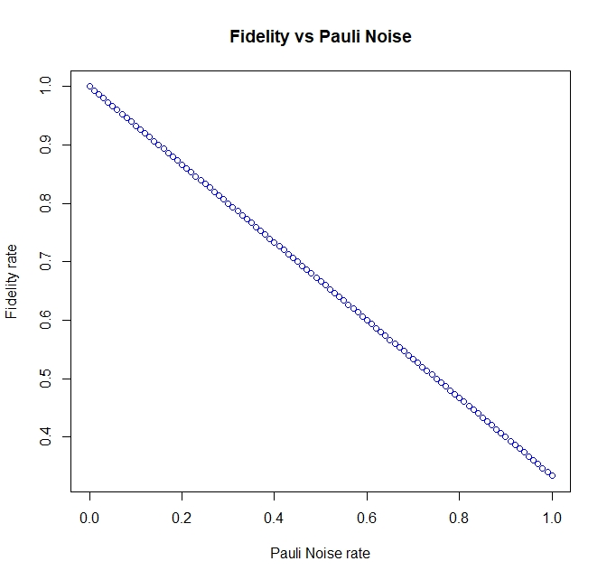

The corresponding fidelity rates shown in the plot are following:

1. [1] 1.0000000 0.9933333 0.9866667 0.9800000 0.9733333 0.9666667
2. [7] 0.9600000 0.9533333 0.9466667 0.9400000 0.9333333 0.9266667
3. [13] 0.9200000 0.9133333 0.9066667 0.9000000 0.8933333 0.8866667
4. [19] 0.8800000 0.8733333 0.8666667 0.8600000 0.8533333 0.8466667
5. [25] 0.8400000 0.8333333 0.8266667 0.8200000 0.8133333 0.8066667
6. [31] 0.8000000 0.7933333 0.7866667 0.7800000 0.7733333 0.7666667
7. [37] 0.7600000 0.7533333 0.7466667 0.7400000 0.7333333 0.7266667
8. [43] 0.7200000 0.7133333 0.7066667 0.7000000 0.6933333 0.6866667
9. [49] 0.6800000 0.6733333 0.6666667 0.6600000 0.6533333 0.6466667
10. [55] 0.6400000 0.6333333 0.6266667 0.6200000 0.6133333 0.6066667
11. [61] 0.6000000 0.5933333 0.5866667 0.5800000 0.5733333 0.5666667
12. [67] 0.5600000 0.5533333 0.5466667 0.5400000 0.5333333 0.5266667
13. [73] 0.5200000 0.5133333 0.5066667 0.5000000 0.4933333 0.4866667
14. [79] 0.4800000 0.4733333 0.4666667 0.4600000 0.4533333 0.4466667
15. [85] 0.4400000 0.4333333 0.4266667 0.4200000 0.4133333 0.4066667
16. [91] 0.4000000 0.3933333 0.3866667 0.3800000 0.3733333 0.3666667
17. [97] 0.3600000 0.3533333 0.3466667 0.3400000 0.3333333

The plot indicates an inverse linear relationship between the Pauli noise injected in the system and the fidelity rate. The maximum amount of noise injected to the system (**ε = 1**) would have a **fidelity of 33.3%.**

We know that **ε** is the summation probability of the corresponding X-gate, Y-gate, and Z-gate errors:

$$ε= ε_{X}+ ε_{Y}+ ε_{Z}$$

Since the we set the fidelity to maximum $ε=1$ and every gate error is linearly independent of each other and collectively exhaustive we get:

$$ε_{X}+ ε_{Y}+ ε_{Z}=1$$

$$ε_{X}= ε_{Y}= ε_{Z}=\frac{1}{3}$$

Because **Z-gate** transformation has no effect whatsoever on **|0> state**, only X-gate and Y-gate influence the fidelity rate. Therefore, the fidelity rate of **|0> state** only dependent on $ε_{X}$ and $ε_{Y}$ and it can only reach a minimum of 33.3% when overall error rate (**ε = 1)** is set to maximum.