Team ID : Gen_88
Project Title : Simple Digital Wallet System

- يحيى أحمد محمد حمزة : 2022170497
- محمد جابر غريب سليمان : 2022170360
- محمد عبدالرحمن محمد عبدالرحمن : 2022170378
- محمد مختار السيد عيد : 2022170387
- يوسف احمد محمد علي : 2022170506
- مؤمن محمد عبدالعظيم محمد : 2022170598

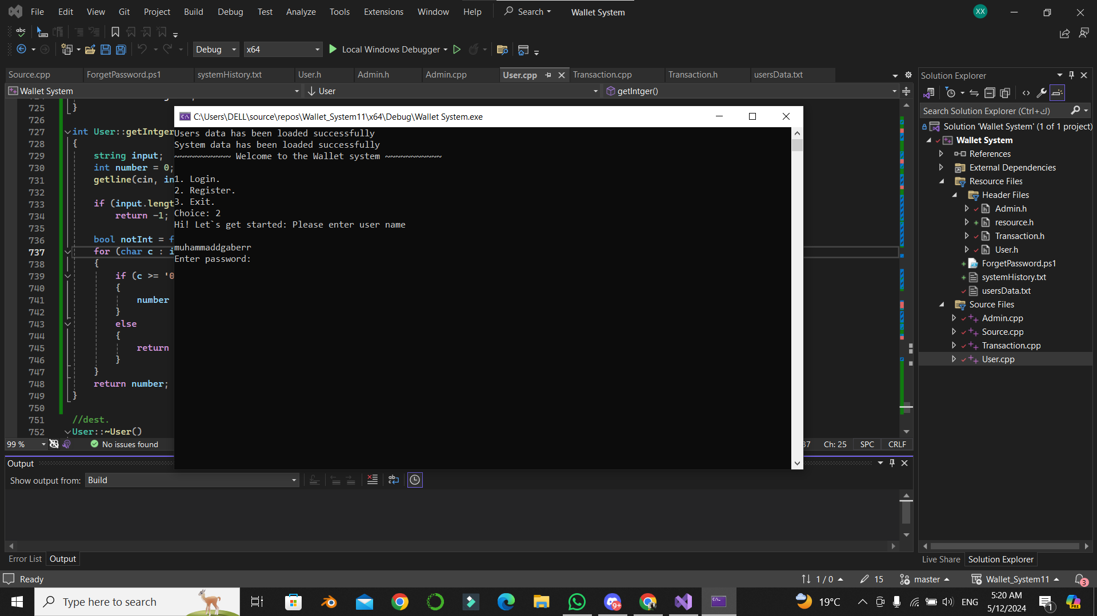Registration process after we input 2 and entered our user name
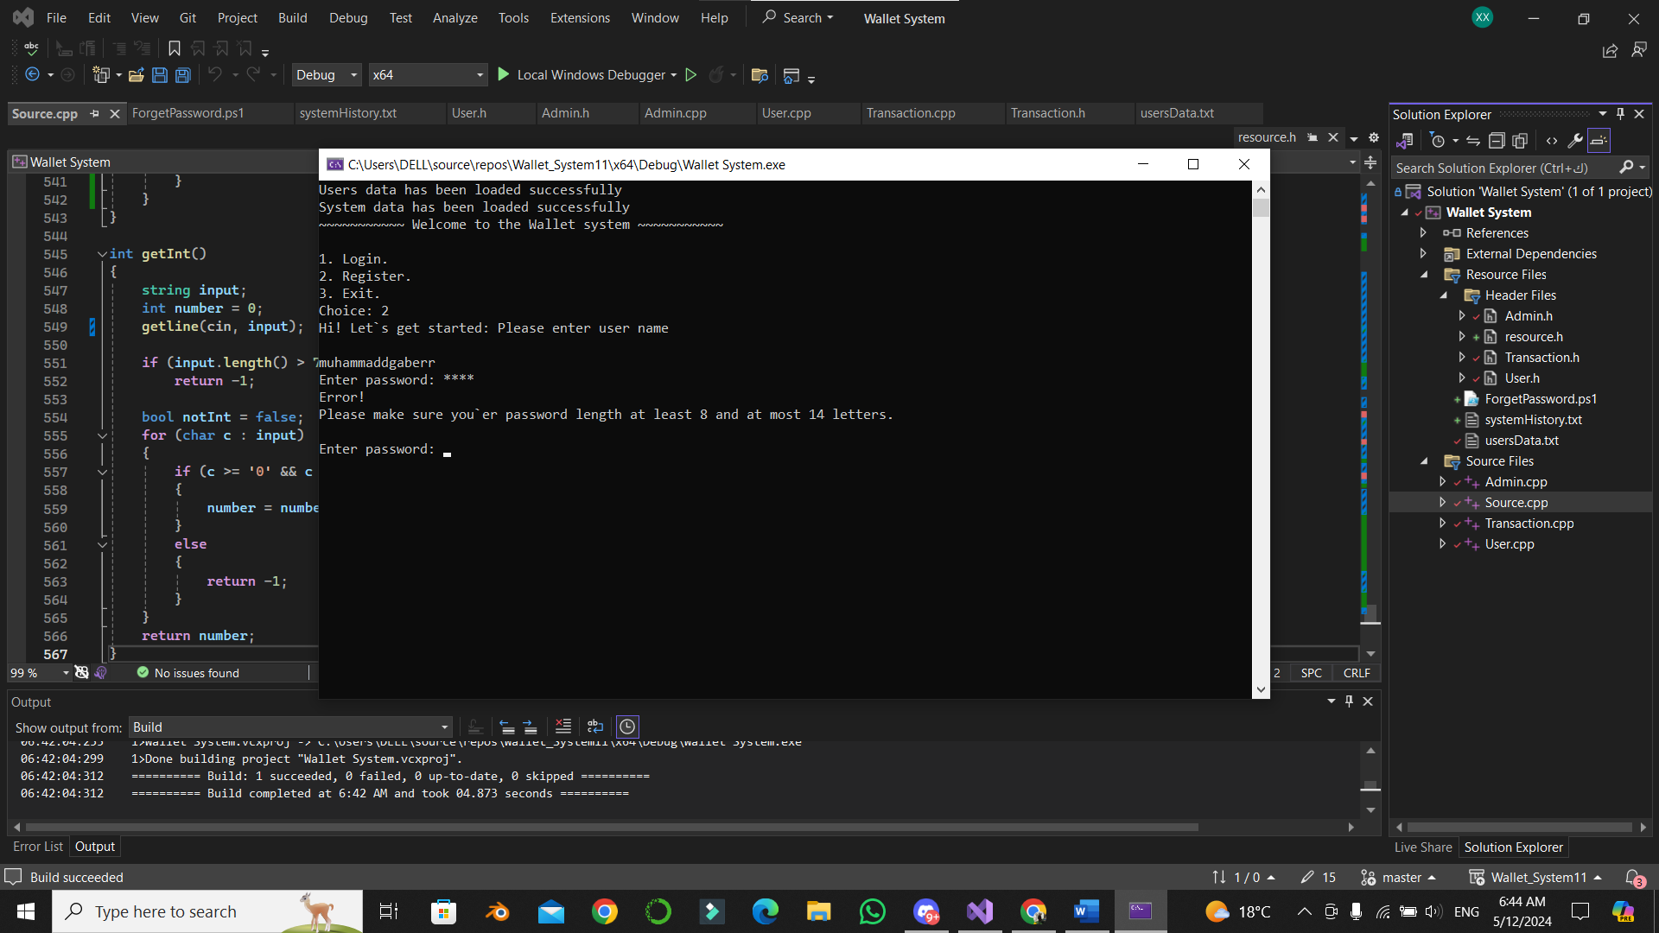
We have to enter a password length at least 8 and at most 14 letters

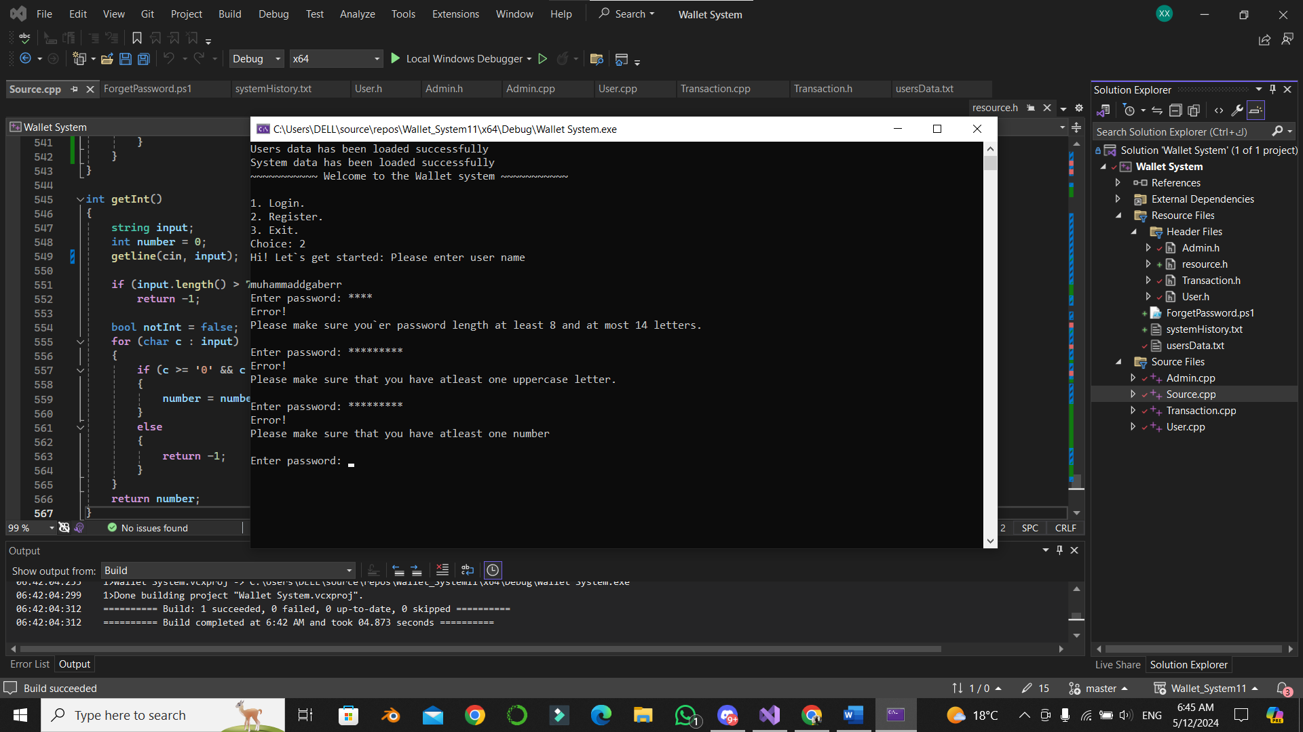
The password should have at least one number
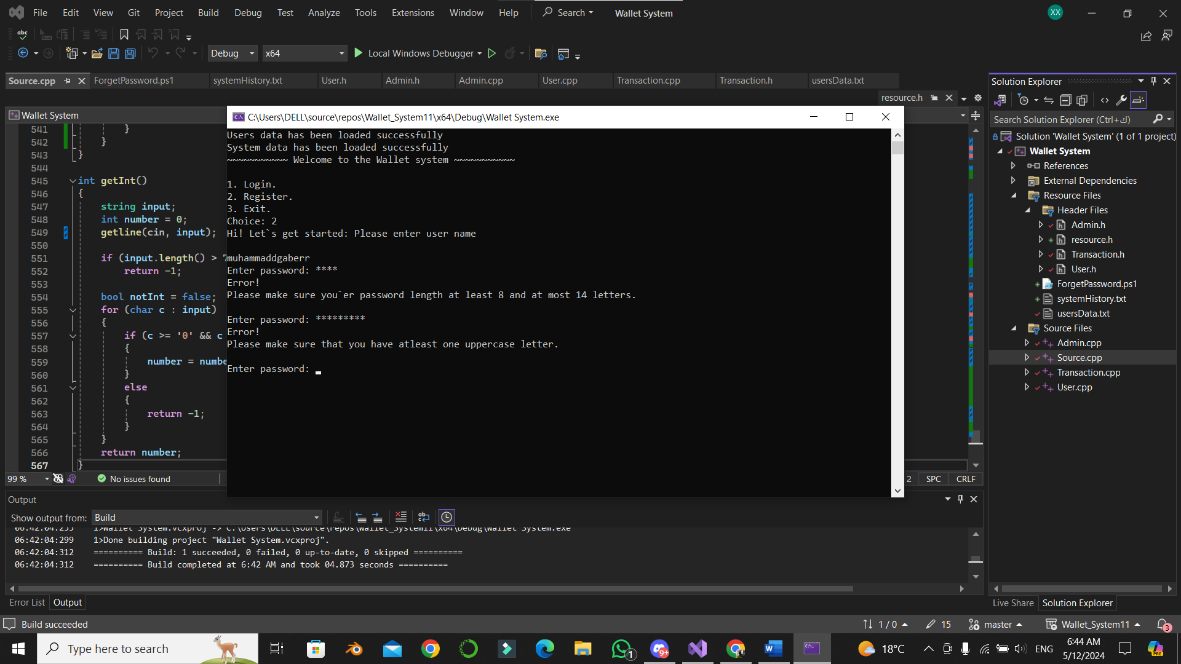
The password should have at least one uppercase letter

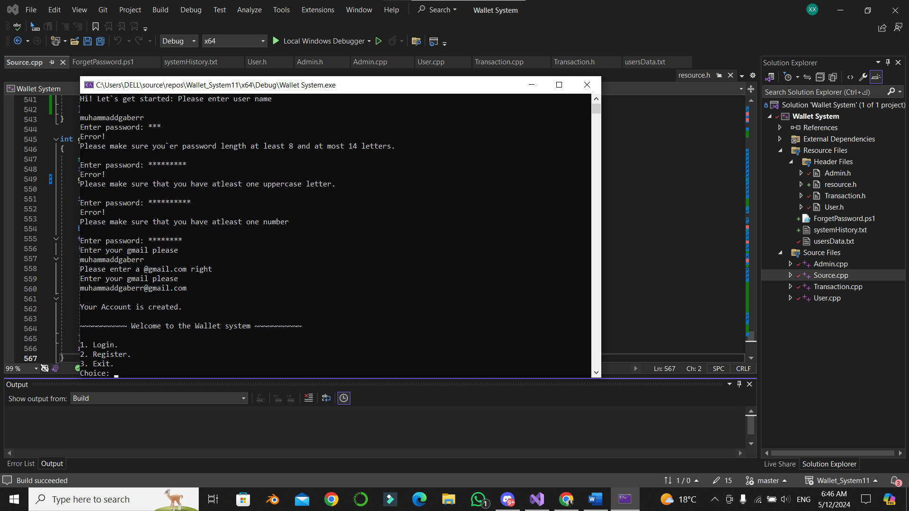
The account created successfully after entering the password and the email …
Let’s try to login
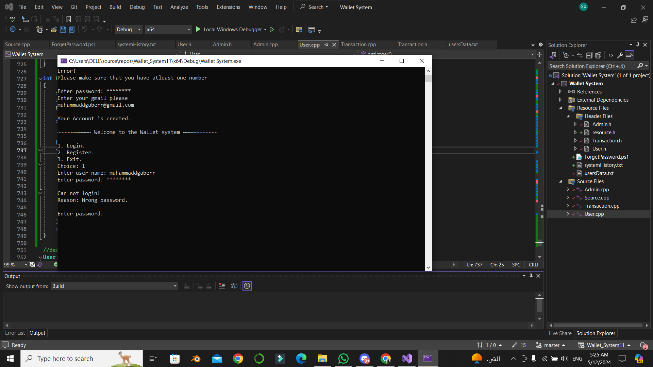
Oops ! Wrong password, Let’s try again
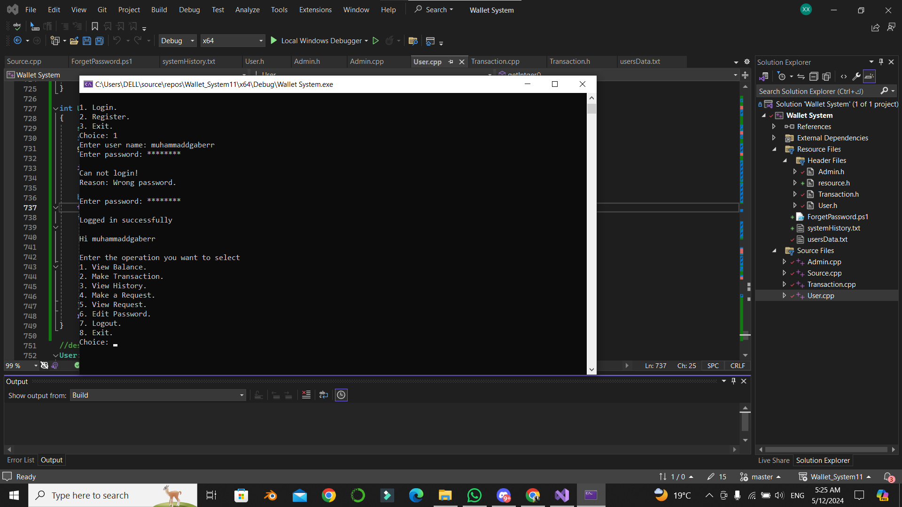
Logged Successfully , Yes !
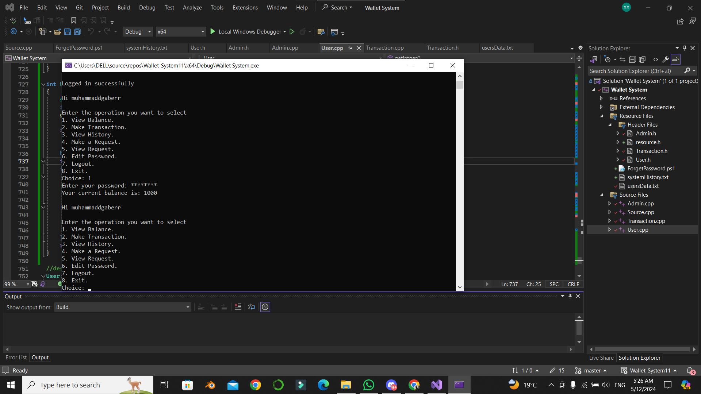
Oh WOW ! Our balance is 1000 , Let us make a Transaction for Yahya

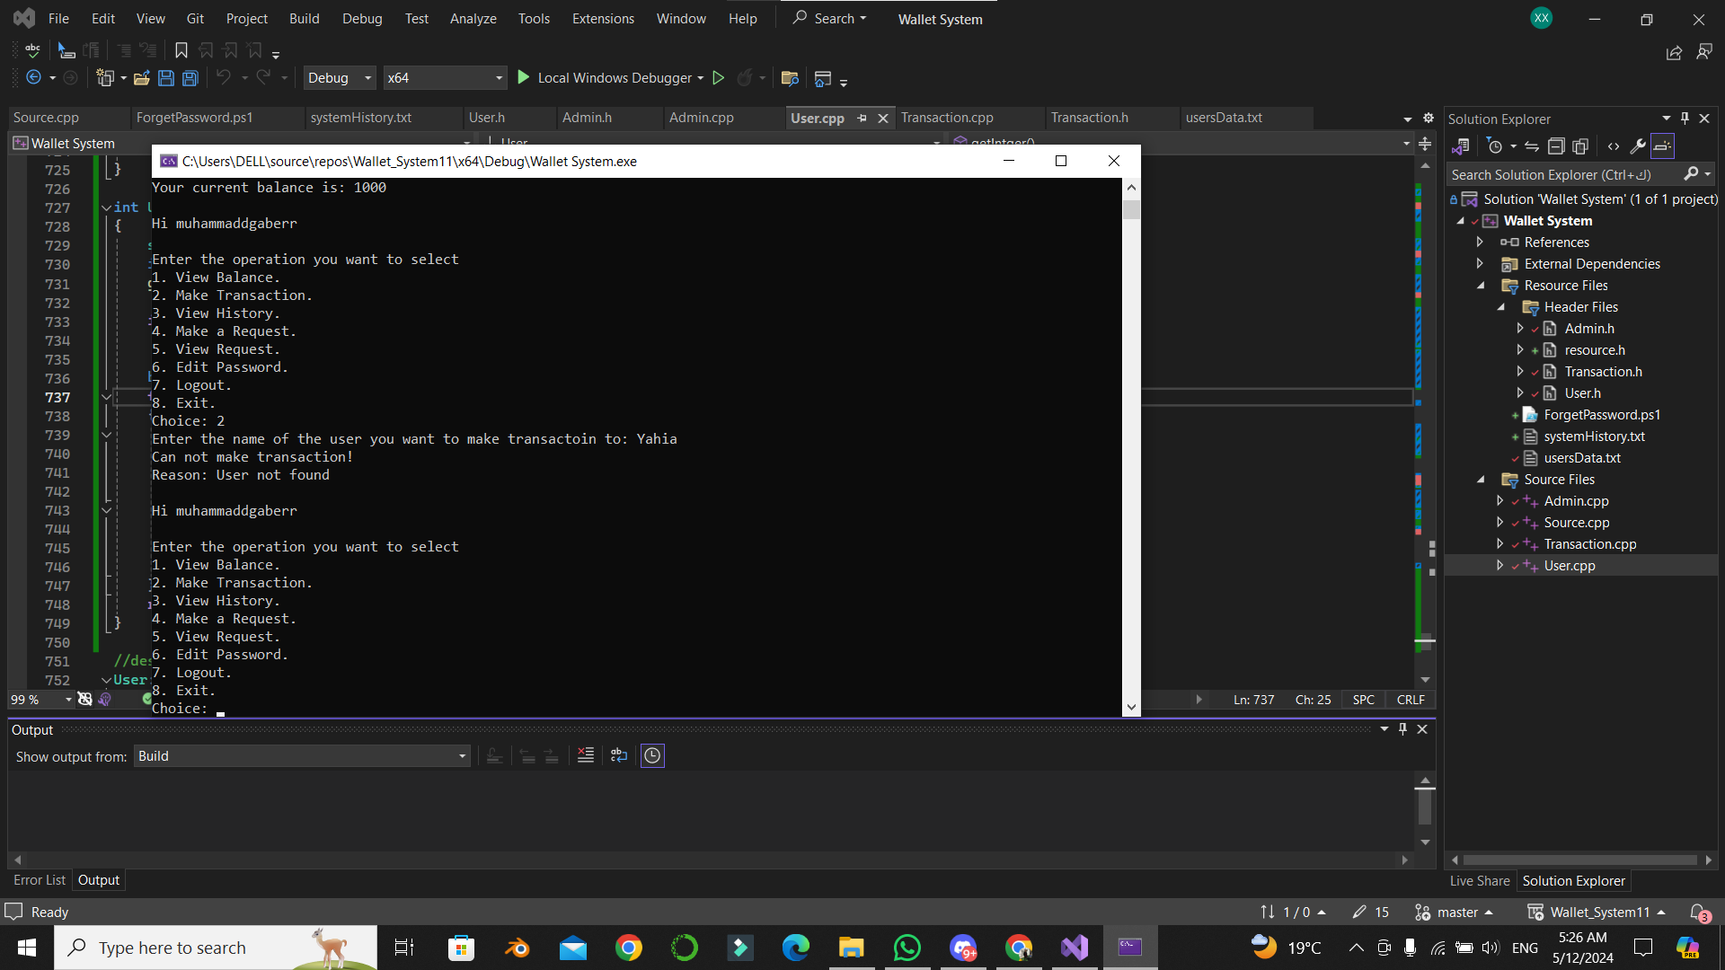
Oh seems like I entered a wrong user name , let us try again
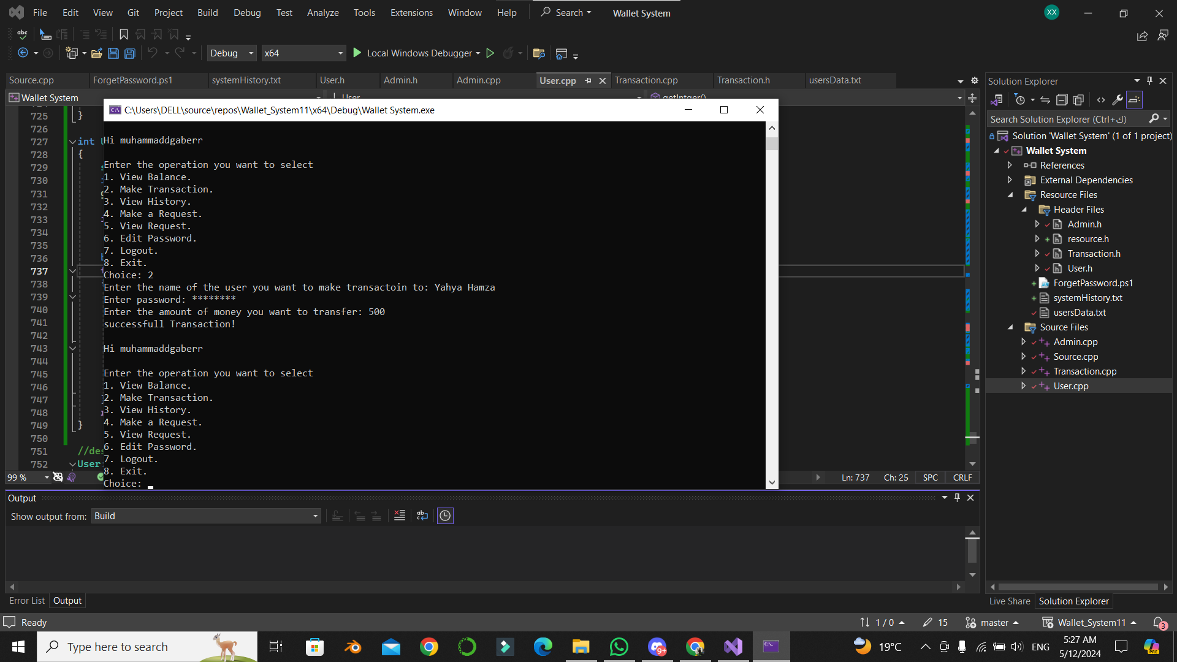
Yees ! Done successfully, let us send another 600
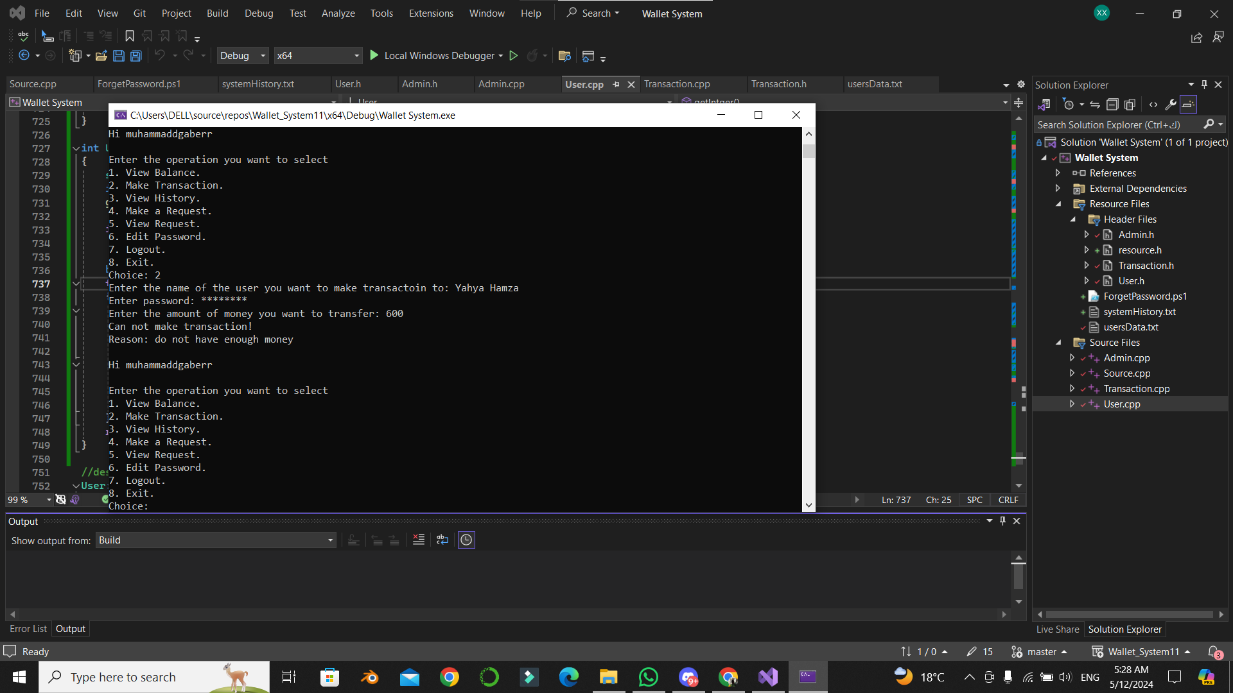
Oh I forgot ! We have only 500 now , let us see our history
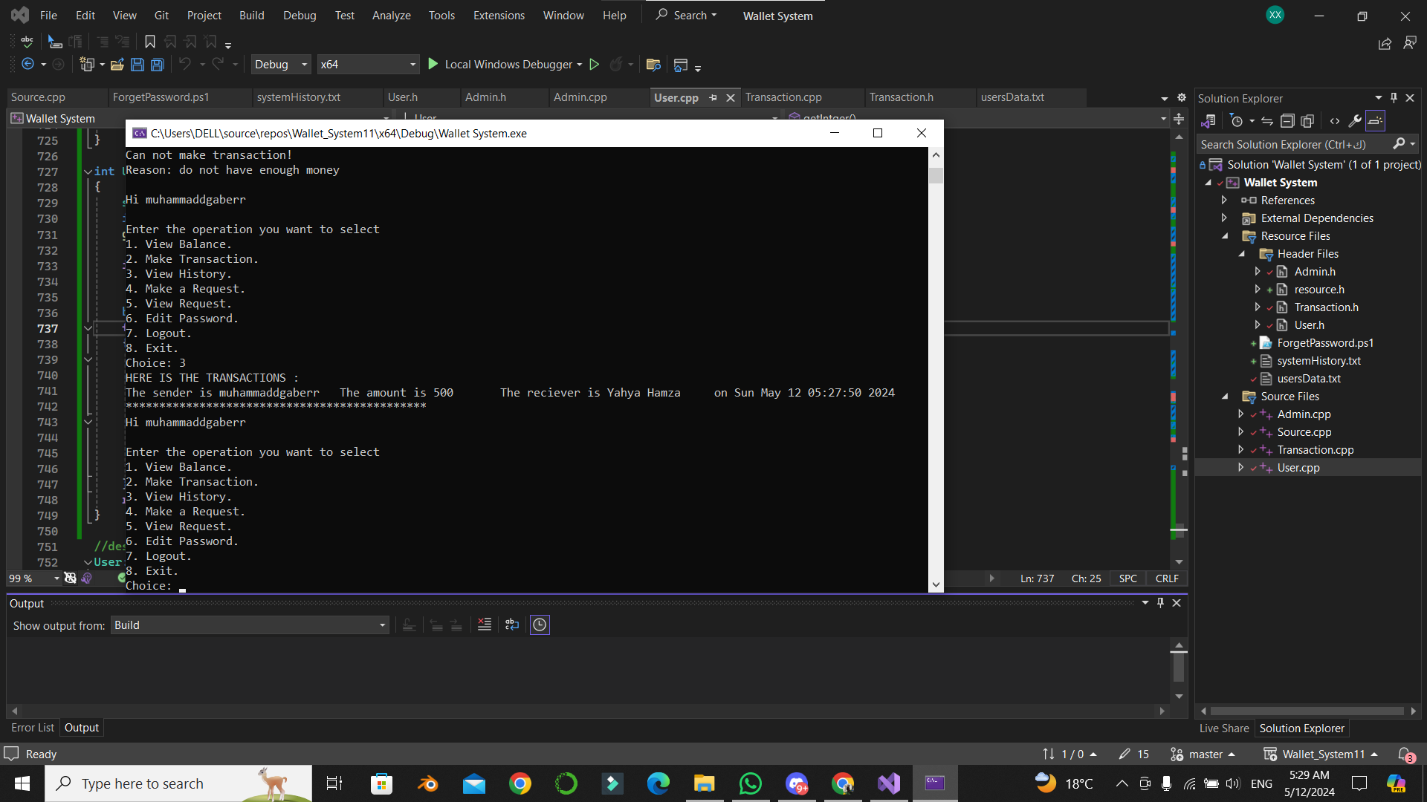
Not too much ,LOL!
I want to change my password, let us make it
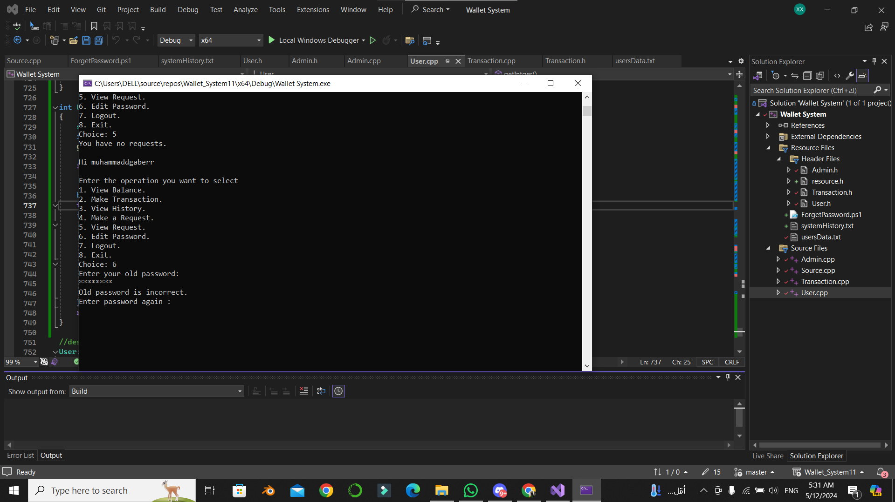
Oops ! Entered the password wrong
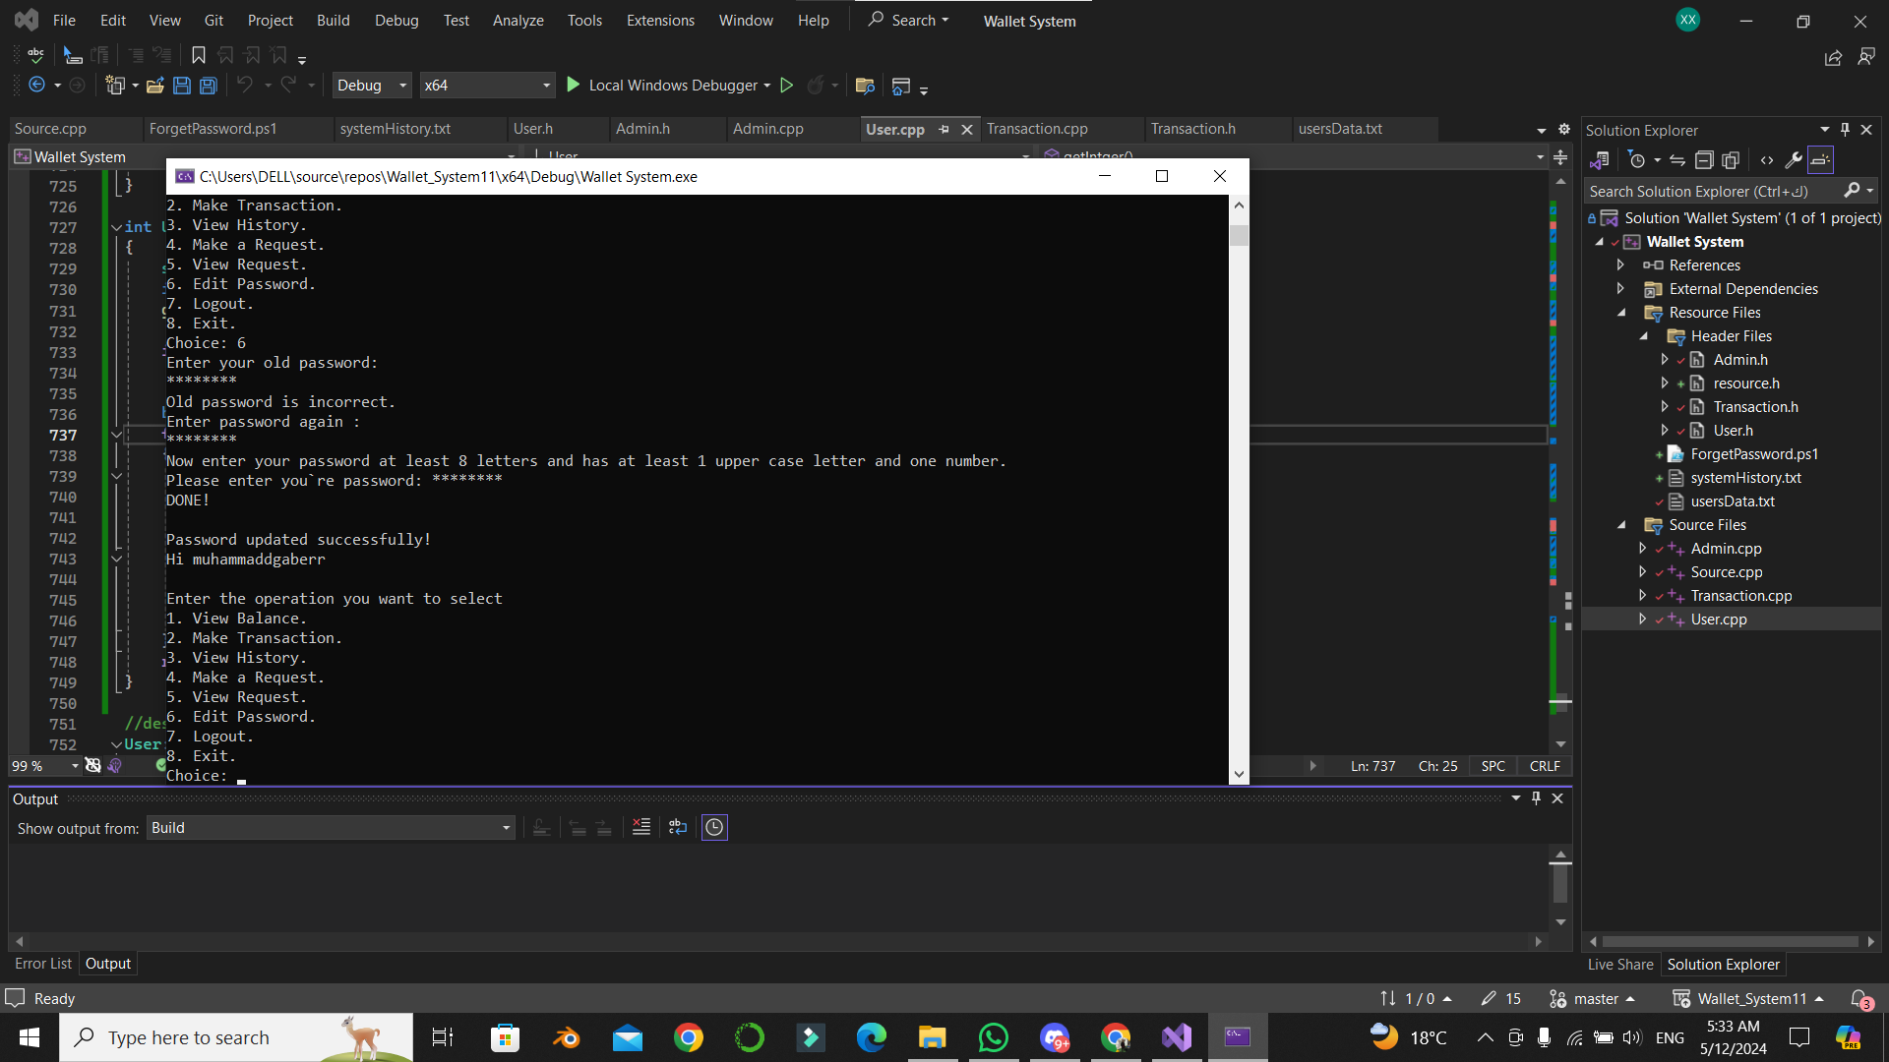
Yaay ! We updated it , don’t tell anyone
Let us logout !

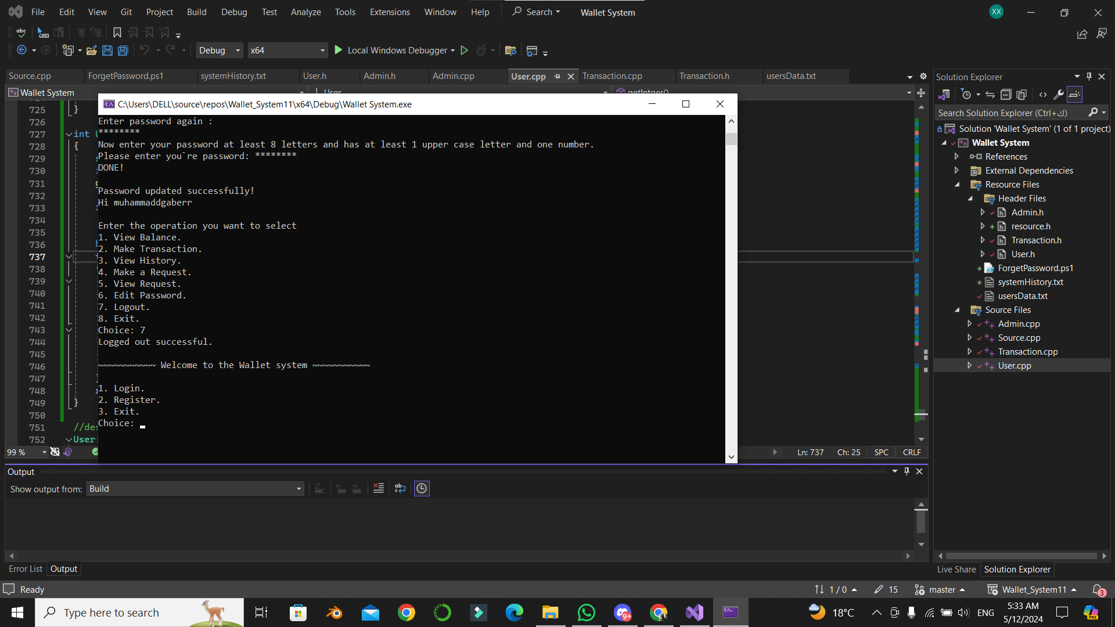
Logged out successfully , Yahya will try to login now to check his history
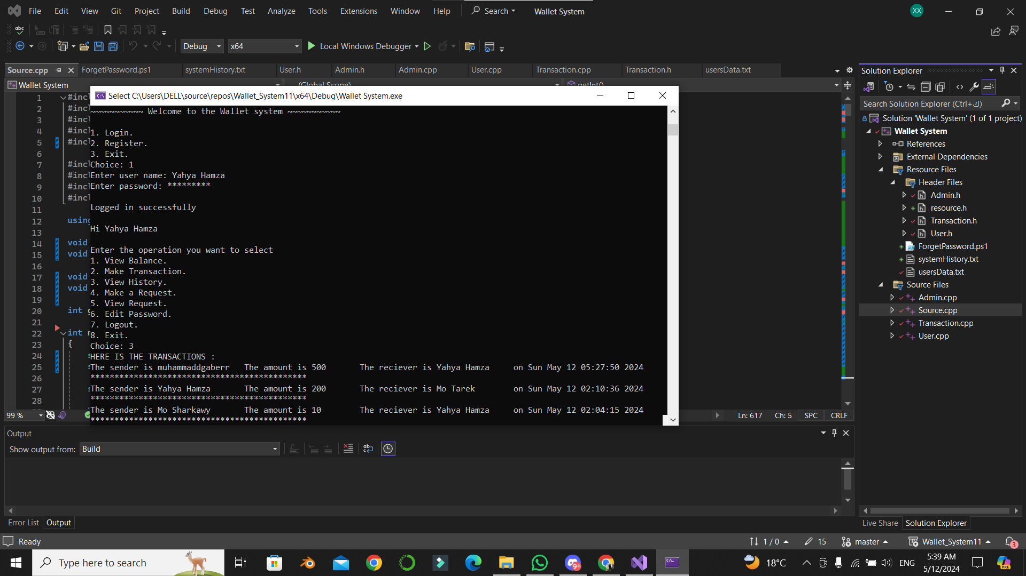
The history seems alright for Yahya also

