Git Bash :

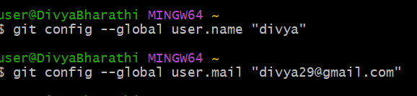

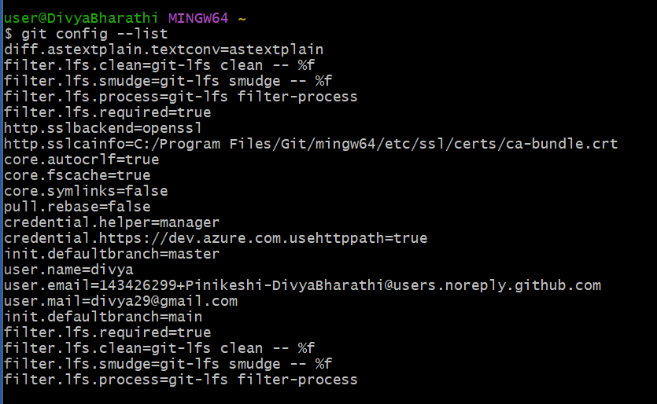

Cloning :

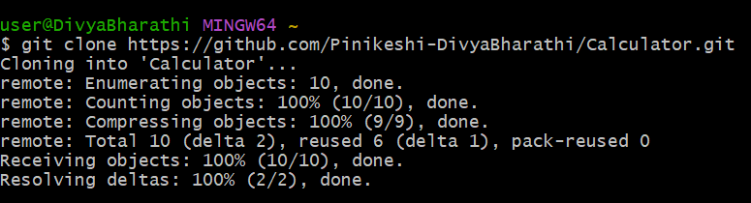

Git init & status :

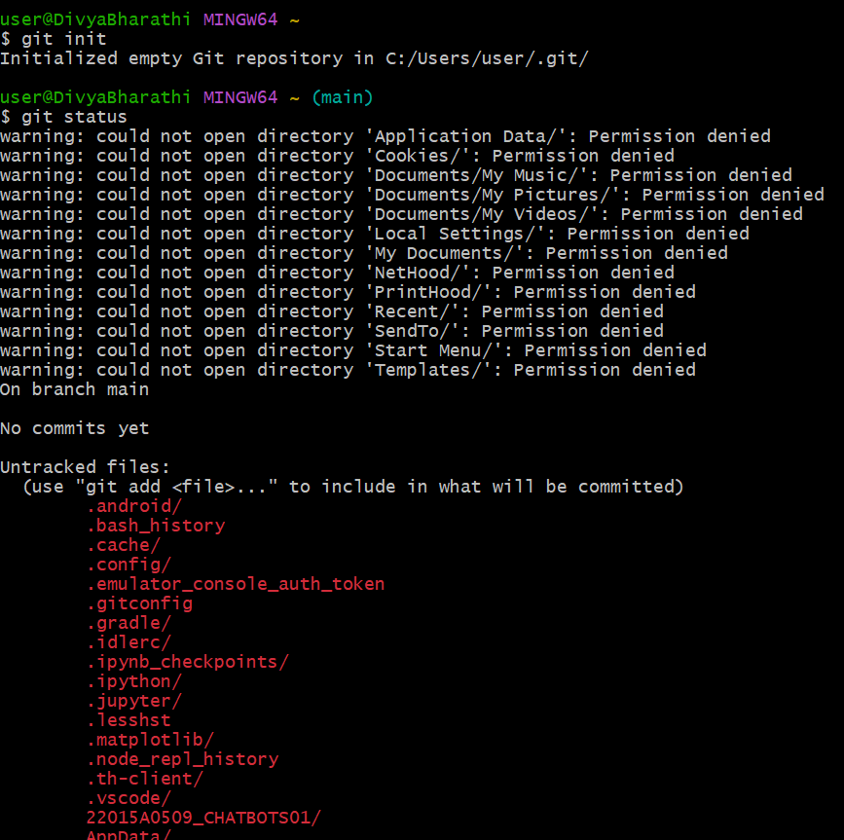

ls : lists all the files

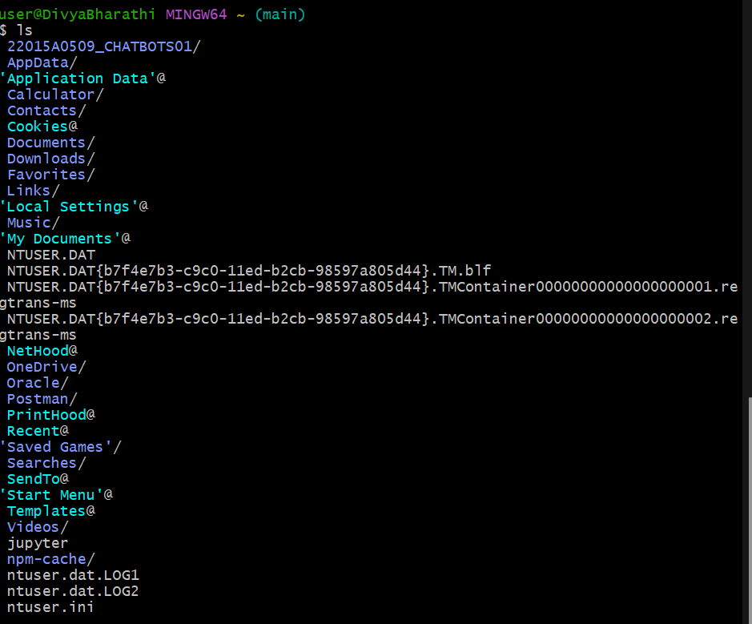

ls -a : hidden files

path change: $ cd /d/3-2/DEVOPS

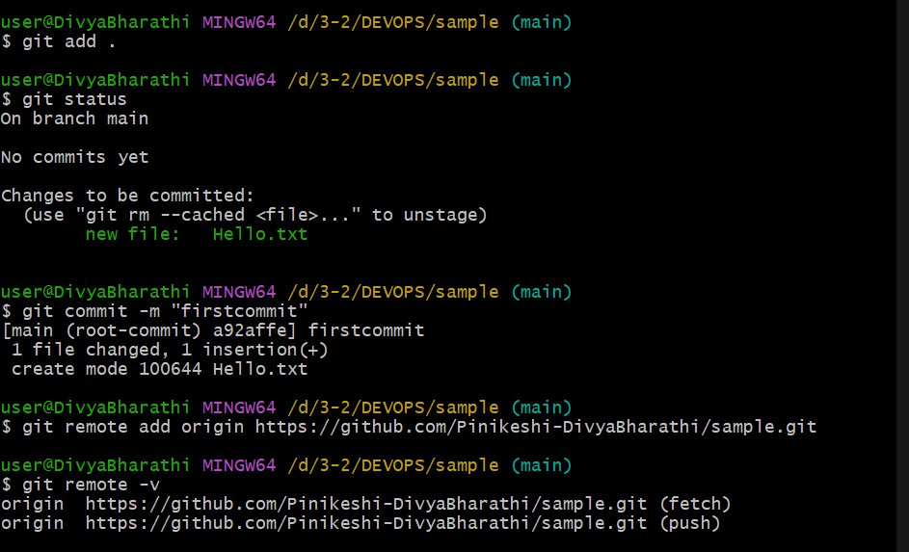

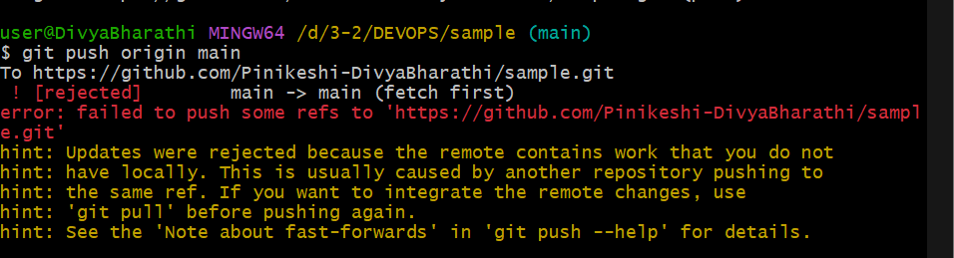

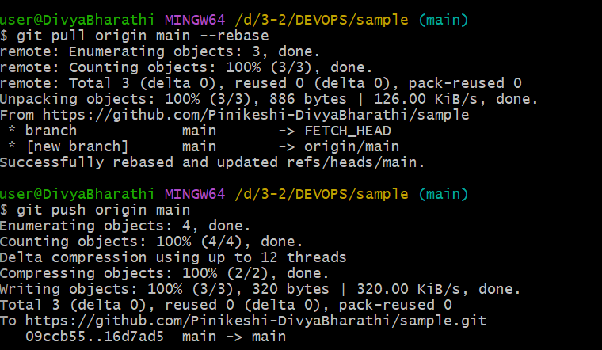

Branch commands :

Current branch output

git branch

* main

__________________________

All remote branches:

git branch -r

________________________-

lists all branches both local and remote

git branch -a

________________________

Create branch :

git branch branchName

_____________________

Switch branch :

git checkout/switch branchName

___________________

Creates a branch and immediately switches to it

git checkout -b <branch-name>

git switch -c <branch-name>

__________________

Rename a current branch

Git branch -m <new branch name>

____________________

Old branch name to new :

Git branch -m <old-branch-name> <new branch name>

_______________________

Delete a branch :

Git branch -d <branch name>

___________________