** Submitted By: Yahya Khan**

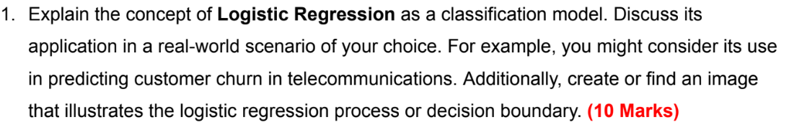

**Logistic Regression as a Classification Model**

Logistic regression is a powerful statistical technique and machine learning algorithm used for classification problems. In simpler terms, it helps predict the likelihood of an event belonging to a particular category based on several independent variables.

**Here's how it works:**

1. **Input**: Features (predictors) representing data points.
2. **Linear** **Model**: It builds a linear equation that combines these features with weights (coefficients).
3. **Sigmoid Function**: This function transforms the linear equation's output to a probability between 0 and 1, representing the likelihood of belonging to a specific class.
4. **Classification**: Based on a chosen threshold (typically 0.5), data points with probabilities above the threshold are assigned to one class, and those below to another.

**Key Points:**

* Works best for binary classification (two classes).
* Interpretable coefficients reveal feature importance.
* Simple to implement and computationally efficient.

**Applications:**

* **Customer churn prediction:** Predicting customers likely to discontinue services, allowing targeted retention efforts.
* Fraud **detection**: Analyzing transactions to identify fraudulent activities based on historical data.
* **Email spam filtering**: Classifying emails as spam or not based on content and sender characteristics.
* **Medical diagnosis**: Predicting the presence of a disease based on symptoms and test results.

**Decision Boundary Visualization:**

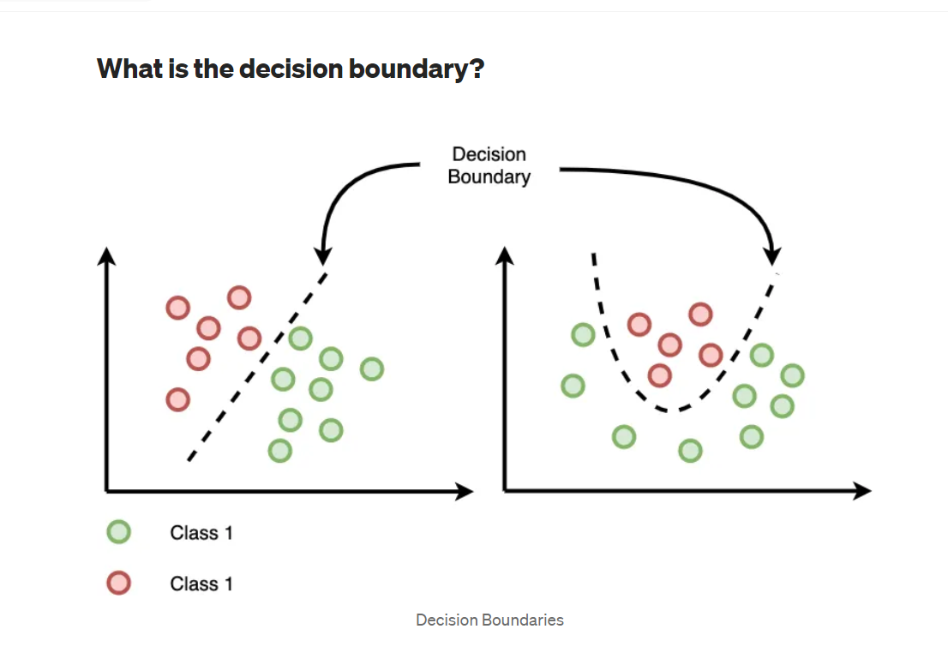

Link of image: <http://tinyurl.com/bwcrbkxz>

**Real-World Example: Customer Churn Prediction**

Imagine a telecommunications company wanting to predict which customers are likely to churn (cancel their service) within the next six months. They have data on various customer features like monthly usage, contract duration, customer service interactions, etc.

**Here's how logistic regression can help:**

1. **Features**: Monthly usage, contract duration, etc., become input features.
2. **Model Training**: The model is trained on historical data with churn labels (churned or not).
3. **Churn Prediction:** For new customers, the model estimates the probability of churn based on their features.
4. **Targeted Retention:** Customers with high churn probability receive personalized offers and incentives to retain them.

**Benefits:**

* Early identification of potential churners allows proactive intervention.
* Efficient marketing campaigns targeting specific customer segments.
* Reduced customer churn and increased customer lifetime value.

**Limitations:**

* May not be suitable for complex non-linear relationships.
* Performance depends on data quality and feature selection.

**Conclusion:**

Logistic regression is a valuable tool for classification tasks, offering interpretability, efficiency, and a wide range of applications. While it has limitations, understanding its concept and applications can empower data-driven decision-making in various domains.

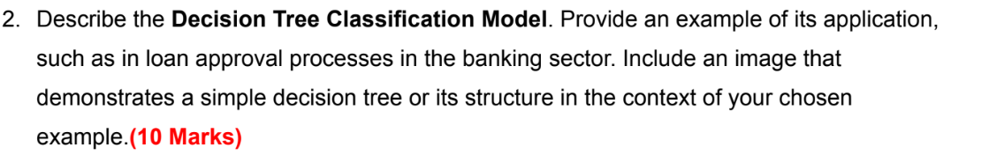

**Decision Tree Classification Model: Making Choices Like a Tree**

Decision Tree Classification is a supervised learning algorithm that makes predictions by asking a series of yes/no questions about the data. Imagine a flowchart where each branch represents a decision based on a feature, leading to a final classification. This intuitive structure makes it easily interpretable and popular for various tasks.

**Key Features:**

* **Tree Structure:** Built from root node (initial question) to leaf nodes (final classifications).
* **Decision Rules:** Each branch represents a rule based on a feature value.
* **Classification:** Data points reach leaf nodes based on their answers to the questions.

**Advantages:**

* **Easy to interpret:** Rules are readily understandable, unlike complex black-box models.
* **Handles various data types:** Works well with numerical and categorical data.
* **Robust to outliers:** Less sensitive to data noise compared to some models.

**Applications:**

* **Fraud detection:** Classifying transactions as fraudulent based on spending patterns, location, etc.
* **Medical diagnosis:** Predicting specific diseases based on symptoms and patient history.
* **Loan approval:** Assessing loan risks based on income, credit score, and other factors.

**Example: Loan Approval**

Imagine a bank uses a decision tree to decide on loan applications. Here's a simplified structure:

Root Node: "Income > $50,000?" applicants proceed to one branch, others to another.

Branches: Each branch asks another question, like "Credit Score > 700?" or "Employment Stable?"

Leaf Nodes: Each leaf represents a final decision: "Approve Loan," "Further Review," or "Deny Loan."

**Benefits:**

* Transparent decision-making based on clear rules.
* Identifies key factors influencing approval decisions.
* Improves model fairness by mitigating bias against certain groups.

**Limitations:**

* Can be sensitive to small changes in data.
* Overfitting risk if trees become too complex.

**Conclusion:**

Decision Tree Classification offers a powerful and interpretable approach to classification tasks. By understanding its structure and applications, you can leverage its strengths in various domains, from loan approval to fraud detection. Remember, while it provides valuable insights, consider its limitations and combine it with other models for comprehensive decision-making.

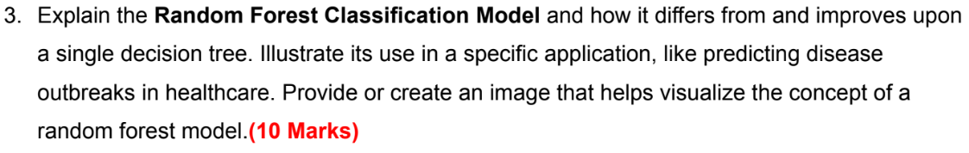

**Random Forest Classification: Wisdom of the Crowd in Predicting the Future**

Random Forest Classification reigns as a powerful ensemble method, harnessing the wisdom of multiple decision trees to outshine their individual limitations. Let's delve into its core, compare it to single decision trees, and explore its real-world impact in predicting disease outbreaks:

**Random Forest:**

* **Imagine a forest:** Not just any forest, but one teeming with multiple decision trees, each trained on different data subsets and random feature selections.
* **Prediction power:** Unlike solo trees, these trees collaborate, making predictions through majority vote (classification) or averaging (regression) their individual insights.

**Visualizing the ensemble:**



**Disease Outbreak Prediction: Harnessing the forest's wisdom**

1. Healthcare authorities tasked with predicting and preventing outbreaks can leverage the power of random forests:
2. Data harvest: Historical outbreak data becomes the training ground, rich with features like location, demographics, travel patterns, and more.
3. Forest growth: Each tree in the forest trains on different data subsets with randomly chosen features, reflecting the real world's diverse scenarios.
4. Predictive power: When a new case arises, each tree independently predicts the likelihood of an outbreak based on its learned patterns.
5. Collective wisdom: The final prediction, based on majority vote among the trees, guides resource allocation and intervention strategies for maximum impact.

**Benefits:**

* Early detection and containment: The forest helps spot potential outbreaks before they spread.
* Resource optimization: Resources are directed towards areas with higher predicted risk.
* Improved public health outcomes: Faster responses lead to better health outcomes for communities.

**Conclusion**:

Random Forest Classification stands as a testament to the power of collaboration. By combining the strengths of multiple decision trees, it overcomes their individual limitations, delivering superior performance in handling complex data, reducing overfitting, and making accurate predictions. While interpretability might be slightly lower, its value in applications like disease outbreak prediction and beyond is undeniable. Remember, the wisdom of the crowd often leads to brighter futures.

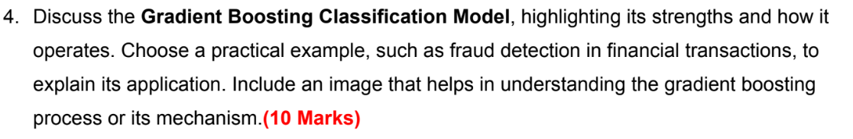

**Gradient** **Boosting for Classification: Boosting Your Fraud Detection Skills**

As a student eager to understand machine learning, let's explore Gradient Boosting Classification! This powerful model combines sequential learning and decision trees to tackle complex problems like fraud detection.

**Concept:**

Imagine boosting your knowledge step-by-step. Gradient boosting works similarly. It starts with a simple model (often a weak decision tree) and iteratively adds new trees, each focusing on correcting the errors made by the previous ones. These trees are learned sequentially, where each subsequent tree focuses on improving the overall model's performance on the most challenging predictions from the previous iteration. This "boosting" approach leads to a powerful ensemble model that outperforms individual trees.

**Strengths:**

* Accuracy: Can achieve high accuracy on complex tasks, making it well-suited for fraud detection.
* Flexibility: Handles both numerical and categorical data, adaptable to various financial transactions.
* Interpretability: Individual trees and their impact on the final prediction can be analyzed.

**Limitations:**

* Computational cost: Training can be computationally expensive due to the sequential nature.
* Tuning complexity: Requires careful tuning of parameters to avoid overfitting.
* Black-box tendencies: While individual trees are interpretable, the overall ensemble can be more opaque.

**Fraud Detection Application:**

Financial transactions generate massive data, and fraudulent activities can hide within. Gradient boosting shines here:

* Data: Transaction details like amount, location, time, and user information are fed into the model.
* Training: The initial weak decision tree identifies basic fraudulent patterns.
* Boosting: Subsequent trees focus on misclassified transactions, refining the detection ability.
* Prediction: New transactions are analyzed, and suspicious ones are flagged for further investigation.

**Benefits:**

* Reduced fraud losses: Early detection and prevention of fraudulent transactions.
* Improved customer experience: Faster and more accurate fraud detection minimizes inconvenience.
* Enhanced security: Adapts to evolving fraud patterns, ensuring continuous protection.

**Conclusion:**

Gradient Boosting Classification stands tall as a versatile tool for tackling complex tasks like fraud detection. Its strengths in accuracy, flexibility, and interpretability make it valuable for financial institutions. However, understanding its limitations and optimizing its training are crucial for successful implementation. Remember, keep learning and boosting your knowledge, just like Gradient Boosting!

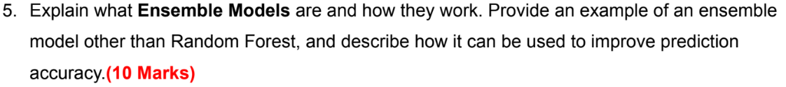

**Ensemble Models: The Strength of Many Over One**

Ensemble models, like a well-coordinated team, combine the predictions of multiple base models to achieve better performance than any single model on its own.

**Essentially, they leverage the "wisdom of the crowd" principle:**

1. Multiple models: Different types of models (e.g., decision trees, linear regression) or variations of the same model are trained on the same data.
2. Independent predictions: Each model makes its own prediction for each data point.
3. Combining predictions: Different methods like voting, averaging, or stacking are used to combine these predictions into a single, final prediction.

* **Advantages of using Ensemble Models:**
* Reduced variance: Averaging out errors from individual models leads to more stable and accurate predictions.
* Improved handling of complex data: Different models can capture different aspects of complex data, resulting in a more robust overall prediction.
* Reduced risk of overfitting: By relying on multiple models, overfitting to specific data patterns is less likely.

**Types of Ensemble Models:**

* Bagging (Bootstrap aggregating): Creates multiple models by training on different random subsets of the data, with voting or averaging for prediction. (e.g., Random Forest)
* Boosting: Builds models sequentially, with each new model focusing on improving the errors of the previous one. (e.g., Gradient Boosting)
* Stacking: Uses a meta-model to learn from the predictions of other models, potentially achieving even better performance.

**Example: XGBoost for Credit Risk Prediction**

XGBoost, a powerful boosting algorithm, can be used to improve credit risk prediction in financial institutions.

* Data: Historical loan data with features like income, credit score, and payment history.
* Base models: Multiple decision trees are trained on different data subsets, focusing on different risk factors.
* Boosting: Each subsequent tree learns from the mistakes of the previous one, gradually improving prediction accuracy.
* Final prediction: XGBoost combines the predictions of all decision trees, providing a more accurate estimation of a borrower's creditworthiness.

**Benefits:**

* More accurate risk assessment: Helps in making better lending decisions, reducing loan defaults.
* Improved financial stability: Mitigates risks associated with bad loans.
* Fairer lending practices: Can help avoid potential bias present in individual models.

**Conclusion**:

Ensemble models offer a powerful approach to improve prediction accuracy and overcome the limitations of individual models. Understanding their working principles and different types opens doors to various applications across diverse fields. Remember, sometimes the key to success lies in working together!



**Activation Functions: The Spark Plugs of Machine Learning**

In the intricate world of machine learning models, activation functions act as the spark plugs, injecting non-linearity and life into the equations. These functions essentially determine how a neuron in an artificial neural network reacts to the weighted sum of its inputs, ultimately influencing the network's final output. Let's delve into their role and explore two key examples:

**The Role:**

Imagine a neural network without activation functions. It would simply perform linear transformations, incapable of learning complex patterns hidden within data. Activation functions introduce non-linearity, breathing life into the network and enabling it to learn intricate relationships between input and output.

**Here's how it works:**

1. Weighted Sum: Neurons receive multiple inputs, each associated with a weight reflecting its importance.
2. Activation Function: This function takes the weighted sum as input and transforms it into a new value, essentially deciding whether the neuron "fires" or not.
3. Output: The transformed value becomes the neuron's output, feeding into other neurons or the final result.

**Common Activation Functions:**

1. Sigmoid: Often used in the output layer for classification tasks. Squeezes values between 0 and 1, representing probabilities. Imagine it as a dimmer switch, gradually turning output on or off.

**Advantages**: Offers interpretability due to its smooth gradient.

**Limitations:** Limited output range might restrict learning ability in deeper networks.

**Applications**: Image recognition, sentiment analysis, spam filtering.

1. ReLU (Rectified Linear Unit): A popular choice for hidden layers due to its computational efficiency. Outputs the input directly if positive, otherwise outputs 0. Think of it as a switch, either fully on or off.

**Advantages**: Faster training due to simpler calculations.

**Limitations**: Can suffer from the "dying ReLU" problem, where some neurons permanently output 0.

**Applications**: Natural language processing, speech recognition, computer vision.

**Conclusion:**

Activation functions play a crucial role in unlocking the power of neural networks. By understanding their purpose and exploring different options like Sigmoid and ReLU, you gain valuable insights into how machine learning models learn and make predictions. Remember, choosing the right activation function can significantly impact your model's performance, so research and experimentation are key!



**Gini Impurity: Deciding Which Way the Tree Grows**

In decision tree algorithms, Gini impurity serves as a crucial measure of impurity, guiding the tree's growth and ultimately influencing its predictive performance. Let's dive into its core and explore how it helps the tree make optimal decisions:

**Imagine a messy room filled with toys:**

* Cleanliness Goal: You want to organize the toys by category (cars, dolls, etc.) to quickly find any toy.
* Decision Steps: You create decision rules (e.g., "put red items to the left, blue to the right").
* In decision trees, each node represents a room, and each split is a decision rule. Gini impurity helps determine the best decision rule by measuring how mixed-up the data is at each node.

**Formula and Interpretation:**

* Gini impurity ranges from 0 (perfectly pure) to 1 (maximally impure).
* It considers the probability of misclassifying a randomly chosen data point if it were labeled based on the majority class at the node.
* A lower Gini impurity indicates a better split, as it results in more homogeneous subsets in the child nodes.

**Example:**

Imagine you have a dataset with "yes" and "no" answers for whether someone likes spicy food.

* Root Node: Gini impurity is 0.5 since both classes have equal probability (2 "yes" and 2 "no").
* Split by Age <= 30:
* Left Node: Gini = 0 (all "yes").
* Right Node: Gini = 0 (all "no").
* Split by Age <= 25:
* Left Node: Gini = 1 (mixed classes).
* Right Node: Gini = 1 (mixed classes).

Based on Gini impurity, the first split (Age <= 30) creates pure child nodes, leading to a better decision tree structure.

**Advantages:**

* Easy to understand and interpret.
* Computationally efficient, making it suitable for large datasets.

**Limitations:**

* Can be sensitive to class imbalance (e.g., if one class has significantly fewer data points).

**Real-world Application:**

Gini impurity is used in various fields, including:

* Fraud detection: Classifying transactions as fraudulent or legitimate.
* Medical diagnosis: Predicting disease presence based on symptoms.
* Customer churn prediction: Identifying customers likely to leave a service.

**Conclusion:**

Gini impurity plays a vital role in decision tree algorithms, guiding the tree's growth towards improved classification accuracy. By understanding its concept and limitations, you can leverage its power in solving various real-world problems. Remember, choosing the right impurity measure depends on your specific data and task, so explore and experiment for optimal results!



**Entropy and Information Gain: Branching Out in Decision Trees**

In the verdant forest of decision tree algorithms, two key concepts guide the growth of each majestic branch: Entropy and Information Gain. Let's explore how these concepts work together to create optimal decision trees for classification tasks:

1. Entropy: Measuring Chaos

Imagine a library with books scattered everywhere. Entropy, in this context, represents the level of disorder or uncertainty within the system. The more haphazardly the books are placed, the higher the entropy.

Similarly, in a decision tree node, entropy reflects how mixed up the different classes (e.g., fiction, non-fiction) are. A perfectly classified node (all fiction or all non-fiction) has zero entropy, meaning no uncertainty about the class. A node with an equal mix of classes has maximum entropy, representing high uncertainty.

**Formula and Interpretation:**

* Entropy depends on the probability of each class.
* Higher probability of a single class results in lower entropy.
* Lower entropy signifies a purer node, which is desirable for a decision tree.

1. Information Gain: Choosing the Wise Split

Now, imagine a librarian arrives and begins organizing the books by genre. This action reduces the entropy (disorder) in the library, making it easier to find any specific book.

Information gain measures how much a specific feature (e.g., book cover color) reduces the entropy (uncertainty) about the class in a decision tree node. The feature that leads to the biggest reduction in entropy is chosen for splitting the node.

**Formula and Interpretation:**

Information gain considers entropy before and after the split.

The feature with the highest information gain brings the most order, guiding the next branching decision.

**Building the Tree:**

1. The algorithm starts with the entire dataset at the root node.
2. It calculates the entropy and information gain for all possible splits based on each feature.
3. The feature with the highest information gain (biggest entropy reduction) is chosen for splitting the node.
4. New child nodes are created based on the split value, and the process repeats for each child node until a stopping criterion is met (e.g., all instances belong to one class or predefined maximum depth).

**Advantages:**

* Easy to understand and interpret.
* Computationally efficient.
* Helps build decision trees that capture important relationships in the data.

**Limitations:**

* Sensitive to class imbalance (if one class has significantly fewer data points).
* May not find the optimal split in complex datasets.

**Beyond Decision Trees:**

These concepts find applications in various domains, including:

* Machine learning: Feature selection in diverse algorithms.
* Data compression: Encoding information efficiently.
* Information theory: Quantifying information content and uncertainty.

**Conclusion:**

Entropy and information gain act as invisible gardeners, meticulously shaping the branches of decision trees. By understanding these concepts, you gain valuable insights into how decision trees learn and make decisions, unlocking their potential for various tasks. Remember, these are just two tools in the machine learning toolbox, and exploring other techniques will broaden your knowledge further.



**Sampling with Replacement: Drawing Marbles with a Twist**

In the realm of statistics and machine learning, sampling with replacement holds a unique significance. Unlike the usual "no peeking back" rule, here, when you draw a marble (data point) from a bag (dataset), you put it right back in before drawing the next one! Let's delve into this unusual process:

**Concept:**

Imagine a bag filled with colored marbles representing your dataset. In traditional sampling, drawing a marble (data point) means removing it from the bag, making subsequent draws less likely to pick the same color again. Sampling with replacement throws this rule out the window. Every time you draw a marble, you put it back, ensuring equal probability for each marble (data point) to be chosen in every draw.

**Importance:**

* Boosts data richness: By allowing repeats, it creates larger and more diverse virtual datasets compared to traditional sampling.
* Combats under-representation: Rare cases or minority groups have a higher chance of appearing, helping address potential biases in the original data.
* Enables powerful techniques: Serves as the foundation for statistical methods like bootstrapping, crucial for assessing model performance and accuracy.

**Scenario: Bootstrap Your Way to Success (or at least avoid failure!)**

Suppose you're training a machine learning model for predicting customer churn (leaving a service). Your initial dataset might not be very large, and potentially biased towards specific customer segments. Here's where sampling with replacement shines:

* Bootstrap: You create multiple virtual datasets by repeatedly drawing samples (with replacement) from your original data.
* Train multiple models: Each virtual dataset is used to train a separate model, capturing different aspects of the original data.
* Ensemble: You combine the predictions from all the models, leading to a more robust and generalizable final prediction.

**Benefits:**

* Improved accuracy: Ensembles often outperform individual models by capturing diverse perspectives.
* Reduced bias: Helps overcome under-representation of certain groups in the original data.
* Error estimation: Bootstrapping allows you to estimate the confidence intervals for your model's predictions, revealing its reliability.

**Limitations:**

* Computational cost: Creating and training multiple models can be resource-intensive.
* Overfitting risk: Requires careful tuning to avoid overfitting to the specific "inflated" virtual datasets.

**Beyond Bootstrapping:**

Sampling with replacement finds applications in other areas:

* Monte Carlo simulations: Estimating outcomes of complex probabilistic systems.
* Randomized data augmentation: Artificially increasing data size by creating variations of existing data points.
* Importance sampling: Efficiently estimating rare events in large datasets.

**Conclusion:**

Sampling with replacement offers a unique tool for data scientists. By understanding its importance and limitations, you can leverage its power to boost model performance, combat bias, and gain deeper insights from your data. Remember, just like drawing marbles, sometimes shaking things up leads to unexpected and valuable discoveries!



**Grading Your Classifier: Exploring Diverse Evaluation Metrics**

In the land of machine learning, evaluating your classification model's performance isn't just about a thumbs-up or thumbs-down. Different metrics, like diverse tools in a carpenter's toolbox, serve distinct purposes. Let's explore some key metrics and the scenarios where they shine:

1. Accuracy: The All-Rounder

* Concept: The simple yet powerful percentage of correct predictions across all instances.
* Example: A spam filter, where catching most spam emails while minimizing false positives is crucial.
* Pros: Easy to understand, universally applicable.
* Cons: Ignores class imbalance, can be misleading when classes are skewed.

1. Precision: The Sniper

* Concept: The proportion of positive predictions that are truly positive (avoiding false positives).
* Example: A medical diagnosis system where accurately identifying true disease cases outweighs flagging healthy individuals as sick.
* Pros: Useful for imbalanced datasets, focuses on true positives.
* Cons: Can be misleading if there are very few positive cases.

1. Recall: The Detective

* Concept: The proportion of actual positive cases that are correctly identified (avoiding false negatives).
* Example: Fraud detection, where missing even a few fraudulent transactions can have significant consequences.
* Pros: Useful for imbalanced datasets, focuses on not missing true positives.
* Cons: Can be misleading if there are many false positives.

1. F1-score: The Diplomat

* Concept: Harmonic mean of precision and recall, offering a balanced view of both true positives and avoiding false positives/negatives.
* Example: When both precision and recall are equally important, such as sentiment analysis where accurately identifying both positive and negative reviews is crucial.
* Pros: Considers both precision and recall, useful for imbalanced datasets.
* Cons: Can be less intuitive than individual metrics.

1. AUC-ROC (Area Under the Receiver Operating Characteristic curve): The Curve Whisperer

* Concept: Summarizes the model's performance across all possible classification thresholds, considering the trade-off between true positives and false positives.
* Example: When the cost of false positives and false negatives varies depending on the context, such as in loan approval where rejecting a good applicant has different consequences than approving a bad one.
* Pros: Class-independent, robust to imbalanced datasets, considers various classification thresholds.
* Cons: May not be suitable for all tasks, doesn't directly reflect precision or recall.

1. Confusion Matrix: The Truth Teller

* Concept: A table visualizing the actual vs. predicted class labels, revealing true positives, false positives, true negatives, and false negatives.
* Example: Any classification task where understanding the different types of errors is crucial for debugging and improvement.
* Pros: Visually insightful, helps identify specific error types.
* Cons: Less interpretable for large datasets with many classes.

**Choosing the Right Tool:**

Remember, there's no one-size-fits-all metric. Consider your specific problem:

* Data balance: Are the classes evenly distributed?
* Cost of errors: Are certain types of errors more costly?
* Interpretability: Do you need to understand the breakdown of errors?

By understanding these diverse metrics and their strengths, you can effectively evaluate your classification model, ensuring it performs optimally in your unique application!