HIGH AVAILABILITY AND INDUSTRY 4.0 FOCUSED GLOBAL ENTERPRISE NETWORK DESIGN AND SIMULATION
Yahya Ozden


1. INTRODUCTION AND PROJECT SCOPE
1.1. Company Profile and Operational Structure
This project is designed for a multinational Technology and Industrial Manufacturing Company headquartered in Ankara, operating across three different continents.
Due to its corporate structure, the company manages both intensive data flow in the office environment and industrial automation in the production field under the same roof.
The geographical and operational distribution of the organization is as follows:
- Ankara (Central Campus / HQ): The administrative center where strategic decisions are made, and all data is collected and managed.
- New York (Finance and Software Base): A critical branch integrated into global financial markets, conducting operations requiring high bandwidth and zero latency (low-latency).
- Amsterdam (European Regional Office): The administrative branch housing sales, marketing, and legal departments, coordinating European operations.
- Tokat (Smart Manufacturing Facility): A factory producing at Industry 4.0 standards, containing autonomous machines and sensors (IoT) that minimize human intervention.
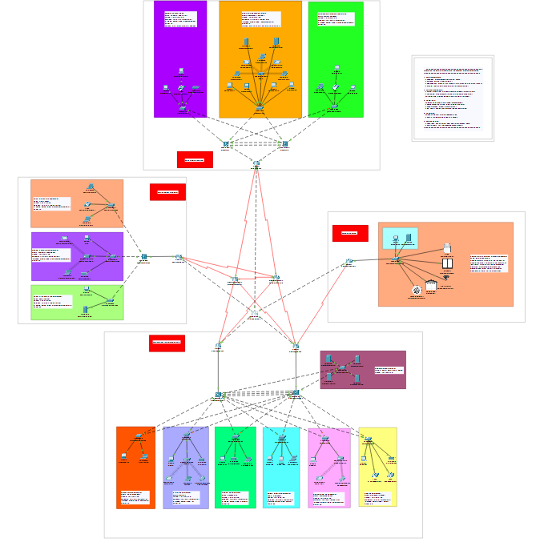

2. NETWORK TOPOLOGY AND PROJECT ARCHITECTURE
In the design phase of the project, the three-layer (Core, Distribution, Access) hierarchical model recommended by Cisco was taken as a basis. However, this model was optimized according to the scale of the branches, and a hybrid structure was created.
A Simplified Logical View, free from physical cabling complexity and showing data flow and main connections, is presented below:
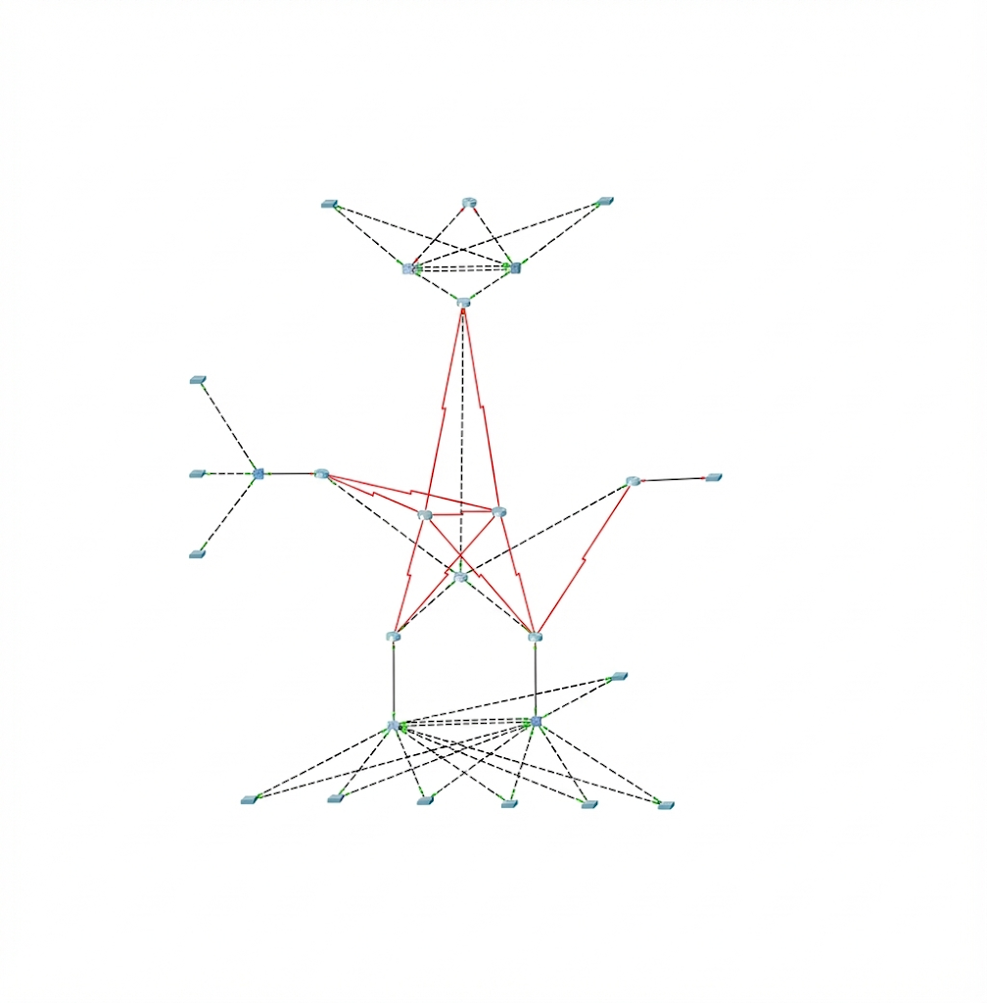
[Figure 2.1: Logical Overview of the Enterprise Network]
Thanks to this structure, the failure of a single device or line does not stop the entire system (there is no Single Point of Failure). The architectural details and topological features of each location are explained below.

2.1. Ankara Headquarters (HQ) and Data Center Architecture
The Ankara location is the management center of the project, the main backbone where all critical services (Web, Mail, DNS) are hosted and departments are managed.
2.1.1. Logical Segmentation and VLAN Structure To optimize network traffic, ensure security, and isolate departments, the Ankara local area network (LAN) is divided into 6 main virtual networks (VLANs). In the topology map below, the physical and logical separation of departments is shown with color codes.
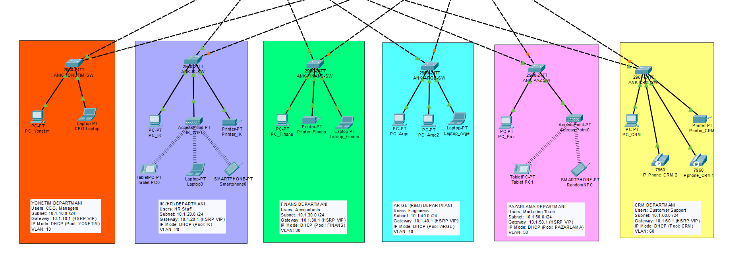
[Figure 2.1.1: Ankara Branch Department and VLAN Segmentation Map]

A separate DHCP Pool has been created for each department, and devices (PC, Phone, Tablet) automatically receive IPs when connected to the network. For uninterrupted access, HSRP (Hot Standby Router Protocol) is used, and a virtual gateway IP (Virtual Gateway IP) is defined for each VLAN.
Color Code | Department | VLAN ID | IP Block (Subnet) | Gateway (HSRP VIP) | User Profile
Orange | MANAGEMENT | 10 | 10.1.10.0 /24 | 10.1.10.1 | CEO, Managers
Purple | HR | 20 | 10.1.20.0 /24 | 10.1.20.1 | Human Resources
Green | FINANCE | 30 | 10.1.30.0 /24 | 10.1.30.1 | Accounting, Finance
Blue | R&D | 40 | 10.1.40.0 /24 | 10.1.40.1 | Engineers
Pink | MARKETING | 50 | 10.1.50.0 /24 | 10.1.50.1 | Marketing Team
Yellow | CRM | 60 | 10.1.60.0 /24 | 10.1.60.1 | Customer Services

2.1.2. Central Services and Server Tests The servers (Server Farm) sustaining the company's digital operations are located in the Ankara data center. Access to these services from all branches has been tested below.
A) Corporate Web Server (HTTP and DNS Resolution Test) A Web Server hosted in the Ankara Data Center (Server Farm) has been commissioned to manage internal information sharing and corporate announcements. To verify the Client-Server architecture, access tests were performed from client computers in different VLANs and locations (e.g., New York or Tokat branch).
The test process covers the following steps:
- DNS Resolution: The client queried the domain name www.ozden.com, and the DNS server successfully resolved this name to the local IP address of the relevant server.
- HTTP Request: The client performed a handshake with the Web Server over TCP port 80 and requested the web page.
- Result: The web server successfully responded to the client, displaying the intranet interface in the browser.
This proves that TCP/IP routing and the DNS service are working healthily across the network.
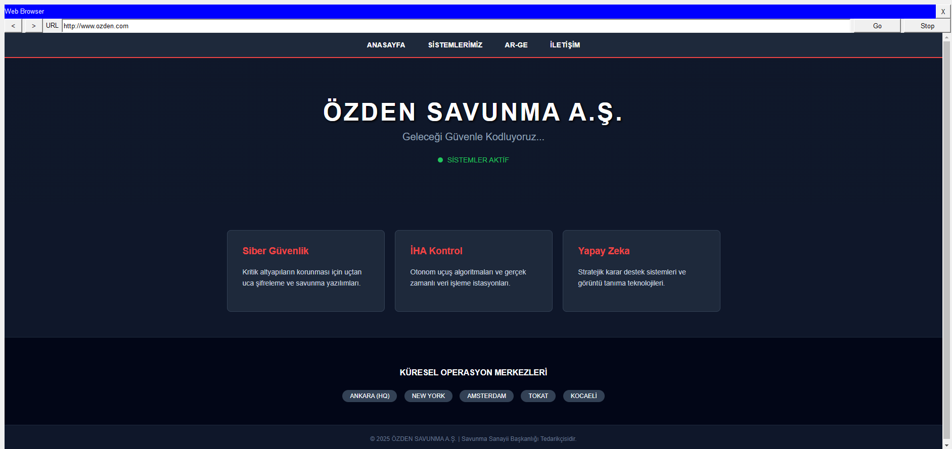
[Figure 2.1.2: Access Test to Intranet Web Page]

B) Corporate E-Mail Server (SMTP/POP3 Test) The Mail Server established for inter-departmental communication is active. In the test below, it is seen that the test mail sent from the CEO account in the Management department to the Accounting officer in the Finance department was successfully delivered.
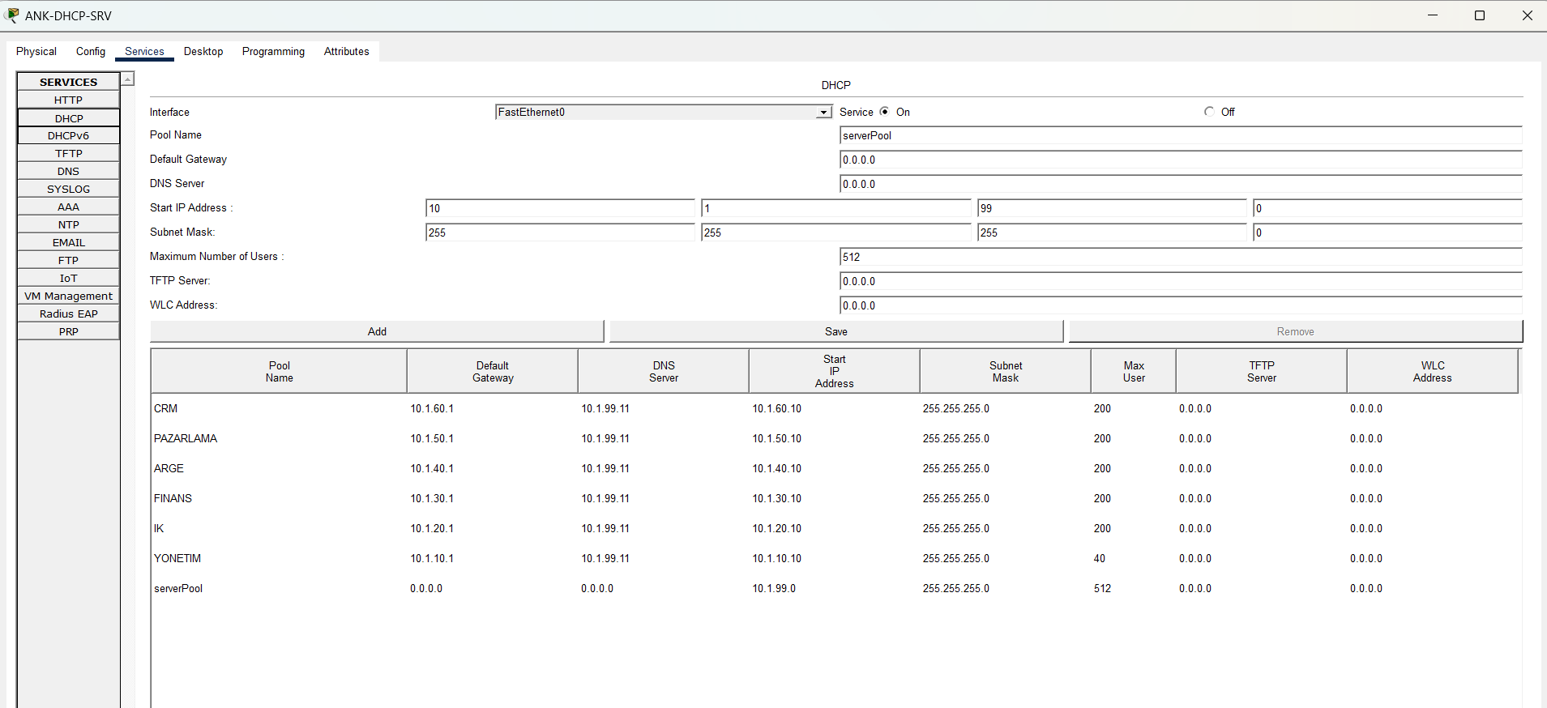
[Figure 2.1.3: Successful Inter-Departmental E-Mail Communication]
C) Automatic IP Distribution and Management (DHCP Service Test) A Central DHCP (Dynamic Host Configuration Protocol) Server has been configured to eliminate manual errors and automate the IP address management of hundreds of end-user devices (PCs, IP Phones, Tablets) across the corporate network. The DHCP Server located within the Ankara Server Farm manages the IP pools (Scopes) defined for different VLANs. Thanks to the ip helper-address commands configured on network devices (Router/L3 Switch), DHCP requests (Discover packets) from clients in different broadcast domains are successfully forwarded to the server.
In the test below, it is verified that a client newly connected to the network received the "DHCP Request Successful" message and automatically obtained:
- The assigned IP address, Subnet Mask, Default Gateway, and DNS server address.
[Figure : Client Device Successfully Receiving IP Address from DHCP Server]
2.1.3. Redundancy Test (HSRP Verification) To prove that the Ankara LAN infrastructure operates uninterruptedly, the HSRP status on the Core Switch was checked. The output below shows that the ANK-CORE-SW1 device is in Active mode, while the ANK-CORE-SW2 device is ready in Standby mode.
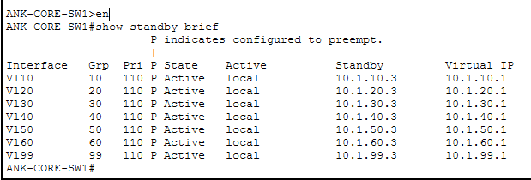

2.1.4. Ankara Central Core and Edge Redundancy Structure In the Ankara Head Office, which manages all internet output and inter-branch (WAN) traffic of the company, a Dual-Homing architecture has been applied to eliminate "Single Point of Failure."
As seen in the figure:
- Edge Layer: Instead of a single router at the gateway to the outside world, two Cisco ISR4321 Routers, ANK-EDGE-R1 and ANK-EDGE-R2, are used.
- Core Layer: For load balancing and continuity in internal network distribution, two Layer 3 Switches, ANK-CORE-SW1 and ANK-CORE-SW2, are positioned.
- Connection Strategy: Cross-connections are established between Core switches and Edge routers so that even if one of the devices shuts down completely, traffic continues to flow through the alternative path (Redundant Path).

2.2. New York Branch: High-Performance Backbone (Collapsed Core)
Since the New York location conducts the company's finance and stock exchange operations, "speed" and "bandwidth" are prioritized here. Therefore, instead of the classic Router-based design, Layer 3 Switching (Cisco 3650) architecture, which maximizes data transmission speed, was preferred.
2.2.1. Collapsed Core Architecture Instead of the traditional three-layer structure, the "Collapsed Core" model was applied by combining the Core and Distribution layers.
Color Code | Department | VLAN ID | IP Block (Subnet) | Gateway IP | User Profile and Notes
Purple | LEGAL | 10 | 10.10.10.0 /24 | 10.10.10.1 | Lawyers and Legal Staff
Orange | SOFTWARE (DEV) | 20 | 10.10.20.0 /24 | 10.10.20.1 | Developers, DevOps. Local Servers: GIT (10.10.20.100), DB (10.10.20.101)
Green | MARKETING | 30 | 10.10.30.0 /24 | 10.10.30.1 | Marketing Team

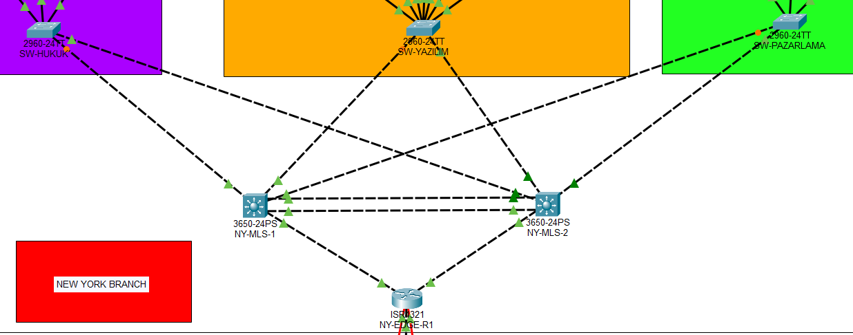 [Figure 2.2.1: New York Branch L3 Switch and EtherChannel Connection Diagram]
- L3 Routing: Inter-VLAN Routing is performed on Cisco 3650 Multilayer Switches (NY-MLS-1 and NY-MLS-2), which have much faster packet processing capacity than routers.
- Advantage: Router bottlenecks are eliminated, and local network traffic is processed at Gigabit speeds.
2.2.2. EtherChannel (LACP) and Bandwidth Increase In Figure 2.2.1, it is seen that the connections between Core Switches are "dual cables." Here, physical ports are combined under a single logical line (Port-Channel) using Link Aggregation Control Protocol (LACP).
- Operation Performed: GigabitEthernet1/0/1 and 1/0/2 ports were combined to create Port-channel 1.
- Gain:
  - Speed Increase: Bandwidth increased from 1 Gbps to 2 Gbps.
  - Redundancy: Even if one of the cables breaks, the line (Port-Channel) stays up, and data flow is not interrupted.
2.2.3. Configuration Verification (EtherChannel Proof) The healthy operation of the LACP configuration on the New York backbone was verified with the "Show EtherChannel Summary" command output taken from the switch.
2.2.4. Port Security For the security of the Finance department, the "Sticky MAC" method was applied to Access Switch ports.
- Rule: The MAC address of the first device connected to the port is memorized.
- Violation: If an unauthorized foreign laptop attempts to plug in the cable, the port automatically shuts itself down (Shutdown) and sends a warning (SNMP Trap) to the administrator.

2.3. Amsterdam Branch: Secure Regional Office Architecture
The Amsterdam location is the structure that carries out the company's European operations and exemplifies the standard branch architecture (Branch Office Model). Cost-efficiency and data security are prioritized here.
2.3.1. "Router-on-a-Stick" Topology Instead of the expensive L3 Switch investment in New York, the Router-on-a-Stick method, where multiple VLANs are carried over a single physical router interface, was applied in this branch.
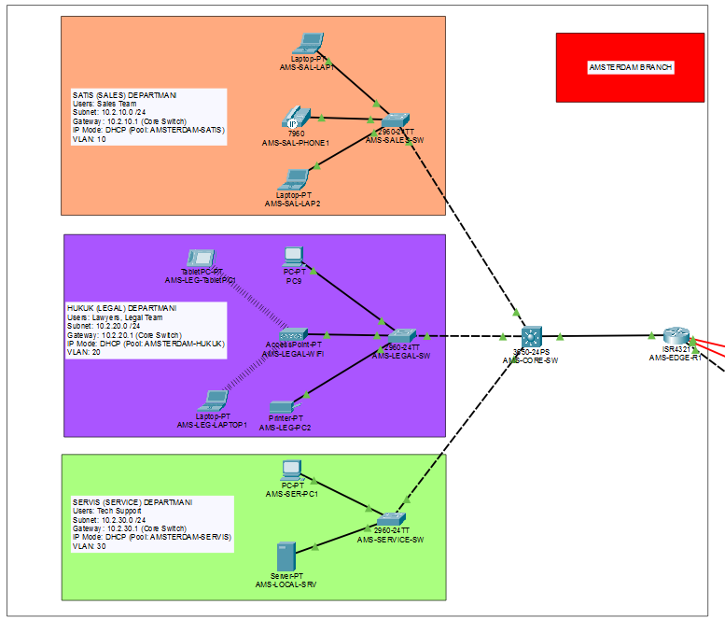
[Figure 2.3.1: Amsterdam Branch VLAN Routing Diagram]
- Working Principle: The LAN leg (GigabitEthernet0/0/1) of the AMS-EDGE-R1 router is divided into sub-interfaces (e.g., Gi0/0/1.30, Gi0/0/1.40).
- Encapsulation: Each sub-interface is tagged with the IEEE 802.1Q protocol to separate the traffic of the relevant department.
2.3.2. Department Structure and Isolation The Amsterdam office is divided into two main departments according to operational requirements:
- Sales (VLAN 30): Processes customer data in the European market.
- Support (VLAN 40): Conducts technical service operations. Although these two departments are physically connected to the same switch, they are logically completely isolated from each other.

Color Code | Department | VLAN ID | IP Block (Subnet) | Gateway IP | User Profile
Salmon | SALES | 10 | 10.2.10.0 /24 | 10.2.10.1 | Sales Team
Purple | LEGAL | 20 | 10.2.20.0 /24 | 10.2.20.1 | Lawyers
Green | SERVICE | 30 | 10.2.30.0 /24 | 10.2.30.1 | Tech Support

2.3.3. WAN Connection Redundancy Like other branches, Amsterdam is connected to the center with redundant lines.
- Primary Link: VPN tunnel over ISP (Simulated).
- Backup Link: The MPLS (Serial) line, which activates in case of a possible internet outage, guarantees the flow of critical Sales data to the center.
2.4. Tokat Production Center: Industry 4.0 and Smart Factory (IoT)
The Tokat location is positioned as the production center of the project. Here, unlike classic data networks, Internet of Things (IoT) technologies that convert the physical world into digital data are used. The factory environment has an autonomous structure that ensures its own safety without the need for human intervention.
2.4.1. IoT Network Architecture and IP Structure Devices on the production line operate on a special VLAN isolated from office traffic. Device management is provided via the IoT Gateway (or IoT Server) in the environment.
- Network Segment: Production
- IP Block: 10.60.10.0 /24
- Communication Protocol: Devices connect to the Gateway via TCP/IP protocol in a wireless or wired environment and register as a "Remote Server."
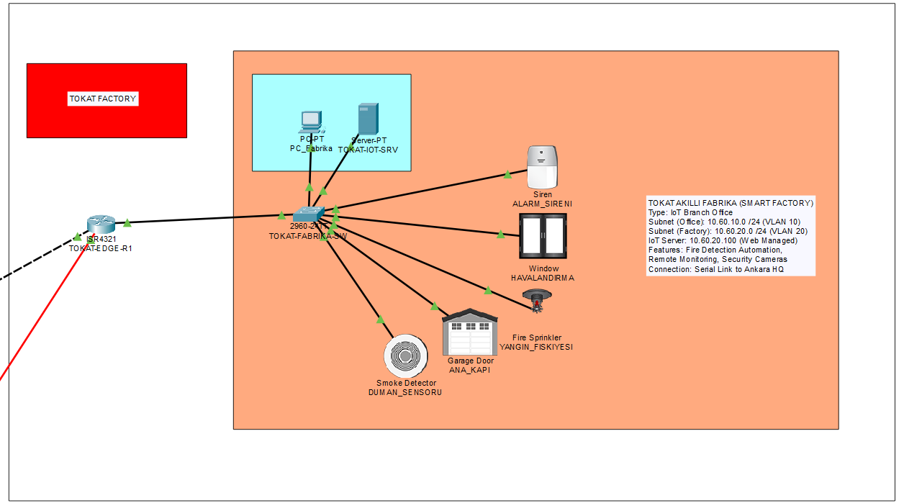
[Figure 2.4.1: Tokat Smart Factory IoT Device Topology]
2.4.2. Smart Device Inventory Used (Sensors and Actuators) Two types of components are used in the system: Sensors that collect data and Actuators that take action.
Device Type | Device Name | Function | Location
Input | Smoke Detector | Measures smoke level in the environment. | Ceiling (Production Line)
Input | Temperature Sensor (Temp Monitor) | Instantly tracks ambient temperature. | Machine Room
Output | Smart Siren | Gives audible warning in case of danger. | Factory Wall
Output | Fire Sprinkler | Sprays water in case of fire. | Ceiling
Output | Garage Door / Window | Automatically opens for evacuation. | Entrance/Exit

2.4.3. Automation Scenario: Fire Safety System For factory safety, an algorithm was written in the "Conditions" tab on Packet Tracer. This algorithm continuously analyzes data from sensors and reacts within milliseconds in case of danger.
Scenario Logic (IF-THEN Algorithm):
- CONDITION (IF): If Smoke Detector level is greater than 0.1 threshold value (Or if "Smoke Detected");
- ACTION (THEN):
  - Siren -> ON (True)
  - Fire Sprinkler -> ON (True)
  - Ventilation Window -> ON (Unlock/Open)
  - Garage Door -> ON (Open)
In this way, as soon as the fire starts, the system automatically starts the extinguishing process and opens evacuation routes.

2.4.4. Smart Factory Test To verify that the system is working, artificial smoke (Alt + Click) was applied to the smoke detector in the simulation environment.
- Result: It was observed that as soon as the smoke level rose, the Siren turned red, water flowed from the sprinkler, and the doors opened. The system works in accordance with the "Fail-Safe" principle.
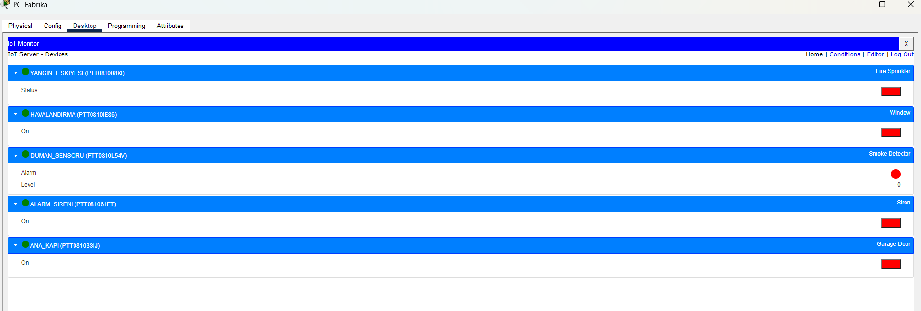
[Figure 2.4.2:IoT Interface ]
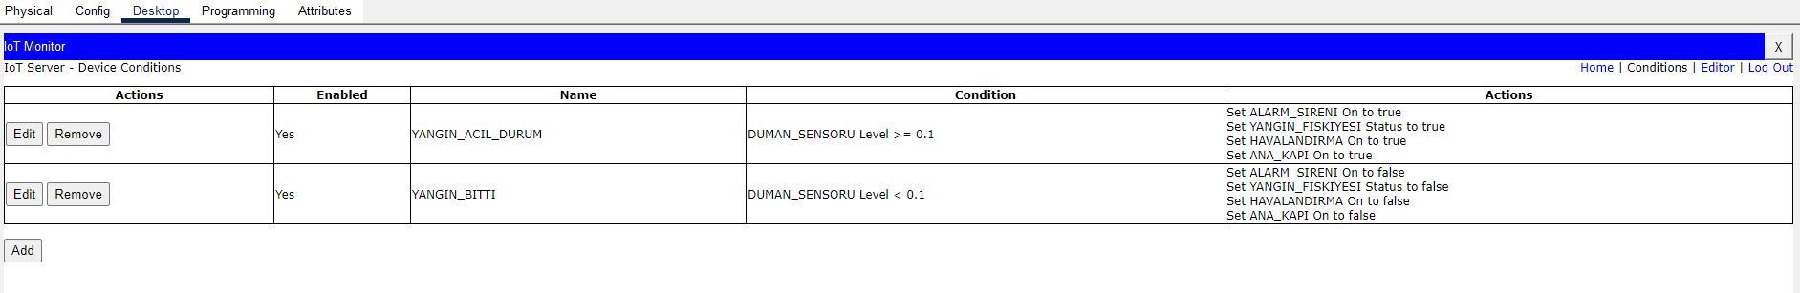[Figure 2.4.3: Fire Scenario Automation Rules and Algorithm]

3. WAN INFRASTRUCTURE AND ROUTING STRATEGY
To ensure uninterrupted communication of branches in different geographical locations, a Hybrid WAN Architecture that is not dependent on a single point (No Single Point of Failure) has been designed.
3.1. Physical WAN Connections and Redundancy
Physical redundancy is provided by using two different line technologies in the intercity data transport layer:
- First Path (Primary Path - ISP): The main internet backbone provided over high-bandwidth Gigabit Ethernet lines. Under normal conditions, all data traffic flows over this fast line.
- Second Path (Backup Path - MPLS): Serial connections that activate in case of a possible fiber cut or ISP failure. These lines simulate transoceanic connections passing through the GLOBAL-MPLS-1 and GLOBAL-MPLS-2 routers at the center.
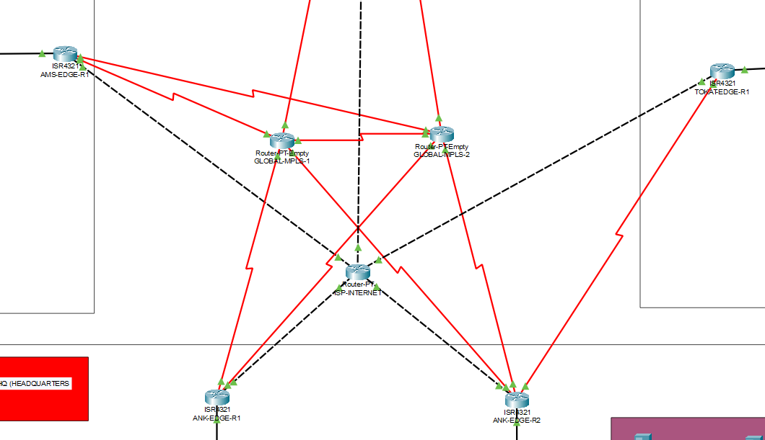[Figure 3.1: Redundant WAN Connection Diagram Between Headquarters and Branches]

3.2. OSPF Dynamic Routing Protocol
OSPF (Open Shortest Path First), which is the industry standard, was preferred as the routing protocol across the entire network (Ankara, New York, Amsterdam, Tokat).
- Area Structure: For ease of management and fast convergence, all routers are configured within the Backbone Area (Area 0).
- Neighbor Relations: Each router establishes dynamic neighbor relationships with its directly connected neighbors (by sending Hello packets) and is instantly informed of topology changes.
3.3. Fault Tolerance and Cost Adjustment
The OSPF "Cost" metric was manipulated for the system to automatically switch to the backup line (Failover).
- Configuration: The cost of the main lines was left as default (low), while the cost of backup Serial lines was artificially increased with the ip ospf cost 1000 command.
- Result: Routers always choose the "cheapest" path (ISP Line) to reach the destination branch. However, when the ISP line breaks (when Cost = Infinite), the OSPF algorithm automatically redirects traffic to the expensive backup path (MPLS).
3.4. Routing Table
The Routing Table below proves that the system dynamically learns all networks (10.0.0.0/8 blocks). The "O" (OSPF) and "O E2" (External) indications in the table show that the routes were automatically discovered by the protocol.
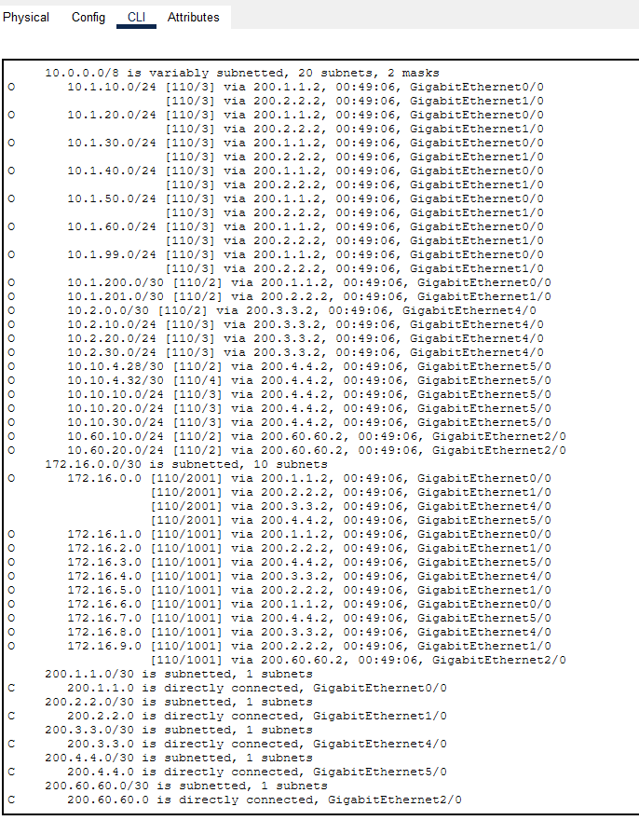
[Figure 3.2: OSPF Routing Table and Learned Routes]
4. CONCLUSION AND EVALUATION
Within the scope of this project; a professional corporate network infrastructure compliant with High Availability and Industry 4.0 standards, connecting four different strategic locations worldwide, has been designed and simulated.
The established system has a Fault Tolerant architecture capable of sustaining data flow uninterrupted even in the event of a single cable break or device failure.
The success of Central Web and DNS services and the integration of Industrial IoT automation show that the network meets modern needs. The "Failover" scenario tests performed have proven the stability and operational determination of the system.

