

**Fundamentalof programmimg:**

**Name: M.Yahya Chand**

**Roll #:** 456727

**Section:** ME-15 B

**DATE:** 17 OCT 2023

**#include <iostream>**

**using namespace std;**

**int main() {**

**char a;**

**int b;**

**cout<<" insert the first letter of the province ";**

**cin>>a;**

**switch(a){**

**case 'p':**

**cout<<" population of punjab is 127,474,000";**

**break;**

**case 's':**

**cout <<"the population of sindh is 54,858,515 ";**

**break;**

**case 'k':**

**cout <<" the population of kpk is 40,8000,000 ";**

**break;**

**case 'b':**

**cout <<"the population of balochistan is 21,7000,000";**

**break;**

**default:**

**cout<< "invalid input";**

**}**

**return 0;}**

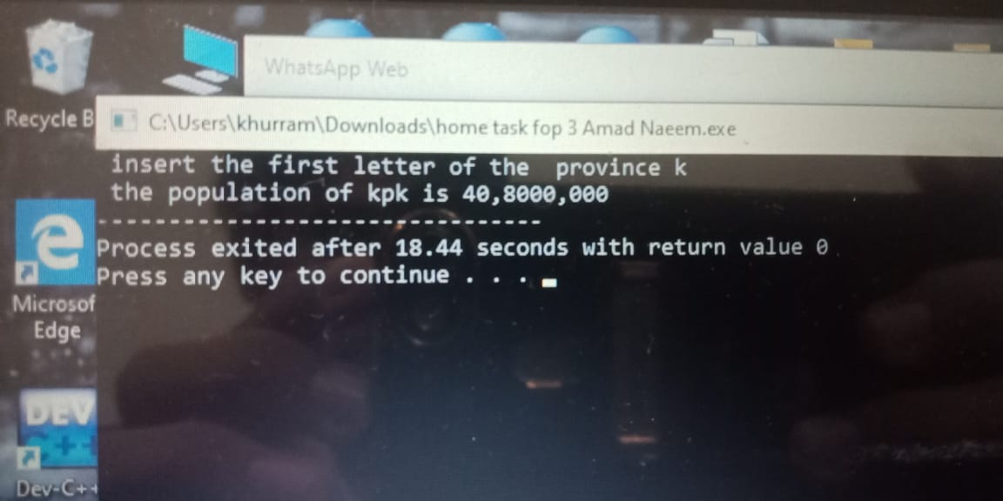

**#include<iostream>**

**using namespace std;**

**Int main(){**

**char x;**

**cout <<"enter the character: ";**

**cin>>x;**

**switch(x){**

**case 'a':; case'e':;case 'i':;case 'o':;case 'u':**

**cout <<x <<"the character is a vowel"<<endl;**

**break;**

**default:**

**cout<<x<<" the character is a consonant"<<endl;**

**}**

**return 0;**

**}**

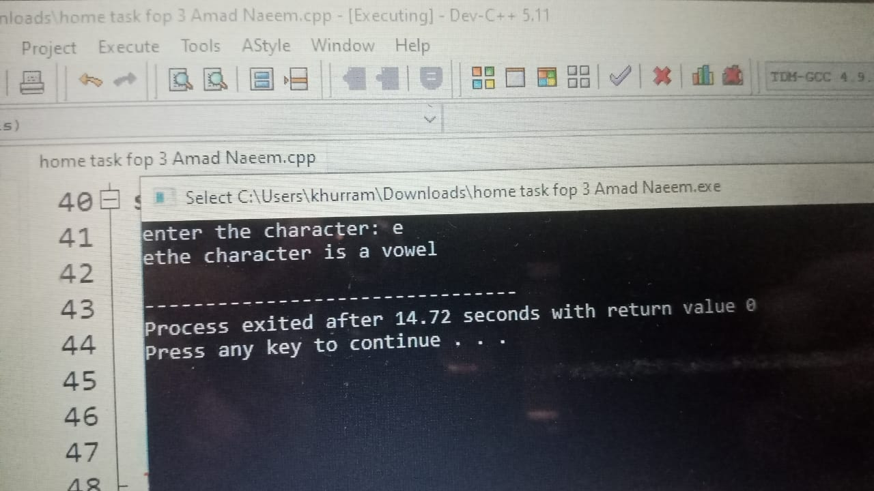

**#include<iostream>**

**Using namespace std;**

**Int main(){**

**float a;**

**cout<<"insert a number"<<endl<<"num = ";**

**cin >>a;**

**switch(a>0){**

**case true:**

**cout<<" insert number is positive";**

**break;}**

**switch(a<0){**

**case true:**

**cout<<" insert the number is negative";**

**break;**

**}**

**switch(a==0){**

**case true:**

**cout <<"number is zero";**

**break;}**

**return 0;**

**}**

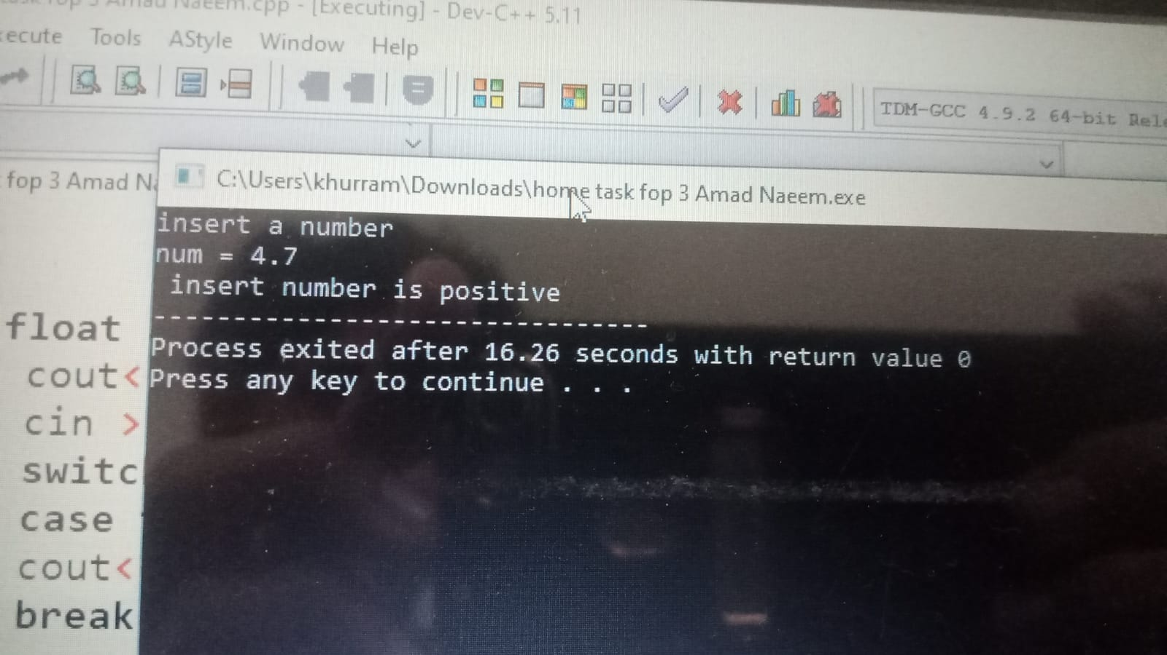

**#include<iostream>**

**Using namespace std;**

**Int main(){**

**\*int a;**

**cout<<" enter the age of the person"<<endl<< " age: ";**

**cin>>a;**

**if(a<=12){**

**cout<<" the person is a child";**

**}**

**else{**

**if(a>12&&a<=17){**

**cout<<" the person is a teenager";**

**}**

**else{**

**if(a>=18){**

**cout<<" the person is an adult";}**

**}**

**}**

**return 0;}**

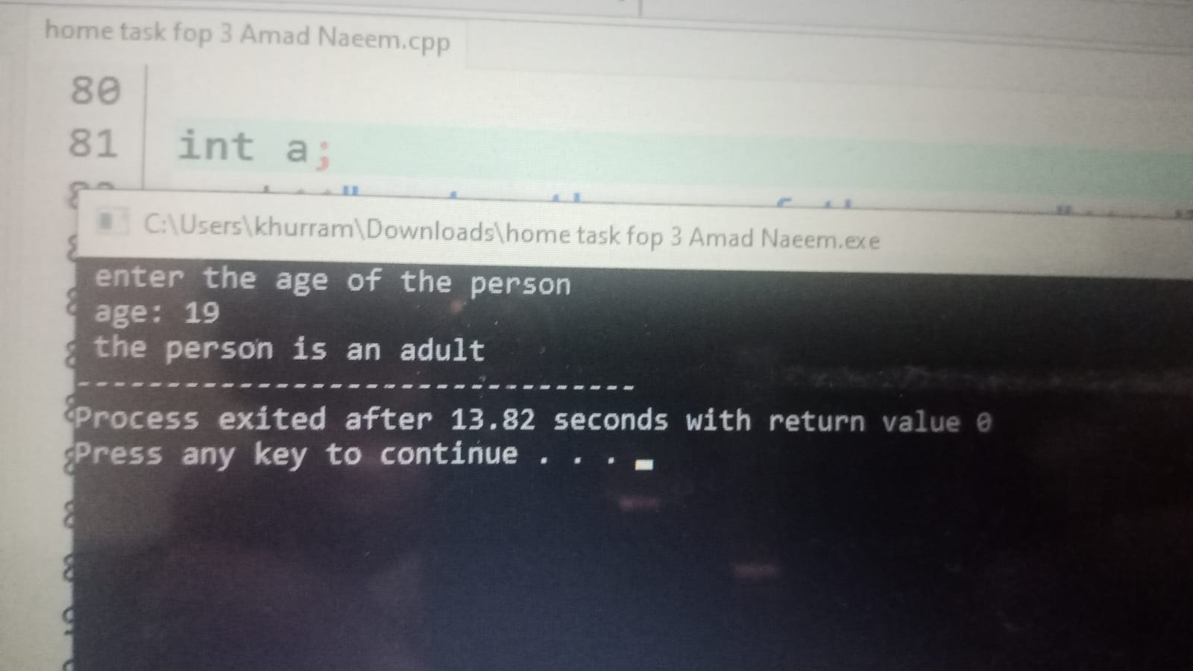

**#include<iostream>**

**Using namespace std;**

**Int main(){**

**float a,b,c;**

**cout<<" insert three numbers"<<endl;**

**cout<<"num 1= ";**

**cin>>a;**

**cout<<"num 2= ";**

**cin>>b;**

**cout<<"num 3= ";**

**cin>>c;**

**if(a>b&&a>c){**

**cout<<a<<" is the greatest number";**

**}**

**else{**

**if(b>a&&b>c){**

**cout<<b<<" is the greatest number";**

**}**

**else{**

**if(c>b&&c>a){**

**cout<<c<<" is the greatest number";**

**}**

**}**

**}**

**return 0;}**

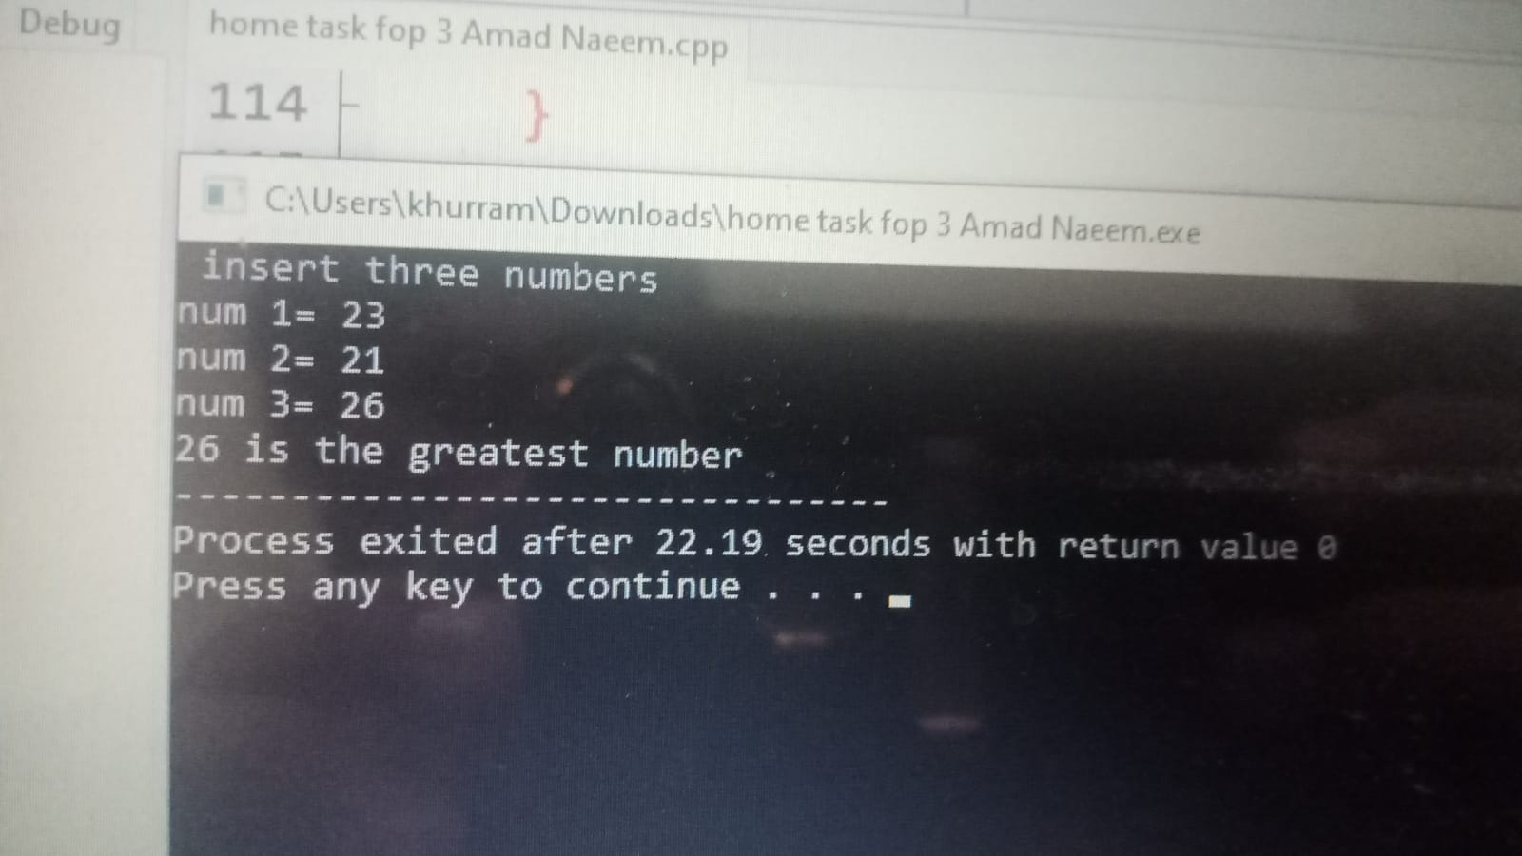

**#include<iostream>**

**Using namespace std;**

**Int main(){**

**char x;**

**cout<<"enter the letter"<<endl<<"letter: ";**

**cin>>x;**

**if(x=='a')**

**{**

**cout<<x<<" is a vowel";**

**}**

**else{**

**if(x=='e')**

**{cout<<x<<" is a vowel";**

**}**

**else{**

**if(x=='i')**

**{ cout<<x<<" is a vowel";**

**}**

**else{**

**if(x=='o')**

**{cout<<x<<" is a vowel";**

**}**

**else{**

**if(x=='u'){**

**cout<<x<<" is a vowel";**

**}**

**else cout<<x<<" is a consonant";**

**}**

**}**

**}**

**}**

**return 0;**

**}**

