* **Task# 1:**

#include<iostream>

#include<cmath>

using namespace std;

int main(){

int a=6;

cout <<"factorial of 6"<<endl;

cout<<a*(a-1)*(a-2)*(a-3)*(a-4)*(a-5)<<endl;

return 0;

}

* **Output:**

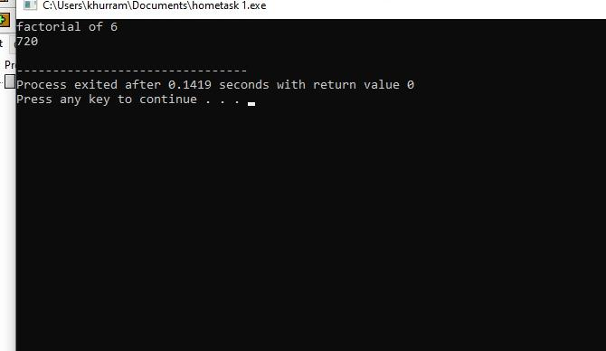

* **Task# 2:**

**#include<iostream>**

**#include<cmath>**

**using namespace std;**

**int main(){**

int X,Y,x,y;

cout<<"distance between two points"<<endl;

cout<<"kindly insert the values of X,Y,x,y"<<endl;

cin>> X;

cin>> Y;

cin>> x;

cin>> y;

cout<<((x-X)^2+(y-Y)^2);

return 0;

}

* **Output:**

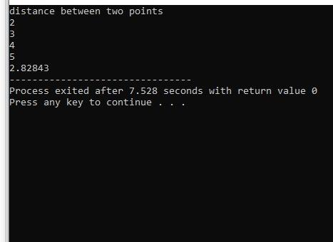

* **Task# 2**

#include<iostream>

#include<cmath>

using namespace std;

int main(){

int X,Y,x,y;

cout<<"distance between two points"<<endl;

cin>>X;

cin>>Y;

cin>>x;

cin>>y;

cout<<pow((pow((x-X),2)+pow((y-Y),2)),0.5);

return 0;

}

* **Output:**

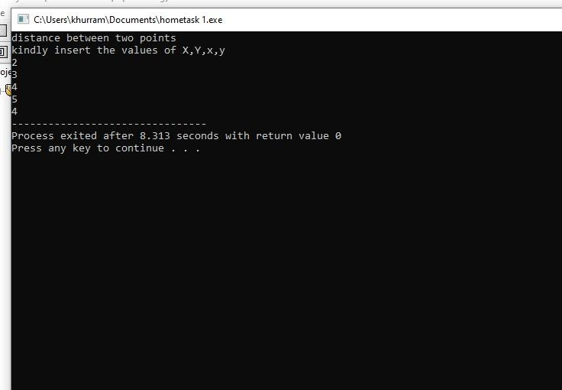

* **Task#3**

#include<iostream>

#include<cmath>

using namespace std;

int main(){

float cm,m,km;

cout<<"kindly insert the value in cm"<<endl;

cin>>cm;

cout<<"result in metre"<<endl;

cout<<cm/100<<endl;

cout<<"result in kilometre"<<endl;

cout<<cm/1000<<endl;

return 0;

}

**Output:**

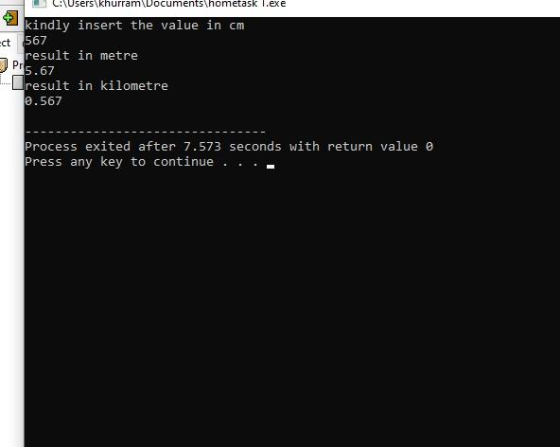

* **Task# 4:**

#include<iostream>

#include<cmath>

using namespace std;

int main(){

float x,y;

cout<<"kindly insert the values of x"<<endl;

cin>>x;

cout<<"kindly insert the value of y"<<endl;

;

cin>>y;

cout<<"result of x^2+2xy+y^2"endl;

cout<<pow(x,2)+2*x*y+pow(y,2)<<endl;

return 0;

}

**Output:**

