

**Fundamental of Programming**

**Lab manual # 6:**

**Name: Muhammad Yahya Chand**

**CMS ID: 456727**

**Section: ME-15B**

**Submitted to: SIR. Affan**

**Date: 23Nov,2023.**

**Task# 1:**

#include<iostream>

using namespace std;

int main(){

int num1=0,num2=1,num3,a,b;

cout<<"Enter the terms of fibonacci sequence :"<<endl;

cin>>a;

for(int i=1;i<=a;++i){

b=num1;

for(int j=0;j<=i;++j){

cout<<num1<<" ";

num3=num1+num2;

num1=num2;

num2=num3;

}

}

return 0;

}

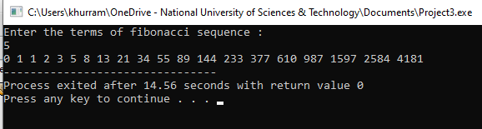

**Task# 2:**

#include<iostream>

using namespace std;

int main(){

int x;

cout<<"Enter the number of rows of the floyds triangle: ";

cin>>x;

int y=1;

for( int i=1; i<=x;i++){

for(int j=1; j<=i;j++){

cout<<y<<" " ;

y++;

}

cout<<endl;

}

}

