

**Fundamental of Programming**

**Lab manual # 6:**

**Name: Muhammad Yahya Chand**

**CMS ID: 456727**

**Section: ME-15B**

**Submitted to: SIR. Affan**

**Date: 23Nov,2023.**

**Task#1:**

#include<iostream>

using namespace std;

int main(){

int sum=0,fact=0;

for(int i=2;i<=50;i++){

for(int j=1;j<=i;j++){

if(i%j==0){

fact++;

}

}

if(fact==2){

sum=sum+i;

}

fact=0;

}

cout<<" Sum of all the prime numbers from 1 to 50 is: " <<sum;

return 0;

}

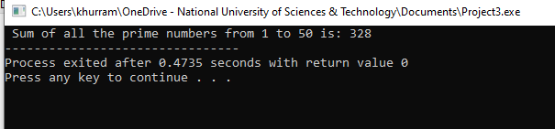

**Task#2:**

#include<iostream>

using namespace std;

int main(){

for(int i=1;i<=5;i++){

for(int j=i;j<=i;j++){

cout<<1;

}

for(int k=2;k<=i;k++){

if(k==2){

cout<<2;

}

}

for(int l=3;l<=i;l++){

if(l==3){

cout<<3;

}

}

for(int m=4;m<=i;m++){

if(m==4){

cout<<4;

}

}

for(int n=5;n<=i;n++){

cout<<5;

}

cout<<endl;

}

return 0;

}

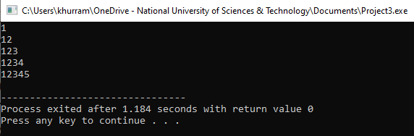

**Task#3:**

#include<iostream>

using namespace std;

int main(){

for(int a=1;a<=5;a++){

for(int b=1;b<=a;b++){

if(a==1){

cout<<1<<endl;

}

}

for(int c=0;c<=a;c++){

if(c<=a&&a<=1){

cout<<2;

}

}

cout<<endl;

for(int d=-2;d<=a;d++){

if(d<=a&&a<=1){

cout<<4;

}

}

cout<<endl;

for(int e=-4;e<=a;e++){

if(e<=a&&a==1){

cout<<6;

}

}

}

return 0;

}

