GROUP 6 • SPRING BOOT + REACT
Apartment Management System
Technical Project Documentation

1. Project Overview
The Apartment Management System is a full-stack web application built to replace manual, paper- and spreadsheet-based rental management with a single, centralized platform. It allows a property management company to manage owners, apartments, units, tenants, leases, rent payments, and maintenance requests, with a live dashboard summarizing the state of the business.
The system is composed of two independently deployable applications: a Spring Boot REST API backend that owns all business logic and data persistence, and a React (Vite) single-page application frontend that consumes the API and provides the user interface.

2. Technology Stack
Layer | Technology | Purpose
Backend framework | Spring Boot 4 (Java 21) | Core application framework and REST API
Database | PostgreSQL | Persistent storage for all business data
Persistence | Spring Data JPA / Hibernate | Object-relational mapping (ORM)
Security | Spring Security + JWT (jjwt) | Stateless authentication and authorization
Build tool | Maven | Dependency management and build
Boilerplate reduction | Lombok | Getters/setters/constructors on entities
Frontend framework | React 18 (Vite) | Single-page application UI
HTTP client | Axios | Communication with the backend API
Routing | React Router | Client-side page navigation
State management | React Context API | Auth session and theme state

3. System Architecture
The frontend (served by Vite on port 5173) and the backend (Spring Boot on port 8080) communicate exclusively over a versionless REST API secured with JSON Web Tokens. The request flow is as follows:
- The user interacts with a page in the React application.
- Axios attaches the JWT access token to the request's Authorization header.
- A JwtAuthenticationFilter on the backend validates the token before the request reaches any controller.
- The relevant Controller delegates to a Service, which applies business rules and calls a Spring Data JPA Repository.
- The Repository executes the query against PostgreSQL and the result is serialized back to the client as JSON.
The API is stateless: no HTTP session is kept on the server (SessionCreationPolicy.STATELESS), and CORS is restricted to the configured frontend origin (http://localhost:5173) only.

4. Data Model
The domain is modeled as eight core JPA entities with the following relationships:
Entity | Key Fields | Relationships
Owner | ownerName, phone, email, address | 1 Owner → many Apartments
Apartment | apartmentName, address, totalFloors, totalUnits, status | 1 Apartment → many Units
ApartmentUnit | unitNumber, floor, bedrooms/bathrooms, monthlyRent, status | 1 Unit → many Leases, many Maintenance Requests
Tenant | fullName, gender, phone, email, nationalId | 1 Tenant → many Leases
Lease | startDate, endDate, monthlyRent, deposit, status, balance | Links one Tenant to one Unit; 1 Lease → many Payments
Payment | amount, paymentDate, method, status | Belongs to one Lease
MaintenanceRequest | title, description, priority, status, dates | Belongs to one Unit; assignable to one User
User | fullName, username, email, password (hashed), role | Application account (ADMIN / EMPLOYEE)
Status fields (ApartmentStatus, UnitStatus, LeaseStatus, PaymentStatus, MaintenanceStatus, Priority, Role) are stored as enumerations, ensuring only valid states are persisted.

Entity-Relationship Diagram
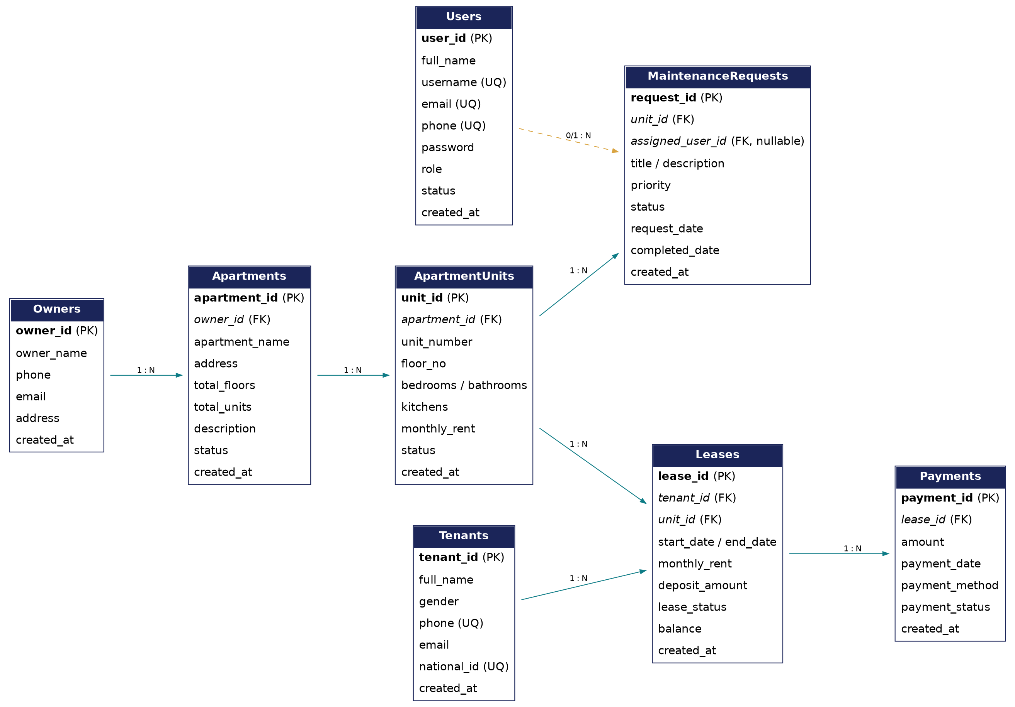

5. Key Business Rules
- When a new lease is created, its unit automatically transitions to OCCUPIED.
- A scheduled job runs every hour, expires leases whose end date has passed, and automatically frees the associated unit back to AVAILABLE.
- Ownership and unit-lease relationships are fixed at creation time and are not altered by update operations, keeping historical data consistent.
- The first user account registered in the system is automatically assigned the ADMIN role; subsequent accounts default to EMPLOYEE.

6. Security and Authentication
Authentication is implemented with a stateless JWT flow:
- A user registers or logs in through /api/auth/register or /api/auth/login.
- Passwords are hashed with BCrypt before being stored; plain-text passwords are never persisted.
- On successful login, the server issues a signed JWT (24-hour expiry by default) containing the user's identity and role.
- Every subsequent request carries the token in the Authorization header; a JwtAuthenticationFilter validates it and populates the Spring Security context.
- All endpoints except /api/auth/** require a valid token; role-based method security restricts sensitive operations to specific roles.

7. REST API Summary
Resource | Base Path | Supported Operations
Authentication | /api/auth/** | register, login (public)
Owners | /api/owners | GET, POST, PUT, DELETE
Apartments | /api/apartments | GET, POST, PUT, DELETE
Units | /api/units | GET, POST, PUT, DELETE
Tenants | /api/tenants | GET, POST, PUT, DELETE
Leases | /api/leases | GET, POST, PUT, DELETE, recalculate-balances
Payments | /api/payments | GET, POST, PUT, DELETE
Maintenance Requests | /api/maintenance-requests | GET, POST, PUT, DELETE, assign
Users | /api/users | GET, PUT, DELETE
Dashboard | /api/dashboard/stats | GET (aggregated statistics)

8. Frontend Modules
The React application provides one page per business area, all following a consistent list → detail/table → create/edit modal pattern: Dashboard, Owners, Apartments, Units, Tenants, Leases, Payments, Maintenance Requests, Employees (Users), Reports, plus Login and Register. A shared AuthContext manages the logged-in session and attaches the JWT to every Axios call; a ThemeContext provides light/dark mode.

9. Challenges Faced
- Coordinating the intermediate relationships (Owner → Apartment → Unit → Lease) so that creating or deleting a record at one level correctly cascades to dependent records without breaking referential integrity.
- Keeping the frontend and backend security in sync — configuring CORS and JWT handling correctly while the two applications run on different ports (5173 and 8080) during development.
- Designing the automatic unit-status logic (OCCUPIED / AVAILABLE) so it stays consistent across manual edits, new leases, and the hourly lease-expiry scheduler, without conflicting updates.
- Agreeing on a consistent data model and naming conventions across the team before backend and frontend development started in parallel.

10. Individual Contributions
The table below summarizes each member's primary area of responsibility. Replace the placeholders with your team's actual names and tasks.
Name | Role / Area | Main Contributions
Said abdullahi Mohamed | Backend | [e.g., entities, repositories, services for Owners/Apartments/Units]
Yahye Adam Mohamed | Frontend | [e.g., Dashboard, Owners, Apartments, Units pages]
Yahye Adam Mohamed | Documentation / QA | [e.g., testing, README, report, presentation]

11. Acknowledgement of GenAI Tools
An AI assistant (Claude, by Anthropic) was used during this project to support documentation and planning work, specifically:
- Translating the project's presentation slides into English.
- Drafting this project report (architecture description, data model summary, and API summary) based on the team's own source code and database schema.
- Generating the entity-relationship diagram from the team's SQL schema.
- Drafting the project README with setup and run instructions.
All application source code (backend and frontend) and the underlying design decisions were produced by the project team. The team reviewed and takes responsibility for all AI-assisted content included in this submission.

12. Conclusion and Future Work
The current implementation delivers a complete, secured CRUD platform covering the full rental lifecycle from owner and property onboarding through leasing, payment tracking, and maintenance handling backed by an automatically computed dashboard. Planned enhancements include finer-grained role-based access control, automated notifications for lease expiry and pending payments, and exportable PDF/Excel reports.

