Number/Color Boxes

You will be making a simple program in an HTML page using javascript and CSS that will look similar to this.



1.

You must first create this design using CSS and HTML Elements. Try to nest elements within rows or columns. For example

<div class=”row”>

<div class=”col”></div>

<div class=”col”></div>

<div class=”col”></div>

</div>

or

<div class=”col”>

<div class=”row”></div>

<div class=”row”></div>

<div class=”row”></div>

</div>

Then, using CSS, make the entire grid be horizontally centered in the screen. If the grid isn’t vertically centered you will not lose points. Just try your best to not have it all the way at the top of the screen.

2.

Now in your JS file, you will select ALL your boxes into one array and then create a loop to loop through each one of these elements and add in the numbers 1 - 9 to each box. The top left box should have the number 1 and the bottom right should have the number 9.

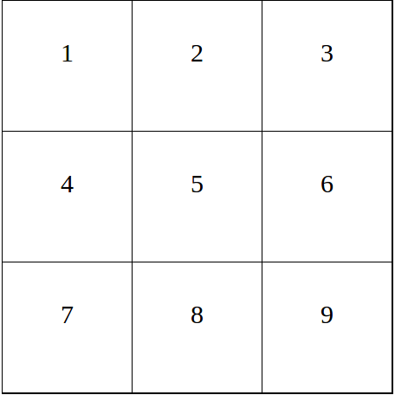

Make sure the numbers are Vertically and Horizontally aligned.

3.

Create a class called Squares. Create two methods inside class Squares called changeNumber and changeColor. Inside these methods just console.log out “Running function…” then the name of that methods. This way you know that it is running properly. Now call these methods within the constructor so that when we make a new instances of this class, these methods run. Then make a new instance of the Squares class. Simply just call the instance squares.

4.

Adding Event Handlers

Create a new method called addClickHandler that takes in changeNumber, changeColor. Run a forEach loop on boxes and for every instance append a click handler whose second parameter takes in an anonymous function with a parameter to hold the event (you can use e or event, whichever one you like) and calls the functions changeNumber and changeColor. Update the constructor so that instead of the changeNumber and changeColor functions being called as a new Instance of Squares class is created, it should only run when one the boxes are clicked.

5.

changeNumber Function

Make the changeNumber function take in a number and the boxes array as variables. Inside the function do a loop that DESCENDS (approaching but stopping before hitting zero) that takes the current number that is in the box and then increments by one. So for example, If I click on the fifth box, box #5,4,3,2,1 numbers should ALL increment by one. There is a problem with continuity if you only use the beginning content of the box because if it increments by 1, the first box might not be #1 anymore. You need to add custom data attributes on each element. That way your for loop knows exactly which ones you need to increment. Also create some sort of checker that if the number gets bigger than 9 make it go back to 1.

6.

changeColor Function

Outside the class, create an array that holds at least five different colors. Make the colors be in rgb syntax (For white it’ll be rgb(255,255,255), for black it’ll be rgb(0,0,0), etc.). Now pass that array into the classes constructor. Set a parameter for the changeColor to hold the colors array. Inside of the changeColor function, do another DESCENDING loop that for each instance you are going to grab the current background color for each box (you should add in a CSS property that gives a value of the box a background color to white). Use the following code to help you get the index of the current background color in the array:

let style = window.getComputedStyle(boxes[i-1])

let index = colors.indexOf(style.backgroundColor)

Now use index to set the new background-color for each box in each iteration of the loop. Make sure that if the color of the box is set to the last color in the colors array it should cycle back to white WHICH MUST BE THE FIRST COLOR OF THE COLORS ARRAY. Update your addClickHandler and you constructor to allow access of colors array to the changeColor Function.

7)

Increment Function

Create a function that will be used in the changeColor and changeNumber function. You will use this to replace the line of code that says when it reaches to the end of the array, reset the index value to zero. Create the function and name it increment. Make it return the value. For example,

value = (value >= 9) ? 1 : value+1

with

value = increment(value)

Make sure it gets proper permission so that it runs properly.

8)

Add three more boxes to the bottom of the row. So you should 12 boxes instead of just 9, and 4 rows instead of three. Make sure that your program still works, and the make the maximum number that can be reached is 12 not 9 anymore. Also make sure that there aren’t corresponding numbers with colors.