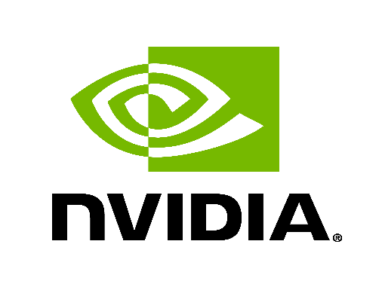

Improve SONiC Thermal Algorithm
High Level Design
Rev. 0.1

Table of Contents
1 General Information 3
1.1 Revision 3
1.2 About this Manual 3
1.3 Scope 3
1.4 Definitions/Abbreviation 3
1.5 Reference 3
2 Overview 4
3 Requirements 5
4 Architecture Design 6
5 High Level Design 7
5.1 thermal-updater change 7
5.2 thermal.py change 7
5.3 hw-management-sync change 8
5.3.1 Prevent thermal-updater from accessing temperature sysfs nodes when they are unavailable 8
Option 1: wait temperature sysfs nodes existence before accessing it 8
Option 2: SDK driver udev event 8
5.4 SAI API 9
5.5 Configuration and management 9
5.5.1 Manifest (if the feature is an Application Extension) 9
5.5.2 CLI/YANG model Enhancements 9
5.5.3 Config DB Enhancements 9
5.6 Warmboot and Fastboot Design Impact 10
5.7 Warmboot and Fastboot Performance Impact 10
5.8 Memory Consumption 10
5.9 Restrictions/Limitations 10
6 Testing Requirements/Design 11
6.1 Unit Test cases 11
6.2 System Test cases 11

General Information

Revision
Table 1 Revision
Rev | Date | Author | Change Description
1.0 |  | Junchao Chen | Base version

About this Manual
This document provides general information about the SONiC thermal algorithm change according to the requirement from MSFT.

Scope
This document outlines an enhancement to the SONiC thermal algorithm for the NVIDIA platform. The primary focus of this improvement is on air-cooled systems, with liquid cooling systems excluded from the scope. The enhancement centers on ASIC, module temperature data, while other thermal sensors are not included.

Definitions/Abbreviation
N/A

Reference
N/A

Overview
The current SONiC thermal algorithm comprises several key components:
- hw-management-sync: This service provides temperature data for ASIC and firmware-controlled modules.
- thermal-updater: Operating as a thread within thermalctld, it supplies temperature data for software-controlled modules and DPUs (smart switch only).
- thermal-monitor: Functioning as a thread inside thermalctld, it collects temperature data from all thermal sensors and stores it in the database. The SONiC CLI accesses this data from the database to present it to users.
- hw-management-tc: This service performs thermal actions, such as adjusting fan speed, based on temperature data changes.
- SDK driver: Providing sysfs nodes for SONiC to accessing ASIC and module temperature data.
This document outlines improvements to the current SONiC thermal algorithm in the following areas:
- A single temperature provider will be implemented to prevent multiple providers from interfering with each other. The hw-management-sync will be disabled, making the thermal-updater the sole temperature provider responsible for supplying temperature data for ASIC, modules (both software-controlled and firmware-controlled), and DPUs.
- A single temperature data source will be used to minimize I2C bus access. The thermal-updater will access the I2C bus to collect temperature data for ASIC and modules and update this data to the hw-management files. The thermal-monitor will then retrieve ASIC and module temperature data from the hw-management files, rather than directly accessing the I2C bus.
- Implement a robust mechanism to prevent thermal-updater from accessing temperature sysfs nodes when they are unavailable.

Requirements
- Single temperature provider
- Single temperature data source
- Avoid accessing temperature sysfs nodes when they are unavailable

Architecture Design
This enhancement does not change existing SONiC architecture. The feature architecture is described in below chart:
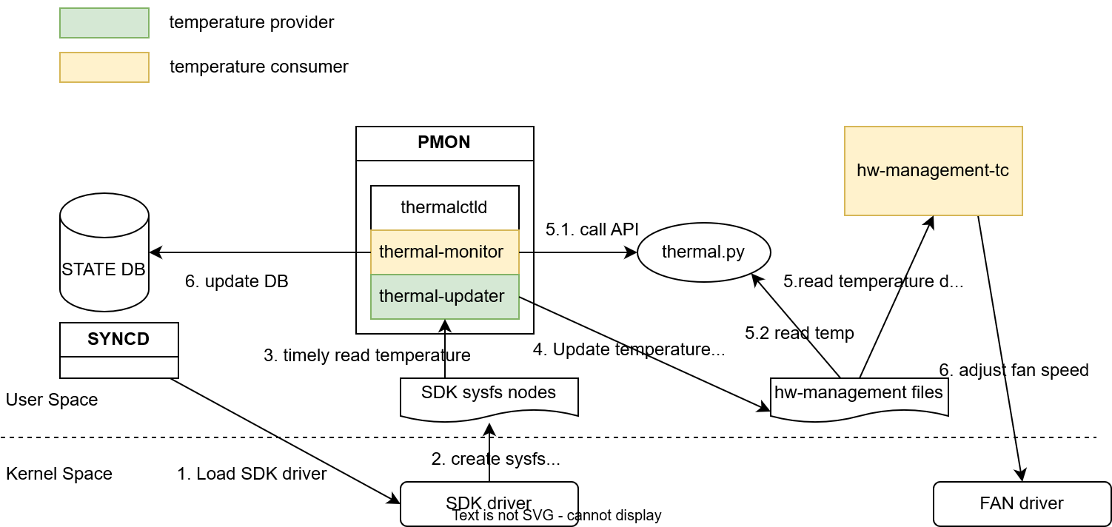
- syncd container startup script load SDK drivers
- SDK driver creates ASIC and module temperature sysfs nodes
- thermal-updater timely reads temperature data from sysfs nodes
- thermal-updater timely updates temperature data to hw-management files
- hw-management-tc timely reads temperature data from hw-management files and adjust fan speed accordingly
- thermal-monitor timely reads temperature data from hw-management files and update DB
The shutdown flow is described below:
- User issues config reload or warmboot or fastboot
- pmon start to shutdown
- thermal-monitor shutdown (ensure thermal-monitor is stopped before thermal-updater)
- thermal-updater suspends hw-management-tc and shutdown
- syncd is stopped and unload SDK drivers

High Level Design

thermal-updater change
Current behavior:
- It runs when module host management mode is enabled.
- It only collect temperature data for software-controlled modules.
- It reads temperature update interval from tc_config.json and halves the value.
Updated behavior:
- It runs always
- It collect temperature data from ASIC, software-controlled modules and firmware-controlled modules.
- ASIC: read from SDK sysfs /sys/module/sx_core/asic0/temperature/*
- software-controlled modules: read from module EEPROM which is also provided by SDK sysfs /sys/module/sx_core/asic0/module{index}/eeprom/*
- firmware-controlled modules: read from SDK sysfs /sys/module/sx_core/asic0/module{self.sdk_index}/temperature/input/*
- It reads temperature update interval from tc_config.json and use the value as it is.

thermal.py change
The thermal-monitor retrieves temperature data through the platform API within thermal.py. This enhancement does not require code changes in thermal-monitor about this part, but the implementation of thermal.py will be updated.
Current behavior:
- It reads the temperature of the ASIC, software-controlled module, and firmware-controlled module from the SDK sysfs node.
Updated behavior:
- It will now read the temperature of the ASIC, software-controlled module, and firmware-controlled module from the hw-management files populated by thermal-updater.
- A retry mechanism for reading the temperature files should be added because therml-updater requires time to initialize.

hw-management-sync change
hw-management-sync shall be disabled.

Prevent thermal-updater from accessing temperature sysfs nodes when they are unavailable
ASIC and module temperature sysfs nodes are created by SDK driver. thermal-updater should only access the sysfs nodes when they are available to avoid error in syslog. There are 2 options:

Option 1: wait temperature sysfs nodes existence before accessing it
Temperature sysfs nodes are created after loading SDK drivers and completing some internal SDK initialization and are removed during unloading SDK drivers. Given this, a new stage can be added to thermal-updater to wait for all temperature sysfs nodes to be ready. The updated flow of thermal-updater will be as follows:
- Clean thermal data.
- Suspend hw-management-tc.
- Load tc_config.json.
- [New] Wait for the temperature sysfs nodes to be present.
- Start collecting temperature data.
[sdk] How about warm-boot?

Option 2: SDK driver udev event
The SDK driver is designed to provide udev events for ASIC PCIE device availability. Currently, these udev events are triggered only when the module host management mode is disabled. To enhance functionality, the SDK should be changed to send udev events regardless of the module host management mode status. Consequently, a udev rule and handler need to be implemented to manage these SDK udev events effectively.
udev rules:
SUBSYSTEM=="pci", DRIVERS=="sx_core", ENV{SX_CORE_EVENT}=="1", ACTION=="add", RUN+="/usr/bin/python /path/to/udev_handler.py add %S %p"
SUBSYSTEM=="pci", DRIVERS=="sx_core", ENV{SX_CORE_EVENT}=="1", ACTION=="remove", RUN+="/usr/bin/python /path/to/udev_handler.py remove %S %p"
SUBSYSTEM=="pci", DRIVERS=="sx_core", ACTION=="online", RUN+="/usr/bin/python /path/to/udev_handler.py w-add %S %p"
SUBSYSTEM=="pci", DRIVERS=="sx_core", ACTION=="offline", RUN+="/usr/bin/python /path/to/udev_handler.py w-remove %S %p"
The udev handler can be a python script or shell script.
- It creates a ASIC ready file upon receiving the "add" or "online" event
- It removes the ASIC ready file upon receiving the "remove" or "offline" event
thermal-updater flow shall be updated as follows:
- Clean old thermal data.
- Suspend hw-management-tc.
- Load tc_config.json.
- Start loop to collect temperature data.
- [New] For each iteration, check ASIC ready file existence before collecting temperature data. If ASIC ready file exists, collect temperature data; otherwise, clean old thermal data.
- [New] For each iteration, if the SFP serial number has changed, verify the vendor information before collecting temperature data. If the vendor information has changed, push the update to hw-management.
[sdk] should we still check temperature file existence after receiving the udev rule?
[hw-management] should we inject some specific value to hw-management files when ASIC is not ready?

SAI API
N/A

Configuration and management

Manifest (if the feature is an Application Extension)
N/A

CLI/YANG model Enhancements
N/A

Config DB Enhancements
N/A

Warmboot and Fastboot Design Impact
N/A

Warmboot and Fastboot Performance Impact
No impact to warmboot and fastboot performance.

Memory Consumption
No extra memory consumption for this feature.

Restrictions/Limitations

Testing Requirements/Design

Unit Test cases
All code change should be covered by new or existing unit test cases.

System Test cases
- FW control mode, confirm that thermal-monitor and thermal-updater is working, “show platform temperature” works as well, no new error log found
- SW control mode, confirm that thermal-monitor and thermal-updater is working, “show platform temperature” works as well, no new error log found
- Confirm that hw-management-sync is disabled
- Test after reboot, “config reload”, thermal-monitor and thermal-updater still work, “show platform temperature” works as well, no new error log found
- Send sig-term to thermalctld, confirm that hw-management-tc is suspended
- Run existing sonic-mgmt platform test cases.
- All test cases shall be performed on SPC1, SPC3, SPC4, SPC5 and smartswitch platforms.

Notice
This document is provided for information purposes only and shall not be regarded as a warranty of a certain functionality, condition, or quality of a product. Neither NVIDIA Corporation nor any of its direct or indirect subsidiaries (collectively: “NVIDIA”) make any representations or warranties, expressed or implied, as to the accuracy or completeness of the information contained in this document and assumes no responsibility for any errors contained herein. NVIDIA shall have no liability for the consequences or use of such information or for any infringement of patents or other rights of third parties that may result from its use. This document is not a commitment to develop, release, or deliver any Material (defined below), code, or functionality.
NVIDIA reserves the right to make corrections, modifications, enhancements, improvements, and any other changes to this document, at any time without notice.
Customer should obtain the latest relevant information before placing orders and should verify that such information is current and complete.
NVIDIA products are sold subject to the NVIDIA standard terms and conditions of sale supplied at the time of order acknowledgement, unless otherwise agreed in an individual sales agreement signed by authorized representatives of NVIDIA and customer (“Terms of Sale”). NVIDIA hereby expressly objects to applying any customer general terms and conditions with regards to the purchase of the NVIDIA product referenced in this document. No contractual obligations are formed either directly or indirectly by this document.
NVIDIA products are not designed, authorized, or warranted to be suitable for use in medical, military, aircraft, space, or life support equipment, nor in applications where failure or malfunction of the NVIDIA product can reasonably be expected to result in personal injury, death, or property or environmental damage. NVIDIA accepts no liability for inclusion and/or use of NVIDIA products in such equipment or applications and therefore such inclusion and/or use is at customer’s own risk.
NVIDIA makes no representation or warranty that products based on this document will be suitable for any specified use. Testing of all parameters of each product is not necessarily performed by NVIDIA. It is customer’s sole responsibility to evaluate and determine the applicability of any information contained in this document, ensure the product is suitable and fit for the application planned by customer, and perform the necessary testing for the application in order to avoid a default of the application or the product. Weaknesses in customer’s product designs may affect the quality and reliability of the NVIDIA product and may result in additional or different conditions and/or requirements beyond those contained in this document. NVIDIA accepts no liability related to any default, damage, costs, or problem which may be based on or attributable to: (i) the use of the NVIDIA product in any manner that is contrary to this document or (ii) customer product designs.
No license, either expressed or implied, is granted under any NVIDIA patent right, copyright, or other NVIDIA intellectual property right under this document. Information published by NVIDIA regarding third-party products or services does not constitute a license from NVIDIA to use such products or services or a warranty or endorsement thereof. Use of such information may require a license from a third party under the patents or other intellectual property rights of the third party, or a license from NVIDIA under the patents or other intellectual property rights of NVIDIA.
Reproduction of information in this document is permissible only if approved in advance by NVIDIA in writing, reproduced without alteration and in full compliance with all applicable export laws and regulations, and accompanied by all associated conditions, limitations, and notices.
THIS DOCUMENT AND ALL NVIDIA DESIGN SPECIFICATIONS, REFERENCE BOARDS, FILES, DRAWINGS, DIAGNOSTICS, LISTS, AND OTHER DOCUMENTS (TOGETHER AND SEPARATELY, “MATERIALS”) ARE BEING PROVIDED “AS IS.” NVIDIA MAKES NO WARRANTIES, EXPRESSED, IMPLIED, STATUTORY, OR OTHERWISE WITH RESPECT TO THE MATERIALS, AND EXPRESSLY DISCLAIMS ALL IMPLIED WARRANTIES OF NONINFRINGEMENT, MERCHANTABILITY, AND FITNESS FOR A PARTICULAR PURPOSE. TO THE EXTENT NOT PROHIBITED BY LAW, IN NO EVENT WILL NVIDIA BE LIABLE FOR ANY DAMAGES, INCLUDING WITHOUT LIMITATION ANY DIRECT, INDIRECT, SPECIAL, INCIDENTAL, PUNITIVE, OR CONSEQUENTIAL DAMAGES, HOWEVER CAUSED AND REGARDLESS OF THE THEORY OF LIABILITY, ARISING OUT OF ANY USE OF THIS DOCUMENT, EVEN IF NVIDIA HAS BEEN ADVISED OF THE POSSIBILITY OF SUCH DAMAGES. Notwithstanding any damages that customer might incur for any reason whatsoever, NVIDIA’s aggregate and cumulative liability towards customer for the products described herein shall be limited in accordance with the Terms of Sale for the product.

Trademarks
NVIDIA, the NVIDIA logo, and Mellanox are trademarks and/or registered trademarks of Mellanox Technologies Ltd. and/or NVIDIA Corporation in the U.S. and in other countries. Other company and product names may be trademarks of the respective companies with which they are associated.
For the complete and most updated list of Mellanox trademarks, visit http://www.mellanox.com/page/trademarks.
Copyright
© 2021 Mellanox Technologies. All rights reserved.

