students names and ID’s:
Yair Zeneve 316350933
Matan Amran 316326313

Exercise 1.1 Solution:
import math
def verify_key(k):
# 1. show key
print(f"Key numbers: {k}")
# 2. Formula for 2x2 determinant: (ad - bc)
# Key positions: 0, 1 (row 1)
# 2, 3 (row 2)
det = (k[0] * k[3] - k[1] * k[2]) % 26 # we are in Z 26 space
print(f"Determinant: {det}")
# 3. Check if valid (not 0 and no common factors with 26)
if math.gcd(det, 26) == 1: # det!=0 is included (gcd(0,26) = 26..
print("gcd == 1, Key is VALID\n")
return True
else:
print("gcd != 1, Key is INVALID\n")
return False
def NameCipher_encryption(plaintext, key1, key2):
# Student names: Yair, Matan, Y = 24, M = 12
a = 24
b = 12
# 1. Show Input
print(f"--- Encryption Input ---")
print(f"Plaintext: {plaintext}")
print(f"Key 1: {key1}, Key 2: {key2}")
print(f"Parameters: a={a}, b={b}\n")
# Handle odd length with Padding by adding 'X' and Flag
is_padded = False
if len(plaintext) % 2 != 0:
plaintext += "X"
is_padded = True
# Convert strings keys to matrix and validate
key1_matrix = []
for char in key1:
number = ord(char.upper()) - ord('A')
key1_matrix.append(number)
key2_matrix = []
for char in key2:
number = ord(char.upper()) - ord('A')
key2_matrix.append(number)
if not verify_key(key1_matrix) or not verify_key(key2_matrix):
return "Encryption failed: One of the keys is invalid"
# Convert plaintext to numbers
text_nums = []
for char in plaintext:
number = ord(char.upper()) - ord('A')
text_nums.append(number)
# First Encryption Step: Y = (X * K1 + (a, b)) mod N
step1_nums = []
for i in range(0, len(text_nums), 2):
# Taking block of m=2
x1 = text_nums[i]
x2 = text_nums[i+1]
# Matrix multiplication for K1: Y = (X * K1 + (a, b))
y1 = (x1 * key1_matrix[0] + x2 * key1_matrix[2] + a) % 26
y2 = (x1 * key1_matrix[1] + x2 * key1_matrix[3] + b) % 26
step1_nums.extend([y1, y2])
print(f"First encryption: {step1_nums}")
# Second Encryption Step: Z = (Y * K2 + (a, b)) mod N
step2_nums = []
for i in range(0, len(step1_nums), 2):
y1_val = step1_nums[i]
y2_val = step1_nums[i+1]
# Matrix multiplication for K2: Z = (Y * K2 + (a, b))
z1 = (y1_val * key2_matrix[0] + y2_val * key2_matrix[2] + a) % 26
z2 = (y1_val * key2_matrix[1] + y2_val * key2_matrix[3] + b) % 26
step2_nums.extend([z1, z2])
print(f"Second encryption: {step2_nums}")
# Convert numbers back to ciphertext string
ciphertext = ""
for num in step2_nums:
ciphertext += chr(num + ord('A'))
return ciphertext, is_padded
cipher_yair, padded_yair = NameCipher_encryption("YAIR", "road", "door")
print(f"Ciphertext for YAIR: {cipher_yair}")
print("\n")
cipher_matan, padded_matan = NameCipher_encryption("MATAN", "road", "door")
print(f"Ciphertext for MATAN: {cipher_matan}")

Exercise 1.1 examples of input/output:
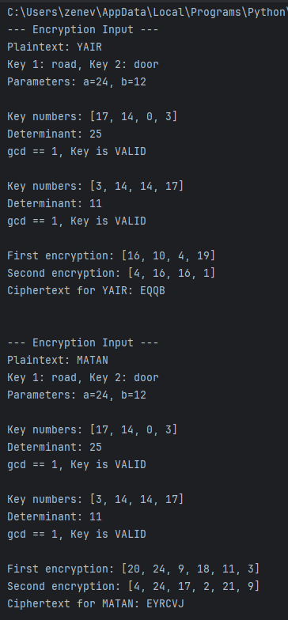

Exercise 1.2 Solution:
import math
def verify_key(k):
# 1. show key
print(f"Key numbers: {k}")
# 2. Formula for 2x2 determinant: (ad - bc)
# Key positions: 0, 1 (row 1)
# 2, 3 (row 2)
det = (k[0] * k[3] - k[1] * k[2]) % 26 # we are in Z 26 space
print(f"Determinant: {det}")
# 3. Check if valid (not 0 and no common factors with 26)
if math.gcd(det, 26) == 1: # det!=0 is included (gcd(0,26) = 26..
print("gcd == 1, Key is VALID\n")
return True
else:
print("gcd != 1, Key is INVALID\n")
return False
def get_inverse_matrix(k):
# Mapping the list to matrix variables:
# [a, b]
# [c, d]
a, b, c, d = k[0], k[1], k[2], k[3]
# 1. Calculate the determinant (ad - bc)
det = (a * d - b * c) % 26
# 2. Find the Modular Inverse of the determinant
# We need a number 'inv' such that (det * inv) % 26 == 1
det_inv = -1
for x in range(1, 26):
if (det * x) % 26 == 1:
det_inv = x
break
# 3. Build the Inverse Matrix: det_inv * adj(K) mod 26
# The adjugate of [[a, b], [c, d]] is [[d, -b], [-c, a]]
inv = []
inv.append((d * det_inv) % 26) # New 'a' position
inv.append((-b * det_inv) % 26) # New 'b' position
inv.append((-c * det_inv) % 26) # New 'c' position
inv.append((a * det_inv) % 26) # New 'd' position
return inv
def NameCipher_decryption(ciphertext, key1, key2, is_padded):
# Student names: Yair, Matan, Y = 24, M = 12
a = 24
b = 12
# Show Input
print(f"--- Decryption Input ---")
print(f"Ciphertext: {ciphertext}")
print(f"Key 1: {key1}, Key 2: {key2}")
print(f"Is Padded Flag: {is_padded}")
print(f"Parameters: a={a}, b={b}\n")
# Convert strings keys to matrix
key1_matrix = []
for char in key1:
number = ord(char.upper()) - ord('A')
key1_matrix.append(number)
key2_matrix = []
for char in key2:
number = ord(char.upper()) - ord('A')
key2_matrix.append(number)
if not verify_key(key1_matrix) or not verify_key(key2_matrix):
return "Decryption failed: One of the keys is invalid"
# Get inverse matrices for decryption
k1_inv = get_inverse_matrix(key1_matrix)
k2_inv = get_inverse_matrix(key2_matrix)
# Convert ciphertext to numbers
cipher_nums = []
for char in ciphertext:
number = ord(char.upper()) - ord('A')
cipher_nums.append(number)
# First Decryption Step: Reverse Key 2 (The last encryption)
step1_nums = []
for i in range(0, len(cipher_nums), 2):
z1 = cipher_nums[i]
z2 = cipher_nums[i+1]
# Substract (a, b) first: (Z - (a, b))
val1 = (z1 - a) % 26
val2 = (z2 - b) % 26
# Multiply by inverse matrix K2
y1 = (val1 * k2_inv[0] + val2 * k2_inv[2]) % 26
y2 = (val1 * k2_inv[1] + val2 * k2_inv[3]) % 26
step1_nums.extend([y1, y2])
print(f"First decryption step: {step1_nums}\n")
# Second Decryption Step: Reverse Key 1
step2_nums = []
for i in range(0, len(step1_nums), 2):
y1_val = step1_nums[i]
y2_val = step1_nums[i+1]
# Substract (a, b)
val1 = (y1_val - a) % 26
val2 = (y2_val - b) % 26
# Multiply by inverse matrix K1
x1 = (val1 * k1_inv[0] + val2 * k1_inv[2]) % 26
x2 = (val1 * k1_inv[1] + val2 * k1_inv[3]) % 26
step2_nums.extend([x1, x2])
print(f"Second decryption step: {step2_nums}\n")
# Convert numbers back to plaintext string
plaintext = ""
for num in step2_nums:
plaintext += chr(num + ord('A'))
if is_padded:
plaintext = plaintext[:-1]
return plaintext
# Run example
print("Plaintext for EQQB:", NameCipher_decryption("EQQB", "road", "door", False))
print("\n")
print("Plaintext for EYRCVJ:", NameCipher_decryption("EYRCVJ", "road", "door", True))
print("\n")

Exercise 1.2 examples of input/output:
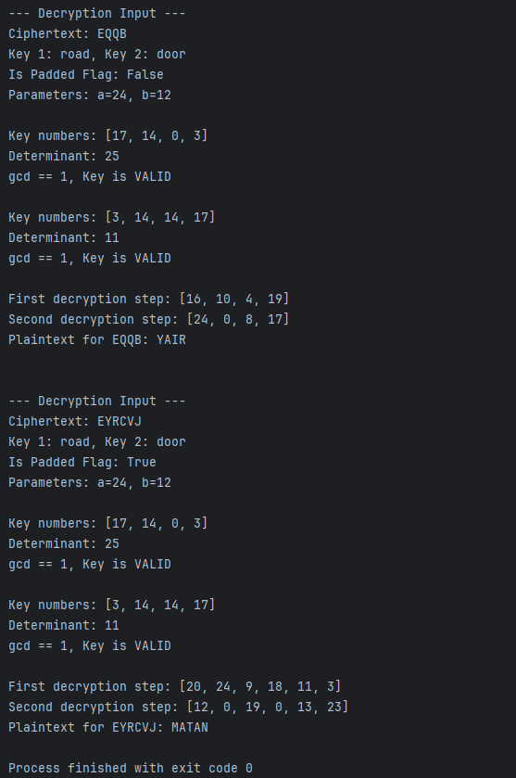
Exercise 1.2 Solution:
import Exercise1_1
final_results = []
def Iterative_Attack(ciphertext, plaintext, key1, key2):
"""
Performs an Iterative Attack using the original function signature.
Matches the exact plaintext length and content.
"""
print(f"--- Starting Iterative Attack for {plaintext} ---")
current_text = ciphertext
iterations = 0
success = False
max_iterations = 30000
while iterations < max_iterations:
iterations += 1
# Calling the original signature
res_text, res_flag = Exercise1_1.NameCipher_encryption(current_text, key1, key2)
current_text = res_text
# If the original plaintext was odd, we compare current_text to plaintext + 'X'
target = plaintext if len(plaintext) % 2 == 0 else plaintext + 'X'
if current_text == target:
success = True
break
print(f"--- Attack Summary ---")
if success:
result_msg = f"Success! Found {plaintext} after {iterations} iterations."
print(result_msg)
final_results.append(result_msg) # שמירה לסיכום הסופי
else:
result_msg = f"Attack failed for {plaintext}. Current state: {current_text}"
print(result_msg)
final_results.append(result_msg)
return iterations
# --- Execution ---
# Example 1: YAIR
Iterative_Attack("EQQB", "YAIR", "road", "door")
print("\n" + "="*40 + "\n")
# Example 2: MATAN
Iterative_Attack("EYRCVJ", "MATAN", "road", "door")
print("\n" + "!" * 20)
print("FINAL RESULTS SUMMARY:")
for res in final_results:
print(res)
print("!" * 20)
Exercise 2 examples of input/output:
Example 1:
- Input Ciphertext: EQQB
- Encryption Keys: road, door
- Output Plaintext: YAIR
- Iterations: 167
Example 2:
- Input Ciphertext: EYRCVJ
- Encryption Keys: road, door
- Output Plaintext: MATAN
- Iterations: 167
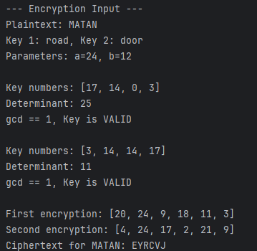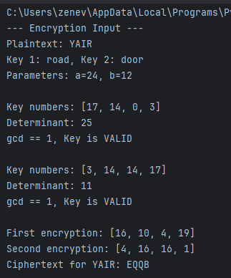
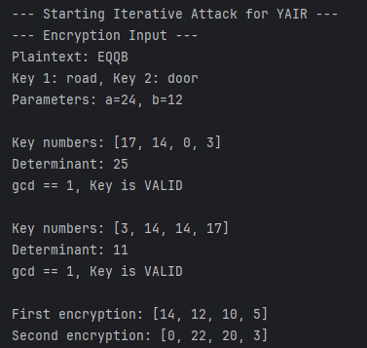
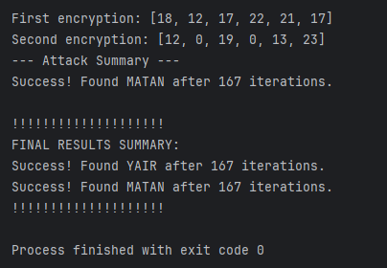

Exercise 3
Yes. For any pair of keys K_1 and K_2, there always exists a single key K_3 that can perform the same encryption.
The encryption process is a mathematical formula that involves two steps:
1. multiplying the text by a key matrix and then adding fixed parameters (a and b).
2. Doing this twice
we can simplify this chain into one single step:
- Instead of multiplying by K_1 and then by K_2, we can multiply by a single matrix K_3.
- The key K_3 is the result of multiplying the two original key matrices:
K_3 = (K_1 * K_2)mod 26
In this Exercise the keys are ("road" and "door"):
- K_1 = (17, 14, 0, 3)
- K_2 = (3, 14, 14, 17)
- Top-Left: $(17 *3 + 14 * 14) = 247 mod 26 = 13
- Top-Right: $(17 * 14 + 14 * 17) = 476 mod 26 = 8
- Bottom-Left: $(0 * 3 + 3 * 14) = 42 mod 26 = 16
- Bottom-Right: $(0 * 14 + 3 * 17) = 51 mod 26 = 25
The Single Key K_3 is:
K_3 = (13, 8, 16, 25)

