

Object oriented programming

**(COURSE CODE: 22CS006)**

Submitted to:

**DR. NAVEEN KUMAR REDDY**

Submitted by:

**YAJAT DUREJA :** 210990970

**VIPASH ARORA :** 2210990964

**VEDESH:** 2210990955

**DEPARTMENT OF COMPUTER SCIENCE & ENGINEERING**

**1. Abstract**

The Stock Management System is designed to efficiently manage inventory by allowing users to add, display, and sell items. It maintains a record of item details such as name, quantity, and price.

**2. Introduction**

The Stock Management System aims to streamline the inventory management process for businesses. It provides functionalities to track available items, their quantities, and prices, enabling easy monitoring and control of stock levels.

**3. Existing System**

Before the implementation of this system, inventory management might have been manual or reliant on basic spreadsheets. It likely lacked real-time updates and comprehensive tracking, leading to inefficiencies and errors in managing stock.

**4. Drawbacks of Existing System**

* Manual data entry prone to errors
* Lack of real-time updates on stock levels
* Difficulty in tracking item movement and sales
* Limited functionalities for quick decision-making

**5. Proposed System**

The proposed system is a software-based Stock Management System that automates inventory control processes. It allows for easy addition, display, and sale of items, providing real-time updates on stock levels.

**6. Advantages of Proposed System**

* Automation reduces human errors in inventory management
* Real-time updates for accurate stock tracking
* Improved decision-making with comprehensive item details
* Easy retrieval of data for analysis and reporting

**7. Modules - Coding Modules**

* **StockItem Class:** Manages item details such as name, quantity, and price.
* **StockManager Class:** Handles functionalities to add items, display stock, and sell items.

**8. Architecture/Design**

The system follows a modular approach, separating item details and management functionalities. It uses a vector-based structure to store and manipulate stock items.

**9. Test Cases**

* **Test Case 1:** Adding an item and verifying its presence in the stock.
* **Test Case 2:** Displaying stock and validating the accuracy of displayed details.
* **Test Case 3:** Selling an item and verifying the reduction in quantity.
* **Test Case 4:** Update price of an item

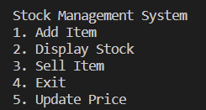**10. Screenshots**

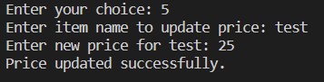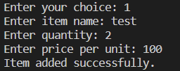

**11. Conclusion and References**

The Stock Management System offers a robust solution for efficient inventory management. By automating processes and providing real-time insights, it enhances control over stock levels, leading to improved decision-making and operational efficiency.

Refrences: Javatpoint, W3schools