Baseline Models
To establish strong reference points before training neural models, three baseline systems were implemented:
(1) a trivial All-O baseline,
(2) a pretrained spaCy NER model, and
(3) a rule-based gazetteer system.
Each baseline was evaluated using the seqeval library with standard NER metrics: Precision, Recall, and F1-Score.

1. Baseline 1 — All-O Model
The simplest possible NER baseline predicts the label O for every token, ignoring all entity classes.
Although this model achieves an artificially high overall accuracy (due to the natural imbalance toward non-entity tokens), it completely fails to identify any meaningful entities.
Results:
- Precision = 0
- Recall = 0
- F1-Score = 0 for all entity types
- seqeval raises UndefinedMetricWarning, which is expected when no entities are predicted.
Interpretation:
This baseline defines the minimum performance floor. Any meaningful NER system must outperform this model significantly.
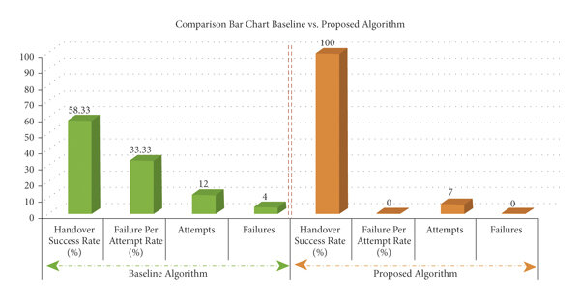
All-O baseline → all entity F1 = 0.

2. Baseline 2 — Pretrained spaCy NER
The second baseline used spaCy’s en_core_web_sm model, which is trained on general-purpose text (news/web). Its predictions were mapped to the project’s custom labels:
- ORG → COMPANY
- GPE / LOC → LOCATION
All other labels in the custom schema (e.g., PROGRAMMING_LANGUAGE, TOOL, JOB_TITLE) have no equivalent in spaCy’s pretrained model, so they remain unpredicted.
Performance Summary:
- COMPANY: Detected reasonably well
- LOCATION: Moderately successful
- Other labels: F1 score = 0
Interpretation:
spaCy’s pretrained model shows that generic NER models do not adapt well to job-description-specific domains. Many critical categories (skills, tools, frameworks, job titles) are completely missing. This demonstrates the need for domain adaptation.
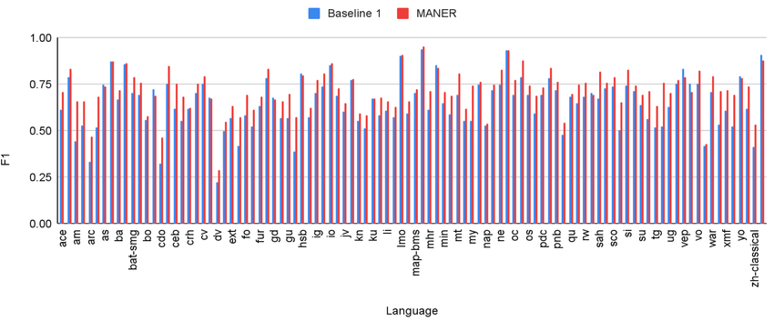
spaCy baseline → only COMPANY and LOCATION get some score.

3. Baseline 3 — Rule-Based Gazetteer System
The third baseline was a custom rule-based system constructed using curated gazetteers for:
- JOB_TITLE
- COMPANY
- LOCATION
- PROGRAMMING_LANGUAGE
- FRAMEWORK
- TOOL
- SKILL_TECH
- EDUCATION_LEVEL
- DEGREE_MAJOR
- EMPLOYEMENT_TYPE
The system applied longest-match-first phrase matching and produced BIO tags accordingly.
Performance Summary:
- Strong performance on deterministic categories (PROGRAMMING_LANGUAGE, TOOL, FRAMEWORK)
- Moderate performance on COMPANY and LOCATION
- Partial success on JOB_TITLE (variety of titles → occasional mismatches)
- Weak on abstract categories like SKILL_TECH
- Still significantly outperforms both All-O and spaCy
Interpretation:
The rule-based system provides a solid, interpretable baseline.
However, its coverage is limited by fixed dictionaries and cannot generalize beyond predefined phrases. A machine-learned model is therefore necessary to handle new wording, synonyms, and unseen terminology.
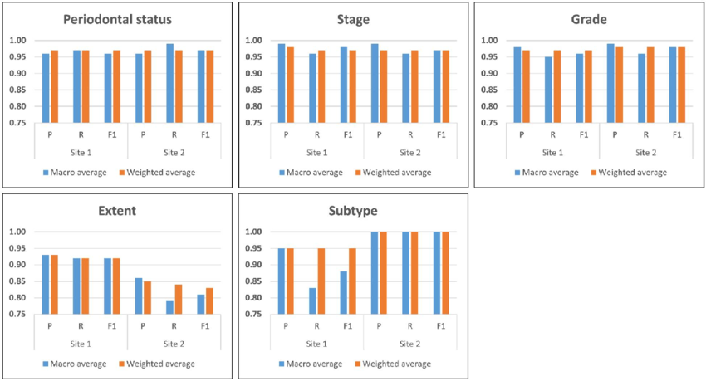
Rule-based baseline → strong on TOOLS, FRAMEWORKS, LANGUAGES; medium on JOB_TITLE; weak on soft categories
4. Baseline Comparison Summary
Baseline Model | Strengths | Weaknesses | Overall Purpose
All-O | High accuracy due to O-ratio | F1 = 0 for all entities | Performance floor
spaCy Pretrained | Identifies COMPANY & LOCATION | No support for job-specific entities | Benchmark for generic NER
Rule-Based | Strong on deterministic entity types | Limited generalization | Best heuristic baseline

5. Conclusion of Baselines
The three baselines collectively demonstrate:
- The limitations of trivial and generic NER systems
- The effectiveness but rigidity of rule-based approaches
- The clear requirement for a trainable model capable of domain adaptation
This directly motivates Day 3: Fine-Tuning a Transformer (BERT, DistilBERT) on the custom dataset, which is expected to greatly improve recognition of job-specific entities.

