Aldo Sanjoto

Assignment3.0 Manual Test Plan

1. In cmd prompt go to PropertyFinder directory and run react-native run-android
2. Also, make sure you have your android emulator running.
3. You should be able to find the app name as PropertyFinder

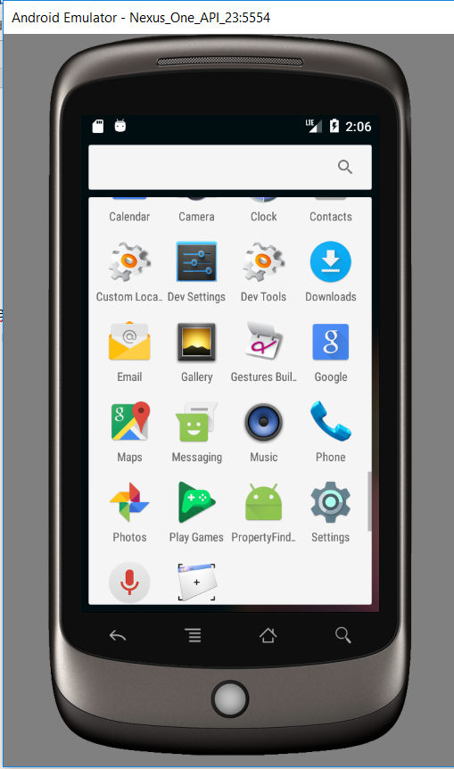

1. Open the app, wait until it loads profile information and you should see the following:

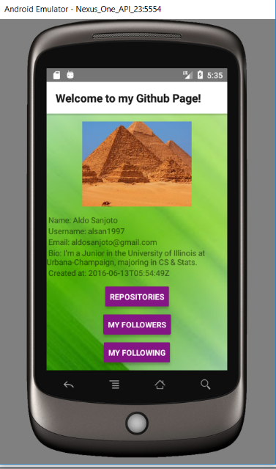

1. There should be 3 clickable buttons Repositories, My followers and My following

Click on each button and make sure each of them will output the following pages:

