Aldo Sanjoto

Sanjoto2

Manual Test Plan – Final Project 1.0

1. Go to spoticool.herokuapp.com and make sure the website looks clean as the following

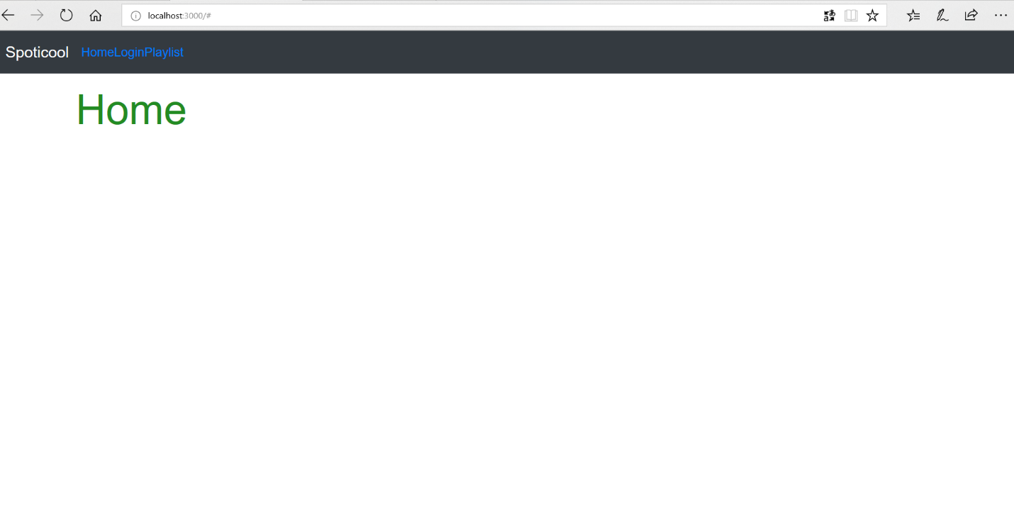

1. There are 3 buttons to navigate Home, Login, Playlist. Each of it should be clickable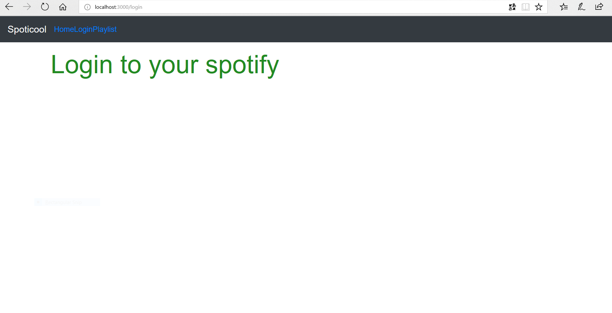
2. The playlist should output the following and filter is functional.

