Aldo Sanjoto

Sanjoto2

MTP1.2

1. Open localhost/3000 and see that the access token is empty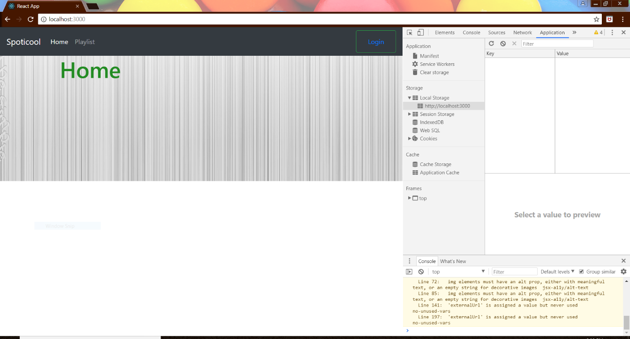
2. Click login and you should have access token filled in localstorage

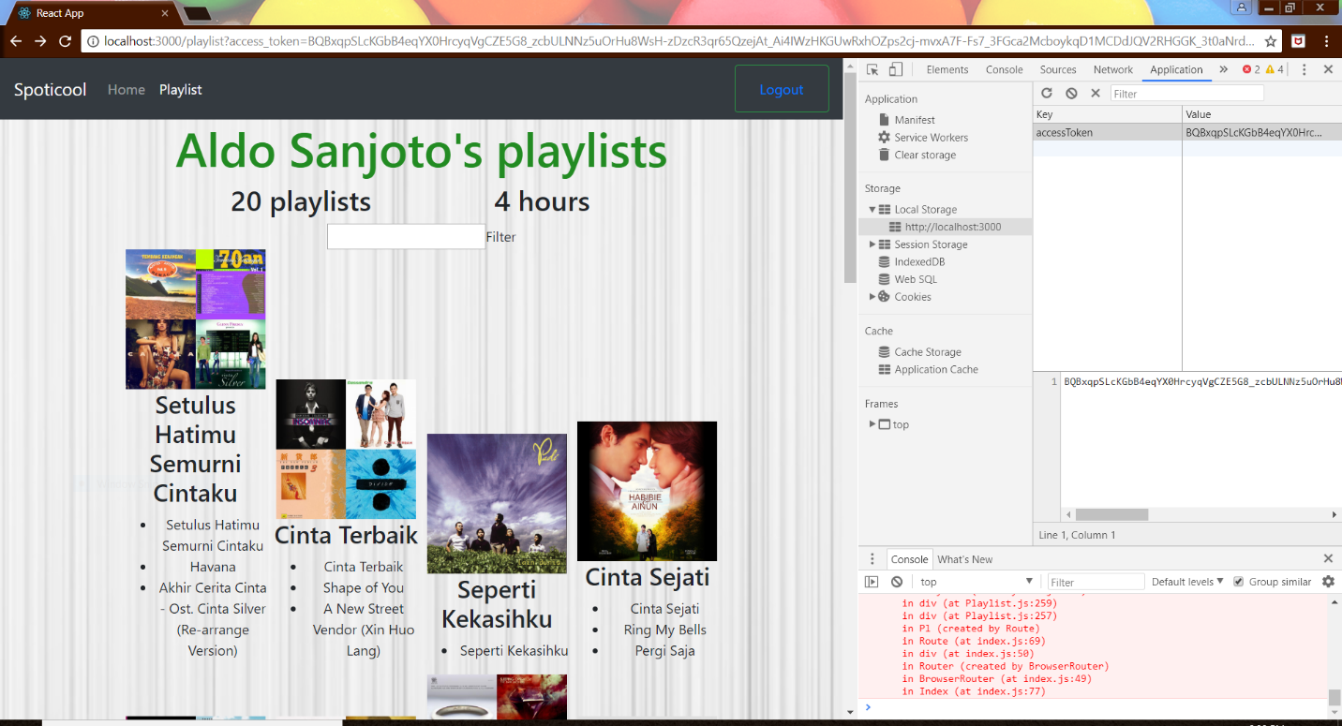

1. Each playlist is clickable

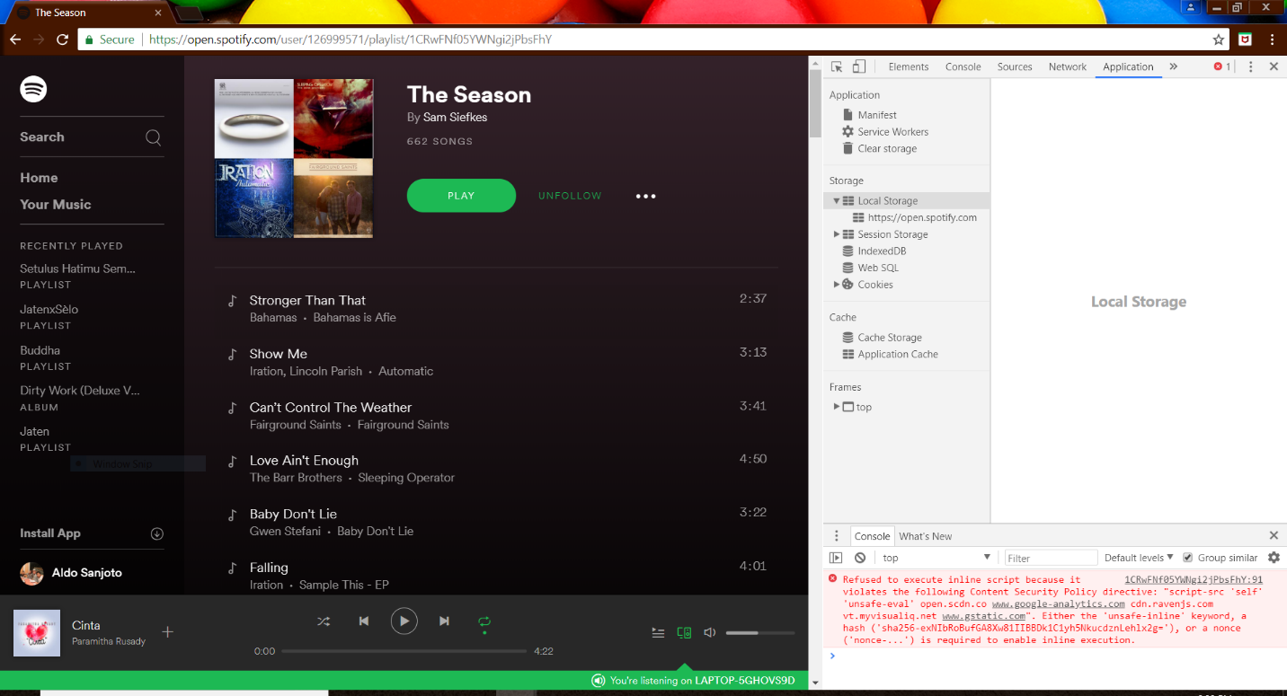

1. When logged out, you should see access_token is empty

