Aldo Sanjoto

Sanjoto2

MTP1.3

1. When logged in, you should see new Tab for the user’s followings artists

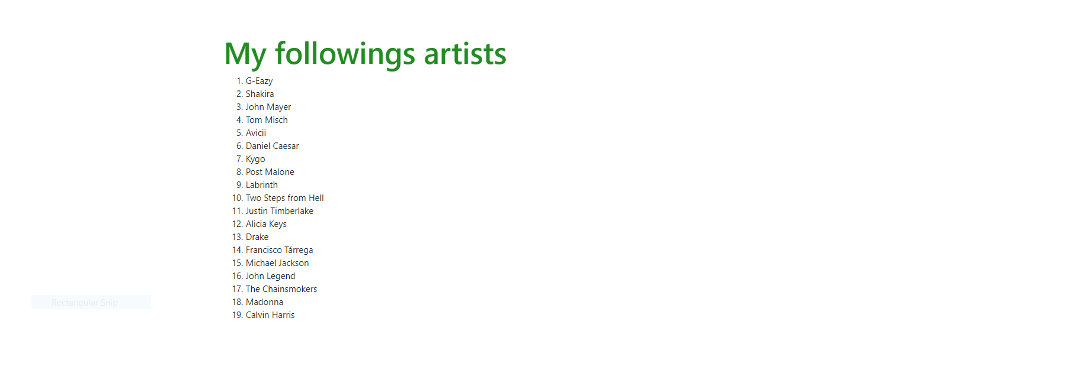

1. Data visualization should appear and shows your favorite genre(Bar chart and Pie chart)

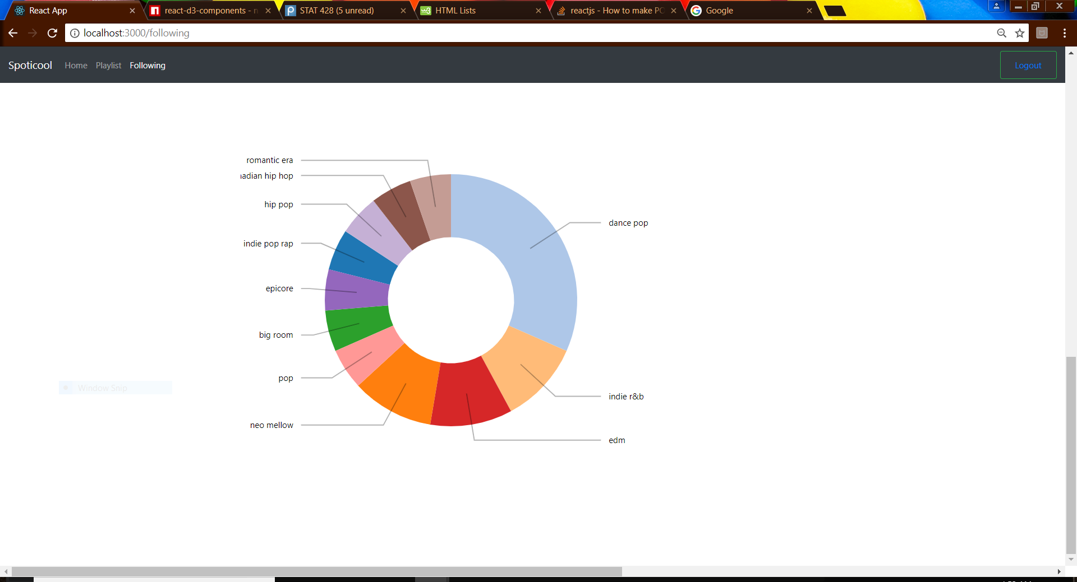

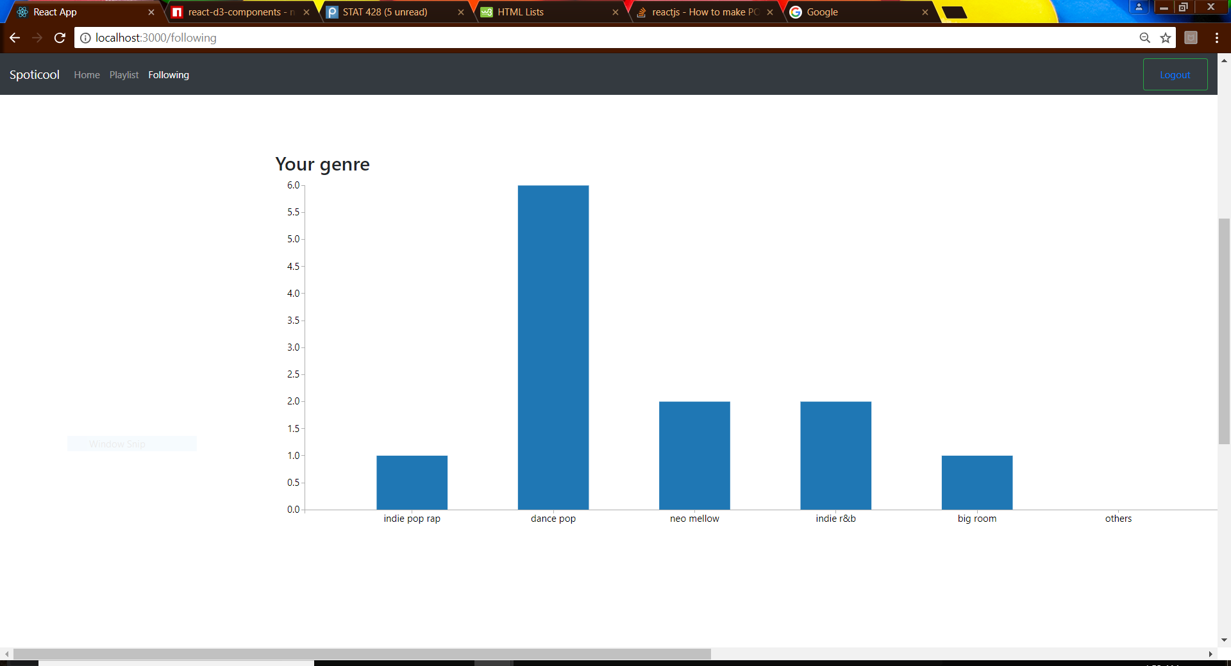

1. For posting API, you should know the tracks ID and your playlist ID

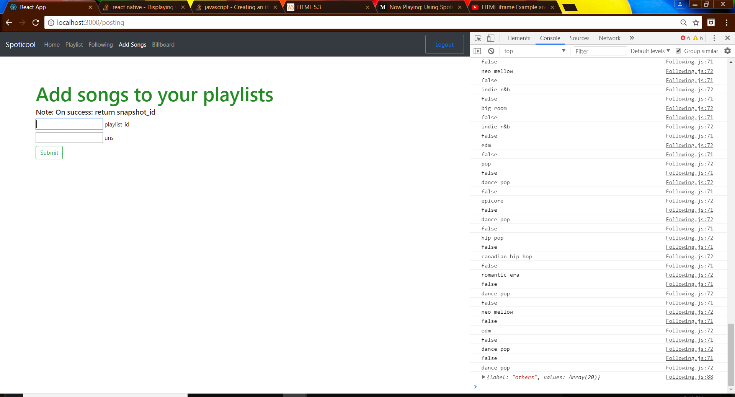

1. On success, you should see an alert of snapshot_id. Check your playlist and see if your song is added.

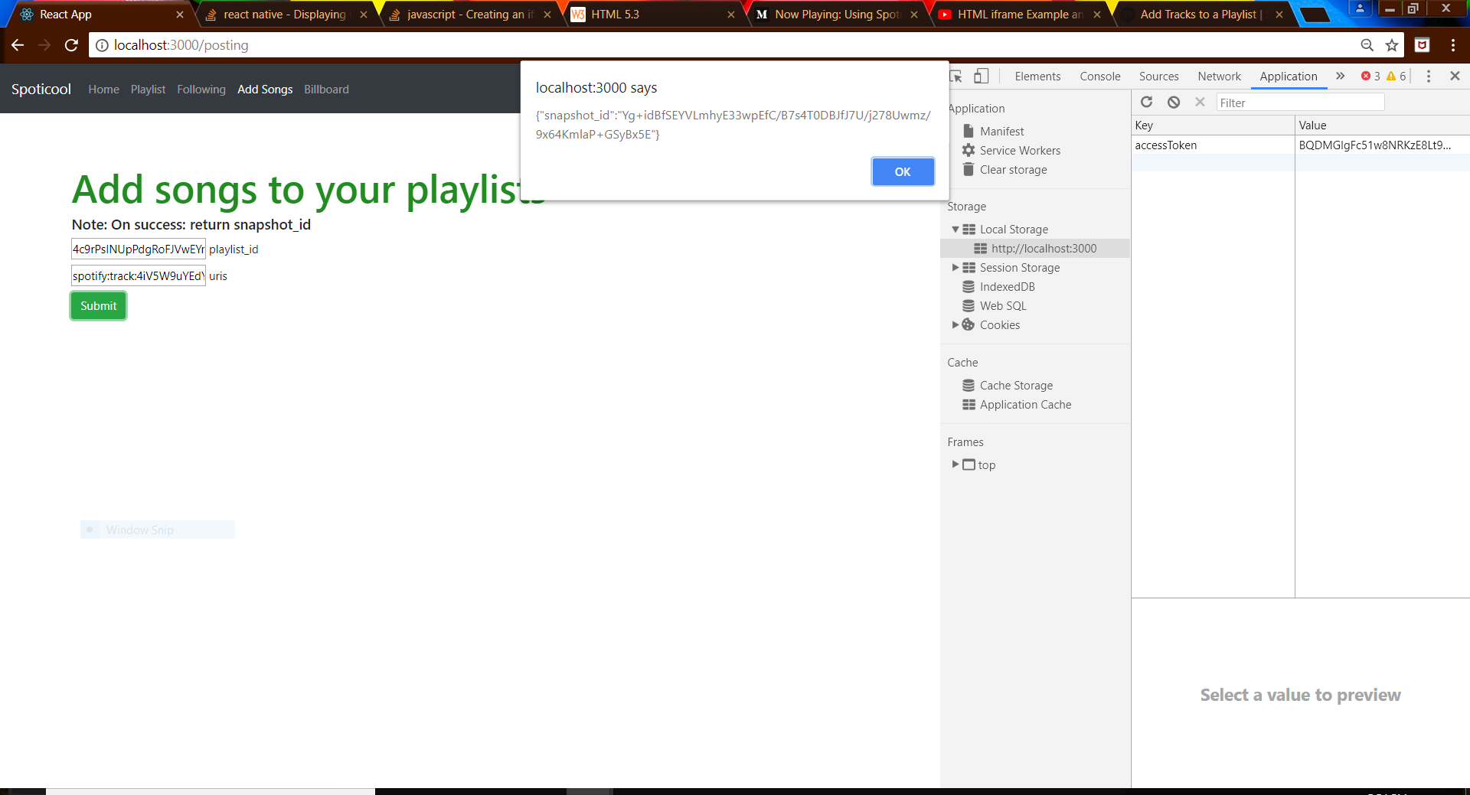

1. To play songs, you can click on button of Top 100 songs on spotify and should pop an iframe that you can play on

