|  |  |
| --- | --- |
| **Ex.No.5**  **22/APR/2019** | **FUNCTION PROGRAMS** |

**Aim:**

To write programs in Python to

1. To print Union of two lists
2. To check whether the number is positive or negative
3. To find the sum of 'n' numbers (eg. 1+2+3+ ....+n)
4. To count the number of vowels, consonants present in the given string

**5a. To print union of two list**

**Algorithm:**

1. Start
2. Read the list l1,l2
3. Call function

Union=union(l1,l2)

1. Print the returned union value
2. Stop

**Union(l1,l2)**

1. Return set(l1+l2)

**Flow Chart:**

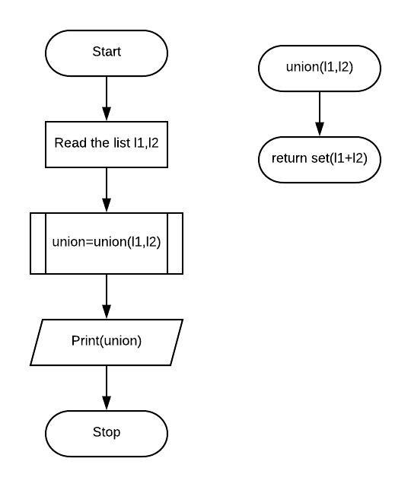

**Coding:**

def union(l1,l2):

return set(l1+l2)

l1= [5,10,15,20,25,30]

l2= [10,20,30]

union= union(l1,l2)

print(union)

**Screen Shots:**

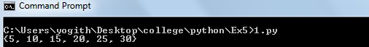

**5b. To check whether the number is positive or negative**

**Algorithm:**

1. Start
2. Read the input(n)
3. Call function

Answer=pos_neg(n)

1. Print the returned answer
2. Stop

**Pos_neg(n)**

1. if n is greater than zero

return "The number is positive"

1. elseif n is lesser than zero

return "The number is negative"

1. else n is equal to zero

return "The number is neutral"

**Flow Chart:**

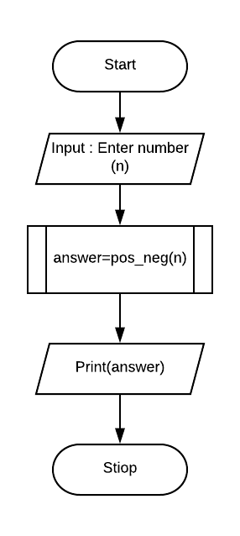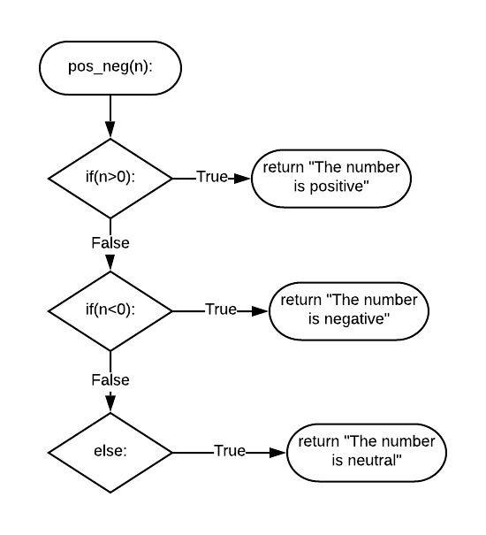

**Coding:**

def pos_neg(n):

if(n>0):

return "The number is positive"

elif(n<0):

return "The number is negative"

else:

return "The number is neutral"

n=int(input("Enter number : "))

answer=pos_neg(n)

print(answer)

**Screen Shots:**

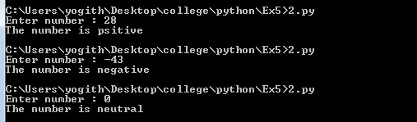

**5c. To find the sum of n numbers**

**Algorithm:**

1. Start
2. Read the input(n)
3. Call function

sum=sum_n_numbers(n)

1. Print the returned sum
2. Stop

**Sum_n_numbers(n)**

1. Assume x=0
2. Compute the range of i as (n+1)
   * 1. Calculate x=x+i
3. Return the value of x

**Flow chart :**

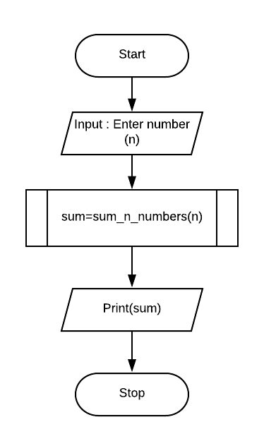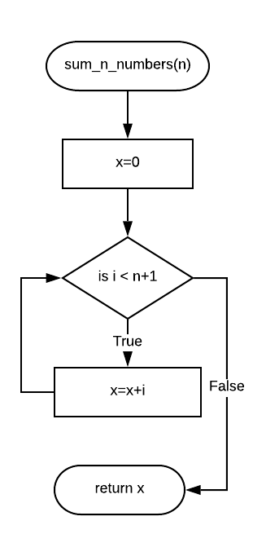

**Coding :**

def sum_n_numbers(n):

x=0

for i in range(n+1):

x=x+i

return x

n=int(input("Enter number : "))

sum=sum_n_numbers(n)

print("The sum of series is ",sum)

**Screesn shot :**

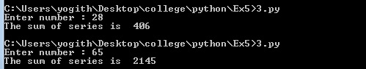

**5d. To count the number of vowels, consonants present in the given string**

**Algorithm:**

1. Start
2. Read the input string (x)
3. Assume v=0 and c = 0
4. Call function

v,c=count(x,v,c)

1. Print the returned value of v,c
2. Stop

**Count(x,v,c)**

1. Compute the range of i as length of string x
   * 1. If x[i] equal to any vowel
        1. Increment the value of v by 1
     2. Else
        1. Increment the value of c by 1
2. Return the value of v and c

**FlowChart:**

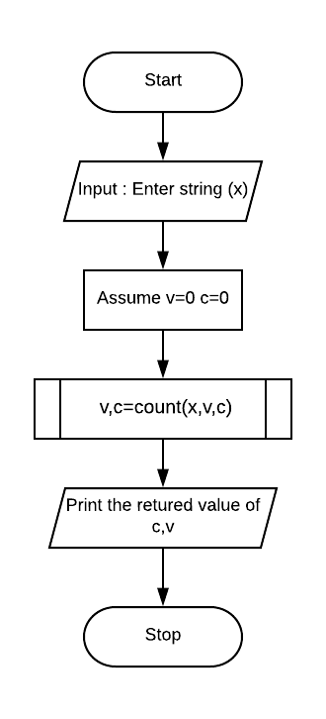

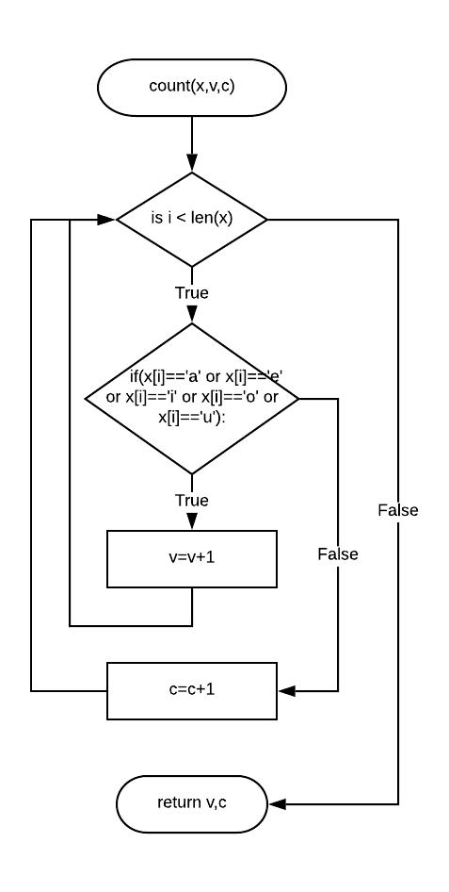

**Coding :**

def count(x,v,c):

for i in range(len(x)):

if(x[i]=='a' or x[i]=='e' or x[i]=='i' or x[i]=='o' or x[i]=='u'):

v=v+1

else:

c=c+1

return v,c

x=input("Enter string : ")

v=0

c=0

v,c=count(x,v,c)

print("The number of vowel is ",v)

print("The number of consonent is",c)

**Screen shot :**

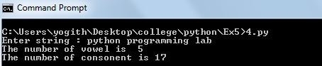

**Result:**

Thus the programs

1. To print Union of two lists
2. To check whether the number is positive or negative
3. To find the sum of 'n' numbers (eg. 1+2+3+ ....+n)
4. To count the number of vowels, consonants present in the given string

are written in Python and the results are verified.

**Assessment Rubrics for Ex 5:**

|  |  |  |
| --- | --- | --- |
| **Parameters** | **Allotted Grade Points** | **Actual Score** |
| Selection of Problem (programs not from the previously lab classes) | 5 |  |
| Use of function concepts (parameter passing, return values, naming of a function, etc) | 5 |  |
| Use of different data types like numbers, strings, list, etc for parameter passing | 5 |  |
| Demonstration of scoping of variables (local, global, nonlocal) | 5 |  |
| Completion on time | 10 |  |
| Viva (Online Test) | 10 |  |
| Adherence to the template for documentation (Record) | 10 |  |
| **Total** | **50** |  |
| **Signature of the Faculty with Date** |  | |