Ex.No.6  12/04/2019 | Dictionary
1a. Write a Python script to sort (ascending and descending) a dictionary by value.
Coding:
import operator
d = {1: 2, 3: 4, 4: 3, 2: 1, 0: 0}
print('Original dictionary : ',d)
sorted_d = sorted(d.items(), key=operator.itemgetter(0))
print('Dictionary in ascending order by value : ',sorted_d)
sorted_d = sorted(d.items(), key=operator.itemgetter(0),reverse=True)
print('Dictionary in descending order by value : ',sorted_d)

Screen Shot:

1b. Write a Python script to add a key to a dictionary

Coding:
d = {0:10, 1:20}
print(d)
d.update({2:30})
print(d)

Screen Shot:

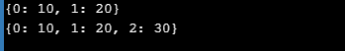

1c. Write a Python script to concatenate following dictionaries to create a new one.
Coding:
dic1={1:10, 2:20}
dic2={3:30, 4:40}
dic3={5:50,6:60}
dic4 = {}
for d in (dic1, dic2, dic3): dic4.update(d)
print(dic4)

Screen Shot:
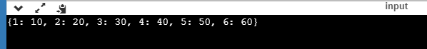
1d. Write a Python script to check if a given key already exists in a dictionary.
Coding:
d = {1: 10, 2: 20, 3: 30, 4: 40, 5: 50, 6: 60}
def is_key_present(x):
if x in d:
print('Key is present in the dictionary')
else:
print('Key is not present in the dictionary')
is_key_present(5)
is_key_present(9)

Screen Shot:
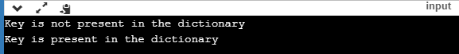

1e. Write a Python program to iterate over dictionaries using for loops.

Coding:
d = {'Red': 1, 'Green': 2, 'Blue': 3}
for color_key, value in d.items():
print(color_key, 'corresponds to ', d[color_key])

Screen Shot:
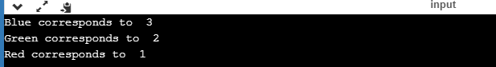

1f. Write a Python script to generate and print a dictionary that contains a number (between 1 and n) in the form (x, x*x).
Coding:
n=int(input("Input a number "))
d = dict()
for x in range(1,n+1):
d[x]=x*x
print(d)

Screen Shot:
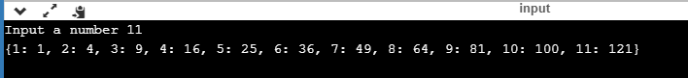

1g. Write a Python script to print a dictionary where the keys are numbers between 1 and 15 (both included) and the values are square of keys.

Coding:
d=dict()
for x in range(1,16):
d[x]=x**2
print(d)

Screen Shot:

1h. Write a Python script to merge two Python dictionaries.
Coding:
d1 = {'a': 100, 'b': 200}
d2 = {'x': 300, 'y': 200}
d = d1.copy()
d.update(d2)
print(d)

Screen Shot:
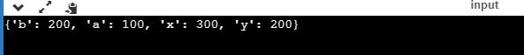

1i. Write a Python program to iterate over dictionaries using for loops

Coding:
d = {'Red': 1, 'Green': 2, 'Blue': 3}
for color_key, value in d.items():
print(color_key,",", d[color_key])

Screen Shot:
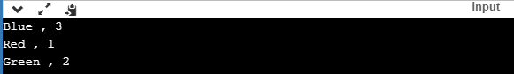

1j. Write a Python program to sum all the items in a dictionary.

Coding:
dict= {'1st':187,'2nd':-28,'3rd':243}
print(sum(dict.values()))

Screen Shot:

1k. Write a Python program to multiply all the items in a dictionary.

Coding:
d={'A':10,'B':10,'C':128}
tot=1
for i in d:
tot=tot*d[i]
print(tot)

Screen Shot:
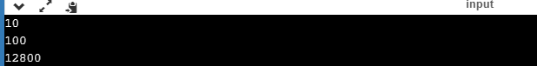

1l. Write a Python program to remove a key from a dictionary.

Coding:
Dict = {'a':1,'b':2,'c':3,'d':4}
print(Dict)
if 'a' in Dict:
del Dict['a']
print(Dict)

Screen Shot:

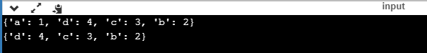

1m. Write a Python program to map two lists into a dictionary.

Coding:

keys = ['red', 'green', 'blue']
values = ['#FF0000','#008000', '#0000FF']
color_dictionary = dict(zip(keys, values))
print(color_dictionary)

Screen Shot:

1n. Write a Python program to sort a dictionary by key.

Coding:
color_dict = {'red':'#FF0000',
'green':'#008000',
'black':'#000000',
'white':'#FFFFFF'}
for key in sorted(color_dict):
print("%s: %s" % (key, color_dict[key]))

Screen Shot:
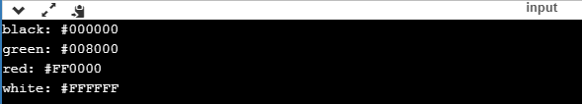

1o. Write a Python program to get the maximum and minimum value in a dictionary.

Coding:
my_dict = {'x':500, 'y':587, 'z': 560, 'a': 123, 'b': 28, 'c' : 612 }
key_max = max(my_dict.keys(), key=(lambda k: my_dict[k]))
key_min = min(my_dict.keys(), key=(lambda k: my_dict[k]))
print('Maximum Value: ',my_dict[key_max])
print('Minimum Value: ',my_dict[key_min])

Screen Shot:

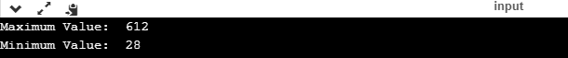

1p. Write a Python program to get a dictionary from an object's fields.

Coding:
class dictObj(object):
def __init__(self):
self.x = 'red'
self.y = 'Yellow'
self.z = 'Green'
def do_nothing(self):
pass
test = dictObj()
print(test.__dict__)

Screen Shot:

1q. Write a Python program to get the top three items in a shop.

Coding:
from heapq import nlargest
from operator import itemgetter
items = {'item1': 45.50, 'item2':35, 'item3': 41.30, 'item4':55, 'item5': 24}
for name, value in nlargest(3, items.items(), key=itemgetter(1)):
print(name, value)

Screen Shot:

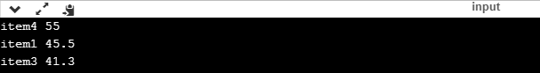

1r. Write a Python program to print a dictionary line by line.

Coding:
students = {'Sowmiyan':{'class':'IX',
'rolld_id':28},
'Ajith':{'class':'VII',
'roll_id':4}}
for a in students:
print(a)
for b in students[a]:
print (b,':',students[a][b])

Screen Shot:
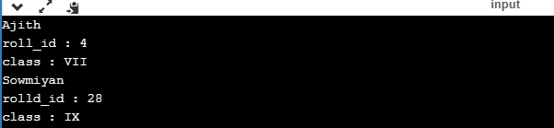

1s. Write a Python program to count number of items in a dictionary value that is a list.

Coding:
dict = {'Alex': ['subj1', 'subj2', 'subj3',’subj4’], 'David': ['subj1', 'subj2']}
ctr = sum(map(len, dict.values()))
print(ctr)

Screen Shot:

1t. Write a Python program to replace dictionary values with their sum.

Coding:
def sum_math_v_vi_average(list_of_dicts):
for d in list_of_dicts:
n1 = d.pop('V')
n2 = d.pop('VI')
d['V+VI'] = (n1 + n2)/2
return list_of_dicts
student_details= [
{'id' : 1, 'subject' : 'math', 'V' : 70, 'VI' : 82},
{'id' : 2, 'subject' : 'math', 'V' : 73, 'VI' : 74},
{'id' : 3, 'subject' : 'math', 'V' : 75, 'VI' : 86}
]
print(sum_math_v_vi_average(student_details))

Screen Shot:

Assessment Rubrics for Ex 6:
Parameters | Allotted Grade Points | Actual Score
Dictionary and its functions | 10
Array and its functions | 10
Mutability/Immutability by Lists/Tuples operations | 10
Viva (Online Test) | 10
Adherence to the template for documentation (Record) | 10
Total | 50
Signature of the Faculty with Date

