Ex.No.7  22/AP/2019 | SET OPERATIONS

Aim:
To write programs in Python to
Write a program to perform the following operations:
- Union of two sets (A) U (B)
- Intersection of two sets
- Superset of a set
- Remove duplicates from the set
Algorithm:
- Start
- Assign A={1,2,3,4 and B={4,6,2,7}
- Get the choice of input from the user
- If C is equal to yes, print the union of A and B
- If C is equal to yes, print the intersection of A and B
- If C is equal to yes, print the superset of A and B
- If C is equal to yes
- Get the input from the user as x
- Remove x from the set A
- Print A
- End

Flow Chart:
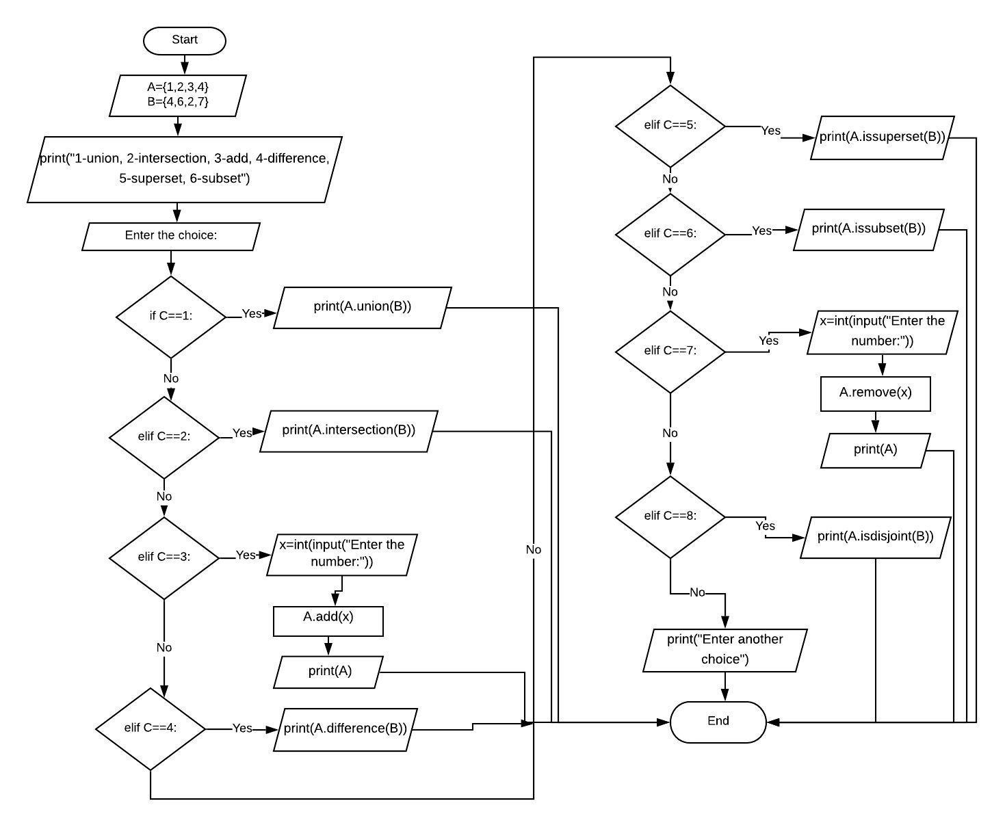
Coding:
print("Set Programs")
print()
for i in range(0,4):
if (i==0):
n=input("Want to find union of set : ")
print()
if (n=="yes"):
print("UNION OS SET")
print()
s1={1,2,3,4,5,6,7,8,9,10}
s2={2,4,6,8,12,28}
c=s1.union(s2)
print(c)
else:
continue
print()
if (i==1):
n=input("Want to find intersection of set : ")
print()
if (n=="yes"):
print("INTERSECTION OF SET")
print()
s1={1,2,3,4,5,6,7,8,9}
s2={2,4,6,8}
c=s1.intersection(s2)
print(c)
else:
continue
print()
if(i==2):
n=input("Want to find Eradicate the duplication in set : ")
print()
if (n=="yes"):
print("DUPLICATING THE SET")
print()
s1={1,2,3,4,5,6,7,8,9,2,4,6,8,10,13,25,25,28}
s2={1}
for i in s1:
if i in s2:
continue
else:
s2.add(i)
print(s2)
else:
continue
print()
if(i==3):
n=input("Want to find superset : ")
print()
if (n=="yes"):
print("SUPERSET OF SET")
print()
s1={1,2,3,4,5,6,7,8,9}
s2={2,4,6,8}
c=s1.issuperset(s2)
print(c," Set-1 is superset of Set-2.")
print()
d=s2.issuperset(s1)
print(d," Set-2 is not a superset of Set-1.")
else:
continue

Screen Shots:
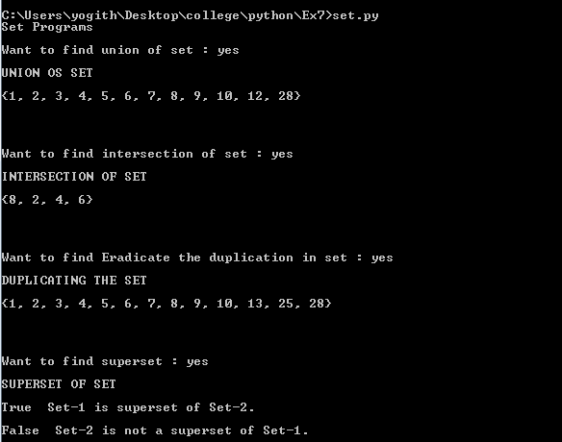

Result:
Thus the programs to
Write a program to perform the following operations:
Union of two sets (A) U (B)
Intersection of two sets
Superset of a set
Remove duplicates from the set

