Ex.No.9  13/Apr/2019 | PROBLEM SOLVING TECHNIQUES

Aim:
To write programs in Python to
- Print the points of the runner
b. To extract digits from a paragraph
c. To find G.C.,D of two numbers
d. Solve Pascal’s triangle

1a.To print the score of runners given the score of n teams:
Algorithm:
STEP 1: Start
STEP 2:Enter the points of every team in list
STEP 3:Sort the list
STEP 4:Print the second last element as the score of runner
STEP 5:Stop

FLOWCHART:
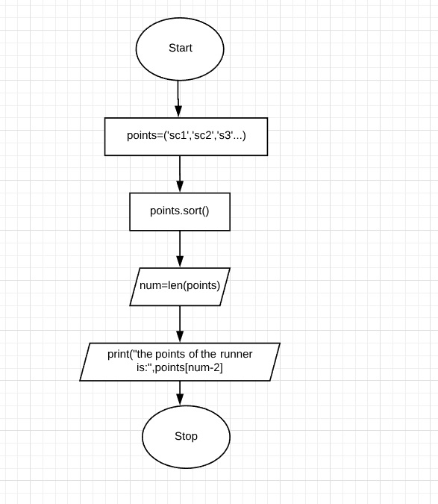

CODING:
points=['78','67','33','68','90','95','87','92','28','88']
points.sort()
print(points)
num=len(points)
print("the points of the runner is",points[num-2])

SCREENSHOT:
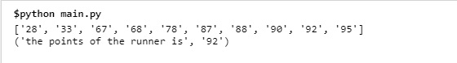
2b.To extract numbers from a given paragraph:
ALGORITHM:
STEP 1: Start
STEP 2:Read the paragraph as input from the user
STEP 3:split the paragraph to convert it as a list
STEP 4:Iterate and check every item in the list for digits
STEP 5:Print the item if it is a digit
STEP 6:Stop

FLOWCHART:
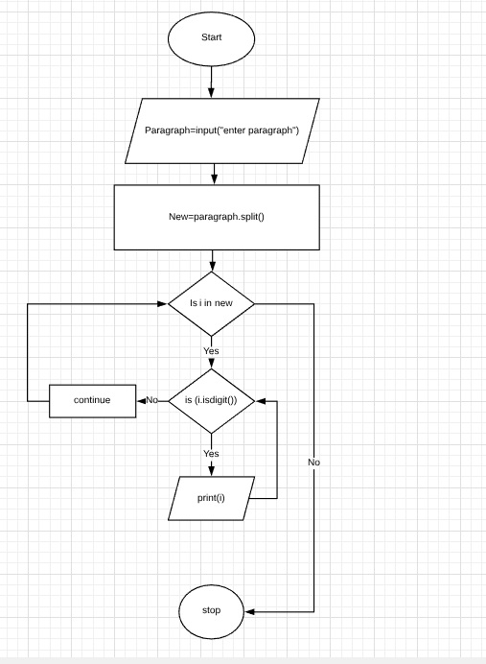

CODING:
Paragraph=input("enter pargraph")
new=Paragraph.split()
for i in new:
if(i.isdigit()):
print(i)
else:
Continue

SCREENSHOT:
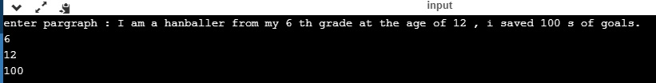

3c.To find GCD OF TWO NUMBERS:

ALGORITHM:
STEP1:Start
STEP2:Get two inputs from the user and create two empty sets s1 and s2
STEP 3:Loop twice in the range of 2 to the num+2
STEP4:Divide the number for every iteration if the loop condition is satisfied and add the quotient of the two loops to set 1 and 2
STEP 5:Find the intersection of two sets and print the output as the G.C.D.
STEP6 :Stop

FLOWCHART:
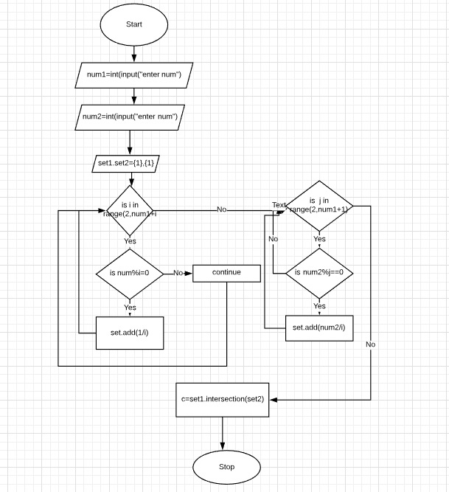

CODING:
num1=int(input("enter num 1:"))
num2=int(input("enter num 2:"))
set1={1}
set2={1}
for i in range(2,num1+1):
if(num1%i==0):
set1.add(num1/i)
else:
continue
for j in range(2,num2+1):
if (num2%j==0):
set2.add(num2/j)
c=set1.intersection(set2)
print("G.C.D IS:",max(c))

SCREENSHOT:

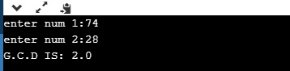

4d. To print Pascal’s triangle:
Algorithm:
- start
- Read number of rows to be printed.
- Loop untill the range
- Append the value of i if the statement is true.
- Create a nested for loop in the range 1 to i
- Append a[i-1][j-1]+a[i-1][j] if the condition is satisfied
- Create another for loop in the range n and nested loop j in range i+1
- stop

Flow Chart:
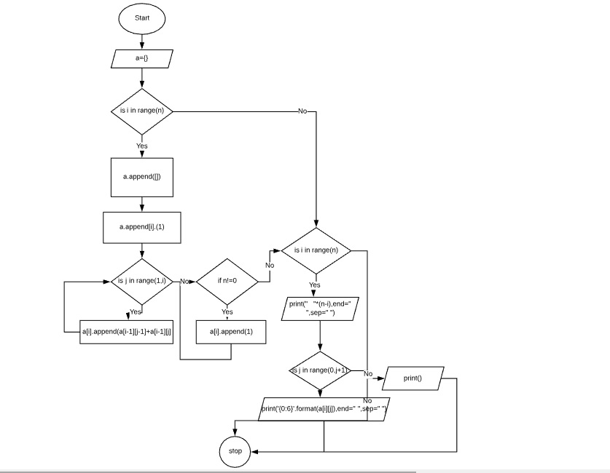
Coding:
n=int(input("Enter number of rows: "))
a=[]
for i in range(n):
a.append([])
a[i].append(1)
for j in range(1,i):
a[i].append(a[i-1][j-1]+a[i-1][j])
if(n!=0):
a[i].append(1)
for i in range(n):
print(" "*(n-i),end=" ",sep=" ")
for j in range(0,i+1):
print('{0:6}'.format(a[i][j]),end=" ",sep=" ")
print()

Screen Shots:
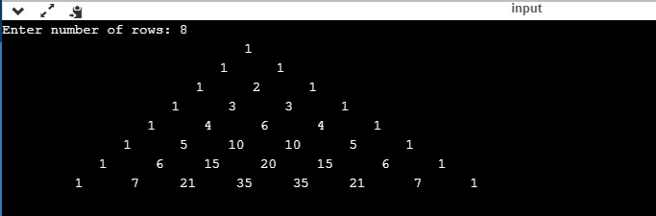

Result:
Thus the programs to
- Print the points of the runner
b. To extract digits from a paragraph
c. To find G.C.,D of two numbers
d. Solve Pascal’s triangle
are written in Python and the results are verified.
