Attendance Management System (AMS)
Complete Developer Handover and Technical Architecture Manual
Table of Contents

ATTENDANCE MANAGEMENT SYSTEM (AMS)
Complete Developer Handover & Technical Architecture Manual
Version: 1.0 - Consolidated Master Edition Prepared: August 2026 Scope: Full source code, database schema, business rules, and maintenance procedures for the AMS ASP.NET WebForms + Oracle application.

How to use this manual
This is a single, self-contained reference. It merges all 13 individually authored chapters of the original developer-handover set into one document, cross-checks each chapter against the actual project source code (attendence.zip), and adds a final chapter covering items that existed in the codebase but were not yet documented, along with maintenance and security recommendations.
A new engineer with zero prior exposure to this project should be able to:
- Understand what the system does and who uses it (Chapter 0).
- Understand every database table and how they relate (Chapter 1).
- Understand the shared code every page depends on (Chapter 2).
- Walk through each functional module page-by-page (Chapters 3-11).
- Follow ready-made recipes to safely add fields, pages, or change business rules (Chapter 12).
- See what is not covered by the original documentation, and what to fix before relying on it in production (Chapter 13 - new).
- Use the glossary at the end as a fast lookup for status codes, role codes, and session variables.
No prior knowledge of this codebase is assumed anywhere in this document.

Foreword: Documentation Set Overview & Quick Start
Welcome to the complete developer handover and technical architecture suite for the Attendance Management System (AMS).
This documentation has been systematically generated to ensure that any software engineer can fully understand, debug, maintain, and extend the entire application independently without requiring assistance from the original author.

📚 Master Chapter Index
Chapter | Title | Focus Area & Key Topics
00 | Master Index & System Architecture | High-level system topology, technology stack (.NET 4.5 WebForms, C#, Oracle, LDAP), request lifecycle, session dictionary, and role hierarchy (Roles 0-7).
01 | Complete Database Schema & Data Dictionary | Complete ER diagram, 25+ Oracle tables, fields, constraints, foreign keys, sequences, triggers, composite indexes, and seed records.
02 | Core Utilities, Data Layer & Authentication Engine | Deep dive into DBHelper.cs (connection pooling, background auto-closing), ActionLogger.cs (reversible JSON state snapshots), and ADHelper.cs (LDAP binding).
03 | Authentication & Global Layout Engine | Login.aspx + Login.aspx.cs authentication flow, role selection modal, session setup, and Site.Master dynamic navigation/notification badges.
04 | Attendance Management (Part 1: Core Grid & Business Logic) | Monthly attendance grid matrix, status codes (P, A, L, UL, H, S), Auto-Saturday rule, public holiday backfill, and working days calculations.
05 | Attendance Management (Part 2: Sub-User Drafts & Auditing) | Staged sub-user draft pipeline (AttendanceDraft), Anchor POC review/commit, retrospective edit window policies, right-click cell remarks, and audit trail.
06 | Employee Lifecycle & Master Management | Employee master records, multi-stint engagements (EmployeeEngagements), contract extensions, leave credit ledger (EmployeeLeaveCredits), resignations, and undo history.
07 | Contracts & Vendor Ecosystem | Vendor registry, dynamic multi-level escalation contacts (VendorContacts), GeM contract periods (ContractPeriods), extensions, and background auto-close.
08 | Payroll Calculations, Wage Orders & Statutory Engine | Government wage orders (WageOrders, CategoryWages), statutory EPF/GST math (StatutoryOrders), attendance reconciliation, and manual overrides (CalculationOverrides).
09 | Automated Document Generation & Certificate Engine | Dynamic generation of Satisfactory Certificates, Covering Letters, Format 8, and Attendance Certificates using customizable placeholder templates (CertificateTemplates).
10 | Administration, Hierarchical Categories & Security Policies | User role administration (AppUsers), division assignments (UserDivisions), sub-user anchors (SubUserAnchor), category sharing (CategoryShareGrant), and edit/view policies.
11 | Communication, Notices, Remarks & Financial Ledger | Official circulars board with read receipts (Notices, NoticeReads), POC-to-Admin attendance correction request tickets (AttendanceRemarks), and financial ledger.
12 | Developer Recipe & Modification Handbook | Step-by-step recipes: Adding new DB fields, adding new pages, altering wage formulas, configuring LDAP, Oracle pooling troubleshooting, and deployment guide.

🛠️ Quick Start Guide for New Developers
- Prerequisites:
  - Microsoft Visual Studio 2019+ or MSBuild (.NET Framework 4.5)
  - Oracle Database 11g R2 / 12c / 19c / XE
  - Microsoft IIS (for production deployment)
- Database Setup: Run oracle_setup.sql as SYSTEM in your Oracle SQL client.
- Local Authentication: Log in with username 1001 (Admin) or 1002 (POC). Any password is accepted under local offline testing mode.

Chapter 00: Master Index & System Architecture
This document serves as the foundational architectural specification and developer handover reference for the Attendance Management System (AMS). Any new software engineer or system administrator maintaining, debugging, or enhancing this application should begin here.

1. System Overview & Core Objectives
The Attendance Management System (AMS) is an enterprise-grade ASP.NET Web Forms web application backed by an Oracle Database and integrated with Windows Active Directory (LDAP).
The system is designed for organizations managing large outsourced manpower forces across multiple divisions, vendor contracts, skill tiers, and statutory wage revisions.

Key Capabilities
- Multi-Role Authentication & Access Control: Dual-mode authentication (Active Directory LDAP with Oracle DB user profile synchronization) supporting Super Admins, Category Admins, Directorate POCs (Point of Contact), and Sub Users (Data Entry).
- Hierarchical Category & Tier Architecture: Flexible organizational classification (Main Category -> Tiers/Skill Levels e.g. Skilled, Semi-Skilled, Unskilled) with fine-grained admin category ownership and cross-admin category delegation/sharing.
- Dynamic Attendance Matrix & Rule Engine: Monthly grid attendance recording, automatic Saturday rule calculation, holiday propagation, right-click cell edit remarks, and multi-tier edit/view restrictions (cutoff dates, allowed retrospective days).
- Staged Sub-User Workflow: Sub-users stage draft attendance records in AttendanceDraft; Anchor POCs review, verify, and commit them into live Attendance.
- Manpower Vendor & Multi-Level Escalation Ecosystem: Central vendor master linked to GeM (Government e-Marketplace) contracts, contract periods with auto-closing backgrounds, and dynamic multi-level contact escalation matrices.
- Dynamic Payroll & Statutory Calculation Engine: Automated wage calculation based on government wage orders, tier-specific rates, overtime rules, final days overrides, and statutory deductions (EPF, ESI, GST) with revision history.
- Dynamic Certificate & Document Generation: Automated production of legal documents including Satisfactory Certificates, Covering Letters, Attendance Certificates, and Format 8 with customizable placeholder templates.
- Comprehensive Audit Trail & History Tracking: Multi-level audit logging (Attendance_Audit_Log, EmployeeActionLogs, AdminActionLog, ActionLog) with pre/post JSON snapshots and undo capabilities.

2. Technology Stack & Specifications
Component | Technology / Library | Specification / Version | Role in Application
Framework | Microsoft .NET Framework | v4.5 (System.Web, WebForms) | Server-side execution runtime and page lifecycle engine
Language | C# | 5.0 / .NET 4.5 syntax | Backend logic, event handlers, and data access layer
Database | Oracle Database | 11g R2 / 12c / 19c / XE | Relational persistence, sequences, triggers, composite indexes
DB Driver | Oracle.ManagedDataAccess | 4.121.2.0 (Fully managed) | Managed Oracle ADO.NET connection provider (zero Oracle Client install)
Directory Service | Microsoft Active Directory | LDAP 3.0 (DirectorySearcher) | Corporate Single Sign-On and employee directory lookup
Authentication | ASP.NET Forms Authentication | Cookies (.ASPXAUTH), 1440m timeout | Session tracking and authenticated route gating (deny users="?")
Frontend UI | HTML5, Vanilla CSS3, JS | Responsive layout, modern CSS | Presentation layer, dynamic grid rendering, modals, DOM scripting
Icons & Fonts | FontAwesome 5 / 6, Google Fonts | Inter, Outfit, Roboto | Premium visual iconography and typography
Web Server | Microsoft IIS | 7.5 / 8.5 / 10.0 | Production HTTP server, static compression, MIME configuration

3. Project Directory & File Structure
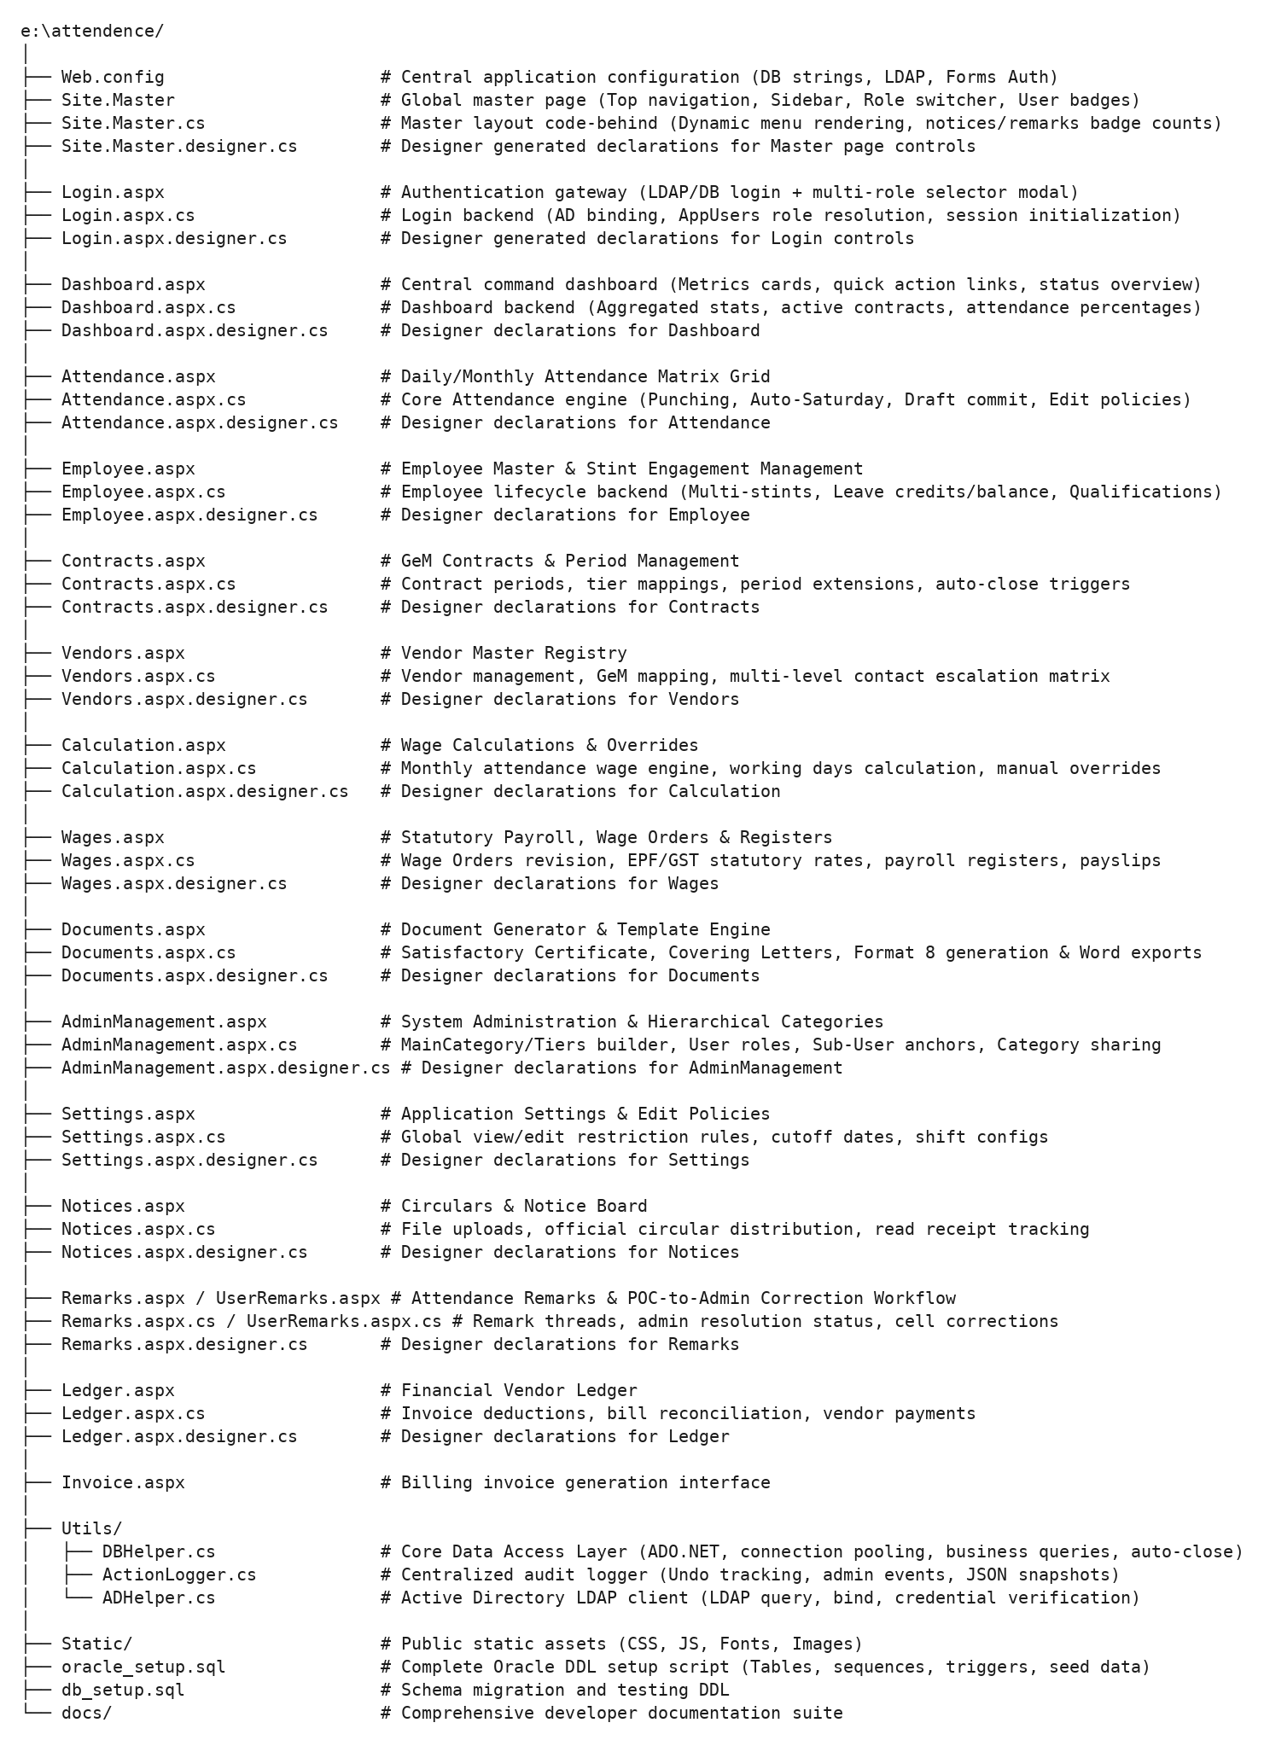

4. Architectural Data Flow & Request Lifecycle
The diagram below illustrates how user requests flow through IIS, Forms Authentication, Active Directory, Application Code-Behind, the Data Access Layer, and the Oracle Database:
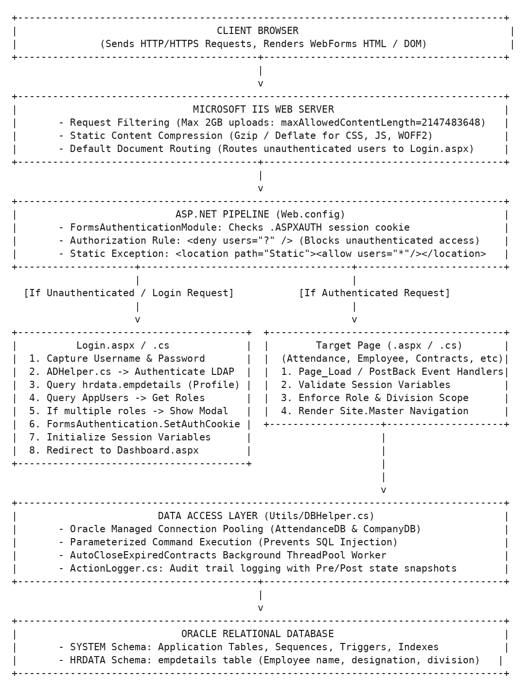

5. Security Model & Role Hierarchy
The application defines a strict integer-based role hierarchy stored in AppUsers.Role. In addition to explicit roles, users can hold primary/secondary admin privileges through category ownership or cross-admin sharing.

Complete Role Definition Matrix
Role Code | Role Mode Name | Display Title | Access Scope & Responsibilities | Revocation Pair Code
4 | SuperAdmin | Super Administrator | Global master access. Can configure system settings, view all divisions/categories, create/revoke admins, and perform database maintenance. | 5 (Revoked Super Admin)
1 | PrimaryAdmin | Primary Category Admin | Manages owned Main Categories (MainCategory.AdminPCNO = :PCNO) and their child tiers. Full access to employees, attendance, contracts, wages, and documents within owned categories. | 2 (Revoked Admin)
1 | SecondaryAdmin | Secondary Admin (Shared) | Access granted via CategoryShareGrant from a Primary Admin. Can manage attendance and operations for delegated categories. | 2 (Revoked Admin)
0 | RegularUser | Directorate POC | Point of Contact for specific divisions (UserDivisions). Can view/edit daily attendance for employees in their division within configured edit windows (EditDaysAllowed, ViewCutoffDate). | 3 (Revoked POC)
6 | SubUser | Sub User (Data Entry) | Restricted data-entry clerk linked to one or more Anchor POCs (SubUserAnchor). Can only input draft attendance in AttendanceDraft; cannot modify live attendance directly. | 7 (Revoked Sub User)

Dual Role Resolution & Role Switcher
If a single user (e.g. PCNO 1001) is configured both as a Primary Admin for Category A and a POC for Division B, or has shared categories, Login.aspx will automatically present the Role Selection Modal upon login. The user selects their operating identity for that session, which sets Session["Role"] and Session["RoleMode"].

6. Session State Variable Dictionary
Every authenticated session relies on standardized session keys set during login in Login.aspx.cs and utilized across all .aspx.cs code-behind pages:
Session Key | Data Type | Populated By | Purpose & Expected Values
Session["PCNO"] | string | Login.CompleteUserLogin | Unique employee personal computer number / ID (e.g. "1001", "EMP045").
Session["Role"] | int | Login.CompleteUserLogin | Active effective role code: 4 (SuperAdmin), 1 (Admin), 0 (POC), 6 (SubUser).
Session["RoleMode"] | string | Login.CompleteUserLogin | Active identity string: "SuperAdmin", "PrimaryAdmin", "SecondaryAdmin", "RegularUser", "SubUser".
Session["Name"] | string | Login.CompleteUserLogin | Full display name resolved from hrdata.empdetails or AppUsers (e.g. "John Doe").
Session["Designation"] | string | Login.CompleteUserLogin | Corporate job designation from hrdata.empdetails (e.g. "Scientist 'F'").
Session["Division"] | string | Login.CompleteUserLogin | Primary division identifier of the logged-in user (e.g. "D-ADMIN", "D-KRM").
Session["AllowedDivisions"] | List<string> | Login.CompleteUserLogin | List of all division names the POC / SubUser is authorized to manage from UserDivisions.
Session["UserRoles"] | List<UserRoleOption> | Login.CompleteUserLogin | All role options available to this user account (enables dynamic role switching without re-entering credentials).
Session["PendingPCNO"] | string | Login.btnLogin_Click | Temporary PCNO held during multi-role selection prior to session completion.
Session["PendingRoles"] | List<UserRoleOption> | Login.btnLogin_Click | Temporary list of role choices presented in Login.aspx repeater.

7. Web.config Configuration Reference
The application configuration is managed via Web.config:

Database Connection Strings
<connectionStrings>
<!-- CompanyDB: Connects to corporate HR schema (hrdata.empdetails) for profile lookups -->
<add name="CompanyDB"
connectionString="User Id=system;Password=root;Data Source=//127.0.0.1:1521/xe;Min Pool Size=2;Max Pool Size=100;Connection Lifetime=120;Statement Cache Size=20;Validate Connection=false;"
providerName="Oracle.ManagedDataAccess.Client" />
<!-- AttendanceDB: Connects to main AMS application database (Attendance, Employees, Contracts, etc.) -->
<add name="AttendanceDB"
connectionString="User Id=system;Password=root;Data Source=//127.0.0.1:1521/xe;Min Pool Size=5;Max Pool Size=200;Connection Lifetime=120;Statement Cache Size=50;Incr Pool Size=5;Decr Pool Size=2;Validate Connection=false;"
providerName="Oracle.ManagedDataAccess.Client" />
</connectionStrings>

Active Directory LDAP Settings
<appSettings>
<add key="ValidationSettings:UnobtrusiveValidationMode" value="None" />
<!-- ADConnectionPath: LDAP server URI used by ADHelper.cs for user authentication -->
<add key="ADConnectionPath" value="LDAP://192.168.0.106/DC=ad01,DC=yajnesh,DC=com" />
</appSettings>

Session & Request Limits
- Forms Authentication Timeout: 1440 minutes (24 hours).
- Session Timeout: 1440 minutes.
- Max Request Length (maxRequestLength): 2097151 KB (~2 GB) allowing large bulk document and certificate uploads.
- Execution Timeout (executionTimeout): 3600 seconds (1 hour) for heavy background calculations and bulk data imports.
- JSON Max Length (maxJsonLength): 2147483647 characters (2 GB) for large AJAX attendance grids and payslip JSON payloads.

8. Master Chapter Index for Developers
To learn or modify specific components of the Attendance Management System, refer to the corresponding chapters in this documentation suite:
- Chapter 01: Complete Database Schema & Data Dictionary All 25+ Oracle tables, column specifications, sequences, triggers, composite indexes, and relational ER diagram.
- Chapter 02: Core Data Access Layer & Utilities Deep dive into DBHelper.cs, ActionLogger.cs, and ADHelper.cs.
- Chapter 03: Authentication & Global Layout Engine Login.aspx + Site.Master lifecycle, navigation menus, and session management.
- Chapter 04: Attendance Management (Part 1: Core Grid & Business Logic) Attendance.aspx matrix rendering, Auto-Saturday rule, holidays, and punch status calculation.
- Chapter 05: Attendance Management (Part 2: Drafts, Edit Policies & Auditing) AttendanceDraft sub-user workflow, POC cutoffs, right-click remarks, and audit logs.
- Chapter 06: Employee Lifecycle & Master Registry Employee.aspx multi-stints, leave credit transactions, carry-over balance logic, and qualifications.
- Chapter 07: Contracts & Vendor Ecosystem Contracts.aspx & Vendors.aspx, multi-level contact matrix, contract extensions, and auto-close triggers.
- Chapter 08: Payroll Calculations & Wage Orders Calculation.aspx & Wages.aspx, statutory EPF/GST math, wage orders, overrides, and payslips.
- Chapter 09: Automated Document Generation & Certificate Engine Documents.aspx & Invoice.aspx, template placeholder engines, Satisfactory Certificates, and Format 8.
- Chapter 10: Administration, Hierarchical Categories & Security Policies AdminManagement.aspx & Settings.aspx, category/tier hierarchy, sub-user anchors, and category sharing.
- Chapter 11: Communication, Notices, Remarks & Financial Ledger Notices.aspx, Remarks.aspx, UserRemarks.aspx, and Ledger.aspx.
- Chapter 12: Developer Recipe & Modification Handbook Step-by-step how-to recipes for adding fields, creating new pages, altering wage formulas, and debugging.

Chapter 01: Complete Database Schema & Data Dictionary
This document provides a comprehensive, field-level data dictionary and entity-relationship model for the entire Attendance Management System (AMS) database schema.

1. Entity-Relationship Overview
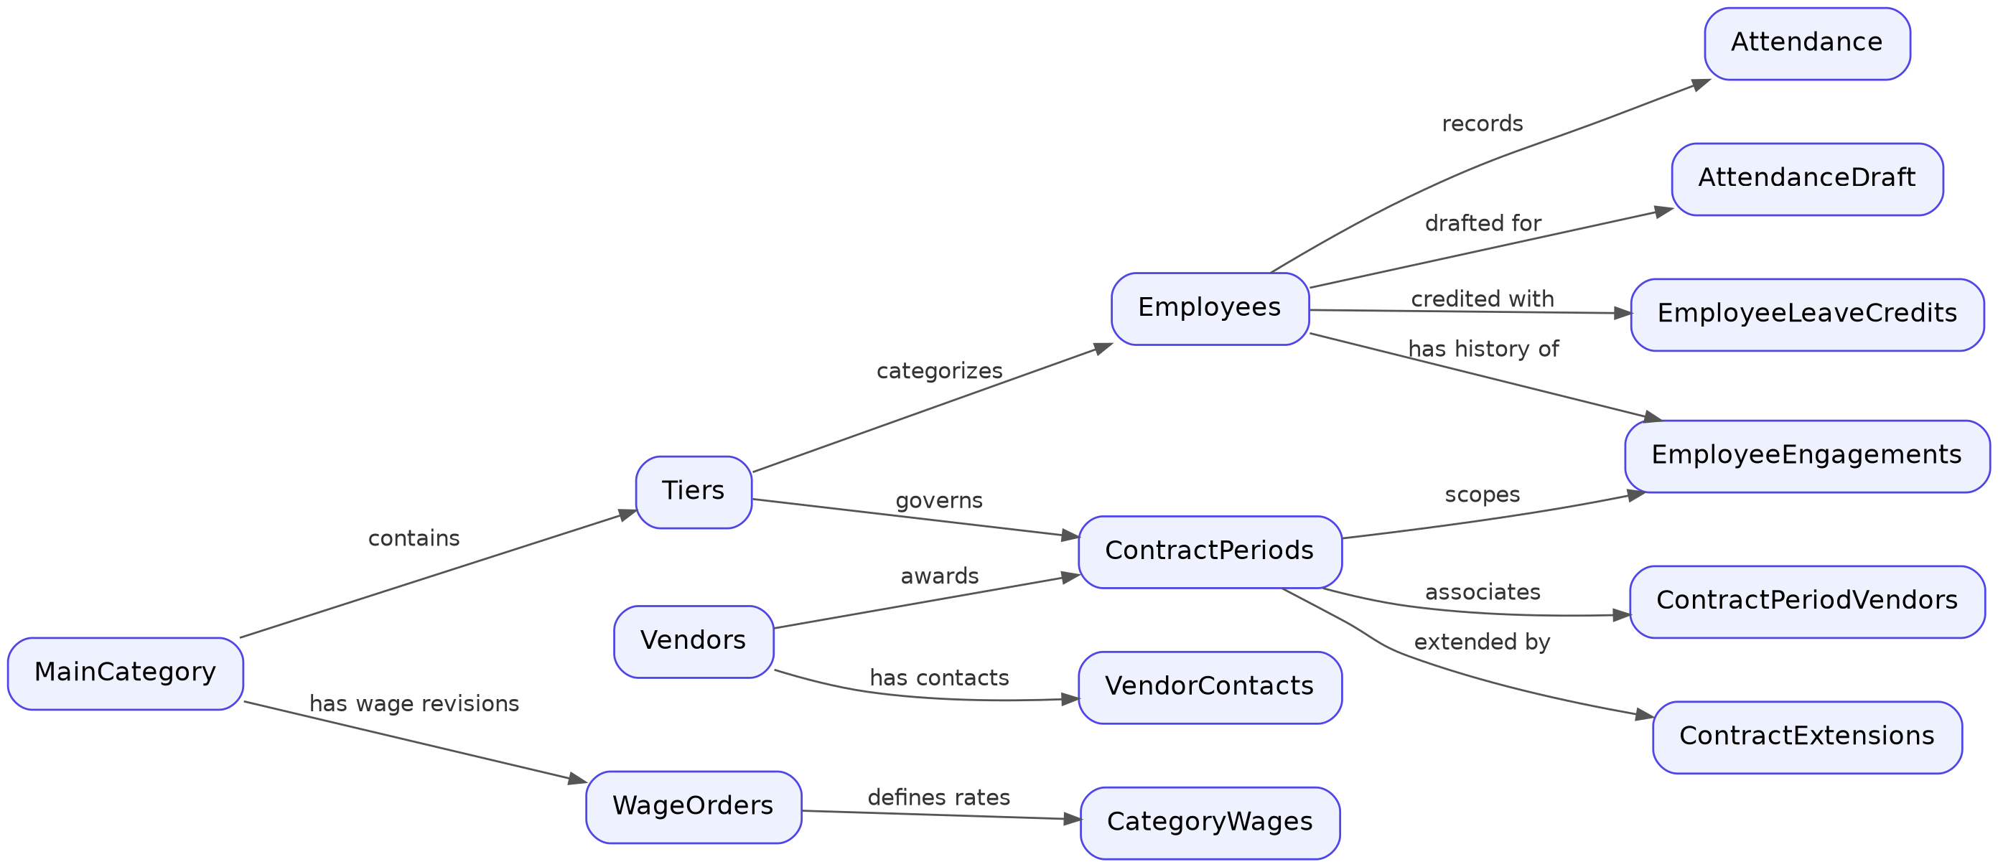
Entity-Relationship Overview: core table relationships across the AMS schema. Field-level detail for every table follows in the data dictionary below.
Diagram note: this overview shows entity relationships only. Every column, data type, and constraint for each table listed here is documented in the field-level data dictionary immediately following this diagram.

2. Table-by-Table Data Dictionary

2.1 User Authentication, Access Control & Divisions

AppUsers
Stores authorized login accounts and access roles. - Primary Key: (PCNO, Role) (Allows a single user to hold multiple distinct roles).
Column Name | Data Type | Nullable | Default | Description & Values
PCNO | VARCHAR2(50) | No | - | Employee computer/personnel number (matches AD / LDAP).
Name | VARCHAR2(200) | No | - | User display name.
Role | NUMBER(1) | No | 0 | Role Codes:0 = Regular User (POC)1 = Category Admin2 = Revoked Admin3 = Revoked POC4 = Super Admin5 = Revoked Super Admin6 = Sub User (Data Entry)7 = Revoked Sub User

Divisions
Master list of organizational departments and divisions. - Primary Key: Id (Sequence: SEQ_Divisions, Trigger: TRG_Divisions) - Unique Key: Name
Column Name | Data Type | Nullable | Default | Description
Id | NUMBER | No | SEQ | Auto-increment unique division ID.
Name | VARCHAR2(100) | No | - | Division name (e.g. 'D-ADMIN', 'D-KRM', 'D-ASR').

UserDivisions
Maps regular users (POCs) and Sub Users to the specific divisions they are allowed to manage. - Primary Key: (PCNO, DivisionName)
Column Name | Data Type | Nullable | Default | Description
PCNO | VARCHAR2(50) | No | - | User PCNO.
DivisionName | VARCHAR2(100) | No | - | Name of authorized division.
DivId | NUMBER | Yes | NULL | Optional foreign key link to Divisions.Id.

SubUserAnchor
Maps a Sub User (data entry clerk) to one or more Anchor POCs whose division/tier scope they inherit. - Primary Key: (SubUserPCNO, AnchorPocPCNO)
Column Name | Data Type | Nullable | Default | Description
SubUserPCNO | VARCHAR2(50) | No | - | PCNO of the Sub User (Role 6).
AnchorPocPCNO | VARCHAR2(50) | No | - | PCNO of the Anchor POC (Role 0).
CreatedAt | TIMESTAMP | No | SYSTIMESTAMP | Timestamp when link was established.
CreatedBy | VARCHAR2(50) | No | - | PCNO of Admin who established the assignment.

2.2 Hierarchical Categories & Sharing

MainCategory
Top-level organizational domain (e.g. “HR”, “Technical Support”, “Security”). - Primary Key: Id (Sequence: SEQ_MainCategory, Trigger: TRG_MainCategory) - Unique Key: Name
Column Name | Data Type | Nullable | Default | Description & Business Rules
Id | NUMBER | No | SEQ | Unique category ID.
Name | VARCHAR2(100) | No | - | Category title (e.g. 'HR').
AdminPCNO | VARCHAR2(50) | Yes | NULL | PCNO of Primary Admin who owns this category.
EditDaysAllowed | NUMBER | No | 0 | Number of retrospective days POCs can edit attendance (0 = current day only).
EditMode | NUMBER(1) | No | 0 | 0 = Unlimited, 1 = Strict window, 2 = Locked.
ViewMode | NUMBER(1) | No | 0 | 0 = Unlimited, 1 = Fixed N months, 2 = Strict Cutoff Date, 3 = Combined rule, 4 = Locked.
ViewMonthsAllowed | NUMBER | No | 2 | Number of historical months accessible in view mode 1.
ViewCutoffDate | DATE | Yes | NULL | Explicit historical calendar cutoff date for view mode 2.
ViewAppliesTo | NUMBER(1) | No | 0 | 0 = Apply to Regular Users (POCs) only, 1 = Apply to all non-superadmins.

Tiers
Sub-classifications / skill levels under a MainCategory (e.g. “Skilled”, “Semi-Skilled”, “Unskilled”). - Primary Key: Id (Sequence: SEQ_Tiers, Trigger: TRG_Tiers) - Foreign Key: MainCategoryId -> MainCategory.Id (ON DELETE CASCADE) - Unique Constraint: (MainCategoryId, TierName, RoleLabel)
Column Name | Data Type | Nullable | Default | Description
Id | NUMBER | No | SEQ | Unique Tier ID.
MainCategoryId | NUMBER | No | - | Parent MainCategory ID.
TierName | VARCHAR2(100) | No | - | Skill designation (e.g. 'Skilled').
RoleLabel | VARCHAR2(100) | Yes | NULL | Optional functional title (e.g. 'DEO').
SortOrder | NUMBER | Yes | 0 | UI display sort order.

UserTiers
Maps regular users (POCs) to specific allowed tiers. - Primary Key: (PCNO, TierId) - Foreign Key: TierId -> Tiers.Id (ON DELETE CASCADE)

CategoryShareGrant
Permits a Primary Admin to delegate management of a MainCategory (or specific Tier) to another Admin. - Primary Key: Id (Sequence: SEQ_CategoryShareGrant, Trigger: TRG_CategoryShareGrant) - Foreign Keys: MainCategoryId -> MainCategory.Id, TierId -> Tiers.Id - Unique Constraint: (OwnerAdminPCNO, SharedWithPCNO, MainCategoryId, TierId)
Column Name | Data Type | Nullable | Default | Description
Id | NUMBER | No | SEQ | Unique share record ID.
OwnerAdminPCNO | VARCHAR2(50) | No | - | Primary Admin granting access.
SharedWithPCNO | VARCHAR2(50) | No | - | Secondary Admin receiving access.
MainCategoryId | NUMBER | No | - | Main category ID being shared.
TierId | NUMBER | Yes | NULL | Optional specific Tier ID (NULL = all tiers in category).
IsActive | NUMBER(1) | No | 1 | 1 = Active grant, 0 = Revoked/Inactive.
GrantedAt | TIMESTAMP | No | SYSTIMESTAMP | Timestamp when grant was created.

2.3 Vendors & GeM Contract Periods

Vendors
Contractor / Manpower supply agencies. - Primary Key: Id (Sequence: SEQ_Vendors, Trigger: TRG_Vendors) - Unique Keys: MasterId, Name
Column Name | Data Type | Nullable | Default | Description
Id | NUMBER | No | SEQ | Unique vendor ID.
MasterId | VARCHAR2(50) | No | - | Unique alphanumeric vendor identifier code.
Name | VARCHAR2(150) | No | - | Vendor agency name (e.g. 'M/s ABC Enterprises').
GemId | VARCHAR2(100) | Yes | NULL | Government e-Marketplace vendor seller ID.
ContactName | VARCHAR2(100) | Yes | NULL | Primary legacy contact name.
ContactPhone | VARCHAR2(20) | Yes | NULL | Primary legacy phone number.
Address | VARCHAR2(4000) | Yes | NULL | Full registered office address.
IsActive | NUMBER(1) | No | 1 | 1 = Active vendor, 0 = Blacklisted / Inactive.

VendorContacts
Dynamic multi-level contact escalation matrix per vendor. - Primary Key: Id (Sequence: SEQ_VendorContacts, Trigger: TRG_VendorContacts) - Foreign Key: VendorId -> Vendors.Id (ON DELETE CASCADE) - Unique Constraint: (VendorId, Priority)
Column Name | Data Type | Nullable | Default | Description
Id | NUMBER | No | SEQ | Unique contact ID.
VendorId | NUMBER | No | - | Parent vendor ID.
Priority | NUMBER | No | - | Escalation level: 1 = Primary, 2 = Escalation L2, 3 = L3.
ContactName | VARCHAR2(100) | No | - | Contact person name.
ContactPhone | VARCHAR2(20) | No | - | Contact phone / mobile number.
ContactEmail | VARCHAR2(200) | Yes | NULL | Email address (Mandatory for Priority 1).
ContactAddress | VARCHAR2(4000) | Yes | NULL | Postal address (Mandatory for Priority 1).
SortOrder | NUMBER | Yes | 0 | Display ordering.

ContractPeriods
GeM contract execution periods tied to specific Tiers and Vendors. - Primary Key: Id (Sequence: SEQ_ContractPeriods, Trigger: TRG_ContractPeriods) - Foreign Keys: TierId -> Tiers.Id (ON DELETE CASCADE), VendorId -> Vendors.Id - Unique Constraint: (TierId, StartDate)
Column Name | Data Type | Nullable | Default | Description
Id | NUMBER | No | SEQ | Unique contract period ID.
TierId | NUMBER | No | - | Skill tier under contract.
VendorId | NUMBER | No | - | Awarded vendor contractor ID.
GemId | VARCHAR2(100) | Yes | NULL | GeM Contract Order Number (e.g. 'GEMC-5116877...').
StartDate | DATE | No | - | Contract commencement date.
EndDate | DATE | Yes | NULL | Contract expiration date (auto-closed when past).
DatedOn | DATE | Yes | NULL | Formal contract signing / execution date.
Status | VARCHAR2(20) | No | 'Active' | 'Active' or 'Closed'.
Notes | VARCHAR2(4000) | Yes | NULL | Administrative contract remarks.

ContractPeriodVendors
Associates additional or consortium vendors attached to a contract period. - Primary Key: Id (Sequence: SEQ_ContractPeriodVendors, Trigger: TRG_ContractPeriodVendors) - Foreign Keys: ContractPeriodId -> ContractPeriods.Id (ON DELETE CASCADE), VendorId -> Vendors.Id, TierId -> Tiers.Id (ON DELETE CASCADE)

ContractExtensions
Audit history of contract end date extensions. - Primary Key: Id (Sequence: SEQ_ContractExtensions, Trigger: TRG_ContractExtensions) - Foreign Key: ContractPeriodId -> ContractPeriods.Id (ON DELETE CASCADE)
Column Name | Data Type | Nullable | Default | Description
Id | NUMBER | No | SEQ | Unique extension log ID.
ContractPeriodId | NUMBER | No | - | Target contract period ID.
OldEndDate | DATE | Yes | NULL | Expiration date prior to extension.
NewEndDate | DATE | No | - | New extended expiration date.
ExtensionDate | TIMESTAMP | No | SYSTIMESTAMP | Timestamp when extension was recorded.

2.4 Employee Master & Engagements

Employees
Master record for contract employees. - Primary Key: MasterId (Unique immutable employee key, e.g. 'EMP_1004') - Foreign Keys: TierId -> Tiers.Id (ON DELETE CASCADE), CurrentEngagementId -> EmployeeEngagements.Id
Column Name | Data Type | Nullable | Default | Description
MasterId | VARCHAR2(50) | No | - | System-generated immutable master key.
ID | VARCHAR2(50) | No | - | Organizational badge / token number.
Name | VARCHAR2(200) | No | - | Full legal employee name.
Department | VARCHAR2(100) | Yes | NULL | Division name text.
DivId | NUMBER | Yes | NULL | Normalized link to Divisions.Id.
TierId | NUMBER | Yes | NULL | Current skill tier ID.
EmployeeHistoryId | VARCHAR2(50) | No | - | Persistent UUID/hash linking historical stints across contracts.
OriginalJoinDate | DATE | Yes | NULL | First date employee entered the establishment.
JoinDate | DATE | Yes | NULL | Current contract stint commencement date.
LeaveBalance | NUMBER | No | 0 | Current available paid leave balance.
PrevLeaveBalance | NUMBER | No | 0 | Carried over balance from preceding contract periods.
Status | VARCHAR2(20) | No | 'Active' | 'Active', 'Resigned', 'Relieved', or 'System'.
ResignDate | DATE | Yes | NULL | Formal relieving / resignation date.
ContractEndDate | DATE | Yes | NULL | Expected end date under current contract stint.
CurrentEngagementId | NUMBER | Yes | NULL | Foreign key pointer to active EmployeeEngagements.Id.
Phone | VARCHAR2(50) | Yes | NULL | Contact telephone number.
Email | VARCHAR2(100) | Yes | NULL | Email address.
Aadhar | VARCHAR2(50) | Yes | NULL | National identification / Aadhar number.
Address | VARCHAR2(4000) | Yes | NULL | Residential address.
Qualification | VARCHAR2(200) | Yes | NULL | Educational qualification (e.g. 'B.Sc Computer Science').
Experience | NUMBER | Yes | NULL | Total relevant experience in years (e.g. 4.5).
ExperienceIn | VARCHAR2(200) | Yes | NULL | Domain of expertise (e.g. 'Data Entry / MS Office').

EmployeeEngagements
Historical employment stints linking employees to specific contract periods, tiers, and vendors. - Primary Key: Id (Sequence: SEQ_EmployeeEngagements, Trigger: TRG_EmployeeEngagements) - Foreign Keys: EmpID -> Employees.MasterId (ON DELETE CASCADE), ContractPeriodId -> ContractPeriods.Id (ON DELETE SET NULL), VendorId -> Vendors.Id, TierId -> Tiers.Id (ON DELETE CASCADE), PrevEngagementId -> EmployeeEngagements.Id
Column Name | Data Type | Nullable | Default | Description
Id | NUMBER | No | SEQ | Unique stint engagement ID.
EmpID | VARCHAR2(50) | No | - | Employee MasterId.
ContractPeriodId | NUMBER | Yes | NULL | Contract period under which this stint ran.
TierId | NUMBER | No | - | Skill tier classification for this stint.
VendorId | NUMBER | No | - | Vendor supplier during this stint.
Department | VARCHAR2(100) | Yes | NULL | Department name during this stint.
DivId | NUMBER | Yes | NULL | Division ID during this stint.
StartDate | DATE | No | - | Stint commencement date.
EndDate | DATE | Yes | NULL | Stint conclusion date (NULL if currently active).
EndReason | VARCHAR2(50) | Yes | NULL | Reason for stint conclusion ('Contract Expired', 'Resigned').
IsCarriedOver | NUMBER(1) | No | 0 | 1 = Leave balance carried over from previous stint.
PrevEngagementId | NUMBER | Yes | NULL | Link to immediately preceding engagement stint.
EmployeeId | VARCHAR2(50) | Yes | NULL | Historical employee token/ID during this stint.

EmployeeLeaveCredits
Explicit leave credit ledger for accruals and credit revisions. - Primary Key: Id (Sequence: SEQ_EmployeeLeaveCredits, Trigger: TRG_EmployeeLeaveCredits) - Foreign Keys: EmpID -> Employees.MasterId (ON DELETE CASCADE), ContractPeriodId -> ContractPeriods.Id (ON DELETE CASCADE)
Column Name | Data Type | Nullable | Default | Description
Id | NUMBER | No | SEQ | Unique credit transaction ID.
EmpID | VARCHAR2(50) | No | - | Employee MasterId.
ContractPeriodId | NUMBER | No | - | Target contract period ID.
Amount | NUMBER | No | - | Number of leave days credited (e.g. 2.5).
EffectiveDate | DATE | No | - | Date on which credit becomes active.
Remarks | VARCHAR2(200) | Yes | NULL | Administrative reason for credit.

2.5 Attendance Matrix & Staging

Attendance
Live production daily attendance matrix records. - Primary Key: Id (Sequence: SEQ_Attendance, Trigger: TRG_Attendance) - Foreign Keys: EmpID -> Employees.MasterId, EngagementId -> EmployeeEngagements.Id, ContractPeriodId -> ContractPeriods.Id - Unique Constraint: (EmpID, Year, Month, Day)
Column Name | Data Type | Nullable | Default | Description & Status Codes
Id | NUMBER | No | SEQ | Unique attendance record ID.
EmpID | VARCHAR2(50) | No | - | Target employee MasterId.
EngagementId | NUMBER | Yes | NULL | Active stint engagement ID.
ContractPeriodId | NUMBER | Yes | NULL | Active contract period ID.
Year | NUMBER(4) | No | - | Calendar year (e.g. 2026).
Month | NUMBER(2) | No | - | Month index (0 = January, 11 = December).
Day | NUMBER(2) | No | - | Day of month (1 to 31).
StatusValue | NUMBER(1) | Yes | NULL | Status Codes:1 = Present0 = Absent2 = Paid Leave (CL/EL)3 = Unpaid Leave (LWP)NULL = Unmarked / Non-working
LeaveType | VARCHAR2(50) | Yes | NULL | Specific leave type string (e.g. 'CL', 'RH').
IsHoliday | NUMBER(1) | Yes | 0 | 1 = National / Declared public holiday.
AutoSat | NUMBER(1) | Yes | 0 | 1 = Automatically counted as absent under the 2-Saturday Rule.
Remarks | VARCHAR2(500) | Yes | NULL | Remarks (e.g. holiday title or Saturday override reason).

AttendanceDraft
Staging table where Sub Users enter provisional attendance before Anchor POC approval. - Primary Key: Id (Sequence: SEQ_AttendanceDraft, Trigger: TRG_AttendanceDraft) - Foreign Keys: EmpID -> Employees.MasterId, EngagementId -> EmployeeEngagements.Id, ContractPeriodId -> ContractPeriods.Id - Unique Constraint: (EmpID, Year, Month, Day)
Column Name | Data Type | Nullable | Default | Description
Id | NUMBER | No | SEQ | Unique draft entry ID.
EmpID | VARCHAR2(50) | No | - | Employee MasterId.
Year, Month, Day | NUMBER | No | - | Date coordinates.
StatusValue | NUMBER | Yes | NULL | Provisional status code (1, 0, 2, 3).
EnteredByPCNO | VARCHAR2(50) | Yes | NULL | PCNO of Sub User who keyed in the draft.
EnteredAt | TIMESTAMP | No | SYSTIMESTAMP | Initial draft entry timestamp.
LastEditedByPCNO | VARCHAR2(50) | Yes | NULL | PCNO of last modifier.
LastEditedAt | TIMESTAMP | No | SYSTIMESTAMP | Last modification timestamp.

2.6 Payroll, Statutory & Wage Orders

WageOrders
Government / Directorate minimum wage notification orders. - Primary Key: Id (Sequence: SEQ_WageOrders, Trigger: TRG_WageOrders) - Foreign Key: MainCategoryId -> MainCategory.Id (ON DELETE CASCADE)
Column Name | Data Type | Nullable | Default | Description
Id | NUMBER | No | SEQ | Unique wage order ID.
OrderId | VARCHAR2(100) | No | - | Official order notification reference (e.g. 'WO/2026/04').
MainCategoryId | NUMBER | No | - | Main category governed by this order.
EffectiveDate | DATE | No | - | Date order takes statutory effect.
OrderDetails | VARCHAR2(4000) | Yes | NULL | Government circular details / gazette text.
CreatedBy | VARCHAR2(50) | No | - | PCNO of administrator who recorded order.
CreatedAt | TIMESTAMP | Yes | CURRENT_TIMESTAMP | Record timestamp.

CategoryWages
Daily / monthly wage rate mapped to each Tier under a Wage Order. - Primary Key: Id (Sequence: SEQ_CategoryWages, Trigger: TRG_CategoryWages) - Foreign Keys: WageOrderId -> WageOrders.Id (ON DELETE CASCADE), TierId -> Tiers.Id (ON DELETE CASCADE)
Column Name | Data Type | Nullable | Default | Description
Id | NUMBER | No | SEQ | Unique rate ID.
WageOrderId | NUMBER | No | - | Parent wage order ID.
TierId | NUMBER | No | - | Governed skill tier ID.
WageRate | NUMBER(10,2) | No | - | Monetary wage rate (e.g. 980.50 per day).

StatutoryOrders
EPF, ESI, and GST statutory deduction rates and ceilings. - Primary Key: Id (Sequence: SEQ_StatutoryOrders, Trigger: TRG_StatutoryOrders)
Column Name | Data Type | Nullable | Default | Description
Id | NUMBER | No | SEQ | Unique statutory revision ID.
OrderId | VARCHAR2(100) | No | - | Government notification reference.
EffectiveDate | DATE | No | - | Date revision takes effect.
EpfRate | NUMBER(5,2) | No | - | EPF percentage rate (e.g. 13.00%).
EpfLimit | NUMBER(10,2) | No | - | Maximum statutory wage ceiling for EPF (e.g. 15000.00).
EpfCappedAmount | NUMBER(10,2) | No | - | Maximum monthly capped EPF contribution (e.g. 1950.00).
GstRate | NUMBER(5,2) | No | 18.00 | GST percentage rate (e.g. 18.00%).
OrderDetails | VARCHAR2(4000) | Yes | NULL | Statutory notes / gazette citations.

CalculationOverrides
Manual adjustments to final billable working days prior to wage disbursement. - Primary Key: (Year, Month, TierId, EmpID) - Foreign Keys: EmpID -> Employees.MasterId, TierId -> Tiers.Id (ON DELETE CASCADE)
Column Name | Data Type | Nullable | Default | Description
Year, Month | NUMBER | No | - | Month coordinates.
TierId | NUMBER | No | - | Target skill tier ID.
EmpID | VARCHAR2(50) | No | - | Target employee MasterId.
FinalDays | NUMBER(5,2) | Yes | NULL | Manually overridden billable days (e.g. 24.50).
Remarks | VARCHAR2(500) | Yes | NULL | Mandatory reason for adjustment.

2.7 Notices, Remarks & Communication

Notices
Official circulars, orders, and documents posted by administrators. - Primary Key: Id (Sequence: SEQ_Notices, Trigger: TRG_Notices) - Foreign Key: MainCategoryId -> MainCategory.Id (NULL = Global to all categories)
Column Name | Data Type | Nullable | Default | Description
Id | NUMBER | No | SEQ | Unique notice ID.
Name | VARCHAR2(255) | No | - | Notice title / subject.
FilePath | VARCHAR2(500) | Yes | NULL | Server file path for uploaded PDF/Doc attachments.
NoticeText | NCLOB | Yes | NULL | Extended announcement body text.
Category | VARCHAR2(100) | Yes | 'General' | Category tag (e.g. 'Statutory', 'General').
IsHidden | NUMBER(1) | No | 0 | 1 = Archived / Hidden from users.
UploadDate | TIMESTAMP | No | SYSTIMESTAMP | Posting timestamp.
MainCategoryId | NUMBER | Yes | NULL | Target main category scope.

NoticeReads
Tracks read receipts and read timestamps by user PCNO. - Primary Key: (NoticeId, PCNO) - Foreign Key: NoticeId -> Notices.Id (ON DELETE CASCADE)

AttendanceRemarks
Correction requests submitted by POCs to Admins regarding locked attendance. - Primary Key: Id (Sequence: SEQ_AttendanceRemarks, Trigger: TRG_AttendanceRemarks) - Foreign Key: MainCategoryId -> MainCategory.Id
Column Name | Data Type | Nullable | Default | Description
Id | NUMBER | No | SEQ | Unique remark ticket ID.
SubmittedBy | VARCHAR2(100) | No | - | PCNO of submitting POC.
SenderName | VARCHAR2(200) | No | - | Display name of submitting POC.
EmpID | VARCHAR2(50) | No | - | Target employee MasterId.
RemarkDate | DATE | No | - | Date coordinate in question.
Message | VARCHAR2(1000) | No | - | Explanation of requested correction.
IsRead | NUMBER(1) | No | 0 | 0 = Unread by Admin, 1 = Reviewed.
CreatedAt | TIMESTAMP | No | SYSTIMESTAMP | Submission timestamp.

AttPocEditRemarks
Stores right-click POC edit explanations entered on attendance cells. - Primary Key: Id (Sequence: SEQ_AttPocEditRemarks, Trigger: TRG_AttPocEditRemarks)
Column Name | Data Type | Nullable | Default | Description
Id | NUMBER | No | SEQ | Unique cell remark ID.
EmpID | VARCHAR2(50) | No | - | Target employee MasterId.
Year, Month, Day | NUMBER | No | - | Date coordinates.
RemarkType | VARCHAR2(50) | No | 'POCEdit' | Remark category classification.
Remark | VARCHAR2(1000) | No | - | Justification text.
CreatedBy | VARCHAR2(100) | No | - | PCNO of editor.
CreatedByRole | VARCHAR2(50) | No | 'POC' | Operating role at time of edit.
CreatedAt | TIMESTAMP | No | SYSTIMESTAMP | Edit timestamp.

2.8 Comprehensive Audit Trails

Attendance_Audit_Log
Tracks cell-level attendance modifications. - Primary Key: Id (Sequence: SEQ_AttendanceAuditLog, Trigger: TRG_AttendanceAuditLog)
Column Name | Data Type | Nullable | Default | Description
Id | NUMBER | No | SEQ | Unique audit log ID.
LogTime | TIMESTAMP | No | SYSTIMESTAMP | Action timestamp.
EmpID | VARCHAR2(50) | Yes | NULL | Target employee MasterId.
Year, Month, Day | NUMBER | Yes | NULL | Date coordinates.
OldValue | NUMBER(1) | Yes | NULL | Previous attendance status code.
NewValue | NUMBER(1) | Yes | NULL | New attendance status code.
ChangedBy | VARCHAR2(100) | Yes | NULL | PCNO of user who performed modification.
Reason | VARCHAR2(500) | Yes | NULL | Stated justification.

EmployeeActionLogs
Tracks employee profile modifications with undoable pre/post JSON states. - Primary Key: Id (Sequence: SEQ_EmployeeActionLogs, Trigger: TRG_EmployeeActionLogs)
Column Name | Data Type | Nullable | Default | Description
Id | NUMBER | No | SEQ | Unique log ID.
ActionTime | TIMESTAMP | No | SYSTIMESTAMP | Timestamp of action.
ActionType | VARCHAR2(50) | No | - | 'INSERT', 'UPDATE', 'DELETE', 'EXTEND'.
EmpMasterId | VARCHAR2(50) | No | - | Target employee MasterId.
Description | VARCHAR2(500) | No | - | Human-readable change summary.
PreState | CLOB | Yes | NULL | JSON snapshot of employee before modification.
PostState | CLOB | Yes | NULL | JSON snapshot of employee after modification.
IsUndone | NUMBER(1) | No | 0 | 1 = Action was subsequently reverted/undone.

AdminActionLog & ActionLog
General administrative and system-wide action audit trails recording ActionType, PerformedBy, TargetId, PreState, and PostState.

2.9 Document & Certificate Templates

CertificateTemplates
Stores dynamic wording and boilerplate templates for generated legal documents. - Primary Key: TemplateKey
Key | Purpose / Usage | Sample Template Value
AttDesc1 | Attendance Certificate Header | This is certify that DEO ({Category}) under GeM Contract No: {ContractNo}, dated: {ContractDate}, Dated On: {DatedOn}
AttDesc2 | Attendance Vendor Details | M/s. {VendorName}, {VendorAddress} worked as following, for the period from {StartDate} to {EndDate}
SatDesc1 | Satisfactory Certificate Opening | This is to certify that M/s. <b>{VendorName}</b>, {VendorAddress} is engaged as an Industry Partner...
SatDesc2 | Satisfactory Manpower Count | The Industry Partner provided <b>{EmpCount}</b> Contract Employees and found working satisfactorily.
SatSignatory | Satisfactory Cert Authority | (Raajita B Reddy)
CovSubject | Covering Letter Subject | HIRING OF MANPOWER SERVICES
CovBody | Covering Letter Text | The copies of the Attendance report along with the wage calculation for {Category} category...

3. High-Performance Composite Indexes
To maintain sub-second response times with 100-500+ concurrent users and large historical datasets, the schema enforces the following composite indexes:
-- 1. Attendance Fast Monthly Range Queries
CREATE INDEX IDX_ATT_YEAR_MONTH ON Attendance (Year, Month, StatusValue, EmpID);
CREATE INDEX IDX_ATT_EMP_DATE ON Attendance (EmpID, Year, Month);
CREATE INDEX IDX_ATT_PERIOD ON Attendance (ContractPeriodId);
-- 2. Employee Engagements Stints
CREATE INDEX IDX_ENG_PERIOD_END ON EmployeeEngagements (ContractPeriodId, EndDate);
CREATE INDEX IDX_ENG_EMP_TIER ON EmployeeEngagements (EmpID, TierId);
CREATE INDEX IDX_ENG_DATES ON EmployeeEngagements (StartDate, EndDate);
-- 3. Employee Master Lookups & Status
CREATE INDEX IDX_EMP_TIER_STATUS ON Employees (TierId, Status);
CREATE INDEX IDX_EMP_DIV_STATUS ON Employees (DivId, Status);
CREATE INDEX IDX_EMP_HIST_ID ON Employees (EmployeeHistoryId);
CREATE INDEX IDX_EMP_CURR_ENG ON Employees (CurrentEngagementId);
-- 4. Contract Periods & Active Status
CREATE INDEX IDX_CP_TIER_STATUS ON ContractPeriods (TierId, Status, StartDate, EndDate);
-- 5. Permission & Security Lookups
CREATE INDEX IDX_USERTIERS_PCNO ON UserTiers (PCNO, TierId);
CREATE INDEX IDX_USERDIVS_PCNO ON UserDivisions (PCNO, DivId);
CREATE INDEX IDX_CATSHARE_SHARED ON CategoryShareGrant (SharedWithPCNO, IsActive);
-- 6. Communication & Audit History
CREATE INDEX IDX_NOTICES_CAT_DATE ON Notices (Category, UploadDate);
CREATE INDEX IDX_ATTREM_EMP_DATE ON AttendanceRemarks (EmpID, RemarkDate);
CREATE INDEX IDX_LEAVECRED_EMP ON EmployeeLeaveCredits (EmpID, ContractPeriodId, EffectiveDate);
CREATE INDEX IDX_POCREM_YEAR_MONTH ON AttPocEditRemarks (Year, Month, EmpID);

4. Special System Seed Records
- Global Adjustment Master (Employees):
- INSERT INTO Employees (MasterId, ID, Name, Department, TierId, EmployeeHistoryId, Status, LeaveBalance)
VALUES ('GLOBAL', 'GLOBAL', 'GLOBAL Adjustment', NULL, NULL, 'GLOBAL', 'System', 0);
- Purpose: Used by Attendance.aspx when an administrator declares a global holiday or organization-wide non-working day across all contract employees simultaneously.

Chapter 02: Core Utilities, Data Layer & Authentication Engine
This document provides a comprehensive technical breakdown of the foundational utilities in AttendanceApp.Utils: 1. ADHelper.cs - Active Directory & LDAP Authentication 2. ActionLogger.cs - Reversible JSON Audit Logging & State Snapshots 3. DBHelper.cs - Central Data Access Layer, Connection Pooling & Background Engine

1. ADHelper.cs (Active Directory / LDAP Authentication)

Purpose & Architectural Role
ADHelper connects the application to corporate Microsoft Active Directory domain controllers using the System.DirectoryServices LDAP provider. It authenticates enterprise credentials and resolves the user’s primary personnel computer number (PCNO / EmployeeID).
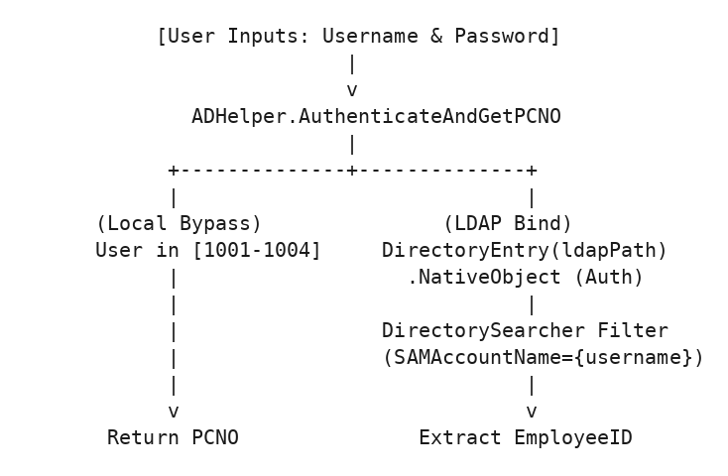

Method Signature & Implementation Details

AuthenticateAndGetPCNO(string username, string password)
- Parameters:
  - username (string): AD account login username (e.g. "john.doe", "1001").
  - password (string): User domain password.
- Returns: string (The user’s unique PCNO / EmployeeID, e.g. "1001").
- Exceptions: Throws Exception if credentials fail LDAP binding or search fails.

Key Mechanics:
- Local Test Bypass:
- if (username == "1001" || username.ToLower() == "admin" || username.ToLower() == "aadmin") return "1001";
if (username == "1002") return "1002";
if (username == "1003") return "1003";
if (username == "1004") return "1004";
- Rationale: Permits developers to log in instantly during local workstation debugging without being connected to the corporate VPN / Domain Controller.
- Forced Native Authentication: In .NET DirectoryEntry, creating the object does not hit the network until a native property is accessed. ADHelper forces instant authentication via:
- object native = entry.NativeObject; // Forces synchronous LDAP bind
- Property Extraction & Fallback: Queries (SAMAccountName={username}) and loads property "EmployeeID". If EmployeeID is not mapped in AD, it gracefully falls back to the username itself.

2. ActionLogger.cs (Undoable JSON Audit Logger)

Purpose & Architectural Role
ActionLogger is a state-capturing audit mechanism for the Employee Master module. Whenever an employee is inserted, updated, extended, or deleted, ActionLogger: 1. Captures a full JSON snapshot of the employee master record and all historical engagement stints (PreState). 2. Performs the database operation. 3. Captures a full JSON snapshot of the modified state (PostState). 4. Allows administrators to click Undo on any previous action, safely rolling the employee and engagements back to the exact historical state without database corruption.

Data Flow Diagram
[Employee Modification Triggered]
|
v
1. ActionLogger.CaptureEmployeeState(masterId) ---------> Generates PreState JSON
|
2. Database UPDATE / INSERT / EXTEND Executed
|
3. ActionLogger.CaptureEmployeeState(masterId) ---------> Generates PostState JSON
|
4. ActionLogger.LogAction(type, masterId, desc, pre, post)
|
v
Saved to EmployeeActionLogs (IsUndone = 0)
|
[User clicks "Undo Action"]
|
v
5. ActionLogger.UndoAction(logId, out error)
- Checks if attendance or wage overrides exist
- Re-inserts / updates pre-state records
- Marks EmployeeActionLogs.IsUndone = 1 in atomic transaction

Key Methods Breakdown

CaptureEmployeeState(string masterId)
- Parameters: masterId (string) - Employee MasterId.
- Returns: string (JSON string containing { "Employee": {...}, "Engagements": [...] }).
- Implementation: Queries Employees and EmployeeEngagements (ordered by StartDate ASC), converts rows into dictionaries with formatted date strings ("yyyy-MM-dd HH:mm:ss"), and serializes them using JavaScriptSerializer.

LogAction(string actionType, string masterId, string description, string preState, string postState)
- Parameters:
  - actionType (string): e.g. 'INSERT', 'UPDATE', 'EXTEND', 'DELETE'.
  - masterId (string): Target employee MasterId.
  - description (string): Human-readable log entry (e.g. "Updated employee phone number and tier").
  - preState (string): Serialized JSON before change.
  - postState (string): Serialized JSON after change.
- Implementation: Inserts into EmployeeActionLogs with IsUndone = 0.

UndoAction(int logId, out string errorMessage)
- Parameters: logId (int), out errorMessage (string).
- Returns: bool (true if successfully reverted, false otherwise).
- Safety Validations (Prevents Data Inconsistencies):
  - If IsUndone == 1, fails with “This action is already undone”.
  - If actionType == "BULK_LEAVE", blocks automated rollback (“Bulk leave adjustments cannot be undone automatically”).
  - If rolling back an employee addition (ADD), verifies SELECT COUNT(*) FROM Attendance WHERE EmpID = :EmpID. If attendance records exist, blocks rollback (“Cannot undo: attendance records already exist for this employee”).
  - If rolling back a contract extension / new engagement, checks if attendance or CalculationOverrides exist for that newly created engagement before deleting it.
  - Atomically nullifies Employees.CurrentEngagementId first to bypass circular foreign key constraints during stint recreation, restores historical stint rows, restores master fields, sets IsUndone = 1, and commits the transaction.

3. DBHelper.cs (Data Access Layer & Background Engine)
DBHelper is the core data access engine of the application. It encapsulates connection management, parameterized query execution, background contract auto-closing, permission resolution, and business calculations.

3.1 Connection Management & Pooling
- GetCompanyDBConnection(): Reads connection string "CompanyDB" from Web.config (used for hrdata.empdetails).
- GetAttendanceDBConnection(): Reads connection string "AttendanceDB" from Web.config (used for all AMS application tables).
Both connection strings configure Oracle Managed Connection Pooling: - Min Pool Size=5, Max Pool Size=200 - Statement Cache Size=50 (caches compiled execution plans on Oracle server) - Connection Lifetime=120 seconds - Validate Connection=false (avoids round-trip SELECT 1 FROM DUAL overhead on every connection fetch)

3.2 Automated Background Contract Closer (AutoCloseExpiredContracts)
[ThreadStatic]
private static bool _inAutoClose;
private static DateTime _lastAutoCloseCheck = DateTime.MinValue;
private static readonly object _syncLock = new object();
public static void TriggerAutoCloseIfNeeded()
{
if ((DateTime.UtcNow - _lastAutoCloseCheck).TotalSeconds < 1800) return;
System.Threading.ThreadPool.QueueUserWorkItem(_ =>
{
try { AutoCloseExpiredContracts(false); } catch { }
});
}

How It Works:
- Throttled Execution: When page requests call TriggerAutoCloseIfNeeded(), the method checks if 30 minutes (1800s) have passed since the last run.
- Asynchronous Non-Blocking Execution: Dispatches the task to the .NET ThreadPool, allowing the user’s HTTP request to return immediately without delay.
- Database Transaction Routine (AutoCloseExpiredContracts):
  - Finds all expired active contract periods:
  - SELECT Id, EndDate FROM ContractPeriods WHERE Status = 'Active' AND EndDate < TRUNC(SYSDATE)
  - For each expired period:
    - Sets ContractPeriods.Status = 'Closed'.
    - Finds all active employee engagements under that period (EndDate IS NULL).
    - Updates engagements: EndDate = :PeriodEndDate, EndReason = 'Contract Expired'.
    - Updates employee master: Status = 'Relieved', ContractEndDate = :PeriodEndDate.
  - All updates for each period execute inside an atomic OracleTransaction.

3.3 Core Execution Primitives
public static DataTable ExecuteQuery(string connStr, string sql, params OracleParameter[] parameters)
public static int ExecuteNonQuery(string connStr, string sql, params OracleParameter[] parameters)
public static object ExecuteScalar(string connStr, string sql, params OracleParameter[] parameters)

Architecture Rules Enforced:
- Always Parameterized: Prevents SQL injection across all inputs.
- Proper Disposal Pattern (using blocks): Ensures OracleConnection, OracleCommand, and OracleDataReader instances are immediately closed and returned to the connection pool, preventing connection leaks.
- Named Parameter Binding: Calls cmd.BindByName = true; to avoid Oracle’s default positional parameter binding bugs when reusing parameters in complex SQL.

3.4 Multi-Role & Permission Resolution

GetAvailableUserRoles(string pcno)
Dynamically inspects AppUsers, MainCategory, CategoryShareGrant, and UserDivisions to produce a list of available UserRoleOption objects for a user.
Evaluated Role | Condition Checked in Database | Role Code
Super Administrator | Role = 4 in AppUsers and not revoked (Role != 5). | 4
Secondary Category Admin | Active record in CategoryShareGrant WHERE SharedWithPCNO = :PCNO AND IsActive = 1. | 1
Primary Category Admin | MainCategory.AdminPCNO = :PCNO OR explicit Role = 1 in AppUsers. | 1
Regular User (POC) | Role = 0 in AppUsers OR user has divisions in UserDivisions. | 0
Sub User (Data Entry) | Role = 6 in AppUsers OR user has anchor mapping in SubUserAnchor. | 6

3.5 POC View & Edit Policy Resolution (GetPocViewRestriction)
public static PocViewRestrictionInfo GetPocViewRestriction(string adminPcno, string pocPcno)
Enforces retrospective view and edit window policies configured in MainCategory and Settings.aspx:
public class PocViewRestrictionInfo
{
public bool IsRestricted { get; set; }
public int ViewMode { get; set; }
public int ViewMonthsAllowed { get; set; }
public DateTime? ViewCutoffDate { get; set; }
public int ViewAppliesTo { get; set; }
public DateTime? MinAllowedDate { get; set; }
public DateTime? MaxAllowedDate { get; set; }
public string Description { get; set; }
public bool IsMonthAllowed(int year, int month1Based)
{
if (!IsRestricted) return true;
DateTime monthStart = new DateTime(year, month1Based, 1);
DateTime monthEnd = new DateTime(year, month1Based, DateTime.DaysInMonth(year, month1Based));
if (MinAllowedDate.HasValue && monthEnd < MinAllowedDate.Value) return false;
if (MaxAllowedDate.HasValue && monthStart > MaxAllowedDate.Value) return false;
return true;
}
}

View Restriction Modes:
- ViewMode 0 (Unlimited): POC can view all historical attendance months.
- ViewMode 1 (Fixed N Months): POC can only navigate back N months from current date.
- ViewMode 2 (Strict Cutoff Date): POC cannot view any month prior to ViewCutoffDate.
- ViewMode 3 (Combined): Uses the most restrictive between N months and cutoff date.
- ViewMode 4 (Locked): POC cannot view historical attendance.

3.6 Holiday Backfill Engine (BackfillHolidaysForAllEmployees)
public static void BackfillHolidaysForAllEmployees(string connStr)
When an admin marks a global holiday (EmpID = 'GLOBAL' in Attendance), this method propagates that holiday record to all active employees whose engagement covers that date, ensuring employee wage calculations and working day totals automatically reflect declared public holidays.

Chapter 03: Authentication & Global Layout Engine
This document details the authentication gateway (Login.aspx / Login.aspx.cs) and the global master layout template (Site.Master / Site.Master.cs).

1. Authentication Lifecycle (Login.aspx.cs)
The authentication engine integrates Windows Active Directory (LDAP), Oracle database profile lookups, dynamic multi-role selection, and ASP.NET Forms Authentication cookies.

1.1 Complete Login Execution Flow
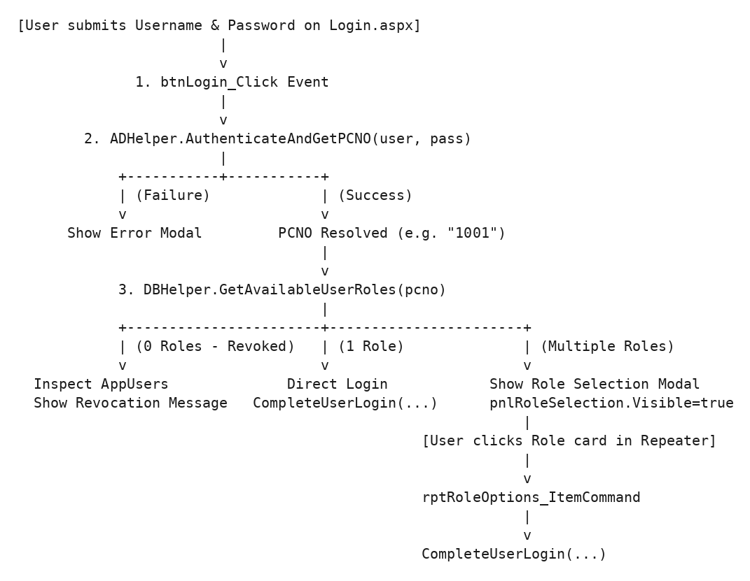

1.2 Multi-Role Selection & Revocation Detection
When a user has access to more than one functional role (for example, a user who is both a Primary Admin for HR and a POC for Division D-ADMIN), the system does not force them into an arbitrary role.
- Role Options Evaluation: DBHelper.GetAvailableUserRoles(pcno) generates a list of UserRoleOption models:
- public class UserRoleOption
{
public string RoleMode { get; set; } // "SuperAdmin", "PrimaryAdmin", "SecondaryAdmin", "RegularUser", "SubUser"
public string Title { get; set; } // e.g. "Primary Category Admin"
public string Subtitle { get; set; } // e.g. "Category Owner (HR)"
public int EffectiveRole { get; set; } // 4, 1, 0, or 6
public string Icon { get; set; } // e.g. "fas fa-user-shield"
public string BadgeColor { get; set; } // e.g. "#4f46e5"
}
- Interactive Selection UI: If roles.Count > 1, Login.aspx hides pnlLoginForm and displays pnlRoleSelection containing an ASP.NET <asp:Repeater ID="rptRoleOptions">.
- Revocation Inspection Logic: If roles.Count == 0, Login.aspx.cs queries AppUsers to distinguish between unassigned accounts and explicitly revoked accounts:
  - Role 5: “Access denied. Your super administrator access has been revoked.”
  - Role 2: “Access denied. Your administrator access has been revoked.”
  - Role 3: “Access denied. Your regular user (POC) access has been revoked.”
  - Role 7: “Access denied. Your sub user access has been revoked.”

1.3 User Profile Synchronization & Session Initialization
Once the active role is chosen, CompleteUserLogin(pcno, selectedRole, availableRoles) executes:
private void CompleteUserLogin(string pcno, UserRoleOption selectedRole, List<UserRoleOption> availableRoles)
{
// 1. Fetch authorized divisions from UserDivisions for POC / SubUser
List<string> allowedDivisions = new List<string>();
if (selectedRole.EffectiveRole != 1 && selectedRole.EffectiveRole != 4)
{
string queryDivs = "SELECT DivisionName FROM UserDivisions WHERE PCNO = :PCNO";
DataTable dtDivs = DBHelper.ExecuteQuery(DBHelper.GetAttendanceDBConnection(), queryDivs, new OracleParameter("PCNO", pcno));
foreach (DataRow row in dtDivs.Rows)
allowedDivisions.Add(row["DivisionName"].ToString());
}
// 2. Fetch Name & Designation from Company HR database (hrdata.empdetails)
string queryDiv = "SELECT NAME, DESIGNATION, DIVNAME FROM hrdata.empdetails WHERE PCNO = :PCNO AND ROWNUM <= 1";
DataTable dt = DBHelper.ExecuteQuery(DBHelper.GetCompanyDBConnection(), queryDiv, new OracleParameter("PCNO", pcno));
if (dt.Rows.Count > 0)
{
name = dt.Rows[0]["NAME"].ToString();
designation = dt.Rows[0]["DESIGNATION"].ToString();
division = dt.Rows[0]["DIVNAME"].ToString();
}
// 3. Initialize Session Variables
Session["PCNO"] = pcno;
Session["Role"] = selectedRole.EffectiveRole;
Session["RoleMode"] = selectedRole.RoleMode;
Session["UserRoles"] = availableRoles;
Session["Name"] = name;
Session["Designation"] = designation;
Session["AllowedDivisions"] = allowedDivisions;
Session["Division"] = division;
// 4. Upsert User Name in AppUsers for local caching
string updateNameQuery = "UPDATE AppUsers SET Name = :Name WHERE PCNO = :PCNO";
DBHelper.ExecuteNonQuery(DBHelper.GetAttendanceDBConnection(), updateNameQuery,
new OracleParameter("Name", name), new OracleParameter("PCNO", pcno));
// 5. Issue Forms Authentication Cookie and Redirect
FormsAuthentication.SetAuthCookie(pcno, false);
Response.Redirect("Dashboard.aspx");
}

2. Global Layout & Master Page Engine (Site.Master.cs)
Site.Master wraps every authenticated page in the system. It enforces layout switching, dynamic navigation filtering, unread notification badges, and instant in-session role switching.

2.1 Dual Layout System: Sidebar vs TopNav
The layout dynamically adapts based on the active page: - On Dashboard.aspx: The left Collapsible Sidebar is rendered (phSidebar.Visible = true; phTopNav.Visible = false;), providing an executive overview and quick navigation cards. - On Content Pages (Attendance.aspx, Employee.aspx, etc.): The compact Top Navigation Bar is rendered (phSidebar.Visible = false; phTopNav.Visible = true;), maximizing horizontal screen width for large data grids and matrix tables.

2.2 In-Session Dynamic Role Switching
Users with multiple assigned roles can switch their active operating role on any page without logging out: 1. The user clicks a different role from the top-right profile dropdown. 2. The browser navigates to ?switchRole={TargetRoleMode}. 3. Site.Master.cs intercepts the request: csharp string switchRoleParam = Request.QueryString["switchRole"]; if (!string.IsNullOrEmpty(switchRoleParam) && !string.IsNullOrEmpty(pcno)) { if (DBHelper.SwitchUserRole(pcno, switchRoleParam, Session)) { Response.Redirect(Request.Url.AbsolutePath); // Reloads page cleanly with new role return; } }

2.3 Role-Based Navigation Visibility Matrix
Site.Master selectively shows or hides menus based on Session["Role"] and Session["RoleMode"]:
Navigation Item | Target Page | SuperAdmin (4) | Admin (1) | POC (0) | Sub User (6)
Dashboard | Dashboard.aspx | Visible | Visible | Visible | Visible
Attendance | Attendance.aspx | Full Matrix | Full Matrix | Division Scoped | Staged Drafts Only
Employees | Employee.aspx | Visible | Visible | Hidden | Hidden
Contracts | Contracts.aspx | Visible | Visible | Hidden | Hidden
Vendors | Vendors.aspx | Visible | Visible | Hidden | Hidden
Calculation | Calculation.aspx | Visible | Visible | Hidden | Hidden
Wages & Statutory | Wages.aspx | Visible | Visible | Hidden | Hidden
Documents | Documents.aspx | Visible | Visible | Hidden | Hidden
Admin Management | AdminManagement.aspx | Full Access | Category Scoped | Hidden | Hidden
Settings | Settings.aspx | Visible | Visible | Hidden | Hidden
Notices | Notices.aspx | Post & View | Post & View | View Only | View Only
Remarks | Remarks.aspx / UserRemarks | Resolution Inbox | Resolution Inbox | Submit Request | Submit Request

2.4 Real-Time Notification & Badge Indicators
Site.Master.cs computes notification badges on Page_Load:
- Admin Unread Remarks Badge (UnreadCount):
- SELECT COUNT(DISTINCT ar.SubmittedBy || '_' || ar.EmpID || '_' || ar.Message || '_' || TO_CHAR(ar.CreatedAt, 'YYYYMMDDHH24MISS'))
FROM AttendanceRemarks ar
WHERE ar.IsRead = 0
- Renders a red badge count on the top notification bell icon (phNotifBell).
- POC Pending Drafts Badge (PendingDraftCount):
- SELECT COUNT(*)
FROM AttendanceDraft ad
JOIN Employees e ON ad.EmpID = e.MasterId
WHERE e.Division IN (SELECT DivisionName FROM UserDivisions WHERE PCNO = :PCNO)
- Alerts Directorate POCs when their assigned Sub Users have staged new attendance entries requiring review and commitment.

2.5 Safe Logout Execution (btnLogout_Click)
protected void btnLogout_Click(object sender, EventArgs e)
{
Session.Clear();
Session.Abandon();
FormsAuthentication.SignOut();
Response.Redirect("Login.aspx");
}
Guarantees: Wipes in-memory session data, clears ASP.NET session ID, invalidates .ASPXAUTH authentication ticket, and redirects client to the login page.

Chapter 04: Attendance Management (Part 1: Core Grid & Business Logic)
This document provides a comprehensive technical breakdown of the core attendance matrix engine in Attendance.aspx and Attendance.aspx.cs.

1. Attendance Matrix Architecture
The Attendance module renders an interactive monthly grid matrix of contract employees versus days of the month (Days 1 through 28/29/30/31).
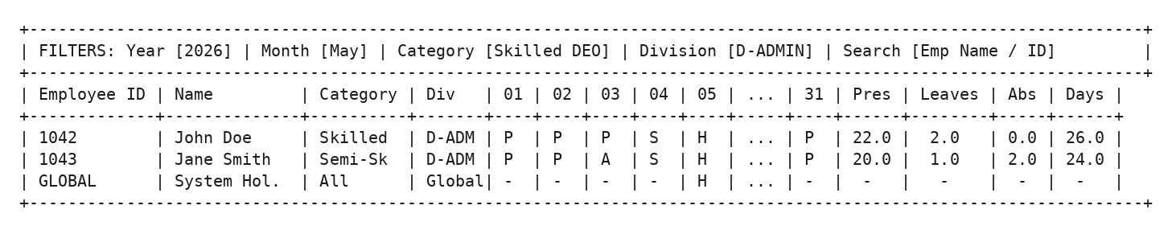

2. Attendance Status Codes & Semantic Values
Every cell in Attendance or AttendanceDraft stores status using standardized values:
Status Code (StatusValue) | Flag (IsHoliday) | Flag (AutoSat) | Leave String (LeaveType) | Grid Symbol | Semantic Meaning & Calculation Rule
1.0 | 0 | 0 | "" | P (Green) | Present: Employee attended duty for a full working shift. Contributes +1.0 to Present Days.
0.0 / 0 | 0 | 0 | "" | A (Red) | Absent: Employee was absent from work without authorized paid leave. Contributes +1.0 to Absent Days.
2.0 | 0 | 0 | "CL" / "EL" | L (Yellow) | Paid Leave: Authorized leave deducted from employee’s LeaveBalance. Contributes +1.0 to Paid Leaves and is fully billable.
3.0 | 0 | 0 | "LWP" | UL (Orange) | Unpaid Leave (Leave Without Pay): Authorized absence without pay. Not billable.
NULL | 1 | 0 | "" | H (Blue) | Declared Public Holiday: Official national/gazetted holiday. Does not penalize attendance.
NULL | 0 | 1 | "" | S (Purple) | Auto-Saturday Absence: Saturday automatically counted as absent under the 2-Saturday rule.
0.5 | 0 | 0 | "Carried" / "Pending" | ½ (Cyan) | Half-Day / Paired Leave: Staged half-day absence waiting to be paired with another half-day.

3. Core Business Rules & Attendance Math

3.1 Automatic Saturday Rule (2-Saturday Rule)
The establishment operates on an alternating Saturday schedule: 1. Employees are entitled to alternate Saturdays off if they have fulfilled minimum attendance on surrounding working days. 2. If an employee is absent on both Friday and Monday flanking an off-Saturday (the Sandwich Rule), the intervening Saturday is converted into an absent day (AutoSat = 1). 3. To compute Saturday eligibility correctly across month boundaries, GetData automatically queries trailing attendance from the previous month (Day >= 24): sql SELECT EmpID, Day, StatusValue, IsHoliday, LeaveType, AutoSat, Remarks FROM Attendance WHERE Year = :PYear AND Month = :PMonth AND Day >= 24

3.2 Global Holiday Declaration & Stint Propagation
When an administrator clicks the calendar header to declare an organization-wide holiday: 1. An entry is created for the system employee record GLOBAL (or tier-specific GLOBAL_{TierId}): sql INSERT INTO Attendance (EmpID, Year, Month, Day, StatusValue, IsHoliday, Remarks) VALUES ('GLOBAL', 2026, 4, 1, NULL, 1, 'May Day') 2. DBHelper.BackfillHolidaysForAllEmployees runs, checking each active employee’s EmployeeEngagements dates (StartDate <= TargetDate <= EndDate). 3. Any employee whose stint covers that date automatically inherits the holiday, guaranteeing that working day formulas across payroll modules reflect the declared holiday.

3.3 Leave Accrual & Balance Deduction Engine
- Accrual Ledger (EmployeeLeaveCredits): Leaves are not stored merely as static counters; they are credited via date-stamped transactions in EmployeeLeaveCredits.
- Dynamic Balance Resolution in GetData: When loading attendance for month M, the system calculates available leave balance dynamically:
$$\text{Resolved Balance}=∑\left(\text{Credits with EffectiveDate}≤\text{Month End}\right)−∑\left(\text{Paid Leaves consumed before Month Start}\right)$$
- Carry-over Across Contract Periods: When a new contract period commences, unused balances from the preceding stint are recorded in Employees.PrevLeaveBalance and EmployeeEngagements.IsCarriedOver = 1.

4. Server-Side Data Assembly (GetData Breakdown)
The AJAX method GetData(int year, int month, string category, string division, string search) in Attendance.aspx.cs constructs the complete dataset for the frontend in a single optimized payload:
[Client calls GetData via AJAX]
|
v
1. EnsureGlobalEmployeesExist()
|
2. Enforce POC View Restriction (PocViewRestrictionInfo)
- If month is blocked by Cutoff Date / N-Months Rule -> Return Early Restricted Payload
|
3. Query Active Employees Matching Tier, Division & Search Scope
- Early Exit Optimization: If 0 employees match, return empty payload immediately
|
4. Batch Query All Engagements for Matched Employees (Single SQL query)
|
5. Batch Query Historical Leaves & EmployeeLeaveCredits
|
6. Query Live Attendance Matrix for Year + Month
|
7. Overlay Declared Global Holidays
|
8. Overlay Staged Drafts from AttendanceDraft (Sub-user drafts)
|
9. Fetch Trailing Previous Month Data (Day >= 24) for Saturday calculations
|
10. Serialize to JSON and Return to Client Browser

JSON Response Schema
{
"Employees": [
{
"MasterId": "EMP_1042",
"ID": "1042",
"Name": "John Doe",
"Department": "D-ADMIN",
"TierId": 1,
"Category": "HR > Skilled (#DEO)",
"JoinDate": "2025-01-01",
"LeaveBalance": 12.0,
"PrevLeaveBalance": 0.0
}
],
"Attendance": {
"EMP_1042": {
"1": { "Val": 1.0, "Holiday": false, "Leave": "", "AutoSat": false, "Remarks": "" },
"2": { "Val": 1.0, "Holiday": false, "Leave": "", "AutoSat": false, "Remarks": "" }
}
},
"EditDaysAllowed": 3,
"EditMode": 1,
"IsRestricted": false
}

Chapter 05: Attendance Management (Part 2: Sub-User Drafts, Edit Policies & Auditing)
This document covers the advanced workflows of the Attendance module: the staged sub-user draft pipeline, edit/view restriction policies, right-click cell edit remarks, audit history tracking, and reporting.

1. Staged Sub-User Draft Pipeline
To maintain data integrity and prevent unauthorized direct modifications to live production attendance, AMS implements a Two-Tier Staging Workflow:
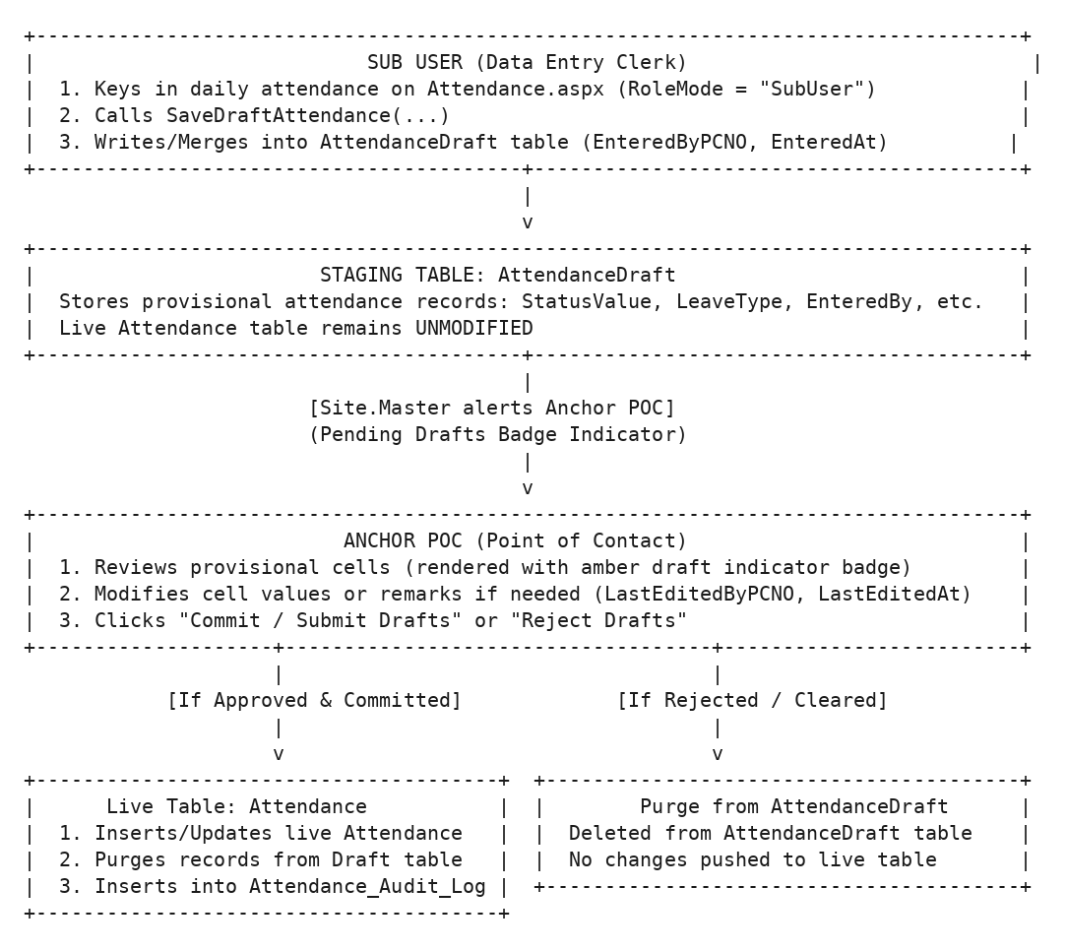

1.1 Draft Database Merge Statement
When a Sub User saves drafts, Attendance.aspx.cs executes an atomic Oracle MERGE:
MERGE INTO AttendanceDraft t
USING (
SELECT :EmpID as EmpID, :Year as Year, :Month as Month, :Day as Day,
:Val as StatusValue, :Holiday as IsHoliday, :Leave as LeaveType,
:AutoSat as AutoSat, :Remarks as Remarks,
:PCNO as PCNO, SYSTIMESTAMP as TS
FROM DUAL
) s
ON (t.EmpID = s.EmpID AND t.Year = s.Year AND t.Month = s.Month AND t.Day = s.Day)
WHEN MATCHED THEN
UPDATE SET t.StatusValue = s.StatusValue, t.IsHoliday = s.IsHoliday, t.LeaveType = s.LeaveType,
t.AutoSat = s.AutoSat, t.Remarks = s.Remarks,
t.LastEditedByPCNO = s.PCNO, t.LastEditedAt = s.TS
WHEN NOT MATCHED THEN
INSERT (EmpID, Year, Month, Day, StatusValue, IsHoliday, LeaveType, AutoSat, Remarks, EnteredByPCNO, EnteredAt, LastEditedByPCNO, LastEditedAt)
VALUES (s.EmpID, s.Year, s.Month, s.Day, s.StatusValue, s.IsHoliday, s.LeaveType, s.AutoSat, s.Remarks, s.PCNO, s.TS, s.PCNO, s.TS);

2. Multi-Tier Edit Policies & Retrospective Rules
Administrators configure attendance edit windows in MainCategory and Settings.aspx. Attendance.aspx.cs rigorously enforces these rules during both cell click edits and batch saves:
DateTime checkDate = new DateTime(year, month + 1, day);
DateTime today = DateTime.Today;
if (editMode == 1) // Mode 1: Strict Current Month Only
{
if (checkDate > today || checkDate.Year != today.Year || checkDate.Month != today.Month)
continue; // Block edit
}
else if (editMode == 2) // Mode 2: Grace Cutoff Day Rule (e.g. 3rd of next month)
{
DateTime prevMonth = today.AddMonths(-1);
bool isCurrentMonth = (checkDate.Year == today.Year && checkDate.Month == today.Month);
int graceCutoffDay = editDaysAllowed > 0 ? editDaysAllowed : 3;
bool isPrevMonthAllowed = (checkDate.Year == prevMonth.Year && checkDate.Month == prevMonth.Month && today.Day <= graceCutoffDay);
if ((!isCurrentMonth && !isPrevMonthAllowed) || checkDate > today)
continue; // Block edit
}
else // Mode 0: Retrospective Days Window
{
DateTime minAllowedDate = today.AddDays(-editDaysAllowed);
if (checkDate > today || checkDate < minAllowedDate)
continue; // Block edit
}

Policy Summary Table
Mode Code | Policy Name | Rule Mechanics & Limitations
0 | Retrospective Days Window | POC can only edit dates within the last EditDaysAllowed days (e.g. 3 days back from today). Cannot edit future dates.
1 | Strict Current Month | POC can edit any day in the current calendar month up to today. All previous months are permanently locked.
2 | Grace Cutoff Day | POC can edit the previous month only up to the Nth day of the current month (e.g. up to the 3rd of May for April attendance). After the 3rd, April is locked.

3. Right-Click Cell Edit Remarks (AttPocEditRemarks)
Whenever a POC or Sub User edits a cell outside normal real-time marking, the frontend triggers a modal requiring a mandatory Justification Remark.
- Table: AttPocEditRemarks
- Fields Captured: EmpID, Year, Month, Day, RemarkType, Remark, CreatedBy (PCNO), CreatedByRole ('POC' or 'SubUser'), CreatedAt.
- Display: Cells with attached remarks render a small red corner triangle. Hovering or right-clicking displays the full chronological explanation thread.

4. Comprehensive Attendance Audit Trail (Attendance_Audit_Log)
Every single change to a production attendance cell (whether made via individual cell click, batch save, draft commit, or administrator override) is recorded in Attendance_Audit_Log.

Log Schema & Trigger Mechanics
CREATE TABLE Attendance_Audit_Log (
Id NUMBER PRIMARY KEY,
LogTime TIMESTAMP DEFAULT SYSTIMESTAMP NOT NULL,
EmpID VARCHAR2(50),
Year NUMBER(4),
Month NUMBER(2),
Day NUMBER(2),
OldValue NUMBER(1),
NewValue NUMBER(1),
ChangedBy VARCHAR2(100),
Reason VARCHAR2(500)
);

Timeline Inspection (GetAuditHistory)
Frontend users can right-click any cell and select View Audit History. The server queries:
SELECT LogTime, OldValue, NewValue, ChangedBy, Reason
FROM Attendance_Audit_Log
WHERE EmpID = :EmpID AND Year = :Year AND Month = :Month AND Day = :Day
ORDER BY LogTime DESC
This returns a chronological timeline showing who changed the status, the previous vs new value, and the timestamp.

5. Excel & Report Export Pipeline
Attendance.aspx.cs provides high-speed, server-side Excel export for monthly attendance sheets: 1. Dynamic Grid Construction: Iterates all filtered employees and day columns (1..31). 2. Formula & Totals Inclusion: Appends summary columns on the right: - Total Present Days ($∑P$) - Total Paid Leaves ($∑L$) - Total Unpaid Leaves / Absents ($∑A+∑UL$) - Final Billable Working Days 3. MIME Response Streaming: Sets Content-Type: application/vnd.ms-excel with Content-Disposition: attachment; filename="Attendance_Report_{Category}_{Month}_{Year}.xls".

Chapter 06: Employee Lifecycle & Master Management Module
This document provides complete technical specifications for the Employee Master and Stint Engagement module (Employee.aspx / Employee.aspx.cs).

1. Architectural Role & Access Control
The Employee Management Module governs the full lifecycle of contract personnel: initial registration, bulk onboarding, multi-stint engagement contracts, leave credit management, qualification tracking, contract extensions, resignations, rejoining, and reversible audit history.

Access Restrictions
- Authorized Roles: Only Super Administrators (Role 4) and Category Administrators (Role 1) can access Employee.aspx.
- Enforcement: If a Regular User (POC) or Sub User attempts direct navigation to Employee.aspx, Page_Load rejects the request, terminates execution via Response.End(), and displays an Access Denied security warning card.

2. Relational Architecture & Engagement Stints
An employee’s lifecycle is modeled across four interconnected tables:
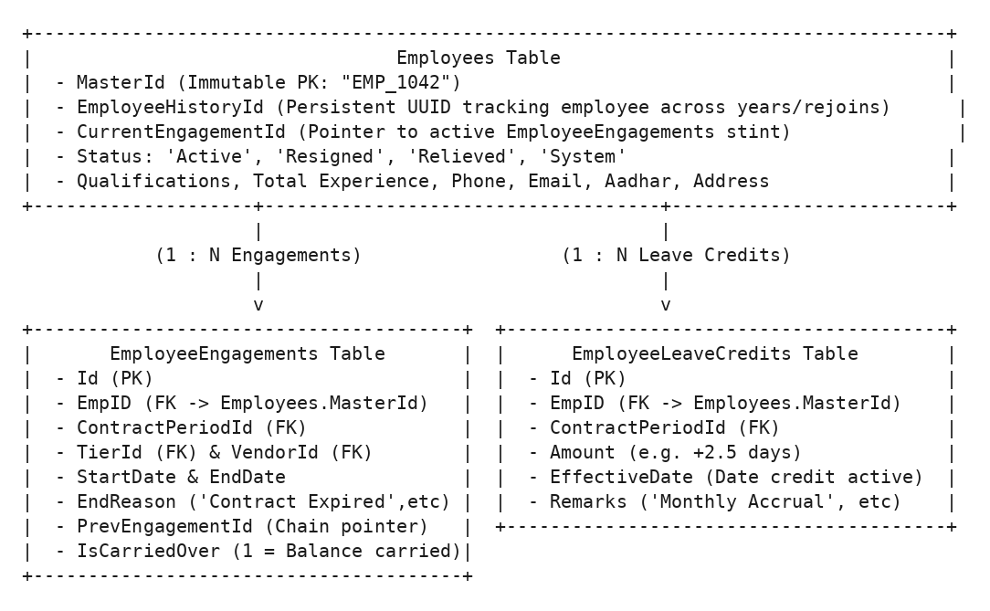

3. Core Employee Lifecycle Operations

3.1 Single Employee Creation (btnAdd_Click)
- Input Capture: Reads ID, Name, Division/Department, Tier (ddlCat), Join Date, Initial Leave Balance, Qualifications, Experience, Aadhar, and Contact info.
- Contract Period Binding: Queries active ContractPeriods for the chosen Tier to resolve the active ContractPeriodId and awarded VendorId.
- Atomic Persistence:
  - Generates unique MasterId and EmployeeHistoryId.
  - Inserts Employees record.
  - Inserts initial EmployeeEngagements record (StartDate = JoinDate, EndDate = ContractPeriod.EndDate).
  - Links Employees.CurrentEngagementId = EmployeeEngagements.Id.
- Audit Logging: Captures post-state snapshot and logs action via ActionLogger.LogAction("ADD", masterId, ...).

3.2 Bulk CSV/Excel Onboarding (btnBulkImport_Click)
- File Ingestion: Accepts CSV or Excel files (.csv, .xlsx).
- Schema Parsing (ParsedImportRow): Validates columns: ID, Name, Department, JoinDate, LeaveBalance, Qualification, Experience, Phone, Email, Aadhar, Address.
- Duplicate Detection: Checks if ID or MasterId already exists. Existing employees are updated; new employees are inserted with fresh engagement stints.

3.3 Contract Extension & Renewal (btnExtendContract_Click)
When an employee’s contract is renewed or extended: 1. PreState is captured via ActionLogger.CaptureEmployeeState(masterId). 2. If the employee remains in the same Tier and Contract Period, Employees.ContractEndDate and EmployeeEngagements.EndDate are updated. 3. If a new GeM contract period has started: - The old engagement is closed (EndDate = OldPeriodEndDate, EndReason = 'Period Renewal'). - A new EmployeeEngagements record is created linking PrevEngagementId = OldEngagement.Id. - Remaining leave balance is carried over (IsCarriedOver = 1). 4. PostState is captured and logged (ActionLogger.LogAction("EXTEND", ...)).

3.4 Resignation & Relieving (btnResign_Click)
- Captures ResignDate and Reason.
- Updates Employees.Status = 'Resigned' and Employees.ResignDate.
- Closes active EmployeeEngagements stint: EndDate = ResignDate, EndReason = 'Resigned'.

3.5 Rejoining a Relieved Employee (btnRejoin_Click)
When an ex-employee rejoins under a new contract: 1. Resolves historical record by matching MasterId or Aadhar. 2. Preserves original EmployeeHistoryId and OriginalJoinDate. 3. Sets Employees.Status = 'Active' and updates JoinDate = NewRejoinDate. 4. Spawns a new EmployeeEngagements row with PrevEngagementId pointing to their prior stint.

3.6 Bulk Leave Credit Ledger (btnApplyBulkLeave_Click)
Allows administrators to credit paid leaves (e.g. +1.5 or +2.5 days) across all employees in a Tier/Division: 1. Iterates all matching active employees. 2. Inserts transactions into EmployeeLeaveCredits: sql INSERT INTO EmployeeLeaveCredits (EmpID, ContractPeriodId, Amount, EffectiveDate, Remarks) VALUES (:EmpID, :ContractPeriodId, :Amount, :EffectiveDate, :Remarks) 3. Updates Employees.LeaveBalance = LeaveBalance + :Amount.

4. Undo Engine & State Rollback Integration
Employee.aspx features a Reversible Audit Log Tab. Administrators can view recent operations and click Undo:
protected void rptActionLogs_ItemCommand(object source, RepeaterCommandEventArgs e)
{
if (e.CommandName == "Undo")
{
int logId = Convert.ToInt32(e.CommandArgument);
string errorMessage;
if (ActionLogger.UndoAction(logId, out errorMessage))
{
ShowMessage("Action successfully undone and historical state restored.", true);
BindGrid();
}
else
{
ShowMessage("Undo failed: " + errorMessage, false);
}
}
}
Guarantees: Safely checks foreign key dependencies (attendance, payroll overrides) before rolling back employee fields and engagement stints.

Chapter 07: Contracts & Vendor Ecosystem Module
This document details the vendor management registry (Vendors.aspx / Vendors.aspx.cs) and the GeM contract period lifecycle engine (Contracts.aspx / Contracts.aspx.cs).

1. Vendor Master Registry (Vendors.aspx)
The Vendor module maintains master profiles for manpower contractor agencies and enforces a structured escalation contact hierarchy.

1.1 Vendor Entity Architecture
- Table: Vendors
- Auto-Generated Master ID: GenerateNextMasterId() produces formatted alphanumeric IDs (e.g. 'VND_001').
- Unique Constraints: Name and MasterId must be strictly unique.
- Active Status Indicator: A vendor is dynamically active if they possess at least one open ContractPeriods row (Status = 'Active').

1.2 Dynamic Escalation Contact Matrix (VendorContacts)
Each vendor can register an unlimited number of escalation levels (Priority 1..N):
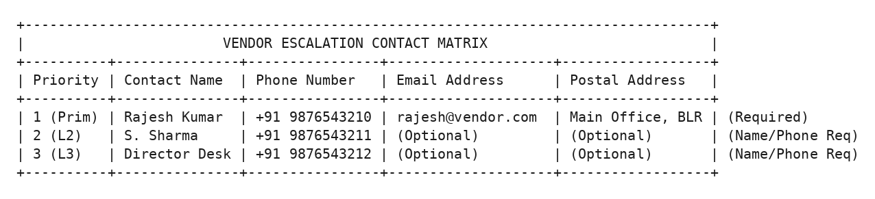

Validation Rules:
- Priority 1 (Primary Contact): Name, Phone, Email, and Address are strictly mandatory.
- Priority 2+ (Escalation Levels): Name and Phone are mandatory; Email and Address are optional.
- Persisted via hfVendorContacts JSON payload and upserted into VendorContacts in an atomic transaction.

2. GeM Contract Periods Engine (Contracts.aspx)
Contracts.aspx manages formal Government e-Marketplace (GeM) contract execution periods.

2.1 Contract Lifecycle Wizard
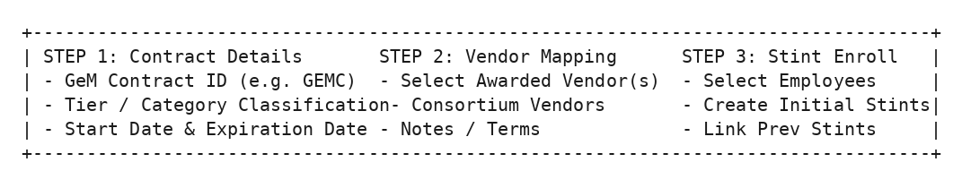

2.2 Contract Period Schema & Constraints
- Table: ContractPeriods
- Unique Constraint: (TierId, StartDate) - Only one active contract period can commence on a given date per skill tier.
- Status Codes: 'Active' (currently running) or 'Closed' (concluded or expired).

3. Contract Extensions Pipeline (ContractExtensions)
When a government contract period is officially extended: 1. The administrator clicks Extend Contract on Contracts.aspx. 2. Enters the NewEndDate and justification notes. 3. Contracts.aspx.cs executes within an atomic transaction: ```sql – 1. Insert audit log INSERT INTO ContractExtensions (ContractPeriodId, OldEndDate, NewEndDate, ExtensionDate) VALUES (:ContractPeriodId, :OldEndDate, :NewEndDate, SYSTIMESTAMP);
– 2. Update Contract Period UPDATE ContractPeriods SET EndDate = :NewEndDate WHERE Id = :ContractPeriodId;
– 3. Extend all active employee engagements under this period UPDATE EmployeeEngagements SET EndDate = :NewEndDate WHERE ContractPeriodId = :ContractPeriodId AND EndDate = :OldEndDate;
– 4. Update employee master records UPDATE Employees SET ContractEndDate = :NewEndDate WHERE CurrentEngagementId IN (SELECT Id FROM EmployeeEngagements WHERE ContractPeriodId = :ContractPeriodId); ```

4. Automated Contract Auto-Closing Engine
To guarantee that expired contracts never allow lingering unbilled attendance, DBHelper.AutoCloseExpiredContracts() runs in a background thread on every page load:
[Contract EndDate < TRUNC(SYSDATE)]
|
v
1. Update ContractPeriods SET Status = 'Closed' WHERE Id = :Id
|
2. Find Active EmployeeEngagements under this period (EndDate IS NULL)
|
3. Update EmployeeEngagements: EndDate = :PeriodEndDate, EndReason = 'Contract Expired'
|
4. Update Employees: Status = 'Relieved', ContractEndDate = :PeriodEndDate
Result: Seamless, autonomous end-of-contract lifecycle enforcement without manual administrator intervention.

Chapter 08: Payroll Calculations, Wage Orders & Statutory Engine
This document details the wage orders management interface (Wages.aspx / Wages.aspx.cs) and the monthly attendance payroll calculation engine (Calculation.aspx / Calculation.aspx.cs).

1. Wage Orders & Statutory Revisions (Wages.aspx)
The Wages Module records statutory minimum wage revisions gazetted by government/directorate orders, as well as statutory employee provident fund (EPF) and Goods and Services Tax (GST) ceilings.
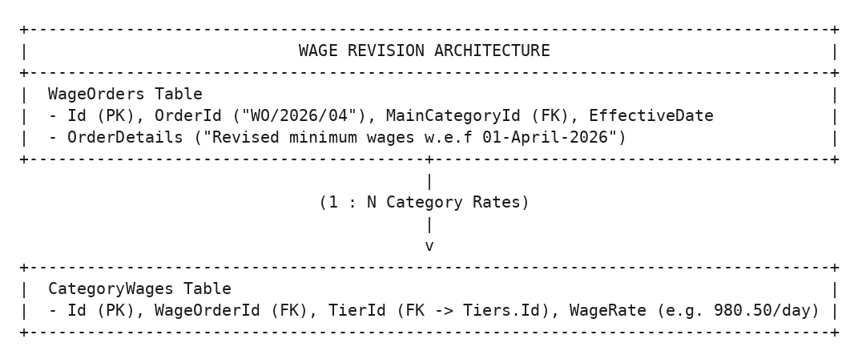

Point-in-Time Wage Rate Resolution
When calculating payroll for month $M$, the system does not merely take the “current” wage; it evaluates the historical wage rate active on that specific month using window functions:
SELECT cw.TierId, cw.WageRate,
ROW_NUMBER() OVER (PARTITION BY cw.TierId ORDER BY wo.EffectiveDate DESC, wo.CreatedAt DESC, cw.Id DESC) AS rn
FROM CategoryWages cw
JOIN WageOrders wo ON cw.WageOrderId = wo.Id
WHERE wo.EffectiveDate <= :LastDayOfMonth

2. Statutory Deduction Orders (StatutoryOrders)
Manages legal statutory rates and contribution ceilings:
Parameter | Default Seed Value | Statutory Rule & Calculation Formula
EpfRate | 13.00% | EPF contribution rate applied to base eligible wage.
EpfLimit | Rs. 15,000.00 | Maximum monthly salary ceiling eligible for EPF computation.
EpfCappedAmount | Rs. 1,950.00 | Statutory monthly contribution ceiling: $15,000×13\%=1,950$.
GstRate | 18.00% | Goods & Services Tax levied on total invoice value.

3. Monthly Payroll Calculation Engine (Calculation.aspx)
Calculation.aspx reconciles raw daily attendance into billable days and monetary wage bills.

3.1 Data Flow & Processing Steps (GetCalculationData)
[User selects Year, Month, Tier, and Division on Calculation.aspx]
|
v
1. Resolve Active ContractPeriodId & Wage Rate for target month
|
2. Query Active Employees with valid EmployeeEngagements in target month
|
3. Query Attendance Matrix for Target Month (Present, Paid Leaves, Holidays)
|
4. Query CalculationOverrides Table (Manual Day Adjustments)
|
5. Apply Wage Formula & Statutory Math
|
6. Render Interactive Calculation Matrix on UI

3.2 Billable Days & Mathematical Formulas
$$\text{Calculated Working Days}=∑\text{Present Days}+∑\text{Paid Leaves (CL/EL)}+∑\text{Declared Holidays}$$
$$\text{Final Days}=\left\{\begin{matrix}\text{CalculationOverrides.FinalDays} & \text{if manual override exists} \\ \text{Calculated Working Days} & \text{otherwise}\end{matrix}\right.$$
$$\text{Gross Wages}=\text{Final Days}×\text{Daily Wage Rate}$$
$$\text{EPF Contribution}=min\left(\text{Gross Wages}×\text{EpfRate}, \text{EpfCappedAmount}\right)$$
$$\text{Total Invoice Bill}=\left(\text{Gross Wages}+\text{EPF}+\text{Agency Service Charge}\right)×\left(1+\text{GstRate}\right)$$

4. Manual Wage & Day Adjustments
Administrators have the authority to make controlled manual adjustments:

4.1 Billable Days Override (CalculationOverrides)
- Table: CalculationOverrides
- Primary Key: (Year, Month, TierId, EmpID)
- Rule: If an employee worked overtime or required exceptional compensation adjustment, the administrator keys in FinalDays and a mandatory Remarks reason. The calculation grid immediately highlights overridden cells in amber.

4.2 Monthly Wage Override (CalculationWages)
- Table: CalculationWages
- Primary Key: (Year, Month, TierId)
- Rule: Overrides the standard wage order rate specifically for month $M$ without altering the master WageOrders record.

Chapter 09: Automated Document Generation & Certificate Engine
This document details the dynamic legal document generator and certificate engine (Documents.aspx / Documents.aspx.cs).

1. Document Engine Architecture
Documents.aspx automates the generation of official statutory compliance certificates and covering letters required for vendor billing submissions to finance/audit.
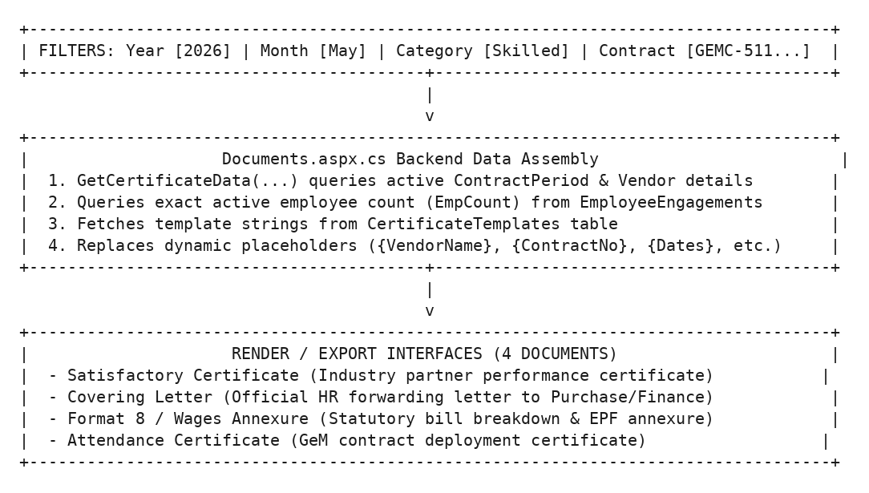

2. Generated Document Types & Business Rules

2.1 Satisfactory Performance Certificate
- Purpose: Certifies that the vendor supplied the requisite number of contract employees and that services rendered during the billing month were satisfactory.
- Key Placeholders: {VendorName}, {VendorAddress}, {Services}, {Duration}, {WefDate}, {ContractNo}, {ContractDate}, {DatedOn}, {EmpCount}, {StartDate}, {EndDate}.
- Signatory: Configured via SatSignatory (e.g. (Raajita B Reddy)) and SatDesignation (e.g. Scientist 'F').

2.2 Official Covering Letter
- Purpose: Official memorandum from the Division/Establishment to Purchase / Accounts (D-FMM/Purchase) forwarding attendance registers and wage bills for payment processing.
- Key Placeholders: {RefNo}, {Year}, {Category}, {VendorName}, {VendorAddress}, {StartDate}, {EndDate}, {Division}.
- Authority Tag: Configured via CovAuthority (For GD, {Division}).

2.3 Format 8 / Wages Annexure
- Purpose: Comprehensive financial annexure showing employee-by-employee billable days, gross wages, EPF deductions, GST calculations, and net payable sums.

2.4 Attendance Certificate
- Purpose: Concise certificate verifying that contract employees performed duties in accordance with the GeM contract terms.

3. Dynamic Template System (CertificateTemplates)
All wording is dynamically decoupled from code and stored in CertificateTemplates:
Template Key | Purpose | Default Boilerplate Text
AttDesc1 | Attendance Header | This is certify that DEO ({Category}) under GeM Contract No: {ContractNo}, dated: {ContractDate}, Dated On: {DatedOn}
SatDesc1 | Satisfactory Opening | This is to certify that M/s. <b>{VendorName}</b>, {VendorAddress} is engaged as an Industry Partner in our Establishment to provide Services towards <b>{Services}</b>...
SatDesc2 | Manpower Count | The Industry Partner provided <b>{EmpCount}</b> Contract Employees and found working satisfactorily.
CovSubject | Letter Subject | HIRING OF MANPOWER SERVICES
CovBody | Letter Body Text | The copies of the Attendance report along with the wage calculation for {Category} category Contract Employees from M/s. {VendorName}...

Modifying Boilerplate Text
Administrators can modify any document wording directly in the database without recompiling the application:
UPDATE CertificateTemplates
SET TemplateValue = 'New approved certificate wording with {VendorName} and {ContractNo}'
WHERE TemplateKey = 'SatDesc1';

4. Export & Printing Capabilities
Documents.aspx supports: 1. Interactive In-Browser Preview: Real-time WYSIWYG preview rendered inside printable cards with official establishment styling. 2. Direct Browser Print: Injects custom @media print stylesheets hiding navigation bars and optimizing margins for A4 paper. 3. Microsoft Word Export (.doc): Streams HTML MIME payload with Content-Type: application/msword and Content-Disposition: attachment; filename="Satisfactory_Certificate.doc".

Chapter 10: Administration, Hierarchical Categories & Security Policies
This document details the user role administration engine (AdminManagement.aspx / AdminManagement.aspx.cs) and the organizational settings interface (Settings.aspx / Settings.aspx.cs).

1. User Administration & Role Lifecycle (AdminManagement.aspx)
The Admin Management Module controls all system access grants, user accounts, division scopes, and cross-admin delegation.
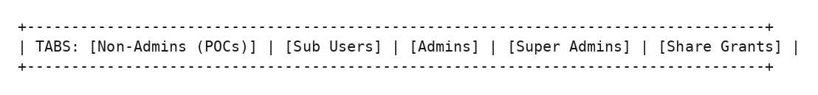

1.1 Role Management & Integer State Machine
Access is governed by integer codes stored in AppUsers.Role. Revoking an account does not delete data; it transitions the account into its corresponding Revoked State Code, immediately terminating active sessions while preserving historical audit trails:
[Super Admin: 4] <---- Revoke / Grant ----> [Revoked Super Admin: 5]
[Admin: 1] <---- Revoke / Grant ----> [Revoked Admin: 2]
[POC User: 0] <---- Revoke / Grant ----> [Revoked POC User: 3]
[Sub User: 6] <---- Revoke / Grant ----> [Revoked Sub User: 7]

1.2 POC Division & Tier Mapping
When creating or editing a Regular User (POC): - Authorized Divisions (UserDivisions): Checkboxes specify which directorates (e.g. 'D-ADMIN', 'D-KRM') the POC can view and mark attendance for. - Allowed Tiers (UserTiers): Checkboxes specify which skill tiers (e.g. Skilled DEO, Unskilled Attender) within those divisions are visible to the POC.

1.3 Sub User Anchor Assignment (SubUserAnchor)
Sub Users do not have standalone division mappings; they inherit their operational scope directly from their assigned Anchor POCs:
INSERT INTO SubUserAnchor (SubUserPCNO, AnchorPocPCNO, CreatedAt, CreatedBy)
VALUES (:SubUserPCNO, :AnchorPocPCNO, SYSTIMESTAMP, :AdminPCNO);

1.4 Cross-Admin Category Sharing (CategoryShareGrant)
A Primary Admin can delegate category management to another Admin without transferring master ownership: - Table: CategoryShareGrant - Fields: OwnerAdminPCNO, SharedWithPCNO, MainCategoryId, TierId (NULL = all tiers), IsActive. - Effect: The guest admin sees a Secondary Admin (Shared) card in their login role selection modal.

2. Hierarchical Category & Tier Builder (Settings.aspx)
Settings.aspx enables administrators to structure the organizational manpower hierarchy.
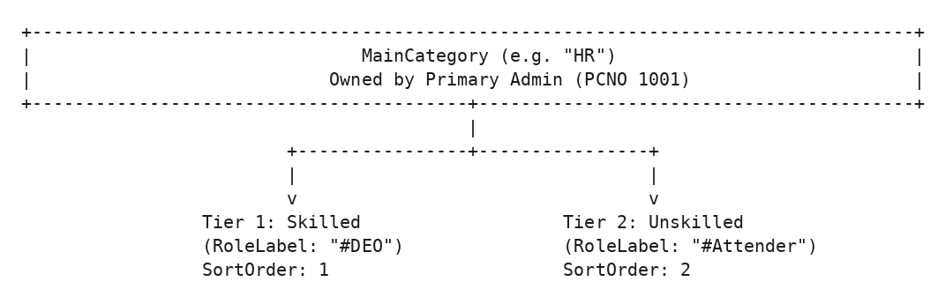

Category Ownership Rules:
- Super Administrator (Role 4): Has global visibility over all Main Categories and Tiers across the organization.
- Primary Administrator (Role 1): Can manage, edit, and create Tiers only under Main Categories they explicitly own (MainCategory.AdminPCNO = :PCNO).
- Secondary Administrator: Can view and manage attendance for shared categories but cannot delete the parent category.

3. Global Edit & View Policy Rules (Settings.aspx)
Configures system-wide security constraints enforced across attendance grids:
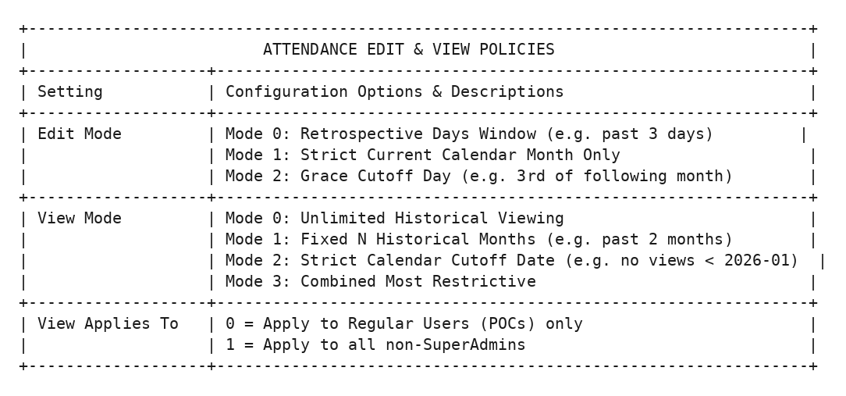

4. System Action Audit Logs (AdminActionLog & ActionLog)
Settings.aspx includes an audit viewer querying AdminActionLog and ActionLog to inspect administrative operations (e.g. user creation, role revocations, category updates, and batch configuration modifications).

Chapter 11: Communication, Notices, Remarks & Financial Ledger
This document details the communication circulars board (Notices.aspx), the attendance correction remark ticket system (Remarks.aspx / UserRemarks.aspx), and the vendor financial accounting register (Ledger.aspx).

1. Circulars & Notice Board (Notices.aspx)
The Notice Board Module enables administrators to distribute official policy circulars, statutory orders, and document attachments to regular users with guaranteed read tracking.
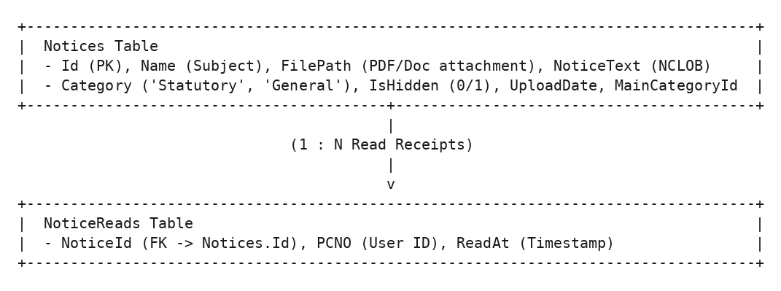

Key Capabilities:
- Targeted Scoping: Notices can be posted globally (visible to all users) or scoped specifically to an owned MainCategoryId.
- Read Receipts Tracking: When a user opens a circular, the system inserts a record into NoticeReads(NoticeId, PCNO, ReadAt). Administrators can view who read each notice and at what timestamp.
- File Attachments: Securely uploads PDF/Word attachments to server directories and delivers them via authenticated handlers.

2. Attendance Correction Request Workflow (Remarks.aspx / UserRemarks.aspx)
When historical attendance dates are locked by edit window policies, Regular Users (POCs) submit formal Attendance Remarks / Correction Requests to administrators.
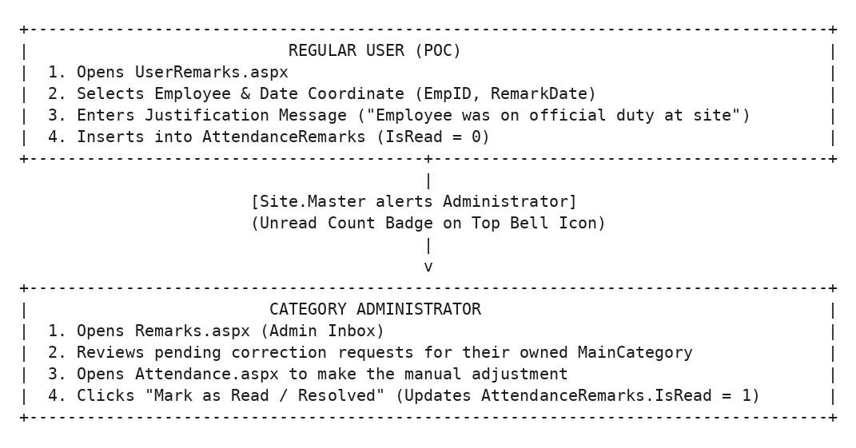

3. Financial Vendor Ledger (Ledger.aspx)
Ledger.aspx provides an accounting audit of billed invoices, statutory deductions, payments, and balance reconciliations across manpower agencies.

Capabilities:
- Summarizes gross billed wages, EPF employer contributions, GST amounts, and agency service commissions per vendor and contract period.
- Tracks penalties, deduction adjustments, and net disbursement figures.
- Generates downloadable financial audit spreadsheets for internal finance reviews.

Chapter 12: Developer Recipe & Modification Handbook
This handbook provides practical, step-by-step recipes for future software engineers who need to maintain, modify, extend, or troubleshoot the Attendance Management System (AMS) without the original author.

Recipe 1: How to Add a New Field to an Existing Table
Scenario: Suppose you need to add an EmergencyContactPhone column to the Employees table and display it on Employee.aspx.

Step 1.1: Database Schema Migration
- Connect to the Oracle database as SYSTEM or your schema owner.
- Execute the ALTER statement:
- ALTER TABLE Employees ADD EmergencyContactPhone VARCHAR2(20) NULL;
- Update oracle_setup.sql under the CREATE TABLE Employees definition so future fresh installations include the new column.

Step 1.2: Update Action Logger JSON Capture
Because ActionLogger.cs serializes employee records for the undo engine, update Utils/ActionLogger.cs: - In UndoAction(...), add the parameter mapping under UPDATE Employees: csharp cmd.Parameters.Add(new OracleParameter("EmergencyContactPhone", empData.ContainsKey("EMERGENCYCONTACTPHONE") ? empData["EMERGENCYCONTACTPHONE"] : DBNull.Value));

Step 1.3: Update Backend CRUD in Employee.aspx.cs
- In btnAdd_Click: Read value from the new textbox txtEmergencyPhone.Text.Trim() and include :EmergencyContactPhone in the INSERT INTO Employees statement.
- In btnEdit_Click: Include EmergencyContactPhone = :EmergencyContactPhone in the UPDATE Employees statement.
- In BindGrid(): Add e.EmergencyContactPhone to the select list.

Step 1.4: Update Frontend UI in Employee.aspx
Add the ASP.NET control inside the edit/create modal:
<div class="form-group col-md-6">
<label>Emergency Contact Phone</label>
<asp:TextBox ID="txtEmergencyPhone" runat="server" CssClass="form-control" placeholder="+91 XXXXXXXXXX" />
</div>

Recipe 2: How to Add a New Page / Module
Scenario: You are creating a new page called Reports.aspx.

Step 2.1: Create Web Form & Code-Behind
- Create Reports.aspx:
- <%@ Page Title="System Reports" Language="C#" MasterPageFile="~/Site.Master" AutoEventWireup="true" CodeBehind="Reports.aspx.cs" Inherits="AttendanceApp.Reports" %>
<asp:Content ID="Content1" ContentPlaceHolderID="MainContent" runat="server">
<div class="container-fluid">
<h1 class="h3 mb-4 text-gray-800">System Reports</h1>
<!-- Content here -->
</div>
</asp:Content>
- Create Reports.aspx.cs:
- using System;
using System.Web.UI;
using AttendanceApp.Utils;
namespace AttendanceApp
{
public partial class Reports : Page
{
protected void Page_Load(object sender, EventArgs e)
{
if (!User.Identity.IsAuthenticated || Session["PCNO"] == null)
{
Response.Redirect("Login.aspx");
return;
}
// Enforce Role Access Control (e.g. Admin only)
int role = Convert.ToInt32(Session["Role"] ?? 0);
if (role != 1 && role != 4)
{
Response.Redirect("Dashboard.aspx");
return;
}
}
}
}

Step 2.2: Register Navigation Link in Site.Master
Open Site.Master and add the menu item:
<li class="nav-item">
<a class="<%= GetNavClass("Reports.aspx") %>" href="Reports.aspx">
<i class="fas fa-chart-bar mr-1"></i> Reports
</a>
</li>
Open Site.Master.cs and configure placeholder visibility if the page should be restricted to specific roles.

Recipe 3: How to Modify Attendance Rules & Wage Formulas

Altering the Saturday Rule
- Open Attendance.aspx.cs.
- Locate the Saturday evaluation section inside GetData.
- Adjust the conditions checking whether Friday or Monday was an absent day (StatusValue == 0).

Altering EPF / GST Statutory Ceilings
- Open Wages.aspx in your browser as Admin, or update the database directly:
- INSERT INTO StatutoryOrders (OrderId, EffectiveDate, EpfRate, EpfLimit, EpfCappedAmount, GstRate, CreatedBy)
VALUES ('STAT/2026/02', TO_DATE('2026-06-01', 'YYYY-MM-DD'), 12.00, 21000.00, 2520.00, 18.00, '1001');
- All subsequent payroll runs will automatically pick up the new statutory rates effective from the designated date.

Recipe 4: How to Configure & Debug Active Directory / LDAP

Local Offline Testing Bypass
During local development without an active domain controller connection, Utils/ADHelper.cs contains built-in bypass accounts: - Username: 1001 or admin $→$ Logs in as Admin (PCNO = 1001) - Username: 1002 $→$ Logs in as POC (PCNO = 1002) - Username: 1003 $→$ Logs in as POC (PCNO = 1003) - Username: 1004 $→$ Logs in as SubUser (PCNO = 1004) (Any password is accepted for bypass accounts during local testing).

Connecting to Production Domain Controller
- Open Web.config.
- Update the ADConnectionPath app setting:
- <add key="ADConnectionPath" value="LDAP://YOUR_DC_IP_OR_HOST/DC=company,DC=corp,DC=in" />
- Ensure server firewall allows outbound TCP port 389 (LDAP) or 636 (LDAPS) to the Domain Controller.

Recipe 5: Oracle Database Connection Troubleshooting

Connection Pool Configuration in Web.config
<add name="AttendanceDB"
connectionString="User Id=system;Password=root;Data Source=//127.0.0.1:1521/xe;Min Pool Size=5;Max Pool Size=200;Connection Lifetime=120;Statement Cache Size=50;Incr Pool Size=5;Decr Pool Size=2;Validate Connection=false;"
providerName="Oracle.ManagedDataAccess.Client" />

Critical ADO.NET Rules to Prevent Connection Leaks:
- Always wrap connections, commands, and readers in using blocks:
- using (OracleConnection conn = new OracleConnection(DBHelper.GetAttendanceDBConnection()))
{
conn.Open();
using (OracleCommand cmd = new OracleCommand(sql, conn))
{
cmd.BindByName = true; // ALWAYS set BindByName = true in Oracle ADO.NET
cmd.Parameters.Add(new OracleParameter("Param1", value));
using (OracleDataReader reader = cmd.ExecuteReader())
{
while (reader.Read()) { ... }
}
}
}
- Never leave DataReaders open without consuming or disposing them.

Recipe 6: Production Build & Deployment Checklist
When deploying changes to the production Windows IIS Server:
- Compile Solution: Using MSBuild or Visual Studio:
- & "C:\Program Files (x86)\Microsoft Visual Studio\2019\Professional\MSBuild\Current\Bin\MSBuild.exe" AttendanceApp.sln /p:Configuration=Release
- Deploy Files to IIS:
  - Copy bin/AttendanceApp.dll and dependencies (Oracle.ManagedDataAccess.dll, MySql.Data.dll).
  - Copy all .aspx, .Master, and .config files.
  - Copy the Static/ folder containing CSS, JS, and font assets.
- Set Folder Permissions: Ensure IIS_IUSRS and NETWORK SERVICE have Read & Execute permissions on the application folder, and Write permissions on temporary upload folders if document attachments are saved locally.
- Update Web.config for Production:
  - Set <compilation debug="false" targetFramework="4.5" />.
  - Update connectionStrings with production database credentials.
  - Update ADConnectionPath with corporate LDAP domain controllers.

Chapter 13: Gap Analysis, Undocumented Files & Recommendations (New - added during consolidation)
The original 13-chapter handover set (Chapters 0-12) is thorough for the pages and utilities it covers. While consolidating it into this single manual, the complete project archive (attendence.zip) was inspected file-by-file against the documentation. This chapter records everything that exists in the codebase but was not documented anywhere in Chapters 0-12, plus a set of practical recommendations for the next maintainer. Treat this chapter as an addendum, not a replacement - always read the relevant module chapter first.

1. Files That Exist in the Project but Were Not Documented

1.1 Invoice.aspx - Standalone Client-Side Invoice Generator
Invoice.aspx is listed only by name in the master index (Chapter 0) and mentioned in passing in Chapter 9’s title, but its actual logic was never explained. It is architecturally different from every other page in the system:
- No code-behind file. It uses <%@ Page Language="C#" AutoEventWireup="true" %> directly with no Invoice.aspx.cs, meaning it has no server-side logic at all. It is a static HTML page served by IIS with an inline <script> block.
- No database access, no session checks. It does not check Session["PCNO"], so unlike every other .aspx page in this system it does not enforce a login gate through code - it relies purely on Web.config’s global <authorization><deny users="?" /></authorization> rule to block anonymous access.
- Data source: localStorage, not the database. The page reads a browser localStorage key called finalData (a JSON blob: { rate, employees: [{days, rate}], category, year, month }). This value is expected to be written by the calling page (most likely Calculation.aspx or Ledger.aspx) via window.open("Invoice.aspx") immediately after localStorage.setItem("finalData", ...), then this page picks it up on load.
- Business math duplicated in JavaScript. The invoice calculation - EPF split (a Rs. 1,800 capped contribution for wages above Rs. 15,000/month, 13% for wages at or below that threshold), a 3.85% service charge, and 18% GST - is hand-coded again in client-side JavaScript, separately from the authoritative server-side EPF/GST formulas described in Chapter 8 (StatutoryOrders, CalculationOverrides). These two implementations can drift out of sync (e.g. Chapter 8’s EPF cap is configurable via StatutoryOrders.EpfCappedAmount, currently seeded at Rs. 1,950, while Invoice.aspx hard-codes Rs. 1,800 and a fixed 3.85% service charge that does not exist anywhere in the StatutoryOrders schema).
- Header text is hard-coded, including the contract number, vendor name (“M/s Vishal Manpower and Security Consultants, Mangalore”), and contract dates - meaning this page currently only produces a correct invoice for one specific contract and must be manually edited for any other vendor/contract, unlike Documents.aspx which is template-driven (Chapter 9).
Recommendation: Either (a) retire this page and route invoice generation through the templated engine in Documents.aspx / CertificateTemplates, or (b) rewrite it to accept a ContractPeriodId query-string parameter, fetch vendor/rate/contract data from the database (reusing DBHelper and StatutoryOrders), and remove the duplicated hard-coded statutory math so it always agrees with Calculation.aspx.

1.2 DbSetup.cs - Standalone Database Bootstrap Console Utility
Not mentioned in any chapter. This is a small console application entry point (class DbSetup { static void Main(...) }) that is not part of the running web application. It:
- Opens oracle_setup.sql from disk.
- Parses it into individual statements (splitting on lines that contain only /, which is how PL/SQL trigger blocks are terminated in Oracle scripts).
- Executes each statement in sequence against the Oracle instance using a hard-coded connection string (system/root@//127.0.0.1:1521/xe).
This is effectively a lightweight alternative to running oracle_setup.sql manually through SQL*Plus or SQL Developer. It is useful for first-time environment setup and automated test-environment provisioning, but:
- It contains a second copy of the database credentials shown in Chapter 0 (system/root), hard-coded rather than read from Web.config.
- It has its own Main() method, meaning it must live in a separate console-app project (or be excluded from the web project’s .csproj/publish profile) so it is never compiled into the IIS bin folder of the live website.
Recommendation: Move the connection string to App.config, document this tool as a one-time setup utility alongside Chapter 12’s “Recipe 5” (Oracle troubleshooting), and confirm it’s excluded from the production deployment package.

1.3 TestNs.cs - Leftover Developer Scratch File
Not part of the application. This is a throw-away diagnostic script with its own class Program { static void Main() } that loads MySqlConnector.dll via reflection and prints its namespaces to the console - almost certainly left over from evaluating whether to use MySQL instead of Oracle (the project ultimately uses Oracle exclusively; MySql.Data and MySqlConnector packages exist under packages/ but do not appear to be referenced by any .aspx.cs file in the modules documented in Chapters 2-11).
Recommendation: Delete TestNs.cs and the MySql.Data / MySqlConnector NuGet packages if they are confirmed unused, to avoid confusing a future maintainer into thinking the app is dual-database.

1.4 SQL Scripts Beyond oracle_setup.sql
Chapter 0 documents oracle_setup.sql and mentions a db_setup.sql in the file tree without explanation. The archive also contains three more undocumented SQL utility scripts at the project root:
File | Purpose (inferred from content)
oracle_setup.sql (~1,228 lines) | The authoritative, complete DDL: all tables, sequences, triggers, and indexes described in Chapter 1. This is the one to run on a brand-new database.
db_setup.sql (~140 lines) | A much smaller / older schema script. Appears to be an earlier or partial version of the setup script. Do not run this against a database that already ran oracle_setup.sql - reconcile the two and delete whichever is stale before handing this project to someone else, since having two “setup” scripts of different vintages is a common source of “works on my machine” bugs.
alter_employees_add_quals.sql | A single ALTER TABLE Employees ADD (...) migration that added the Qualification / Experience / ExperienceIn columns described in Chapter 1 - evidence that oracle_setup.sql was patched after initial release. oracle_setup.sql already includes these columns natively (confirmed against Chapter 1’s table dictionary), so this file is only needed when upgrading a pre-existing older database, not a fresh one.
check_fk.sql | A short diagnostic query for inspecting foreign-key constraints - a DBA convenience script, safe to keep for troubleshooting.
CHECK_INDEXES.sql | A diagnostic script (~79 lines) that queries Oracle’s data dictionary to confirm which of the composite indexes listed in Chapter 1, Section 3 actually exist on the live database - useful after a fresh install to verify nothing was missed.
Recommendation: Consolidate all schema history into a single, dated migrations folder (e.g. db/migrations/001_initial.sql, db/migrations/002_add_qualifications.sql, …) so the next developer always knows the exact order to apply scripts, instead of guessing between oracle_setup.sql and db_setup.sql.

1.5 Non-Application Tooling in the Repository
The zip archive also contains directories that are not part of the deployed website and were correctly left out of the original 13 chapters, but are worth flagging so a new developer doesn’t waste time trying to understand them as “part of AMS”:
- .agents/, graphify-out/, example/ - AI coding-assistant configuration and generated documentation caches used while building this very documentation set. Not deployed, not referenced by the site.
- .vs/, obj/, bin/, packages/ - standard Visual Studio build artifacts and NuGet package caches. These should be excluded from source control via .gitignore (a .git/ folder exists in the archive, so check whether these bulky, machine-specific folders are already tracked - if so, remove them from git history to shrink the repository).
- Satisfactory_Certificate_May_2026_format8_files/ - looks like a browser “Save As -> Webpage, Complete” output folder (an artifact of manually saving a generated certificate from Chapter 9’s export feature), not source code.
Recommendation: Add a .gitignore covering bin/, obj/, .vs/, packages/, and any *_files/ folders, and move .agents/ / graphify-out/ outside the web project’s root directory so a fresh git clone only contains the actual application.

2. Cross-Checks Against the Source Code (Confirmed Accurate)
The following details in Chapters 0-12 were spot-checked directly against the live source files and confirmed correct, so they can be trusted as-is:
- Web.config’s connection strings, ADConnectionPath, Forms Authentication timeout (1440 minutes), maxRequestLength (2097151 KB), and executionTimeout (3600s) all match Chapter 0 exactly.
- The AD bypass accounts (1001 / admin / aadmin -> 1001; 1002, 1003, 1004) in ADHelper.cs match Chapter 2 and Chapter 12 exactly.
- The page/code-behind inventory (Login, Dashboard, Attendance, Employee, Contracts, Vendors, Calculation, Wages, Documents, AdminManagement, Settings, Notices, Remarks, UserRemarks, Ledger) matches the actual root-level .aspx / .aspx.cs files one-for-one.

3. Additional Production-Readiness Recommendations
These are not bugs in the documentation, but observations worth a new maintainer’s attention because they affect how safely this system can be operated going forward:
- Web.config currently ships with <compilation debug="true" .../>. Debug builds are slower and can leak stack traces to end users on unhandled errors. Set this to false before any production deployment (Chapter 12’s Recipe 6 already tells you to do this - just confirm it’s actually flipped before go-live).
- Database credentials are stored in plain text in Web.config (system/root) and duplicated in DbSetup.cs. For production, move to Windows-integrated Oracle authentication or at minimum an encrypted connectionStrings section (aspnet_regiis -pef), and rotate the password away from the default system/root pairing.
- The AD local-bypass accounts (1001-1004) authenticate with any password. This is explicitly documented as a developer convenience (Chapter 2, Chapter 12), but because the check lives directly in ADHelper.AuthenticateAndGetPCNO rather than behind a compile-time flag or a Web.config toggle, it will keep working in a production build unless someone remembers to remove it. Recommend gating it behind an appSettings flag (e.g. <add key="EnableLocalAuthBypass" value="false" />) that is explicitly turned off in the production Web.config.
- No automated tests were found anywhere in the archive. Given the amount of date-math and financial calculation logic (Saturday sandwich rule, leave balance carry-over, EPF/GST rounding), even a small suite of unit tests around DBHelper’s calculation helpers would catch regressions that are otherwise easy to introduce silently (see Chapter 12’s guidance on modifying the Saturday rule and wage formulas - currently the only verification method is manual testing).
- Two disconnected sources of truth for invoice math (Invoice.aspx’s JavaScript vs. the server-side Calculation.aspx / StatutoryOrders engine in Chapter 8) - see Section 1.1 above. This is the single highest-value fix for data-integrity risk in the whole system, since a vendor-facing invoice could show different totals than the internal calculation grid.
- Two versions of the schema setup script (oracle_setup.sql vs db_setup.sql) - see Section 1.4 above. Reconcile before the next fresh install.

End of new material. The chapters before this one (Chapters 0-12) are the original developer-handover documentation, reproduced here in full and cross-checked against source.

Appendix A: Quick-Reference Glossary
A fast lookup table for the codes and session variables used throughout the system. Full context for each is in the chapter noted.

A.1 AppUsers.Role / Session Role Codes (see Chapter 0 Section 5, Chapter 10 Section 1.1)
Code | Meaning
0 | Regular User / POC (active)
1 | Category Admin (active) - Primary or Secondary depending on ownership vs. CategoryShareGrant
2 | Revoked Admin
3 | Revoked POC
4 | Super Administrator (active)
5 | Revoked Super Admin
6 | Sub User / Data Entry (active)
7 | Revoked Sub User

A.2 Attendance Status Codes (see Chapter 4 Section 2)
StatusValue | Symbol | Meaning
1.0 | P | Present
0.0 / 0 | A | Absent
2.0 (+ LeaveType CL/EL) | L | Paid Leave
3.0 (+ LeaveType LWP) | UL | Unpaid Leave
NULL + IsHoliday=1 | H | Declared Public Holiday
NULL + AutoSat=1 | S | Auto-Saturday Absence
0.5 (+ LeaveType Carried/Pending) | 1/2 | Half-Day / Paired Leave (staged only)

A.3 Employee Lifecycle Status Values (see Chapter 6)
Active, Resigned, Relieved, System (used only by the GLOBAL seed employee, Chapter 1 Section 4).

A.4 Edit Mode / View Mode Policy Codes (see Chapter 5 Section 2, Chapter 10 Section 3)
Setting | Mode | Meaning
Edit Mode | 0 | Retrospective Days Window
Edit Mode | 1 | Strict Current Calendar Month Only
Edit Mode | 2 | Grace Cutoff Day
View Mode | 0 | Unlimited historical viewing
View Mode | 1 | Fixed N historical months
View Mode | 2 | Strict calendar cutoff date
View Mode | 3 | Combined (most restrictive of 1 and 2)
View Mode | 4 | Locked (no historical viewing)

A.5 Key Session Variables (see Chapter 0 Section 6)
Session["PCNO"], Session["Role"], Session["RoleMode"], Session["Name"], Session["Designation"], Session["Division"], Session["AllowedDivisions"], Session["UserRoles"], Session["PendingPCNO"], Session["PendingRoles"].

A.6 Core Tables at a Glance
Domain | Key Tables
Access control | AppUsers, UserDivisions, UserTiers, SubUserAnchor, CategoryShareGrant
Org structure | MainCategory, Tiers, Divisions
Vendors & contracts | Vendors, VendorContacts, ContractPeriods, ContractPeriodVendors, ContractExtensions
Employees | Employees, EmployeeEngagements, EmployeeLeaveCredits
Attendance | Attendance, AttendanceDraft, Attendance_Audit_Log, AttPocEditRemarks
Payroll | WageOrders, CategoryWages, StatutoryOrders, CalculationOverrides, CalculationWages
Communication | Notices, NoticeReads, AttendanceRemarks
Audit | EmployeeActionLogs, AdminActionLog, ActionLog
Documents | CertificateTemplates

A.7 Where to Look When You Need To…
Task | Start in
Add a field to an existing table | Chapter 12, Recipe 1
Add a brand-new page/module | Chapter 12, Recipe 2
Change the Saturday rule or wage formula | Chapter 12, Recipe 3
Fix LDAP / local login | Chapter 12, Recipe 4
Fix an Oracle connection issue | Chapter 12, Recipe 5
Deploy to production IIS | Chapter 12, Recipe 6
Understand a specific table’s columns | Chapter 1
Understand a page’s business logic | Chapters 3-11 (matching module)
Know what’s undocumented / still needs cleanup | Chapter 13

