Software Requirements Specification (SRS)

for

Attendance & Contract Workforce Management System
Version 2.0
Date: July 2026

Table of Contents
- Introduction
1.1 Purpose
1.2 Document Conventions
1.3 Intended Audience and Reading Suggestions
1.4 Product Scope
1.5 References
- Overall Description
2.1 Product Perspective
2.2 Product Functions
2.3 User Classes and Characteristics
2.4 Operating Environment
2.5 Design and Implementation Constraints
2.6 User Documentation
2.7 Assumptions and Dependencies
- System Features and Requirements
3.1 Authentication and Authorization Module
3.2 Dashboard Module
3.3 Employee Master Module
3.4 Vendor Management Module
3.5 Contract Management Module
3.6 Attendance Management Module
3.7 Calculation / Payroll Module
3.8 Ledger Module
3.9 Document Generation Module
3.10 Notices Module
3.11 Remarks / Correction Request Module
3.12 Admin / User Management Module
3.13 Settings Module
- External Interface Requirements
4.1 User Interfaces
4.2 Hardware Interfaces
4.3 Software Interfaces
4.4 Communications Interfaces
- Non-Functional Requirements
5.1 Performance Requirements
5.2 Security Requirements
5.3 Software Quality Attributes
- Database Architecture and Design
6.1 Schema Overview
6.2 Entity-Relationship Diagram
6.3 Table Descriptions and Relationships
6.4 Key Business Logic in Database
- System Architecture
7.1 Architecture Overview
7.2 Technology Stack
7.3 Module Interaction Flow
- Glossary
- Appendices

1. Introduction

1.1 Purpose
This Software Requirements Specification (SRS) document describes the complete functional and non-functional requirements for the Attendance & Contract Workforce Management System. This system is developed to manage contract-based employees in an organization, handling their attendance tracking, leave management, wage/salary calculation, document generation, and contract lifecycle management. The system will be deployed in a company environment with no internet connectivity and will operate entirely on an intranet.

1.2 Document Conventions
- SHALL / MUST — Indicates a mandatory requirement.
- SHOULD — Indicates a recommended requirement.
- MAY — Indicates an optional requirement.
- Bold text — Highlights key terms and important concepts.
- Monospace text — Denotes code, SQL queries, table names, and file paths.
- All Mermaid diagrams are rendered from mermaid code blocks.

1.3 Intended Audience and Reading Suggestions
This document is intended for: - Project stakeholders — To understand system capabilities and scope. - Development team — To implement features according to specifications. - Quality assurance team — To create test plans and test cases. - System administrators — To understand deployment and configuration requirements. - End users (HR administrators and POCs) — To understand system functionality.

1.4 Product Scope
The Attendance & Contract Workforce Management System is a web-based application that manages the complete lifecycle of contract/outsourced employees in an organization. The system:
- Tracks daily attendance for contract employees across multiple divisions/departments.
- Manages employee categories (Skilled, Semi-Skilled, Unskilled) with upgrade/downgrade capabilities.
- Handles contract periods with vendors, including contract extensions.
- Computes wages based on attendance with support for manual overrides.
- Generates official documents (Attendance Certificates, Satisfactory Certificates, Covering Letters, Wage Calculation reports).
- Provides a ledger view of employee leave balances and attendance summaries.
- Supports two user roles: Admin (HR) with full access and Regular User (POC) with division-restricted access.
- Manages employee history including resignations, re-joining, transfers, and category changes with full undo support.
The system is currently being used with approximately 80 employees across 30 divisions and will scale to support the organization’s contract workforce needs.

1.5 References
Reference | Description
IEEE Std 830-1998 | IEEE Recommended Practice for Software Requirements Specifications
Oracle Database 11g Documentation | Oracle SQL and PL/SQL Reference
ASP.NET 4.5 Documentation | Microsoft .NET Framework Documentation
Active Directory / LDAP Integration | Microsoft Directory Services Documentation

2. Overall Description

2.1 Product Perspective
The system is an ASP.NET Web Forms application designed for an intranet-only environment. It replaces manual paper-based attendance tracking and spreadsheet-based wage calculation with a centralized digital system.
System Context Diagram:
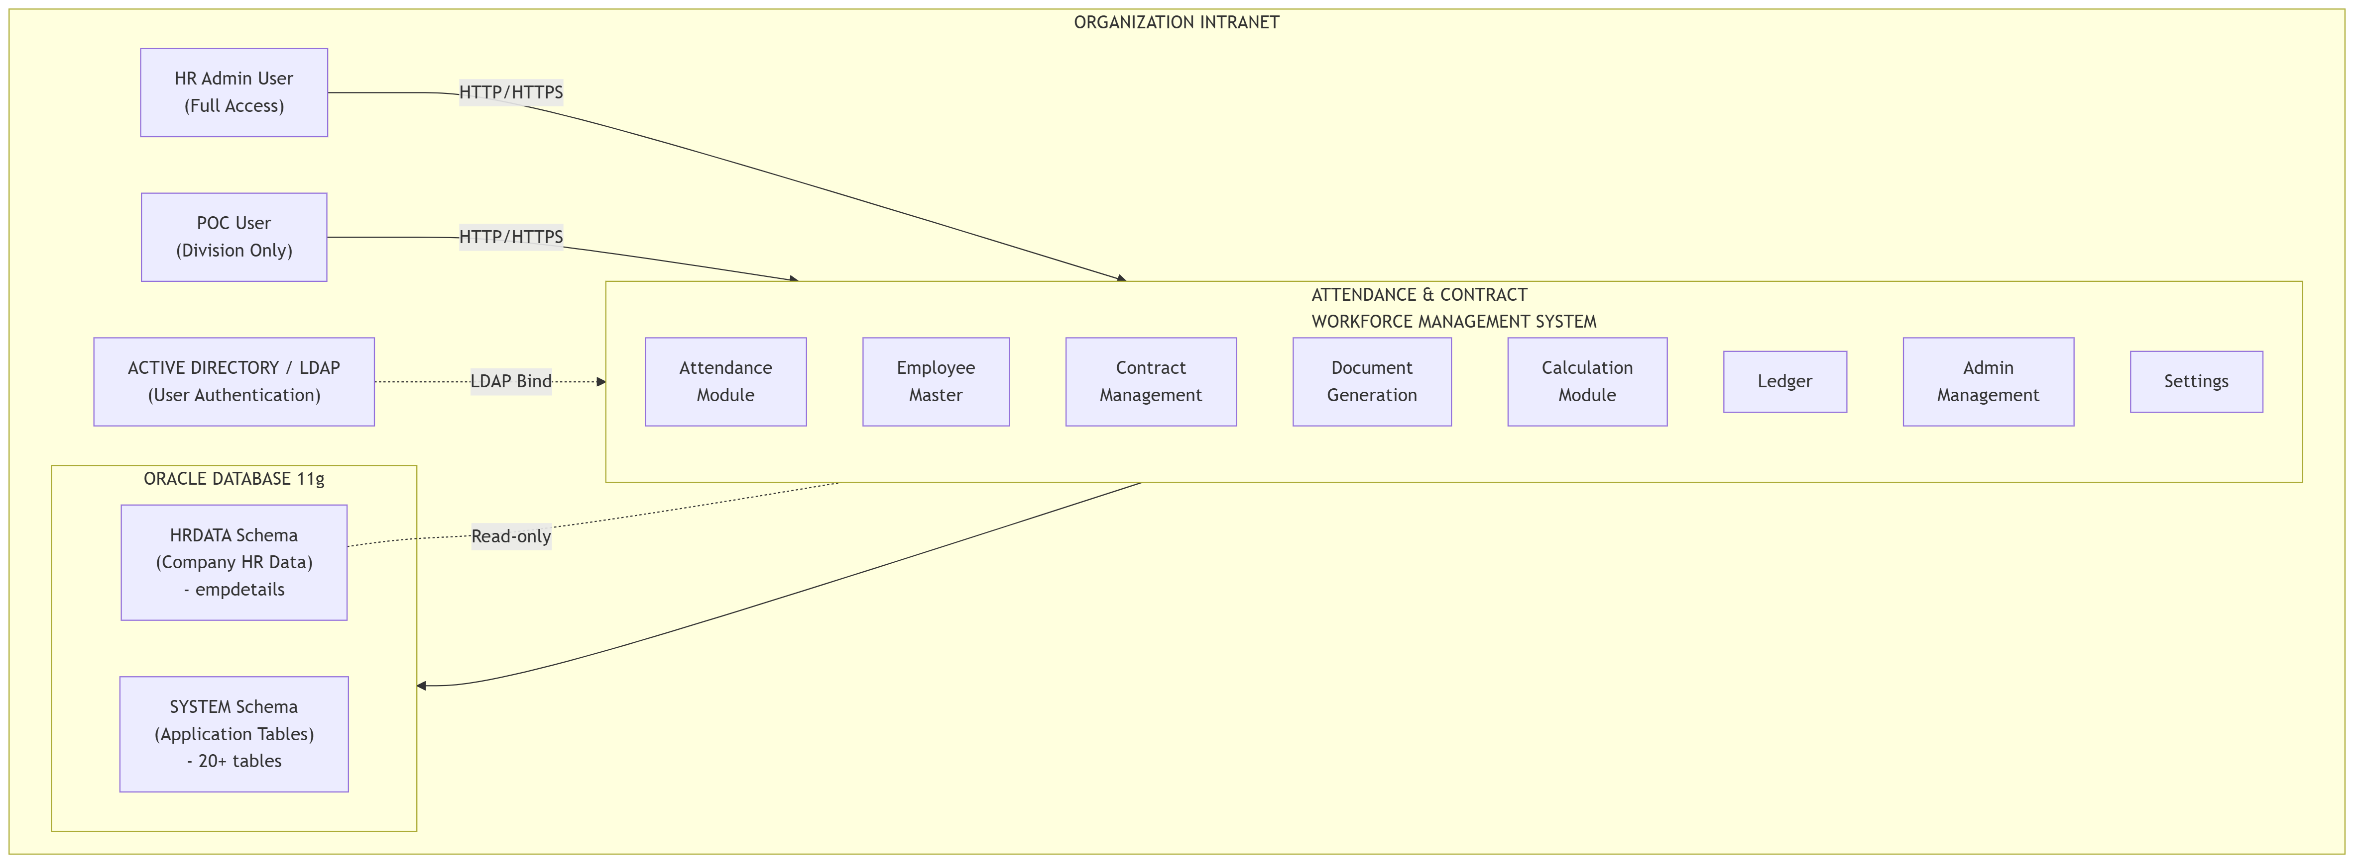
Diagram 1

2.2 Product Functions
The major functions of the system are:
# | Function | Description
1 | User Authentication | LDAP/Active Directory-based login with fallback to database authentication. Users authenticate using their company PCNO (Personnel Number) and network password.
2 | Attendance Management | Monthly grid-based attendance marking. Supports Present (1), Absent (0), Half-Day (0.5), Paid Leave, Unpaid Leave, Holiday marking. Includes automatic Saturday logic and global adjustment.
3 | Employee Master | Complete employee registry with MasterId, personal details, qualifications, experience, leave balances. Supports import via CSV, re-joining with history, category upgrades/downgrades, division transfers, and complete employee deletion.
4 | Vendor Management | Manages manpower agencies/contractors. Supports vendor creation, editing, deactivation, and full contract history viewing. Vendors have MasterId (e.g., VND001).
5 | Contract Management | Manages contract periods per category per vendor. Supports new contract creation with employee enrollment, contract extension, early termination, and deletion with full cascading rollback. Contract periods are typically 2 years with extension support.
6 | Wage Calculation | Monthly wage calculation based on attendance. Supports category-specific wage rates, manual override of present days per employee, and global adjustment.
7 | Document Generation | Generates Attendance Certificates, Satisfactory Certificates, Covering Letters, and Wage Calculation reports in various formats. Templates are customizable via Settings. Uses placeholder presets (e.g., {VendorName}, {ContractNo}) for dynamic data. Invoice.aspx is not used; all documents are managed through Documents.aspx.
8 | Ledger | Comprehensive monthly view showing opening/closing leave balances, paid/unpaid leave counts, half-day deductions, Saturday cuts, present days, and all remarks for each employee.
9 | Notice Board | Admin can upload, hide/show official notices and documents.
10 | Remarks / Correction Requests | Regular users (POCs) can submit attendance correction requests to admin. Admin receives notifications and can view/manage remarks.
11 | Admin Management | Create/manage admin and regular user accounts. Assign division-level access to regular users. Revoke/grant user access.
12 | Settings | Manage divisions, categories, certificate templates, database backup/restore, and undo manager for rolling back employee actions.
13 | Dashboard | Summary view showing key metrics, statistics, and recent activity.

2.3 User Classes and Characteristics
User Class | Role Value | Description | Access Rights
Admin (HR) | Role = 1 | HR department personnel responsible for overall system management. | Full access to all modules. Can edit attendance for any date. Can override Saturdays. Can manage employees, vendors, contracts, and all settings.
Regular User (POC) | Role = 0 | Point of Contact (POC) personnel who oversee contract employees within specific divisions. | Access restricted to assigned divisions. Can mark attendance for current day only. Can view Ledger (division-restricted), Notices, and submit remarks to admin. Cannot override Saturday attendance. Cannot modify previous attendance data.
Revoked Admin | Role = 2 | Former admin whose access has been revoked. | Cannot log in.
Revoked User | Role = 3 | Former regular user whose access has been revoked. | Cannot log in.

2.4 Operating Environment
Component | Environment
Server OS | Windows Server (compatible with IIS)
Web Server | Internet Information Services (IIS)
Target Framework | .NET Framework 4.5
Database | Oracle Database 11g (primary). MySQL was used only for local testing by the developer and is NOT part of the production system.
Development IDE | Visual Studio 2015
Client Browser | Modern browsers (Chrome, Firefox, Edge) on the intranet
Authentication | Active Directory / LDAP (intranet)
Network | Intranet-only — no internet connectivity required

2.5 Design and Implementation Constraints
- No internet access: The application and all its dependencies must operate entirely within the company intranet.
- Oracle 11g compatibility: All database operations must use Oracle 11g-compatible syntax. GENERATED ALWAYS AS IDENTITY (Oracle 12c+) is NOT used. Instead, sequences + BEFORE INSERT triggers are used for auto-increment.
- .NET Framework 4.5: The application targets .NET 4.5 (Visual Studio 2015 compatible).
- Intranet deployment: LDAP path and database connection strings must be configurable via Web.config for different deployment environments.
- Schema separation: The company HR data (hrdata.empdetails) resides in a separate schema and is treated as read-only. The application’s own tables reside in the SYSTEM schema.
- No external CDNs: All JavaScript libraries and CSS frameworks must be bundled locally (e.g., Static/ folder contains bootstrap.min.css, angular.min.js, xlsx.full.min.js, fontawesome-free, sb-admin-2.min.css).

2.6 User Documentation
The user documentation will include: - This SRS document - Database documentation (see example/database_documentation.md) - User manual (to be created) - Administrator guide (to be created)

2.7 Assumptions and Dependencies
- Active Directory availability: The system assumes an Active Directory server is available on the intranet for user authentication. The AD server’s LDAP path is configured in Web.config.
- Company HR database: The system assumes the existence of an hrdata.empdetails table (in a separate schema) containing employee PCNO, NAME, DESIGNATION, and DIVNAME for all company employees.
- Oracle Database: The system requires an Oracle 11g (or higher) database instance.
- Browser compatibility: The frontend uses Bootstrap 4.x, AngularJS, and standard HTML5/CSS3, requiring a modern browser.
- Printer access: Document generation (Satisfactory Certificates, etc.) requires access to a printer for physical copies.

3. System Features and Requirements

3.1 Authentication and Authorization Module

3.1.1 Description
The system authenticates users via Active Directory / LDAP. After successful AD authentication, the user’s PCNO is matched against the AppUsers table to determine their role and access permissions.

3.1.2 Functional Requirements
ID | Requirement | Priority
REQ-AUTH-01 | The system SHALL authenticate users against Active Directory using their PCNO (Personnel Number) as username and their network password. | High
REQ-AUTH-02 | After successful AD authentication, the system SHALL query the AppUsers table to determine the user’s Role (0=Regular User, 1=Admin, 2=Revoked Admin, 3=Revoked User). | High
REQ-AUTH-03 | Users with Role 2 or 3 SHALL be denied access with an appropriate message. | High
REQ-AUTH-04 | The system SHALL query hrdata.empdetails to fetch the user’s display name, designation, and division for session data. If not found, it SHALL fall back to the name stored in AppUsers. | High
REQ-AUTH-05 | For Regular Users, the system SHALL load their allowed divisions from UserDivisions table and store them in the session. | High
REQ-AUTH-06 | The system SHALL use Forms Authentication with a 1440-minute (24 hour) session timeout. | High

3.1.3 Login Flow Diagram
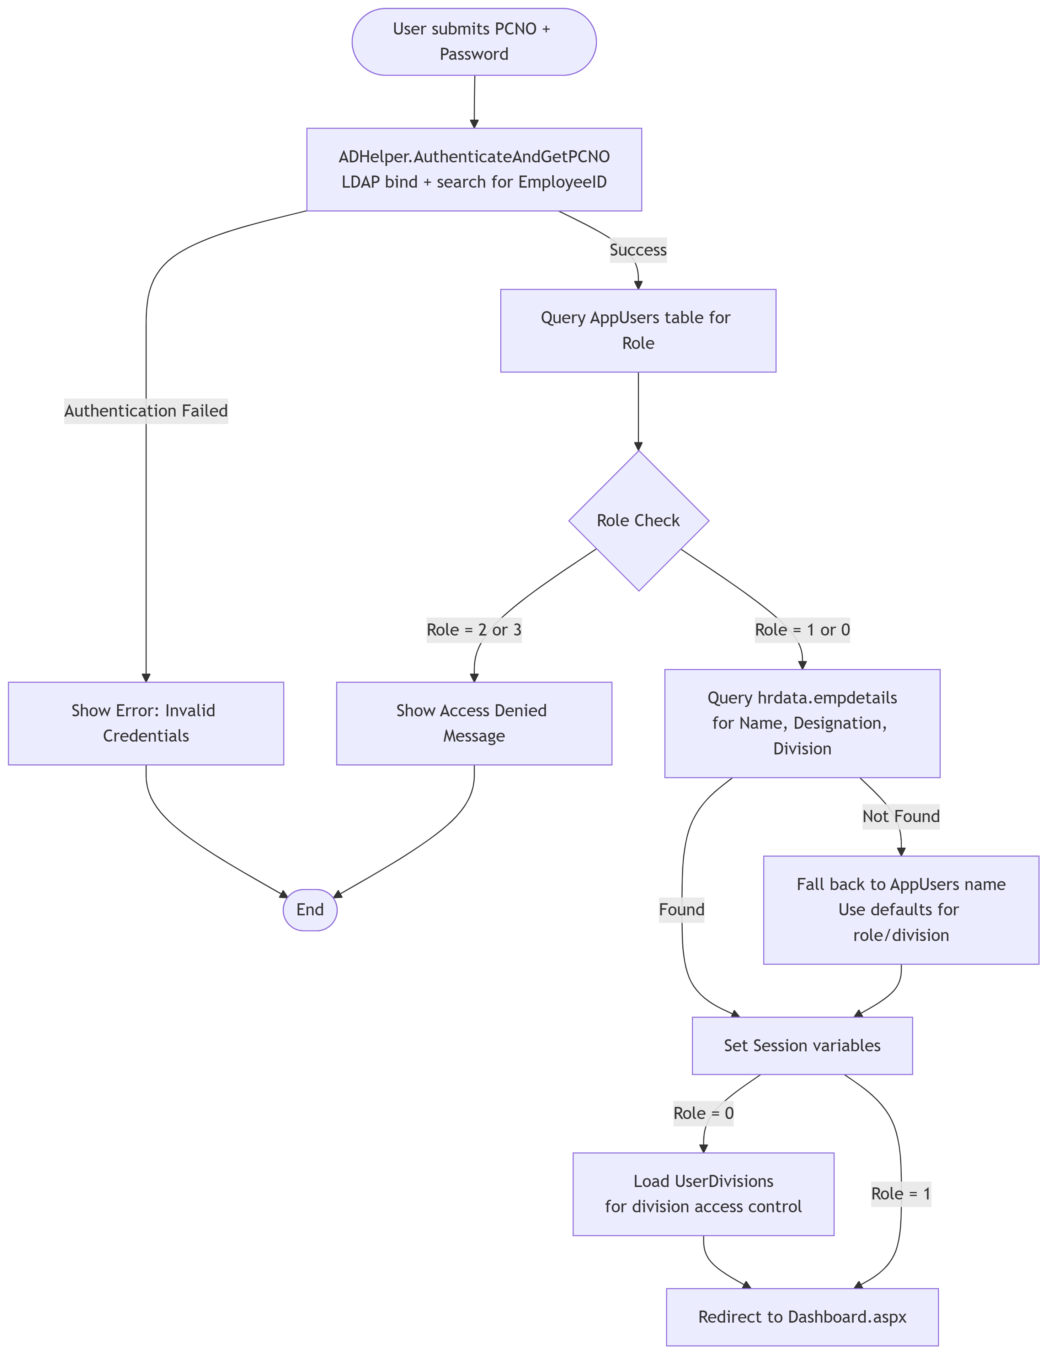
Diagram 2

3.2 Dashboard Module

3.2.1 Description
The Dashboard provides a summary view of system-wide statistics and metrics. The content may differ based on user role.

3.2.2 Functional Requirements
ID | Requirement | Priority
REQ-DASH-01 | The dashboard SHALL display summary statistics (employee counts, attendance status, etc.). | Medium
REQ-DASH-02 | The dashboard SHALL be accessible to all authenticated users. | High
REQ-DASH-03 | For non-admin users, the dashboard SHALL only show data relevant to their assigned divisions. | Medium

3.3 Employee Master Module

3.3.1 Description
The Employee Master is the central registry for all contract workers. It maintains complete employee information, employment history, leave balances, and status tracking. Each employee is assigned a unique MasterId (permanent identifier) that never changes.

3.3.2 Functional Requirements
ID | Requirement | Priority
REQ-EMP-01 | The system SHALL maintain a unique MasterId for each employee that persists across engagements, contracts, and re-joinings. | High
REQ-EMP-02 | The system SHALL support adding employees individually via a form with the following fields: ID, Name, Department, Category, Join Date, Leave Balance, Prev Leave Balance, Phone, Email, Aadhar, Address, Qualification, Experience, Experience In. | High
REQ-EMP-03 | The system SHALL support bulk import of employees via CSV file upload with columns for ID, Name, Department, Join Date, Leave Balance, Qualification, Experience, Experience In, Phone, Email, Aadhar, Address. | High
REQ-EMP-04 | The system SHALL support advanced filters for searching employees based on: Category, Division (Department), Status (Active/Resigned/Upgraded/Downgraded/Transferred/ContractEnded), Name/ID search, and Qualification/Experience search. | High
REQ-EMP-05 | The system SHALL support editing employee details. | High
REQ-EMP-06 | The system SHALL support complete deletion of an employee (all associated records including attendance, engagements, overrides, and action logs). | High
REQ-EMP-07 | The system SHALL support employee re-joining: When a resigned employee is re-added, the system SHALL present an option to select “Is Rejoining” and display a dropdown of previously resigned employees. Upon re-joining, the old MasterId is retained and historical data (attendance, engagements) is preserved. The OriginalJoinDate remains unchanged; JoinDate is updated to the new start date. | High
REQ-EMP-08 | The system SHALL maintain employee history: All changes including upgrades, downgrades, transfers, resignations, and re-joinings SHALL be recorded in EmployeeActionLogs with before/after state snapshots (JSON). | High
REQ-EMP-09 | The system SHALL support employee upgrade/downgrade between categories (Unskilled ↔ Semi-Skilled ↔ Skilled). | High
REQ-EMP-10 | The system SHALL support employee transfer between divisions/departments. | High
REQ-EMP-11 | The system SHALL support bulk leave addition: Admin can add leave balance to multiple employees at once by specifying the effective date, leave amount, remarks, and optionally filtering by category and division. | High
REQ-EMP-12 | The system SHALL support leave balance reset: Admin can reset all employees’ leave balances to zero with a single operation, recording the effective date and remarks. | Medium
REQ-EMP-13 | When adding an employee for a new contract, the system SHALL support setting a fresh leave balance for the contract year. After one year, admin can add additional leave via bulk leave option specifying a new effective date from which the new balance applies. | High
REQ-EMP-14 | The system SHALL support viewing resigned employees in a separate tab, with the ability to filter and search. | Medium

3.3.3 Employee Status Flow
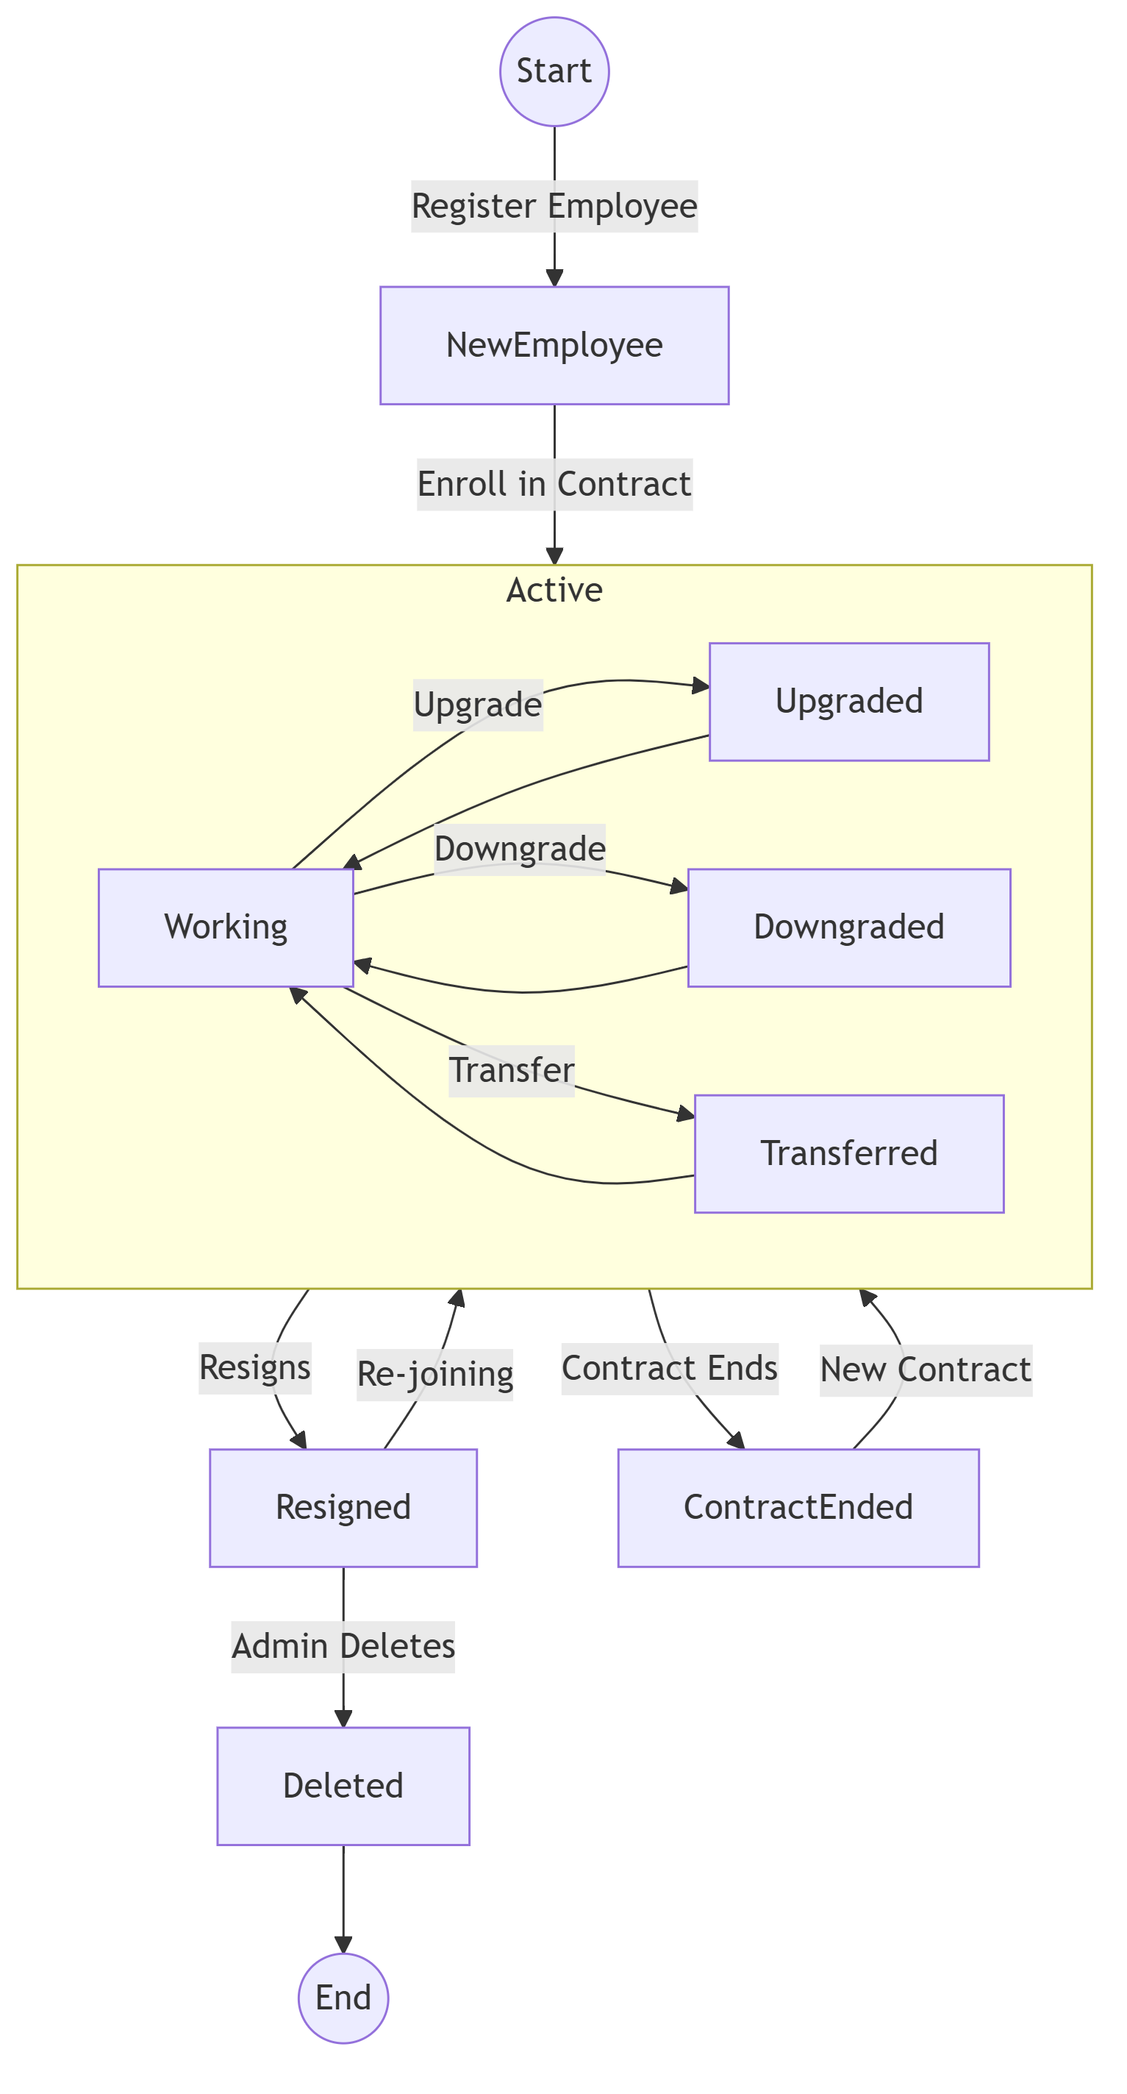
Diagram 3

3.4 Vendor Management Module

3.4.1 Description
Manages manpower agencies/contractors who supply contract employees. Each vendor has a unique MasterId (e.g., VND001).

3.4.2 Functional Requirements
ID | Requirement | Priority
REQ-VEN-01 | The system SHALL allow admin to add, edit, and deactivate vendors with fields: MasterId (auto-generated like VND001), Name, GeM ID, Contact Name, Contact Phone, Address. | High
REQ-VEN-02 | The system SHALL auto-generate the Vendor MasterId using the format VND + incrementing number (e.g., VND001, VND002). | High
REQ-VEN-03 | The system SHALL support vendor search by MasterId, Name, or GeM ID. | Medium
REQ-VEN-04 | The system SHALL support vendor history viewing: Admin can view the complete contract timeline for a vendor, including all contract periods, extensions, and the number of employees supplied per period. | High
REQ-VEN-05 | Vendors with active contracts SHALL be deactivated (not deleted) to preserve data integrity. Vendors with no references MAY be completely deleted. | Medium

3.5 Contract Management Module

3.5.1 Description
Manages the lifecycle of formal contract periods between the organization and vendors for supplying contract workers of specific categories. Contracts are typically for 2 years with extension options.

3.5.2 Functional Requirements
ID | Requirement | Priority
REQ-CON-01 | The system SHALL allow admin to create a new contract period by selecting Category, Vendor, specifying GeM ID, Start Date, End Date, and Dated On date. | High
REQ-CON-02 | The system SHALL prevent creating a new active contract for a category if another active contract already exists for that category. The current contract must be ended first. | High
REQ-CON-03 | During contract creation, the system SHALL provide a wizard-based process to enroll employees from the previous contract period (carry-over) or newly registered employees. | High
REQ-CON-04 | The system SHALL support contract extension: Admin can extend a contract’s end date. The extension is recorded in ContractExtensions table with old end date, new end date, and extension timestamp. | High
REQ-CON-05 | The system SHALL support early contract termination (ending a contract before its end date). When ended, all active employee engagements under that contract are closed with EndReason = ‘ContractEnd’. | High
REQ-CON-06 | The system SHALL support contract deletion with full cascading rollback: Attendance records, calculation overrides, employee engagements, and previous contract periods are restored to their prior state. | High
REQ-CON-07 | The system SHALL display contract history with filters for category, status (Active/Closed), and vendor search. | Medium
REQ-CON-08 | The system SHALL automatically close expired contracts by checking EndDate < SYSDATE (via DBHelper.AutoCloseExpiredContracts()). | High

3.5.3 Contract Lifecycle Flow
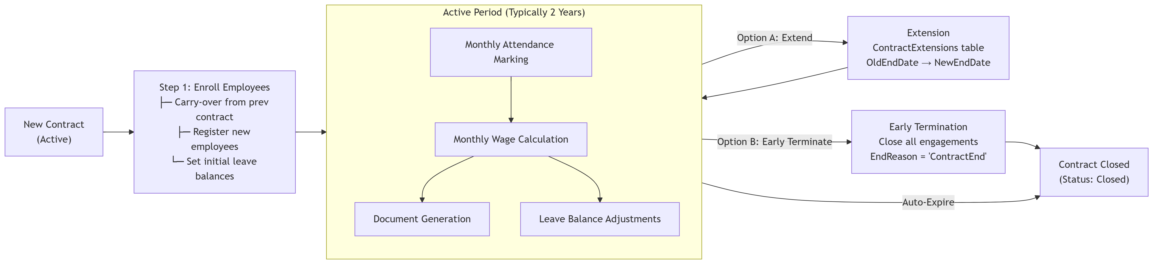
Diagram 4

3.6 Attendance Management Module

3.6.1 Description
The core module of the system. It provides a monthly grid-based interface for marking daily attendance of contract employees. The system uses 0-indexed months internally (0=January, 11=December).

3.6.2 Functional Requirements
ID | Requirement | Priority
REQ-ATT-01 | The system SHALL display a monthly grid showing all eligible employees with each calendar day as a cell. Each cell can be toggled between Present (1), Absent (0), Half-Day (0.5), or left empty. | High
REQ-ATT-02 | Status values: 0 = Absent, 1 = Present, 0.5 = Half-Day. NULL = not yet filled. | High
REQ-ATT-03 | Leave types: When absent, admin MUST specify a leave type: Paid, Unpaid. When half-day is taken, the 1st half-day is marked as Carried with StatusValue=1, the 2nd half-day prompts for Paid or Unpaid — if Paid, StatusValue=1 and LeaveType=Paired Paid; if Unpaid, StatusValue=0 and LeaveType=Paired Unpaid. | High
REQ-ATT-04 | Saturday rule: If an employee is absent on ANY day Monday–Friday of a week, the following Saturday is automatically marked Absent (StatusValue=0, AutoSat=1). If the employee is present ALL 5 days (Mon–Fri), Saturday is automatically marked Present (StatusValue=1). If an employee takes a half-day during the week, the Saturday is NOT marked absent (the half-day counts as attendance). | High
REQ-ATT-05 | Admin Saturday override: Admin can manually override the automatic Saturday marking via right-click edit. When overridden, a remark is recorded. Admin can also mark an employee Present on a holiday and record a remark for that day — this can be used as a compensatory leave other day. | High
REQ-ATT-06 | Non-admin restrictions: Regular Users (POCs) can only mark attendance for the current day. They cannot modify any previous dates. They CANNOT override Saturday attendance — only admin can do this. | High
REQ-ATT-07 | Admin modification: Admin can change attendance data for any date without restriction. | High
REQ-ATT-08 | Holiday marking: Admin can mark specific dates as holidays in the attendance grid. Holidays count as Present for wage calculation purposes. Admin can also add remarks for holidays. | High
REQ-ATT-09 | Global Adjustment: There is a “GLOBAL” adjustment option in the attendance page. If total working days do not reach 26 days (or for any other reason), admin can set a global adjustment value that adds to all employees’ present days for that month. Category-specific global adjustments (GLOBAL_Skilled, GLOBAL_Semi-Skilled, GLOBAL_Unskilled) are also supported. | High
REQ-ATT-10 | Saturday auto-recalculation: When attendance data is saved, the system automatically recalculates the first-Saturday attendance of the next month based on the last 5 working days of the current month. | High
REQ-ATT-11 | The system SHALL validate leave balances before saving. If an employee’s leave balance would go negative, the save is rejected with an error message. | High
REQ-ATT-12 | The system SHALL maintain a unique constraint on (EmpID, Year, Month, Day) — one record per employee per day. | High
REQ-ATT-13 | The grid SHALL show employees filtered by: Category (Skilled/Semi-Skilled/Unskilled), Division, and text search. For non-admin users, only their assigned divisions’ employees are shown. | High

3.6.3 Attendance Marking Logic
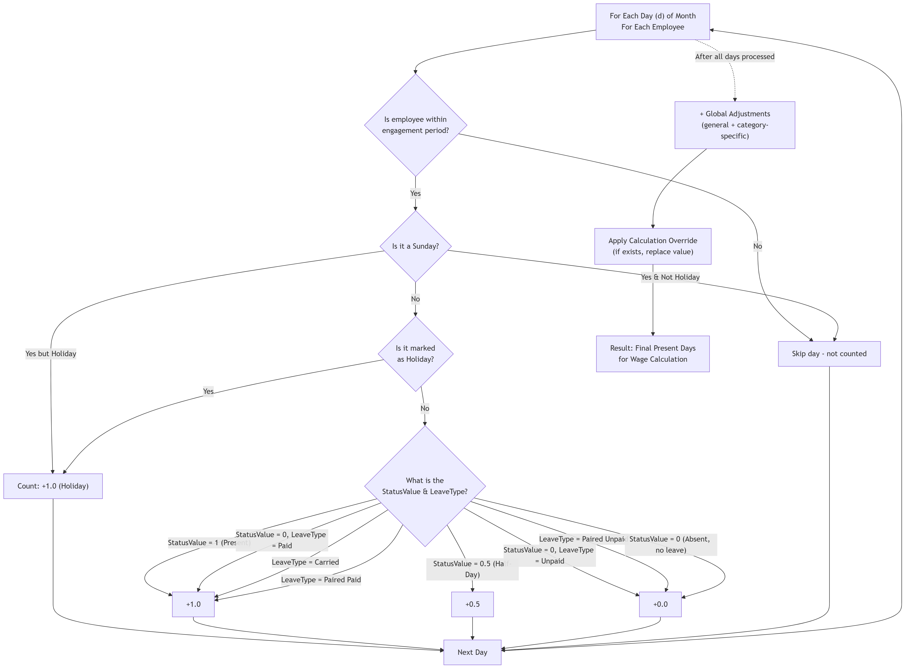
Diagram 5

3.6.4 Saturday Auto-Marking Rule
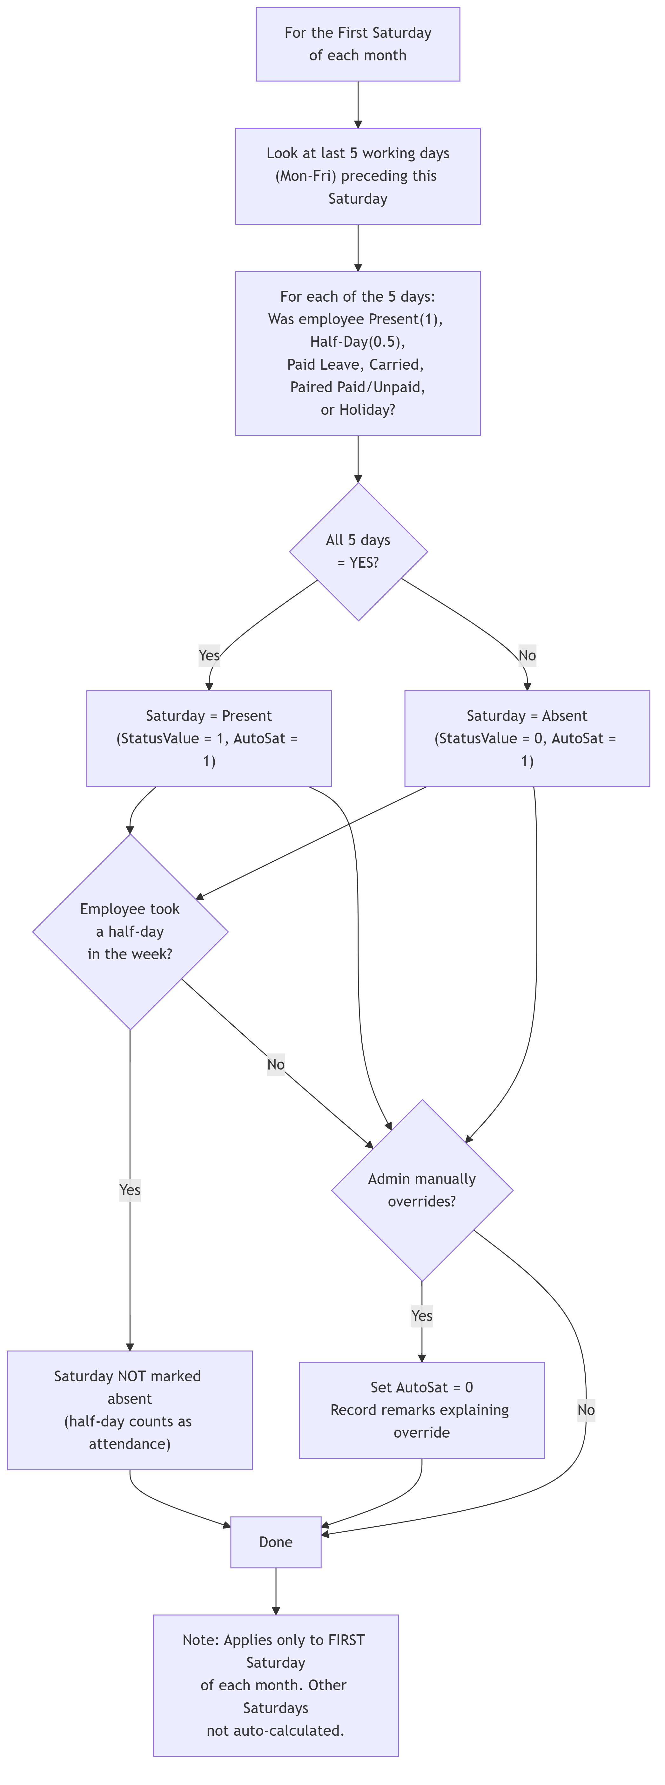
Diagram 6

3.7 Calculation / Payroll Module

3.7.1 Description
The Calculation module computes monthly wages for each employee based on attendance data, wage rates, and manual overrides. Wages are calculated as WageRate × PresentDays = TotalWage.

3.7.2 Functional Requirements
ID | Requirement | Priority
REQ-CAL-01 | The system SHALL display a monthly calculation grid showing each employee’s present days, wage rate, calculated amount, and final days. | High
REQ-CAL-02 | Admin SHALL be able to set wage rates per category per month (e.g., Skilled = ₹650/day, Semi-Skilled = ₹500/day, Unskilled = ₹350/day). Rates are stored in CalculationWages table. | High
REQ-CAL-03 | Admin SHALL be able to override the present days for an individual employee (increase or decrease). The override is recorded in CalculationOverrides table with a remarks field. | High
REQ-CAL-04 | Admin SHALL be able to remove overrides (revert to auto-calculated present days). | Medium
REQ-CAL-05 | The calculation SHALL filter by year, month, category, division, and optionally contract period. | High
REQ-CAL-06 | Admin SHALL be able to change present days for employees — for example: if an employee was marked Present in a previous month but was actually absent, admin can deduct days here. Conversely, if an employee was mistakenly marked Absent, days can be added here. | High
REQ-CAL-07 | Wages SHALL be calculated as: FinalDays × WageRate = TotalWage. The FinalDays is either the auto-calculated present days or the manual override value. | High
REQ-CAL-08 | Global adjustments (both general and category-specific) SHALL be applied before overrides. | High
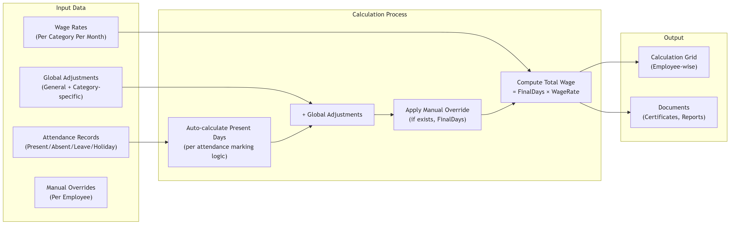
Diagram 7

3.8 Ledger Module

3.8.1 Description
The Ledger provides a comprehensive monthly view of each employee’s attendance summary, leave balance tracking, and all associated remarks.

3.8.2 Functional Requirements
ID | Requirement | Priority
REQ-LED-01 | The system SHALL display for each employee per month: Opening Balance, Paid Leave count, Half-Day count, Unpaid Leave count, Saturday Cuts count, Closing Balance, Present Days, Final Days, and all Remarks. | High
REQ-LED-02 | Opening Balance = Initial Leave Balance - (Historical Paid Leaves + 0.5 × Historical Half-Days). | High
REQ-LED-03 | Closing Balance = Opening Balance - Current Month Paid Leaves - (0.5 × Legacy Half-Days). | High
REQ-LED-04 | Paired half-days — the first half-day is Carried (counted as present, StatusValue=1), the second half-day creates a pair where the user picks Paired Paid (StatusValue=1) or Paired Unpaid (StatusValue=0). The ledger shows paired remarks like “2 half days: 01-Jun & 15-Jun”. | High
REQ-LED-05 | The ledger SHALL display Saturday edits with remarks (e.g., “Saturday edited: 2026-06-06 (Reason: Overtime)”). | High
REQ-LED-06 | The ledger SHALL display holiday details for the selected month. | Medium
REQ-LED-07 | The ledger SHALL display the global adjustment value applied. | Medium
REQ-LED-08 | The ledger SHALL support filtering by year, month, category, contract period, and text search. | High
REQ-LED-09 | Non-admin users SHALL only see employees from their assigned divisions in the ledger. | High
REQ-LED-10 | The ledger SHALL show join/resign remarks if the employee joined or resigned during the selected month (e.g., “Joined on 15-Jun-2026” or “Resigned on 20-Jun-2026”). | Medium
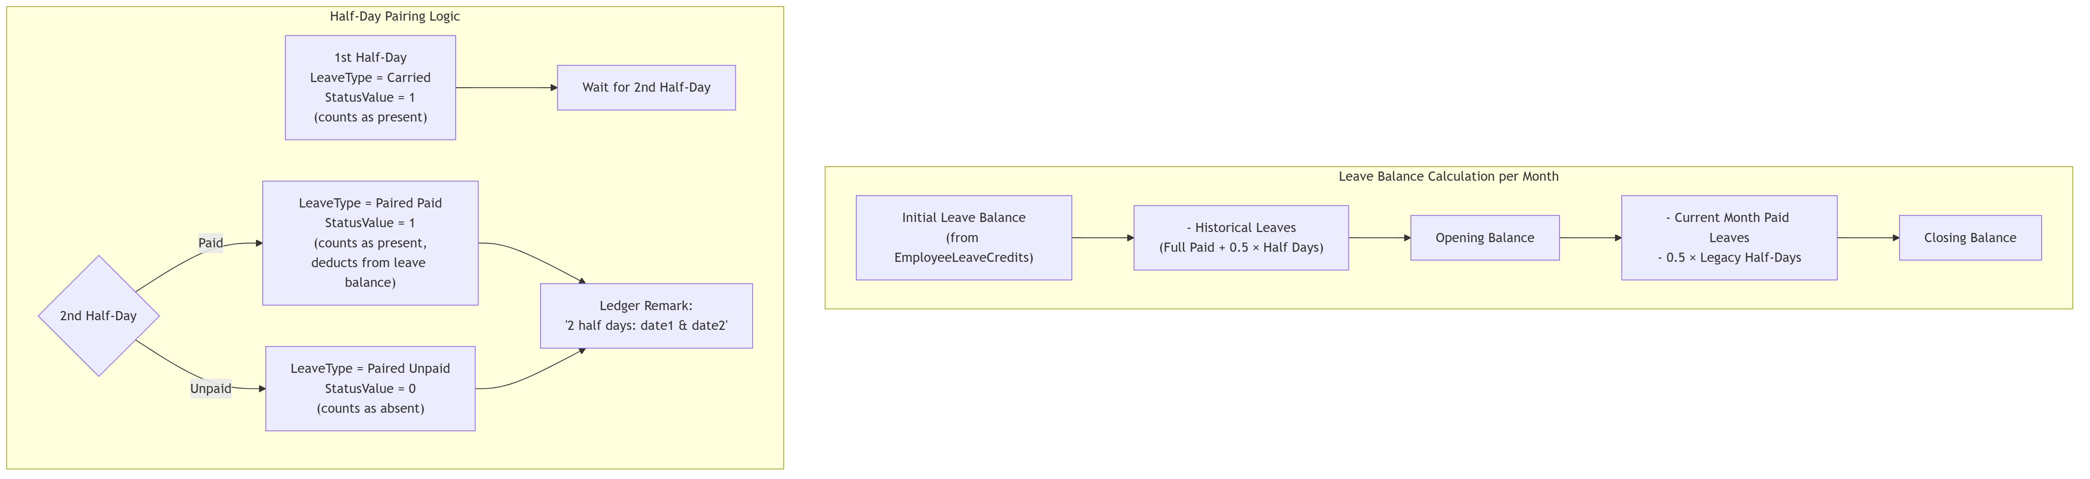
Diagram 8

3.9 Document Generation Module

3.9.1 Description
Generates official documents including Attendance Certificates, Satisfactory Certificates, Covering Letters, and Wage Calculation reports. Invoice.aspx is not used — all document generation is handled through Documents.aspx.

3.9.2 Functional Requirements
ID | Requirement | Priority
REQ-DOC-01 | The system SHALL generate Attendance Certificates listing employees with their present days, paid/unpaid leaves, Saturday cuts, and final days. | High
REQ-DOC-02 | The system SHALL generate Satisfactory Certificates for vendors confirming satisfactory service of contract employees. | High
REQ-DOC-03 | The system SHALL generate Covering Letters addressed to the purchasing department (D-FMM/Purchase). | High
REQ-DOC-04 | The system SHALL generate Wage Calculation reports showing employee-wise wage computation. | High
REQ-DOC-05 | Template customization: All document templates are stored in CertificateTemplates table and can be customized in the Settings page (Template Settings). Templates use placeholder presets like {VendorName}, {ContractNo}, {StartDate}, {EndDate}, {Category}, {EmpCount}, etc. | High
REQ-DOC-06 | Signing authority: In Satisfactory Certificates and Covering Letters, the signing authority name is fetched using the PCNO of the authorized signatory. | High
REQ-DOC-07 | The system SHALL support configurable font size, section spacing, and signature spacing for generated documents. | Medium
REQ-DOC-08 | The system SHALL generate documents based on selected year, month, category, and contract period. | High
REQ-DOC-09 | Documents can be generated in HTML format for printing. The system also supports export to DOC/DOCX and XLSX formats. | Medium

3.10 Notices Module

3.10.1 Description
Admin can upload, manage, and publish official notices and documents visible to all authenticated users.

3.10.2 Functional Requirements
ID | Requirement | Priority
REQ-NOT-01 | Admin SHALL be able to upload notices/files with a name and file path. | Medium
REQ-NOT-02 | Admin SHALL be able to hide/unhide notices. | Low
REQ-NOT-03 | All authenticated users SHALL be able to view visible notices. | Medium

3.11 Remarks / Correction Request Module

3.11.1 Description
Regular Users (POCs) can submit attendance correction requests to the admin when they notice discrepancies.

3.11.2 Functional Requirements
ID | Requirement | Priority
REQ-RMK-01 | Regular Users SHALL be able to submit a remark regarding an employee’s attendance, specifying the employee, the date in question, and the message. | High
REQ-RMK-02 | Admin SHALL receive a notification (badge on the bell icon in the navigation bar) showing the count of unread remarks. | High
REQ-RMK-03 | Admin SHALL be able to view all remarks, mark them as read, or delete them. | High
REQ-RMK-04 | Regular Users SHALL be able to view their own sent remarks history. | Medium
REQ-RMK-05 | Remarks SHALL store: SubmittedBy (PCNO), SenderName, EmpID (MasterId), RemarkDate, Message, IsRead flag, and CreatedAt timestamp. | High
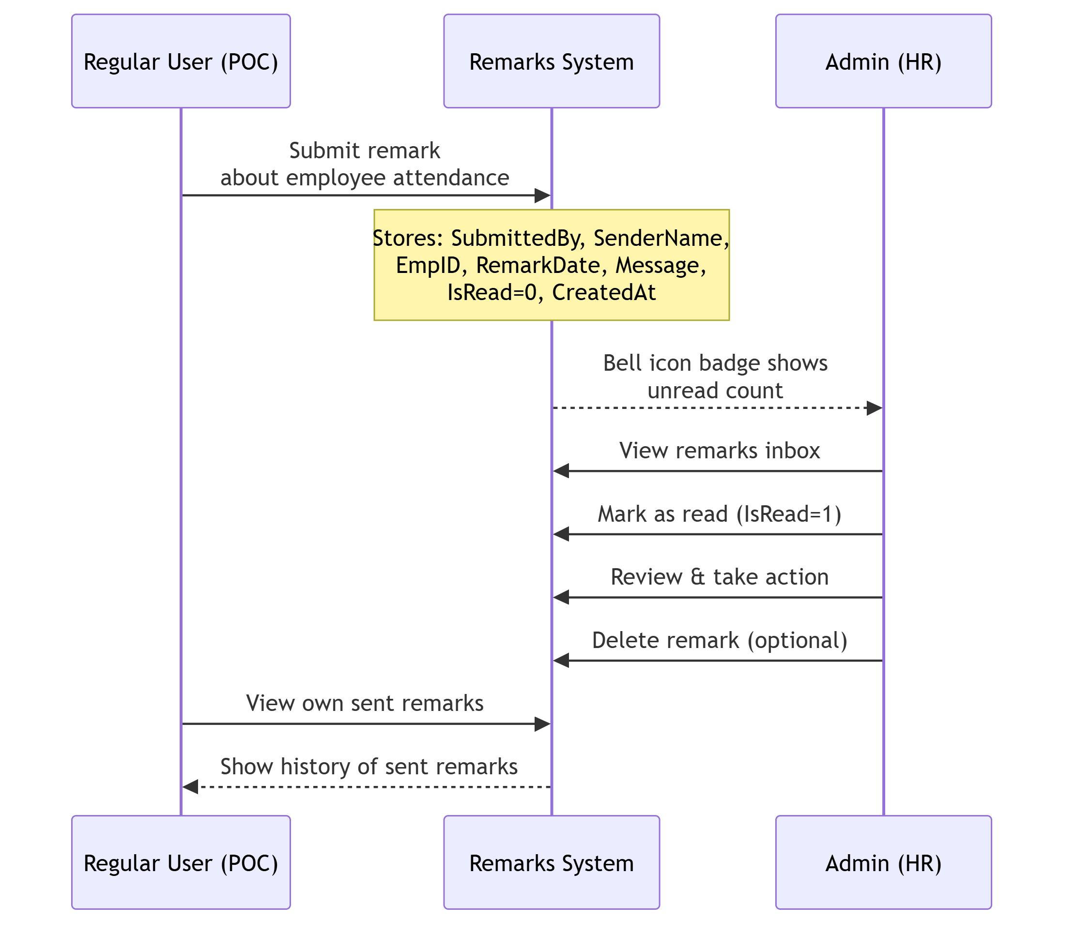
Diagram 9

3.12 Admin / User Management Module

3.12.1 Description
Manages system user accounts. Admin users have full access, while Regular Users are restricted to specific divisions.

3.12.2 Functional Requirements
ID | Requirement | Priority
REQ-ADM-01 | Admin SHALL be able to create, edit, and delete Admin users. | High
REQ-ADM-02 | Admin SHALL be able to create, edit, and delete Regular Users and assign division-level permissions. | High
REQ-ADM-03 | Admin SHALL be able to revoke access for any user (sets Role to 2 or 3). | High
REQ-ADM-04 | Admin SHALL be able to restore access for revoked users (sets Role back to 1 or 0). | High
REQ-ADM-05 | Users are identified by their PCNO (same as AD username). | High
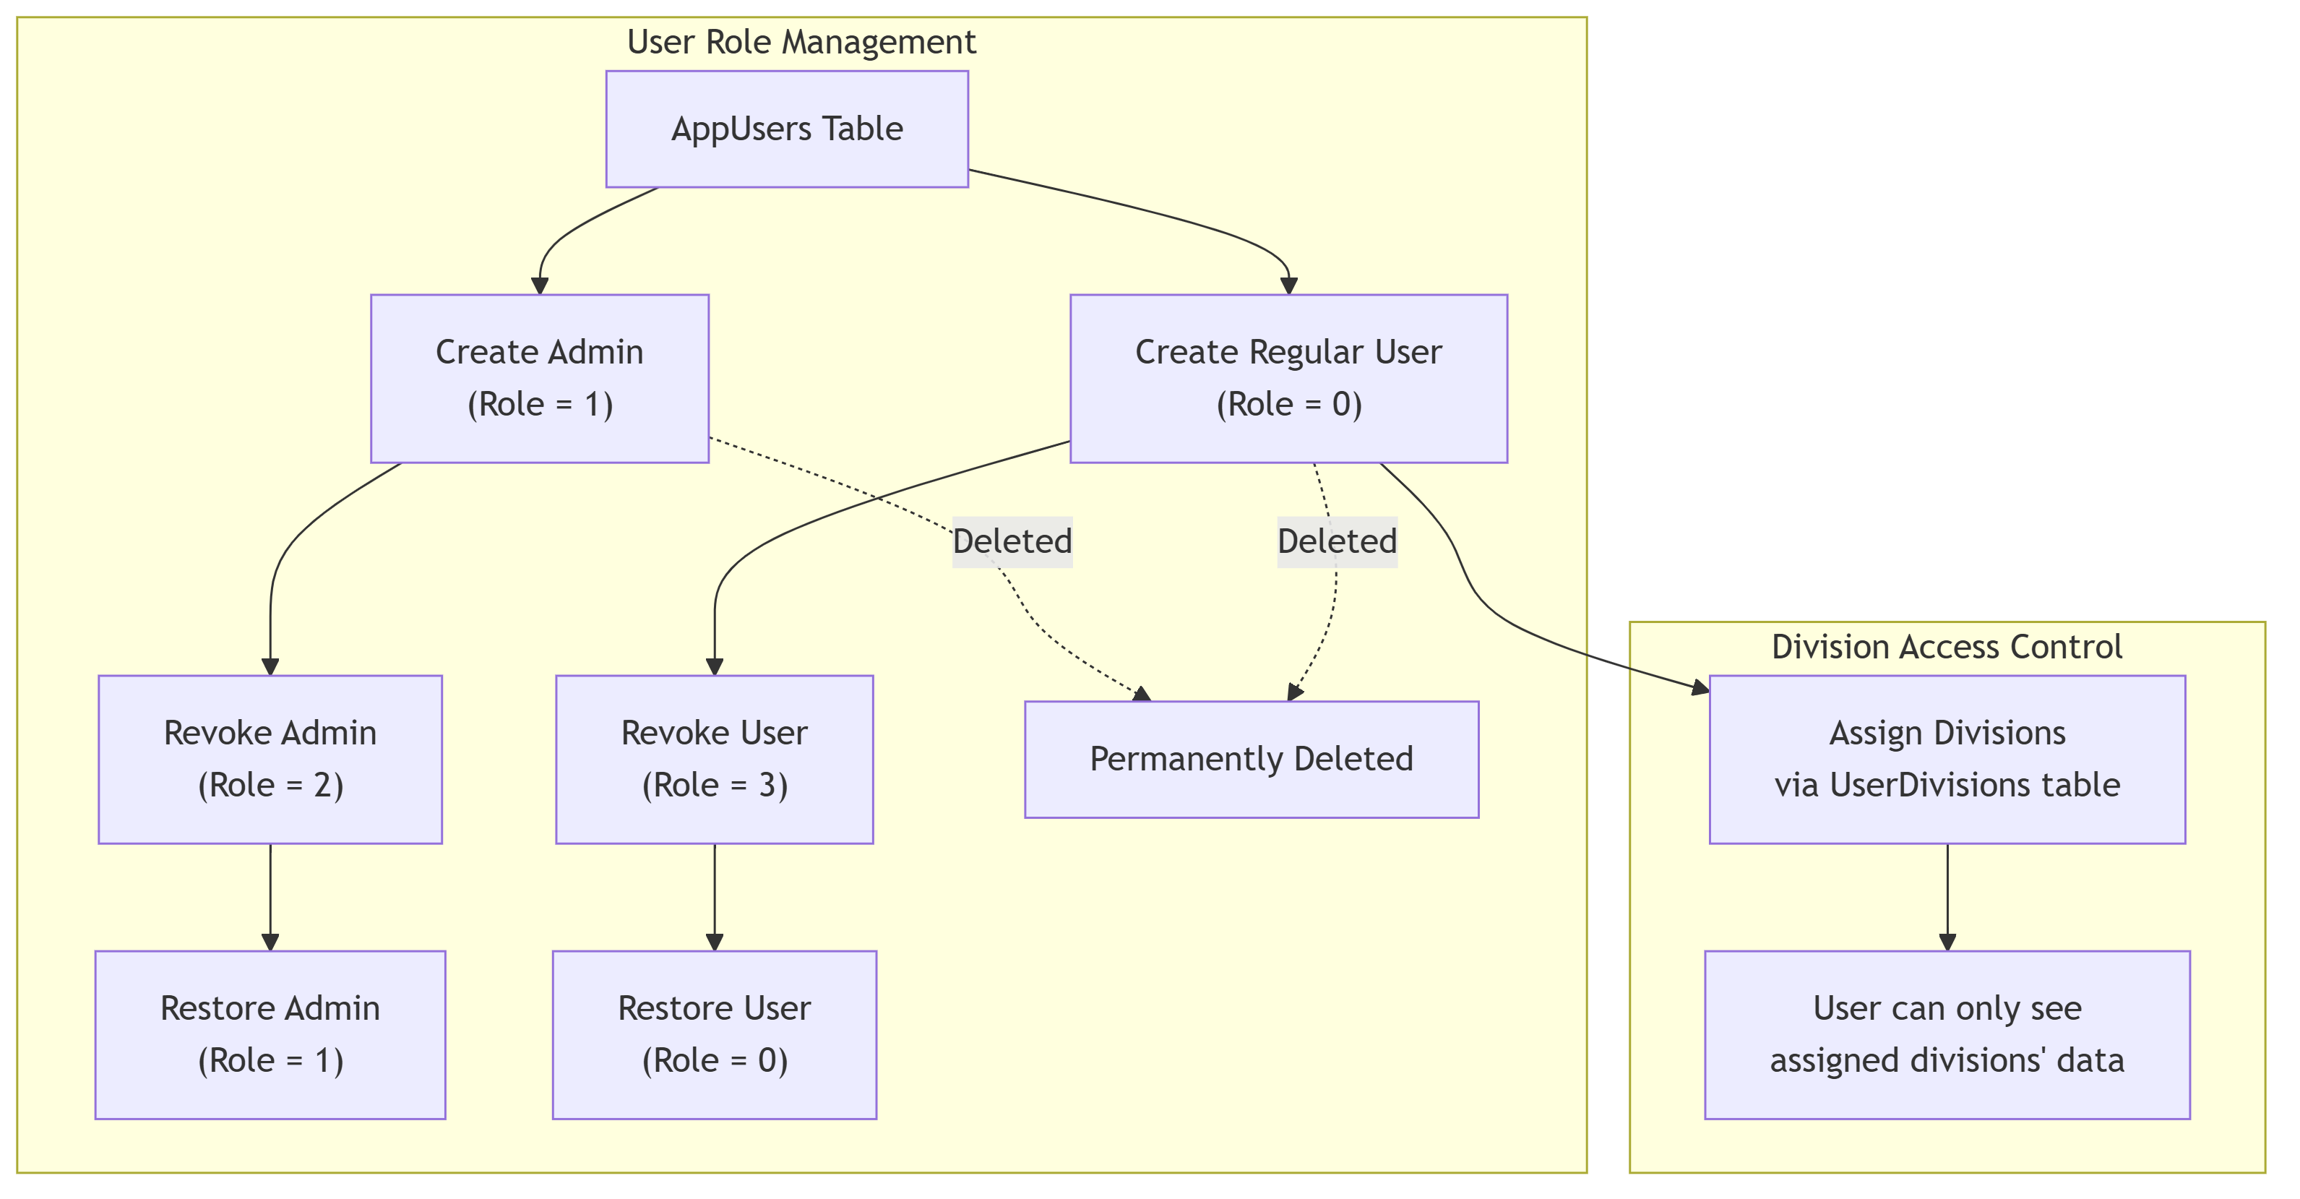
Diagram 10

3.13 Settings Module

3.13.1 Description
System settings and configuration management.

3.13.2 Functional Requirements
ID | Requirement | Priority
REQ-SET-01 | Division Management: Admin SHALL be able to add, edit, and delete divisions. Editing a division name cascades to all employee records. Deleting is blocked if employees are assigned to the division. | High
REQ-SET-02 | Category Management: Admin SHALL be able to add, edit, and delete categories. Editing cascades to Employees, CalculationWages, and CalculationOverrides tables. Deleting is blocked if employees or wage records exist. | High
REQ-SET-03 | Undo Manager: Admin SHALL be able to undo the last N actions (employee adds, edits, upgrades, downgrades, transfers). The system supports sequential rollback of linked changes. Bulk leave adjustments cannot be undone. If attendance records exist for the employee, add/delete actions cannot be undone. The undo restores the PreState JSON snapshot from EmployeeActionLogs. | High
REQ-SET-04 | Database Backup: Admin SHALL be able to export all application tables as a JSON file for backup. | High
REQ-SET-05 | Database Restore: Admin SHALL be able to restore the database from a previously exported JSON backup file. The restore process deletes existing data, reinserts from the backup, and resets sequences. | High
REQ-SET-06 | Template Settings: Admin SHALL be able to customize document templates (Certificate descriptions, Satisfactory Certificate content, Covering Letter content, Wage Calculation headers). Placeholder presets like {VendorName}, {ContractNo}, {Category}, {StartDate}, {EndDate}, {Year} are used to represent specific data. | High
REQ-SET-07 | Admin SHALL also be able to customize Attendance Report Templates with configurable headings. | Medium
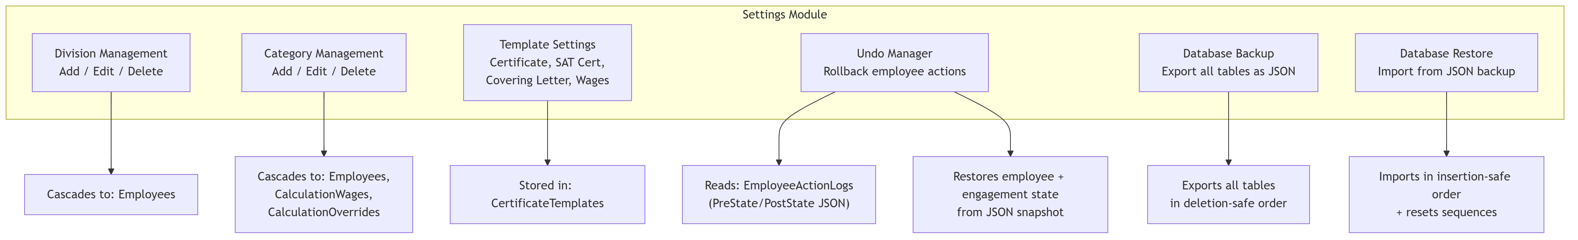
Diagram 11

4. External Interface Requirements

4.1 User Interfaces
The system uses a modern, Bootstrap 4-based responsive UI with the SB Admin 2 template. Key UI characteristics:
- Layout: Fixed-top navigation bar with sidebar menu. Admin sees all menu items; Regular Users see a restricted subset.
- Theme: Dark gradient backgrounds (dark blue/navy shades), glass-morphism card designs, gradient buttons.
- Attendance Grid: Interactive month-grid with cells for each employee/day combination. Color-coded: Green = Present, Red = Absent, Yellow = Half-Day, Purple = Holiday.
- Modals: Used extensively for forms (add/edit employee, vendor, contract, etc.).
- Toast notifications: For success/error messages.
- JavaScript libraries: AngularJS (for data binding), Bootstrap 4.x, FontAwesome icons, SB Admin 2 template.

4.2 Hardware Interfaces
No direct hardware interfaces. Printing is handled via browser print functionality.

4.3 Software Interfaces
Interface | Technology | Purpose
Database | Oracle.ManagedDataAccess.Client (.NET Data Provider) | All CRUD operations on Oracle 11g
Active Directory | System.DirectoryServices (LDAP) | User authentication
File System | System.IO | CSV file import, notice file management

4.4 Communications Interfaces
- HTTP/HTTPS: The application runs on IIS and communicates with clients via standard HTTP.
- LDAP: The application communicates with Active Directory via LDAP protocol.
- Oracle Net Services: The application communicates with the Oracle database via Oracle Net (port 1521 by default).

5. Non-Functional Requirements

5.1 Performance Requirements
ID | Requirement | Priority
REQ-PERF-01 | The attendance grid for a month should load within 5 seconds for up to 200 employees. | Medium
REQ-PERF-02 | The calculation page should process data for up to 200 employees within 10 seconds. | Medium
REQ-PERF-03 | Database queries should complete within 3 seconds under normal load. | Medium
REQ-PERF-04 | The system should support concurrent access by at least 10 users simultaneously. | Medium

5.2 Security Requirements
ID | Requirement | Priority
REQ-SEC-01 | All users MUST authenticate via Active Directory before accessing the system. | High
REQ-SEC-02 | Users who cannot be found in AppUsers after AD authentication MUST be denied access. | High
REQ-SEC-03 | Revoked users (Role 2 or 3) MUST be denied access with a clear message. | High
REQ-SEC-04 | Regular Users MUST only see data from their assigned divisions. | High
REQ-SEC-05 | Regular Users MUST NOT be able to override Saturday attendance. | High
REQ-SEC-06 | Regular Users MUST NOT be able to modify attendance for past dates. | High
REQ-SEC-07 | Page-level access control MUST be enforced in the code-behind of each page. | High
REQ-SEC-08 | Database connection strings and LDAP paths are stored in Web.config and should be encrypted in production. | High

5.3 Software Quality Attributes
Attribute | Requirement
Reliability | The system should maintain data integrity during concurrent access. The AutoCloseExpiredContracts feature uses thread-safe locking to prevent race conditions.
Maintainability | Code is organized in a standard ASP.NET Web Forms project structure with utility classes (DBHelper.cs, ADHelper.cs, ActionLogger.cs).
Data Integrity | Foreign key constraints are enforced at the database level. Attendance records have a unique constraint on (EmpID, Year, Month, Day).
Availability | The system should be available during working hours (9 AM - 6 PM) with minimal downtime.
Recoverability | Full database backup/restore functionality via JSON export/import. Action logs with JSON state snapshots support undo operations.

6. Database Architecture and Design

6.1 Schema Overview
The system uses two Oracle database schemas:
Schema | Purpose | Tables
HRDATA | Company’s existing HR database (read-only for the app) | empdetails
SYSTEM (App Schema) | Application’s own data tables | 20+ tables for attendance, employees, contracts, vendors, etc.

6.2 Entity-Relationship Diagram
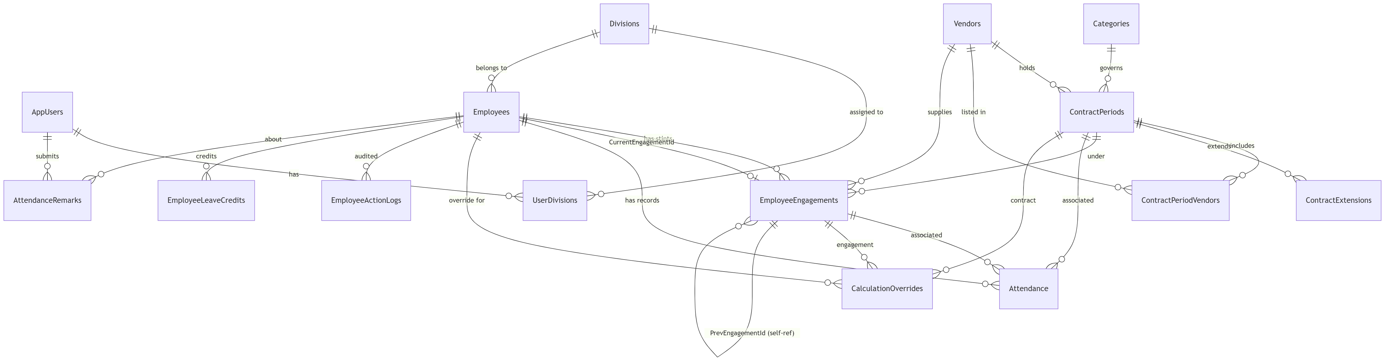
Diagram 12

6.3 Table Descriptions and Relationships

6.3.1 hrdata.empdetails (HRDATA Schema)
External company HR table — read by login to fetch employee name, designation, and division.
Column | Type | Description
PCNO | VARCHAR2(50) PK | Personnel/Company Number
NAME | VARCHAR2(200) | Employee display name
DESIGNATION | VARCHAR2(100) | Job title
DIVNAME | VARCHAR2(100) | Division/department

6.3.2 AppUsers
Application user registry — stores PCNO, name, and role.
Column | Type | Description
PCNO | VARCHAR2(50) PK | Personnel Number (matches AD EmployeeID)
Name | VARCHAR2(200) | Display name
Role | NUMBER(1) | 1=Admin, 0=Regular User, 2=Revoked Admin, 3=Revoked User
Relationships: PCNO → UserDivisions.PCNO, AttendanceRemarks.SubmittedBy

6.3.3 Divisions
Organizational divisions/departments.
Column | Type | Description
Id | NUMBER PK | Auto-incremented via SEQ_Divisions
Name | VARCHAR2(100) UNIQUE | Division name
Relationships: Name → Employees.Department, UserDivisions.DivisionName

6.3.4 Categories
Employee skill categories.
Column | Type | Description
Id | NUMBER PK | Auto-incremented via SEQ_Categories
Name | VARCHAR2(100) UNIQUE | Category name (Skilled, Semi-Skilled, Unskilled)
Relationships: Name → ContractPeriods.Category, EmployeeEngagements.Category, CalculationWages.Category, CalculationOverrides.Category

6.3.5 UserDivisions
Maps regular users to divisions they can manage.
Column | Type | Description
PCNO | VARCHAR2(50) PK, FK→AppUsers | User PCNO
DivisionName | VARCHAR2(100) PK, FK→Divisions | Assigned division

6.3.6 Vendors
Manpower agencies/contractors.
Column | Type | Description
Id | NUMBER PK | Auto-incremented
MasterId | VARCHAR2(50) UNIQUE | Vendor code (e.g., VND001)
Name | VARCHAR2(150) UNIQUE | Vendor company name
GemId | VARCHAR2(100) | Government e-Marketplace ID
ContactName | VARCHAR2(100) | Contact person
ContactPhone | VARCHAR2(20) | Phone number
Address | VARCHAR2(4000) | Postal address
IsActive | NUMBER(1) | 1=Active, 0=Inactive
Relationships: Id → ContractPeriods.VendorId, ContractPeriodVendors.VendorId, EmployeeEngagements.VendorId

6.3.7 ContractPeriods
Contract periods linking vendors to categories.
Column | Type | Description
Id | NUMBER PK | Auto-incremented
Category | VARCHAR2(100) FK→Categories | Skill category
VendorId | NUMBER FK→Vendors | Primary vendor
GemId | VARCHAR2(100) | GeM contract ID
StartDate | DATE | Contract start
EndDate | DATE | Contract end (NULL=ongoing)
DatedOn | DATE | Contract signing date
Status | VARCHAR2(20) | Active / Closed
Notes | VARCHAR2(4000) | Free-text notes
Unique Constraint: (Category, StartDate)
Relationships: Id → EmployeeEngagements.ContractPeriodId, Attendance.ContractPeriodId, CalculationOverrides.ContractPeriodId, ContractExtensions.ContractPeriodId, ContractPeriodVendors.ContractPeriodId

6.3.8 ContractPeriodVendors
Junction table — all vendors participating in a contract period.
Column | Type | Description
Id | NUMBER PK | Auto-incremented
ContractPeriodId | NUMBER FK | Contract period
VendorId | NUMBER FK | Vendor
Category | VARCHAR2(100) | Worker category
IsActive | NUMBER(1) | Active status

6.3.9 ContractExtensions
Tracks extensions to contract periods.
Column | Type | Description
Id | NUMBER PK | Auto-incremented
ContractPeriodId | NUMBER FK | Extended contract
OldEndDate | DATE | Previous end date
NewEndDate | DATE | New end date
ExtensionDate | TIMESTAMP | When extended

6.3.10 Employees
Master employee registry.
Column | Type | Description
MasterId | VARCHAR2(50) PK | Permanent unique ID
ID | VARCHAR2(50) | Display ID
Name | VARCHAR2(200) | Full name
Department | VARCHAR2(100) FK→Divisions | Current division
Category | VARCHAR2(50) | Current category
OriginalJoinDate | DATE | First-ever join date
JoinDate | DATE | Current engagement start
LeaveBalance | NUMBER | Current paid leave balance
PrevLeaveBalance | NUMBER | Previous contract leave balance
Status | VARCHAR2(20) | Active/Resigned/ContractEnded/Upgraded/Downgraded/Transferred
ResignDate | DATE | Resignation date
ContractEndDate | DATE | Contract end date
CurrentEngagementId | NUMBER FK→EmployeeEngagements | Active engagement pointer
Phone | VARCHAR2(50) | Phone number
Email | VARCHAR2(100) | Email
Aadhar | VARCHAR2(50) | Aadhar number
Address | VARCHAR2(4000) | Address
Qualification | VARCHAR2(200) | Educational qualification
Experience | NUMBER | Years of experience
ExperienceIn | VARCHAR2(200) | Experience domain(s)
Relationships: MasterId → EmployeeEngagements.EmpID, Attendance.EmpID, CalculationOverrides.EmpID, EmployeeActionLogs.EmpMasterId, AttendanceRemarks.EmpID, EmployeeLeaveCredits.EmpID

6.3.11 EmployeeEngagements
Employment stints — one employee can have multiple engagements over time.
Column | Type | Description
Id | NUMBER PK | Auto-incremented
EmpID | VARCHAR2(50) FK→Employees | Employee MasterId
ContractPeriodId | NUMBER FK→ContractPeriods | Contract context
Category | VARCHAR2(100) | Category for this stint
VendorId | NUMBER FK→Vendors | Supplying vendor
Department | VARCHAR2(100) | Division for this stint
StartDate | DATE | Engagement start
EndDate | DATE | Engagement end
EndReason | VARCHAR2(50) | Resigned/ContractEnded/Upgraded/Downgraded/CarriedOver
IsCarriedOver | NUMBER(1) | 1=carried from prev contract
PrevEngagementId | NUMBER FK (self-ref) | Previous engagement in chain
EmployeeId | VARCHAR2(50) | Official ID in this engagement
Relationships: Id → Employees.CurrentEngagementId, Attendance.EngagementId, CalculationOverrides.EngagementId. PrevEngagementId → self-reference for engagement chaining.

6.3.12 EmployeeLeaveCredits
Date-specific leave credits/bulk additions.
Column | Type | Description
Id | NUMBER PK | Auto-incremented
EmpID | VARCHAR2(50) FK→Employees | Employee
ContractPeriodId | NUMBER FK→ContractPeriods | Contract context
Amount | NUMBER | Leave days added
EffectiveDate | DATE | When the credit applies
Remarks | VARCHAR2(200) | Reason/note

6.3.13 Attendance
Core attendance table — one row per employee per day.
Column | Type | Description
Id | NUMBER PK | Auto-incremented
EmpID | VARCHAR2(50) FK→Employees | Employee
EngagementId | NUMBER FK→EmployeeEngagements | Active engagement
ContractPeriodId | NUMBER FK→ContractPeriods | Contract context
Year | NUMBER(4) | Calendar year
Month | NUMBER(2) | Month (0-indexed: 0=Jan)
Day | NUMBER(2) | Day of month
StatusValue | NUMBER(1) | 0=Absent, 1=Present, 0.5=Half-Day, NULL=unfilled
LeaveType | VARCHAR2(50) | Paid/Unpaid/Carried/Paired Paid/Paired Unpaid
IsHoliday | NUMBER(1) | 1=Holiday
AutoSat | NUMBER(1) | 1=Auto-calculated Saturday
Remarks | VARCHAR2(500) | Free-text remarks
Unique Constraint: (EmpID, Year, Month, Day)

6.3.14 CalculationWages
Monthly wage rates per category.
Column | Type | Description
Year | NUMBER(4) PK | Year
Month | NUMBER(2) PK | Month (0-indexed)
Category | VARCHAR2(50) PK | Category name
WageRate | NUMBER(10,2) | Daily wage rate

6.3.15 CalculationOverrides
Manual overrides of present days for wage calculation.
Column | Type | Description
Year | NUMBER(4) PK | Year
Month | NUMBER(2) PK | Month
Category | VARCHAR2(50) PK | Category
EmpID | VARCHAR2(50) PK, FK→Employees | Employee
EngagementId | NUMBER FK | Engagement context
ContractPeriodId | NUMBER FK | Contract context
FinalDays | NUMBER(5,2) | Overridden days
Remarks | VARCHAR2(500) | Reason for override

6.3.16 EmployeeActionLogs
Audit trail with snapshots for undo support.
Column | Type | Description
Id | NUMBER PK | Auto-incremented
ActionTime | TIMESTAMP | When action occurred
ActionType | VARCHAR2(50) | ADD/EDIT/RESIGN/UPGRADE/DOWNGRADE/UNDO etc.
EmpMasterId | VARCHAR2(50) | Affected employee
Description | VARCHAR2(500) | Human-readable summary
PreState | CLOB | JSON before state
PostState | CLOB | JSON after state
IsUndone | NUMBER(1) | 1=undo performed

6.3.17 AttendanceRemarks
Correction requests sent by POCs to admin.
Column | Type | Description
Id | NUMBER PK | Auto-incremented
SubmittedBy | VARCHAR2(100) | PCNO of submitter
SenderName | VARCHAR2(200) | Display name
EmpID | VARCHAR2(50) | Employee being remarked about
RemarkDate | DATE | Attendance date referred to
Message | VARCHAR2(1000) | Remark text
IsRead | NUMBER(1) | 0=Unread, 1=Read
CreatedAt | TIMESTAMP | Submission timestamp

6.3.18 Notices
Official notices and uploaded documents.
Column | Type | Description
Id | NUMBER PK | Auto-incremented
Name | VARCHAR2(255) | Notice name
FilePath | VARCHAR2(500) | File path
IsHidden | NUMBER(1) | Visibility flag
UploadDate | TIMESTAMP | Upload timestamp

6.3.19 CertificateTemplates
Customizable templates for document generation.
Column | Type | Description
TemplateKey | VARCHAR2(50) PK | Template identifier (e.g., AttDesc1, SatSignatory)
TemplateValue | VARCHAR2(1000) | Template text with placeholders like {VendorName}

6.3.20 ActionLog, AdminActionLog, Attendance_Audit_Log
These tables exist in the schema but are not actively used by the application in the current version. They were created for future implementation. They will be removed once the project is finalized.

6.4 Key Business Logic in Database

Auto-Increment Strategy
All tables with numeric Id primary keys use Oracle 11g-compatible sequences with BEFORE INSERT triggers:
CREATE SEQUENCE SEQ_TableName START WITH 1 INCREMENT BY 1 NOCACHE NOCYCLE;
CREATE OR REPLACE TRIGGER TRG_TableName
BEFORE INSERT ON TableName
FOR EACH ROW
BEGIN
IF :NEW.Id IS NULL THEN
SELECT SEQ_TableName.NEXTVAL INTO :NEW.Id FROM DUAL;
END IF;
END;
/

Key Foreign Key Relationships
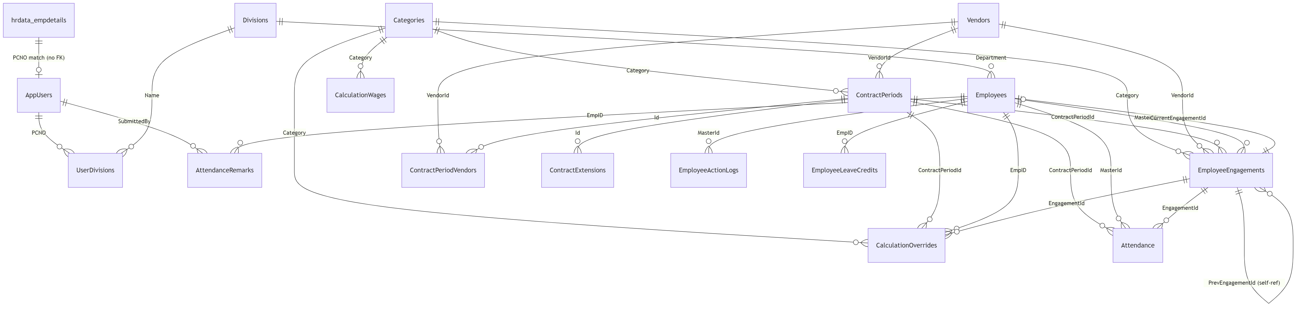
Diagram 13

7. System Architecture

7.1 Architecture Overview
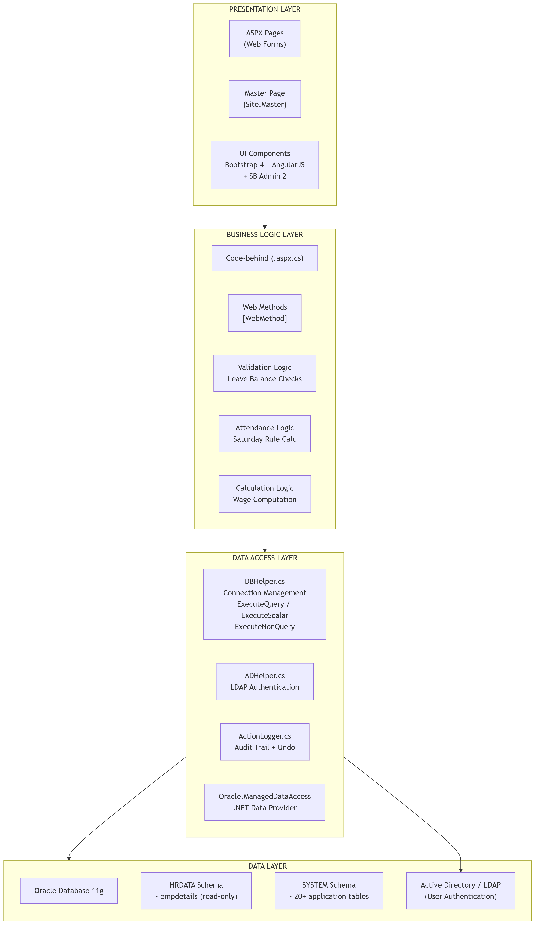
Diagram 14

7.2 Technology Stack
Layer | Technology | Version | Purpose
Frontend | HTML5 / CSS3 | — | Page structure and styling
 | Bootstrap | 4.x | Responsive UI framework
 | SB Admin 2 | — | Admin dashboard template
 | FontAwesome | — | Icon library
 | AngularJS | 1.x | Client-side data binding
 | XLSX (SheetJS) | — | Excel file generation
Backend | ASP.NET Web Forms | 4.5 | Server-side page framework
 | C# | 6.0 | Code-behind logic
 | System.Web.Services | — | AJAX WebMethods
 | System.DirectoryServices | — | LDAP/AD authentication
Data Access | Oracle.ManagedDataAccess.Client | — | Oracle database connectivity
 | JSON serialization | — | Data transfer via WebMethods
Database | Oracle Database | 11g | Primary data store
 | Sequences + Triggers | — | Auto-increment (Oracle 11g compatible)
Utilities | DBHelper.cs | — | Database connection and query execution
 | ADHelper.cs | — | Active Directory authentication
 | ActionLogger.cs | — | Audit trail management
Configuration | Web.config | — | Connection strings, AD path, app settings

7.3 Module Interaction Flow
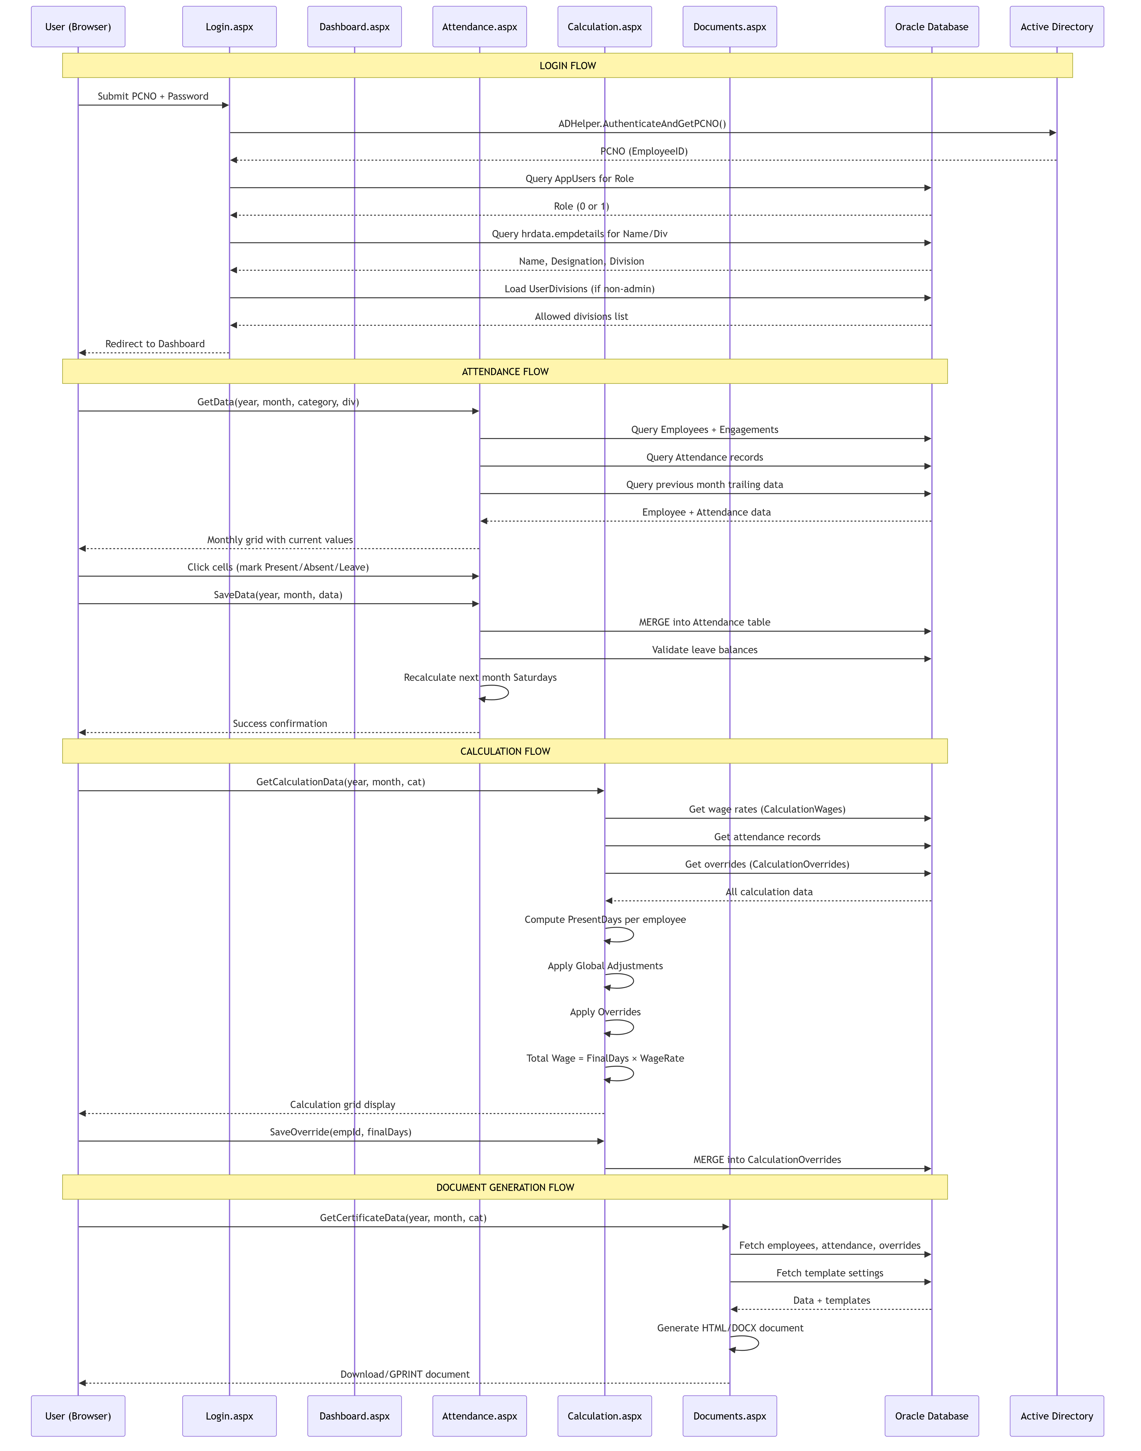
Diagram 15

8. Glossary
Term | Definition
Admin | HR department user with full system access (Role=1).
AD / LDAP | Active Directory / Lightweight Directory Access Protocol — used for user authentication.
AutoSat | Automatic Saturday attendance marking based on weekday attendance pattern.
Carried | The first half-day in a pair — marked StatusValue=1 (counts as present).
Contract Period | A formal agreement between the organization and a vendor to supply workers of a specific category for a defined period (typically 2 years).
Contract Extension | Extending an active contract period’s end date.
Division / Department | Organizational unit within the company (e.g., D-KRM, AD-Admin).
Engagement | An employment stint linking an employee to a specific contract period.
GeM ID | Government e-Marketplace portal ID for vendor contracts.
Global Adjustment | A system-wide modifier to present days applied to all employees in a month.
Half-Day Pairing | Two half-days paired together: 1st = Carried (StatusValue=1), 2nd = Paired Paid (StatusValue=1) or Paired Unpaid (StatusValue=0).
MasterId | Permanent unique identifier for employees (e.g., EMP-0001) and vendors (e.g., VND001).
Oracle 11g | Target database version. Uses sequences + triggers instead of identity columns.
Paired Paid | A second half-day that counts as paid leave (StatusValue=1).
Paired Unpaid | A second half-day that counts as unpaid leave (StatusValue=0).
PCNO | Personnel/Company Number — unique employee identifier used for login.
POC / Regular User | Point of Contact — a division-restricted user (Role=0) who marks attendance for contract employees.
Re-joining | When a resigned employee is rehired, their old MasterId and history are preserved.
Satisfactory Certificate | Document confirming vendor service quality.
Wage Calculation | Monthly computation of employee wages based on attendance.

9. Appendices

Appendix A: Placeholder Presets for Document Templates
The following placeholders can be used in CertificateTemplates values for dynamic document generation:
Placeholder | Description
{VendorName} | Vendor company name
{VendorAddress} | Vendor postal address
{ContractNo} | GeM Contract ID
{ContractDate} | Contract signing date
{DatedOn} | Dated On date
{Category} | Employee skill category
{CategoryDesc} | Category description (e.g., “Data Entry Operators(Skilled)”)
{StartDate} | Contract/period start date
{EndDate} | Contract/period end date
{EmpCount} | Number of employees
{Year} | Current year
{Period} | Contract period string
{PaymentStart} | Payment period start
{PaymentEnd} | Payment period end
{WorkingDays} | Number of working days
{PeopleCount} | People count for category
{ExtraCode} | Extra contract code
{Services} | Service description
{Duration} | Contract duration
{WefDate} | With effect from date
{Division} | Division name

Appendix B: File Structure
Diagram 16

Appendix C: Web Pages and Their Functions
Page | Access | Function
Login.aspx | All | User authentication
Dashboard.aspx | All | Summary statistics
Employee.aspx | Admin only | Employee master management
Attendance.aspx | All (role-based) | Monthly attendance grid
Calculation.aspx | Admin only | Wage calculation
Ledger.aspx | All (role-based) | Monthly attendance ledger
Documents.aspx | Admin only | Document generation
Invoice.aspx | Not used | Legacy — all document generation in Documents.aspx
Vendors.aspx | Admin only | Vendor management
Contracts.aspx | Admin only | Contract lifecycle management
AdminManagement.aspx | Admin only | User account management
Settings.aspx | Admin only | System settings
Remarks.aspx | Admin only | Remark inbox
UserRemarks.aspx | Regular Users | Send/view remarks
Notices.aspx | All | View notices

