Robin Davis, Robert Corkran, Rob Gaskell  
ECE 412/4123

RocketTracks

Final Report

# Ackowledgements

We would like to thank our faculty advisor Dr. Jeske and our industry sponsor for their support and guidance throughout this project. Special thanks to Dan Kirkpatrick for lending a hand in control theory and Cody Gabriel for spending extra hours in the EPL so that our team could have access. We would also like to thank our friends and family members for putting up with our stress and the long hours we put into this project.

Table of Contents

Ackowledgements 1

List Of Figures 2

List of Tables 2

Introduction 2

Specifications 3

Top-Level Requirements 3

Lower-Level Requirements 3

Functionality 3

Energy 3

Economic 4

Health and Safety 4

Maintainability 4

Manufacturability 4

Operability 4

Design 4

SyStem Level 4

RocketTracks Controller 5

Manual Remote 6

Power Precharge Circuit and E-Stop 6

Future Work 6

Expansion and Improvement 6

Appendixes 7

Appendix A: RocketTracks Controller 7

Schematics 7

Component Selection 8

Appendix B: Manual Remote 18

# **List Of Figures**

Figure 1: Original tracking technique involves keeping antennas pointed by shoulder mounted/handheld device 2

Figure 2: Mechanical Design of RocketTracks System 2

Figure 3: System Level Block Diagram 5

Figure 4: RocketTracks Controller Block Diagram 5

Figure 5: RTx Controller ADC Circuitry 7

Figure 6: RTx Controller Power Circuitry 7

Figure 7: RTx Controller μC Circuitry 8

Figure 8: Manual Remote Schematic 18

# Introduction

What good is a high tech rocket if you can’t track it?

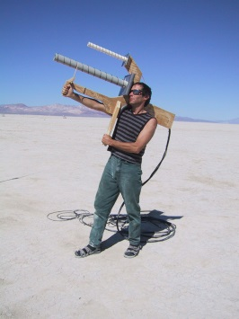

Figure 1: Original tracking technique involves keeping antennas pointed by shoulder mounted/handheld device

Current tracking technology is limited by its dependence on the human eye. Automation and streamlining of tracking technology can give us more consistent and reliable data but such improvements have yet to be made.

RocketTracks was originally conceptualized in 2011 by a group of PSAS members (Rob Gaskell, Dan Kirkpatrick, Chris Mullens). They designed a mechanical structure that was controlled manually by a few nobs. The structure was designed to be able to move dfast enough to keep up with the launch speeds of the rocket. While this was an improvement over earlier handheld models it still left far too much room for human error. It also had several flaws in its design when it came to safety. Details of this original design process can be found on the rockettracks wiki site (psas.pdx.edu/rockettracks).

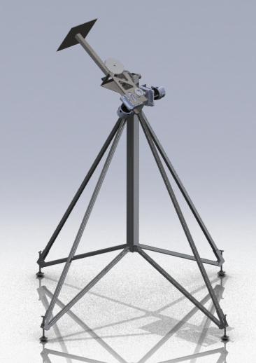

Figure 2: Mechanical Design of RocketTracks System

# Specifications

## Top-Level Requirements

The system will:

1. Be capable of tracking the PSAS launch vehicle throughout the duration of its boost stage of flight
2. Be portable / self-powered
3. Withstand exposure to rain while powered down (Excluding payload)
4. Be operable in temperatures typical of Brothers, OR year-round
5. Prevent single points of failure from causing injury or permanent damage to the unit or properly attached payloads
6. Allow manual control of individual axes
7. Interface with existing mechanical design and motor drivers
8. Support remote operation
9. The system will contain an API for relevant communications via Ethernet
10. Interface with Sightline SLA1500 via Ethernet
11. Provide power over Ethernet to payload devices

## Lower-Level Requirements

### Functionality

1. System should be able to switch between two modes (Manual and Automatic).
2. The system will use a PID control loop to control the position of each axis.
3. The system must be able to read the current position of each axis.
4. The system must be able to drive each axis.
5. The system must have the ability to interface with a PC over Ethernet during operation.

### Energy

1. The system will operate off of batteries.
2. The system will operate from a 24V nominal supply.
3. The system must be operational, in an idle state, for a minimum of 4 hours without needing to be recharged.
4. The batteries must be able to supply the maximum motor current for 10 min continuously.

### Economic

1. The cost for developing the system should target $500 and should not exceed $1000.

### Health and Safety

1. An FMEA will be conducted to determine single points of failure.

### Maintainability

1. The system must interface with the current motor drivers which have two axes, but include hardware support of two additional axes for future expansion.

### Manufacturability

1. The system must be able to fit on a 4 layer PCB.
2. The PCB must comply with OSH Park’s design rules.
3. The system will utilize an STM32 family microprocessor.
4. The firmware environment will be ChibiOS/RT.

### Operability

1. The system must be able to operate in the temperature range of -31o to 105oF
2. The PCB(s) must be contained in a water resistant enclosure.
3. The PCB(s) must be able to withstand vibrations caused by the movement of the mechanical structure.
4. All external digital connections will be designed to conform to IEC 61000-4-2 for ESD protection.

# Design

## SyStem Level

The following block diagram designs the concept for the system. The items within the dashed line are those that were to be designed by the capstone team. The main items are

1. Manual Remote
2. RocketTracks Controller
3. Power Precharge Circuit and Emergency Stop

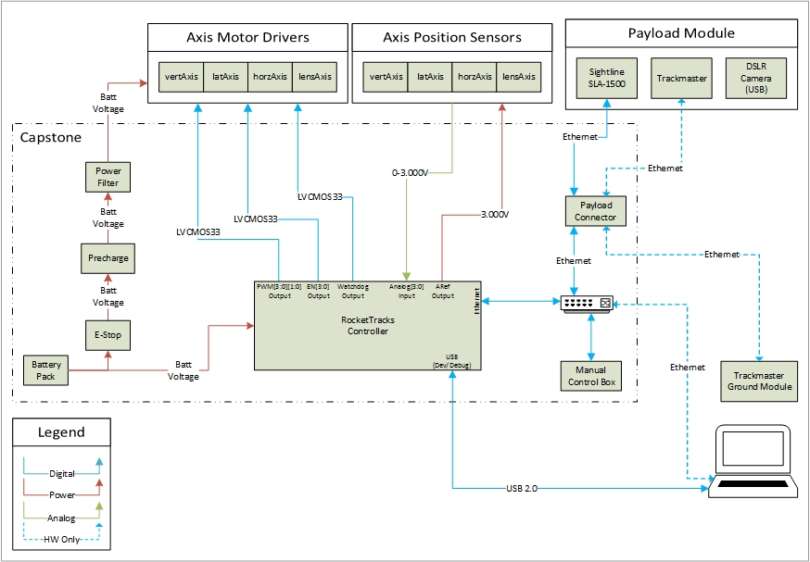

Figure 3: System Level Block Diagram

## RocketTracks Controller

The RocketTracks Controller board controls the position of the axes on the RocketTracks camera and antenna pointer. The RTx Controller Board features an Ethernet port for communication with input control devices, as well as a USB port to aid in firmware development and debugging. Commands and tracking data will be sent via Ethernet to the RTx Controller board, and the onboard microcontroller will process the data and output PWM and other control signals to the Generic Motor Driver boards for each axis.

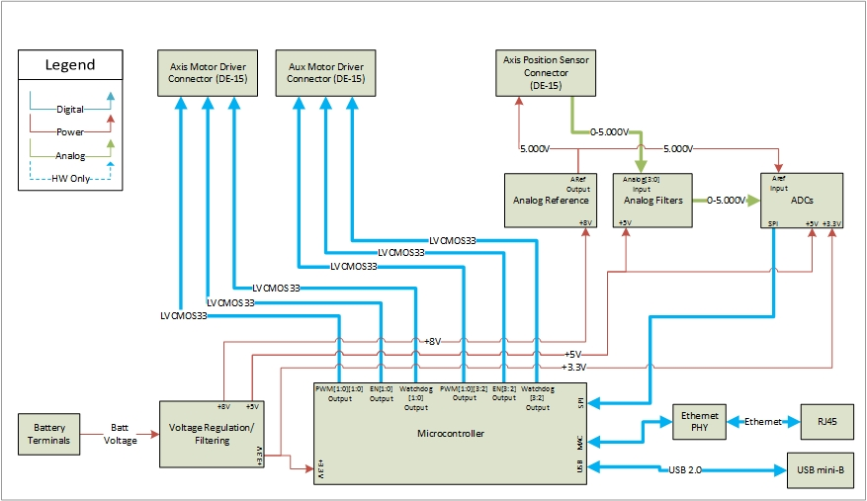

Figure 4: RocketTracks Controller Block Diagram

A detailed description of the design of each component of this block diagram as well as schematics can be found in Appendix A.

## Manual Remote

The Manual Remote Adapter Board allows simple connection of the manual control box inputs and indicator LED’s to the Olimex STM32-E407 Development Board which will be used to process manual inputs and communicate with the RTX Controller Board. The Adapter Board includes appropriate pull-up, pull-down, current-limiting and filtering circuits as required for the various input and output signals. The Adapter Board is powered entirely from the STM32-E407

A detailed description of this design and component selection as well as schematic can be found in Appendix XXX

## Power Precharge Circuit and E-Stop

# Future Work

We hope to do some more debugging to improve the system. We would also like to make some improvements to the physical structure such as determining a better way to attach the enclosure to the mechanical structure PSAS launch 11 will take place on July 20th, 2014. It is our plan to attend this launch and test out RocketTracks. We will then be able to provide Sightline with the data we obtain in order to help them improve their tracking algorithm.

# Expansion and Improvement

We discussed that in the future it would be nice to get rid of the manual control box and replace it with a phone app. This would allow for the user to work from more of a distance, it could also eliminate the use of a laptop with the system.

# Appendixes

## Appendix A: RocketTracks Controller

### Schematics

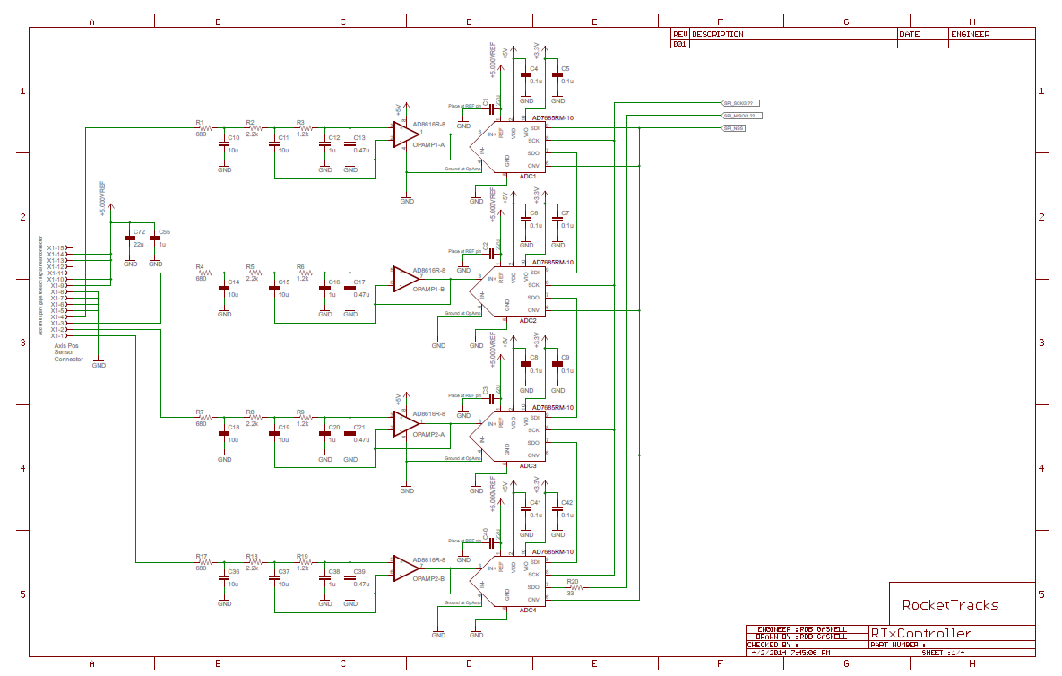

Figure 5: RTx Controller ADC Circuitry

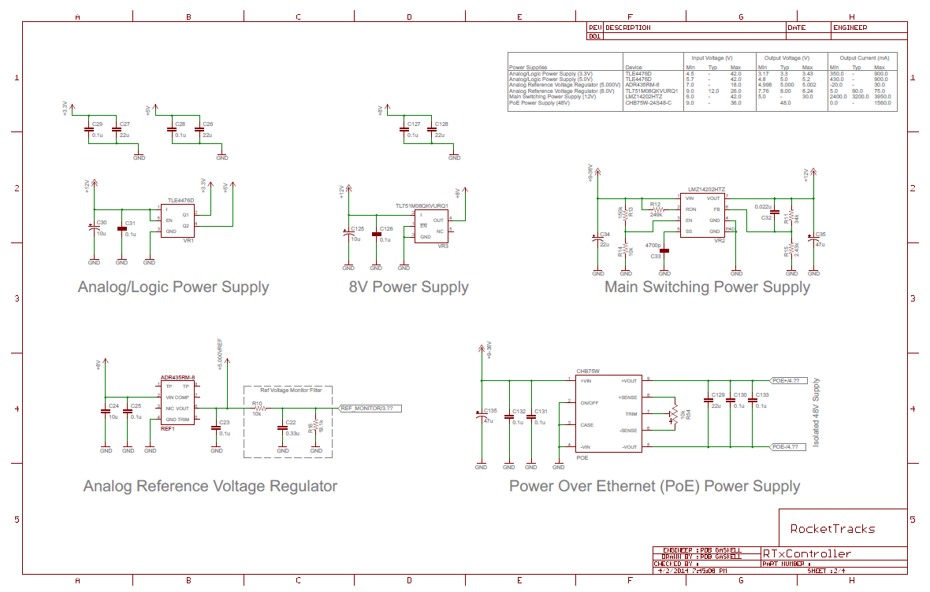

Figure 6: RTx Controller Power Circuitry

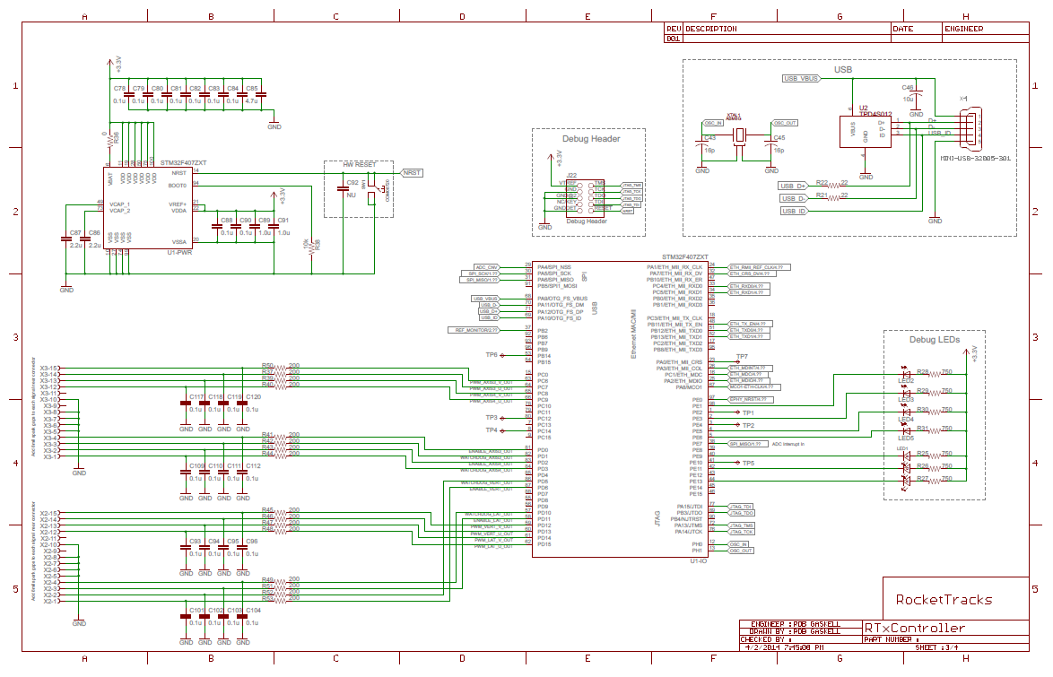

Figure 7: RTx Controller μC Circuitry

## Component Selection

1. Axis Position Feedback
2. Axis Position Feedback Overview

RocketTracks uses a potentiometer as a position sensor for each axis. The output voltage is filtered and compared to the input reference voltage via an on-board ADC. The Low-Pass Filter is designed based on control theory requirements, and is a compromise of noise-reduction and phase margin requirements.

1. Analog-to-Digital Converters (ADCs) for Feedback circuits
2. Component List
3. ADC1

|  |  |  |  |
| --- | --- | --- | --- |
| C1 | C4 | C5 | ADC1 |

1. ADC2

|  |  |  |  |
| --- | --- | --- | --- |
| C2 | C6 | C7 | ADC2 |

1. ADC3

|  |  |  |  |  |
| --- | --- | --- | --- | --- |
| C3 | C8 | C9 | R16 | ADC3 |

1. ADC4

|  |  |  |  |  |
| --- | --- | --- | --- | --- |
| C40 | C41 | C42 | R20 | ADC4 |

1. Analog Reference Voltage Regulator

|  |  |  |  |
| --- | --- | --- | --- |
| C23 | C24 | C25 | REF1 |

1. Design Overview
2. ADC Resolution

The resolution of the axis position feedback ADC’s corresponds to the resolution of measurement of the angular position of the axis. Assuming the potentiometer provides a resistance through the axis range of motion which is linear with angle and corresponds to a full-range output voltage sweep through a 360-degree rotation, we have:

The tracking precision required at full-range is then:

We must track a ~2m length object at distances in excess of 18,000ft. However, we need not stay perfectly centered on the rocket at this distance, as video will not be at full zoom, and telemetry signals require less precision than video. Assuming we want to keep the rocket both in the frame and zoom such that the rocket length is 5% of the frame, the tracking resolution at this range becomes:

However, the control system will not be capable of tracking to 1 LSb of the ADC, so as a rule of thumb we will assume tracking precision to within 30% of ADC resolution. Then we have:

As ADC’s are most commonly available in power-of-2 resolutions, a 16 bit ADC will be used.

1. ADC Digital Interface

Given a sample rate of 2000Hz as described in section B.3.a below, we must have a data bandwidth of 2kSamples/sec, with a sample size of 16 bits or 2 Bytes. We must then have a data bandwidth of 4kB/s for each ADC, or 16kB/s if they are on a shared or daisy-chained bus. However, latency is of great concern in a control system, so it is not sufficient that the data transfer complete within the sample period.

A daisy-chain SPI interface allows a single sample command to be issued to all ADC’s simultaneously, and allows a single data transfer from all axes to be performed with lower overhead as compared to a chip-select based SPI interface.

1. ADC and Analog Reference Voltage Regulator Choice

Common ADC data buses are I2C and SPI. The AD7685 is a 16-bit ADC supporting both SPI and daisy-chain serial interfaces at up to 55MHz, or more than 6.5MB/s. It also has a sample rate of up to 250kSamples/s, and a sample-to-data ready time of no more than 2.2us, minimizing latency and satisfying throughput requirements.

1. ADC Supply Voltages

The AD7685 has separate supplies for the converter and for the digital I/O interface. was chosen to match that of the microcontroller, while selection was based on the desire to minimize conversion latency, as higher voltages allow for faster conversion times as well as higher conversion rates. The following voltages were chosen:

1. Reference Voltage Regulator Choice

A stable and noise-free reference voltage is required for the ADC and feedback position sensor potentiometer circuits. The chosen analog reference voltage regulator is recommended for use with the AD7685, and is offered in a range from   
 The model, ADR435, was chosen as the higher voltage maximizes the signal-to-noise ratio.

1. ADC Decoupling Capacitors

Per the datasheet, 0.1uF capacitors were chosen to decouple the supply pins. A 1206-package 22uF capacitor with an X5R temperature coefficient decouples the analog reference input pin, as this is the recommended value when using an ADR43x reference voltage regulator.

1. Analog Reference Supply Decoupling Capacitors

The ARef regulator’s supply pin is decoupled with a 10uF and 0.1uF capacitor, and the output is decoupled with a 0.1uF capacitor, per the device datasheet.

1. Summary of Parameters
2. Low-Pass Filters for Feedback ADCs
3. Component List
4. ADC1 Feedback LPF

|  |  |  |  |  |  |  |  |
| --- | --- | --- | --- | --- | --- | --- | --- |
| R1 | R2 | R3 | C10 | C11 | C12 | C13 | OPAMP1-A |

1. ADC2 Feedback LPF

|  |  |  |  |  |  |  |  |
| --- | --- | --- | --- | --- | --- | --- | --- |
| R4 | R5 | R6 | C14 | C15 | C16 | C17 | OPAMP1-B |

1. ADC3 Feedback LPF

|  |  |  |  |  |  |  |  |
| --- | --- | --- | --- | --- | --- | --- | --- |
| R7 | R8 | R9 | C18 | C19 | C20 | C21 | OPAMP2-A |

1. ADC4 Feedback LPF

|  |  |  |  |  |  |  |  |
| --- | --- | --- | --- | --- | --- | --- | --- |
| R17 | R18 | R19 | C36 | C37 | C38 | C39 | OPAMP2-B |

1. Design Overview/Component Choice
2. Control Bandwidth and Cutoff Frequency

The control bandwidth frequency for the closed-loop control system was chosen based on the requirement to track fast-moving objects with video during manual and automated control operation. The cutoff frequency for the ADC input LPF is specified to be one decade higher than . This convention places far enough above the to prevent the LPF from limiting performance at the , while still providing satisfactory noise filtering.

1. ADC 1-bit Frequency, desired noise level and Filter Order

The frequency of the ADC’s LSB is the minimum frequency at which we will observe a change on the least significant bit. The maximum noise level desired at is -96dβ. must be a low enough frequency such that the Nyquist rate is reasonable given our choice of ADC’s and microcontroller. With a 3rd Order LPF with our , we have:

The Nyquist rate, or minimum rate we must sample the ADC’s is then , which is a reasonable sample rate for the system.

1. Topology

A Sallen-Key topology Butterworth Low-Pass Filter was chosen due to its simplicity, and the ability to attain 3rd-order filtering and a low with relatively low RLC values in combination.

1. Op-Amp

The AD861x Op-Amp was chosen to produce the Sallen-Key topology because it is recommended for use in conjunction with the chosen ADC’s.

1. Consequences
2. Control Rate and ADC Sampling

A rule of thumb for minimum control rate is , then:

The Nyquist rate must also be satisfied, so the sample rate must be:

Choosing and gives us 20 samples per control loop iteration.

1. Summary of Parameters
2. Microcontroller
3. Microcontroller Overview

The RocketTracks Controller must process axis feedback position data as well as desired position data from the manual controller and target position data from the Sightline device, both of which communicate via Ethernet. It must also drive the PWM and control signals required by the PSAS Generic Motor Driver boards. The STM32F407 was chosen for its support of Ethernet, SPI for receiving axis postion data from the ADC’s, plentiful PWM output capabilities, as well as its current use with other PSAS projects and its support of ChibiOS/RT, the operating system used by other PSAS projects.

1. Microcontroller circuit
2. Component List

|  |  |  |  |  |  |  |  |  |  |  |
| --- | --- | --- | --- | --- | --- | --- | --- | --- | --- | --- |
| R36 | R38 | R168 | C78 | C79 | C80 | C81 | C82 | C83 | C84 | C85 |
| C86 | C87 | C88 | C89 | C90 | C91 | C92 | SW1 | J22 | U1 |

1. Design Overview/Component Choice
2. Peripheral Requirements
3. Ethernet MAC

The 10/100 MAC peripheral meets the requirements for bidirectional communication with the RTx Manual Control Box as well as the Sightline device.

1. SPI Controller

The ADC’s described in section I when used in Daisy-Chain mode require a minimum digital interface clock period of 18ns with the 3.3V IO voltage used. The maximum digital data bus frequency then is:

The STM32F407’s SPI1 Controller has a maximum frequency of 37.5MHz, so the SPI controller can run at a high frequency without risk of violating the timing requirements of the ADC’s. With 4 16-bit ADC’s sampling at 2kHz, as described in section I, the minimum bit rate is then:

So, the 37.5MHz bit rate is sufficient and will provide relatively low latency.

1. PWM

Each axis requires a pair of PWM signals with independent single-edge control. This means a total of 8 PWM outputs to support up to 4 axes. The STM32 easily accommodates this requirement, with several of its hardware timers supporting 4 PWM channels each.

1. External Interrupts (EXT)

The ADC’s are interfaced to the microcontroller using a Daisy-Chain configuration with a busy indicator. In this mode, the ADC nearest the microcontroller in the chain drives its SDO line high when the data is ready. This signal can be used to interrupt the microcontroller and initiate the data transfer using the SPI controller. The STM32F407 supports external interrupts on most of its GPIO pins, allowing use of this feature.

1. GPIO

Additional digital outputs are required to operate the PSAS GMD’s. Each GMD requires an Enable signal as well as a Watchdog signal which switches periodically, so an additional 8 GPIO pins are required. The STM32F407 chosen has 114 GPIO’s, far surpassing this GPIO requirement.

1. Analog-to-Digital Converter

As axis position is considered safety-critical data, it was deemed necessary to monitor the Analog Voltage Reference Regulator to ensure accurate operation of the axis position sensor ADC’s. The STM32F407 has multiple internal ADC’s which are multiplexed on multiple channels and GPIO pins.

1. Multiplexing of Pins

In addition to supporting each peripheral, all peripherals must be accessible to external devices with which they communicate. While it is possible to multiplex pins at runtime for use with more than one peripheral, this adds complexity and latency to firmware, as well as to external hardware. The 100-pin version of the STM32F407 allows independent GPIO interfacing with all required peripherals as well as those described in the following Program, Debug and Development Support subsection.

1. Program, Debug and Development Support
2. Programming and Debug

The STM32F407 supports both JTAG and SWD for programming and on-chip debugging. A standard JTAG/SWD header was used which is common to other PSAS projects.

1. Development Support

A USB port was added to the RTx Controller for development support only. Chibios/RT features a command-line shell that is easily connected via USB, and is a convenient way to communicate with the STM32F407 for development purposes.

1. Supply, Digital IO and Analog Voltages
2. Ethernet Port
3. Ethernet Overview

RocketTracks uses the Ethernet protocol to receive command and tracking data to be used by the microcontroller for processing. The microcontroller has an onboard 10/100 Ethernet MAC which is interfaced to an external Ethernet PHY. The Ethernet PHY has a connector with built in magnetics for proper signal integrity. An additional power over Ethernet (PoE) controller maintains appropriate power levels to be supplied over the Ethernet interface.

1. Ethernet PHY
2. Component List

|  |  |  |  |  |  |  |  |  |  |  |  |  |
| --- | --- | --- | --- | --- | --- | --- | --- | --- | --- | --- | --- | --- |
| U3 | R56 | R55 | C73 | C75 | L3 | C97 | C98 | C76 | C77 | R60 | C99 | C54 |

1. Design Overview

Micrel’s KSZ8081RNAIA was chosen as the Ethernet transceiver for its compact design and ability to easily communicate with the chosen microcontroller. In addition, the timing control for the KSZ8081RNAIA can be done from the MCO output of the microcontroller and even generate the necessary 50MHz reference clock to be sent back for use with the RMII mode of operation. The component operates from a single 3.3VDC power supply.

The capacitors and inductor are all recommendations by the manufacturer to ensure proper data transmission and reception. Bypass capacitors are placed close to the device itself to ensure proper supply voltage levels during operation and signal integrity.

The Ethernet transceiver also requires a clocked input either from a separate external oscillator or from a clock signal coming from the microcontroller. Since the microcontroller has the ability to provide a clock signal to the transceiver, adding a separate crystal oscillator seemed redundant. There are also sufficient GPIO pins to support this. Therefore the microcontroller will supply the Ethernet transceiver with its clock input.

1. Summary of Parameters

The RMII interface is used to communicate with the microcontroller.

A 25MHz clock signal is required from the microcontroller to synchronize timing of data transmission and processing. This will be sourced from the microcontroller. A 50MHz clock will be generated by the KSZ8081RNAIA to be sent back to the microcontroller for proper RMII synchronization.

1. Ethernet Connector
2. Component List

|  |  |
| --- | --- |
| X8 | R59 |

1. Design Overview/Component Choice

The Ethernet protocol requires signal isolation through transformer coupling. This can be achieved from a dedicated LAN Discrete Transformer Module or from an Ethernet connector with incorporated transformers. A connector with incorporated transformers was chosen to reduce needed board space and improve signal reliability. The connector transformers also support center-tapping, which is used on the controller board to supply PoE. Built in LEDs allow for visual Ethernet diagnosis at the connector itself.

1. Power over Ethernet (PoE)
2. Component List

|  |  |  |  |  |  |  |  |  |  |  |  |
| --- | --- | --- | --- | --- | --- | --- | --- | --- | --- | --- | --- |
| IC2 | C50 | C48 | L2 | R_LED | C44 | D4 | C51 | R99 | D5 | R24 | R23 |

1. Design Overview

Maxim’s MAX5984C was chosen in order to incorporate PoE to the RTx design. The component is a single PSE controller compliant with IEEE 802.3af/at standard. This model allows for PoE+ which will offer an output power tolerance of up to 40W; sufficient to source power to the external devices requiring power from Ethernet.

The PoE controller circuit was taken directly from the product datasheet when used from a single 48VDC supply and incorporated with indicator LED for diagnostic purposes.

1. USB Development/Debug Port
2. Component List

|  |  |  |  |  |  |
| --- | --- | --- | --- | --- | --- |
| R21 | R22 | C45 | C46 | U2 | X4 |

1. Design Overview/Component Choice

The USB port requires ESD protection. For this TI’s TPD4S012 was chosen because it was a cheap and straightforward solution. A 22Ω current-limiting resistor was placed in series on the D+ and D- line. The two capacitors were placed to reduce noise. The capacitor and resistor sizes were the suggested sizes on the datasheet for the TPD4S012. The pins selected on the microcontroller were chosen to be the same as those used for USB on the dev board. Note: the TPD4S012 was removed from the design due to PCB layout complications.

1. Supply Voltage Regulation/Filtering

|  |  |  |  |  |  |  |  |  |
| --- | --- | --- | --- | --- | --- | --- | --- | --- |
| **Device** | **Input Voltage (V)** | | **Output Voltage (V)** | | | **Output Current (mA)** | | |
| **Min** | **Max** | **Min** | **Typ** | **Max** | **Min** | | **Max** |
| TLE4476D | 4.5 | 42.0 | 3.17 | 3.3 | 3.43 | 350.0 | 900.0 | |
| TLE4476D | 5.7 | 42.0 | 4.8 | 5.0 | 5.2 | 430.0 | | 900.0 |
| ADR435RM-8 | 7.0 | 18.0 | 4.998 | 5.000 | 5.002 | -20.0 | | 30.0 |
| TL751M08QKVURQ1 | 9.0 | 26.0 | 7.76 | 8.00 | 8.24 | 5.0 | | 75.0 |
| LMZ14202HTZ | 6.0 | 42.0 | 5.0 | - | 30.0 | 2400.0 | | 3950.0 |
| CHB75W-24S48-C | 9.0 | 36.0 | 47.5 | 48.0 | 48.5 | 0.0 | | 1560.0 |

Since the ADR435RM-8 power supply will be used for precision analog reference, it was desired that an LDO power supply be used as its input voltage source instead of the switching power supply, used to drive other components. The TL751M08QKVURQ1 was chosen to act as this filter between the switching and analog reference power supplies. The TL751M08QKVURQ1 allowed for a 12V input from the LMZ14202HTZ with an output close to that of the minimum voltage for the ADR435RM-8. Using the minimum input voltage for the ADR435RM-8 meant that less power loss would occur through this component. The TL751M08QKVURQ1 was chosen as a robust component, as it is cataloged for use in automotive applications, at a broad range of ambient temperatures, with very low dropout voltage (less than 0.6V) when used at high current. The component is also surface mount, requiring minimal board area, and with a standard type package already found in the present device library.

## Appendix B: Manual Remote

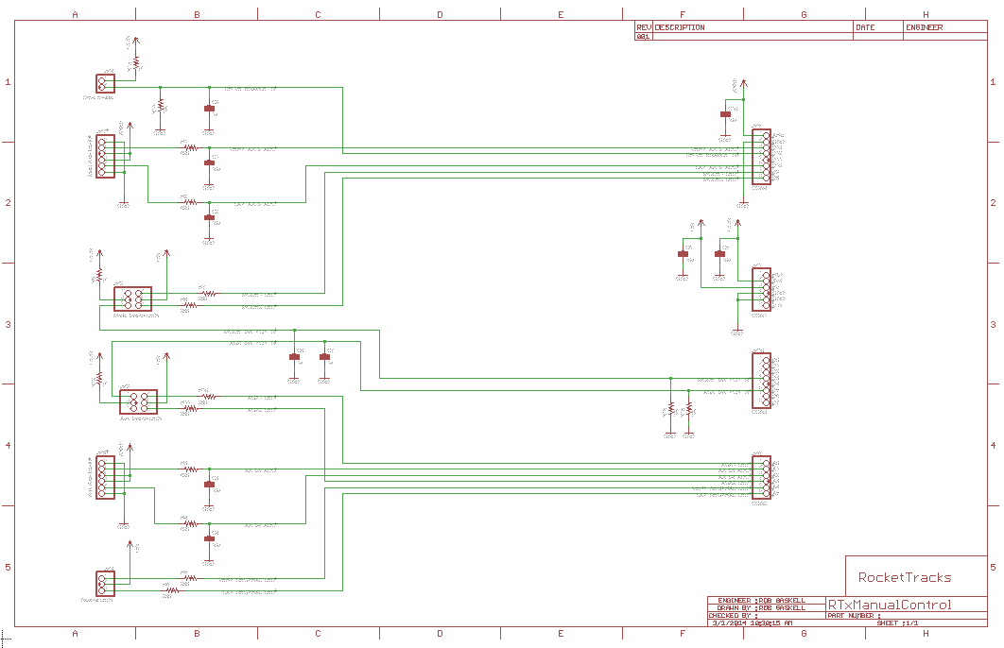

Figure 8: Manual Remote Schematic

1. Axis Manual Inputs
2. Axis Manual Inputs Overview

The axis manual inputs are potentiometers which are turned by the user to change the position or velocity of each axis. The potentiometer positions are measured via the on-chip ADC’s on the STM32F407 microcontroller on the STM32-E407 development board.

1. Low-Pass Filters for Manual Input ADC’s
2. Component List
3. Vertical Axis LPF

|  |  |
| --- | --- |
| C1 | R1 |

1. Lateral Axis LPF

|  |  |
| --- | --- |
| C2 | R2 |

1. Axis3 LPF

|  |  |
| --- | --- |
| C3 | R3 |

1. Axis4 LPF

|  |  |
| --- | --- |
| C4 | R4 |

1. Design Overview/Component Choice

Connectors with a locator tab will be used to prevent switch operation from being reversed.

1. Control Bandwidth and Cutoff Frequency

For details, see RTx Controller Board Design.

1. Axis Input Connector Pin-out

The pin-out of each connector prevents overvoltage/overcurrent and short-circuit conditions from occurring in the event the connector is inserted backwards. Each connector is pinned differently, so that no axis inputs will function if the two connectors are swapped.

1. Drive Enable Switch
2. Drive Enable Switch Overview

The Drive Enable switch toggles an input to the microcontroller to enable or disable the RTx motor drivers. The circuit is pulled low by default, and is pulled high when the switch is closed to enable. The switch is de-bounced with a capacitor and its pull-up/pull-down resistors.

1. Drive Enable Switch Circuit
2. Component List

|  |  |  |  |  |
| --- | --- | --- | --- | --- |
| C9 | R13 | R14 | JP4 | JP5 |

1. Design Overview/Component Choice
2. Pull-up/Pull-down resistors

In addition to an external pull-down resistor, the active pull-down on the processor GPIO will be used to prevent a single point-of-failure from causing a stuck-high drive enable. A pull-up value of 1kOhm and a pull-down of 22kOhms + 10kOhm GPIO active pull-down results in a closed-switch voltage, in the absence of:

Which exceeds the microcontroller’s threshold. The current-limiting effect of the pull-up resistor also results in a max current of:

Which is well below the max current rating for GPIO pins on the microcontroller.

1. Switch De-bounce

Switch de-bouncing is not critical for this circuit, so a rule-of-thumb value of 1uF was used as a de-bounce capacitor. As the circuit uses both pull-up and pull-down resistors, no additional resistance is required for the capacitor to act as a de-bounce filter.

1. Mode/Aux Selectors
2. Mode/Aux Selector Overview

The Manual Remote features 2 toggle switches with indicator LEDs. The right switch acts as a Mode selector switch to change between position and velocity control modes, and the left switch is supported for future functionality. Each switch circuit is configured similarly to the Drive Enable Switch circuit above, with pull-down, pull-up resistors and a de-bounce capacitor. The indicator LEDs for the switches are driven with active-low GPIO outputs by the microcontroller, through current-limiting resistors.

1. Mode/Aux Switch Circuits
2. Component List
3. Mode Switch

|  |  |  |  |  |
| --- | --- | --- | --- | --- |
| C8 | R9 | R16 | JP2 | JP10 |

1. Aux Switch

|  |  |  |  |  |
| --- | --- | --- | --- | --- |
| C7 | R12 | R15 | JP9 | JP10 |

1. Design Overview/Component Choice

The values for pull-up, pull-down and de-bounce capacitors were chosen with the same requirements and parameters as those for the Drive Enable Switch Circuit above. Connectors with a locator tab will be used to prevent switch operation from being reversed.

1. Mode/Aux Indicator LED Circuits
2. Component List
3. Mode Indicator LEDs

|  |  |  |  |
| --- | --- | --- | --- |
| R7 | R8 | JP2 | JP5 |

1. Aux Indicator LEDs

|  |  |  |  |
| --- | --- | --- | --- |
| R7 | R8 | JP9 | JP5 |

1. Design Overview/Component Choice
2. Supply Voltage and topology

The LEDs used on the Manual Control box are large, through-hole style components with relatively high forward voltages and current requirements, so the available 5V supply was chosen to power the LEDs. This configuration allows the microcontroller to sink rather than source current in order to illuminate the LEDs, and also eliminates the constraint of microcontroller IO voltage.

1. Current Limiting Resistors

The green LEDs used in the Manual Control box have a forward voltage of approximately 2.2V. A target forward operating current of 10mA was chosen, as it should provide ample brightness without approaching the current limit of the LEDs or of the GPIO pins. The resistor values are then:

1. Mode/Aux Selector Connector Pin-out
2. Component List
3. Mode Selector

|  |
| --- |
| JP2 |

1. Mode Selector

|  |
| --- |
| JP9 |

1. Design Overview

The pin-out of the Mode and Aux Selector connectors prevents functioning of the switches if the two connectors are swapped. In addition, the pin-out prevents overvoltage/overcurrent and short-circuit conditions from occurring in the event the connectors are inserted backwards.

1. Neutral Indicator LEDs
2. Neutral Indicator LEDs Overview

The Neutral Indicator LEDs illuminate when the Vertical and Lateral axes are individually disabled when changing Control Modes. The LEDs and circuits are similar to those of the Mode/Aux Indicator LED circuits.

1. Neutral Indicator LED Circuits
2. Component List

|  |  |  |  |
| --- | --- | --- | --- |
| R7 | R8 | JP3 | JP6 |

1. Design Overview/Component Selection

The LED circuit topology and current-limit resistors were chosen with the same requirements and parameters as those for the Mode/Aux Indicator LED Circuits above.

1. LED Connector Pin-out
2. Pin-out

The pin-out of the connector prevents overvoltage/overcurrent and short-circuit conditions from occurring in the event the connector is inserted backwards.

1. Consequences of Pin-out

The connector pin-out does not prevent operation of the LEDs if the connector is inserted backwards. The LEDs will indicate opposite axes in this case, therefore a connector pair with a locator tab or other means of preventing backward insertion should be used.

1. Power Supply Connections
2. Power Supply Connections Overview

The Manual Remote Adapter board connects to the STM32-E407 development board’s voltage rails, analog reference and ground, allowing circuits to be powered without the addition of on-board voltage regulators or external power sources.

1. Power Supply Connections
2. Component List

|  |  |  |  |  |
| --- | --- | --- | --- | --- |
| C5 | C6 | C10 | JP1 | JP5 |

1. Design Overview/Component Selection
2. Decoupling Capacitors

Each supply and the Analog Reference are decoupled with a 10uF capacitor. This rule-of-thumb value was chosen to provide bulk capacitance to the various circuits on the development board as well as the off-board switches and LEDs.

1. Supply Voltages

The following voltages are available on the Manual Remote Adapter board: