REALmagic DirectShow interface

REALmagic DirectShow 接口
Everyone interested in Directshow programming should first download the DirectX SDK, read the Directshow documentation and start with a few samples.

Theorical part...
It is quite simple to get the XCard to read a MPEG I, II or 4 with Directshow.
用Directshow可以十分简单的获取 Xcard 去读取一个MPEG1/2/4.
We need to create a FilterGraph manager object, which instantiates all the
necessary filters, so we can:
我们必须去创建一个FilterGraph 管理器对象，和实例的全部必要的解码器，我们就可以：
- Read the physical file 读取物理文件
- Separate the audio and video streams 分离音视频流
- Use the Sigma MPEG2 Hardware decoder 使用 Sigma MPEG2 硬件解码器
- Use the lc3codec filter to decompress the mp3 audio stream (in a Divx movie)
- Use the Sigma PCM swapper (Which converts the little endian byte order of the
mp3 decoder to the big endian byte order expected by the EM8475 XCard chipset audio input)
- Render the video stream
Here is the GraphEdit filtergraph to read a divx movie with the XCard:
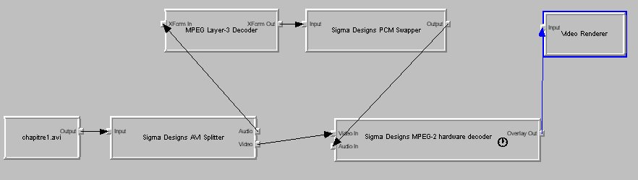

For a Mpeg I or II movie, the schematic is simpler :
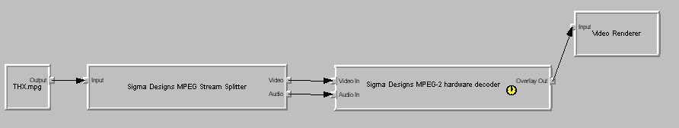

Practical part...
Let's see how to implement the graphedit representation. I will first explain how to do this in VB which, in my opinion, is easier.

VB
You must first add the quartz dll reference in your VB project :
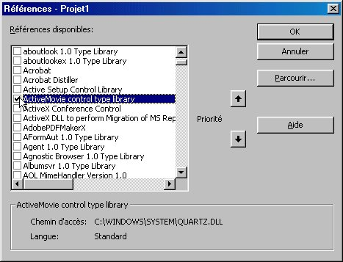
Then, declare the IMediaControl object :
Dim MonControlGraph as IMediaControl
This object is the control interface of the FilterGraph that you're about to build (This interface will then give you the methods to play, pause or stop your movie)
To instantiate it, type :
Set MonControlGraph = New FilgraphManager
This creates a Filtergraph object. It internally calls the
CoCreateInstance and QueryInterface methods to extract the IMediaControl Interface
in order to pass the reference to your "MonControlGraph" object.
Now, you have to create all the necessary objects to read your Divx AVI file.
In VB, you can create these objects using the IFilterInfo type. You have to declare a IFilterInfo object for each filter you need inside your graph :
Dim pSourceFilter As IFilterInfo
Dim pAVISplitter As IFilterInfo
Dim pXCARDFilter As IFilterInfo
Dim pSPCMFilter As IFilterInfo
Dim pMP3Filter As IFilterInfo
Dim pVidRenderer As IFilterInfo
The first filter can be created using the "AddSourceFilter" method of the FilterGraph :
MonControlGraph.AddSourceFilter "fichier.AVI", pSourceFilter
if everything is OK (check if your object is not nothing after this call), you can go on with the instantiation of the other objects :
To create the other filters, you will have to look among all the filters registered on your system. To do that, the FilterGraph objects provides a collection of all the available filters in the Windows registry. To get the reference of the filter we are looking for, we just enumerate this collection, and when we find the correct name, we just assign the reference to our IFilterInfo object.
To make things easier, here is a method I use to find and assign a filter whose name is given in argument :
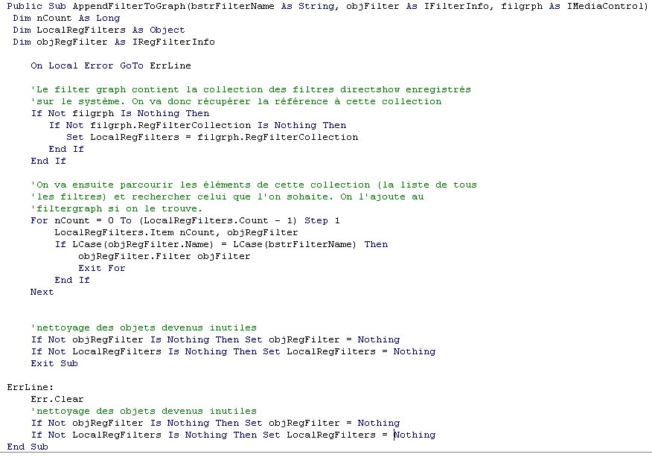
This is a simple adaptation of an example provided in the Directshow SDK.
Now let's call this method to create the instance of all our objects :
AppendFilterToGraph "Sigma Designs AVI Splitter", pAVISplitter, MonControlGraph
AppendFilterToGraph "Sigma Designs MPEG-2 hardware decoder", pXCARDFilter, MonControlGraph
AppendFilterToGraph "Video Renderer", pVidRenderer, MonControlGraph
AppendFilterToGraph "Sigma Designs PCM swapper", pSPCMFilter, MonControlGraph
AppendFilterToGraph "MPEG layer-3 decoder", pMP3Filter, MonControlGraph
Of course, don't forget each time to check that your object is different from "nothing".
And now, let's connect those elements each other.
To achieve that, you can use two methods. The first is easier and works most of the time :
You have to find the output plug of your source filter. There are a collection of plugs (or pins) on each filter. Pins can be input type or output type. By enumerating the pin name on our filters, we can get references to the pin objects. The pins are connected to link the filters together.
To use the first method, we have to find the only pin on the source filter. If we call the method "Render" on this pin, the filtergraph will try to connect all the other pins of the different filters we instantiate.
To do that, declare a pPin object and a pSourceFilterPin :
dim pPin as iPinInfo
dim pSourceFilterPin as iPinInfo
pPin will be used to enumerate the pins on the source filter, and pSourceFilterPin will get the reference of the pin we find.
We now have to look inside the pins collection of the source filter :
if not pSourceFilter is nothing then
for each pPin in pSourcefilter.pins
if pPin.name = "Output" then
Set pSourceFilterPin = pPin
end if
next
end if
Now, by calling the method : pSourceFilterPin.Render, connection between all the filters will be done automatically.
The other way to realize the connections between filters is a little more complex : we have to find all the pins of each filter and manually connect them (the "connect" method on the IPinInfo object). Unfortunaltely, some filters expose their output pins only when their input pin is connected. That's why we have to enumerate the pin collection twice on some filters.
Here is the method I use in VB to create a filtergraph that reads a Divx :
Public Function Render_Divx(AVIfilename As String, filgrph As IMediaControl) As Boolean
Dim pPin As IPinInfo ' déclaré pour la recherche des "pins" des différents filtres
Dim pSourceFilter As IFilterInfo ' filtre "source" : lecture dans un buffer du fichier
Dim SourceOutputPin As IPinInfo ' pin de sortie du filtre source
Dim pAVISplitter As IFilterInfo ' filtre "splitter" : permet de séparer le stream audio et vidéo
Dim SplitterInPin As IPinInfo ' pin d'entrée du filtre splitter
Dim SplitterOut00Pin As IPinInfo ' pin de sortie du stream vidéo du filtre splitter
Dim SplitterOut01Pin As IPinInfo ' pin de sortie du stream audio du filtre splitter
Dim pXCARDFilter As IFilterInfo ' filtre du décodeur hardware XCard
Dim XCARDInVideoPin As IPinInfo ' pin d'entrée du flux vidéo
Dim XCARDInAudioPin As IPinInfo ' pin d'entrée du flux audio
Dim XCARDOutOverlayPin As IPinInfo ' pin de sortie "overlay" de la XCard
Dim pSPCMFilter As IFilterInfo ' filtre "PCM swapper" de Sigma Designs
Dim SPCMInPin As IPinInfo ' pin d'entrée du swapper
Dim SPCMOutPin As IPinInfo ' pin de sortie du swapper
Dim pMP3Filter As IFilterInfo ' filtre du décodeur MP3 audio
Dim MP3InPin As IPinInfo ' pin d'entrée du décodeur MP3
Dim MP3OutPin As IPinInfo ' pin de sortie du décodeur MP3
Dim pVidRenderer As IFilterInfo ' filtre du vidéo renderer
Dim VidRendInPin As IPinInfo ' pin d'entrée du vidéo renderer

On Local Error GoTo ErrLine

' on vérifie que la chaine contenant le nom du fichier à lire ne soit pas vide
' et on demande au filtergraph de nous instancier un filtre pour lire ce fichier
If AVIfilename <> vbNullString Then
filgrph.AddSourceFilter AVIfilename, pSourceFilter
Else: Exit Function
End If

' On retrouve le pin de sortie du filtre d'entrée
For Each pPin In pSourceFilter.Pins
If pPin.Name = "Output" Then
Set SourceOutputPin = pPin
End If
Next

' On ajoute ensuite l'AVI splitter, chargé de séparer les canaux
' audio et vidéo
If pAVISplitter Is Nothing Then
AppendFilterToGraph "Sigma Designs AVI Splitter", pAVISplitter, filgrph
End If

' On recherche seulement le pin d'entrée du spliter afin de pouvoir le connecter
' au filtre source, et voir apparaitre ensuite ses pin de sortie
If Not pAVISplitter Is Nothing Then
If Not pAVISplitter.Pins Is Nothing Then
For Each pPin In pAVISplitter.Pins
If pPin.Name = "Input" Then
Set SplitterInPin = pPin
End If
Next
End If
End If

' On connecte ensuite, puisque l'on a obtenu la pin de sortie du filtre source
' et la pin d'entrée du splitter
If Not SourceOutputPin Is Nothing And Not SplitterInPin Is Nothing Then
SourceOutputPin.Connect SplitterInPin
Else
GoTo ErrLine
End If

' Maintenant le Splitter a fait apparaitre dans sa liste les pin de sortie qu'il était
' possible de connecter, puisqu'il connait le contenu du fichier source
If Not pAVISplitter Is Nothing Then
If Not pAVISplitter.Pins Is Nothing Then
For Each pPin In pAVISplitter.Pins
If pPin.Name = "Video" Then
Set SplitterOut00Pin = pPin
ElseIf pPin.Name = "Audio" Then
Set SplitterOut01Pin = pPin
End If
Next
End If
End If

' On ajoute le décodeur Hardware de la XCard (il se nomme MPEG-2 hardware decoder,
' mais sait aussi décoder du mpeg 1 et 4, rassurez-vous...)
If pXCARDFilter Is Nothing Then
AppendFilterToGraph "Sigma Designs MPEG-2 hardware decoder", pXCARDFilter, filgrph
End If

' on essaye maintenant de retrouver les deux pins d'entrée
' du décodeur de la XCard (on ne verra la pin de sortie qu'une
' fois que l'on aura connecté la pin vidéo)
If Not pXCARDFilter Is Nothing Then
If Not pXCARDFilter.Pins Is Nothing Then
For Each pPin In pXCARDFilter.Pins
If pPin.Name = "Video In" Then
Set XCARDInVideoPin = pPin
End If
If pPin.Name = "Audio In" Then
Set XCARDInAudioPin = pPin
End If
Next
End If
End If

' instanciation de l'objet vidéoRenderer (même si ce filtre n'est pas utilisé
' pour afficher l'image... d'ailleurs je ne vois pas bien pourquoi on a besoin de
' le mettre dans le filtre...)
AppendFilterToGraph "Video Renderer", pVidRenderer, filgrph

' recherche de la pin d'entrée du filtre de rendu vidéo DirectX
For Each pPin In pVidRenderer.Pins
If pPin.Name = "Input" Then
Set VidRendInPin = pPin
End If
Next

' On ajoute le filtre d'inversion de l'ordre des octets audio
' (format little <-> big endian)
If pSPCMFilter Is Nothing Then
AppendFilterToGraph "Sigma Designs PCM swapper", pSPCMFilter, filgrph
End If

' et on recherche les pin de connexion de ce filtre
If Not pSPCMFilter Is Nothing Then
If Not pSPCMFilter.Pins Is Nothing Then
For Each pPin In pSPCMFilter.Pins
If InStr(pPin.Name, "Input") Then
Set SPCMInPin = pPin
End If
If InStr(pPin.Name, "Output") Then
Set SPCMOutPin = pPin
End If
Next
End If
End If

' Enfin, on instancie le codec de décompression audio MP3
If pMP3Filter Is Nothing Then
AppendFilterToGraph "MPEG layer-3 decoder", pMP3Filter, filgrph
End If

' puis on recherche sa pin d'entrée et sa pin de sortie
If Not pMP3Filter Is Nothing Then
If Not pMP3Filter.Pins Is Nothing Then
For Each pPin In pMP3Filter.Pins
If InStr(pPin.Name, "XForm In") Then
Set MP3InPin = pPin
End If
If InStr(pPin.Name, "XForm Out") Then
Set MP3OutPin = pPin
End If
Next
End If
End If

' Maintenant que tout ces objets sont instanciées, on va les relier entre-eux...
' on connecte la sortie vidéo du splitter avec l'entrée vidéo de la XCard
If Not XCARDInVideoPin Is Nothing And Not SplitterOut00Pin Is Nothing Then
SplitterOut00Pin.Connect XCARDInVideoPin
Else
GoTo ErrLine
End If

' Maintenant que la XCard est contente, elle a un flux vidéo reconnu en entrée,
' on peut lui demander sa pin de sortie "overlay"
If Not pXCARDFilter Is Nothing Then
If Not pXCARDFilter.Pins Is Nothing Then
For Each pPin In pXCARDFilter.Pins
If pPin.Name = "Overlay Out" Then
Set XCARDOutOverlayPin = pPin
End If
Next
End If
End If

' voilà, on peut (on pourrait) connecter cette sortie "overlay" au filtre de rendu directX qui
' est censé, sur une vidéo lue par les décodeurs software (comme le divx5.02 par exemple)
' afficher la vidéo finale en fenêtre ou en plein écran sur votre moniteur VGA. Le truc c'est que
' le filtre XCard est déjà un filtre de rendu terminal... je ne vois donc pas pourquoi cette
' liaison est permise... enfin de toute façon, si vous voulez décommenter cette partie, vous
' verrez aparaitre une fenêtre active movie noire sur votre moniteur et le film qui
' apparait sur votre télé... mais à mon avis cette liaison n'est pas necessaire car ça a l'air
' de très bien marcher sans...
'If Not XCARDOutOverlayPin Is Nothing And Not VidRendInPin Is Nothing Then
' XCARDOutOverlayPin.Connect VidRendInPin
'End If

' Pour la partie audio maintenant (la partie vidéo est reliée)
' on va connecter la pin de sortie du stream audio issue du filtre AVI Splitter
' à la pin d'entrée du décodeur MP3 audio...
If Not MP3InPin Is Nothing And Not SplitterOut01Pin Is Nothing Then
SplitterOut01Pin.Connect MP3InPin
Else
GoTo ErrLine
End If

' ensuite, la pin de sortie du décodeur MP3 doit être reliée à la pin d'entrée du
' filtre de transformation audio (little <-> bif endian) "PCM swapper"
If Not SPCMInPin Is Nothing And Not MP3OutPin Is Nothing Then
MP3OutPin.Connect SPCMInPin
Else
GoTo ErrLine
End If

' enfin, on connecte la pin de sortie du PCM Swapper à la pin d'entrée
' du décodeur Hardware de la XCard
If Not XCARDInAudioPin Is Nothing And Not SPCMOutPin Is Nothing Then
SPCMOutPin.Connect XCARDInAudioPin
Else
GoTo ErrLine
End If

Render_Divx = True

' on nettoie de la mémoire tous les objets instanciés
' (c'est nécessaire si vous voulez sortir du programme de façon propre
' en libérant complètement DirectShow et la XCard)
Set pSourceFilter = Nothing
Set SourceOutputPin = Nothing
Set pAVISplitter = Nothing
Set SplitterInPin = Nothing
Set SplitterOut00Pin = Nothing
Set SplitterOut01Pin = Nothing
Set pXCARDFilter = Nothing
Set XCARDInVideoPin = Nothing
Set XCARDInAudioPin = Nothing
Set XCARDOutOverlayPin = Nothing
Set pSPCMFilter = Nothing
Set SPCMInPin = Nothing
Set SPCMOutPin = Nothing
Set pMP3Filter = Nothing
Set MP3InPin = Nothing
Set MP3OutPin = Nothing
Set pVidRenderer = Nothing
Set VidRendInPin = Nothing
Exit Function

ErrLine:
' on doit se retrouver ici si quelque chose va mal
Render_Divx = False
' de même que quand ça va bien, il faut libérer les objets
' devenus inutiles
Set pSourceFilter = Nothing
Set SourceOutputPin = Nothing
Set pAVISplitter = Nothing
Set SplitterInPin = Nothing
Set SplitterOut00Pin = Nothing
Set SplitterOut01Pin = Nothing
Set pXCARDFilter = Nothing
Set XCARDInVideoPin = Nothing
Set XCARDInAudioPin = Nothing
Set XCARDOutOverlayPin = Nothing
Set pSPCMFilter = Nothing
Set SPCMInPin = Nothing
Set SPCMOutPin = Nothing
Set pMP3Filter = Nothing
Set MP3InPin = Nothing
Set MP3OutPin = Nothing
Set pVidRenderer = Nothing
Set VidRendInPin = Nothing
End Function
This method takes a AVI file name, and a previously created iMediaControl object.
If this method returns true, you can start to read the movie by calling MonControlGraph.run.
You can then pause the movie with the method MonControlGraph.pause and stop it with MonControlGraph.stop.
If you want to get the total length, the reading position or to seek in the movie, you will need the iMediaPosition interface from the FilterGraph.
For this, declare a IMediaPosition object and get the interface by assigning a reference on the IMediaControl object.
Dim MaPosition as IMediaPosition
Set MaPosition = MonControlGraph
' les temps sont exprimés en secondes dans un type DOUBLE
tempsTotalSecondes = CLong(MaPosition.duration)
tempsTotalMinutes = tempsTotalSecondes \ 60
tempsTotalSecondes = tempsTotalSecondes Mod 60
tempsTotalHeures = tempsTotalMinutes \ 60
tempsTotalMinutes = tempsTotalMinutes Mod 60
LabeltempsTotal.caption = format(tempsTotalHeure, "00") & ":" & _
format(tempsTotalMinutes, "00") & ":" & _
format(tempstotalSecondes, "00")
This code shows how to display the total duration of a movie in a VB Label control.
On the IMediaPosition, the property "duration" gives you the total length of the movie, and the property "CurrentPosition" gives you playback position.
Those times are in seconds, with a decimal part (a DOUBLE type).
The CurrentPosition property can be read but also write. That means that you can assign a value to change the playback position.

C++
If you want to program the directshow interface in C++, you will have to find the GUID of the filters you want to use (you can also use pure C programming, but accessing the COM objects is less convenient : you will have to use some macro provided by Microsoft to access the objects' vtables - check the Microsoft COM architecture documentation for more information).
The Divx player for my machine is programmed in C/C++. The source code will be provided quite soon.
First, you have to add the libraries winmm.lib and strmbase.lib in the link settings of your project.
In a C++ file (XXX.cpp), start with the GUID definitions (XCard hardware decoder, MP3 audio decoder, Sigma Designs PCM Swapper and Sigma Designs AVI Splitter) :
DEFINE_MY_GUID(CLSID_SDMPEG2HardwarePlayer,
0x4E3ABD41, 0x458E, 0x11D1, 0x91, 0x7E, 0x00, 0x00, 0x1B, 0x4F, 0x00, 0x6F);
DEFINE_MY_GUID(CLSID_MP3SoftDecoder,
0x38BE3000, 0xDBF4, 0x11D0, 0x86, 0x0E, 0x00, 0xA0, 0x24, 0xCF, 0xEF, 0x6D);
DEFINE_MY_GUID(CLSID_SDPCMSwapper,
0x1236F6AF, 0x1A72, 0x4A62, 0x9B, 0x2B, 0xC5, 0xF7, 0xB6, 0x2C, 0x6B, 0x1C);
DEFINE_MY_GUID(CLSID_SDAVISplitter,
0xDFD5043E, 0xB0C1, 0x4406, 0xBF, 0x29, 0x32, 0x75, 0x57, 0x3E, 0xAE, 0xEF);
Then, declare your filters :
IFilterGraph *pSDGraph = NULL;
IGraphBuilder *pSDBuilder = NULL;
IFileSourceFilter *pSourceFilter = NULL;
IBaseFilter *pAVISplitter = NULL;
IBaseFilter *pHardwareDecoder = NULL;
IBaseFilter *pMP3Codec = NULL;
IBaseFilter *pPCMSwapper = NULL;
Now, before using the COM layer from Microsoft, you have to initialize it :
CoInitialize(NULL);
Instantiation of the filtergraph object :
if (FAILED(CoCreateInstance(CLSID_FilterGraph, NULL, CLSCTX_INPROC, IID_IFilterGraph, (void**) &pSDGraph)))
{
/* nettoyage */
CoUninitialize();
return 0;
}
NOTE : FAILED is a macro provided that tests the return code. It is declared inside Winerror.h
Now, let's instantiate all the other filters :
if (FAILED(CoCreateInstance(CLSID_AsyncReader, NULL, CLSCTX_INPROC, IID_IBaseFilter, (void**) &pSourceFilter)))
{
/* nettoyage */
if (pSDGraph)
pSDGraph->release();
CoUninitialize();
return 0;
}
if (FAILED(CoCreateInstance(CLSID_SDAVISplitter, NULL, CLSCTX_INPROC, IID_IBaseFilter, (void**) &pAVISplitter)))
{
/* nettoyage */
if (pSDGraph)
pSDGraph->release();
if (pSourceFilter)
pSourceFilter->release();
CoUninitialize();
return 0;
}
if (FAILED(CoCreateInstance(CLSID_SDMPEG2HardwarePlayer, NULL, CLSCTX_INPROC, IID_IBaseFilter, (void**) &pHardwareDecoder)))
{
/* nettoyage */
if (pSDGraph)
pSDGraph->release();
if (pSourceFilter)
pSourceFilter->release();
if (pAVISplitter)
pAVISplitter->release();
CoUninitialize();
return 0;
}
if (FAILED(CoCreateInstance(CLSID_MP3SoftDecoder, NULL, CLSCTX_INPROC, IID_IBaseFilter, (void**) &pMP3Codec)))
{
/* nettoyage */
if (pSDGraph)
pSDGraph->release();
if (pSourceFilter)
pSourceFilter->release();
if (pAVISplitter)
pAVISplitter->release();
if (pHardwareDecoder)
pHardwareDecoder->release();
CoUninitialize();
return 0;
}
if (FAILED(CoCreateInstance(CLSID_SDPCMSwapper, NULL, CLSCTX_INPROC, IID_IBaseFilter, (void**) &pPCMSwapper)))
{
/* nettoyage */
if (pSDGraph)
pSDGraph->release();
if (pSourceFilter)
pSourceFilter->release();
if (pAVISplitter)
pAVISplitter->release();
if (pHardwareDecoder)
pHardwareDecoder->release();
if (pMP3Codec)
pMP3Codec->release();
CoUninitialize();
return 0;
}
And now, we have to start the graph by adding the source filter to the filtergraph object :
if (FAILED(pSDGraph->AddFilter(pSourceFilter, NULL)))
{
/* nettoyage */
if (pSDGraph)
pSDGraph->release();
if (pSourceFilter)
pSourceFilter->release();
if (pAVISplitter)
pAVISplitter->release();
if (pHardwareDecoder)
pHardwareDecoder->release();
if (pMP3Codec)
pMP3Codec->release();
if (pPCMSwapper)
pPCMSwapper->release();
CoUninitialize();
return 0;
}
In the rest of the document, I will not write the cleanup code, but don't forget it !
We now have to find the GraphBuilder interface :
if (FAILED(pSDGraph->QueryInterface(IID_IGraphBuilder, (void **) &pSDBuilder)))
{
/* nettoyage */
...
}
And now, all the other filters must be added on the GraphBuilder interface :
if (FAILED(pSDBuilder->AddFilter(pAVISplitter, NULL)))
{
/* nettoyage */
...
}
if (FAILED(pSDBuilder->AddFilter(pHardwareDecoder, NULL)))
{
/* nettoyage */
...
}
if (FAILED(pSDBuilder->AddFilter(pMP3Codec, NULL)))
{
/* nettoyage */
...
}
if (FAILED(pSDBuilder->AddFilter(pPCMSwapper, NULL)))
{
/* nettoyage */
...
}
Now we can give the name of the file we want to play to the Source filter. (The source filter expects a string in a wide char format. If you have a string of type char[], don't forget to convert it first) :
if (szMonFichierAVI)
{
unsigned short szFileName[256];

MultiByteToWideChar(GetACP(), 0, szMonFichierAVI, strlen(szMonFichierAVI) + 1, szFileName, 256);
if (FAILED(pSourceFilter->Load(szFileName, NULL)))
{
/* nettoyage */
...
}
}
Now, like we did in the VB code, we have to find the output pin of the source filter.
For that, we declare two interfaces : IPin and IEnumPins
IPin *pPin = NULL;
IEnumPin *pEnumPins = NULL;
Now, we can get the pin collection of the source filter :
if (FAILED(pSourceFilter->EnumPins(&pEnumPins)))
{
/* nettoyage */
...
}
We look in this collection for a pin named "Output" :
pEnumPins->Reset();
ULONG nPlaced = 0;
if (FAILED(pEnumPins->Next(1, &pPin, &nPlaced)))
{
/* nettoyage */
...
}
if (FAILED(pEnumPins->FindPin(L"Output", &pPin)))
{
/* nettoyage */
...
}
Last step is to call the "Render" method on the pin we found, so the GraphBuilder will try to connect all the other filters to each other.
if (FAILED(pSDBuilder->Render(pPin)))
{
/* nettoyage */
...
}
Now the graph is build and ready to run. To play the movie, we have to query our filtergraph for its IMediaControl interface :
IMediaControl *pMonControlGraph = NULL;
if (FAILED(pSDGraph->QueryInterface(IID_IMediaControl, (void **) &pMonControlGraph)))
{
/* nettoyage */
...
}
Once we have it, we just have to call the "Run", "pause" or "stop" methods on it to start, pause or stop the movie playback.
pMonControlGraph->Run();
pMonControlGraph->Pause();
pMonControlGraph->Stop();
To get or set the playback position, just declare and ask the filtergraph to instantiate the IMediaPosition interface :
IMediaPosition *pCurPosition = NULL;
if (FAILED(pSDGraph->QueryInterface(IID_IMediaPosition, (void **) &pCurPosition)))
{
/* nettoyage */
...
}
and use pCurPosition->get_Duration() to get the total duration of your movie, pCurPosition->get_CurrentPosition() to get the current playback position. If you want to quickly move your playback position, just use pCurPosition->put_CurrentPosition().
Times are in seconds with a decimal part (double type).
When you don't need your objects anymore, don't forget to clean everything by calling the "Release" method on each COM object you instantiate. When you quit the program, don't forget also to call the function CoUninitialize().

