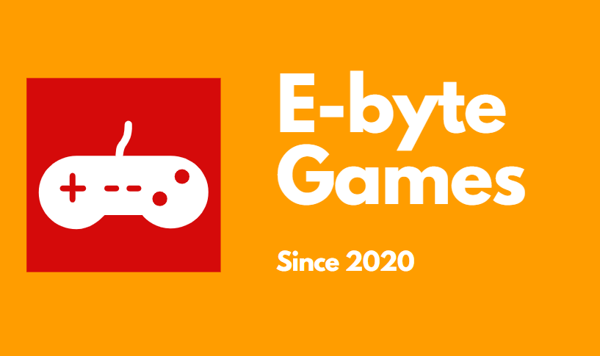

E-byte

Game platform

Table of Contents

1. Authors 2

2. Topic 3

3. Summary 3

Main stages in accomplishment of the project: 3

Planning 3

Realization 3

Presentation 3

Level of difficulty main problems during realization: 3

Game models 3

**QUIZ PLATFORM**

# Authors

Boris Savov

BNSavov@codingburgas.bg

Stefan Stratev

sdstratev18@codingburgas.bg

Yavor Karakolev

Yakarakolev18@codingburgas.bg

Ivan Mihaylov

INMihaylov19@codingburgas.bg

Nikola Peshev

NDPeshev19@codingburgas.bg

# Topic

The topic of our project is a game that is based on exploring and quests. “”””” THE NAME””” is designed to bring you into countless hours of playing either alone or with friends. By writing code on C# we made our implementation of the “The Games Project”.

# Goal

Our main goal was to create a game platform with a couple of games. The platform was to be part of our previous project E-byte. In the finalized project you can create your own profile, verify it and use it to play different games with your friends.

# Summary

## Main stages in accomplishment of the project:

Planning – In this stage, we thought about the idea of our project. Firstly, we wanted to use C++, but we saw what the program “Unity” can do. After a few ideas we came to doing a two-dimensional game.

Realization – We started learning C# and how to integrate into our game. After that we started writing the code and the site.

Presentation – The final step is presenting the almost finished product in front of the judges.

## Level of difficulty main problems during realization:

The most difficult part of completing our project was writing the code for the game. Along the way we had a few misunderstandings about different parts of the code. After that we found our common ground and started to plan design the rest of the game.

# Game models

Here we will present you with out map and most of our game models.