**DSP Lab Session: 05**

**Title: Filter Design using moving average of last 5 samples (Circular**

**convolution, Linear convolution and Convolution performed in frequency domain)**

**Submitter: Abhishek Kumar Sharma  
 PES1UG23EE002**

# Specific Objectives of Tasks

* **Design of a impulse response moving average filter.**
* **Develop function for circular convolution**
* **Validate circular convolution and linear convolution equivalence**
* **To check convolution in time domain is product in frequency convolution.**

# Background Theory

* **A Moving Average Filter is implemented as a convolution in the time domain with the impulse response.**
* **Linear convolution applies to both aperiodic and periodic signals and provides accurate results for finite-duration signals.**
* **Circular convolution is a faster computation method using the FFT algorithm but is inherently periodic.**
* **Linear convolution can be computed using circular convolution by applying the zero-padding method, ensuring accurate results without time-domain aliasing.**
* **In the frequency domain, convolution in the time domain corresponds to multiplication in the frequency domain.**

# Procedure code/Descriptions

**Task1: Develop Circular convolution function**

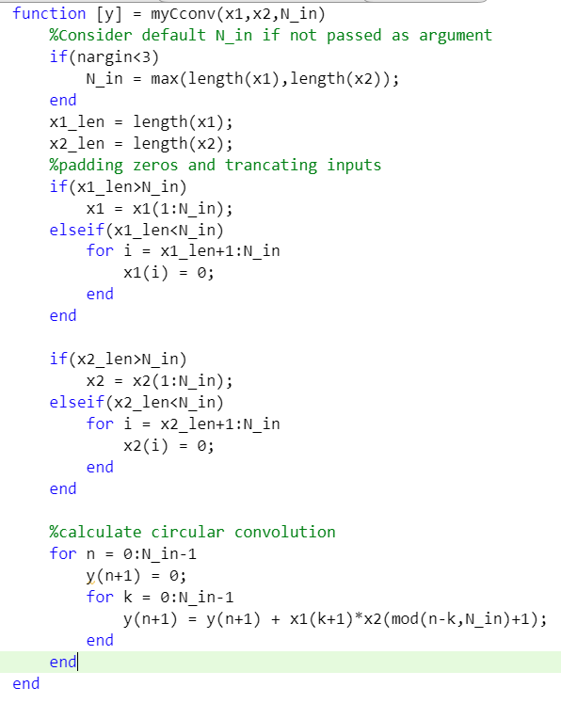

**Testing function with different inputs and arguments**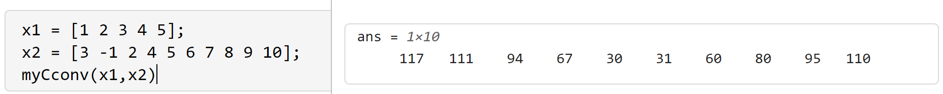

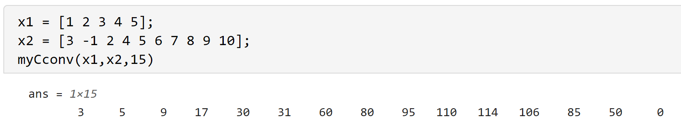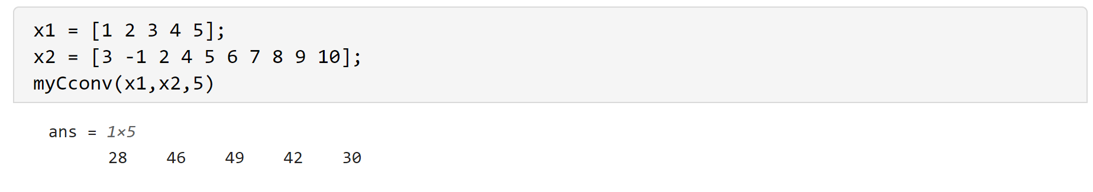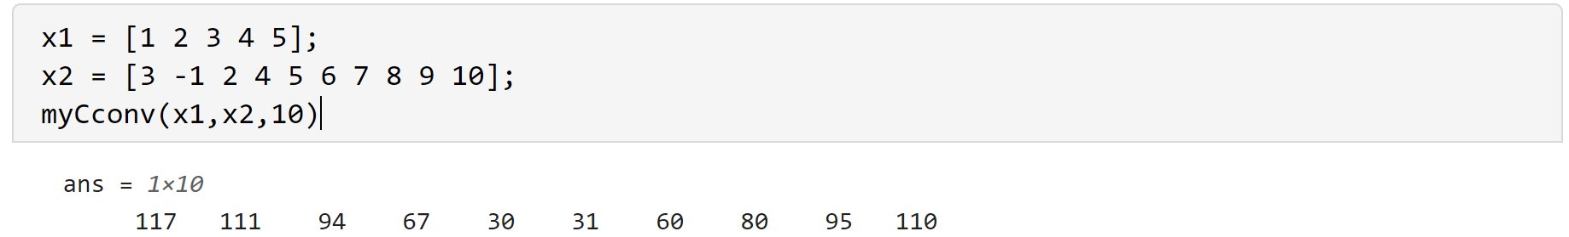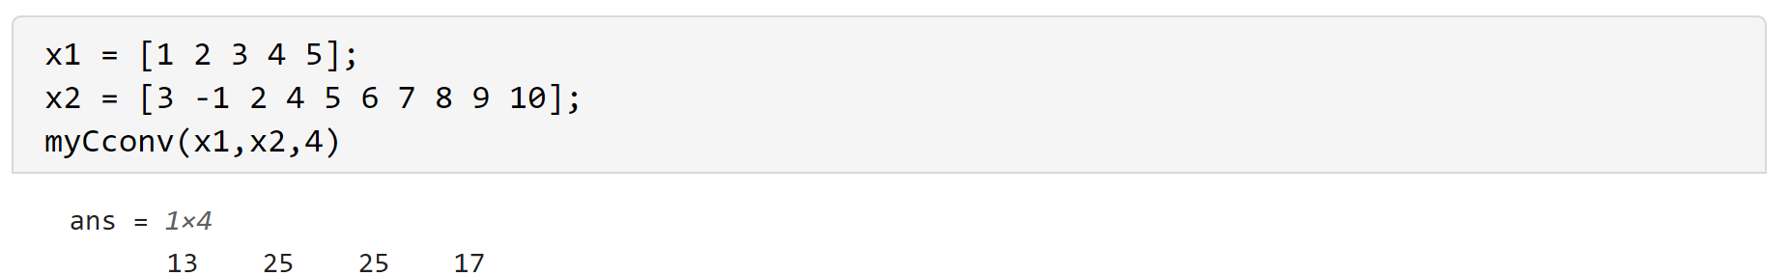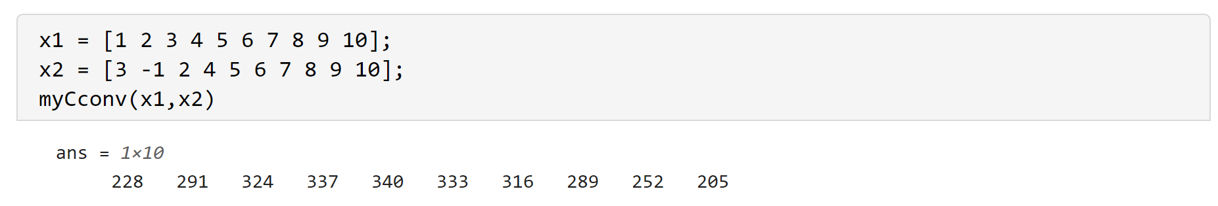

**Task2: Develop linear convolution using circular convolution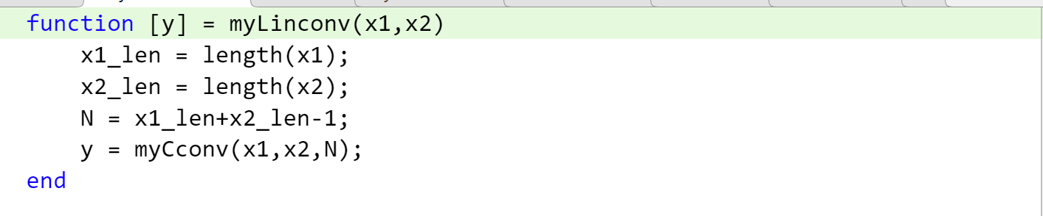 Testing the function with different inputs and args**

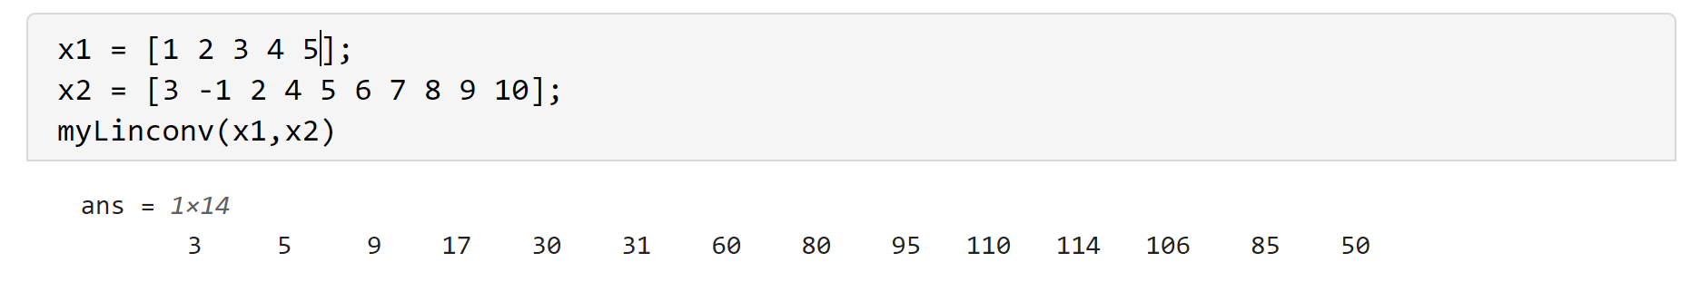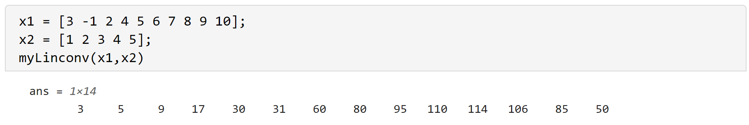 **Task3: Define impulse response for moving average  
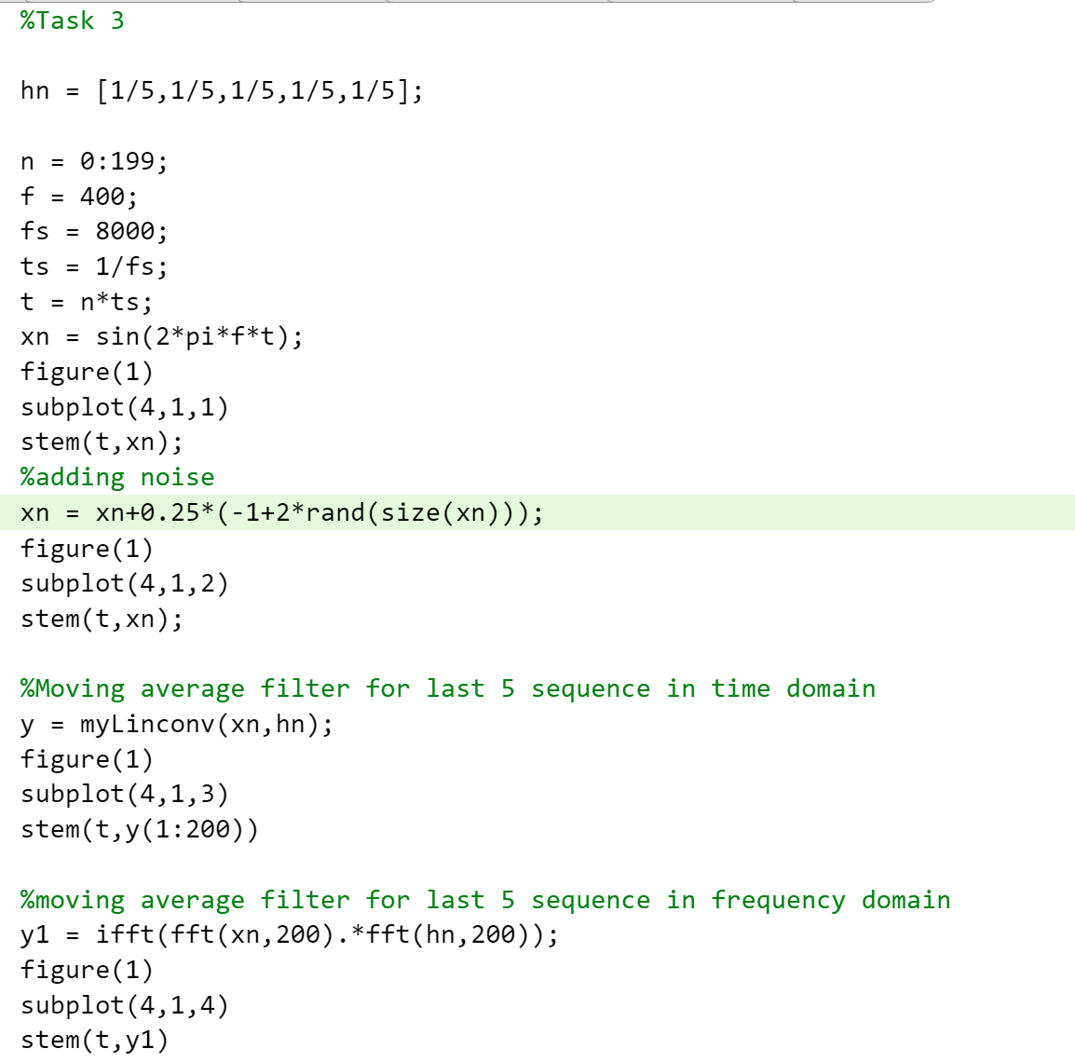**

# Results and Inferences

**Moving average filter**

**The moving average filter smooths the curve. Convolution in time domain is just multiplication in frequency domain.**

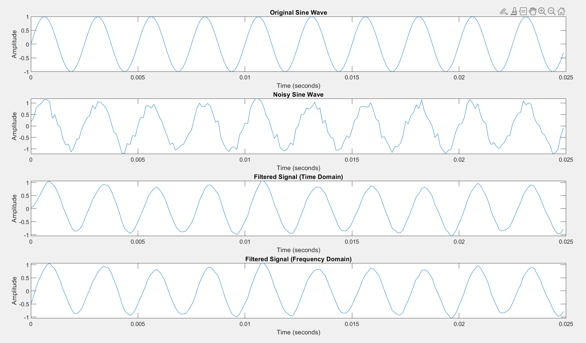

**Frequency Spectrum of the moving average filter:**

**The frequency spectrum of the Impulse response of the moving average filter shows that the filter acts as a low pass filter, attenuating high frequency components.**

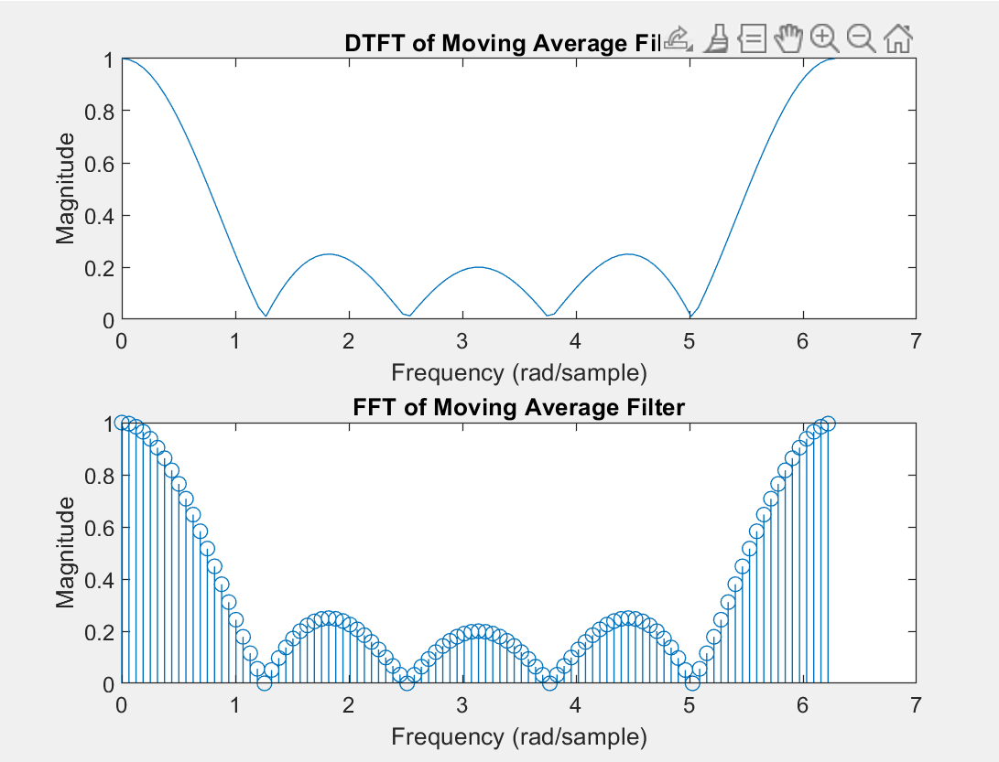

# Learnings and Conclusions

**Design of a low pass filter using a impulse response moving average filter.**

**Finding the impulse response of a filter.**

**Finding the type of filter.**