**DSP Lab Session: 05**

**Title: Auto Correlation and Cross Correlation**

**Submitter: Abhishek Kumar Sharma  
 PES1UG23EE002**

# Specific Objectives of Tasks

* Circular Auto Correlation of signals, its properties and interpretation
* Circular Cross Correlation of signals, its properties and interpretation
* Performing Circular Cross Correlation on generated signals and speech signals as an application
* Understanding difference between circular correlation and linear correlation.

# Background Theory

* Circular Correlation is a method used to find the relationship between two signal where the signal is periodic, cyclic.
* Auto-correlation: This tells us how a signal relates to a time-shifted version of itself. It helps in identifying repeating patterns, such as periodic waveforms.
* Cross-correlation: This measures the similarity between two different signals, which can indicate whether one is a delayed or modified version of the other.

# Procedure code/Descriptions

**Task1: Signal Preparation**

N = 200-1; %Number of Samples

n = 0:N;

fi =400; %Input freq

fs = 8000; %Sampling freq

ts = 1/fs; %Sampling period

t1 = ts*n; %sample time

%Descrete Cosine wave with fire 400hz

x1n = cos(2*pi*fi*t1);

figure(1)

subplot(3,2,1)

stem(t1,x1n);

%adding noise to cosine signal

x2n = x1n+0.25*(-1+2*rand(size(x1n)));

%shifting cosine signal

shiftvalue = 30;

x2s = [zeros(1,shiftvalue),x2n];

%Audio signal

[x1n,fs1] = audioread('audio1.wav'); %Audio signal with 1,2,3,4

[x2n,fs2] = audioread('audio2.wav'); %Audio signal with only 4

**Task2: Circular Auto-Correlation**

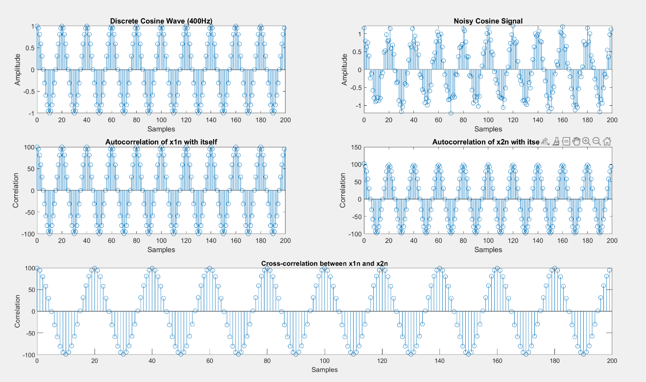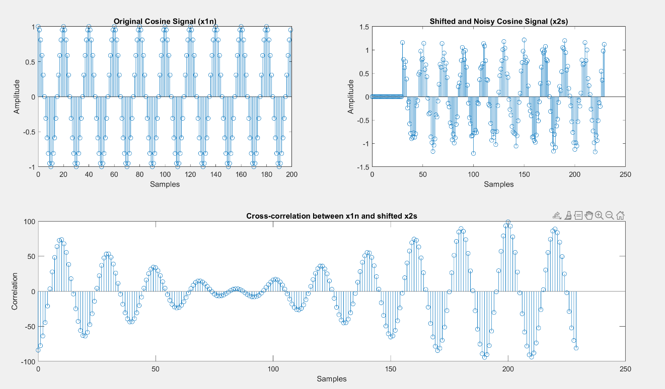 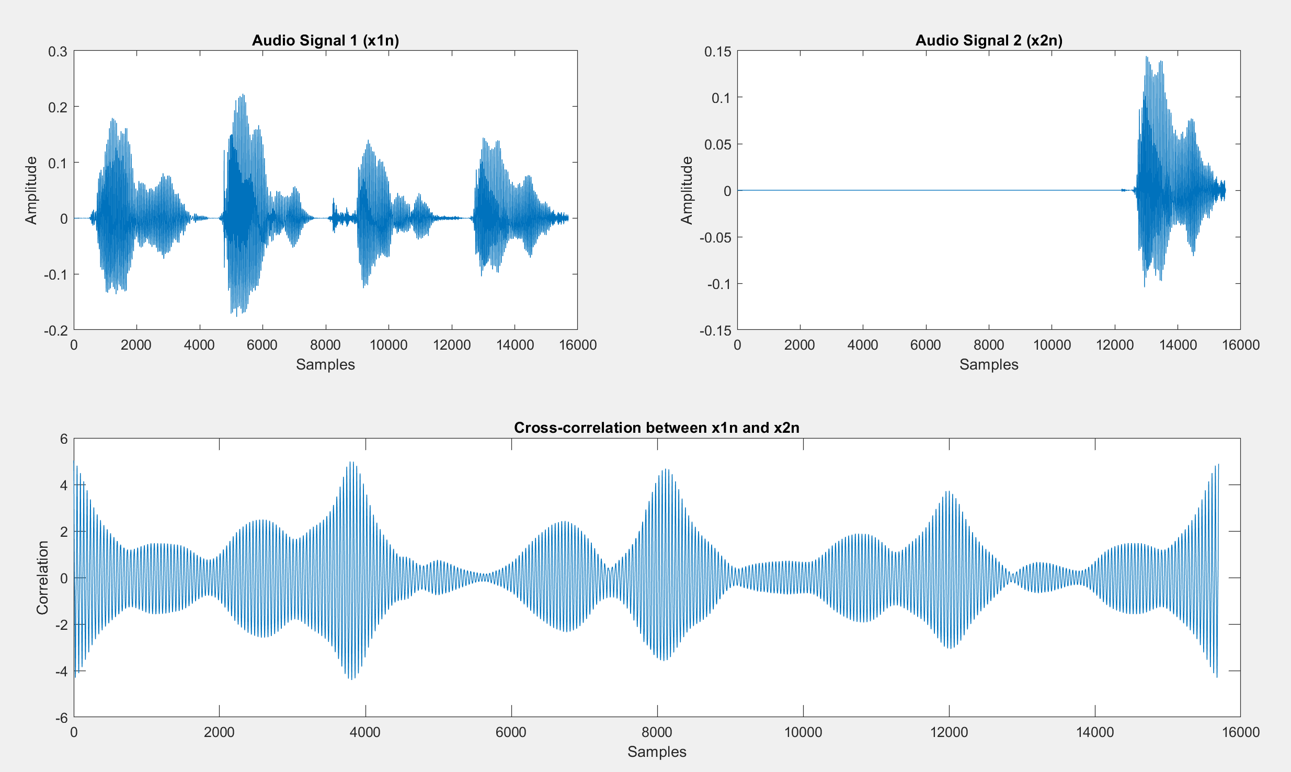

**The peaks in the correlation relates the similarity. The signal is best matched with the shifted signal at the highest peaks which indicates time shift when both the signal is matched**

**Circular correlation is applied on two signal which are periodic cyclic to find the similarity between taking into account of their cyclic nature whereas linear correlation is applied on two signal which is non periodic( infinite signal) to find a linear similarity between them.**

# Learnings and Conclusions

* **Application of correlation like finding the distance, the time shift of a signal by performing circular correlation and observing the peaks**
* **Implementation of Circular correlation in MATLAB.**
* **Difference between Circular correlation and Linear correlation**