Lyapunov exponent of different system:

Through our function:

Chen:  
[t,LE]=FO_Lyapunov(3, @LE_Chen, 0, 0.02, 3000, [0.1;0.1;0.1], 0.005, 0.999, 1000);

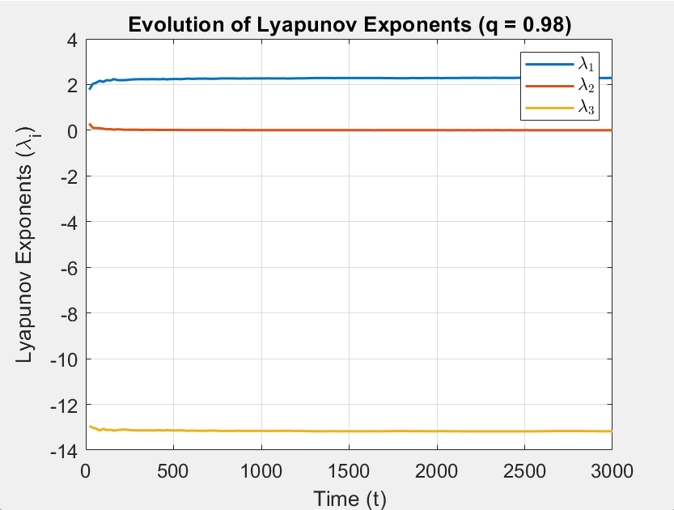  
  
  
  
  
  
  
  
  
  
  
  
  
Bhalekar-Gejji Sytem:

q = 0.98;ne = 3;

[t_hist,LE_hist]=FO_Lyapunov(ne, @LE_Bhalekar_Gejji, 0, 0.02, 3000, [0.1;0.1;0.1], 0.005, q , 1000);

