ATTORNEY DIRECTORY AND CASE FILE ARCHIVE SYSTEM (PACFAS)
APPENDICES A–D
Supporting documents for the Software Engineering project (Elect 5 — Gingoog City Colleges, Inc.)
Appendix A: User's Manual
Appendix B: Curriculum Vitae — Harvard-Style Template
Appendix C: Changelog
Appendix D: Release Notes

APPENDIX A
USER'S MANUAL
A.1 Introduction
The Attorney Directory and Case File Archive System (PACFAS) is a web-based legal case archiving and public directory application designed to help public attorney offices and legal staff digitalize, organize, and retrieve legal records while providing the public with a verified directory of legal counsel.
To make the system easy to use while protecting sensitive legal records, PACFAS is divided into two main parts:
• 1. Public Portal (No Login Required): Accessible to clients, legal researchers, and visitors without logging in. Visitors can search the Attorney Directory by name or specialization, view attorney profiles and credentials, and browse non-confidential public case summaries.
• 2. Internal Workspace (Login Required): Accessible only to authenticated personnel (Attorneys, Office Staff, and System Administrators). Authorized users can manage case files, upload digital or scanned documents with automatic Optical Character Recognition (OCR) text extraction, search inside archived documents, manage client profiles, assign legal counsel, and schedule court hearings with automatic 1-hour conflict validation.
User Roles and Permissions
PACFAS enforces role-based access control so each user sees only the tools and records appropriate for their role:
Role | Access Level | What You Can Do in the System
Public Visitor | No Login | Browse and search the Attorney Directory, view attorney profiles, and view non-confidential public case summaries.
Registered User (Role 5) | Read-Only Account | Sign in to view attorney profiles, public case records, and authorized read-only case information.
Client (Role 4) | Client Profile | Linked to specific case files with a designated party role (Plaintiff, Defendant, or Petitioner).
Attorney (Role 2) | Workspace User | View and manage assigned cases, upload case documents for OCR archiving, download case files, and schedule court hearings.
Staff (Role 3) | Office Staff | Create new case files, register client profiles, link clients to cases, assign primary/co-counsel attorneys, upload documents, and schedule hearings.
Administrator (Role 1) | Full System Admin | Perform all Staff and Attorney actions, create/update/deactivate attorney accounts, override hearing scheduling conflicts, and review system audit logs.

A.2 System Requirements and Setup Guide
End-User Requirements (To Use the Web Application)
• Desktop computer, laptop, or tablet capable of running a modern web browser.
• Updated web browser such as Google Chrome, Mozilla Firefox, Microsoft Edge, or Apple Safari.
• Local network (LAN) or internet connection to the PACFAS server.
• Valid user account (email address and password) for accessing the internal Attorney Workspace.
Server and Deployment Prerequisites (For System Administrators)
Component | Required Version | Purpose / Notes
Node.js | v18.0+ (tested on v22) | JavaScript runtime environment for the Express.js backend server.
npm | v9.0+ | Package manager (bundled with Node.js) for installing dependencies.
MySQL or MariaDB | MySQL 8.0+ / MariaDB 10.4+ | Relational database server hosting the 18 normalized tables in pacfas_db.
OCR & PDF Engine | Bundled via npm | Uses tesseract.js (WebAssembly), pdf-parse, and pdf-to-png-converter; no separate OS install needed.

First-Time Server Installation Steps
1. Download the Project: Open a terminal, clone the project repository, and navigate into the project folder: git clone https://github.com/Yakeo/Public-Attorney-and-Case-File-Archive.git && cd Public-Attorney-and-Case-File-Archive
2. Install Dependencies: Run npm install to install Express, mysql2, jsonwebtoken, bcrypt, multer, tesseract.js, pdf-parse, and pdf-to-png-converter.
3. Initialize the Database: Start your MySQL/MariaDB server, create the database named pacfas_db, and import database.sql (mysql -u root -p pacfas_db < database.sql). This creates all 18 tables and seeds default roles, case categories, statuses, priorities, and 3 initial attorney accounts.
4. Configure Environment Variables: Open the .env file in the project root and verify PORT=3000, DB_HOST=localhost, DB_USER, DB_PASSWORD, DB_NAME=pacfas_db, DB_PORT=3306, JWT_SECRET, and JWT_EXPIRES_IN=24h.
5. (Optional) Load Sample Data: Run npm run seed if you wish to populate 10 sample attorneys, 10 cases, sample documents, hearings, and 5 clients for testing.
6. Start the Application: Run npm start (or npm run dev for development mode) and open http://localhost:3000 in your web browser.
A.3 Using the Public Portal (No Login Required)
Any visitor can search for legal counsel and inspect non-confidential case records directly from the public pages.
A.3.1 Searching the Public Attorney Directory
1. Open the PACFAS home page (index.html) in your web browser.
2. In the center search bar labeled "Search attorney name, practice area...", type an attorney's first or last name or a legal topic.
3. Use the specialty dropdown next to the search box (e.g., All Specialties, Corporate, Criminal, Civil) to narrow down the list.
4. Click the Search Directory button (or press Enter).
5. Browse the Attorney Directory cards below. Each card displays the attorney's initials avatar, full name, specialization badge, and brief biography.
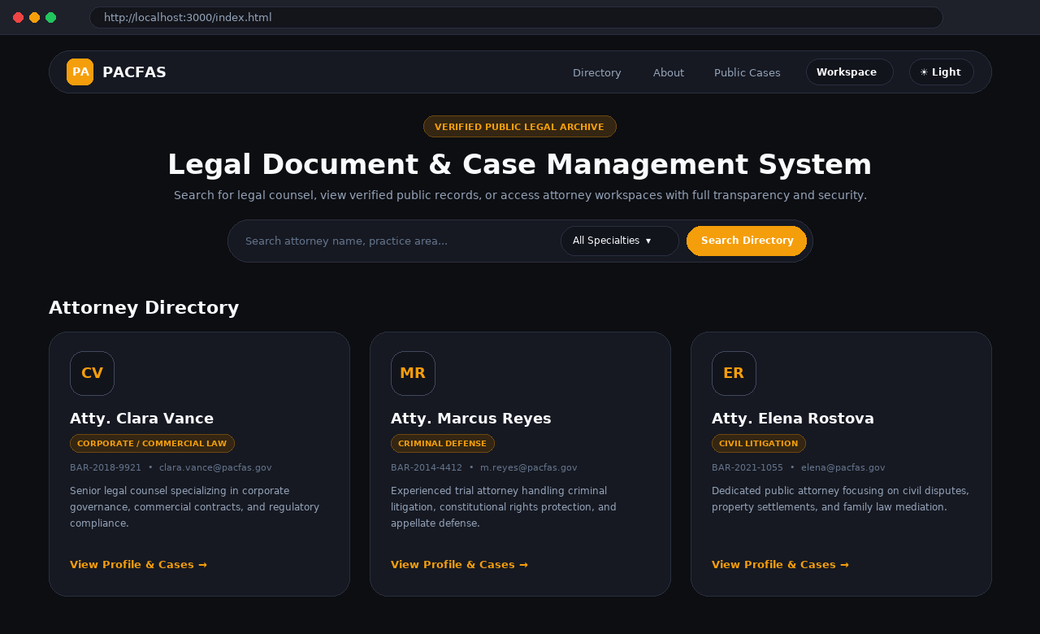
Figure A.1. Public Landing Page and Attorney Directory Search Interface (index.html).
A.3.2 Viewing an Attorney's Profile and Public Case History
1. On any card in the Attorney Directory, click View Profile & Cases →.
2. The Attorney Profile page (attorney-profile.html) opens and displays two main panels:
• Professional Overview (Left Column): Displays the attorney's full name, specialization, Bar Number, email address, and professional details.
• Public Records & Verified Cases (Right Column): Lists non-confidential, publicly visible cases handled by that attorney so prospective clients can verify their track record.
3. Click ← Back to Directory in the top navigation bar at any time to return to the directory.
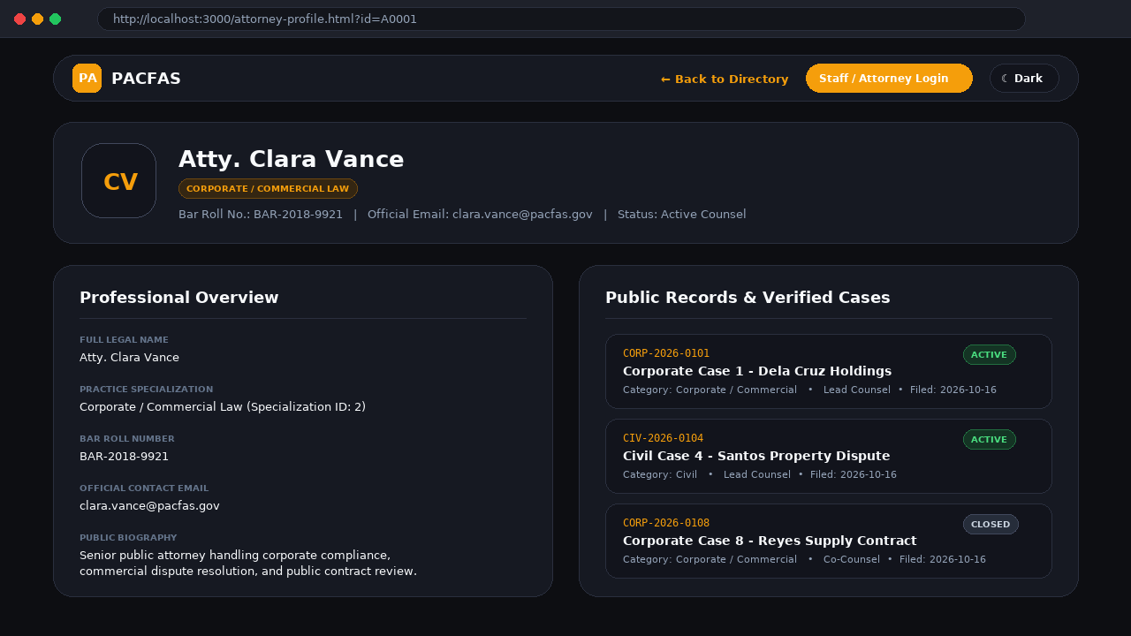
Figure A.2. Attorney Profile and Public Case History Page (attorney-profile.html).
A.3.3 Looking Up Public Case Summaries
1. From the top navigation bar on the landing page, click Public Cases.
2. The Public Case Lookup page (public-cases.html) lists all non-confidential case summaries (records marked as publicly visible), showing the case number, title, category, and current status.
3. Click ← Home in the top bar to return to the main landing page.
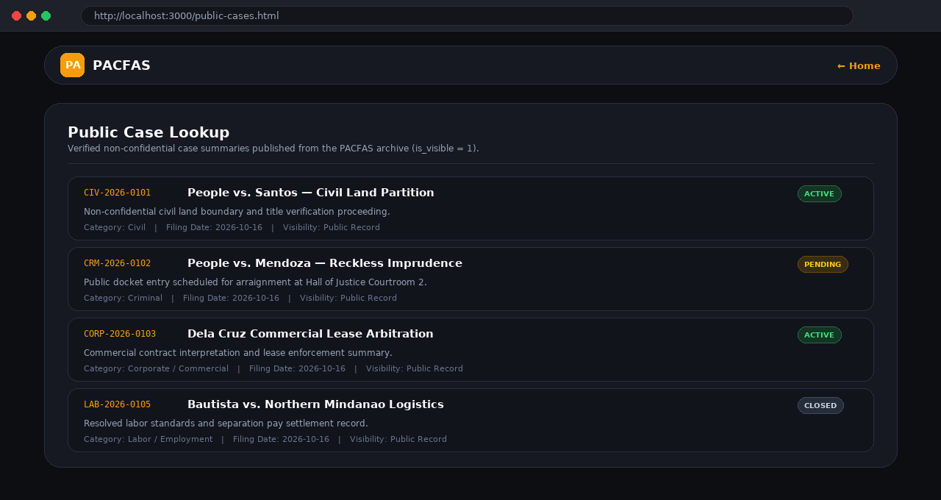
Figure A.3. Public Case Lookup Interface for Non-Confidential Records (public-cases.html).
A.4 Logging In to the Staff and Attorney Workspace
1. From the landing page or an attorney profile page, click Staff / Attorney Login (or click Workspace in the top navigation bar).
2. In the Staff Portal Sign In window, enter your registered Email Address (for example, one of the default seeded accounts: clara.vance@pacfas.gov, m.reyes@pacfas.gov, or elena@pacfas.gov).
3. Enter your account Password (default seeded password: password123).
4. Click the Sign In button.
5. Wait for the system to verify your credentials and open the Attorney Workspace Dashboard (dashboard.html).
6. If access is denied, a red error banner will explain the issue (such as an invalid email or password). Double-check your typing or contact the system administrator.
Tip — Switching Between Light and Dark Mode: On any page of the system, click the theme button in the top-right navigation bar (☀ Light / ☾ Dark) to switch between light and dark display modes.
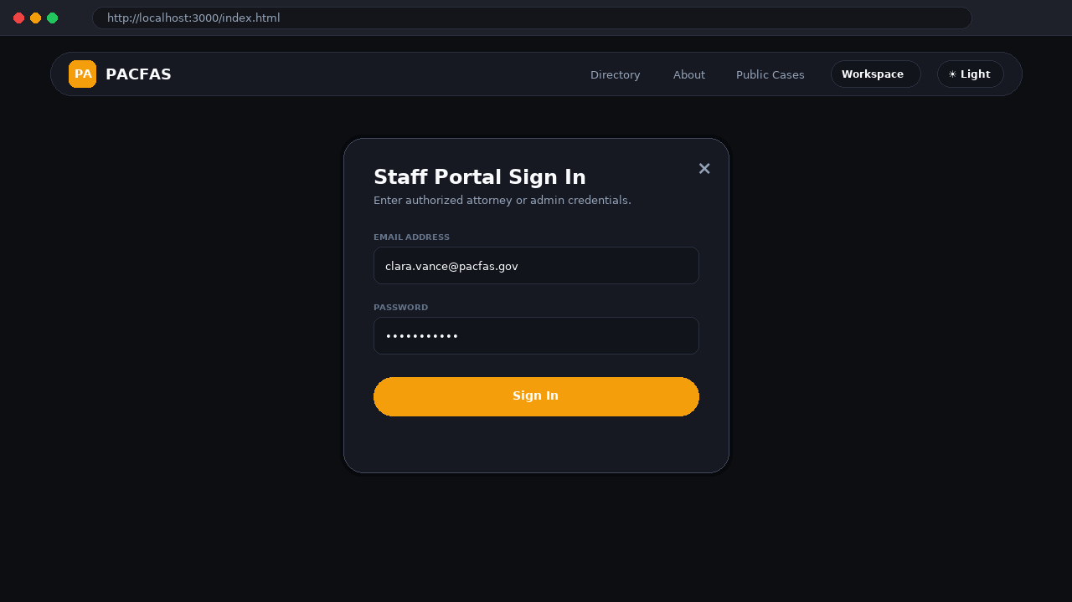
Figure A.4. Staff Portal Sign In Authentication Modal.
A.5 Navigating the Dashboard and Searching Case Files
After signing in, you land on the Attorney Workspace Dashboard (dashboard.html), which gives you an immediate overview of office activity and fast search tools.
1. Review Quick Statistics: At the top of the page, review the three summary counters: Active Cases, Pending Hearings, and Total Documents.
2. Search by Keyword or Case Number: Type any word from a case title or a case number into the "Search case title or number..." text box.
3. Filter Cases by Status, Category, or Priority: Use any combination of the three dropdown filters in the action toolbar to narrow down the table automatically:
• Status Filter: All Statuses, Active, Pending, Closed, or Archived.
• Category Filter: All Categories, Civil, Criminal, Corporate, and other legal practice categories.
• Priority Filter: All Priorities, Low, Medium, High, or Urgent.
4. Open a Case File: In the Managed Case Files table, review the Case Number, Title, Client, Status badge, and Filing Date, then click Open File → on any row to view or manage that case.
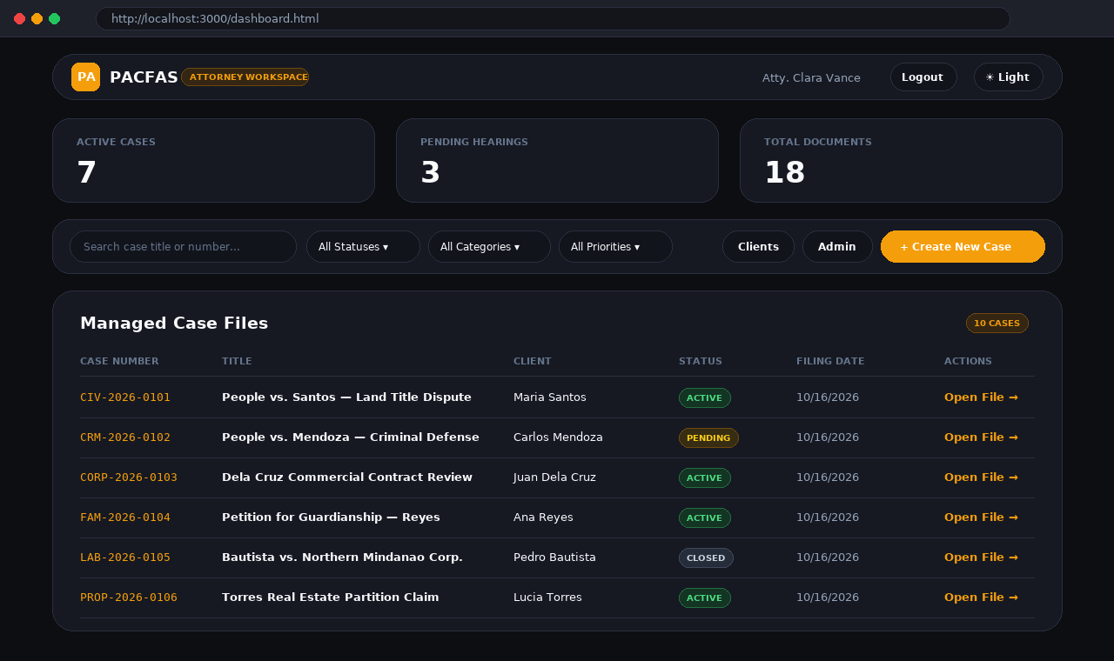
Figure A.5. Attorney Workspace Dashboard, Quick Statistics, and Managed Case Files Table (dashboard.html).
A.6 Creating a New Case File (Staff and Administrators)
Users with Staff or Administrator permissions can register new legal case files from the Dashboard.
1. On the Dashboard toolbar, click the + Create New Case button on the right side.
2. The Create New Legal Case slide-over drawer opens on the right side of the screen.
3. Select the Case Category / Type from the 11 built-in legal categories:
Category ID | Category Name | Prefix Code | Auto-Generated Case Number Format
1 | Civil | CIV | CIV-2026-XXXX
2 | Criminal | CRM | CRM-2026-XXXX
3 | Corporate / Commercial | CORP | CORP-2026-XXXX
4 | Family | FAM | FAM-2026-XXXX
5 | Labor / Employment | LAB | LAB-2026-XXXX
6 | Property / Real Estate | PROP | PROP-2026-XXXX
7 | Tax | TAX | TAX-2026-XXXX
8 | Intellectual Property | IP | IP-2026-XXXX
9 | Immigration | IMM | IMM-2026-XXXX
10 | Administrative | ADM | ADM-2026-XXXX
11 | Environmental | ENV | ENV-2026-XXXX

4. Check the Generated Case Number box, which automatically previews the case number format (TYPE-YEAR-XXXX) based on your chosen category.
5. Enter the Case Title (for example, People vs. Santos) and the Client Full Name.
6. Select the Initial Status (Active, Pending, or Closed) and type a brief summary in Case Description / Notes.
7. Click Save Case Record (or click Cancel to close the drawer without saving). The new case file is immediately added to the Managed Case Files table.
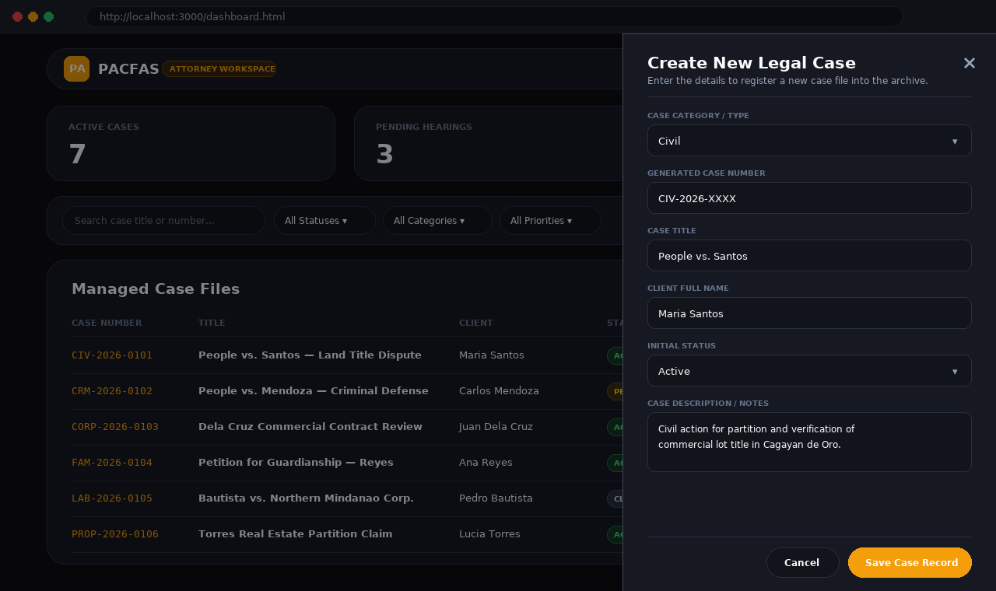
Figure A.6. Create New Legal Case Slide-Over Drawer with Auto-Generated Case Number Preview.
A.7 Uploading Case Documents and Viewing Extracted OCR Text
PACFAS includes an automated Optical Character Recognition (OCR) engine that extracts text from both digital PDFs and scanned paper documents/images so they can be read and searched online.
Uploading a Document to a Case
1. From the Dashboard, click Open File → on the desired case to open the Case File Details page (case-details.html).
2. In the right-hand Document Archive card, click the + Upload Document button.
3. In the Upload Case Document pop-up window, type a clear Document Title / Tag (for example, Sworn Affidavit of Witness or Motion for Reconsideration).
4. Click Select File and choose a file from your computer. Supported file formats are PDF (.pdf), PNG (.png), JPEG (.jpg / .jpeg), and TIFF (.tiff), up to 25 MB per file.
5. Click Upload & Extract Text. The system stores the document, creates a version entry, and automatically runs OCR in the background:
• Digital (Text-Based) PDFs: Text is extracted immediately using pdf-parse.
• Scanned (Image-Only) PDFs: Each page is automatically converted to an image and read using Tesseract.js OCR.
• Image Files (PNG, JPG, TIFF): Text is recognized directly from the image using Tesseract.js OCR.
Reading Extracted OCR Text and Downloading Original Files
1. Under the Document Archive section of the Case File Details page, find the document card.
2. Click View Extracted OCR Text to expand the text box and read the full text recognized from the document.
3. Click Download ↗ on the right side of the document card to securely download or open the original uploaded file.
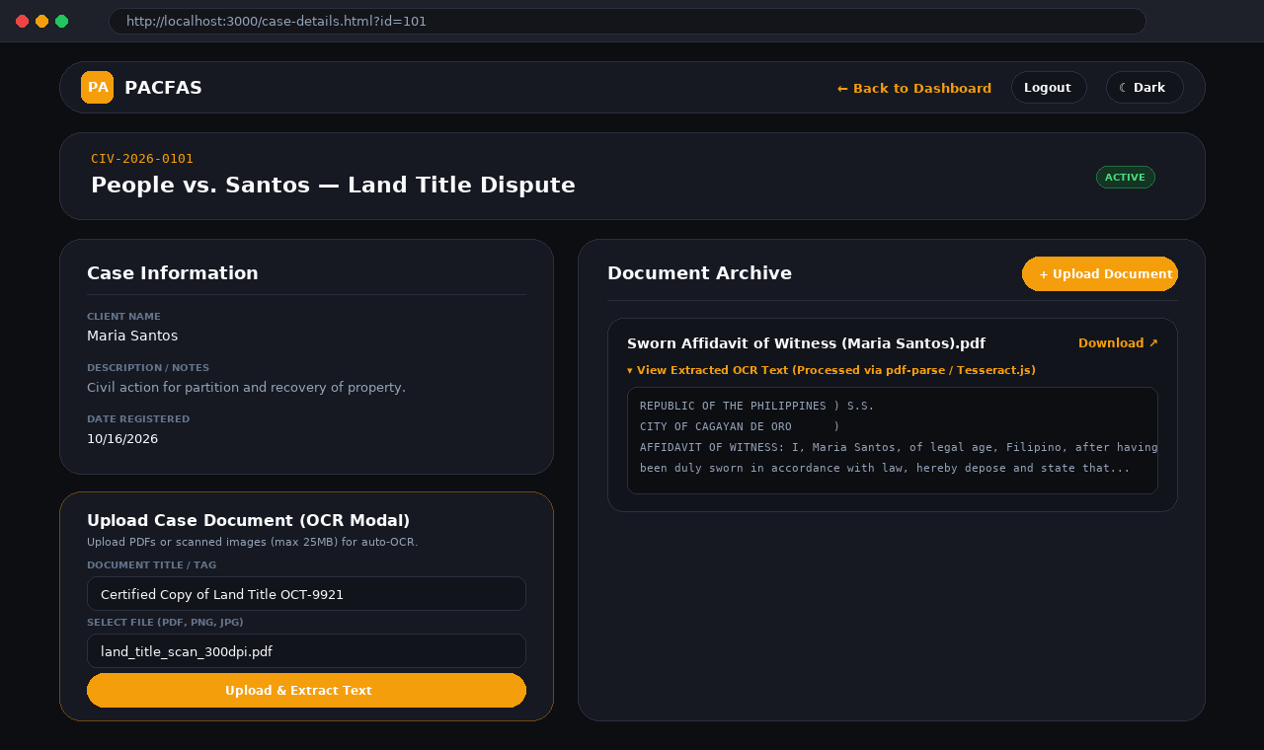
Figure A.7. Case File Details, Document Archive with Extracted OCR Text, and Upload Document Modal (case-details.html).
A.8 Managing Client Profiles and Linking Clients to Cases
Creating a New Client Profile (Staff and Administrators)
1. On the Dashboard action toolbar, click the Clients button to open the Client Management page (clients.html).
2. Existing clients are displayed in the Client Profiles list at the top of the page.
3. In the Create New Client form, fill in the client's details: First Name (required), Last Name (required), Birth Date (required), Email, Contact Number, City, and Region.
4. Click Create Client. The system saves the client profile and automatically creates a linked Client user account.
Linking a Client to a Case File
1. Open the relevant case in the Case File Details page (case-details.html).
2. In the left column under the Linked Clients card, choose the client's name from the Link Client dropdown menu.
3. In the Client Role box, enter the client's role in the legal proceeding (for example, Plaintiff, Defendant, or Petitioner).
4. Click Link Client. The client's name, role badge, and contact details appear immediately in the Linked Clients list.
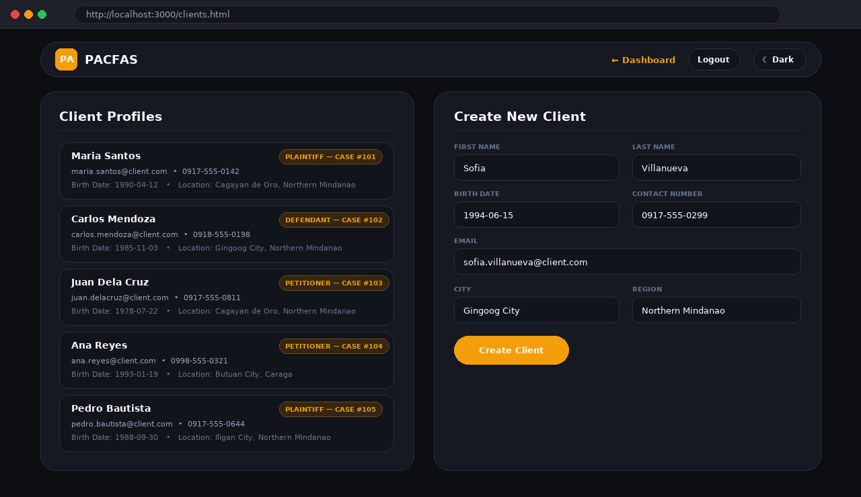
Figure A.8. Client Profiles List and Create New Client Registration Form (clients.html).
A.9 Assigning Legal Counsel to a Case
1. Open the target case on the Case File Details page (case-details.html).
2. Locate the Assigned Counsel card in the left column.
3. Select an active attorney from the Assign Attorney dropdown menu (inactive or deactivated attorneys are automatically prevented from being assigned).
4. In the Role on Case field, type the attorney's responsibility (such as Lead Counsel or Co-Counsel).
5. Click Assign Counsel. The system records the assignment date and displays the attorney's name, role badge, specialization, and Bar Number while preserving any historical assignment records.
A.10 Scheduling Court Hearings and Conflict Prevention
Attorneys, Staff, and Administrators can schedule court hearings for a case. PACFAS automatically checks for scheduling conflicts to prevent double-booking an attorney.
1. Open the case in the Case File Details page (case-details.html) and scroll to the Scheduled Hearings card in the left column.
2. Click + Add Hearing and provide the hearing schedule details: Hearing Date and Time, Venue (e.g., Hall of Justice), Courtroom, Hearing Type (e.g., Arraignment, Pre-Trial, Trial), Assigned Judge, and Remarks/Notes.
3. Automatic 1-Hour Conflict Validation: When submitting the hearing, the system automatically checks whether any attorney assigned to the case already has another hearing scheduled within 1 hour before or after the requested time.
4. If a conflict is found, the system blocks the schedule and displays a conflict warning so you can select a different time. (If an overlapping schedule is intentional, an Administrator can authorize it using the conflict override option.)
5. Once saved, the hearing appears under Scheduled Hearings showing the scheduled date/time, courtroom/venue location, and notes.
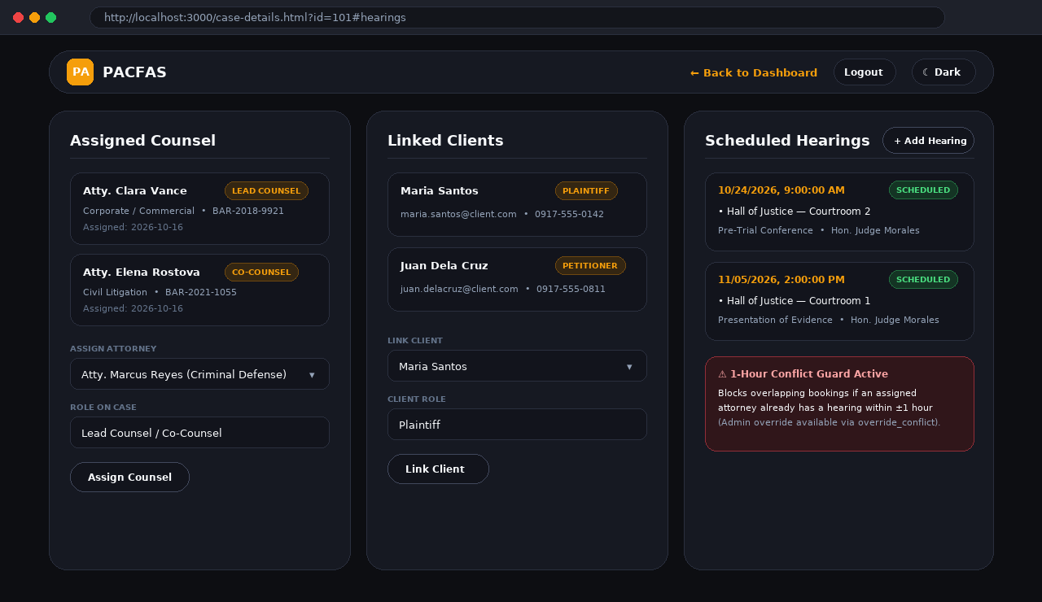
Figure A.9. Assigned Counsel, Linked Clients, and Scheduled Hearings with 1-Hour Conflict Guard.
A.11 Managing Attorney Accounts (Administrator Module)
Users logged in with an Administrator account (Role 1) have access to the Admin page (admin.html) to register and manage attorneys.
1. On the Dashboard toolbar, click the Admin button (this button is automatically hidden for non-admin users).
2. In the Create Attorney (Admin) form, enter the new attorney's information:
• First Name & Last Name (Required): Enter the attorney's legal first and last name.
• Email (Required): Enter the attorney's official login email address.
• Username & Password (Optional): Provide a custom username and initial password (if left blank, the password defaults to password123).
• Specialization ID: Enter a number from 1 to 12 corresponding to the attorney's practice area: (1) General Practice, (2) Corporate / Commercial Law, (3) Criminal Defense, (4) Civil Litigation, (5) Family Law, (6) Labor & Employment Law, (7) Tax Law, (8) Intellectual Property, (9) Immigration Law, (10) Real Estate & Property, (11) Environmental Law, or (12) Administrative Law.
• Bar Number: Enter the attorney's official bar roll number (e.g., BAR-2021-1055).
3. Click Create Attorney. The system creates both the login account and the public directory profile, and refreshes the Attorney Directory list at the bottom of the page.
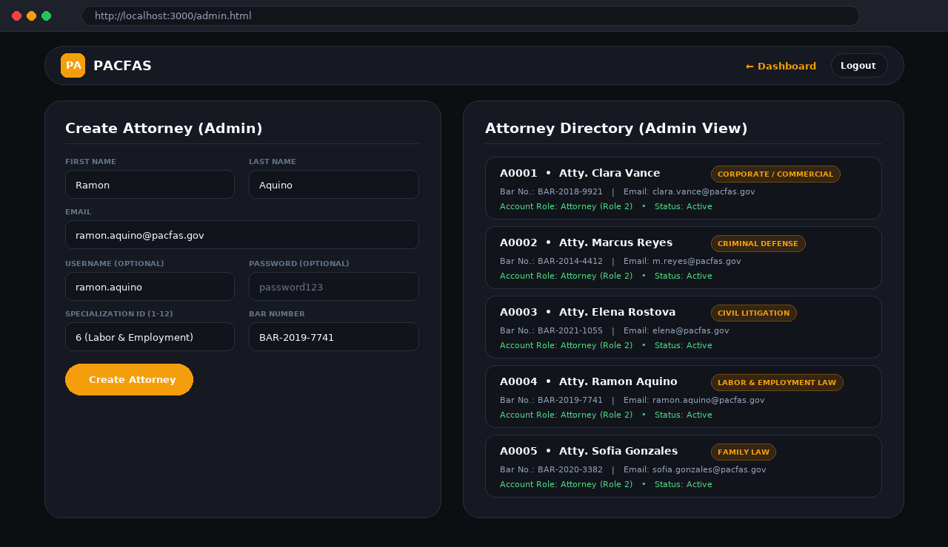
Figure A.10. Administrator Attorney Management and Directory Overview (admin.html).
A.12 Logging Out and Troubleshooting Common Issues
Logging Out Safely
• When you finish your work, click the Logout button in the top-right corner of the navigation bar. This clears your active login token and returns you to the public home page so unauthorized users cannot access internal case files.
Quick Troubleshooting Reference
• "401 Unauthorized" Message: Your session has expired or you are not logged in. Click Staff / Attorney Login and sign in again.
• "403 Forbidden" Message: Your current account role does not have permission for that action (for example, only Staff and Admins can create cases or clients, and only Admins can create attorney accounts).
• Document Upload Fails: Make sure the file is a PDF, PNG, JPG, or TIFF and is 25 MB or smaller.
• OCR Text Is Empty or Incomplete: Scanned PDFs are automatically converted to images and read by Tesseract OCR. If text is missing or garbled, re-scan the physical document at a clearer resolution (300 DPI recommended).
• "Database connection error: ECONNREFUSED": The MySQL/MariaDB service is stopped or the database credentials in .env do not match. Start MySQL and confirm DB_NAME=pacfas_db.

APPENDIX B
CURRICULUM VITAE

EDUCATION

Relevant coursework:
Academic distinctions:

PROJECT EXPERIENCE
Attorney Directory and Case File Archive System (PACFAS) | 2026
Student Developer / Researcher — Gingoog City Colleges, Inc.
• Designed and developed a web-based legal case archiving and public attorney directory system using Node.js, Express.js, MySQL (18 normalized tables), and HTML5/CSS3/JavaScript.
• Implemented a hybrid Optical Character Recognition (OCR) document archiving pipeline using pdf-parse, pdf-to-png-converter, and Tesseract.js to extract searchable text from digital PDFs, scanned PDFs, and image files.
• Built role-based access control (JWT and bcrypt), automated case number generation (TYPE-YEAR-XXXX), client-case linking, counsel assignment tracking, and court hearing scheduling with 1-hour conflict validation.
• Contributed to requirements analysis, relational database modeling, functional system testing, and user documentation.
WORK EXPERIENCE

•
•
LEADERSHIP AND ACTIVITIES

•
TECHNICAL SKILLS
Programming:
Database:
Tools:
Other:
TRAINING AND CERTIFICATIONS

AWARDS AND ACHIEVEMENTS

APPENDIX C
CHANGELOG
The changelog records all notable development changes made to the Attorney Directory and Case File Archive System (PACFAS) across versions, from its initial prototype stage to the current production-ready release (v2.6.0).
C.1 Version History Summary
Version | Date | Changes | Status
0.1.0 | Initial Prototype | Initial backend controllers for authentication, cases, documents (OCR), and hearings. | Completed
0.2.0 | Prototype | Express router layer (/api/v1/*) and route-level JWT authentication middleware. | Completed
0.3.0 | Prototype | Centralized error handling (errorHandler, customError, catchAsync) and role authorization. | Completed
0.4.0 | Prototype | Multer disk storage (25 MB limit, MIME validation) and Tesseract.js worker integration. | Completed
0.5.0 | Prototype | MySQL connection pool (config/db.js), Express server assembly (server.js), and .env setup. | Completed
0.6.0 | Prototype | Client-side HTML/CSS/JS frontend interfaces for landing, dashboard, case details, and profile. | Completed
1.0.0 | Initial Release | Integrated full-stack system with canonical 18-table 3NF MySQL schema (database.sql). | Released
1.1.0 | 2026-10-16 | PDF-aware OCR (pdf-parse), Attorney Directory API, public case summaries, and DB seed data. | Released
1.2.0 | 2026-10-16 | Slice A backend: Client profile CRUD, Client-Case linking, and Case-Attorney assignments. | Released
1.3.0 | 2026-10-16 | Slice B backend: 1-hour hearing conflict prevention (with admin override) and audit logging. | Released
1.4.0 | 2026-10-16 | Slice A frontend: Client profiles management page and case counsel/client linking panels. | Released
1.5.0 | 2026-10-16 | Admin attorney CRUD endpoints (create, update, and soft-deactivate attorney records). | Released
1.6.0 | 2026-10-16 | Server-side case search filters and authenticated secure document download endpoint. | Released
1.7.0 | 2026-10-16 | Hybrid OCR support for scanned (image-only) PDFs via PDF rasterization and Tesseract fallback. | Released
1.8.0 | 2026-10-16 | Admin Attorney Management UI (admin.html and admin.js). | Released
1.9.0 | 2026-10-16 | Authenticated document download links integrated into the Case File Details UI. | Released
2.0.0 | 2026-10-16 | Advanced server-side case search and filtering wired to the Workspace Dashboard UI. | Released
2.0.1 | 2026-10-16 | Navigation bar gating to hide the Admin link for non-administrator users. | Released
2.1.0 | 2026-10-16 | Public Case Lookup page (public-cases.html) and role-based UI gating across modules. | Released
2.2.0 | 2026-10-16 | Comprehensive User Manual (USER_MANUAL.md) and global toast notifications (toast.js). | Released
2.3.0 | 2026-10-16 | Role separation between read-only registered users (Role 5) and CRUD staff/attorneys/admins. | Released
2.4.0 | 2026-10-16 | Automated sample data seeder script (scripts/seed.js via npm run seed). | Released
2.5.0 | 2026-10-16 | Automated case number generation in TYPE-YEAR-XXXX format with live form preview. | Released
2.6.0 | 2026-10-16 | Expanded legal case categories (11 types) and attorney specializations (12 practice areas). | Released (Current)

C.2 Detailed Changelog Entries
Version 2.6.0 — Expanded Case Types & Attorney Specializations (2026-10-16)
Added: Expanded legal case categories to 11 types (Civil, Criminal, Corporate / Commercial, Family, Labor / Employment, Property / Real Estate, Tax, Intellectual Property, Immigration, Administrative, and Environmental) and expanded attorney specializations to 12 real-world practice areas.
Changed: Updated database seed records, scripts/seed.js, and frontend category/specialization dropdowns.
Version 2.5.0 — Automated Case Number Generation (2026-10-16)
Added: Auto-generated case numbers formatted as TYPE-YEAR-XXXX (e.g., CIV-2026-0101, CRM-2026-0102) derived from the selected category, filing year, and case code, along with a live preview in the Create Case drawer.
Version 2.4.0 — Sample Data Seeder (2026-10-16)
Added: Created scripts/seed.js (npm run seed) to populate 10 sample attorneys, 10 cases, case-attorney assignments, sample documents with extracted text, court hearings, and 5 linked client profiles.
Version 2.3.0 — Role Separation & Access Control (2026-10-16)
Added: Introduced Role 5 (User) for registered public users with read-only permissions and enforced strict role-based authorization on case creation, document upload, client management, and counsel assignment routes.
Changed: Defaulted public self-registration to the read-only User role and removed mock token injection from the frontend.
Version 2.2.0 — User Manual & Toast Notifications (2026-10-16)
Added: Added USER_MANUAL.md covering prerequisites, setup, user roles, feature guides, API overview, and troubleshooting, plus non-intrusive toast notifications via frontend/js/toast.js.
Version 2.1.0 & 2.0.1 — Public Case Lookup & Role-Based UI Gating (2026-10-16)
Added: Created public-cases.html and public-cases.js for browsing non-confidential case summaries without logging in.
Changed: Hid Admin navigation links, Create Case controls, Clients links, and counsel/client assignment forms from unauthorized roles.
Version 2.0.0 & 1.9.0 — Advanced Search UI & Secure Download UI (2026-10-16)
Added: Connected Dashboard keyword search and status/category/priority dropdown filters to server-side query parameters, and added authenticated document download links in case-details.html.
Version 1.8.0 & 1.7.0 — Admin Attorney UI & Scanned PDF OCR (2026-10-16)
Added: Built admin.html and admin.js for administrator attorney creation and directory listing.
Added: Implemented hybrid PDF OCR in controllers/documentController.js: digital PDFs extract text via pdf-parse, while scanned (image-only) PDFs automatically rasterize pages via pdf-to-png-converter and run Tesseract.js OCR.
Version 1.6.0 & 1.5.0 — Server Filters, Secure Downloads & Admin CRUD (2026-10-16)
Added: Added server-side filtering on GET /api/v1/cases (keyword, category, priority, status, attorney) and authenticated file download endpoint GET /api/v1/documents/:id/download.
Added: Implemented Admin-only attorney CRUD endpoints (POST /api/v1/users, PATCH /api/v1/users/:id, DELETE /api/v1/users/:id for soft-deactivation).
Version 1.4.0 & 1.3.0 — Client/Counsel UI, Conflict Validation & Audit Logging (2026-10-16)
Added: Built clients.html and updated case-details.html with Assigned Counsel and Linked Clients panels.
Added: Implemented 1-hour attorney hearing conflict prevention in hearingController.createHearing (with administrator override support via override_conflict) and fail-safe append-only audit logging (utils/auditLog.js writing to user_log).
Version 1.2.0 & 1.1.0 — Client Profiles, Case Assignments, PDF OCR & Directory API (2026-10-16)
Added: Created client profile CRUD (/api/v1/clients), Client-Case linking, and Case-Attorney assignment endpoints (controllers/clientController.js, controllers/caseAssignmentController.js).
Added: Added pdf-parse integration, extracted_text storage on document_version, public Attorney Directory endpoints (/api/v1/users/attorneys), public case summaries (/api/v1/cases/public), and canonical schema alignment.
Changed: Replaced frontend mock API client with live fetch requests to /api/v1 using JWT Bearer authentication.
Version 1.0.0 — Initial Integrated System Release
Added: Initial integrated Express.js backend, 18-table Third Normal Form (3NF) MySQL schema (database.sql), and responsive web frontend.

APPENDIX D
RELEASE NOTES
Product: Attorney Directory and Case File Archive System (PACFAS)
Version: 2.6.0
Release Date: October 16, 2026
D.1 Overview
Release 2.6.0 of the Attorney Directory and Case File Archive System (PACFAS) provides a complete web-based platform for public attorney offices and legal teams to digitalize case records, extract searchable text from uploaded documents via Optical Character Recognition (OCR), manage client profiles and counsel assignments, prevent court hearing schedule conflicts, and publish a verified public directory of attorneys and non-confidential case summaries.
D.2 Features Included
• Role-Based Authentication & Access Control: JWT session management, bcrypt password hashing, and 5 distinct permission tiers (Administrator, Attorney, Staff, Client, and Registered Read-Only User).
• Case File Management & Auto-Numbering: Creation, viewing, and server-side filtering of legal cases across 11 legal categories, 4 statuses (Active, Pending, Closed, Archived), and 4 priority levels (Low, Medium, High, Urgent), with automatic TYPE-YEAR-XXXX case number generation.
• Document Archiving & Hybrid OCR Engine: Multipart document uploads (PDF, PNG, JPEG, TIFF up to 25 MB), version tracking, authenticated file downloads, and background OCR text extraction supporting both digital PDFs (pdf-parse) and scanned image-only PDFs/images (pdf-to-png-converter + Tesseract.js).
• Full-Text Document & Case Search: Full-text search across OCR-extracted document text and multi-filter case lookup.
• Hearing Schedule Management & Conflict Prevention: Court hearing registration (date, time, venue, courtroom, hearing type, assigned judge, remarks) with automatic 1-hour conflict validation for assigned attorneys and administrator override capability.
• Client Management & Legal Counsel Assignment: Client profile registration with auto-linked client accounts, party-role case linking (Plaintiff, Defendant, Petitioner), and primary/co-counsel attorney assignment with inactive-attorney guards and historical tracking.
• Public Attorney Directory & Public Case Lookup: Publicly searchable attorney directory across 12 legal specializations, individual attorney profile pages, and public lookup of non-confidential case summaries.
• Administration & Audit Trail Logging: Admin interface for creating, updating, and soft-deactivating attorney accounts, plus fail-safe append-only audit trail logging (user_log) and Light/Dark theme support.
D.3 Installation and Access Requirements
• Desktop or laptop computer with a modern web browser (Chrome, Firefox, Edge, or Safari) and network access to the PACFAS server.
• Node.js runtime environment (v18.0 or newer; tested on v22) and npm package manager (v9.0 or newer).
• MySQL (v8.0+) or MariaDB (v10.4+) database server initialized with the canonical database.sql schema (pacfas_db).
• Configured .env environment variables (PORT, DB_HOST, DB_USER, DB_PASSWORD, DB_NAME, DB_PORT, JWT_SECRET, JWT_EXPIRES_IN).
• Valid user account credentials for accessing protected internal workspace features.
D.4 Known Limitations
• Uploaded case documents are stored on the local server disk under uploads/; external cloud object storage (such as AWS S3) is not yet integrated.
• Automated email or SMS reminders for upcoming court hearings are not included in this release.
• OCR recognition accuracy on scanned PDFs and image files depends on the clarity, contrast, and resolution of the scanned source document.
• Integration with external judiciary or court e-filing systems is not supported in this version.
D.5 Recommendations for Users
• Verify attorney availability, active status, and specialization details before assigning counsel or scheduling court hearings.
• Scan physical legal documents at a clear resolution (at least 300 DPI) to achieve accurate OCR text extraction and searchability.
• Review hearing schedules and resolve any detected 1-hour attorney conflicts before finalizing hearing dates.
• Perform scheduled backups of both the pacfas_db MySQL database and the local uploads/ directory according to office procedures.
• Report any system errors, login issues, or role permission requests to the designated system administrator.
D.6 Support and Maintenance
Authorized system administrators and IT personnel should manage server deployment, database backups, user role assignments, and environment security. All future system modifications, bug fixes, and schema updates should be documented in the project changelog, verified through functional testing, and deployed according to the institution's software maintenance procedures.

