PACFAS
  - Illustrated User Manual
Public Attorney and Case File Archive System
A5 folded booklet edition • 17 October 2026
Editable manuscript. Use the supplied PDFs for controlled pagination and booklet printing.

Start here
This handbook explains the Public Attorney and Case File Archive System (PACFAS). It covers public browsing and the main workflows available to authorized office users.

Public visitor
Open the home page, search the attorney directory, and view approved public case summaries. No account is needed for those public pages.

Office user
1. Choose Staff Login, or select Workspace to open the login prompt.
2. Use the account supplied by your administrator.
3. Open or create a case, check its linked people, then manage hearings and documents.
4. Select Logout when finished.
OCR supports reading and retrieval. Always compare extracted text with the original document; recognition is not certified evidence or legal interpretation.
Screenshots show fictional records. Most were recovered from the earlier application walkthrough; the login dialog was recaptured after the overlay fix. Sample names, spacing, dates and counts can differ from your installation.

Contents
Topic | Page
Access, roles and privacy | 4
Public directory / public cases | 5–6
Sign in and sign out | 7
Dashboard / create a case | 8–9
Clients / counsel and case links | 10–11
Hearings / scheduling conflicts | 12–13
Upload / extraction status | 14–15
Revisions / downloads | 16–17
Failed OCR and retry | 18
Administrator: attorney accounts | 19
Mobile use / troubleshooting | 20–21
Local startup and maintenance | 22
Fictional demo quick reference | 23
Before you finish | 24
Reading this PDF on screen? Use the A5 reading copy. Printing a folded booklet? Use the separate A4 booklet file and the included PRINTING.txt instructions.

Access, roles and privacy
Account | Main access
Administrator | Office archive; case/client creation; counsel assignment; hearings; documents; attorney creation; explicit hearing override.
Staff | Office archive; case/client creation; counsel assignment; hearings and documents. No administrator override.
Attorney | Office archive, hearings and documents. No case/client creation or assignment changes.
Public visitor / public role | Public directory and approved public summaries only. No private workspace.
The server checks permissions on protected requests. A hidden button is not the only protection. Office roles currently share archive access; this is not a per-client or assignment-only portal.
New cases are private by default. The browser has no publishing control. Only approved, non-confidential information should be made public through an authorized administrative process.
Use your own account. Do not share passwords, tokens, private screenshots or downloaded client documents.

Find an attorney
1. Open the home page in your browser.
2. Enter an attorney name or practice area.
3. Optionally choose a specialty, then select Search Directory.
4. Scroll to the results and choose View Profile & Cases.
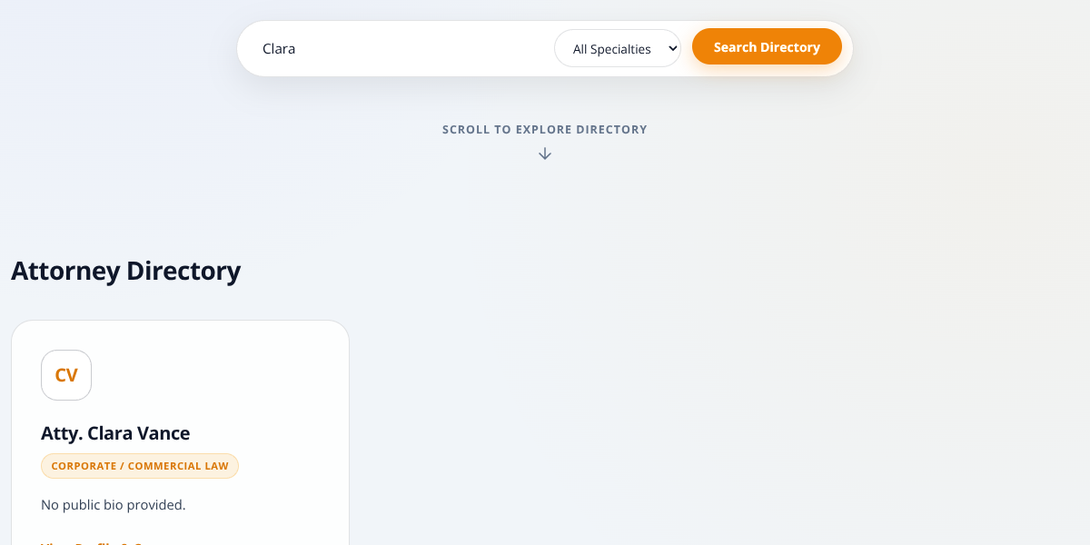
Directory search with a fictional result. Scroll to reach the profile link.
An empty search result can mean that no attorney matches the entered name or chosen specialty. Clear the search and reset the specialty before trying again.

View public case summaries
1. Choose Public Cases in the navigation to view approved public records.
2. Alternatively, open an attorney profile to see that attorney’s public case list.
3. Read the available title, status and summary. An empty attorney list does not mean the private archive has no cases.

What is not public
Private document attachments, extracted OCR text, private case relationships and office actions are not made available by public browsing.
Public means explicitly approved for display—not every case assigned to an attorney. Do not change publication flags merely to fill an empty profile.

In the supplied fictional dataset
Mateo Demo has DEMO-17 and Iris Demo has DEMO-18 as public training summaries. Tala, Nico and Lila have only private cases in that dataset. See page 23.
The public API deliberately omits the private case description. A public card may therefore show no summary text even when a case title is listed.

Sign in and sign out
1. Choose Staff Login on the home page.
2. Enter the office email address and password supplied by your administrator.
3. Select Sign In. A successful office login opens the workspace.
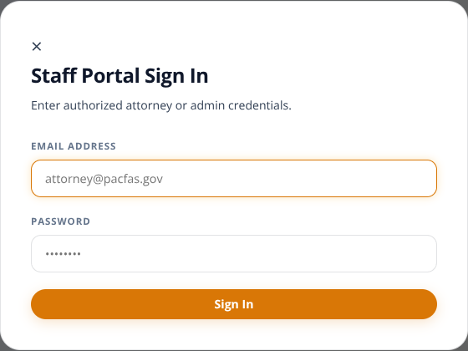
Current login dialog. Example fields are blank; no live credentials are shown.
Workspace prompts for login when you are signed out. Opening a private page directly also triggers a session check. Public-role accounts cannot enter through the staff login.
Select Logout when finished. Closing a tab does not clear the saved session. If a session expires, sign in again. An inactive account cannot log in; contact the administrator.

Navigate the dashboard
The workspace lists managed cases. Use search and the status, category and priority filters to narrow the list. Select Open File on a row to view that case.
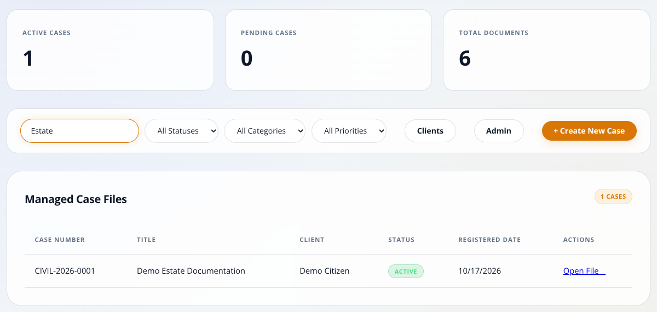
Dashboard with a saved fictional case. Counts vary with the loaded list.
Active Cases, Pending Cases and Total Documents describe the loaded case list. Filters affect the displayed counts. Pending Cases is not a scheduled-hearing count.
1. If a case seems missing, clear search and reset filters to All.
2. Confirm you have a valid office session.
3. Check linked client names and the case reference before opening attachments.

Create a case
Administrator or staff
1. Choose + Create New Case.
2. Select a category, enter a clear title and choose a status.
3. Add a description where appropriate, avoiding unnecessary sensitive details.
4. Review the number preview and submit.
5. Find the saved case and choose Open File.
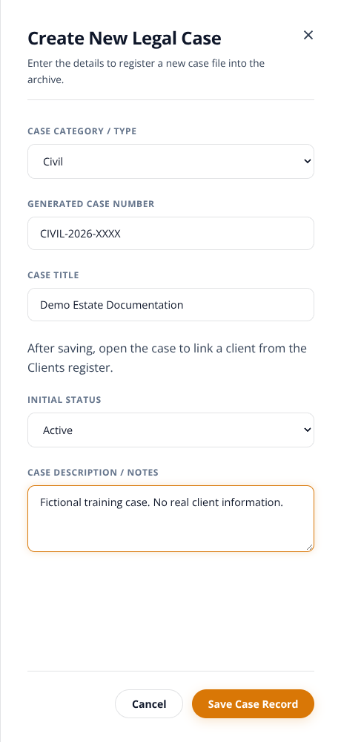
Creation drawer. XXXX is a preview, not a reserved number.
The reference combines category code, creation year and a padded database ID. It is not a court-issued docket number or a gap-free category counter. Link clients after saving; Registered Date is not proof of legal filing date.

Create a client profile
Administrator or staff
1. Open Clients from the dashboard.
2. Enter first name, last name and birth date.
3. Add appropriate contact/location details.
4. Submit and confirm the profile appears in Client Profiles.
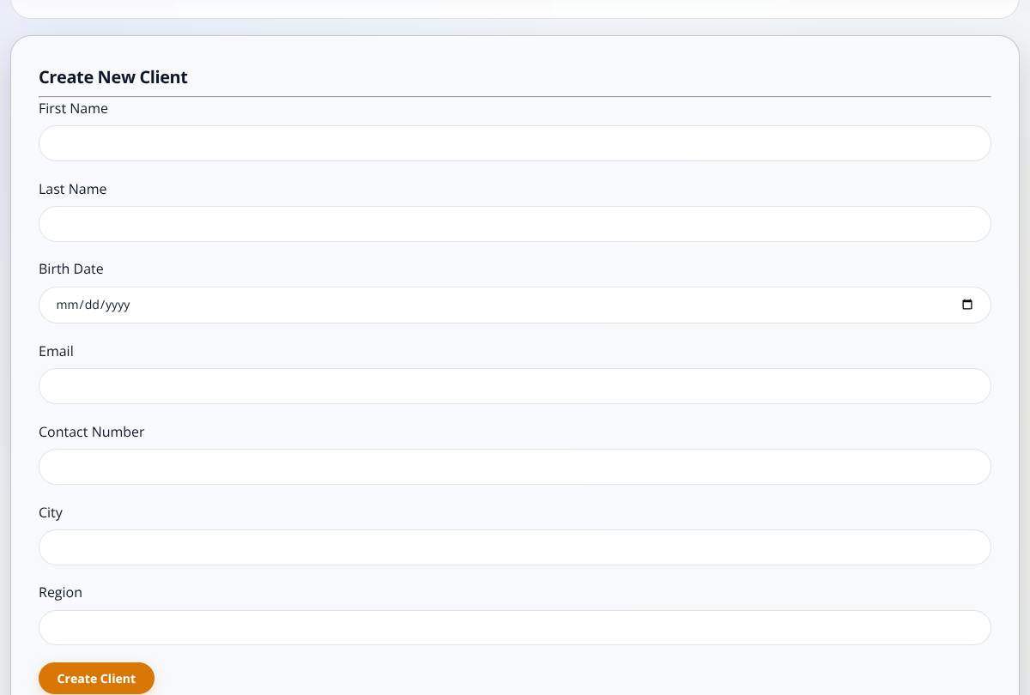
Client register with a fictional profile.
Creating a client profile does not supply a usable client-portal login or grant access to private case records. Check existing profiles before creating another.

Link clients and counsel

Link an existing client
1. Open the saved case. Select an existing client in the client-link form.
2. Enter the role on the case, such as Petitioner or Defendant.
3. Submit and confirm the client appears in the linked-client section.

Assign legal counsel
1. As admin or staff, select an active attorney in the assignment form.
2. Enter Role on Case, such as Lead Counsel, then submit.
3. Confirm the assigned counsel before scheduling hearings.
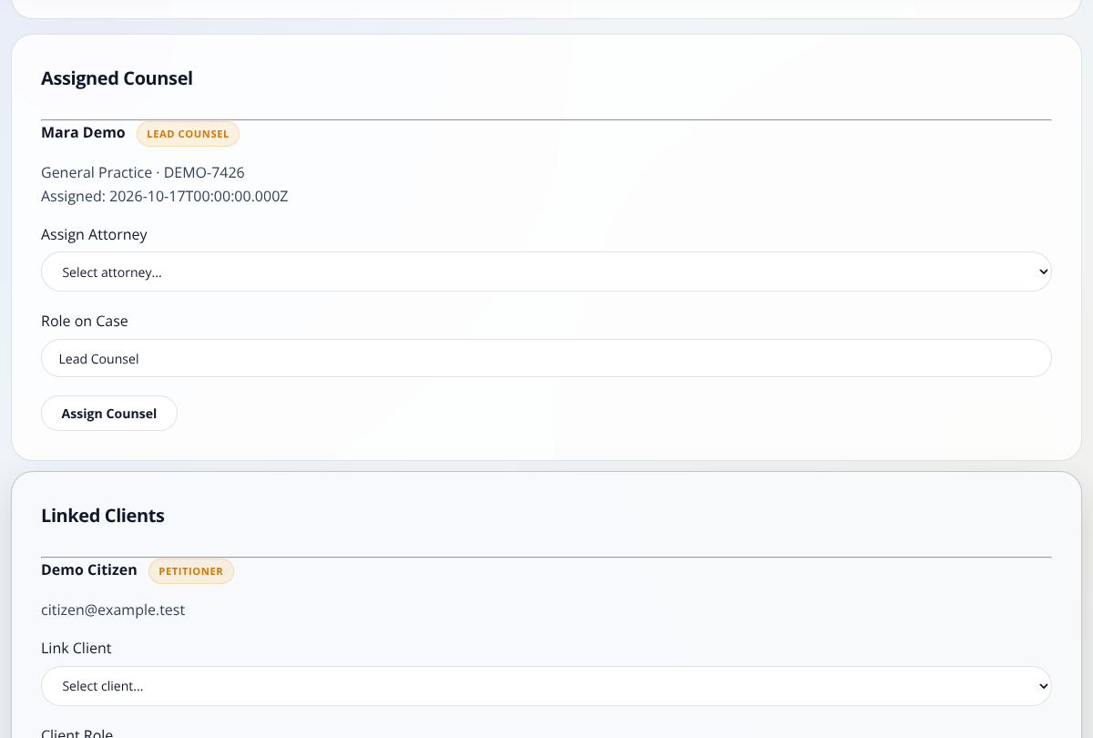
Case view with linked people and related records.
One client may be linked to several cases, and a case may have multiple clients/counsel. Do not assume duplicate profiles or duplicate links are automatically prevented.

Schedule a hearing
1. Open the correct case and choose + Add Hearing.
2. Enter a hearing title/type, up to 50 characters.
3. Choose the date and time.
4. Enter the court/venue and optional notes.
5. Select Save Hearing and confirm it appears after the case view reloads.
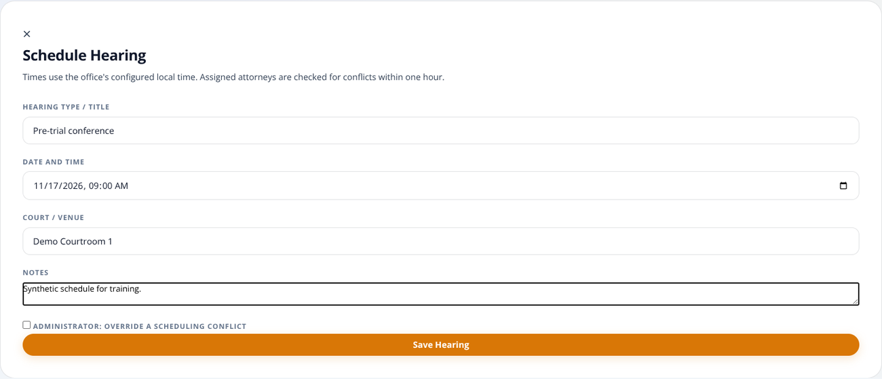
Hearing form with fictional details.
Use the office’s agreed local time. Confirm the server and browser time zones, particularly when changing devices. There is no explicit timezone selector in the form.
The application is not a substitute for an official court notice or the office calendar. Independently confirm the hearing details.

Handle scheduling conflicts
When creating a hearing, the system checks for another hearing within one hour of the requested start time for assigned counsel. The boundary times are included. It does not calculate hearing duration, preparation or travel time.
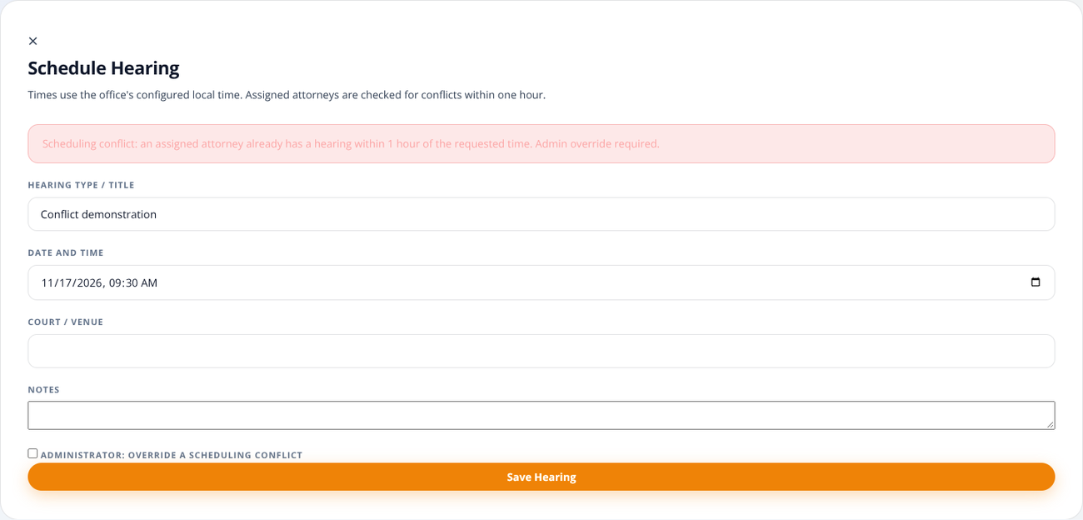
A conflict message; administrator override is a separate choice.
1. Read the conflict message and review counsel assignments.
2. Prefer an alternative time and verify it against the office calendar.
3. Only an administrator may explicitly choose the override checkbox and resubmit. Staff and attorneys cannot override.
The browser does not provide a complete hearing edit/reschedule/cancel interface. Do not assume creation-time conflict checks also certify rescheduling or simultaneous booking.

Upload a document
Supported files: PDF, PNG, JPEG/JPG and TIFF, up to 25 MiB per file (labelled 25 MB in the interface). The content must match a supported file type.
1. Open the correct case and confirm its title.
2. Choose + Upload Document.
3. Enter a meaningful document title/tag and select the file.
4. Submit Upload & Extract Text.
5. Confirm a document card appears; wait for extraction.
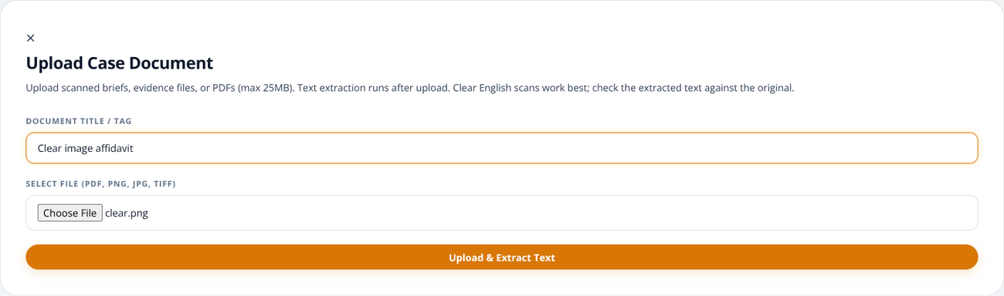
Document upload form with a synthetic testing file.
Saving the file and recognizing text are separate operations. A successful upload does not guarantee usable OCR. A file-type check is not a malware scan.

Read extraction status
Status | Meaning / action
PENDING | File was saved; extraction has not started. Wait or refresh status.
PROCESSING | Extraction is running. Wait; avoid duplicate uploads.
COMPLETED | Nonempty text was stored. Open it and compare with the original.
FAILED | No usable text or an extraction error. Check the source; see page 18.
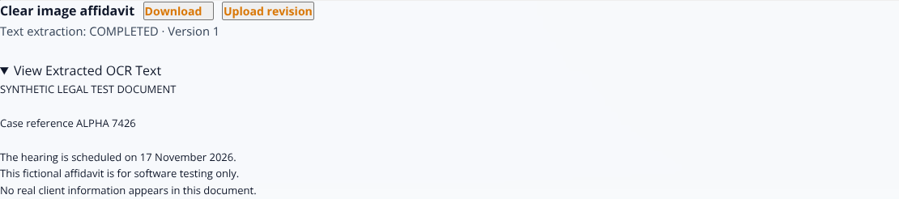
Extracted text shown on a document card.
Open View Extracted OCR Text when ready. The page polls pending work for about two minutes; use Refresh status or reload if needed.
COMPLETED means text exists—not that every word is correct. Names, dates, amounts, handwriting and poor scans need careful review. Mixed text/image PDFs can require additional checks.

Upload a revision
1. Find the correct existing document card.
2. Choose Upload revision—not + Upload Document.
3. Choose the replacement file and submit the form.
4. Confirm the next version number and wait for extraction.
5. Review the extracted text for the current revision.
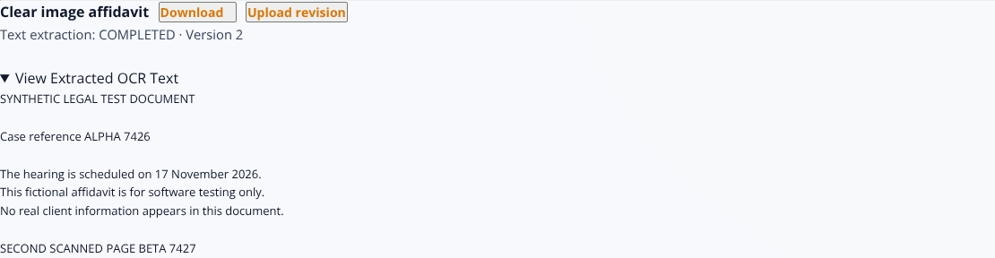
Current version 2 with recognized scanned-PDF text.
The document ID stays the same while the version number increases. The existing document title is retained. Uploading a new logical document instead creates a separate card.
The backend retains version records, but the current browser does not provide a historical-version picker. Do not promise users that they can select any old revision from this screen.

Download and verify
1. Confirm the case and the document card.
2. Check the current version number and choose Download.
3. Save only to an approved location.
4. Open the file and check that its contents match the intended record.

What is downloaded?
The authenticated download uses the current document version. The original attachment and extracted text are different things: OCR does not replace the source file.

If the download fails
Check browser download permissions and whether the session expired. Sign in again if needed. If the record is listed but the file is missing, ask the administrator to check the matching uploads folder and stored path.
Do not bypass a failed download by exposing the raw uploads folder. Do not assume Logout deletes copies already saved on the device.

Quality check
For scans, compare important names, dates, amounts and page counts against the original. Improve poor scans and upload a revision rather than relying on questionable extracted text.

Failed OCR and retry
1. Read the document card’s failure message.
2. Check the original: is it blank, damaged, dark, protected or in an unsupported language?
3. For a temporary failure on the same source, select Retry extraction.
4. Wait for the updated status. Only failed extractions may be retried.
5. If the source needs improvement, upload a better scan as a revision.
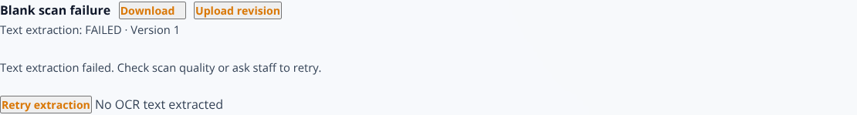
Blank-image failure with Retry extraction available.
Retry cannot repair a blank or corrupt source. For persistent PENDING/PROCESSING after a server restart, contact the administrator. Ordinary users should not run recovery commands.
Use upright, readable English scans with good contrast. Recognition of poor handwriting, protected files and complex mixed layouts is not guaranteed.

Create an attorney account
Administrator only
1. Open Admin from the dashboard.
2. Enter first name, last name and email. Username is optional.
3. Supply a unique initial password of at least 12 characters.
4. Enter a valid specialization ID and appropriate bar reference.
5. Submit and confirm the attorney appears in the directory/list.
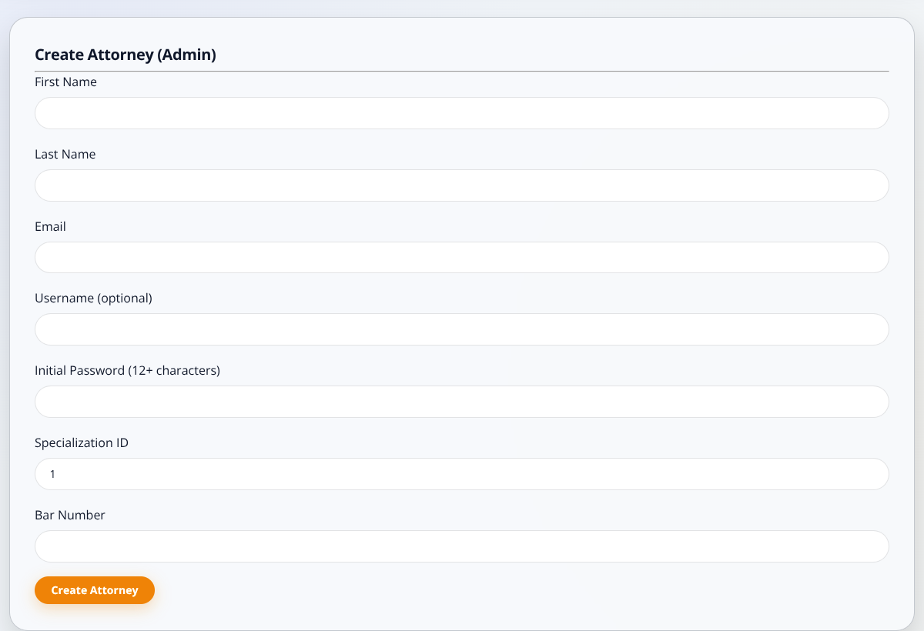
Administrator attorney-creation screen with fictional records.
Verify organizational authorization before creating the account. Deliver credentials privately. The form has no named specialty picker and is not complete user/role/password-reset administration. There is no in-app approval-request workflow.

Use a smaller screen
Navigation and filters wrap at narrow widths. Scroll to reach case controls, and swipe horizontally inside a wide table to see additional columns.
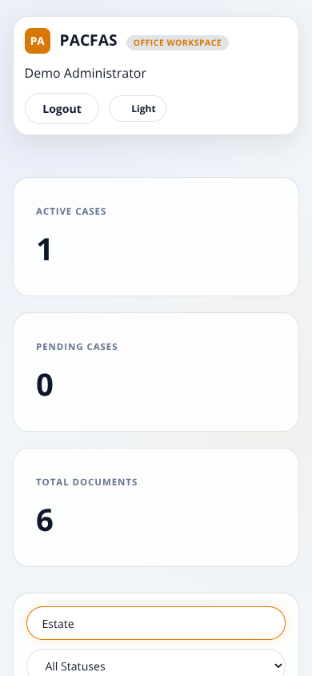
Earlier 390-pixel viewport capture with fictional records.
Drawers and dialogs scroll when their content is taller than the available screen. Use a larger display for reviewing dense documents where practical. Never assume an off-screen control or column is missing.

Troubleshooting
Symptom | Check / action
Login fails | Check email/password; contact admin for an inactive account.
No cases displayed | Clear filters, verify the session and correct database. Public profiles show public cases only.
Permission denied | Check your assigned role. Signing in does not grant every office permission.
Upload rejected | Check type, size, content and whether the source opens locally.
OCR fails / stays pending | Refresh status; check scan quality. Ask admin about language data or a restart.
Record exists; no download | Check session/browser permission; ask admin about matching uploads and stored paths.
Database unavailable | Start/check MySQL and saved connection settings; reloading the browser does not start it.
Changes seem ignored | Save .env, restart Node, then hard-refresh the browser (Ctrl+Shift+R).
When reporting a problem, supply the action, time, safe record identifier and sanitized error. Never send passwords, tokens or real confidential documents.

Local startup and maintenance
Administrator / local operator
1. Keep a private backup of .env, the MySQL database and its matching uploads.
2. For a new download, run npm ci once while online; use Node.js 22 or newer.
3. Save the correct DB_HOST, DB_PORT, DB_USER, DB_PASSWORD, DB_NAME and a strong JWT_SECRET in .env.
4. For offline OCR, set TESSDATA_PATH to the absolute folder containing eng.traineddata—not the file itself.
5. Start MySQL, run npm start, then open the configured PORT (3000 in .env.example).
The database persists between restarts. Do not import database.sql or rerun demo seeding just to start the app. Never overwrite a database containing records you need.
For the demo installed earlier, use DB_NAME=pacfas_defense_demo. Keep the language-data folder and matching uploads. Use forward slashes in a Windows TESSDATA_PATH.
OCR runs in-process, not a durable queue. Stop every app/worker before using scripts/recover-ocr.js. Migrations are controlled maintenance: back up first and use the actual migration files, not an old printed filename.

Fictional demo quick reference
The optional defense dataset contains 5 fictional attorneys, 18 cases and 90 logical documents, with 2 additional revision files. All people/events are synthetic, not real legal records.
Example | What to demonstrate
DEMO-01 | Image-only PDF + PNG; extracted-text marker ORCHID.
DEMO-02 / DEMO-03 | Intake has revisions 1 and 2. Current text includes REVISIONTWO.
DEMO-03 | Two counsel and two linked clients.
DEMO-17 / DEMO-18 | Public summaries for Mateo Demo / Iris Demo. Other 16 cases are private.

Show live OCR honestly
The imported sample text was already extracted during dataset preparation. Upload a new scan through the interface to show live pending/processing/completed behavior.

Hearing example
The supplied reference date is 17 October 2026. DEMO-01 has a hearing on 31 October 2026 at 09:00. A DEMO-06 request at 09:30 conflicts because both share Tala Demo. Confirm local times and rehearsal changes first.
Use administrator-supplied demo credentials privately. Demo setup tools are separate from ordinary npm start operation.

Before you finish

Daily closing checklist
1. Confirm the correct case and linked people.
2. Check upload/extraction status; review important text against the original.
3. Verify current revision and download location.
4. Confirm hearing times independently.
5. Select Logout and secure any downloaded files.

Keep these distinctions clear
Public summary ≠ private case file.
An approved listing does not expose the office’s attachments.
Client profile ≠ client portal.
A profile/link does not provide a usable client login.
Uploaded ≠ recognized accurately.
COMPLETED means stored text exists, not legal correctness.
Saved data ≠ repository files.
Transfer the MySQL backup and matching uploads together.
PACFAS • User handbook
A5 saddle-stitch edition • 17 October 2026
Fictional screenshots for instruction only.

