**Driver Alertness Detection**

Padma sanjana1 , Jaya krishna2 , Yakesh3 , Ashok4

∗Dept. of Computer Science and Engineering, Presidency University, Bengaluru, India Email:[parachuru.20221LCS0012@presidencyuniversity.in](mailto:parachuru.20221LCS0012@presidencyuniversity.in)

School of Computer Science and Engineering, Presidency University, Bengaluru, India Emails: [lingala.20211CSE0482@presidencyuniversity.in,](mailto:manaswi.20211cse0443@presidencyuniversity.in)  yakesh.20221lcs0006@presidencyuniversity.in,

[Ashok.20221LCS0019@presidencyuniversity.in](mailto:Ashok.20221LCS0019@presidencyuniversity.in), [parachuru.20221LCS0012@presidencyuniversity.in](mailto:parachuru.20221LCS0012@presidencyuniversity.in)

***Abstract*—** **Driver drowsiness and distraction are among the major contributors to road accidents, and hence, monitoring systems need to be developed to improve the safety of driving. The present research introduces a compact real-time driver monitoring system for a vehicle that uses image-processing techniques to detect drowsiness and inattention. The system continuously monitors eye and head movements by identifying key indicators such as slow blinking, closed eyes, or head turning. The system immediately alerts the driver with auditory alarms or seat vibrations if it detects potential risks to minimize the chance of accidents. In extreme cases, when the driver does not respond, the system increases the alert levels by sending text messages and emails to designated family members. The system therefore allows live camera streams to be merged with machine learning algorithms that determine a driver's alertness level as detected in real-time images; the research offers an innovative, scientifically-based approach to increasing safety on roads. It, therefore, provides a robust yet accessible solution to mitigate drivers' risks associated with drowsiness and distraction, toward improved safe driving practices.**

***Index Terms*—** **Driver Monitoring System, Drowsiness, Machine Learning, Python, Face Detection, Eye extraction, OpenCV.**

1. INTRODUCTION

Driver fatigue and distraction are among the most prevalent causes of traffic accidents globally, posing immense challenges to road safety. According to studies, drowsiness drastically reduces reaction time and decision-making, especially in long journeys, night driving, or during prolonged commute hours. Mobile phone use or in-car conversations also add to this risk. Advances notwithstanding on safety features in cars, more than these is dealing with humans-in-finding drivers of good consciousness regarding drowsiness or attention lapses and also focusing on the problem associated with this: innovations targeting straight-on monitoring and rectifying of driver fatigue as well as distractions that enhance safe highways usage.

The focus for research under which a real-time system concerning drivers will be based will depend on image processing machine-learning principles. The system continuously analyses eye movements, blinking patterns, and head positions to identify signs of fatigue or inattention. It's different from the indirect approach of using lane deviation for detecting drowsiness since this system offers direct physiological feedback that is accurate, which will trigger timely alerts and correct actions. Designed to be adaptable and scalable, the proposed solution caters to diverse vehicle types and driving conditions; it promises a significant step toward reducing traffic accidents and improving the overall safety oftransportation systems.

1. LITERATURE SURVEY

Driver drowsiness and distraction detection have been highly emphasized recently as a vital aspect of road safety. A number of approaches have been developed, each having unique methodologies to address the issues related to monitoring the driver's behavior. The present section discusses existing literature using image processing techniques, machine learning algorithms, and advanced technologies for real-time monitoring of the driver.

Vision-Based Detection Techniques

A number of studies have been carried out in detecting driver drowsiness and distraction through vision-based techniques. These approaches rely on visual cues like eye movements, blinking patterns, and head orientation, which are recorded using dashboard-mounted cameras. For example, Vural et al. (2013) and Kale et al. (2017) relied on the extraction of eye and blink features to determine drowsiness. These systems utilize computer vision tools that help identify robust blinks and facial landmark tracking to provide non-invasive, real-time monitoring. In the same direction, Wang et al. (2019) and Ma et al. (2020) utilized deep learning models such as convolutional neural networks (CNNs) to improve accuracy in detecting fatigue conditions even under varying illumination conditions.

Advancements in Deep Learning and Computer Vision

The advancements in deep learning and computer vision have improved driver monitoring systems to become highly accurate and robust. Behavioral cues have been widely analyzed by head pose estimation and facial feature tracking. CNN-based models have particularly addressed low-light environments and diverse driver profiles. The use of IR technology has further integrated it to work effectively in adverse climatic conditions and at night.

Benefits and Challenges

The literature under review shows several benefits of the vision-based technique. They are non-invasive, meaning no wearables or physiological monitoring equipment is required, and in fact, they can monitor and alert in real time should drowsiness or distraction be detected. In addition, these systems can function satisfactorily under changing environmental and climatic conditions, particularly in IR-enabled cameras.

However, there are still certain limitations. Vision-based systems are susceptible to occlusions, including sunglasses and masks, that can mask facial features and therefore reduce the detection accuracy.

1. METHODOLOGY

The proposed driver drowsiness and distraction detection system is based on a real-time implementation to monitor driver alertness using systematic acquisition, processing, and analysis of visual information to detect fatigue and distraction cues.

1. Data Acquisition

A dashboard-mounted camera of infrared (IR) abilities captures real-time video of the head and face movements of drivers, ensuring reliable performance against changing lighting conditions.

1. Preprocessing

Video frames are passed through noise reduction, grayscale conversion, and normalization to improve image quality and ensure uniformity in order to prepare the data for proper analysis in any environmental condition.

1. Feature Extraction

Major behavioral features such as eye closure, blinking patterns, head orientation, and facial landmarks are detected to determine drowsiness and distraction.

1. Real-Time Detection and Analysis

Advanced image-processing techniques analyze the extracted features to determine the level of alertness of a driver, with thresholds set for minimizing false positives and false negatives.

1. Alert Mechanism

The system triggers immediate alerts, including auditory alarms, seat or steering wheel vibrations, and emergency notifications to designated contacts if the driver remains unresponsive.

1. System Validation and Optimization

The system is tested using validation metrics, such as precision, recall, and F1-score, for accuracy. It uses real-world feedback to refine the performance and reduce computational demands.

1. Integration and Scalability

The system is designed to be compact, cost-effective, and compatible with a wide range of vehicle types, allowing for seamless integration into existing and future transportation technologies.

1. RESEARCH GAPS OF EXISTING METHODS

Introduction

Driver drowsiness and distraction are major contributors to road accidents, resulting from long driving hours, monotonous routes, and lack of sleep. This project aims to design a compact, real-time system for cars and trucks for detecting driver drowsiness and distraction using image processing techniques. The system is continuously monitoring the driver's eyes and head movements and identifies key indicators such as prolonged blinking, slow eyelid closure, and head turns. It offers immediate alerts through auditory alarms or vibrations upon detection and enables timely corrective actions. It is a non-intrusive, easily integrable solution that improves road safety through accident reduction and saving of lives.

Existing Approaches and Their Limitations

The present techniques of detecting driver drowsiness and distraction involve physiological monitoring, vehicle behavior analysis, and visual-based methods. Physiological monitoring can have a high accuracy but is not practical since it uses intrusive sensors. Vehicle behavior analysis, which involves the monitoring of lane deviations or steering patterns, is less sensitive and mostly driven by external factors like road conditions. Non-intrusive, real-time techniques rely on facial features, blinking patterns, and head movements but are prone to lower accuracy due to changing lighting conditions, occlusions by sunglasses or headgear, and false positives from natural behaviors. Moreover, most systems lack computational efficiency, making them infeasible for deployment in resource-constrained environments. These challenges emphasize the need for a strong, adaptive solution that will guarantee the detection in diverse driving scenarios.

Identified Research Gaps

Although great strides have been made in driver drowsiness and distraction detection technologies, many areas still remain unexplored that limit their effective use on a large scale. A critical gap here is that current systems do not hold accuracy under a variety of environmental conditions like changing lighting, shadows, and occlusions caused by eyewear or masks. Most of the existing systems heavily depend on specific cues such as eye blinks or head orientation that can be easily misinterpreted by rapid movements, vibrations, and partial occlusions. These systems lack robustness that makes them unreliable under actual driving conditions.

Another crucial limitation is the inability of the system to adapt to individual differences in drivers. Facial feature variations, blinking patterns, and natural behaviors will reduce the efficacy of the system over a larger demographic. More recently, most systems have also struggled with high false-positive rates; legitimate activities like talking or briefly looking away tend to trigger unnecessary alerts, disrupting the driver experience but also reducing user trust and system adoption. In fact, computational overhead is another major barrier: processing real-time video requires very significant resources, which makes these systems impossible in resource-constrained or cost-sensitive environments. Covering these gaps is crucial for the development of a practically applicable, efficient, and universally applicable driver monitoring system.

Proposed Research Topics

There are a couple of ways in which research could advance through overcoming these challenges identified: development of advanced algorithms resistant to variations in illumination, occlusion, or changes in environmental conditions may prove important to enhance accuracy; infrared technology incorporated within cameras will provide a dependable source for system performance consistency with respect to lowlight driving conditions.

Personalization and adaptability are also critical research areas. Development of systems that can learn individual driver characteristics and accommodate changes in facial features and blinking patterns can make significant improvements in usability. Algorithms or machine learning models self-calibrating to certain driver behaviors over time may also enhance the effectiveness of the system.

Another important consideration is to reduce computational overhead without compromising real-time performance. Lightweight algorithms and optimized hardware can make the system accessible for low-cost vehicles and resource-constrained environments. Integrating multiple behavioral cues, such as combining eye and head movement analysis with contextual data, can also help in addressing false-positive triggers and improving detection accuracy.

Finally, modular and compact system designs that can be easily integrated into various vehicle types will support broader adoption. These systems should be scalable, ensuring compatibility with future advancements in automotive technology while remaining cost-effective for large-scale implementation. Pursuing these research directions will help develop robust and efficient systems that meet the demands of real-world driving conditions.

1. Proposed Methodology

1. Introduction

Driver attentiveness is an important factor in ensuring road safety, since drowsiness and distraction are some of the major causes of vehicular accidents. This project proposes a robust, real-time driver monitoring system that uses advanced image processing techniques to detect signs of fatigue and inattention for enhancing road safety. It focuses on two primary areas: eye tracking and head pose estimation.

The eye-tracking component of the system continuously monitors the eyes of the driver for drowsiness indicators such as extended eye closure and slow blinking and variations in blinking frequency, quantifiable by the PERCLOS measure. To ensure reliable performance under varying environmental conditions, like nighttime driving or low visibility, the system is integrated with infrared (IR) technology for enhanced accuracy and robustness.

Complementing eye tracking is the 3D head pose estimation that takes in the orientation and motion of the driver's head. The monitoring of head movements that are over some safety thresholds, such as prolonged turning or tilting, makes the system perfectly identify distractions, including having conversations with passengers or focusing elsewhere from the road ahead.

This dual approach of real-time monitoring of eye and head behavior provides an all-rounded solution for detecting driver drowsiness and distraction, significantly reducing the risks associated with accidents while promoting safer driving practices.

**Add image \**

Data Preprocessing

Data preprocessing is important for the driver drowsiness and distraction detection system to ensure that it is reliable and accurate. Raw video data captured by a camera mounted on the dashboard undergoes several preprocessing steps to improve quality and prepare it for analysis. These include noise reduction, grayscale conversion, normalization, and region-of-interest extraction.

Noise Reduction: This is the filtering of noise artifacts and vibration-induced noise which can blur the image and prevent interference with the analysis.

Converting the Video Frames: Converting the video frames into grayscale simplifies the computational load but does not affect the eyes' movements and facial marks.

Normalization: The pixel intensities are normalized so that variations between frames shot under dissimilar lighting conditions are uniform. That helps the system to handle a real-world scenario, better.

Region of Interest Extraction: This involves certain areas of the frame-the eyes and the face from where the in-depth analysis shall take place. That reduces data amount to be processed and gets most relevant for the detection of drowsiness and distractions.

Proposed Methodology for Driver Monitoring System.

The proposed driver monitoring system is designed to identify driver behavior in real-time using more advanced image processing techniques such as two major areas - eye tracking for drowsiness detection and head pose estimation for distraction detection. Continuous monitoring of these behavioral cues helps alert the driver for potential accidents in advance.

Image Processing in Real-Time for Eyes and Blink Detection

Blink and Eye Closure Monitoring: The system uses the PERCLOS (Percentage of Eyelid Closure) metric to detect prolonged eye closures, delayed blinks, or frequent blinking patterns—strong indicators of drowsiness. These metrics are calculated in real time to allow timely interventions.

Advanced Algorithm Used for Eye Tracking: These algorithms include facial landmark detection and optical flow analysis techniques for better monitoring of eye movement. Advanced Algorithms can detect a change in blink frequency, slowness, and even the partial closure of eyes when detecting fatigue.

Infrared Integration Technology: IR technology helps track this data with reliable detection through changing lighting conditions such as night or low visibility, providing efficiency and accuracy across all ranges.

Detection Head Pose Distraction

Head Movement Analysis: The system utilizes 3D head pose estimation in calculating head rotation and tilt. Persistent head turns beyond 100 degrees are considered to be distractions.

Long-Term Distraction Analysis: Patterns like long-term head turns toward passengers which is indicative of long conversations or drifting off are analyzed. It determines short glances from distractions with advanced movement analysis.

Safety Thresholds: It sets predefined safe head angles and durations that can help avoid false alarms, hence the system's reliability in real-world deployments.

Benefits of System

It includes a comprehensive solution for detecting drowsiness and distraction of drivers by integrating real-time eye-tracking with head pose estimation. By using IR technology, advanced image processing algorithms, and behavioral analysis, the system ensures reliable performance under different conditions. Immediate auditory alerts or seat vibrations enable corrective actions by the drivers, and therefore, the chances of accidents reduce significantly. This solution answers questions about precision, adaptability, and user-centric design, offering a robust tool to improve road safety.

1. Software Requirements Specification

The proposed system intends to detect driver drowsiness in the real driving environment. Its performance totally depends on the quality of its camera. It is fully accessible both for day and night drivers, whenever such a requirement arises, in case the user's system meets all the necessary requirements. The application will be designed such that it will quickly recover in case of a system crash and become operational once again. The prototype will be implemented on a Raspberry Pi microcontroller board, equipping necessary peripherals, and drowsiness detection functionality will be developed using Python 3.

1. System Design

The system architecture captures the driver's face through a camera, which translates it into a video stream. The application then analyzes the stream for drowsiness and fatigue detection and the state of alertness. The main analysis parts are the tracking of faces, state evaluation of fatigue, and the recognition of essential facial areas such as closure of the eyes and yawning. In case of detecting drowsiness, an auditory warning is triggered in the system to alert the driver.

Result

During execution of the Driver Drowsiness Detection System, the camera is activated to monitor the driver. The system processes the video feed for detection of drowsiness or fatigue signs and issues alerts in real time to prevent driver sleep.

Fig 1: Detecting the eyes

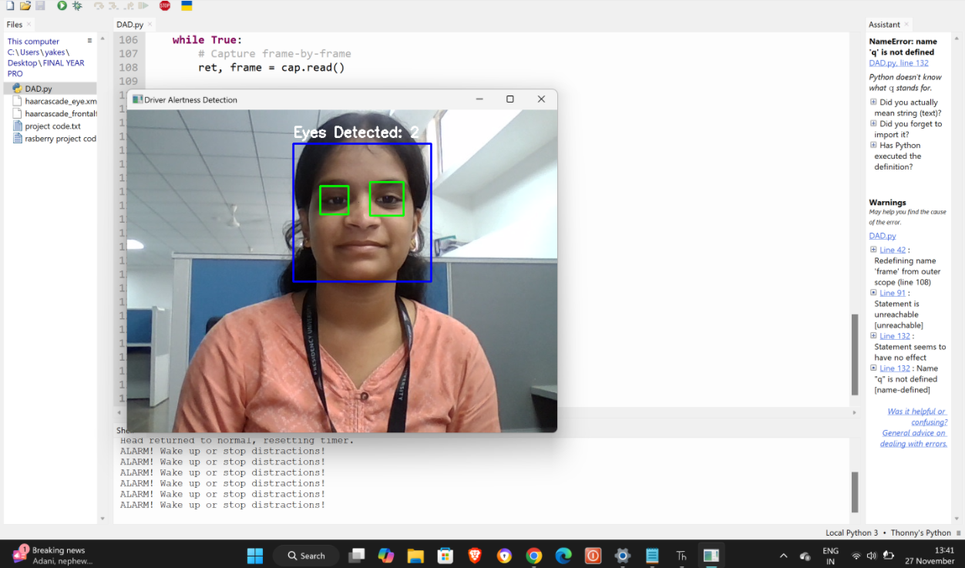

Whether the face of the user is in frame or not. • Once the face of the user is detected it goes on to detect the Eye Aspect Ratio of the user so that it can detect whether the face of the user is in drowsy state or not. If the box surrounding the face of the user becomes green, it tells us that the user is active. Otherwise, if the box surrounding the face of the user is red it says that it is in the drowsy state.

Fig 2 : Detected eyes closed

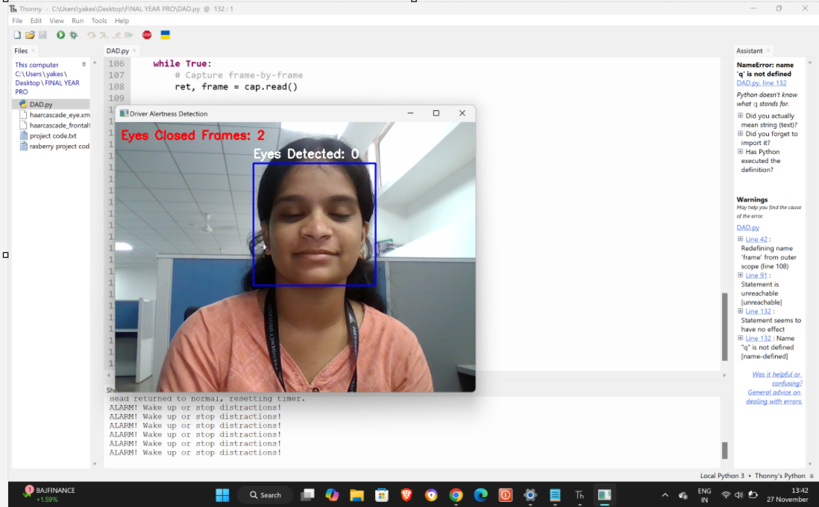

The system checks whether the user's face falls within the camera frame. If the face is detected, the system calculates the Eye Aspect Ratio (EAR) for determining the drowsiness state of the user. If a green bounding box surrounds the detected face, it signifies that the user is active and alert. However, if the bounding box turns red, it shows that the user is in a drowsy state, which requires the system to take necessary actions to alert the driver. This visual feedback mechanism ensures real-time monitoring and clear indications of the driver's condition.

Fig 3 : Drowsiness Detected

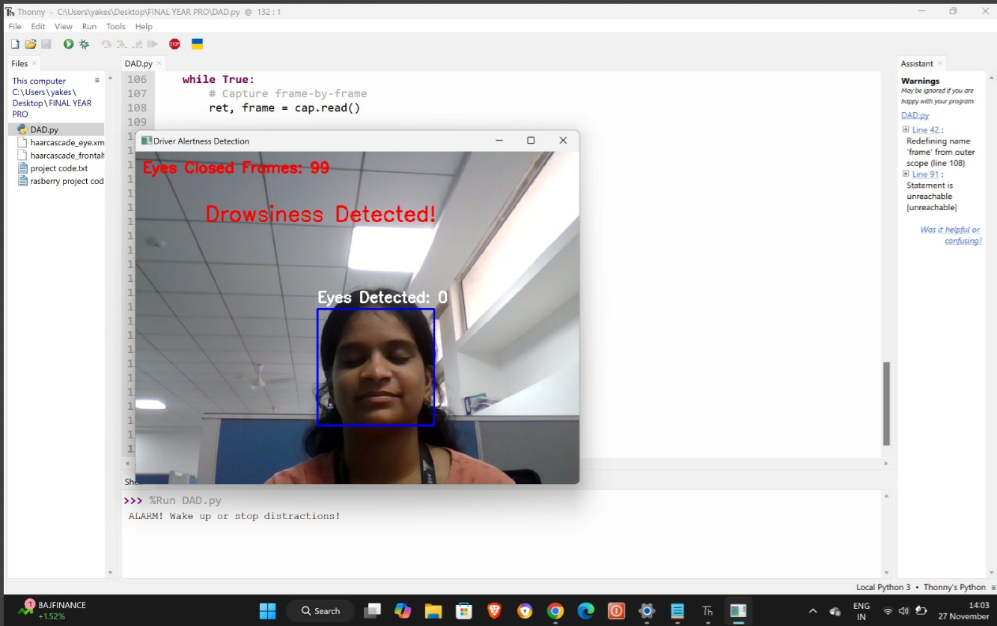

1. CONCLUSION:

In this paper, we proposed a vision-based approach for driver drowsiness detection using OpenCV. The proposed system was able to accurately detect drowsiness by monitoring the driver's eye and mouth movements. The system provides an effective mechanism for preventing road accidents caused by driver drowsiness. Future work can focus on extending the system to detect other forms of driver fatigue, such as microsleeps, and on improving the system's performance in real-world conditions.

Detailed Design The system is designed in such a manner that the face of the driver and therefore, eyes and mouth are at all times under observation, and should any predefined levels of alertness be defaulted and compromised then an appropriate alarm goes off and action is consequently initiated to avoid any probable death. Fig. 2 shows the System Design of Driver Drowsiness and Yawn Detection System. It is clear that the camera is used for continuous monitoring of a driver's face and in case some drowsiness or fatigue is detected, the system situated in the dashboard sends a voice alert type warning to the driver.

REFERENCES

1. 1.Alam, A., & Muqeem, M. (2024). An optimal heart disease prediction using chaos game optimization-based recurrent neural model. International Journal of Information Technology, 16(5), 3359-3366.
2. 2.Alam, A., & Muqeem, M. (2022, March). Integrated k-means clustering with nature inspired optimization algorithm for the prediction of disease on high dimensional data. In 2022 international conference on electronics and renewable systems (ICEARS) (pp. 1556-1561). IEEE.
3. 3.Alam, A., Ahamad, M. K., Mohammed Aarif, K. O., & Anwar, T. (2024). Detection of rheumatoid arthritis using CNN by transfer learning. In Artificial Intelligence and Autoimmune Diseases: Applications in the Diagnosis, Prognosis, and Therapeutics (pp. 99-112). Singapore: Springer Nature Singapore.
4. 4.Alam, A., & Ahamad, M. K. (2023). K-Means Hybridization with Enhanced Firefly Algorithm for High-Dimension Automatic Clustering. Journal of Advanced Research in Applied Sciences and Engineering Technology, 33(3), 137-153.

[5] A. Shahid, K. Wilkinson, S. Marcu, and C. M. Shapiro, “Karolinska Sleepiness Scale (KSS),” in STOP, THAT and One Hundred Other Sleep Scales, A. Shahid, K. Wilkinson, S. Marcu, and C. M. Shapiro, Eds. New York, NY: Springer, 2012, pp. 209–210. doi: 10.1007/978-1-4419-9893- 4_47. [6] C. Berka et al., “EEG Correlates of Task Engagement and Mental Workload in Vigilance, Learning, and Memory Tasks,” Aviat. Space Environ. Med., vol. 78, no. 5, pp. B231–B244, May 2007.

[7] H.-S. Shin, S.-J. Jung, J.-J. Kim, and W.-Y. Chung, “Real time car driver’s condition monitoring system,” in 2010 IEEE SENSORS, Nov. 2010, pp. 951–954. doi: 10.1109/ICSENS.2010.5690904.

[8] M. Gillberg, G. Kecklund, and T. Åkerstedt, “Sleepiness and performance of professional drivers in a truck simulator—comparisons between day and night driving,” J. Sleep Res., vol. 5, no. 1, pp. 12–15, 1996, doi: 10.1046/j.1365-2869.1996.00013.x.

[9] C. Cajochen, D. P. Brunner, K. Kräuchi, P. Graw, and A. Wirz-Justice, “EEG and subjective sleepiness during extended wakefulness in seasonal affective disorder: circadian and homeostatic influences,” Biol. Psychiatry, vol. 47, no. 7, pp. 610–617, Apr. 2000, doi: 10.1016/S0006- 3223(99)00242-5.

[10] S. Otmani, T. Pebayle, J. Roge, and A. Muzet, “Effect of driving duration and partial sleep deprivation on subsequent alertness and performance of car drivers,” Physiol. Behav., vol. 84, no. 5, pp. 715–724, Apr. 2005, doi: 10.1016/j.physbeh.2005.02.021.

[11] C. Papadelis et al., “Indicators of Sleepiness in an ambulatory EEG study of night driving,” in 2006 International Conference of the IEEE Engineering in Medicine and Biology Society, Aug. 2006, pp. 6201–6204. doi: 10.1109/IEMBS.2006.259614. [12] R.-S. Huang, T.-P. Jung, and S. Makeig, “Tonic Changes in EEG Power Spectra during Simulated Driving,” in Foundations of Augmented Cognition. Neuroergonomics and Operational Neuroscience, Berlin, Heidelberg, 2009, pp. 394–403. doi: 10.1007/978-3-642- 02812-0_47.

[13] L.-C. Shi and B.-LLu, “Dynamic clustering for vigilance analysis based on EEG,” in 2008 30th Annual International Conference of the IEEE Engineering in Medicine and Biology Society, Aug. 2008, pp. 54–57. doi: 10.1109/IEMBS.2008.4649089.

[14] R. N. Khushaba, S. Kodagoda, S. Lal, and G. Dissanayake, “Driver Drowsiness Classification Using Fuzzy Wavelet-Packet-Based Feature-Extraction Algorithm,” IEEE Trans. Biomed. Eng., vol. 58, no. 1, pp. 121–131, Jan. 2011, doi: 10.1109/TBME.2010.2077291.

[15] S. Hu and G. Zheng, “Driver drowsiness detection with eyelid related parameters by Support Vector Machine,” Expert Syst. Appl., vol. 36, no. 4, pp. 7651–7658, May 2009, doi: 10.1016/j.eswa.2008.09.030.

[16] M. B. Kurt, N. Sezgin, M. Akin, G. Kirbas, and M. Bayram, “The ANN-based computing of drowsy level,” Expert Syst. Appl., vol. 36, no. 2, Part 1, pp. 2534–2542, Mar. 2009, doi: 10.1016/j.eswa.2008.01.085.

[17] S. K. L. Lal and A. Craig, “A critical review of the psychophysiology of driver fatigue,” Biol. Psychol., vol. 55, no. 3, pp. 173–194, Feb. 2001, doi: 10.1016/S0301-0511(00)00085-5.

[18] M. Akin, M. B. Kurt, N. Sezgin, and M. Bayram, “Estimating vigilance level by using EEG and EMG signals,” Neural Comput. Appl., vol. 17, no. 3, pp. 227–236, Jun. 2008, doi: 10.1007/s00521-007-0117-7.

[19] L. Chen, Y. Zhao, J. Zhang, and J. Zou, “Automatic detection of alertness/drowsiness from physiological signals using wavelet-based nonlinear features and machine learning,” Expert Syst. Appl., vol. 42, no. 21, pp. 7344–7355, Nov. 2015, doi: 10.1016/j.eswa.2015.05.028.

[20] T. Ouyang and H.-T. Lu, “Vigilance Analysis Based on Continuous Wavelet Transform of EEG Signals,” in 2010 International Conference on Biomedical Engineering and Computer Science, Apr. 2010, pp. 1–4. doi: 10.1109/ICBECS.2010.5462289.

[21] M. Khan, “Efficient Car Alarming System for Fatigue Detection during Driving,” Int. J. Innov. Manag. Technol., vol. 3, no. 4, 2012, doi: 10.7763/IJIMT.2012.V3.280.

[22] S. Mohanty, S. V. Hegde, S. Prasad, and J. Manikandan, “Design of Real-time Drowsiness Detection System using Dlib,” in 2019 IEEE International WIE Conference on Electrical and Computer Engineering (WIECON-ECE), Nov. 2019, pp. 1–4. doi: 10.1109/WIECONECE48653.2019.9019910.

[23] L. M. Bergasa, J. Nuevo, M. A. Sotelo, R. Barea, and M. E. Lopez, “Real-time system for monitoring driver vigilance,” IEEE Trans. Intell. Transp. Syst., vol. 7, no. 1, pp. 63–77, Mar. 2006, doi: 10.1109/TITS.2006.869598.

[24] B. F. Momin, “Current Status and Future Research Directions in Monitoring Vigilance of Individual or Mass Audience in Monotonous Working Environment,” Int. J. Soft Comput., vol. 3, no. 2, pp. 45–53, May 2012, doi: 10.5121/ijsc.2012.3204.