College of Saint Benedict & Saint John’s University

Computer Science Department

GABeS

Phase 3

Team Potatoes

Grant Boyer, Kyle Olson, Tom Husen

[This page has been intentionally left blank]

Table of Contents

Database Design ……………………………………………………………………………………………………………………... 4

EER Diagram ………………………………………………………………………………………………………………... 4

Relational Map Diagram ...…………………………………………………………………………………………... 5

Physical Database Design ………………………………………………………………………………………………………… 6

Issues Faced During Phase .……………………………………………………………………………………………………… ?

Task Decomposition ………………………………………………………………………………………………………………… ?

Meeting Minutes …………..………………………………………………………………………………………………………… ?

November 8, 2016 ..……………………………………………………………………………………………………... ?

November 13, 2016 ……………………………………………………………………………………………………... ?

November 14, 2016 ……………………………………………………………………………………………………... ?

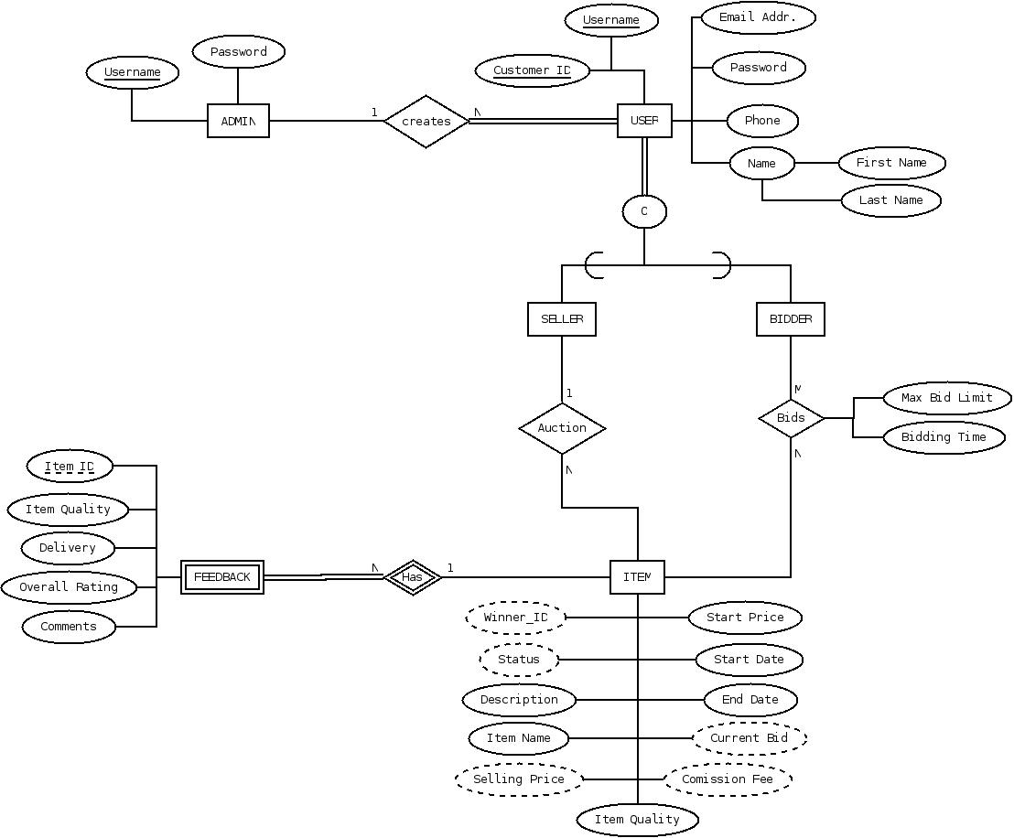Database Design *-* EER Diagram

Explanation of EER Diagram

Above is an updated version of our EER Diagram. Since our original submission of this diagram, we have restructured how *Feedback* links to the database, deleted various unnecessary entities, and where possible changed to derived attributes.

**CHANGE EER DIAGRAM – NEED TO DELETE ADMIN ENTITY**

Logical Database Design – Relational Mapping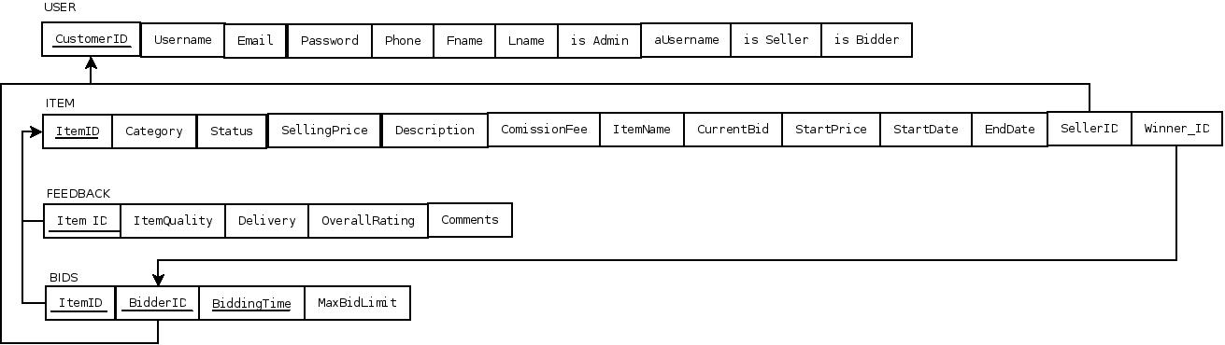

Explanation of Relational Map

Above is our up-to-date Relational Map. Since our original map design, we have made several changes. Including eliminating a few unnecessary items, and more properly mapping the relations involving foreign keys.

Issues Faced

During this phase we faced many different issues stemming from SQL Developer not working properly to figuring out how on earth everything would be connected and come together. Ultimately, we were able to vanquish many of these issues and by not cutting corners and working our hardest to ensure our solutions were both efficient and forward thinking, we will be saving ourselves lots of work in the next phase as well as making our product more complete.

When we began working on this phase, we started by going through every website that we designed during phase 1. For each webpage we discussed what exactly the purpose of that page was, and how we though to best accomplish that in terms of SQL implementation. Then we divided all of the tasks so each team member could work on their tasks before bringing them all together into final products. For some of these, issues arose when trying to implement our initial ideas so we had to bounce ideas off each other to determine what would actually be the best approach to the problems. This collaboration about our ‘separate’ parts of the project was immensely helpful as they often applied to more than one task which caused us to be consistent across the board when it came to the implementation.

Another problem we faced was a couple times when testing a SQL query on our team server, we experienced lag and sometimes crashing of our Horizon Client that was running on our personal computer (though not always the Client’s fault). While there is nothing we could really do at the time of crashing, we agreed that if we were each to have a copy of the databases on each of our individual Oracle DB connections, we could test our queries/functions/procedures/etc. without these bugs happening.

Task Decomposition

Grant:

* Responsible for (Components):
  + Admin Commission Report (View)
  + Sale Summary Report (View)
  + Bid Status (View)
  + User’s Rating(s) (View)

Kyle:

* Responsible for (Components):
  + Update Profile (Procedure)
  + Item List (View)
  + Update Item Info (Procedure)
  + Post Item (Procedure) – Additionally Sequence for ITEM_ID

Tom:

* Responsible for (Components):
  + Admin Login (Function)
  + User Login (Function)
  + Manage Users (View)
  + Add New User (Procedure) – Additionally Sequence for USER_ID
  + Bidder List (View)
  + Leave Feedback (Procedure)
* Compiled information into final report

All Team Members:

* Responsible for (Components):
  + Item Search
  + Search Results
  + Bid on Item
* Creating test cases and documentation to demonstrate the full functionality of the components they created

Team Potatoes Minutes

November 8, 2016

Meeting began at 3:45 am.

**In Attendance**:

* Grant Boyer
* Kyle Olson
* Thomas Husen

**All**:

* Discussed all of the elements that goes into this phase and the best approach for completing them
* Began creating database tables and populating them with sample data values
* Discussed our relational map and EER diagram as they relate to the database and began making appropriate changes

Meeting adjourned at 5:30 am.

Meeting Minutes

Team Potatoes Minutes

November 13, 2016

Meeting began at 4:30 pm.

**In Attendance**:

* Grant Boyer
* Kyle Olson
* Thomas Husen

**Tom**:

* Update EER and Relational Map based on our most recent decisions regarding our database

**All**:

* Review all webpages created during Phase 1 – generate spreadsheet breaking down each page to the tasks it needs to accomplish, how we think to best accomplish that task, comments about the task, and who is going to be responsible for completing that task
* Discuss any changes that are required to be made on the EER diagram or the Relational map

Meeting adjourned at 11:30 pm.

Team Potatoes Minutes

November 14, 2016

Meeting began at 11:15 am.

**In Attendance**:

* Grant Boyer
* Kyle Olson
* Thomas Husen

**Kyle**:

* Manage our task spreadsheet – ensuring all data is up to date with the latest decisions we have made as a group

**Tom**:

* Compile all information into phase report

**All**:

* Continue working on our individually assigned SQL components
* Continue developing test cases to ensure proper functioning of all SQL components

Meeting adjourned at 11:30 am.