College of Saint Benedict & Saint John’s University

Computer Science Department

GABeS

Phase 1

Team Potatoes

Grant Boyer, Kyle Olson, Tom Husen

[This page has been intentionally left blank]

Table of Contents

User Interface Map Design ………………………………………………………………………………………………………. 4

User Interface Sketches …………………………………………………………………………………………………… 5 - XX

User Interface Map Design:

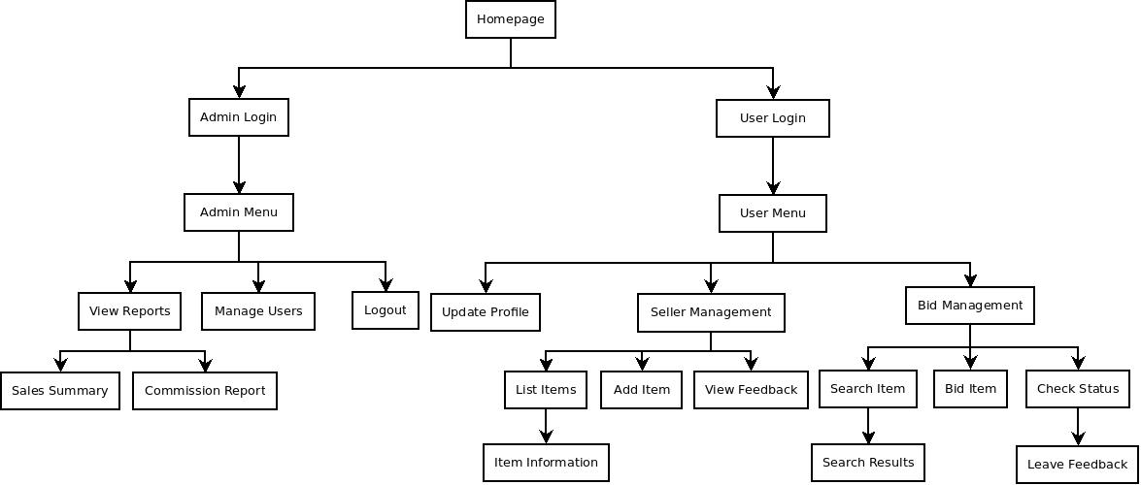

User Pages:

* User Login
* User Menu
* Update Profile
* Seller Management
  + List Items
    - Item Information
  + Add Item
  + View Feedback
* Bid Management
  + Search Item
    - Search Results
  + Bid Item
  + Check Status
    - Leave Feedback

Administrator Pages:

* Admin Login
* Admin Menu
* View Reports
  + Sales Summary
  + Commission Report
* Manage Users
* Logout

User Interface Sketches

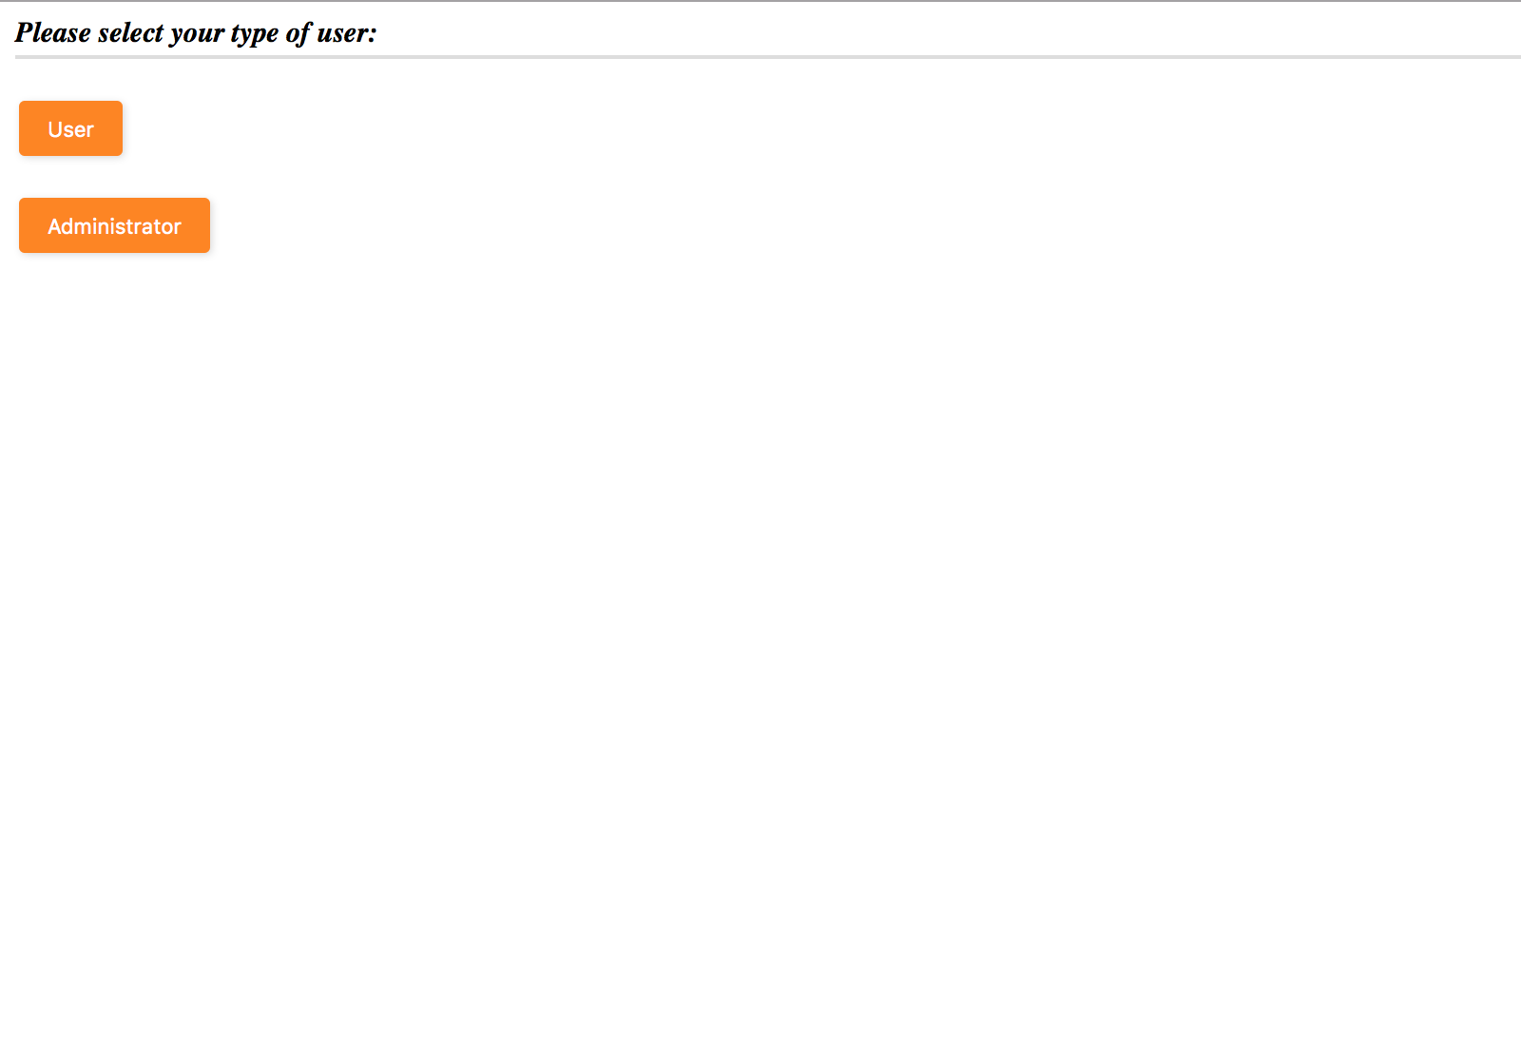

Homepage – This is the homepage for the site. You can either choose to login as a “user” or an “administrator”.

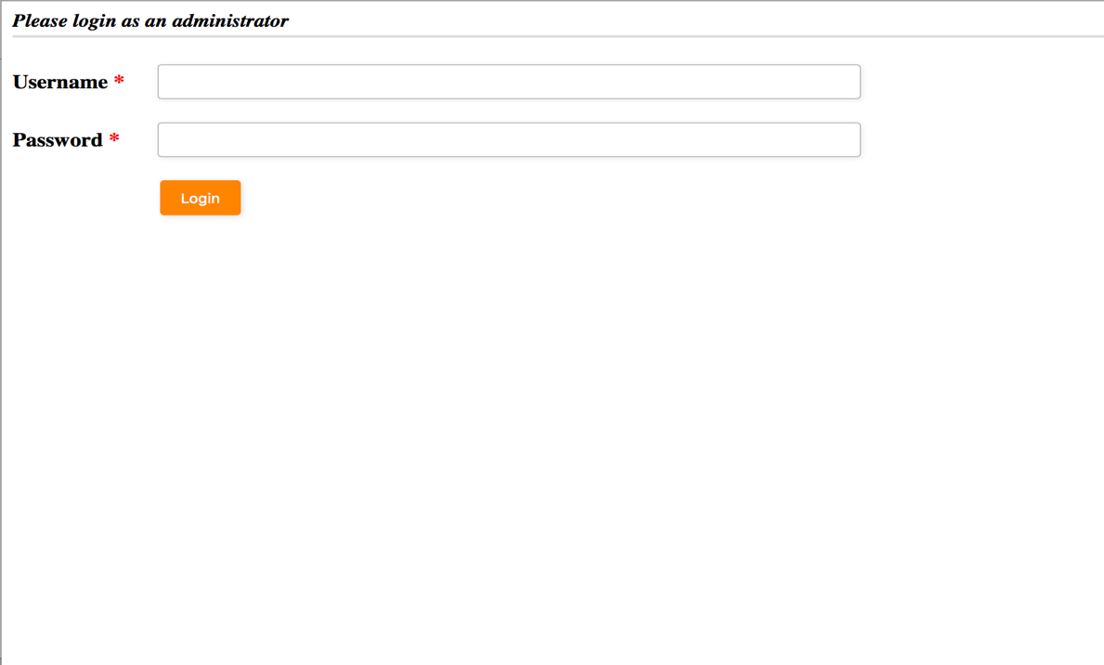

Admin Login – This is the page where administrator users will log into the system.

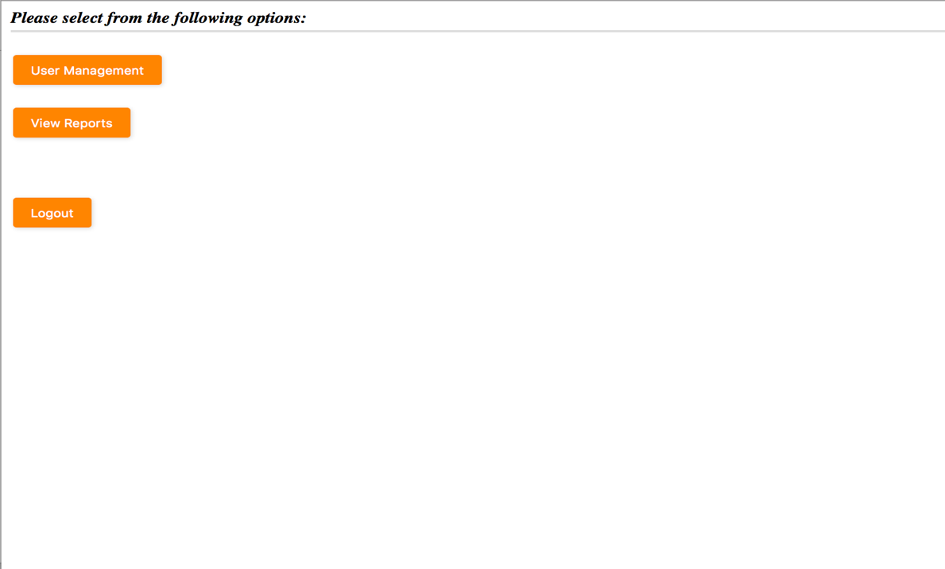

Admin Menu – This is the page that administrators will see when they log in. They will also have the option to navigate back to this page when on other pages within the website.

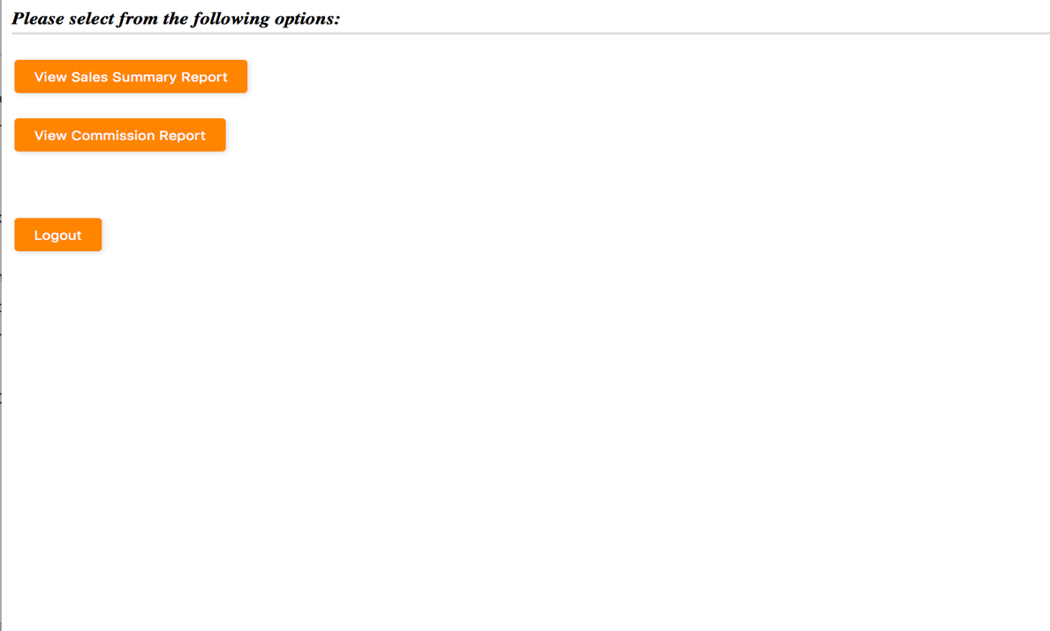

View Reports – This is the page that administrators will see if they choose to “View Reports” from the main menu. Here they can choose to view 2 different kinds of reports.

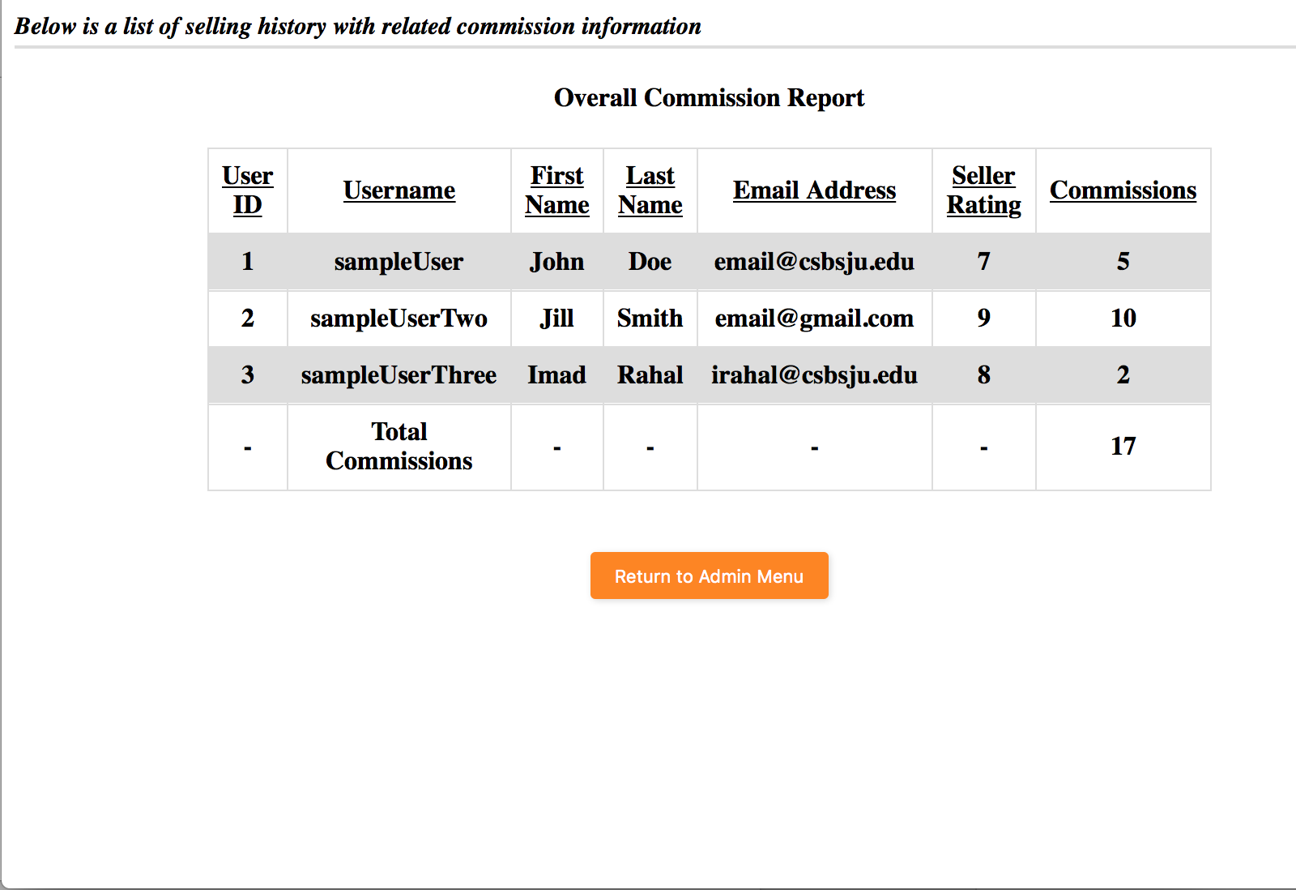

Admin Commission Report – This is the Commission Report page. Here administrators are able to see a list of users, their ratings, as well as their commissions. Also totals commissions for the entire site.

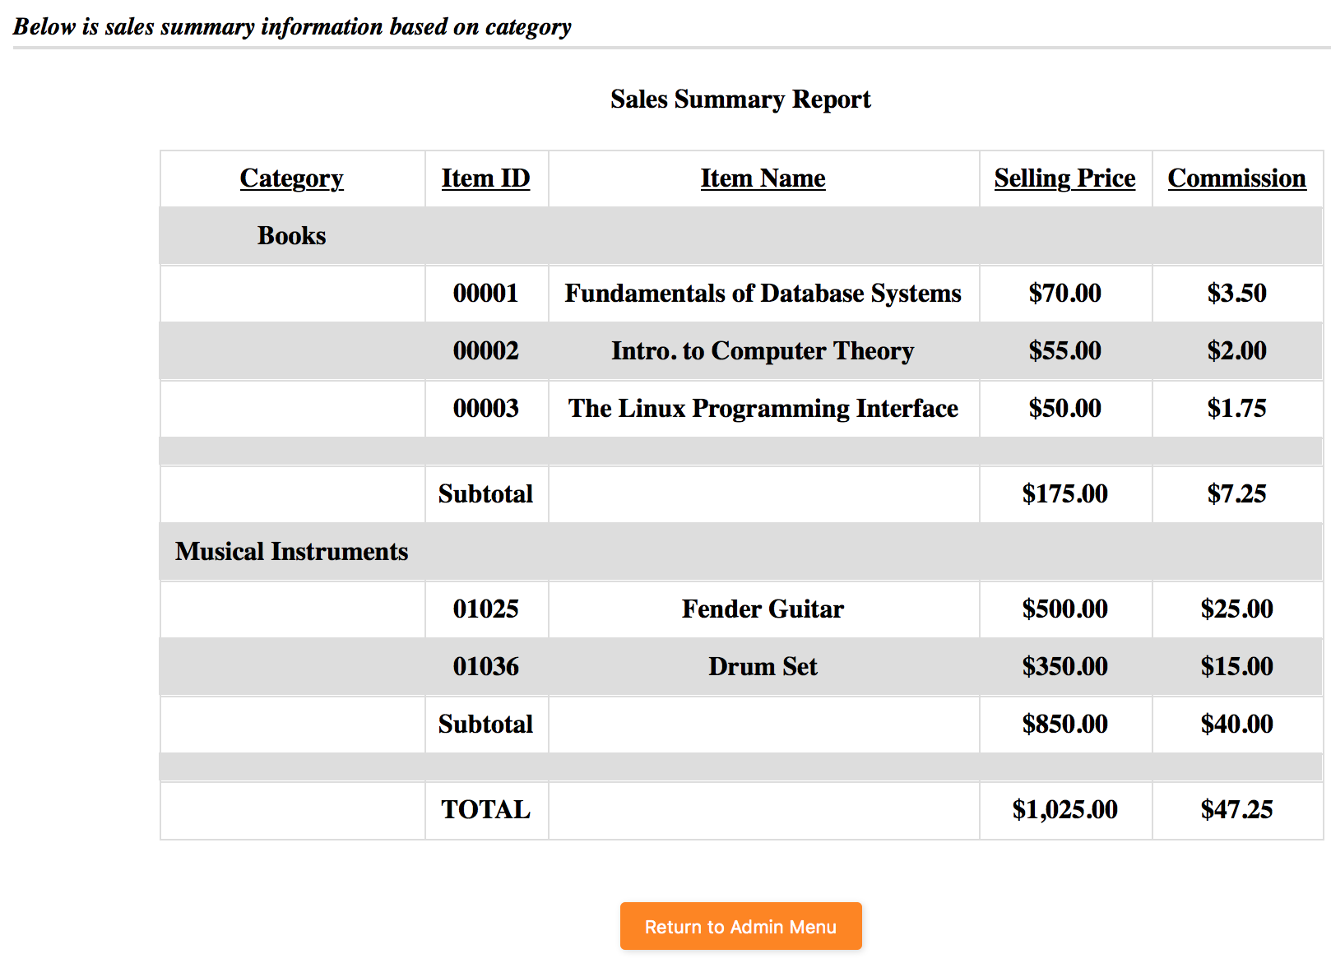

Sales Summary – This is the Sales Summary page. Here administrators can see a summary of things purchased on the site. Items are sorted by category. The info available is category, item id, name, price, and commission.

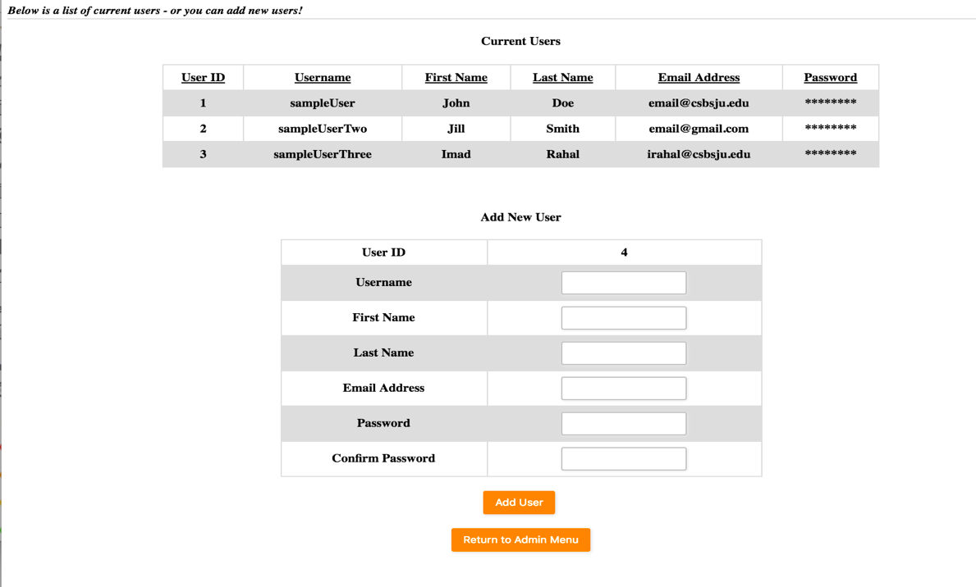

Manage Users – Here administrators can view all of the information for currently registered users. They can also create a profile for a new user (though they cannot change the user ID as it is generated by the system).