Ariel University
Department of Computer Science
Wireless and Mobile Network Security | Course #2-7038910-1

Assignment 1: Evil Twin Attack
Implementation Report

Submitted by:
Yakir Litmanovitch | Noa Agassi

Instructor: Dr. Eyal Berliner
June 2026

1. Introduction
The Evil Twin attack is a rogue access point (Rogue AP) attack targeting the inherent trust model of 802.11 wireless networks. A legitimate user who habitually connects to a known SSID (the "good twin") is forcibly disconnected via a spoofed Deauthentication frame and reconnects to a malicious AP operated by the attacker (the "evil twin"). Because both APs advertise the same SSID and BSSID, the victim's device cannot distinguish them. The attacker intercepts all victim traffic and redirects HTTP/HTTPS requests to a Captive Portal that harvests network credentials.
This report documents the design, implementation, and testing of a complete Evil Twin attack tool and a passive Evil Twin detection tool, developed for Assignment 1 of the Wireless and Mobile Network Security course at Ariel University.

1.1 Assignment Objectives
- Understand 802.11 WLANs: Gain hands-on understanding of Beacon Frames, Management Frames, and 802.11 protocol vulnerabilities.
- Develop an Attack Tool: Implement the full Evil Twin pipeline as a single interactive CLI tool.
- Implement Countermeasures: Build a passive detector that identifies Evil Twin attacks in real time.
- Technical Skills: Apply Python/Scapy for 802.11 packet analysis and Linux system utilities (hostapd, dnsmasq, iptables) for network management.

1.2 Key 802.11 Concepts Exploited
- Beacon Frames: Periodically broadcast by every AP. Contain SSID, BSSID, channel, and capabilities. Unauthenticated — any device can forge them.
- Deauthentication Frames: Management frames (type=0, subtype=12). In WPA2 without 802.11w, they carry no cryptographic authentication and can be spoofed trivially.
- BSSID Cloning: By setting addr2/addr3 equal to the legitimate AP's MAC, a rogue AP appears identical in all client association logic.
- DNS Hijacking: The rogue AP's dnsmasq resolves all DNS queries to the attacker's IP, ensuring every URL the victim visits hits the Captive Portal.
- Captive Portal: An HTTP server intercepting all victim web traffic. Combined with iptables NAT rules, HTTPS requests are also redirected (connection warning appears on victim browser).

2. System Architecture
The project is organized as a set of focused Python modules, each responsible for exactly one attack stage. The orchestrator (evil_twin.py) drives all stages sequentially from a single sudo python3 evil_twin.py invocation with no additional shell commands required.
Module | Stage | Responsibility
evil_twin.py | Orchestrator | Hardware setup, stage sequencing, real-time status loop, clean shutdown
scanner.py | Stage 2 | Channel-hopping Beacon sniffer; builds deduplicated network list
client_discovery.py | Stage 4 | Data/management frame sniffer; ranks clients by packet count
rogue_ap.py | Stage 5 | Launches hostapd + dnsmasq; configures IP and iptables redirect rules
captive_portal.py | Stage 6 | Threaded Flask server; serves fake login page; stores captured credentials
deauth.py | Stage 7 | Injects spoofed Deauth frames in both directions via monitor interface
defense/detector.py | Defense | Passive Beacon monitor; multi-method Evil Twin detection with alert levels

2.1 Hardware Setup
Two wireless adapters are recommended:
- Adapter 1 (monitor interface) — monitor mode; used for Beacon sniffing, client discovery, and Deauth injection.
- Adapter 2 (AP interface) — used exclusively by hostapd to host the Evil Twin AP.
The tool detects single-adapter scenarios and disables Deauth automatically to avoid interface conflicts.

3. Attack Tool
The attack tool implements all six required stages as a unified interactive CLI. The operator is guided through each stage with clear prompts and real-time feedback.

Stage 1 — Hardware Selection
The tool auto-detects all wireless interfaces using the iw command. The user selects one interface for monitor mode (sniffing + Deauth) and a second for AP mode. The monitor interface is then configured with: iw dev <iface> set monitor none.
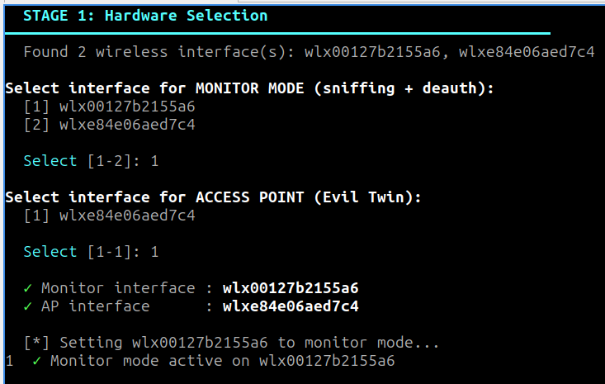
Figure 1 — Stage 1: Hardware selection and monitor mode activation.

Stage 2 — Network Discovery (60-second scan)
The monitor interface hops across channels 1-13 while Scapy sniffs for Beacon Frames. Each Beacon is parsed for SSID (Dot11Elt ID=0), BSSID (addr3), Channel (Dot11Elt ID=3), RSSI (RadioTap.dBm_AntSignal), and Security type (WPA2 via Dot11EltRSN, WPA via vendor IE 0x00-50-f2-01, WEP via capability bit, otherwise Open). Results are deduplicated by BSSID.
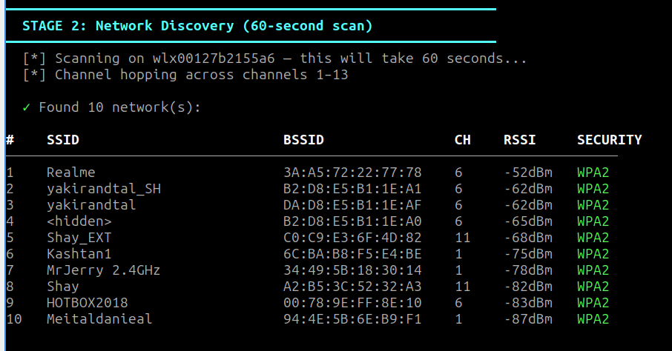
Figure 2 — Stage 2: Network scan results table after 60-second channel-hopping scan.

Stage 3 — Target Selection
The user selects a target network by number. The tool prints the confirmed selection (SSID, BSSID, Channel, Security) and passes it to all downstream stages.
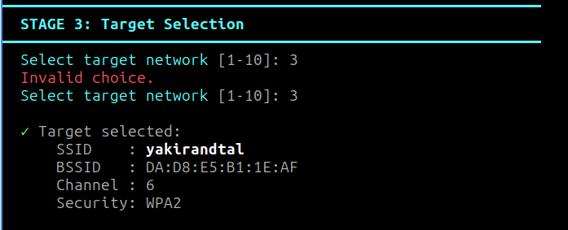
Figure 3 — Stage 3: Target network confirmed.

Stage 4 — Victim (Client) Discovery
The monitor interface is locked to the target channel. Scapy sniffs for 30 seconds, collecting all 802.11 frames referencing the target BSSID. Client MACs are extracted from address fields (addr1/addr2 depending on frame direction). Multicast and broadcast MACs are filtered using the 802.11 multicast bit rule (LSB of first byte == 1). Clients are sorted by packet count (most active first).
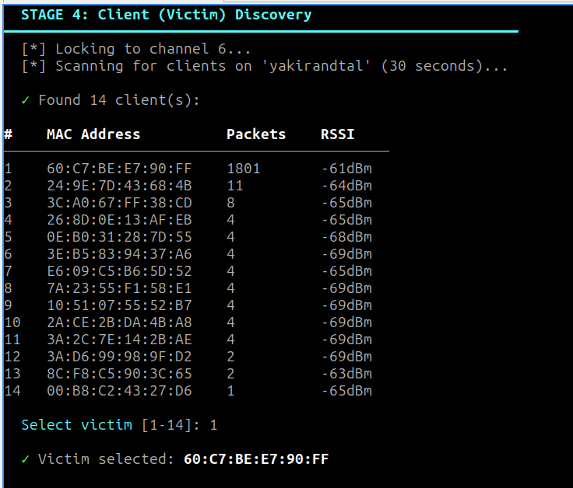
Figure 4 — Stage 4: Client discovery. Phone identified as most active client (1801 packets).

Stage 5 — Evil Twin AP Creation
The rogue_ap module creates the Evil Twin by:
- Generating hostapd.conf: target SSID, cloned BSSID, target channel, hw_mode=g, no WPA (open network)
- Starting hostapd as a subprocess; PID tracked for clean shutdown
- Assigning static IP 10.0.0.1 to the AP interface via ip addr add
- Starting dnsmasq: DHCP pool 10.0.0.10-50, all DNS queries resolved to 10.0.0.1 (DNS hijacking)
- Installing iptables PREROUTING rules: TCP port 80 and 443 redirected to port 8080 (Captive Portal)
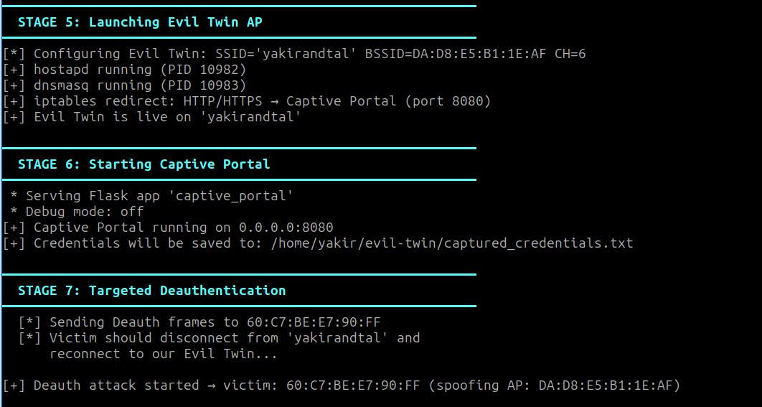Insert screenshot here

Figure 5 — Stage 5: Evil Twin AP live. All subsystems confirmed running.

Stage 6 — Captive Portal (Credential Capture)
A threaded Flask server runs on 0.0.0.0:8080. Combined with DNS hijacking and iptables redirect rules, any URL the victim opens resolves to the Captive Portal. The portal serves a 'Network Authentication' page. When credentials are submitted, they are:
- Printed immediately to the attacker's terminal with timestamp, IP, username, and password
- Appended to captured_credentials.txt in the format: [YYYY-MM-DD HH:MM:SS] IP=... USER=... PASS=...
- Followed by a 'connection verified' page shown to the victim (social engineering)
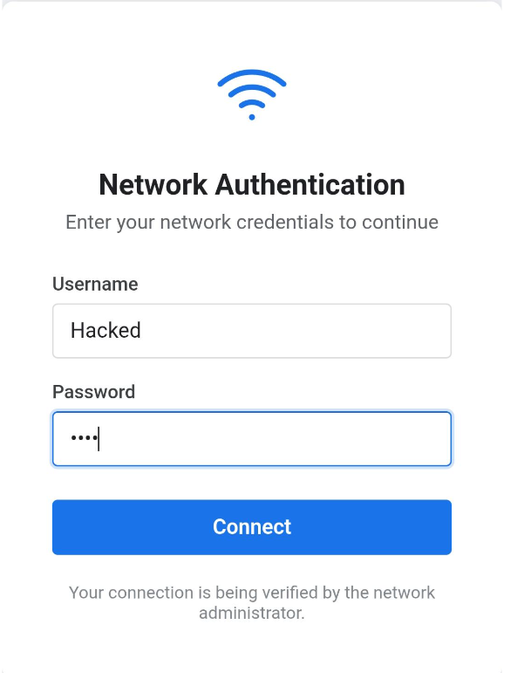
Figure 6 — Stage 6: Captive portal as displayed on the victim's device.
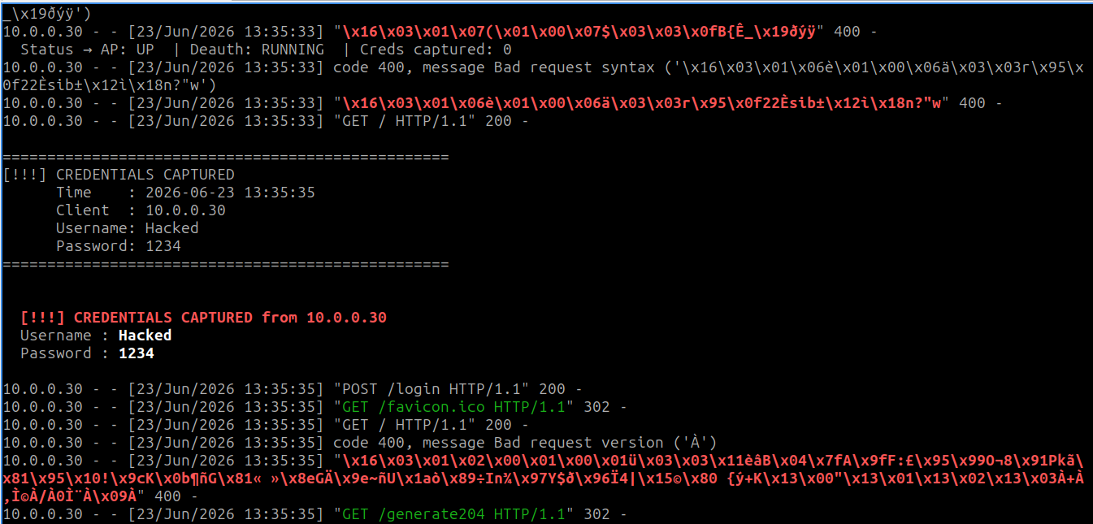
Figure 7 — Stage 6: Real-time credential capture notification and status update.

Stage 7 — Targeted Deauthentication
Spoofed 802.11 Deauth frames are sent via the monitor interface. Two directions are used per burst:
- AP to Client: addr1=victim MAC, addr2=spoofed AP BSSID. The victim's device believes its own AP is requesting disconnection.
- Client to AP: addr1=AP BSSID, addr2=spoofed victim MAC. The AP believes the client is disconnecting.
Burst size: 64 frames per direction. Inter-frame gap: 10ms. Reason code: 7 ('Class 3 frame received from nonassociated STA'). The burst loop runs continuously until the operator stops the tool (Ctrl+C).
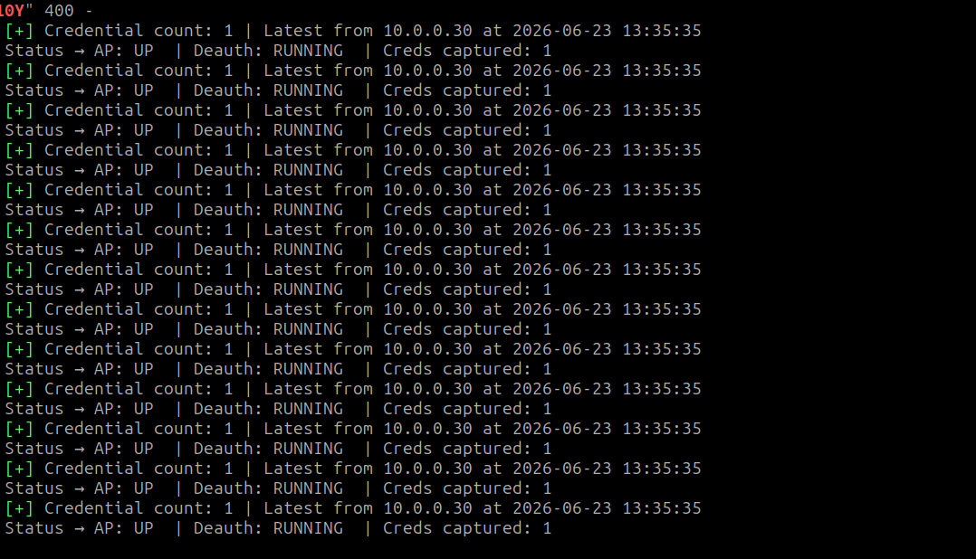

Figure 8 — Stage 7: Targeted deauthentication active. Status loop confirms all components running.

4. Defense Tool
The defense tool (defense/detector.py) is a standalone passive Evil Twin detector. It operates entirely on a monitor-mode interface using Scapy Beacon sniffing — no active probing, no network interference.

4.1 Operating Phases
- Learning Phase (default 30 seconds): All observed APs are recorded as legitimate baseline entries. No alerts are raised. Each entry stores: SSID, BSSID, channel, security type, RSSI, and IE fingerprint.
- Detection Phase (indefinite): Every subsequent Beacon is compared against the baseline. Anomalies trigger color-coded alerts.

4.2 Detection Methods
Detection Method | Alert Level | Logic
BSSID Anomaly | HIGH | New BSSID seen for an SSID already recorded from a different BSSID during learning. Indicates a rogue AP cloning a known network name.
Security Downgrade | HIGH | Known WPA2/WPA network suddenly appears as Open. Core Evil Twin indicator — rogue AP drops encryption to allow easy victim connection.
Evil Twin Confirmed | CRITICAL | BSSID anomaly AND security downgrade simultaneously. Highest-confidence detection; definitively identifies Evil Twin.
Beacon Fingerprint | MEDIUM | The ordered sequence of Information Element IDs in Beacon Frames differs from the baseline. Different hardware/firmware produces unique IE orderings even for identical SSIDs.

4.3 Why These Methods Are Effective
An Evil Twin must replicate the SSID to lure victims but cannot perfectly replicate the baseline from a different physical device. The open network requirement (to avoid needing the WPA2 password) creates a measurable security downgrade anomaly. Beacon fingerprinting adds a hardware-level signal: even if the attacker clones SSID and BSSID, the IE element ordering produced by different chipsets is effectively a device fingerprint.

4.4 Test Results
The detector was tested against a simulated Evil Twin created by configuring the operator's phone as a hotspot with SSID='yakirandtal' (open, no password) — matching the legitimate WPA2 network. After the 30-second learning phase, the detector identified the attack immediately.
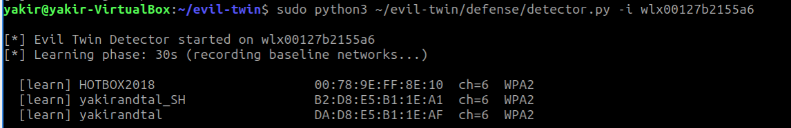

Figure 9 — Defense tool learning phase: 3 legitimate APs recorded as baseline.
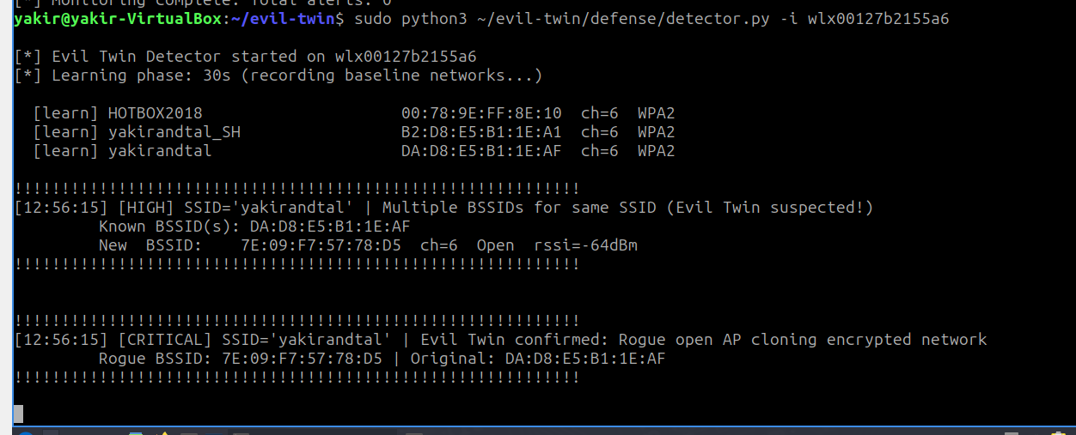

Figure 10 — Detection result: HIGH + CRITICAL alerts raised. Rogue BSSID and original confirmed.

5. Test Results Summary
Stage / Test | Description | Result
Hardware Selection | 2 interfaces detected; monitor + AP assigned; monitor mode set | PASS
Network Discovery | 60-second scan; 10 networks with correct SSID/BSSID/CH/RSSI/Security | PASS
Target Selection | User selects target by number; full details confirmed | PASS
Client Discovery | Phone (60:C7:BE:E7:90:FF) identified; 1801 packets; -61dBm | PASS
Evil Twin AP | hostapd + dnsmasq started; IP assigned; iptables redirect active | PASS
Captive Portal | Victim connects; login page served; credentials captured and saved | PASS
Credential File | captured_credentials.txt: timestamped IP/USER/PASS entries | PASS
Deauth (no PMF) | Spoofed frames injected; victim disconnected from legitimate AP | PASS
Deauth (PMF enabled) | PMF-protected router ignores spoofed frames; expected limitation | LIMITATION
Cleanup (Ctrl+C) | hostapd, dnsmasq, iptables, Flask all stopped cleanly | PASS
Defense — Learning | 3 legitimate APs recorded in 30 seconds | PASS
Defense — Detection | HIGH + CRITICAL alerts raised within seconds of rogue AP activation | PASS

Test environment: Ubuntu 22.04 VM (VirtualBox). Monitor adapter: EDUP AX3000 (wlx00127b2155a6). AP adapter: second USB adapter (wlxe84e06aed7c4). Target: yakirandtal (WPA2, CH 6). Victim: Android phone.

6. Known Limitations
PMF / 802.11w (Protected Management Frames)
Deauthentication attacks are fully mitigated when the AP enforces 802.11w (PMF mandatory). The client cryptographically verifies management frames and ignores spoofed Deauth packets. This is a protocol-level defense standardized precisely to prevent this attack class. WPA2 networks without PMF remain vulnerable. Manual disconnection is the workaround.
Two Wireless Adapters Required for Full Functionality
hostapd takes exclusive control of the AP interface. Using the same interface for both the AP and Deauth injection is not possible simultaneously. The tool detects single-adapter mode and disables Deauth, printing a clear warning. Two adapters are strongly recommended.
2.4 GHz Focus
hostapd is configured with hw_mode=g (802.11g, 2.4 GHz). Targeting 5 GHz APs requires hw_mode=a and a 5 GHz-capable adapter. The tool can be extended for dual-band operation.
MAC Randomization
Android 10+ and iOS 14+ randomize MAC addresses per Wi-Fi network by default. When randomization is active, the victim's MAC changes each connection session, making reliable client identification more difficult. The fix: disable per-network MAC randomization on the victim device, or use packet-count and RSSI heuristics to identify the target.
NetworkManager Interference
NetworkManager may attempt to reconfigure or reconnect the wireless interfaces, disrupting the Evil Twin AP or monitor mode. It must be stopped before running the tool (sudo systemctl stop NetworkManager).

7. Conclusion
This project successfully implements a complete Evil Twin attack pipeline and a corresponding passive detection system. The attack demonstrates a fundamental 802.11 vulnerability: the absence of mutual authentication for management frames and the inability of clients to cryptographically verify AP identity beyond SSID matching.
All six required attack stages are implemented and tested end-to-end under a single interactive CLI. The credential capture pipeline — from DNS hijacking through captive portal submission — was verified in live testing. The tool provides real-time feedback at every stage, meeting the assignment requirement for situation awareness.
The defense tool demonstrates that Evil Twin attacks are passively detectable through Beacon Frame analysis alone. The combination of BSSID anomaly detection, security downgrade monitoring, and beacon fingerprinting provides high-confidence, low-false-positive detection without any active probing or impact on the monitored network.
The primary real-world limitation — PMF (802.11w) rendering Deauth injection ineffective — reinforces the educational value of this assignment: understanding both the attack and the standardized protocol-level defenses that exist against it.

7.1 Key Takeaways
- 802.11 management frames are unauthenticated by default, enabling trivial spoofing of Deauth and Beacon frames.
- PMF (802.11w) is the standardized defense against Deauth injection and should be enforced on all WPA2/WPA3 deployments.
- Evil Twin detection is achievable passively — no active probing needed — by monitoring for BSSID anomalies and security changes.
- Beacon fingerprinting via IE ordering provides a hardware-level identity signal that is difficult for attackers to replicate.
- The captive portal is effective because HTTP redirect failures mimic legitimate authentication prompts, especially on mobile devices.

Appendix A — Installation & Usage

A.1 System Dependencies
sudo apt update
sudo apt install -y hostapd dnsmasq python3-pip
sudo systemctl stop NetworkManager systemd-resolved
sudo systemctl disable NetworkManager systemd-resolved

A.2 Python Dependencies
pip3 install -r requirements.txt
# requirements.txt: scapy, flask

A.3 Running the Attack Tool
cd ~/evil-twin/evil_twin
sudo python3 evil_twin.py

A.4 Running the Defense Tool
sudo python3 defense/detector.py -i wlan0
# -i / --interface monitor-mode interface (required)
# -l / --learn learning phase in seconds (default: 30)
# -d / --duration total runtime in seconds (0 = infinite)

A.5 File Structure
evil_twin/
evil_twin.py # Main entry point / orchestrator
scanner.py # Stage 2: Network discovery
client_discovery.py # Stage 4: Victim identification
rogue_ap.py # Stage 5: Evil Twin AP (hostapd + dnsmasq)
deauth.py # Stage 7: Targeted deauthentication
captive_portal.py # Stage 6: Credential capture (Flask)
templates/login.html # Captive portal web page
configs/ # Runtime config files (auto-generated)
defense/detector.py # Defense: passive Evil Twin detector
requirements.txt
README.md

