Assignment #4 — ThingsBoard Hello World
Student: Yakira_S
Course: IoT
Date: 2026-05-29

Login to ThingsBoard Cloud
Signed up at thingsboard.cloud and logged in via GitHub OAuth. The ThingsBoard Tenant interface homepage confirms successful authentication.
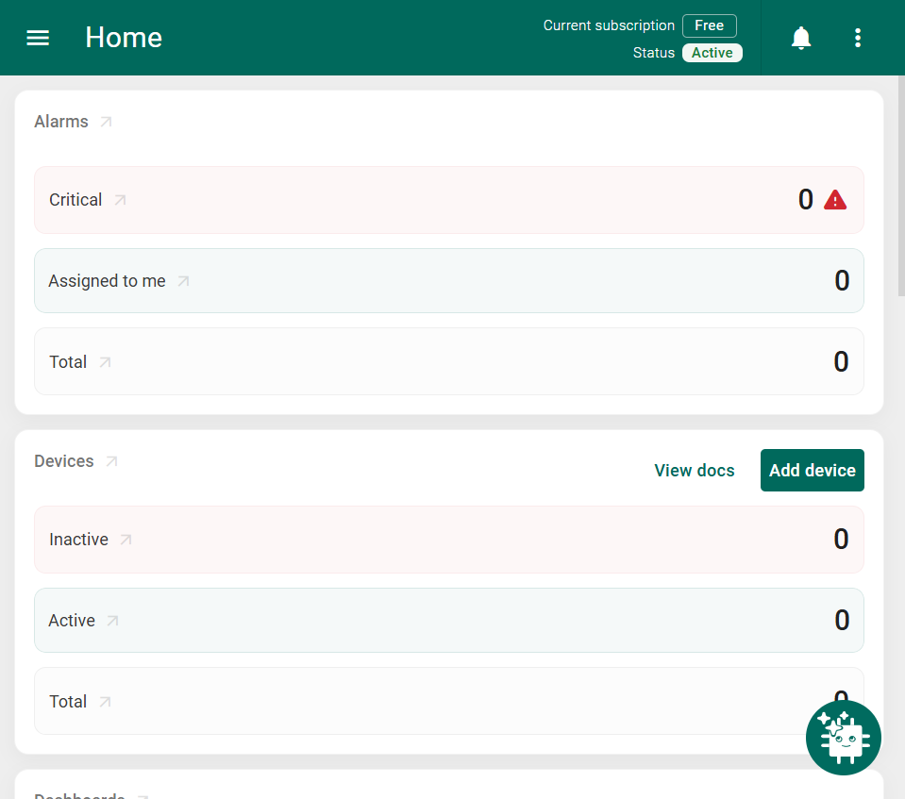

Step 1: Device Provisioned
Created a device named 'Thermometer' using Entities → Devices → Add new device. The device was created with Device profile: default.
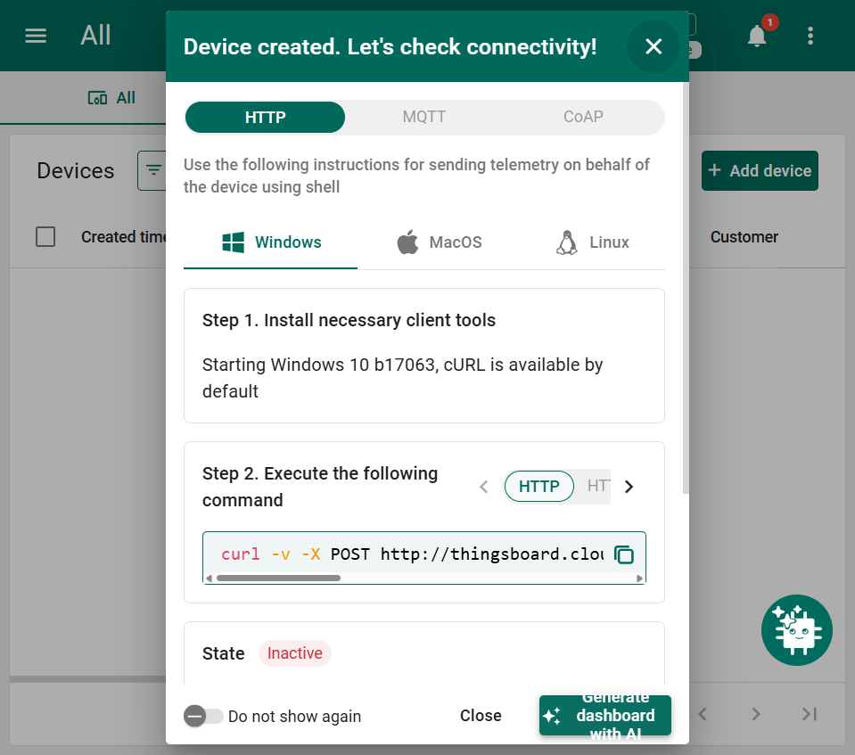

Step 1: Telemetry Active
Used the built-in 'Check connectivity' tool to send temperature=25 via HTTP POST. Device status changed from Inactive to Active and Latest Telemetry shows temperature=25.
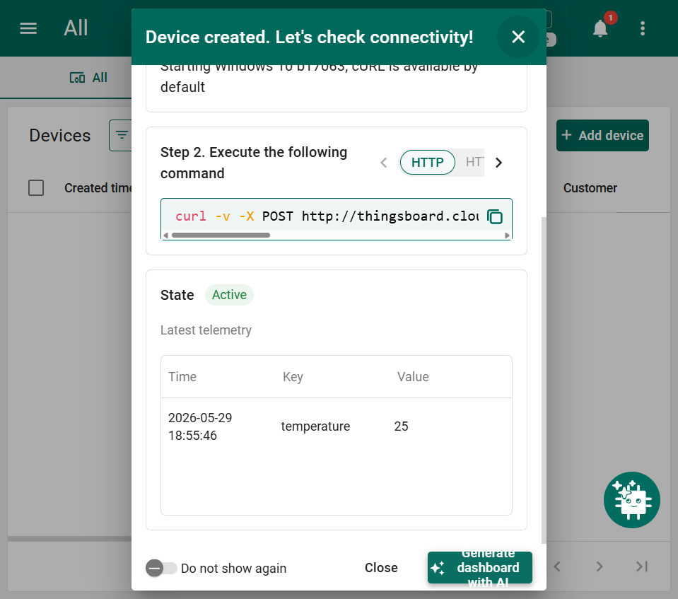

Step 2: Real-Time Dashboard
Created 'My Dashboard' with three widgets: Value card (current temperature), Time series chart (historical data), and Alarms table — all showing live data from the Thermometer device.
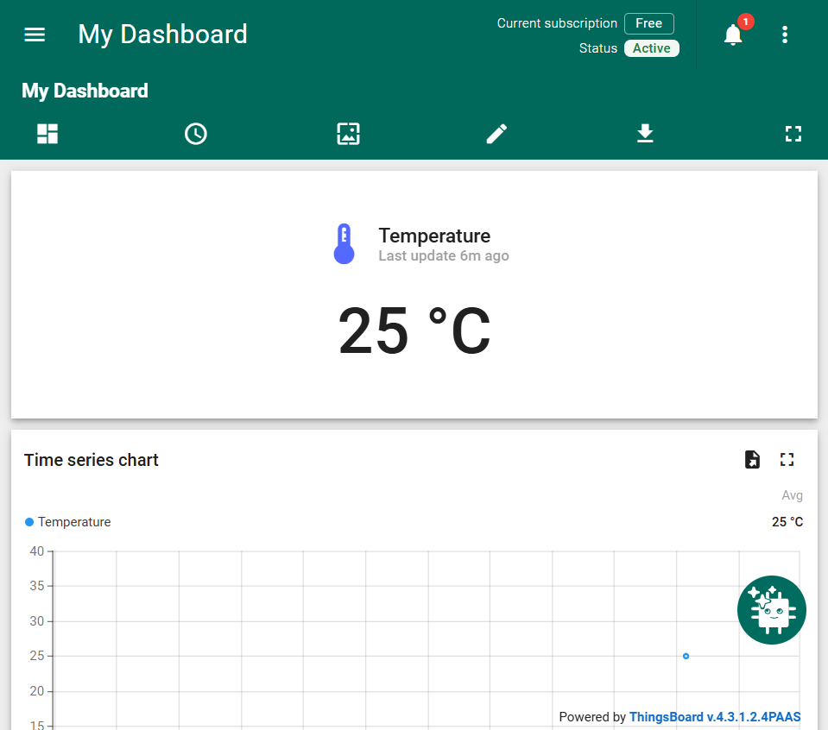

Step 3: Alarm Rule Defined
Created a 'High temperature' alarm rule via Alarms → Alarm rules. Condition: return temperature > 25; (Script mode, severity: Critical, Device profile: default).
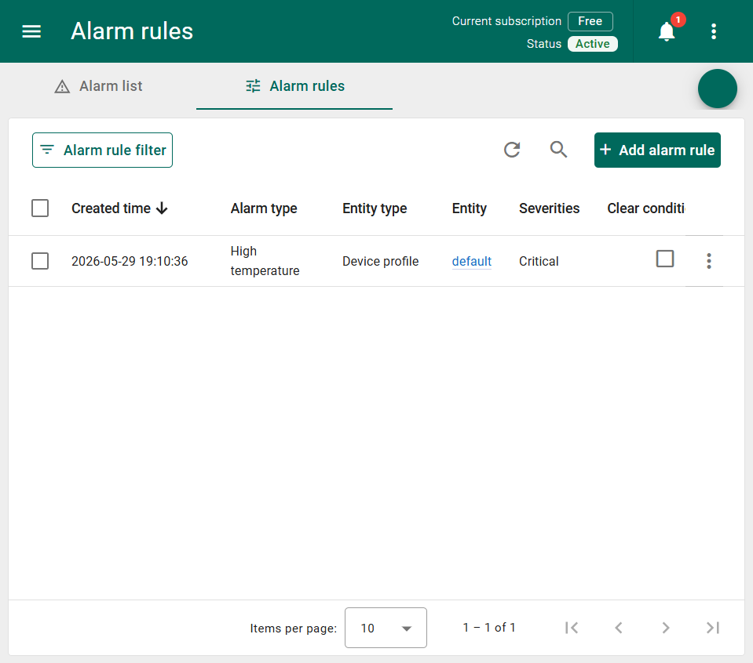

Step 3: Alarm Triggered
Sent temperature=26 via Check connectivity (above the threshold of 25). ThingsBoard raised a Critical 'High temperature' alarm visible in the Alarm list.
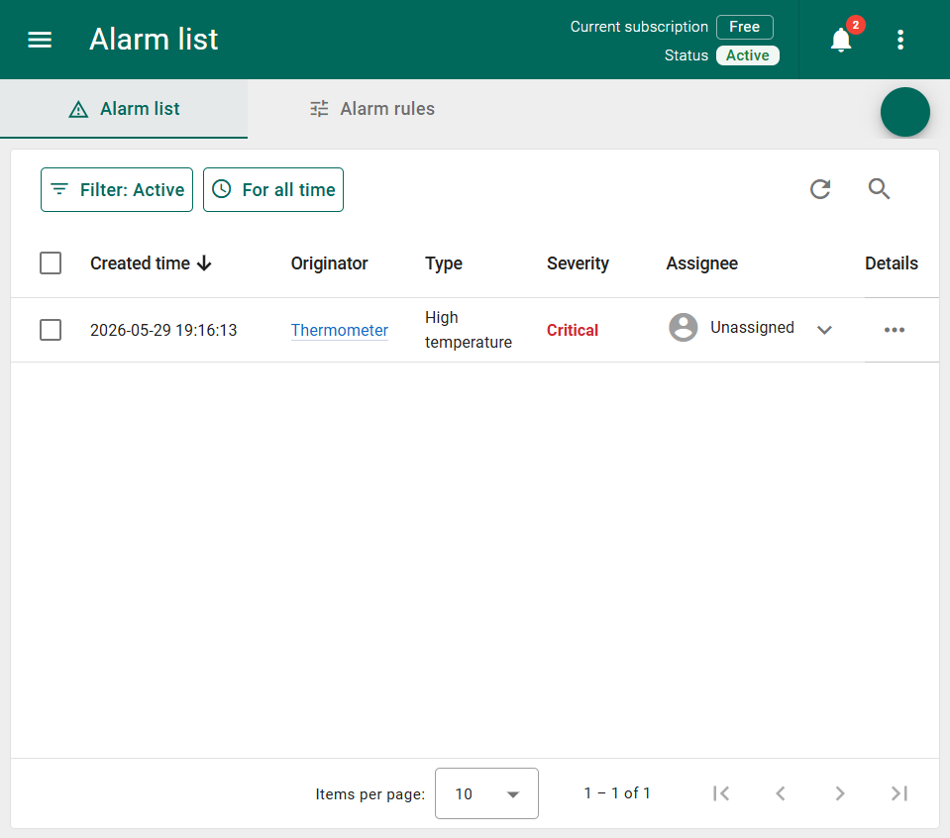

Step 4: Customer Created
Created customer 'My New Customer' and assigned the Thermometer device and My Dashboard to them via Manage owner and groups on each entity.
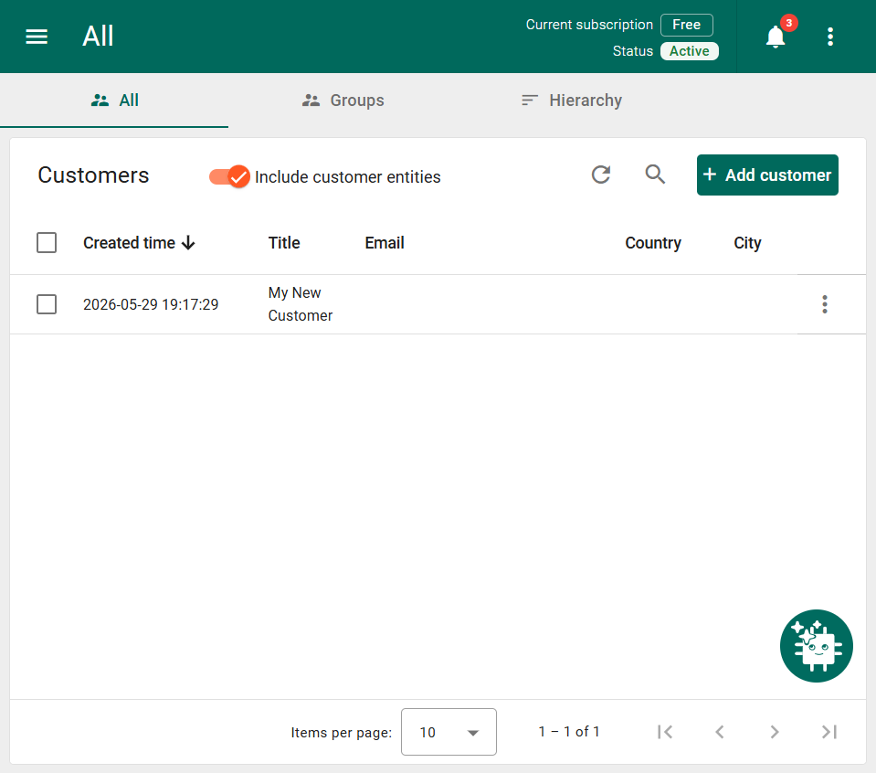

Step 5: Customer User Activated
Created customer user account (customer.test.iot@yopmail.com) and activated it via the Display activation link method. The customer user sees only Home, Resources, and Notification center — no admin features, confirming the limited customer role.
