EduTutor AI

# Personalized Learning Revolution

EduTutor AI is an advanced educational platform leveraging Artificial Intelligence to deliver a truly personalized learning experience. Unlike conventional systems, it dynamically adapts to each student's unique needs, offering tailored content, interactive quizzes, and comprehensive performance tracking. Our platform aims to make learning more effective, engaging, and accessible by utilizing powerful AI models for explanations, question answering, and material recommendations.

TEAM DETAILS

Team ID: NM2025TMID03700

Team Size: 4

Team Leader: MOHAMMED YAKOOB Z

Team Member: BALAMURUGAN E

Team Member: BHARATHI M

Team Member: BHUVANESH K

# Our Vision: Bridging the Educational Gap

The core purpose of Edu-Tutor AI is to bridge the divide between traditional education and modern digital learning. We empower students to grasp complex concepts at their own pace through personalized learning paths, while simultaneously providing educators with invaluable insights into individual student progress. This design enhances learning efficiency, improves knowledge retention, and reduces the administrative burden on teachers, fostering an interactive and engaging educational environment.

**Personalized Pace**

Students learn at their optimal speed, ensuring deeper understanding.

**Educator Insights**

Teachers gain data-driven views into student performance and needs.

**Enhanced Efficiency**

Streamlined learning processes lead to better retention and engagement.

# Core Features: Empowering Students & Educators

EduTutor AI is packed with innovative features designed to transform the learning journey, making it more intuitive and effective for everyone involved.

### Personalized Paths

Content adapts based on individual student progress and learning preferences.

### Interactive Q&A

Students receive instant, AI-generated explanations for their questions.

### Progress Tracking

Visual dashboards monitor learning achievements and pinpoint weak areas.

### Content Recommendations

Intelligent suggestions for additional study materials to deepen understanding.

### Multiple Formats

Upload and utilize PDF and text documents as primary study materials.

### Feedback System

Students can submit feedback for continuous improvement of the system.

# Robust & Scalable Architecture

EduTutor AI is built on a modular architecture, ensuring high scalability, maintainability, and ease of updates. Each component is designed to function independently while seamlessly integrating to provide a cohesive and powerful platform.

### Frontend

Gradio-based user interface for all interactions and

visualizations.

### Authentication

Secure layer for user login and session management.

### Backend

Python server processing requests and managing data flow.

### AI Model

Pre-trained language model (e.g., IBM Granite) for content generation.

### Database

Relational database for secure storage of user data and progress.

# Quick Start Guide: Setting Up EduTutor AI

Follow these straightforward steps to get EduTutor AI up and running on your local machine. Ensure you have Python 3.8 or above installed before proceeding.

01

### Clone Repository

02

### Install Dependencies

git clone https://github.com/your- repo/EduTutorAI.git

cd EduTutorAI

pip install -r requirements.txt

03

### Download AI Model

Place the pre-trained AI model into the /models

directory.

04

### Configure Database

Set up your database connection details in

config.py.

05

### Run Application

06

### Access Interface

Open the displayed local URL in your browser to start using EduTutor AI.

python app.py

# Project Structure & Execution

## Organized Folder Structure

The project is meticulously organized for clarity and modularity, making development and maintenance efficient.

EduTutorAI/

=%% app.py

=%% requirements.txt

=%% models/

=%% assets/

=%% database/

=%% utils/

=%% tests/

=%% config.py

5%% README.md

## Running the Application

Once the setup is complete, launching EduTutor AI is simple. The system will provide a local URL for interaction.

Execute the main Python script:

python app.py

Access the intuitive web interface via the provided URL (e.g., [**http://localhost:7860**](http://localhost:7860/)). Students can then ask questions, upload study materials, track progress, and provide feedback.

# Seamless Integration: EduTutor AI APIs



**POST /feedback**

Submit feedback regarding system suggestions or answers. Request Format:

**3**

{ "user_id": "1234", "feedback": "Answer was unclear, please elaborate more."

}

Response:

{ "status": "Feedback submitted successfully." }

EduTutor AI exposes several RESTful APIs, enabling easy integration with other systems and extending its functionality.

**POST /ask**

Submit a question and receive an AI-generated answer. Request Format:

**1**

{ "user_id": "1234", "question": "What is photosynthesis?" }

Response Format:

{ "answer": "Photosynthesis is the process by which plants convert sunlight..."

}

**2**

**GET /progress**

Retrieve a student9s learning progress and performance metrics. Response Format:

{ "user_id": "1234", "completed_lessons": 5, "accuracy": "85%" }

# Secure & Intuitive User Experience

## Robust Authentication

EduTutor AI prioritizes user security with a robust authentication system:

 Users register securely using email and password.

 Passwords are hashed before storage in the database.

 Secure session management prevents unauthorized access.



Future plans include token-based authentication for enhanced API security.

## User-Friendly Interface

The UI is meticulously designed for simplicity and effectiveness, ensuring a seamless learning experience:

 Clean input forms for easy question submission.

 Interactive progress graphs visualize learning over time.

 Dedicated section for uploading study materials (PDFs, text files).

 Responsive design ensures optimal usability across all devices.

# Project Output

1. Enter the Concept in the Concept Explanation section to Generate detailed Explanation For the Given Concept.

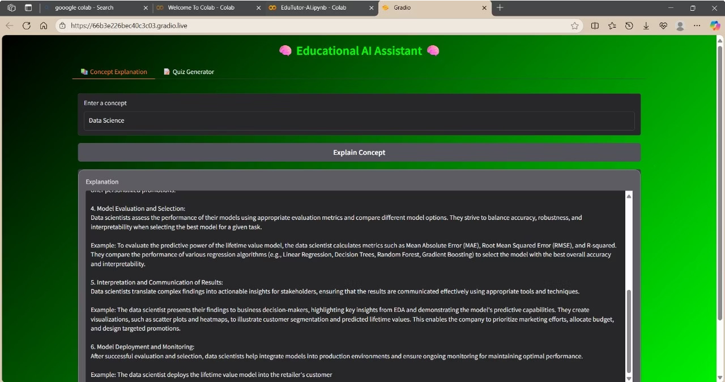

1. Enter any Topic in the quiz generator section to generate quizzes related to the given topic with the help of edututor ai.



# Known Issues

1. Lack of Emotional Support 3 AI tutors cannot provide empathy or motivation like human teachers.
2. Over-Reliance on Technology 3 Students may depend too much on AI, affecting critical thinking.
3. Reduced Social Interaction 3 Limited peer and teacher interaction impacts social skill development.
4. Risk of Misinformation 3 AI may provide incorrect answers if data is flawed.
5. Privacy Concerns 3 Collects student data, raising potential privacy issues.
6. Accessibility Issues 3 Requires good internet and devices; can widen the digital divide.
7. Bias in AI Algorithms 3 Training data biases may affect fairness in learning outcomes.
8. Technical Challenges 3 Integration with existing curricula and systems can be difficult.

# The Road Ahead: Future Innovations & Current Limitations

EduTutor AI is continuously evolving. While we have ambitious plans for future enhancements, we also acknowledge current limitations that we are actively working to address.

## Known Issues

 Occasional latency in model inference, depending on hardware.

 Limited multimedia support, currently only PDFs and text files.

 Basic error handling for network failures or invalid inputs.

 Voice-based interaction is not yet implemented.

## Future Enhancements

 Implement voice-based question answering for hands-free interaction.

 Expand support to include video content as study materials.

 Develop adaptive quizzes based on real-time student performance.

 Integrate an improved recommendation engine using advanced analytics.

 Launch a dedicated mobile application for on-the-go learning.