Database Grad Project

Milestone 4

David Hawbaker

Yaksh Patel

**Description of Project:**

This project is to build a database for organizing the 3D meshes of the ShapeNet dataset from Stanford. The dataset includes 3D meshes, texture images, metadata, descriptions and how they are all related together. The data was organized in json files and text files. We converted those into a database to improve the organization and to quickly get information from the database about the dataset.

**DDL SQL**

CREATE TABLE mesh.Categories (synsetId INT, Name Varchar(100), numInstances INT, Primary key (synsetId));

CREATE TABLE mesh.ChildrenRel (ParentID INT, ChildID INT, Foreign Key (ParentID) References Categories (synsetId), Foreign Key (ChildID) References Categories (synsetId) );

CREATE TABLE mesh.MeshData (MeshID VARCHAR(40), numVerticies INT, minX NUMERIC(8, 5), minY NUMERIC(8, 5), minZ NUMERIC(8, 5), maxX NUMERIC(8, 5), maxY NUMERIC(8, 5), maxZ NUMERIC(8, 5), centroidX NUMERIC(18, 16), centroidY NUMERIC(18, 16), centroidZ NUMERIC(18, 16), Primary Key (MeshID));

CREATE TABLE mesh.Metadata ( fullId varchar(50), wnsynset INT, wnlemmas varchar(232), front varchar(30), up varchar(30), name varchar(142), tags varchar(1112), Primary Key(fullId), Foreign Key (wnsynset) references Categories (synsetId));

CREATE TABLE mesh.Images (ImageID VARCHAR(15), MeshID VARCHAR(40), Primary Key (ImageID, MeshID), Foreign Key (MeshID) References MeshData (MeshID));

CREATE TABLE mesh.MeshRel (synsetID INT, MeshID varchar(40), Foreign Key (synsetId) References Categories (synsetId), Foreign Key (MeshID) References MeshData (MeshID));

create schema mesh;

alter schema mesh owner to postgres;

**Questions:**

1. Find all models with more than 2000 vertices.
   1. select DISTINCT M.name from metadata M JOIN meshdata MD ON M.fullID = MD.meshID where MD.numVerticies > 2000;
   2. select C.name from categories C JOIN ChildrenRel CR ON C.synsetId = CR.ChildID where C.numInstances > 100;
   3. 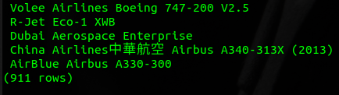
2. List the names and number of instances of all plane types.
   1. select Distinct C.name, C.numInstances from categories C where C.name LIKE '%plane';
   2. 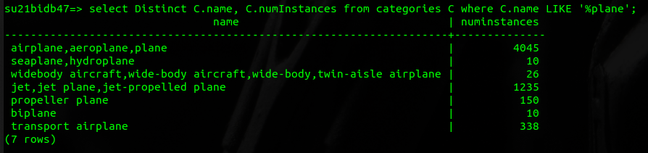
3. List the names of airplane children with more than 100 instances.
   1. select C.name from categories C JOIN ChildrenRel CR ON C.synsetId = CR.ChildID where C.numInstances > 100;
   2. 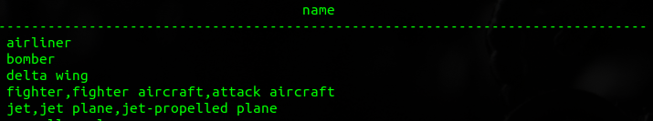
   3. 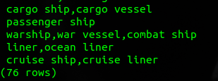
4. How many airplanes have a max X value > 1,000 and a min X value < -10,000?
   1. select COUNT(*) from meshData MD where MD.maxx > 1000 AND MD.minx < -10000;
   2. 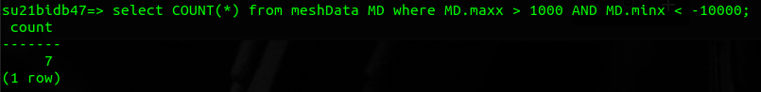
5. Which meshes have images associated with them?
   1. select DISTINCT M.name, I.MeshID from images I JOIN metadata M on I.meshID =M.fullID;
   2. 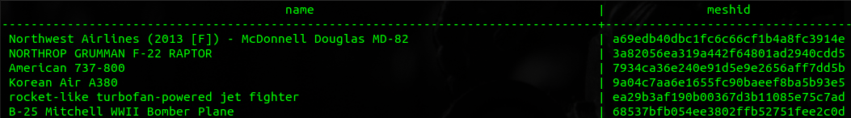
   3. 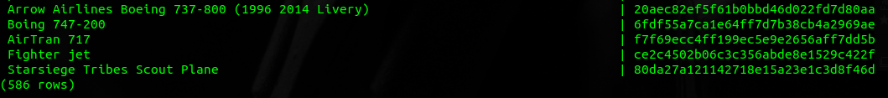
6. How many categories have more than 5 children?
   1. select distinct C.Name from Categories C JOIN ChildrenRel CR ON C.synsetID = CR.parentID where CR.ParentID IN (select distinct ParentID from (select *, count(1) over (partition by ParentID) as occurs from childrenRel) AS P where occurs > 5);
   2. 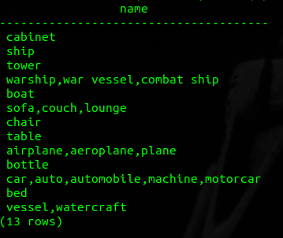
7. Which meshes have an ID starting with ‘f5’?
   1. select name, fullID from metadata where fullID LIKE 'f5%';
   2. 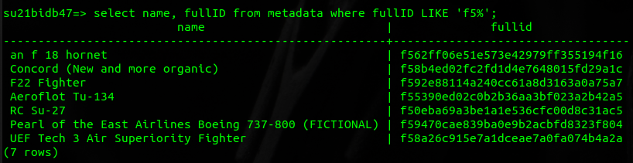
8. Which category names have the word chair in them?
   1. select name from categories where name LIKE '%chair%';
   2. 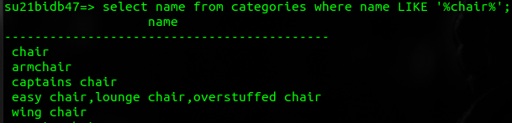
   3. 
9. What models have a name with Boeing in it?
   1. select M.name from metadata M where M.name LIKE '%Boeing%';
   2. 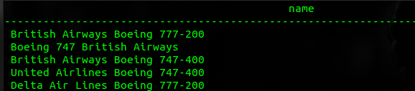
   3. 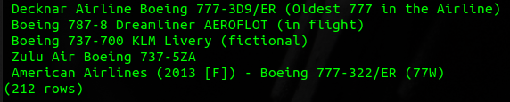
10. What unique up orientations are there?
    1. select COUNT(*), M.up from metadata M group by M.up;
    2. 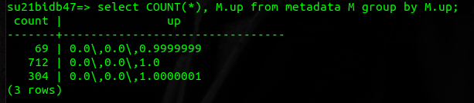
11. What airplane models have more than 35,000 vertices?
    1. select M.MeshID from MeshData M JOIN MeshRel MR ON M.meshID = MR.MeshID JOIN Categories C ON MR.synsetID = C.synsetId where C.Name LIKE '%plane%' AND M.numVerticies > 35000;
    2. 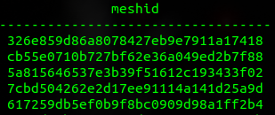
    3. 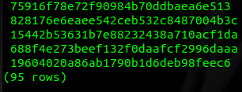
12. What are the top 10 categories with the most instances sorted in descending order?
    1. select name, numinstances from categories order by numinstances DESC LIMIT 10;
    2. 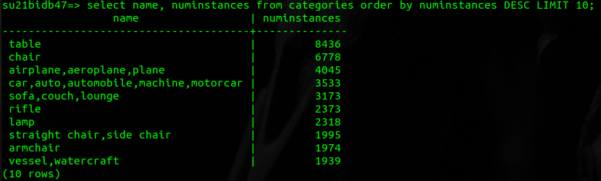
13. What are the names of models that have more than 2 images?
    1. select distinct M.name from metadata M JOIN IMAGES I ON M.fullID = I.meshID where I.meshID IN (select distinct meshID from (select *, count(1) over (partition by meshID) as occurs from images) AS IM where occurs > 5);
    2. 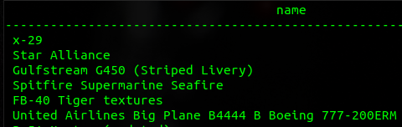
    3. 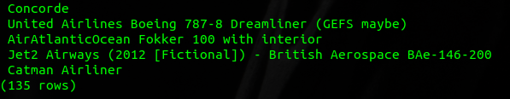
14. How many planes have tags?
    1. select count(*) from categories c join metadata m on c.synsetid=m.wnsynset where m.tags is NOT NULL;
    2. 
15. Which plane has the largest wingspan (assuming x is the width of wings)?
    1. select meshID from meshData where maxX = (select max(maxX) from meshdata);
    2. 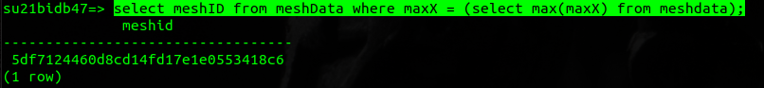
16. What is the order of airplanes from smallest to largest in X axis?
    1. select meshID, ABS(maxX - minX) AS difference from meshdata order by (difference) ASC;
    2. 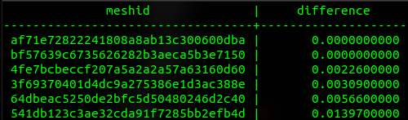
    3. 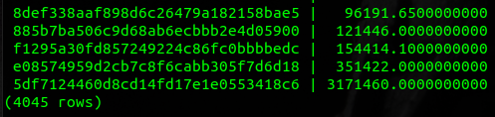
17. How wide is the largest plane?
    1. select max(ABS(maxX - minX)) AS differencex from meshdata;
    2. 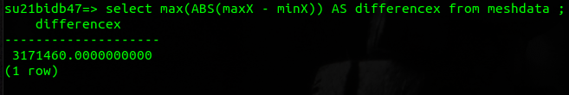
18. What model has a centroid closest to 0,0,0?
    1. select meshID, centroidx, centroidy, centroidz from meshdata where centroidz = (select min(ABS(centroidz)) AS differencez from meshdata ) OR centroidy = (select min(ABS(centroidy)) AS differencey from meshdata ) OR centroidx = (select min(ABS(centroidx)) AS differencex from meshdata );
    2. 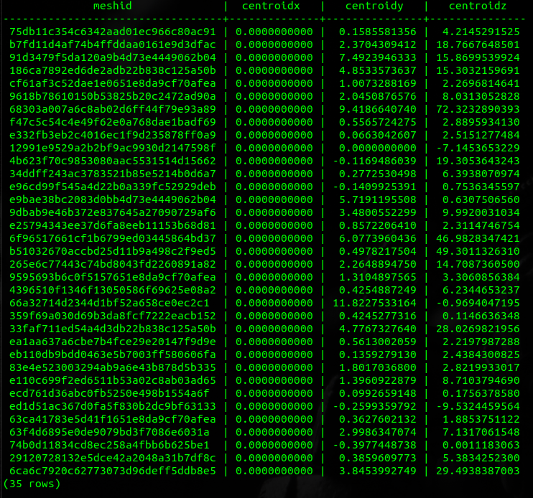
    3. Turns out that 35 meshes have a centroidX value of 0
19. How many entries are tagged with ‘jet’ or ‘Boeing’?
    1. select count(*) from metadata m where m.tags LIKE '%jet%' or m.tags LIKE '%Boeing%';
    2. 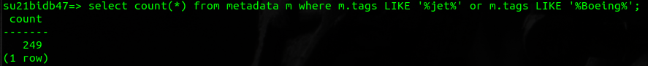
20. How many models are pointed toward the -x axis? (ie front is -1 on X)
    1. select count(*) FROM metadata where front LIKE '-1.0\\,0.0\\,0.0';
    2. 