

System Analysis & Design
NYAN
CPRO 2901 F.
Yaksh Sharma, Aaryan Garg, Harmanpreet Singh, Ramandeep Kaur and Fedil

1. Introduction
This document presents the System Analysis & Design (SAD) for a 2D Unity game prototype that demonstrates adaptive, personality-aware NPC behavior. The player begins with no NPCs instantiated. When the player enters the Blacksmith Shop, the Blacksmith NPC spawns. The system interprets player input (typed text plus optional in-scene action), retrieves relevant facts (policy, price, lore), selects an NPC action, and returns a short line and/or animation cue.
This report includes analysis models (DFDs, Use Case, conceptual ERD, Data Dictionary) and design artifacts (architecture, UI, algorithms/flowcharts, module descriptions).

2. System Modeling

2.1 Data Flow Diagrams (DFDs)

2.1.1 Context-Level DFD (Level 0)
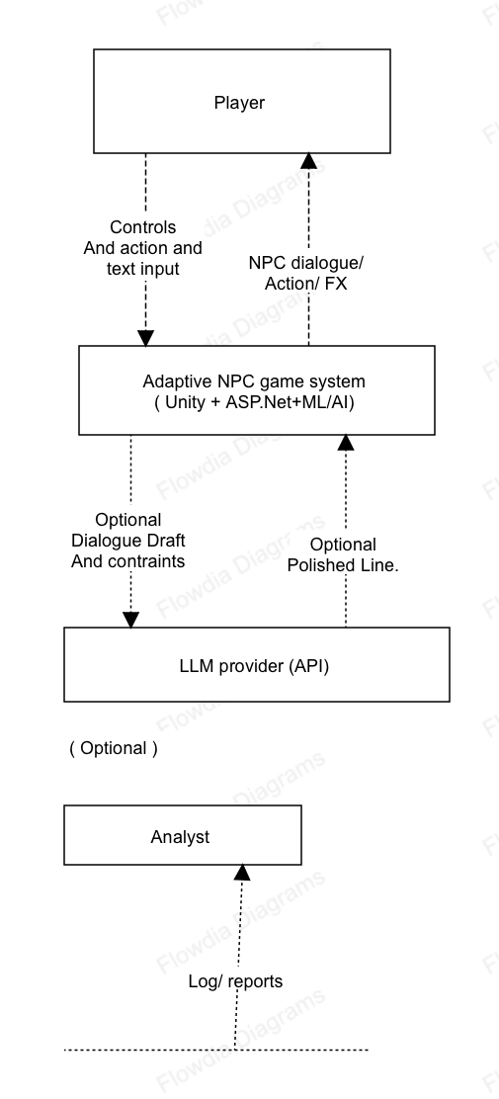
The Player exchanges controls and text with the Unity client, which calls the back-end REST API. The back end may optionally call a cloud LLM to polish a selected line; the system degrades gracefully without it.

2.1.2 Level 2 DFD — 1.0 Interpret Player Input (NLU)
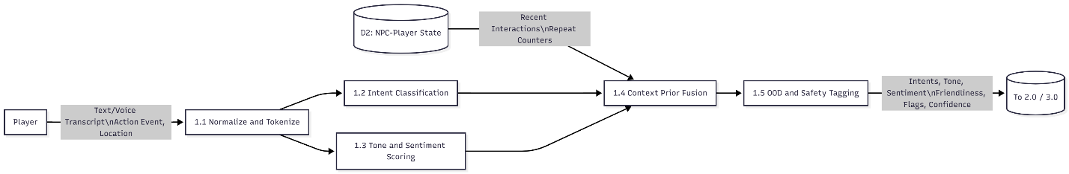
Text normalization precedes multi-label intent detection and tone/sentiment scoring. Scores are fused with context priors (location, action). Low-confidence or unsafe content is flagged for safe handling.

2.1.3 Level-2 DFD — 3.0 Generate & 4.0 Select
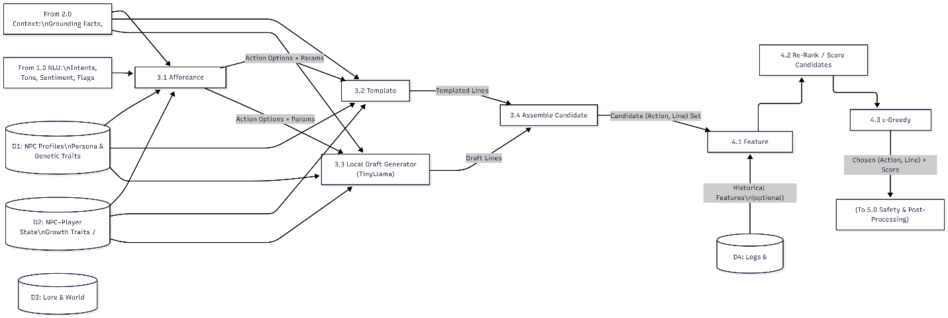The system builds candidate actions (e.g., OFFER_REPAIR, WARN_CIVILITY), drafts one–two short lines per action (template or tiny local model), then scores and selects the best. A safety/lore gate validates facts and tone.

2.1.4 Level-2 DFD — 6.0 Update Traits & Persist
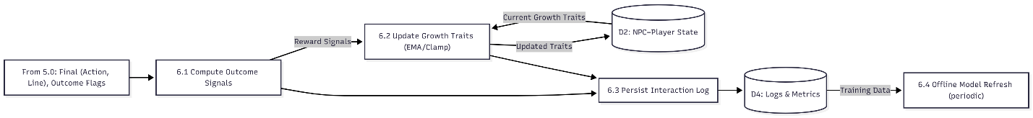

2.2 Data Dictionary (Planned Schema)

Table: PLAYER
Field Name | Data Type | Size | Constraints | Description
player_id | INT | – | PK, IDENTITY | Unique player ID
display_name | NVARCHAR | 100 | NOT NULL | Player name
created_at | DATETIME2 | – | DEFAULT UTCNOW | Creation timestamp

Table: NPC (genetic traits as columns)
Field Name | Data Type | Size | Constraints | Description
npc_id | INT | – | PK, IDENTITY | NPC ID
name | NVARCHAR | 100 | NOT NULL | NPC name
archetype | NVARCHAR | 50 | NOT NULL | Persona key
base_friendliness | DECIMAL | 3,2 | 0..1, NOT NULL | Genetic trait
base_patience | DECIMAL | 3,2 | 0..1, NOT NULL | Genetic trait
base_curiosity | DECIMAL | 3,2 | 0..1, NOT NULL | Genetic trait
base_openness | DECIMAL | 3,2 | 0..1, NOT NULL | Genetic trait
base_confidence | DECIMAL | 3,2 | 0..1, NOT NULL | Genetic trait
created_at | DATETIME2 | – | DEFAULT UTCNOW | Created time

Table: PLAYER_NPC_STATE (growth traits)
Field Name | Data Type | Size | Constraints | Description
player_id | INT | – | PK/FK PLAYER | Player ref
npc_id | INT | – | PK/FK NPC | NPC ref
trust | DECIMAL | 3,2 | 0..1, NOT NULL | Growth trait
patience | DECIMAL | 3,2 | 0..1, NOT NULL | Growth trait
curiosity | DECIMAL | 3,2 | 0..1, NOT NULL | Growth trait
openness | DECIMAL | 3,2 | 0..1, NOT NULL | Growth trait
memory | NVARCHAR | 400 | NULL | Short per-pair notes
last_interaction_at | DATETIME2 | – | NULL | Most recent interaction time

Table: ACTION_CATALOG
Field Name | Data Type | Size | Constraints | Description
action_id | INT | – | PK, IDENTITY | Unique action ID
code | NVARCHAR | 50 | NOT NULL, UNIQUE | e.g., OFFER_REPAIR, WARN_CIVILITY
intent_tag | NVARCHAR | 30 | NOT NULL | assist, inform, warn, refuse
description | NVARCHAR | 200 | NULL | Human-readable summary

Table: INTERACTION (turn log)
Field Name | Data Type | Size |  | Constraints | Description
interaction_id | BIGINT | – | PK, IDENTITY |  | Unique log ID
player_id | INT | – | FK PLAYER |  | Player ref
npc_id | INT | – | FK NPC |  | NPC ref
occurred_at | DATETIME2 | – | DEFAULT UTCNOW |  | Timestamp
location | NVARCHAR | 80 | NULL |  | Scene key
player_action | NVARCHAR | 60 | NULL |  | e.g., DROP_ITEM_ON_COUNTER
player_text | NVARCHAR(MAX) | – | NULL |  | Raw input
nlu_top_intent | NVARCHAR | 40 | NULL |  | Top detected intent
sentiment | DECIMAL | 4,2 | −1..1, NULL |  | Sentiment score
friendliness | DECIMAL | 3,2 | 0..1, NULL |  | Friendliness score
tone_tag | NVARCHAR | 30 | NULL |  | Tone label
nsfw_flag | BIT | – | DEFAULT 0 |  | Safety flag
chosen_action_id | INT | – | FK ACTION_CATALOG |  | Chosen action
response_text | NVARCHAR(MAX) | – | NULL |  | Final line returned
response_source | NVARCHAR | 20 | NULL |  | TEMPLATE | LOCAL_LLM | CLOUD_LLM
model_versions | NVARCHAR | 120 | NULL |  | e.g., “nlu=v1;ranker=v2”
reward_score | DECIMAL | 5,2 | NULL |  | Aggregated reward for learning
outcome_flags | NVARCHAR(MAX) | – | NULL |  | e.g., continued, repeated, progressed

3. System Design

3.1 System Architecture Diagram
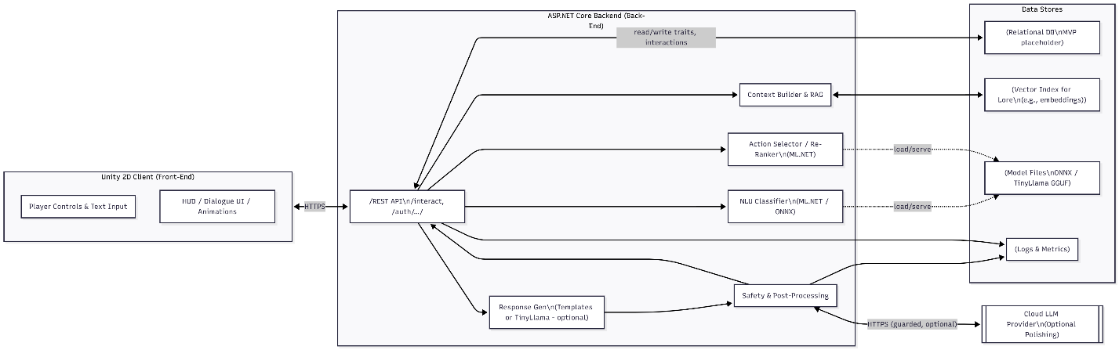
The image above shows the system architecture diagram and the different components namely frontend(unity), backend (ASP.NET) and Data stores, with the optional LLM API call.
The Unity client sends a single interaction request. The back end orchestrates NLU → retrieval → generation/templating → ranking → safety, then returns {action, line, ui_cues}. The system runs fully local; cloud polish is optional.

4. Sequence Diagram
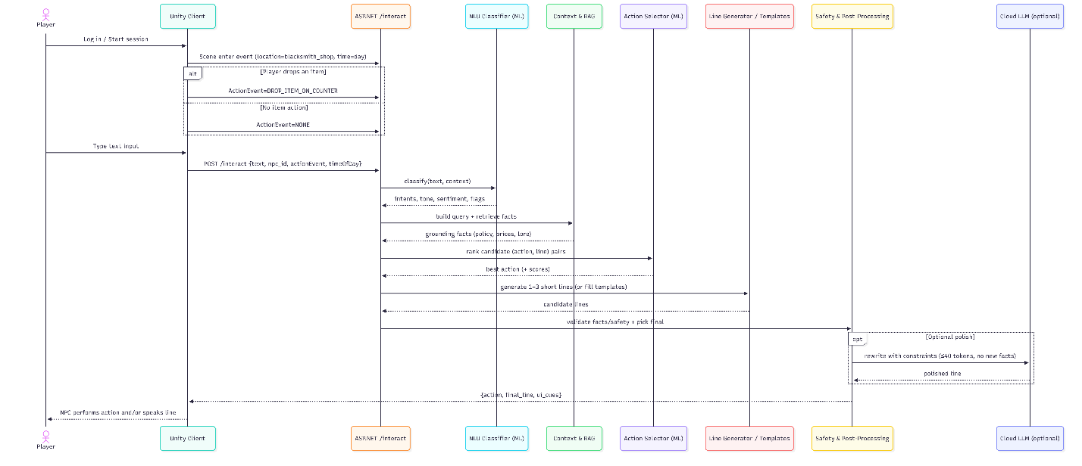
The Unity client calls /interact only when the player types text or triggers a meaningful ActionEvent. The backend runs NLU (intents/tone), then Context/RAG to fetch grounding facts, generates 1–3 candidate (action, line) pairs, scores & selects the best, applies safety/lore checks, and optionally sends a bounded polish to a cloud LLM (no new facts, ≤40 tokens). The final {action, line, ui_cues} is returned to the client for display and logging.

5. Activity Diagram
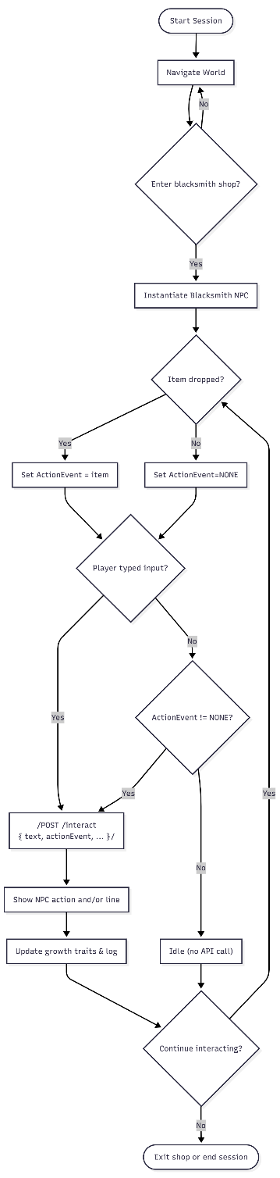
The Player initiates interaction only inside the Blacksmith Shop. Item actions are optional; the system still responds to text alone.

6. Use case diagram
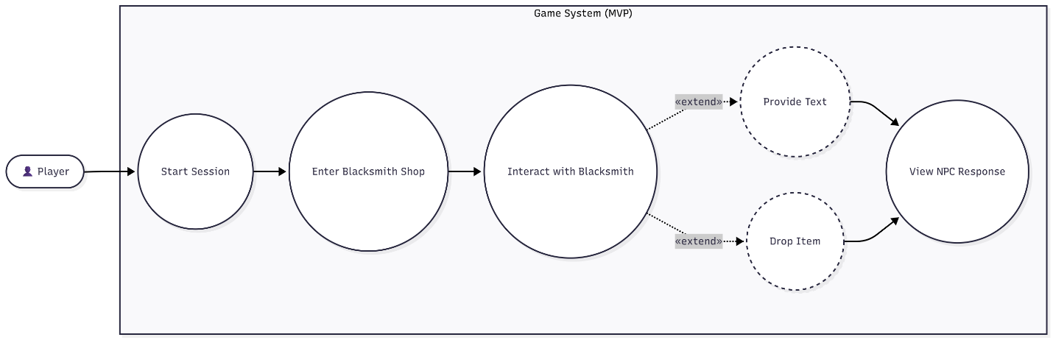

The diagram above is a use case diagram of a user/player when interacting with a npc.
The Player initiates interaction only inside the Blacksmith Shop. Item actions or text are optional; the system still responds to text or action alone.

7. ERD Diagram (Conceptual)
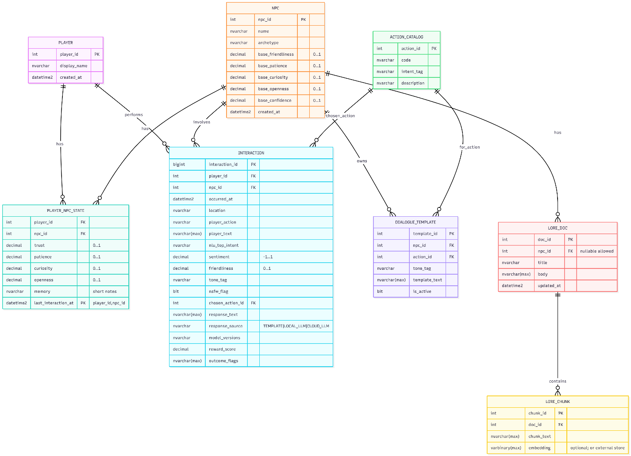
PLAYER, NPC (genetic traits as columns), PLAYER_NPC_STATE (growth traits per relationship), INTERACTION (turn log), ACTION_CATALOG, DIALOGUE_TEMPLATE (fallback), LORE_DOC, LORE_CHUNK.]
The MVP defers DB implementation but defines a schema now to keep analysis/design aligned and future-proof.
It should be noted that traits given in the NPC table are a placeholder and may differ in the final implementation.

8. Level-1 DFD (annotated, wide)
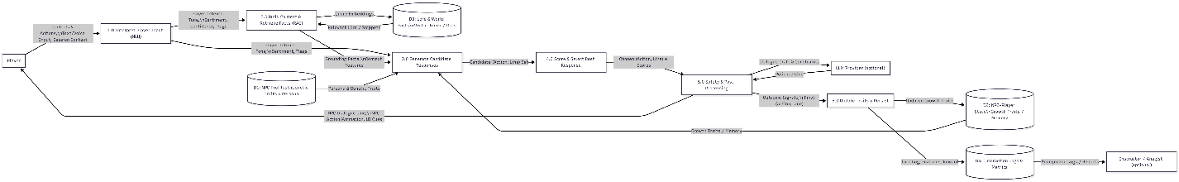

9. Module Descriptions
- Unity 2D Client: Captures controls/text; manages scene triggers; renders dialogue/animations.
- REST API (/interact): Orchestrates NLU → retrieval → generation/templating → ranking → safety; returns {action, line, ui_cues}.
- NLU Classifier (ML.NET/ONNX): Multi-label intents; tone/sentiment; safety flags; context-prior fusion.
- Context & RAG: Builds compact queries; fetches shop policies/prices/lore for grounding.
- Action Selector / Re-Ranker (ML.NET): Scores candidate (action, line) pairs; chooses top 1.
- Response Generation: Templates (primary) or tiny local model (≤40 tokens) under strict constraints.
- Safety & Post-Processing: Profanity/NSFW/lore checks; optional cloud polish behind a feature flag.
- Logging & Metrics: Writes structured logs for evaluation and future training.

